**CSE499A Project Report (GROUP-4)**

**Ezab Quader | Durjoy Das| Minhajul Imaj | Irin Sultana**

**AR based NSU 3D Model**

**ABSTRACT**

Augmented Reality is a technology where we can create a virtual platform to make things easier and efficient. Here we can integrate 3-D models and create a real 3-D environment in real time. Nowadays AR technology is the most demanded ones in Technology world. We are going to use the AR technology and create a virtual platform which helps people to understand the complex thing. Our research aim is to build environment where we can use the AR technology easily and make thing efficient. Our main focuses are to integrate a 3-D model of North South University and create a real time environment of North South University. We are also going to implement 2-D to 3-D AR conversion, 3-D Newspaper, 3-D AR Visiting card etc.

**INTRODUCTION**

Augmented reality is the technology that expands our physical world, adding layers of digital information onto it. Unlike Virtual Reality (VR), AR does not create the whole artificial environments to replace real with a virtual one. AR appears in direct view of an existing environment and adds sounds, videos, and graphics to it. A view of the physical real-world environment with superimposed computer-generated images, thus changing the perception of reality, is the AR.

The term itself was coined back in 1990, and one of the first commercial uses was in television and military. With the rise of the Internet and Smartphone, AR rolled out its second wave and nowadays is mostly related to the interactive concept. 3D models are directly projected onto physical things or fused together in real-time, various augmented reality apps impact our habits, social life, and the entertainment industry.

AR apps typically connect digital animation to a special ‘marker’, or with the help of GPS in phones pinpoint the location. Augmentation is happening in real time and within the context of the environment, for example, overlaying scores to live feed sport events.

**History of AR technology**

In 1968 Ivan Sutherland and Bob Sproull created a first head-mounted display, they called it The Sword of Damocles. Obviously, it was a rough device that displayed primitive computer graphics. In 1975 Myron Krueger created Videoplace – an artificial reality laboratory. The scientist envisioned the interaction with digital stuff by human movements. This concept later was used for certain projectors, video cameras, and onscreen silhouettes. In 1980 Steve Mann developed a first portable computer called EyeTap, designed to be worn in front of the eye. It recorded the scene to superimposed effects on it later, and show it all to a user who could also play with it via head movements. In 1987 Douglas George and Robert Morris developed the prototype of a heads-up display (HUD). It displayed astronomical data over the real sky.

The year 1990 marked the birth of the “augmented reality” term. It first appeared in the work of Thomas Caudell and David Mizell – Boeing company researchers. In 1992 Louis Rosenberg of the US Air Force created the AR system called “Virtual Fixtures”. In 1999, a group of scientists led by Frank Delgado and Mike Abernathy tested new navigation software, which generated runways and streets data from a helicopter video. In 2000 a Japanese scientist Hirokazu Kato developed and published ARToolKit – an open-source SDK. Later it was adjusted to work with Adobe. In 2004 Trimble Navigation presented an outdoor helmet-mounted AR system. In 2008 Wikitude made the AR Travel Guide for Android mobile devices. And in 2013 Google beta tested the Google Glass – with internet connection via Bluetooth. In 2015 Microsoft presented two brand new technologies: Windows Holographic and HoloLens (an AR goggles with lots of sensors to display HD holograms). In 2016 Niantic launched Pokemon Go game for mobile devices. The app blew the gaming industry up and earned $2 million in a just first week.

**The Working Procedure of AR technology**

AR a certain range of data (images, animations, videos, 3D models) may be used and people will see the result in both natural and synthetic light. Also, users are aware of being in the real world which is advanced by computer vision, unlike in VR. AR can be displayed on various devices: screens, glasses, handheld devices, mobile phones, head-mounted displays. It involves technologies like S.L.A.M., depth tracking and the following components:

* **Cameras and sensors**. Collecting data about user’s interactions and sending it for processing. Cameras on devices are scanning the surroundings and with this info, a device locates physical objects and generates 3D models. It may be special duty cameras, like in Microsoft Holo Lens, or common Smartphone cameras to take pictures/videos.
* **Processing**. AR devices eventually should act like little computers, something modern Smartphone already do. In the same manner, they require a CPU, a GPU, flash memory, RAM, Bluetooth/Wi-Fi, a GPS, etc. to be able to measure speed, angle, direction, orientation in space, and so on.
* **Projection.** This refers to a miniature projector on AR headsets, which takes data from sensors and projects digital content (result of processing) onto a surface to view. In fact, the use of projections in AR has not been fully invented yet to use it in commercial products or services
* **Reflection.** Some AR devices have mirrors to assist human eyes to view virtual images. Some have an “array of small curved mirrors” and some have a double-sided mirror to reflect light to a camera and to a user’s eye. The goal of such reflection paths is to perform a proper image alignment.

**Types of Augmented Reality**

There are four types of AR and they are:

1. **Marker-based AR,** as it requires a special visual object and a camera to scan it. It may be anything, from a printed QR code to special signs. The AR device also calculates the position and orientation of a marker to position the content, in some cases. Thus, a marker initiates digital animations for users to view, and so images in a magazine may turn into 3D models.

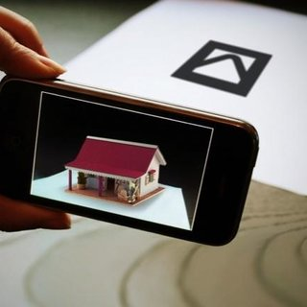

**Fig: Marker-based AR**

1. **Marker less AR**. A.k.a. location-based or position-based augmented reality, that utilizes a GPS, a compass, a gyroscope, and an accelerometer to provide data based on user’s location. This data then determines what AR content you find or get in a certain area. With the availability of Smartphone this type of AR typically produces maps and directions, nearby businesses info.

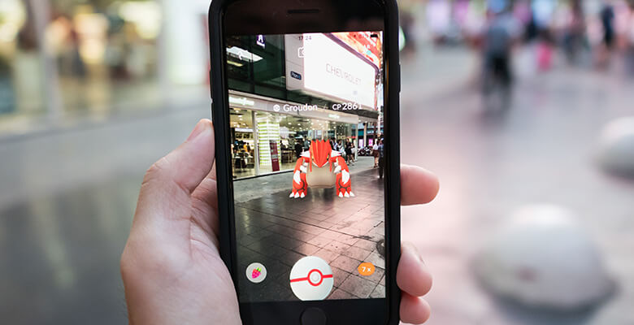

**Fig: Marker less AR**

1. **Projection-based AR.**Projecting synthetic light to physical surfaces, and in some cases allows to interact with it. These are the holograms on the surface. It detects user interaction with a projection by its alterations.

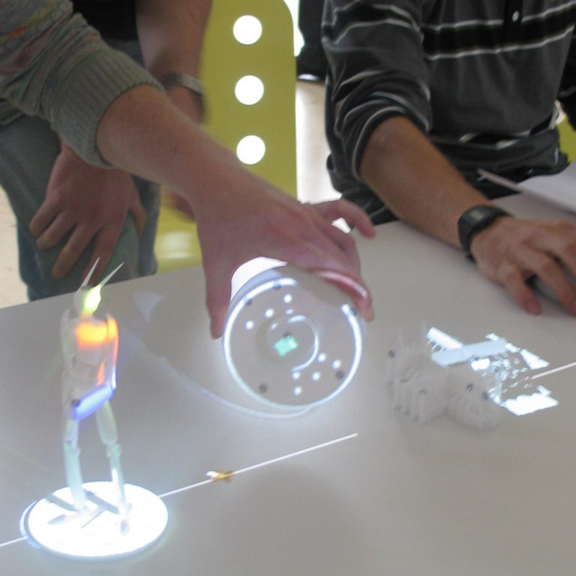

**Fig: Holograms**

1. **Superimposition-based AR.** replaces the original view with an augmented, fully or partially. Object recognition plays a key role, without it the whole concept is simply impossible.

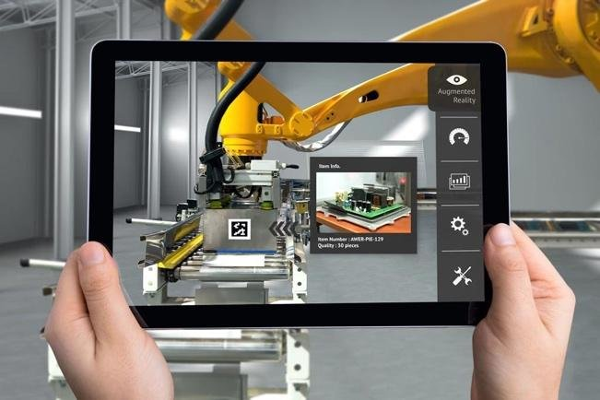

**Fig: Superimposition-based AR**