**Repository Setup:**

– Created a GitHub repository for the MLOPS project

Repository Link: <https://github.com/Minhal-Zafar/MLOPS_Final_Project.git>

– Each team member has their own branch in the repository.

Create 3 branches for each member minhal, hammas, and abeeha respectively.

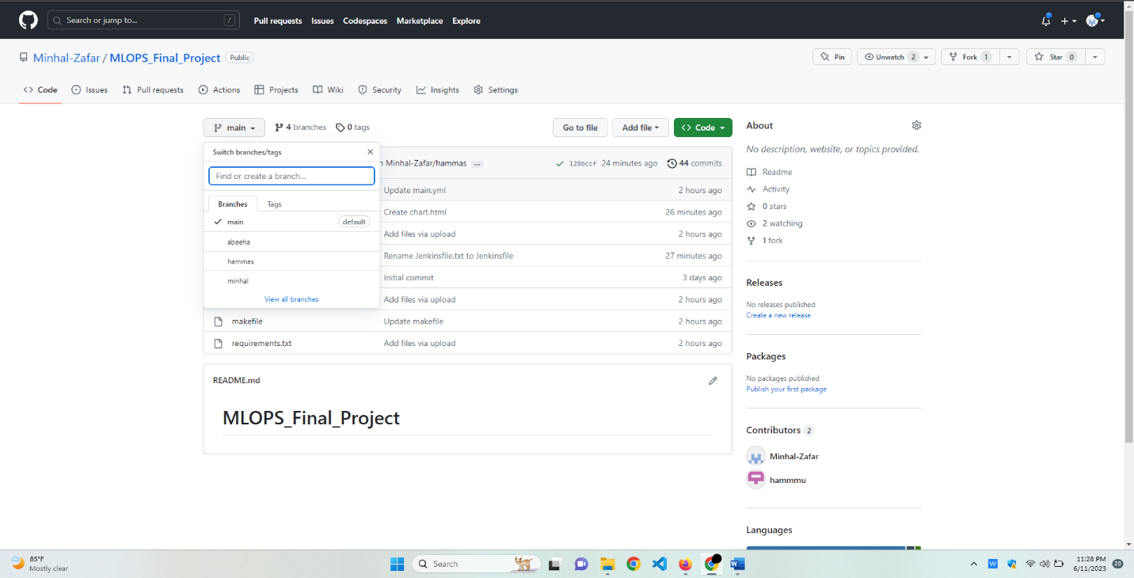

– Designated the main branch as the production branch.

If builds passed successfully, created a workflow for auto-merging into the main branch.

**GitHub Actions Workflow**

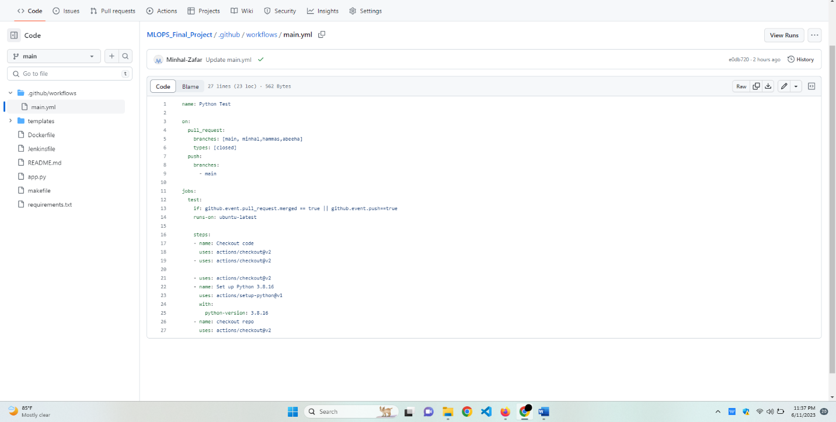

**Containerization with Docker:**

Docker Image

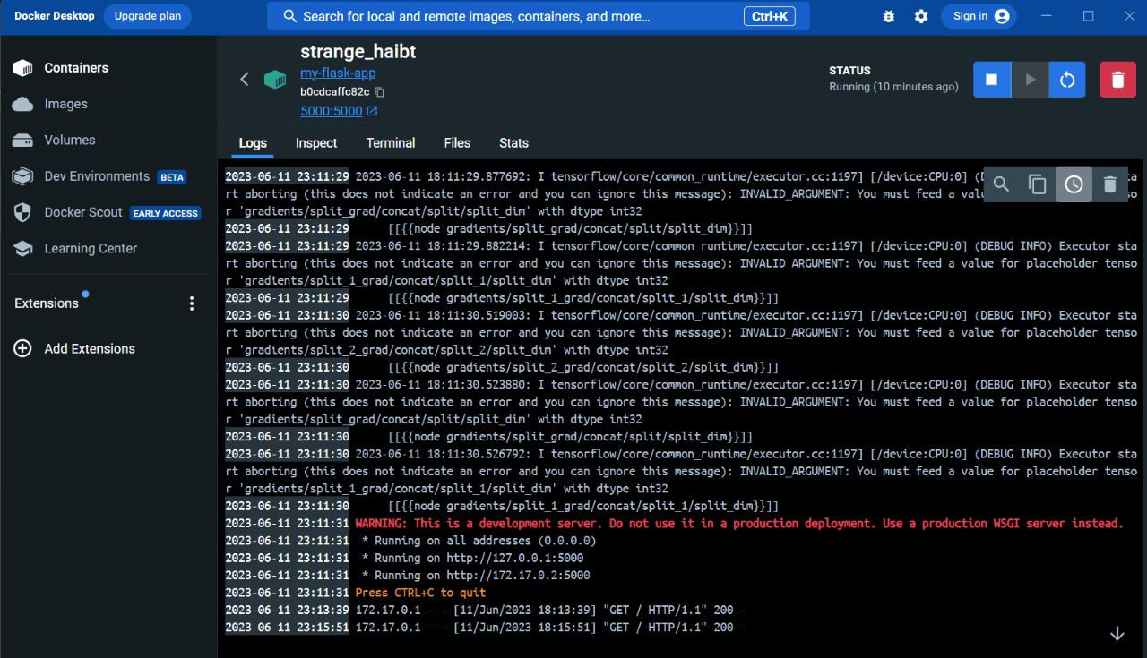

Dockerfile

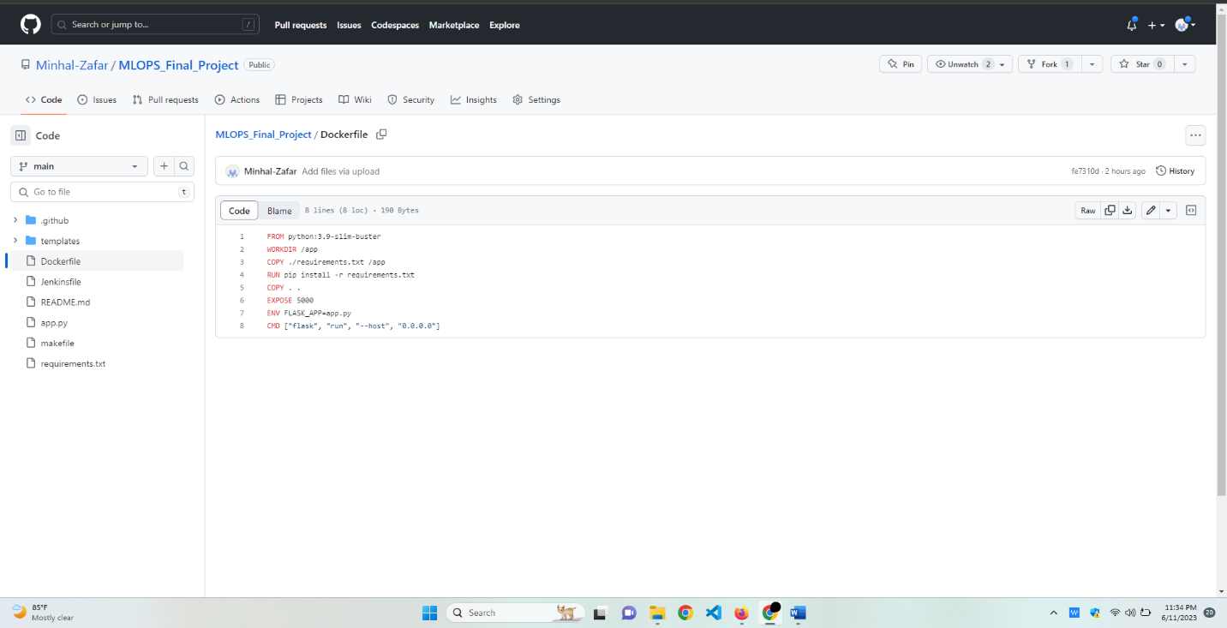

**Configured Jenkins as CI/CD server:**

Jenkinsfile

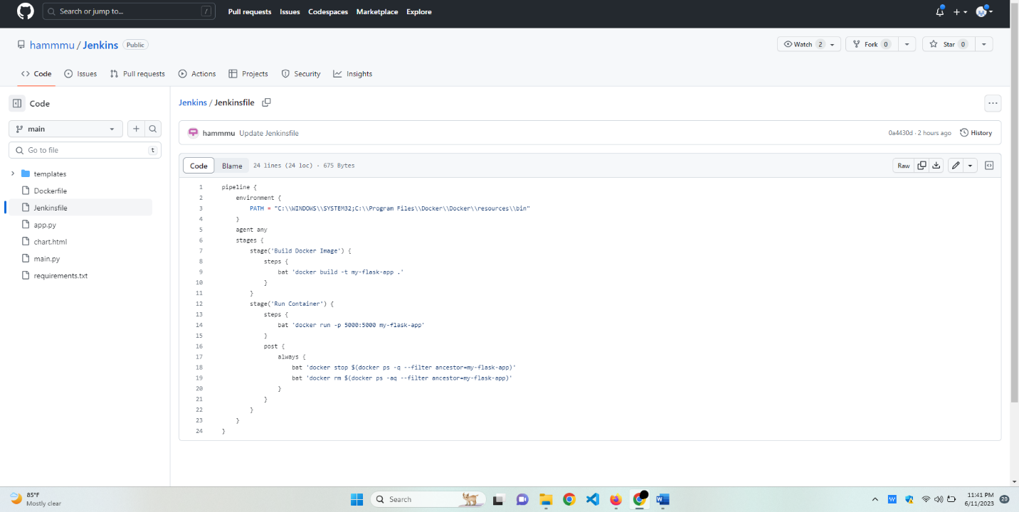

– Created a Jenkins pipeline that automates the build, test, and deployment process.

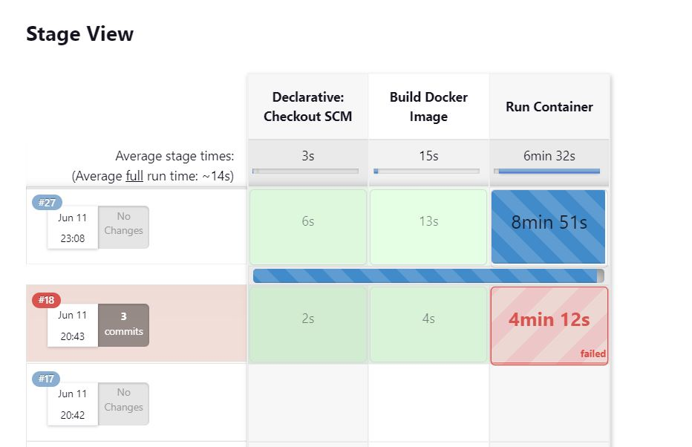

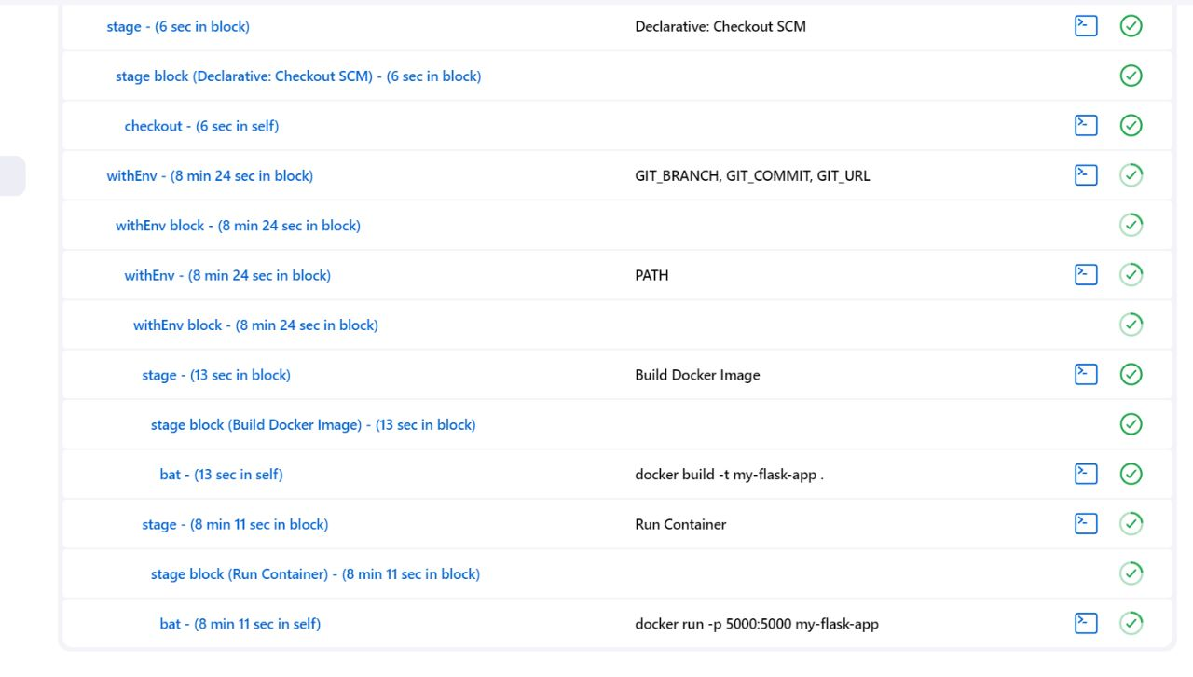

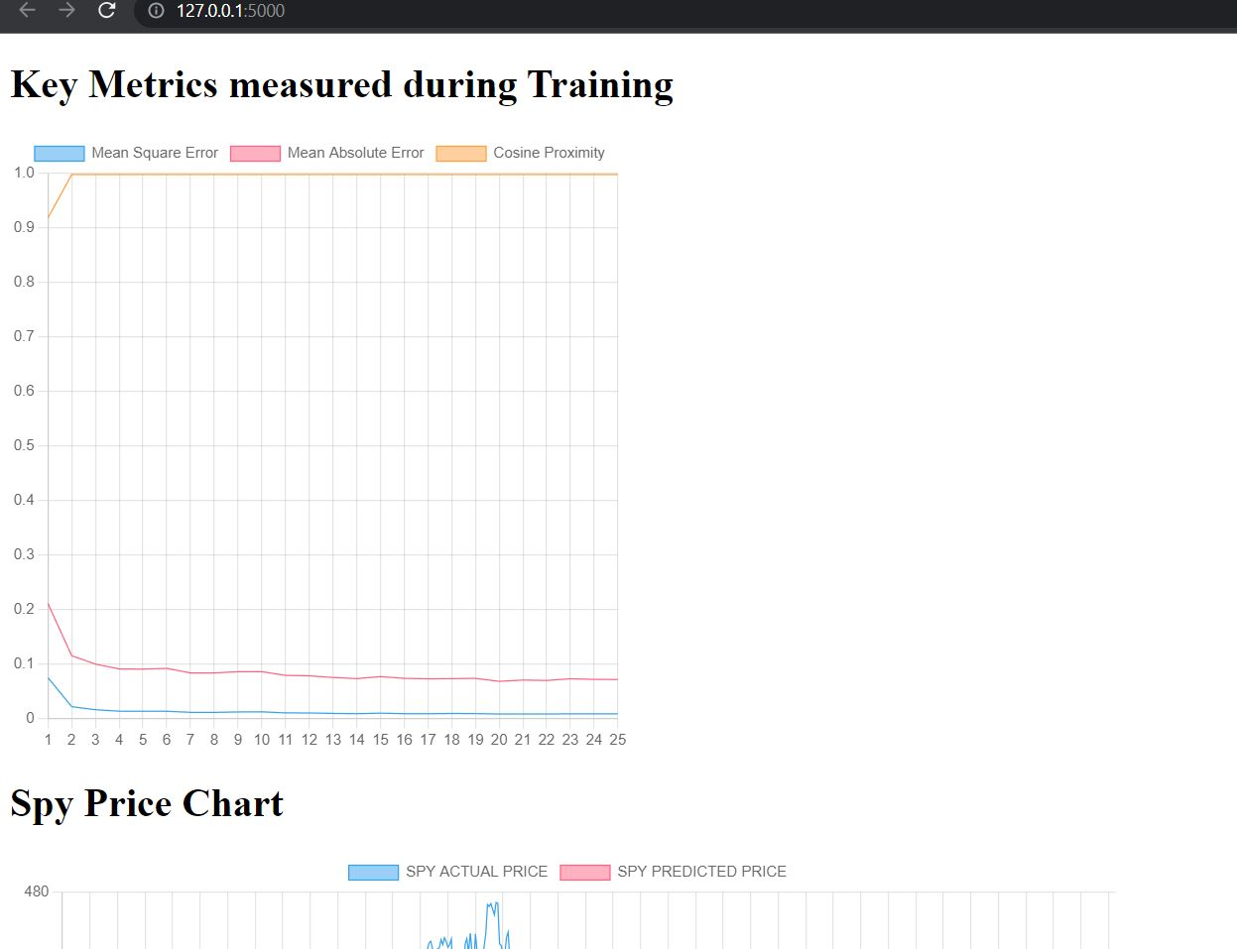



**Workflow Management with Apache Airflow:**

testDag file

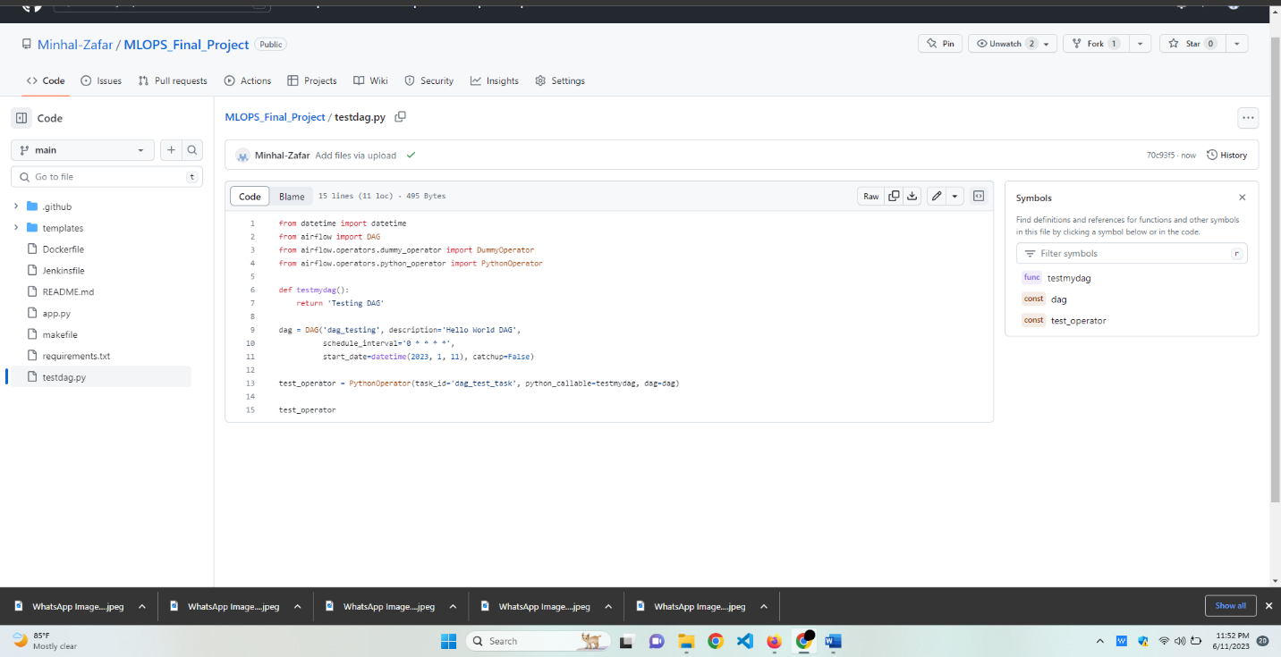

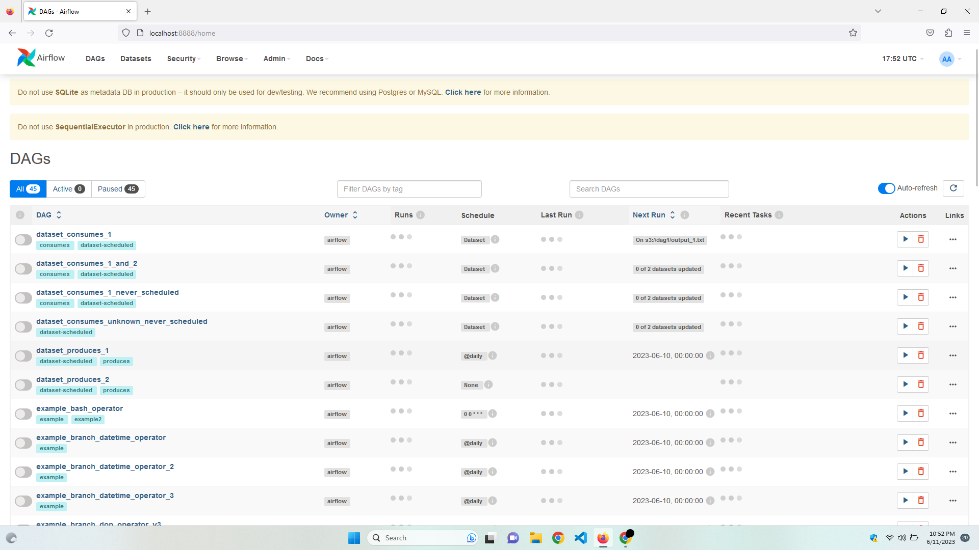

Commands used for Apache airflow workflow management:

