The Basics
What is Machine Learning?

Machine Learning Overview
Welcome to the Machine Learning course! Machine Learning is a way of taking data and turning it into insights. We use computer power to analyze examples from the past to build a model that can predict the result for new examples.
We encounter machine learning models every day. For example, when Netflix recommends a show to you, they used a model based on what you and other users have watched to predict what you would like. When Amazon chooses a price for an item, they use a model based on how similar items have sold in the past. When your credit card company calls you because of suspicious activity, they use a model based on your past activity to recognize anomalous behavior.
In this course we’ll learn several techniques for solving machine learning problems.
Machine Learning can be used to create a chatbot, detect spam or image recognition.

Course Basics
One of the most common languages used by Machine Learning professionals is Python.
It's both very approachable and very powerful, so it's what we'll be using in this course. We assume a working knowledge of Python.
In this course we’ll use several Python packages that are helpful in solving Machine Learning problems. We’ll be using pandas, numpy, matplotlib and scikit-learn. Pandas is used for reading data and data manipulation, numpy is used for computations of numerical data, matplotlib is used for graphing data, and scikit-learn is used for machine learning models. Each of these packages is quite extensive, but we will review the functions we will be using. We will also review some basic statistics as it is the foundation of machine learning.
The course will cover both the theory and practice of machine learning techniques, but will focus on how to use them on real examples.

What's in this Course?
In Machine Learning, we talk about supervised and unsupervised learning. Supervised learning is when we have a known target based on past data (for example, predicting what price a house will sell for) and unsupervised learning is when there isn't a known past answer (for example, determining the topics discussed in restaurant reviews).
In this course we'll be focusing on supervised learning. Within supervised learning, there are classification and regression problems. Regression is predicting a numerical value (for example, predicting what price a house will sell for) and classification is predicting what class something belongs to (for example, predicting if a borrower will default on their loan).
We'll be focusing on classification problems. These are problems where we’re predicting which class something belongs to.
Our examples will include:
• Predicting who would survive the Titanic crash
• Determining a handwritten digit from an image
• Using biopsy data to classify if a lump is cancerous
We'll be using a number of popular techniques to tackle these problems. We'll get into each of them in more detail in upcoming modules:
• Logistic Regression
• Decision Trees
• Random Forests
• Neural Networks
At the end of this course, you'll be able to take a classification dataset and use Python to build several different models to determine the best model for the given problem.
Machine Learning can be used to solve a broad range of problems. This course will focus on supervised learning and classification.

Statistics Review

Averages
When dealing with data, we often need to calculate some simple statistics.
Let's say we have a list of the ages of people in a class.
We have them in ascending order since it will be easier to do the calculations.
15, 16, 18, 19, 22, 24, 29, 30, 34
The mean is the most commonly known average.
Add up all the values and divide by the number of values:
(15 + 16 + 18 + 19 + 22 + 24 + 29 + 30 + 34) / 9 = 207/9 = 23
The median is the value in the middle. In this case, since there are 9 values, the middle value is the 5th, which is 22.
In statistics, both the mean and the median are called averages. The layman’s average is the mean.

Percentiles
The median can also be thought of as the 50th percentile. This means that 50% of the data is less than the median and 50% of the data is greater than the median. This tells us where the middle of the data is, but we often want more of an understanding of the distribution of the data. We’ll often look at the 25th percentile and the 75th percentile.
The 25th percentile is the value that’s one quarter of the way through the data. This is the value where 25% of the data is less than it (and 75% of the data is greater than it).
Similarly, the 75th percentile is three quarters of the way through the data. This is the value where 75% of the data is less than it (and 25% of the data is greater than it).
If we look at our ages again:
15, 16, 18, 19, 22, 24, 29, 30, 34
We have 9 values, so 25% of the data would be approximately 2 datapoints. So the 3rd datapoint is greater than 25% of the data. Thus, the 25th percentile is 18 (the 3rd datapoint).
Similarly, 75% of the data is approximately 6 datapoints. So the 7th datapoint is greater than 75% of the data. Thus, the 75th percentile is 29 (the 7th datapoint).
The full range of our data is between 15 and 34. The 25th and 75th percentiles tell us that half our data is between 18 and 29. This helps us gain understanding of how the data is distributed.
If there is an even number of datapoints, to find the median (or 50th percentile), you take the mean of the two values in the middle.

Standard Deviation & Variance
We can get a deeper understanding of the distribution of our data with the standard deviation and variance. The standard deviation and variance are measures of how dispersed or spread out the data is.
We measure how far each datapoint is from the mean.
Let's look at our group of ages again:
15, 16, 18, 19, 22, 24, 29, 30, 34
Recall that the mean is 23.
Let's calculate how far each value is from the mean. 15 is 8 away from the mean (since 23-15=8).
Here's a list of all these distances:
8, 7, 5, 4, 1, 1, 6, 7, 11
We square these values and add them together. 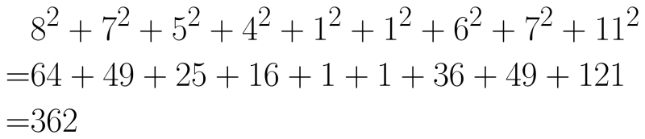
We divide this value by the total number of values and that gives us the variance.
362 / 9 = 40.22
To get the standard deviation, we just take the square root of this number and get: 6.34
If our data is normally distributed like the graph below, 68% of the population is within one standard deviation of the mean. In the graph, we’ve highlighted the area within one standard deviation of the mean. You can see that the shaded area is about two thirds (more precisely 68%) of the total area under the curve. If we assume that our data is normally distributed, we can say that 68% of the data is within 1 standard deviation of the mean.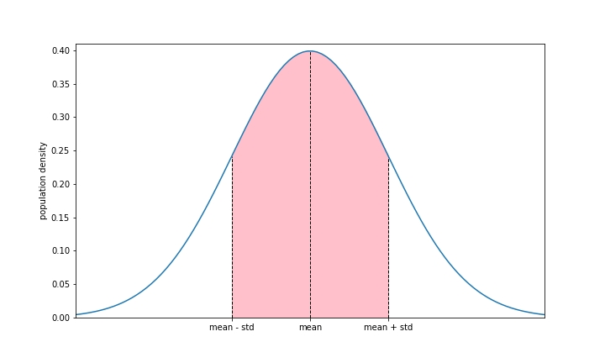
In our age example, while the ages are likely not exactly normally distributed, we assume that we are and say that approximately 68% of the population has an age within one standard deviation of the mean. Since the mean is 23 and the standard deviation is 6.34, we can say that approximately 68% of the ages in our population are between 16.66 (23 minus 6.34) and 29.34 (23 plus 6.34).
Even though data is never a perfect normal distribution, we can still use the standard deviation to gain insight about how the data is distributed.

Statistics with Python
We can calculate all of these operations with Python. We will use the Python package numpy. We will use numpy more later for manipulating arrays, but for now we will just use a few functions for statistical calculations: mean, median, percentile, std, var.
First we import the package. It is standard practice to nickname numpy as np.
import numpy as np
Let’s initialize the variable data to have the list of ages.
data = [15, 16, 18, 19, 22, 24, 29, 30, 34]
Now we can use the numpy functions. For the mean, median, standard deviation and variance functions, we just pass in the data list. For the percentile function we pass the data list and the percentile (as a number between 0 and 100).
Try it now:
import numpy as np
data = [15, 16, 18, 19, 22, 24, 29, 30, 34]
print("mean:", np.mean(data))
print("median:", np.median(data))
print("50th percentile (median):", np.percentile(data, 50))
print("25th percentile:", np.percentile(data, 25))
print("75th percentile:", np.percentile(data, 75))
print("standard deviation:", np.std(data))
print("variance:", np.var(data))
Numpy is a python library that allows fast and easy mathematical operations to be performed on arrays.

Reading Data with Pandas

What is Pandas?
This course is in Python, one of the most commonly used languages for machine learning.
One of the reasons it is so popular is that there are numerous helpful python modules for working with data. The first we will be introducing is called Pandas.
Pandas is a Python module that helps us read and manipulate data. What's cool about pandas is that you can take in data and view it as a table that's human readable, but it can also be interpreted numerically so that you can do lots of computations with it.
We call the table of data a DataFrame.
Python will satisfy all of our Machine Learning needs. We’ll use the Pandas module for data manipulation.

Read in Your Data
We need to start by importing Pandas. It's standard practice to nickname it pd so that it's faster to type later on.
import pandas as pd
We will be working with a dataset of Titanic passengers. For each passenger, we’ll have some data on them as well as whether or not they survived the crash.
Our data is stored as CSV (comma-separated values) file. The titanic.csv file is below. The first line is the header and then each subsequent line is the data for a single passenger. Survived, Pclass, Sex, Age, Siblings/Spouses, Parents/Children, Fare
0, 3, male, 22.0, 1, 0, 7.25
1, 1, female, 38.0, 1, 0, 71.2833
1, 3, female, 26.0, 0, 0, 7.925
1, 1, female, 35.0, 1, 0, 53.1
We're going to pull the data into pandas so we can view it as a DataFrame.
The read_csv function takes a file in csv format and converts it to a Pandas DataFrame.
df = pd.read_csv('titanic.csv')
The object df is now our pandas dataframe with the Titanic dataset. Now we can use the head method to look at the data.
The head method returns the first 5 rows of the DataFrame.
print(df.head())
Run this code to see the results:
import pandas as pd
df = pd.read_csv('https://sololearn.com/uploads/files/titanic.csv')
print(df.head())
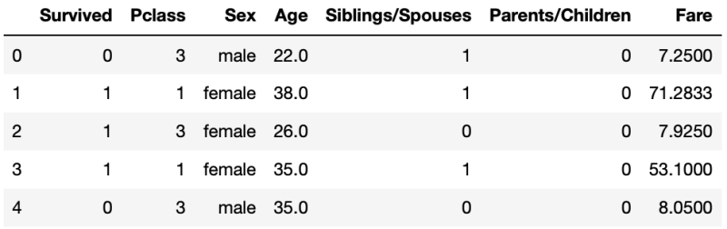
Generally data is stored in CSV (comma-separated values) files, which we can easily read in with panda’s read_csv function. The head method returns the first 5 rows.

Summarize the Data
Usually our data is much too big for us to be able to display it all.
Looking at the first few rows is the first step to understanding our data, but then we want to look at some summary statistics.
In pandas, we can use the describe method. It returns a table of statistics about the columns.
print(df.describe())
We add a line in the code below to force python to display all 6 columns. Without the line, it will abbreviate the results.
Run this code to see the results:
import pandas as pd
pd.options.display.max_columns = 6
df = pd.read_csv('https://sololearn.com/uploads/files/titanic.csv')
print(df.describe())
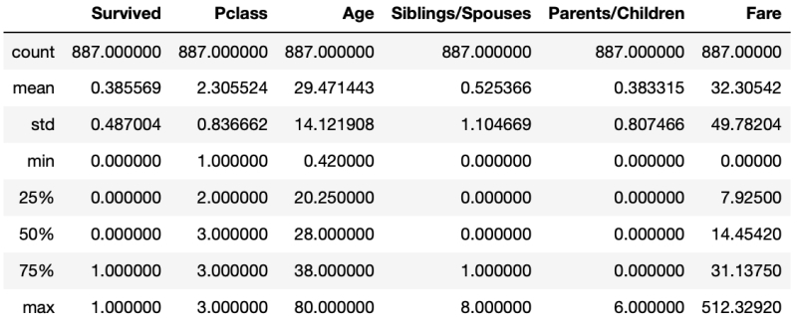
For each column we see a few statistics. Note that it only gives statistics for the numerical columns.
Let's review what each of these statistics means:
Count: This is the number of rows that have a value. In our case, every passenger has a value for each of the columns, so the value is 887 (the total number of passengers).
Mean: Recall that the mean is the standard average.
Std: This is short for standard deviation. This is a measure of how dispersed the data is.
Min: The smallest value
25%: The 25th percentile
50%: The 50th percentile, also known as the median.
75%: The 75th percentile
Max: The largest value
We use the Pandas describe method to start building some intuition about our data.
Manipulating Data with Pandas

Selecting a Single Column
We often will only want to deal with some of the columns that we have in our dataset. To select a single column, we use the square brackets and the column name.
In this example, we're selecting just the column with the passenger fares.
col = df['Fare']
print(col)
The result is what we call a Pandas Series.
A series is like a DataFrame, but it's just a single column.
Run this code to see the results:
import pandas as pd
df = pd.read_csv('https://sololearn.com/uploads/files/titanic.csv')
col = df['Fare']
print(col)
A Pandas Series is a single column from a Pandas DataFrame.

Selecting Multiple Columns
We can also select multiple columns from our original DataFrame, creating a smaller DataFrame.
We're going to select just the Age, Sex, and Survived columns from our original DataFrame.
We put these values in a list as follows:
['Age', 'Sex', 'Survived']
Now we use that list inside of the bracket notation df[...] When printing a large DataFrame that’s too big to display, you can use the head method to print just the first 5 rows.
small_df = df[['Age', 'Sex', 'Survived']]
print(small_df.head())
Run this code to see the results:
import pandas as pd
df = pd.read_csv('https://sololearn.com/uploads/files/titanic.csv')
small_df = df[['Age', 'Sex', 'Survived']]
print(small_df.head())
Result: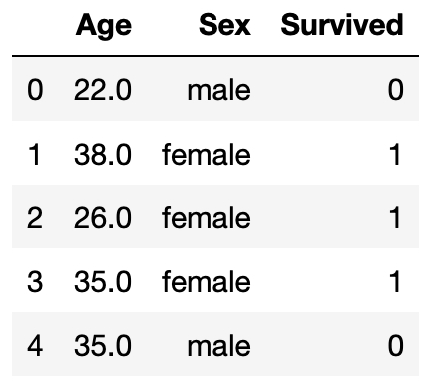
When selecting a single column from a Pandas DataFrame, we use single square brackets. When selecting multiple columns, we use double square brackets.

Creating a Column
We often want our data in a slightly different format than it originally comes in. For example, our data has the sex of the passenger as a string ("male" or "female"). This is easy for a human to read, but when we do computations on our data later on, we’ll want it as boolean values (Trues and Falses).
We can easily create a new column in our DataFrame that is True if the passenger is male and False if they’re female.
Recall the syntax for selecting the Sex column:
df['Sex']
We create a Pandas Series that will be a series of Trues and Falses (True if the passenger is male and False if the passenger is female).
df['Sex'] == 'male'
Now we want to create a column with this result. To create a new column, we use the same bracket syntax (df['male']) and then assign this new value to it.
df['male'] = df['Sex'] == 'male'
Run this code to see the results:
import pandas as pd
df = pd.read_csv('https://sololearn.com/uploads/files/titanic.csv')
df['male'] = df['Sex'] == 'male'
print(df.head())
Our dataframe now looks as follows. Note the new column at the end.
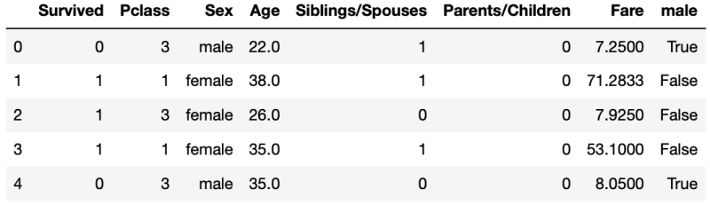
Often our data isn’t in the ideal format. Luckily Pandas makes it easy for us to create new columns based on our data so we can format it appropriately.

What is Numpy?
Numpy is a Python package for manipulating lists and tables of numerical data. We can use it to do a lot of statistical calculations. We call the list or table of data a numpy array.
We often will take the data from our pandas DataFrame and put it in numpy arrays. Pandas DataFrames are great because we have the column names and other text data that makes it human readable. A DataFrame, while easy for a human to read, is not the ideal format for doing calculations. The numpy arrays are generally less human readable, but are in a format that enables the necessary computation.
Numpy is a Python module for doing calculations on tables of data. Pandas was actually built using Numpy as it’s foundation.

Converting from a Pandas Series to a Numpy Array
We often start with our data in a Pandas DataFrame, but then want to convert it to a numpy array. The values attribute does this for us.
Let's convert the Fare column to a numpy array.
First we recall that we can use the single bracket notation to get a pandas Series of the Fare column as follows.
df['Fare']
Then we use the values attribute to get the values as a numpy array.
df['Fare'].values
Run this code to see the results:
import pandas as pd
df = pd.read_csv('https://sololearn.com/uploads/files/titanic.csv')
print(df['Fare'].values)
This is what the above array looks like:
array([ 7.25 , 71.2833, 7.925, 53.1, 8.05, 8.4583, …
The result is a 1-dimensional array. You can tell since there's only one set of brackets and it only expands across the page (not down as well).
The values attribute of a Pandas Series give the data as a numpy array.

Converting from a Pandas DataFrame to a Numpy Array
If we have a pandas DataFrame (instead of a Series as in the last part), we can still use the values attribute, but it returns a 2-dimensional numpy array.
Recall that we can create a smaller pandas DataFrame with the following syntax.
df[['Pclass', 'Fare', 'Age']]
Again, we apply the values attribute to get a numpy array.
df[['Pclass', 'Fare', 'Age']].values
Run this code to see the results:
import pandas as pd
df = pd.read_csv('https://sololearn.com/uploads/files/titanic.csv')
print(df[['Pclass', 'Fare', 'Age']].values)
This is what the above array looks like:
array([[ 3. , 7.25 , 22. ],
[ 1. , 71.2833, 38. ],
[ 3. , 7.925 , 26. ],
... ,
[ 3. , 23.45 , 7. ],
[ 1. , 30. , 26. ],
[ 3. , 7.75 , 32. ]])
This is a 2-dimensional numpy array. You can tell because there’s two sets of brackets, and it expands both across the page and down.
The values attribute of a Pandas DataFrame give the data as a 2d numpy array.

Numpy Shape Attribute
We use the numpy shape attribute to determine the size of our numpy array. The size tells us how many rows and columns are in our data.
First, let's create a numpy array with the Pclass, Fare, and Age.
arr = df[['Pclass', 'Fare', 'Age']].values
If we look at the shape, we get the number of rows and the number of columns:
print(arr.shape) #(887, 3)
Run this code to see the results:
import pandas as pd
df = pd.read_csv('https://sololearn.com/uploads/files/titanic.csv')
arr = df[['Pclass', 'Fare', 'Age']].values
print(arr.shape)
This result means we have 887 rows and 3 columns.
Use the shape attribute to find the number of rows and number columns for a Numpy array. You can also use the shape attribute on a pandas DataFrame (df.shape).
More with Numpy Arrays

Select from a Numpy Array
Let's assume we have created the following numpy array:
arr = df[['Pclass', 'Fare', 'Age']].values
We can select a single element from a numpy array with the following:
arr[0, 1]
This will be the 2nd column of the 1st row (remember that we start counting at 0).
So it'll be the Fare of the 1st passenger, or 7.25.
We can also select a single row, for example, the whole row of the first passenger:
print(arr[0])
To select a single column (in this case the Age column), we have to use some special syntax:
print(arr[:,2])
Run this code to see the results:
import pandas as pd
df = pd.read_csv('https://sololearn.com/uploads/files/titanic.csv')
arr = df[['Pclass', 'Fare', 'Age']].values
print(arr[0, 1])
print(arr[0])
print(arr[:,2])
The syntax can be interpreted as we’re taking all of the rows, but just the column at index 2.
Using different syntax within brackets, we can select single values, a whole row or a whole column.

Masking
Often times you want to select all the rows that meet a certain criteria.
In this example, we'll select all the rows of children (passengers under the age of 18). A reminder of our definition of the array:
arr = df[['Pclass', 'Fare', 'Age']].values
Recall that we can get the Age column with the following syntax:
arr[:, 2]
We create what we call a mask first. This is an array of boolean values (True/False) of whether the passenger is a child or not.
mask = arr[:, 2] < 18
Let's look at the mask array to make sure we understand it.
array([False, False, False, False, False, False, False, True, False, …
The False values mean adult and the True values mean child, so the first 7 passengers are adults, then 8th is a child, and the 9th is an adult.
Now we use our mask to select just the rows we care about:
arr[mask]
Let's look at this new array.
array([[3., 21.075, 2.],
[2., 30.0708, 14.],
[3., 16.7, 4.],
[3., 7.8542, 14.],
If we recall that the third column is the passengers age, we see that all the rows here are for passengers that are children.
Generally, we don't need to define the mask variable and can do the above in just a single line:
arr[arr[:, 2] < 18]
Run this code to see the results:
import pandas as pd
df = pd.read_csv('https://sololearn.com/uploads/files/titanic.csv')
# take first 10 values for simplicity
arr = df[['Pclass', 'Fare', 'Age']].values[:10]
mask = arr[:, 2] < 18
print(arr[mask])
print(arr[arr[:, 2] < 18])
A mask is a boolean array (True/False values) that tells us which values from the array we’re interested in.

Summing and Counting
Let’s say we want to know how many of our passengers are children. We still have the same array definition and can take our mask or boolean values from the previous part.
arr = df[['Pclass', 'Fare', 'Age']].values
mask = arr[:, 2] < 18
Recall that True values are interpreted as 1 and False values are interpreted as 0. So we can just sum up the array and that’s equivalent to counting the number of true values.
print(mask.sum())
Again, we don’t need to define the mask variable.
print((arr[:, 2] < 18).sum())
Run this code to see the results:
import pandas as pd
df = pd.read_csv('https://sololearn.com/uploads/files/titanic.csv')
arr = df[['Pclass', 'Fare', 'Age']].values
mask = arr[:, 2] < 18
print(mask.sum())
print((arr[:, 2] < 18).sum())
Summing an array of boolean values gives the count of the number of True values.
Plotting Basics

