D-ESCA 2 Project

Setup environment on ThinkEdge SE70-12A7S00E Guide

SPARC Laboratory
Technical Report

Created by | Ho Trong Thanh
Date of Report: | 16 Jan-2023
Reporting Period:

Foreword
This document shows how to setup environment to training on ThinkEdge SE70-12A7S00E.

I. Flash OS for ThinkEdge SE70-12A7S00E
(Reference : https://smartsupport.lenovo.com/us/en/products/smart/smart-edge/thinkedge-se70/12a7/12a7s00e/solutions/ht513731)

To flash OS for ThinkEdge SE70-12A7S00E, follow the steps listed below.

Dowload OS Image
- Go to the website : Lenovo Technical Support (support.lenovo.com)
- Select Drivers & Software, then select Select Order Recovery Media.
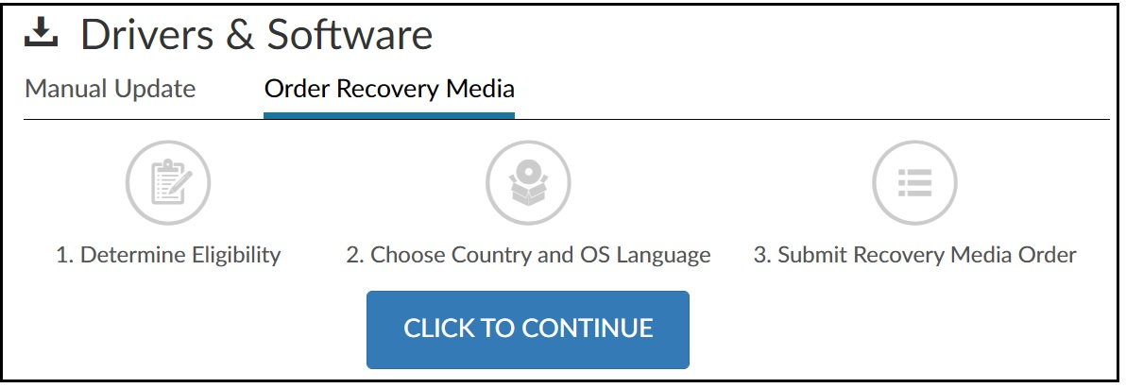
- Select “Click to continue” and enter the ThinkEdge SE70 Serial Number (printed on the case) to dowload OS image
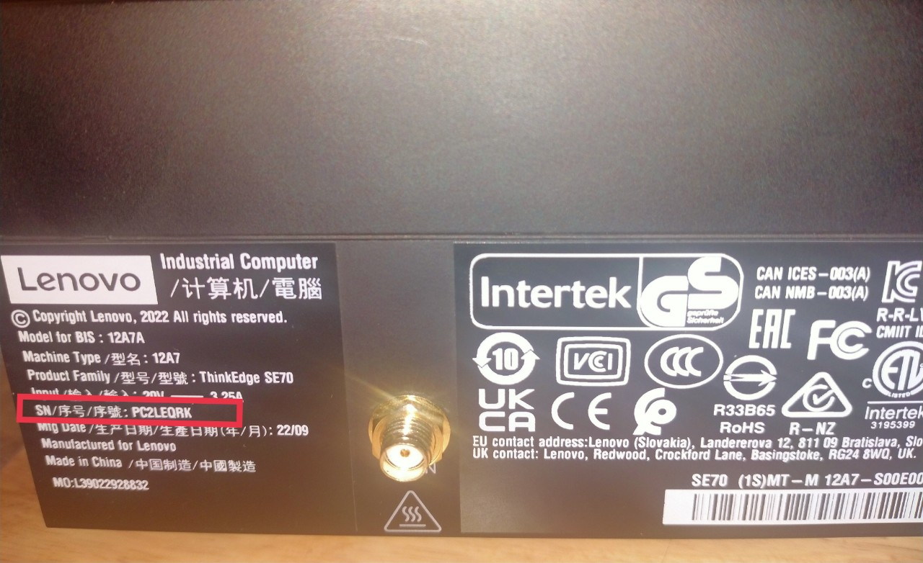
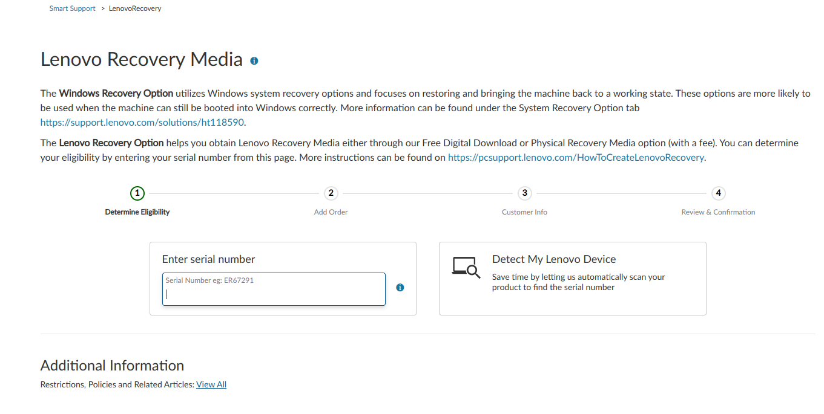
The download image should be name as: se70_generic_preload_tarball.tgz

Flash the system using the image download
- Put the SE70 into Force Recovery Mode by following these steps:
  - Ensure that SE70 is powered off, and the power adapter is connected.
  - Press and hold RECOVERY button usinge a pointed object, such as pen tip, needle or toothpick.
  - Press POWER button to power on.
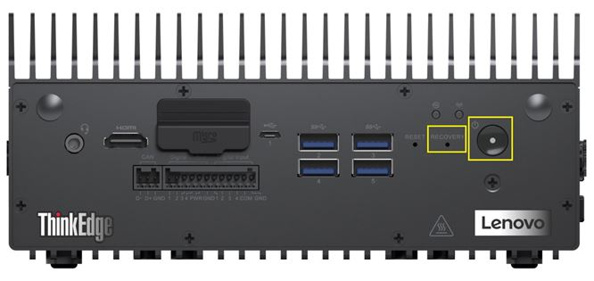
  - Then release the RECOVERY and POWER buttons.
  - After Recovery Mode has been entered, the LED light, under the Wi-Fi icon turns red.
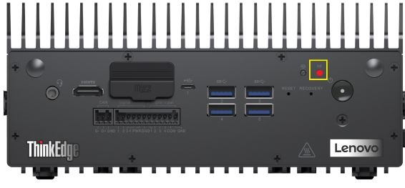
- Connect the SE70 with an Ubuntu host system:
  - Prepare, and login to a Ubuntu host system
  - Connect the SE70 to the Ubuntu host system using a Micro-USB port.
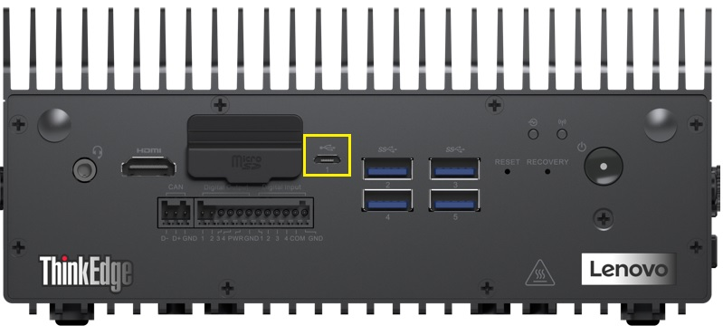
  - Enter lsusb command to confirm if the SE70 is deteced by the Unbuntu host system. If the SE70 is detected, "NVIDIA Corp" appears in the listing results.
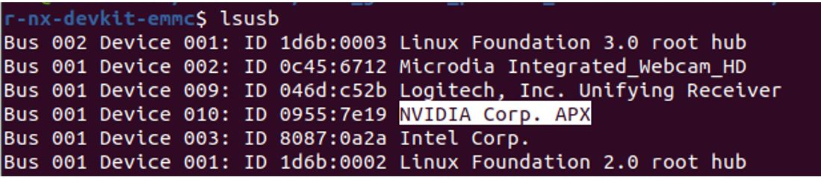
- Flash the system using download image.
  - Login to the Unbuntu host system, Copy and Paste the recovery image file to a directory.
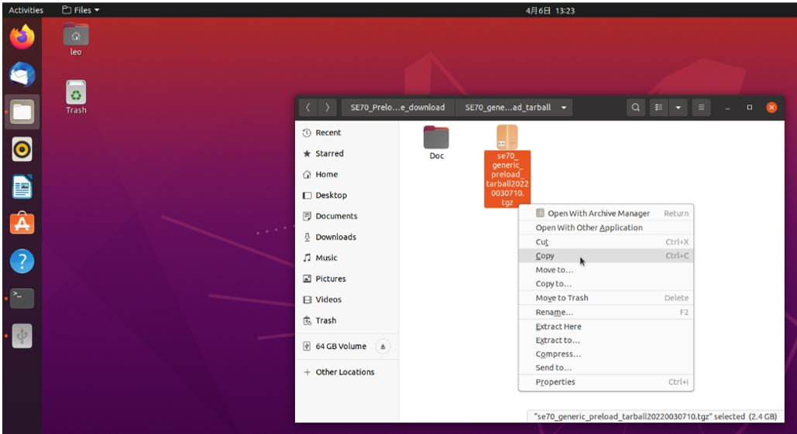
  - Entering into the directory where you put the image file (*.tgz), Extract the tar ball by right-click and choose ”Extract Here”.
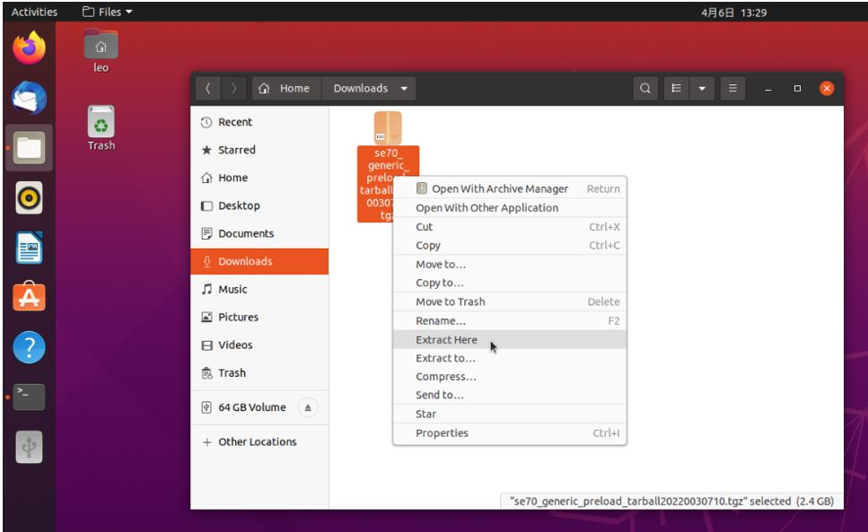
  - Inside the extracted folder, entering into the subfolder se70_generic_preload_tarball2022030710/se70_preload_tarball/, right-click on the mfi_jetson-xavier-nx-devkit-emmc.tbz2 and choose to “Extract Here”.
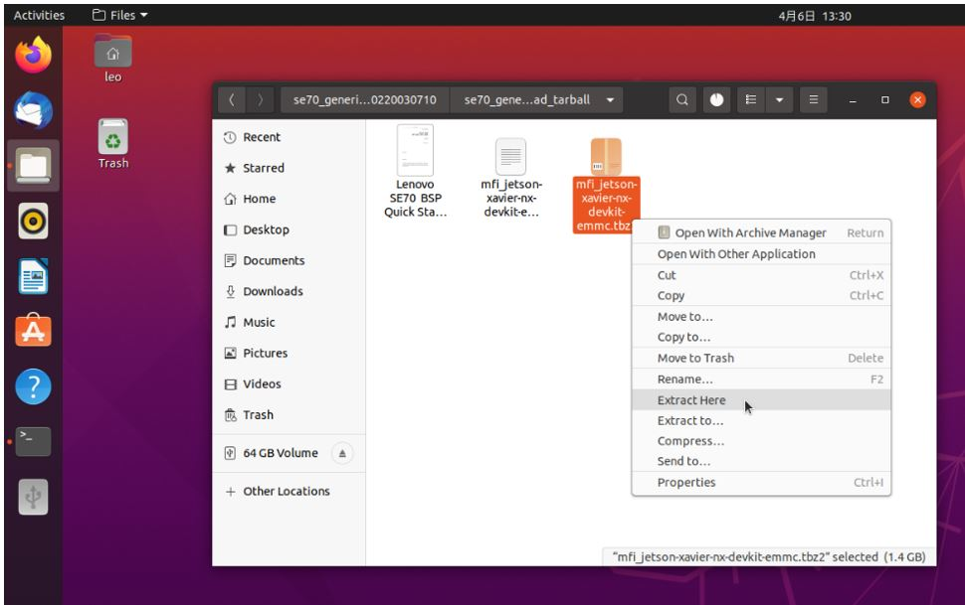

  - Open the the terminal, type command in sequence and press Enter: cd /home/Downloads/se70_generic_preload_tarball20220030710/ cd se70_generic_preload_tarball/ cd mif_jetson-xavier-nx-devkit-emmc/
  - Execute Burning script with sudo superuser privileges sudo ./nvmflash.sh
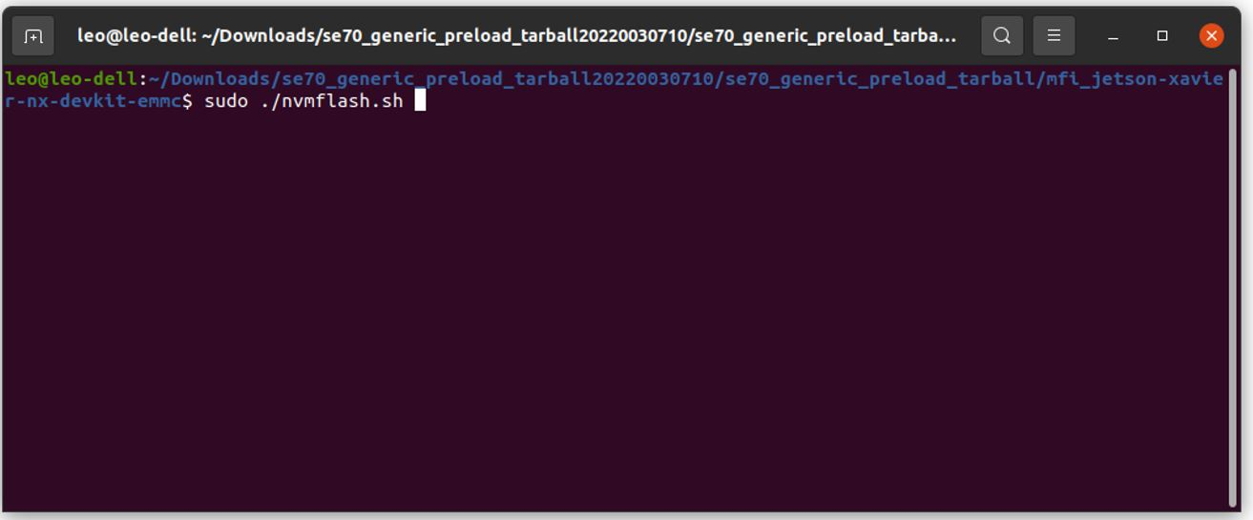
When prompted for the password, type the super user (root) password and press enter. Note there will be no input character displaying when entering password in. Important Notes: please make sure to use SuperUser privilege (root) to launch and execute the scripts.
  - Flashing will be started with “Starting flashing device:…”
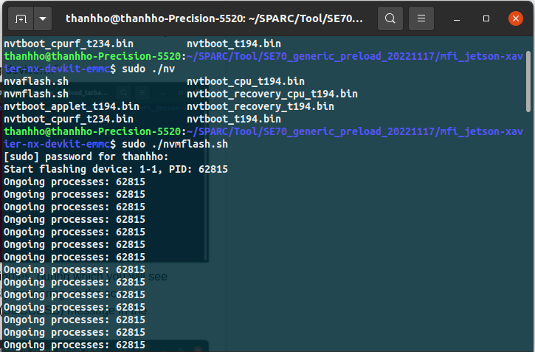

  - The whole flashing process will take a few minutes, during which you will see “Ongoing processes: “information continuously appearing on the screen.

  - Flash should complete with “Flash complete (SUCCESS) message in the end of the line . on SE70, system will reboot.
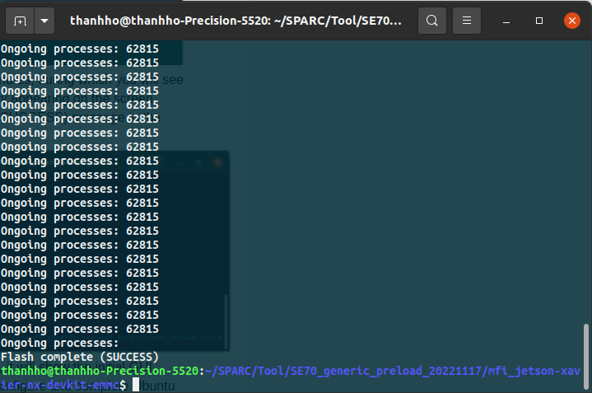

  - On SE70 after reboot with Monitor connected, it will show the initial GUI desktop setup, follow the onscreen steps to configure and complete Ubuntu initial setup.
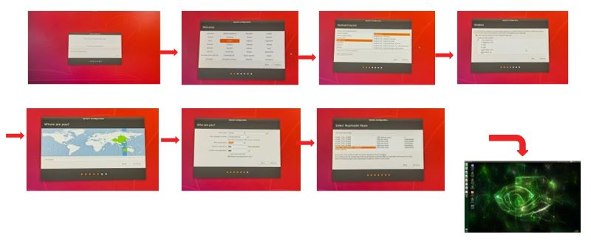

II. Install CUDA and Tensorflow

Install CUDA
1. Open the SDK Manager (requires the Ubuntu 18.04 host or virtual machine on VMware Workstation), select version of Jetpack and skip to step 2, and download CUDA; after the download is complete, find the CUDA installation package in directory /Downloads/nvidia/sdkm_downloads

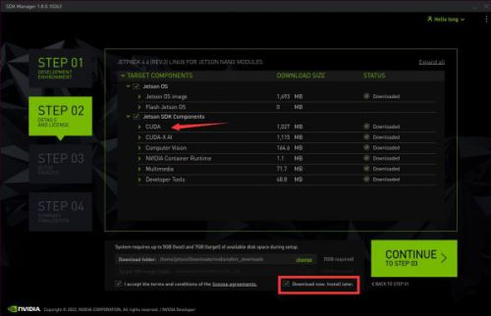
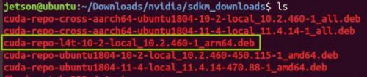

Transfer the installation package to ThinkEdge SE70 using scp and install using the following commands:

Install cuDNN library:

Install Tensorflow
1. Install system packets required by Tensorflow:

2. Install python independencies:

3. Install the latest version of Tensorflow:

(compatible with JetPack 5.0.2)

Install other library

III. Dowload source code
To download the source code of the D-ESCA project, run the following command:

IV. Check the operation of some programs

Check plotting_graph.py
To fix the issue with the matplotlib library, please modify the function update_from_first_child(tgt, src) in the path /usr/lib/python3/dist-packages/matplotlib/legend_handler.py as shown below.

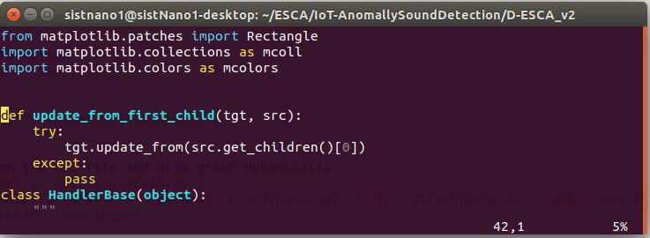

Run the following command to test the graph plotting function.

If the graph appears as shown below, the graph plotting function is working properly.

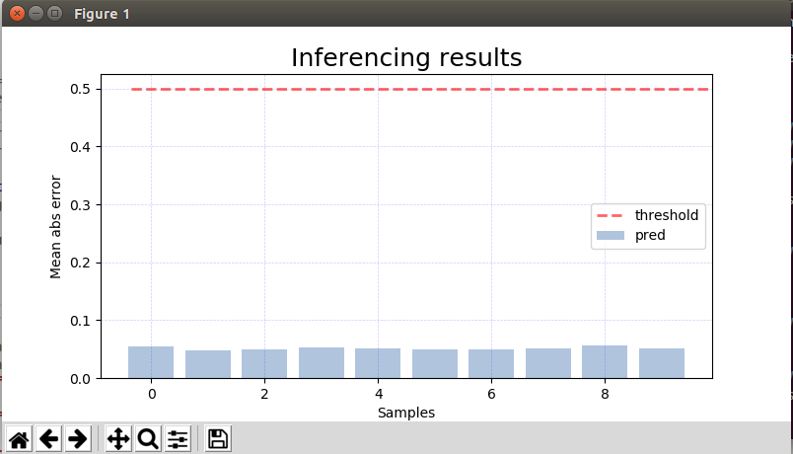

Check Resource_monitoring.py
Please run the following command to check the operation of the resource monitoring library:
If the result displayed is as shown below, it means that the installation of the resource monitoring library was successful. Otherwise, it is necessary to reinstall the jtop library.

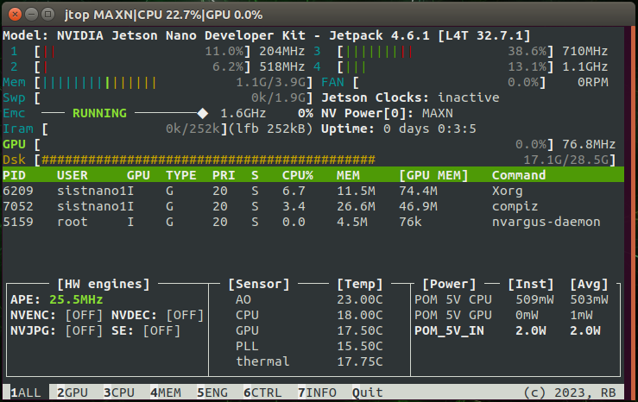

After confirming the successful installation of the resource monitoring library, run the following command to check the resource monitoring program.

