
International School
CAPSTONE PROJECT 1
CMU-SE 450 – C1SE.10
Project Proposal
Version 1.0
Date:
Intelligent Legal Assistant System
Submitted by
An, Nguyen Thanh Quoc
Liem, Dang Thanh
Huy, Nguyen Thai Quang
Hieu, Le Minh

Approved by
PhD Dieu, Huynh Ba
Proposal Review Panel Representative:

Name Signature Date

Capstone Project 1 - Mentor:

Name Signature Date

PROJECT INFORMATION
Project acronym | ILAS
Project Title | Intelligent Legal Assistant System
Start Date |  | End Date
Lead Institution | International School, Duy Tan University
Project Mentor
Scrum master / Project Leader & contact details
Partner Organization | Duy Tan University
Project Web URL
Team members | Name | Email |  | Tel

DOCUMENT APPROVALS
The following signatures are required for approval of this document.
An, Nguyen Thanh Quoc  Student ID: 28210204778  Team Member | Signature | Date
Liem, Dang Thanh  Student ID: 28219044809  Team Member | Signature | Date
Hieu, Le Minh  Student ID: 28211100142  Team Member | Signature | Date
Huy, Nguyen Thai Quang  Student ID: 28211103837  Team Member | Signature | Date

DOCUMENT NAME
Document Title | Proposal Document
Author(s) | C1SE.10
Role | Product Owner, Team Member, Scrum Master
Date |  | File name: | C1SE.10_Proposal_ILAS _1.0.docx

REVISION HISTORY
Version | Date | Comments | Author
1.0 | February 7th, 2025 | Initial Release | C1SE.61 Team

TABLE OF CONTENT
1. Project Title 1
2. Team Members 1
3. Supervisor(s) 1
4. Problem Statement 2
5. Survey / Existing Solutions 2
6. Objectives and Scope 3
6.1. Objectives 3
6.2. Scope 4
6.2.1. In Scope 4
6.2.2. Out of Scope 5
7. Key Features & Requirements 5
7.1. Key Features 5
7.1.1. Legal Information Lookup (User) 5
7.1.2. AI Chatbot Support (User & Admin) 5
7.1.3. Administration Functions 6
7.1.4. Moderation Functions 6
7.1.5. User Feedback (User) 6
7.1.6. Statistics & Reporting (Admin) 6
7.1.7. Role-Based Access Control & Security 6
7.2. Requirements 6
7.2.1. Functional Requirements (FR) 6
7.2.2. Non-Functional Requirements (NFR) 7
8. Constraints and Assumptions 7
8.1. Constraints 7
8.2. Assumptions 8
9. Target Users / Stakeholders 8
9.1. Target Users 8
9.1.1. User (Worker) 8
9.1.2. Moderator (Legal Support Staff) 9
9.1.3. Admin (System Administrator) 9
9.2. Stakeholders 10
10. Technology Stack 10
11. Methodology & Development Plan 11
11.1. Methodology 11
11.2. Development Plan (Timeline schedule) 12
12. System Architecture Overview 13
12.1. System context diagram 13
12.2. System context description 13
13. Potential Risks and Mitigation Strategies 14
14. Expected Outcomes / Deliverables 15
14.2. Complete Source Code and Technical Documentation 15
14.3. User Manuals (Readme) and Demo Video 15
14.4. Final Project Report and Presentation 16
15. References 16

LIST OF TABLES
Table 1. Current Status of Art 2
Table 2. Stakeholders and User Descriptions Summary 10
Table 3. Timeline schedule 12
Table 4. Potential Risks and Mitigation Strategies 14

LIST OF FIGURES
Figure 1. SCRUM Process 11
Figure 2. System Context Diagram 13

1. Project Title
ILAS - Intelligent Legal Assistant System

2. Team Members
- An, Nguyen Thanh Quoc
- Student ID: 28210204778
- Email: nguyentquocan2@gmail.com
- Role:
- Liem, Dang Thanh
- Student ID: 28211131997
- Email: dangthanhwtf@gmail.com
- Role:
- Hieu, Le Minh
- Student ID: 28211100142
- Email: leminhhieu21@dtu.edu.vn
- Role: Huy, Nguyen Thai Quang
- Student ID: 28211103837
- Email: qhuynguyenthai@gmail.com
- Role:

3. Supervisor(s)
- Full Name:
- Academic Degree:
- Department: International School - CMU
- Email:

4. Problem Statement
In today's social context, accessing legal information remains a major challenge for the majority of people. Legal documents are often published in an official format, with specialized language and complex structures, making it difficult for those without a legal background to grasp. Additionally, legal data is scattered across various information portals, lacking synchronization and intelligent support tools, resulting in people spending a lot of time searching but still being uncertain about the accuracy and currency of the information.
As a result, many people do not clearly understand their rights and obligations, making it easy for their legal rights to be violated or overlooked. Legal aid organizations, trade unions, or regulatory agencies also face difficulties in conveying information clearly and transparently to the community. This reduces the effectiveness of law enforcement and creates a gap between legal regulations and real-life situations.
The Intelligent Legal Assistant System (ILAS) project was developed to address this issue by applying intelligent search technology combined with artificial intelligence. The system provides original legal documents along with easy-to-understand summaries, while also integrating an AI chatbot to answer questions directly, always being transparent about the source of the information. In addition, ILAS has content management and moderation mechanisms to ensure quality and reliability before reaching users.

5. Survey / Existing Solutions
Table 1. Current Status of Art
Features | ILAS | thuvienphapluat.vn | LuatVietnam
Original Legal Text Search | X | X | X
Free to use | X | X
Regular Legal Updates | X | X | X
Simplified Law Explanations | X
AI-Powered Q&A Based on Internal Database | X
Structured Content Approval Process | X
LuatVietnam: Provides original legal documents, updated regularly. Aimed at lawyers and experts. Lacks simple explanations, no AI support, and many features require payment.
thuvienphapluat.vn: Free, large database. Only original documents, no simplified content or personalized support for workers.
LSSW: Fully integrated: original text + easy-to-understand interpretation + transparent AI chatbot Q&A. Completely free, focused on the public and workers, with a strict content moderation process.
Key difference: IILAS provides not only legal documents but also helps users quickly understand the content through AI summaries, while allowing them to ask questions directly and receive transparent feedback – something that current platforms do not offer.

6. Objectives and Scope

6.1. Objectives
- Specific: Develop an intelligent legal assistant system that allows users to ask questions directly, receive transparent responses from AI, and simultaneously view the original legal text alongside an easy-to-understand summary.
- Measurable: The system is expected to serve at least 5,000 users during the pilot phase, with the database containing more than 200 important laws from the 2019 Labor Code and related decrees. The estimated processing capacity is based on actual data from workers in industrial parks.
- Achievable: The system will be developed using Spring Boot (backend), ReactJS (frontend) and MySQL (database). Python will be used for crawling the legal data. The AI ​​chatbot part will be integrated experimentally using an available API during the demo phase, and the research team is aiming to use open-source AI for long-term internal deployment. This approach both leverages existing technology and ensures feasibility within 3–4 months.
- Relevant: The system digitizes access to the law for workers, providing easy-to-understand, transparent and convenient support tools, contributing to reducing violations of labor rights, raising legal awareness, and supporting trade unions and authorities in monitoring and consulting.
- Time-bound: Deliver a Minimum Viable Product (MVP) within 3 months and complete the full system by December 12th, 2025, following key milestones: Proposal (August 2025), Midterm Report (October 2025), and Final Submission (December 2025).

6.2. Scope

6.2.1. In Scope
- User:
- Look up legal documents using keywords or natural language questions (NLQ).
- View the original text alongside the AI-generated summary/interpretation.
- Supports highlighting and expand/collapse to see detailed articles.
- Ask questions directly via AI chatbot and receive answers based on internal legal data.
- Rate the quality of the answer (like/dislike or rating).
- Receive error notifications when no related legal provisions are found..
- Moderator:
- Censor AI feedback to ensure legal accuracy.
- Approve new legal data before adding it to the system.
- Approve new legal data.
- Mark content that needs editing and suggest improvements to the Admin.
- Admin:
- Legal data management (uploading, updating, segmenting by clauses).
- Legal data version management (saving old and new versions when laws change).
- User management (creating, editing, assigning permissions).
- Monitoring logs, query statistics, and system performance.
- Controlling AI response quality.
- System configuration (limiting the number of queries, setting up error notifications).
- Editing data based on suggestions from the Moderator.

6.2.2. Out of Scope
- Does not provide in-depth legal advice: ILAS only supports searching, summarizing, and interpreting legal documents, and does not replace lawyers or legal experts.
- Does not cover the entire legal system: the initial stage focuses on the 2019 Labor Code and related documents, without extending to other areas such as civil, criminal, or commercial law.
- No support for multiple languages other than Vietnamese and English: the system does not yet have the capability to translate into other languages.
- Moderators do not directly edit data: Moderators only mark and suggest content that needs editing; only Admins have the authority to perform technical actions.
- Does not replace official legal procedures: ILAS is only an information support tool and has no legally binding value in disputes or litigation.

7. Key Features & Requirements

7.1. Key Features

7.1.1. Legal Information Lookup (User)
- Search for legal documents using keywords or natural language questions (NLQ).
- Display both the original text and AI-generated summary/interpretation.
- Highlight and expand/collapse to view detailed clauses.
- Save query history (optional).
- Error notifications when no related legal provisions are found.
- Allow users to rate and provide feedback on AI answers.

7.1.2. AI Chatbot Support (User & Admin)
- AI chatbot answers user questions based on internal legal data.
- Responses are transparent and reference the source law.
- Admin can configure chatbot scope and monitor its performance.

7.1.3. Administration Functions
- Manage legal data (upload, update, segmentation, version control).
- Manage users and assign roles (User, Moderator).
- Review and edit data based on Moderator suggestions.
- Monitor logs, query statistics, and system performance.

7.1.4. Moderation Functions
- Review AI responses to ensure accuracy.
- Approve new legal data before publication.
- Mark content that requires editing.
- Suggest improvements to Admin for data updates.

7.1.5. User Feedback (User)
- Users can rate AI answers and submit feedback.
- Feedback is stored for Admin/Moderator to review and improve content.

7.1.6. Statistics & Reporting (Admin)
- Generate reports on user queries, popular laws, and system usage.
- Provide dashboards for monitoring system performance.

7.1.7. Role-Based Access Control & Security
- User: search laws, view summaries, ask chatbot, rate answers.
- Moderator: review AI responses, approve new data, suggest edits.
- Admin: manage data, users, approve content, monitor system.
- Security: authentication, authorization, and encryption.

7.2. Requirements

7.2.1. Functional Requirements (FR)
- FR01: Allow users to search legal documents using keywords or NLQ.
- FR02: Display original text alongside AI-generated summary.
- FR03: Support highlighting and expand/collapse for detailed clauses.
- FR04: Save query history (optional).
- FR05: Provide error notifications when no related legal provisions are found.
- FR06: Enable users to rate and submit feedback on AI answers.
- FR07: Provide AI chatbot support for Q&A based on internal legal data.
- FR08: Moderator reviews AI responses, approves new legal data, marks content needing edits, and suggests improvements.
- FR09: Admin manages legal data (upload, update, segmentation, version control).
- FR10: Admin manages users and assigns roles.
- FR11: Admin monitors logs, query statistics, and system performance.
- FR12: Admin edits data based on Moderator suggestions.
- FR13: System enforces role-based access control (User, Moderator, Admin).

7.2.2. Non-Functional Requirements (NFR)
- NFR01 – Performance: Handle ≥ 5,000 concurrent users and ≥ 200 clauses without performance degradation.
- NFR02 – Security: Ensure data encryption, secure authentication, and strict role-based authorization.
- NFR03 – Usability: Provide an intuitive interface suitable for non-legal professionals.
- NFR04 – Scalability: Support expansion of legal data and user base.
- NFR05 – Reliability: Maintain uptime ≥ 99%, with backup and recovery mechanisms.

8. Constraints and Assumptions

8.1. Constraints
- Time Constraint: The project must be completed within a 4-month timeframe (from proposal to final report), including Proposal, Midterm Report, and Final Submission milestones.
- Technology Constraint:
  - Backend: Java Spring Boot
  - Frontend: ReactJS
  - Database: MySQL
  - Data Crawling: Python
  - AI Chatbot: API integration in the demo phase, aiming to use an open-source AI model for long-term deployment.
- Resource Constraint: The system is developed and tested on personal computers with limited configurations (8–16GB RAM, universal CPU).
- Data Constraint: Only stores official legal documents (Labor Code 2019 and related decrees). AI responses are based solely on internal data, not a substitute for in-depth legal advice.
- Security Constraint: The system must comply with security standards (password hashing, role-based decentralization, HTTPS, prevent unauthorized access to legal data).
- Role Constraint: The moderator does not directly edit the data, only marks and recommends it to the Admin.

8.2. Assumptions
- Users are able to ask basic legal questions without needing in-depth legal knowledge.
- Moderators have sufficient legal knowledge to review AI responses and approve new data.
- Admins have technical skills to manage data, users, and the system.
- The system will expand legal data over time as new updates become available.
- Users will provide feedback to improve the quality of AI and legal content.
- The system will initially focus on the Labor Code 2019 and a few related decrees before scaling up to broader legal coverage.

9. Target Users / Stakeholders

9.1. Target Users

9.1.1. User (Worker)
Characteristics:
    - Unskilled workers, with limited legal knowledge, often face difficulties when reading and understanding legal documents.
    - They are concerned about basic rights such as contracts, wages, insurance, and occupational safety.
Needs:
    - Quickly look up legal regulations using keywords or natural questions (NLQ).
    - View the original document alongside the AI-generated summary/interpretation.
    - Ask questions directly through the AI chatbot to receive responses based on internal legal data.
    - Receive error notifications when no related law is found.
    - Evaluate the quality of the answers and provide feedback.
Benefits:
    - Access legal information that is transparent and easy to understand.
    - Reduce the risk of violating labor rights.
    - Increase confidence when negotiating with employers.

9.1.2. Moderator (Legal Support Staff)
Characteristics:
    - Personnel with basic legal knowledge (e.g., law students, trade union staff).
    - Capable of reviewing AI feedback and approving new legal data..
Needs:
    - Tools to check AI responses to ensure legal accuracy.
    - Procedure for approving legal data before implementation in the system.
    - Function to mark content that needs editing and suggest improvements for the Admin.
Benefits:
    - Ensure the transparency and accuracy of legal data.
    - Contribute to improving the quality of AI responses.
    - Assist Admin in maintaining a reliable system.

9.1.3. Admin (System Administrator)
Characteristics:
    - The technical staff is responsible for system administration.
    - Not necessarily a legal expert, but capable of managing data and users.
Needs:
    - Legal data management tool (upload, update, segmentation, version control).
    - User management and permissions (User, Moderator).
    - Monitor logs, query statistics, system performance.
    - Control AI response quality and edit data based on Moderator suggestions.
Benefits:
- Ensure the system operates stably, safely, and efficiently.
- Control the quality of content before it reaches users.
- Have reporting and monitoring tools to support management.

9.2. Stakeholders
Table 2. Stakeholders and User Descriptions Summary
Role | Description | Name
Product Owner | The Person who gives the Requirement.
Scrum Master | This is the stakeholder who leading, manage the website development Team.
Requirement Analyzer | This is a stakeholder that works with the Analysts to correctly translate requests or needs into requirements to be used for design. | All Member
Coder | This is a stakeholder that programs the software. | All Member

10. Technology Stack
- Programming language: Java, Javascript, Python
- Frameworks & Libraries: Spring Boot, ReactJS, Bootstrap
- Database: MySQL
- Version Control: GitHub
- Team Management: Zalo, Google drive
- Develop tools: Visual Studio Code

11. Methodology & Development Plan

11.1. Methodology
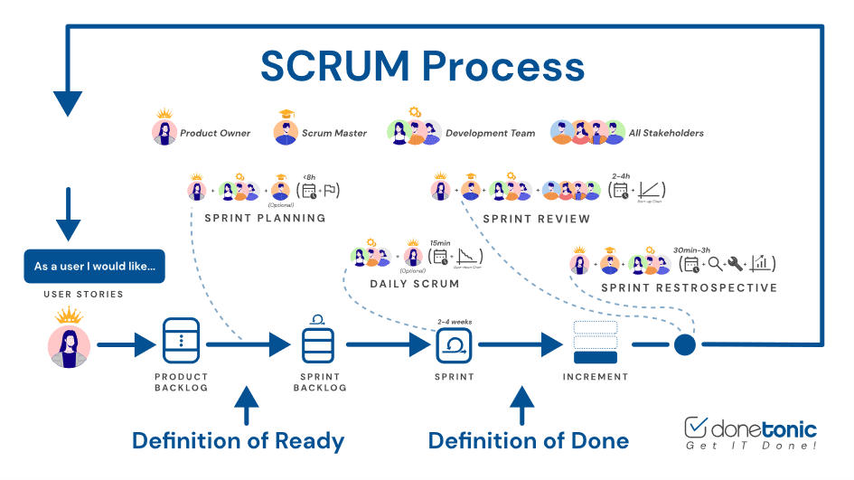
Figure 1. SCRUM Process
Scrum is an agile framework for software development that follows an iterative and incremental approach, helping teams manage complex projects and product development effectively.
It is particularly well-suited for environments where detailed upfront planning is difficult, emphasizing adaptability and flexibility.
Unlike traditional command-and-control project management methods, Scrum relies on empirical process control, using continuous feedback loops as a core technique to guide decision-making and progress.
Scrum empowers teams by shifting decision-making authority to those directly involved in the development process, allowing them to respond more effectively to real-world conditions and uncertainties.
Key benefits of using Scrum include:
- Enhanced ability to adapt to change
- Early detection of problems and issues
- Prioritization of the most valuable features for the customer
- Deliverables that better align with customer needs
- Increased team productivity
- Consistent and predictable delivery timelines

11.2. Development Plan (Timeline schedule)
Table 3. Timeline schedule
NO | Task Name | Duration | Start | Finish
1 | Project Initiation | 7 days
1.1 | Requirement Gathering | 2 days
1.2 | Proposal Document Creation | 2 days
2 | System Design & Planning | 7 days
2.1 | Define Architecture & Roles | 3 days
2.2 | UI/UX Wireframes & Database Schema | 4 days
3 | Development Phase | 88 days
3.1 | Sprint 1 – Legal Search & Display | 28 days
3.2 | Sprint 2 – AI Chatbot & Feedback Module | 30 days
3.3 | Sprint 3 – Admin & Moderator Functions | 30 days
4 | Testing & Quality Assurance | 7 days
5 | Final Review & Retrospective | 3 days
6 | Documentation & Final Submission | 4 days

12. System Architecture Overview

12.1. System context diagram
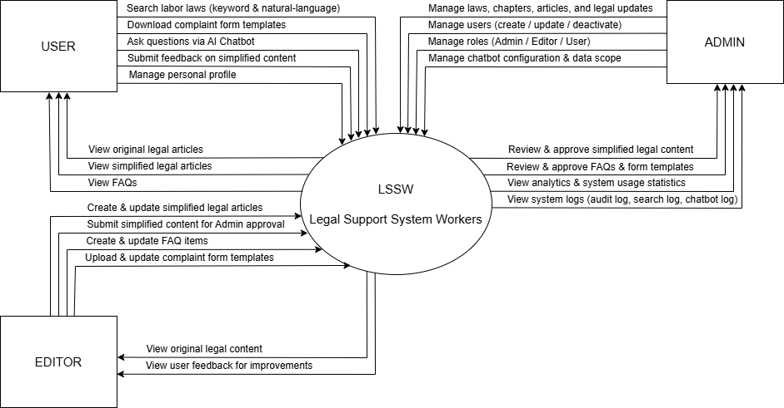

Figure 2. System Context Diagram

12.2. System context description
- USER (Worker):
- Search labor laws using keywords or natural questions (NLQ)
- View original documents and AI summaries
- Ask questions via AI Chatbot
- Submit feedback on content
- Receive error notifications when a law cannot be found
- View FAQ.
- Can manage personal profile information.
- MODERATOR (Legal Support Staff):
- Censor AI feedback to ensure legal accuracy
- Approve new legal data before adding it to the system
- Mark content that needs editing
- Suggest improvements to the Admin.

- ADMIN (System Administrator):
- Legal data management (upload, update, segmentation, version control)
- User management and access control
- Log tracking, query statistics, system performance
- AI response quality control
- Chatbot configuration and query limits.

13. Potential Risks and Mitigation Strategies
Table 4. Potential Risks and Mitigation Strategies
Risk Category | Potential Risk | Mitigation Strategies
Technical | - AI chatbot may provide inaccurate answers if legal data is incomplete or not properly moderated.  - System performance may degrade under heavy concurrent queries. | - Ensure Moderator reviews and approves legal data before chatbot integration.  - Optimize queries and apply caching mechanisms.
Security | - Unauthorized access to internal legal data or AI responses.  - Leakage of user information. | - Enforce secure authentication, role-based access control, encryption, and HTTPS.
Timeline | - Delays due to integration of multiple modules (search, AI chatbot, feedback, moderation).  - Risk of slippage in legal content moderation. | - Adopt Agile methodology with clear sprints and milestones.  - Assign responsibilities clearly to Moderator and Admin.
Human Resources | - Team may lack expertise in AI or legal domain.  - Risk of losing key members during development. | - Organize internal training and knowledge-sharing sessions.  - Cross-assign responsibilities and consult external experts if needed.
Data Quality | - Legal data may be outdated or incomplete.  - AI summaries may mislead users if not moderated. | - Use only official legal documents and update regularly.  - Require Moderator approval before publishing AI-generated summaries.
Adoption & Trust | - Workers may hesitate to trust AI-generated legal answers.  - Difficulty in encouraging adoption among target users. | - Display both original legal text and AI summaries for transparency.  - Conduct pilot testing with workers and unions to build trust.

14. Expected Outcomes / Deliverables
Upon successful completion of the Intelligent Legal Assistance System (ILAS) project, the following deliverables will be provided:
14.1. A Fully Functional Web Application
- A deployed and operational web system accessible via modern web browsers.
- Core functionalities include:
- Legal document search (keyword and natural language queries).
- Display of both original and AI-generated summaries.
- AI chatbot for Q&A based on internal legal data.
- Feedback submission and moderation workflow.
- Role-based access control (User, Moderator, Admin).

14.2. Complete Source Code and Technical Documentation
- Source Code:
- Well-structured, commented, and version-controlled codebase hosted on GitHub.
- Includes backend (Spring Boot), frontend (ReactJS), database schema (MySQL), and Python scripts for data crawling.
- Technical Documentation:
- System architecture overview.
- API documentation.
- Setup and deployment guide.

14.3. User Manuals (Readme) and Demo Video
- User Manuals (Readme):
- Clear instructions for Workers (searching laws, using chatbot, submitting feedback).
- Guidelines for Moderators (reviewing AI responses, approving legal data).
- Instructions for Admins (managing users, approving content, monitoring system).
- Demo Video:
- A 5-10 minute screen recording showcasing key workflows of ILAS.

14.4. Final Project Report and Presentation
- Final Project Report:
- Comprehensive documentation summarizing system design, implementation, challenges, results, and future improvements.
- Presentation Slides:
- Professional slide deck for final defense, highlighting objectives, features, architecture, risks, and outcomes.

15. References
[1]. Scrum Methodology:
https://donetonic.com/scrum-methodology/
[2]. How Can We Measure Success in Scrum?
https://www.pragmaticinstitute.com/resources/articles/product/9-scrum-metrics-to-keep-your-team-on-track/
[3]. Vietnam Labor Code 2019 (Official Legal Document):
https://thuvienphapluat.vn/van-ban/lao-dong-tien-luong/bo-luat-lao-dong-2019-403010.aspx

