Name: Nhat Minh Tran

Unit: COS100026

ID: 104082552

1. Half-adder

|  |  |  |  |
| --- | --- | --- | --- |
| Input 1 | Input 2 | Sum Output | Carry Output |
| 0 | 0 | 0 | 0 |
| 0 | 1 | 1 | 0 |
| 1 | 0 | 1 | 0 |
| 1 | 1 | 0 | 1 |

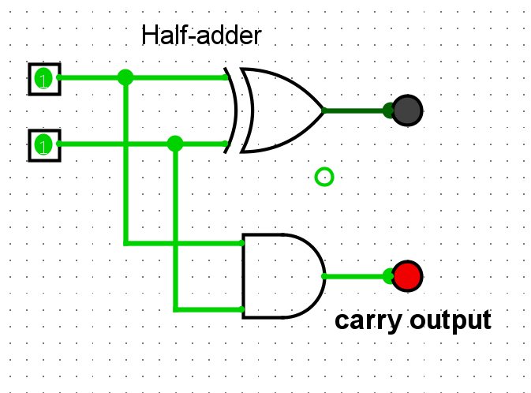

1. Full-adder

|  |  |  |  |  |
| --- | --- | --- | --- | --- |
| Input 1 | Input 2 | Carry in | Sum output | Carry output |
| 0 | 0 | 0 | 0 | 0 |
| 0 | 1 | 0 | 1 | 0 |
| 1 | 0 | 0 | 1 | 0 |
| 1 | 1 | 0 | 0 | 1 |
| 0 | 0 | 1 | 1 | 0 |
| 0 | 1 | 1 | 0 | 1 |
| 1 | 0 | 1 | 0 | 1 |
| 1 | 1 | 1 | 1 | 1 |

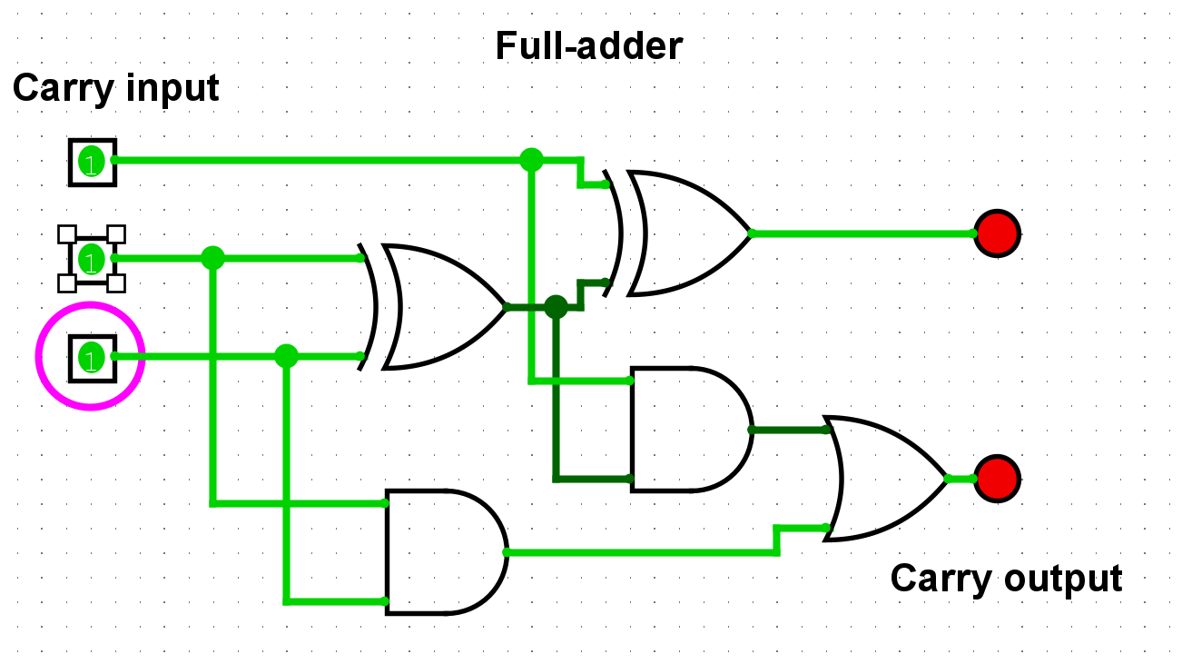

1. 4 bits adder

|  |  |  |
| --- | --- | --- |
| Input A | Input B | Output |
| 0101 | 0000 | 0101 |
| 0101 | 0001 | 0100 |
| 0101 | 0010 | 0111 |
| 0101 | 0011 | 0110 |
| 0101 | 0100 | 0011 |
| 0101 | 0101 | 0010 |
| 0101 | 0110 | 0000 |
| 0101 | 0111 | 0001 |
| 0101 | 1000 | 1101 |
| 0101 | 1001 | 1100 |
| 0101 | 1010 | 1111 |
| 0101 | 1011 | 1110 |
| 0101 | 1100 | 1101 |
| 0101 | 1101 | 1010 |
| 0101 | 1110 | 1000 |
| 0101 | 1111 | 1001 |

