Name: Nhat Minh Tran

Unit: COS10004

ID: 104082552

Question 1:

* 1. ROM is means for Read Only Memory. This device receives data and permanently write in on the chip. This data is encoded not to be overwritten. (e.g., startup programs, printer software)
  2. RAM stands for Random Access Memory. RAM temporarily stores data on a computer. The difference is that ROM stores data permanently.
  3. DRAM is the most common type of memory in use today. Each memory cell holds one bit of information and is made up of two parts: a transistor and a capacitor. There are millions of them in a chip.

SRAM

|  |  |
| --- | --- |
| DRAM | SRAM |
| Most common type of memory in use today | Flipflop holds each bit of memory  Uses less power |
| Each memory cell holds one bit of information and is made up of two parts: a transistor and a capacitor. (Millions in a chip) | A flipflop for a memory cell takes four or six transistors |
| Continuously refreshed | Never has to be refreshed |
| Takes time and slows down memory | Significantly faster but takes more spaces.  More expensive, less memory (more parts needed) |

* 1. USB thumb drives employ flash memory. We should not rely on critical data storage because it is incompatible with backups. The Neumann architecture is distinguished using a single path to reach a main memory that stores both instructions and data. Harvard architecture is associated with distinct recollections.

1. 8589934592 bits are required to address all bytes in the system’s RAM.

|  |  |
| --- | --- |
| Von Neumann all memory has capability of storing all program elements, data and instructions | Von Neumann all memory has capability of storing all program elements, data and instructions |
| Small and personal computers | Signal processing as well as microcontrollers |

1. Cache memory also known as CPU memory, is a type of high-speed SRAM that a computer microprocessor may access faster than conventional RAM. Makes retrieving data from the computer's memory more efficient.
2. PC uses interrupt requests to handle various hardware or some software functions. Devices like keyboards, a mouse requires services of CPU and generates an interrupt to get the attention from CPU and process the requested service. 4 common types:

+ Hardware

+ Internal

+ External

+ Software

* 1. Yes, polling is also an alternative to interrupts. Polled interrupt is an inefficient technique of data transfer that spend a large amount of time reading the I/O of hardware devices. It informs CPU that a system needs attention, while interrupts requests CPU to do so

1. A stack is an abstract data type that serves as a collection of elements.

The order in which components are removed from a stack gives rise to the LIFO. A peek operation may provide access to the top of a stack without altering the stack. A series of physical items placed on top of each other. However, getting many deeps in a stack may refer to the problems to remove other item at the top first.

* 1. Interrupt is a type of hardware-triggered procedure call. When an interrupt request occurs, the stack is used as a place to temporarily store the program and the value of the pc that were running until just before the interrupt occurred.
  2. Stack is useful in programming because they can be used to maintain a list of operation for an ‘’undo’’ function in a piece of software, where the most recent operation is the first to be undone. Stacks are also used to facilitate recursion. In stack, users can swap, duplicate and rotate.

1. 5 bit-deep, 1-bit wide

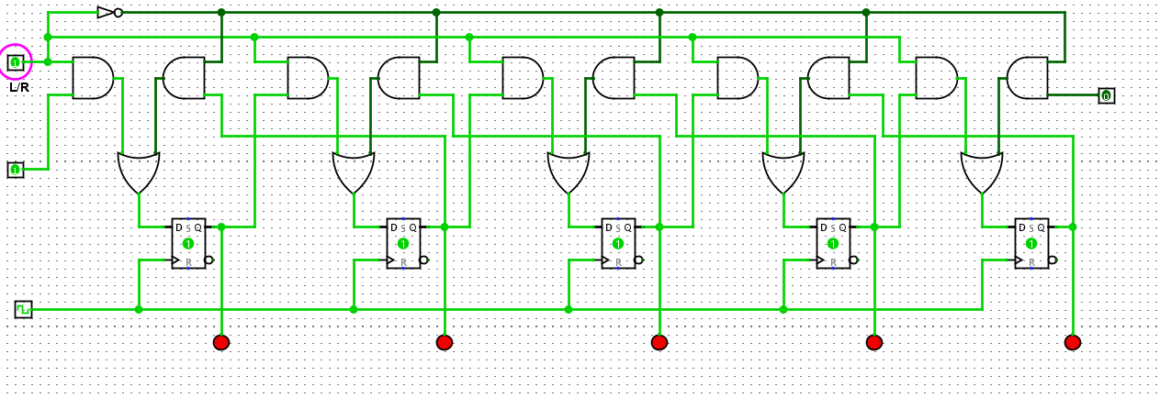

12.

