**LAB REPORT: RSA-OAEP Cipher using CryptoPP**

|  |  |  |
| --- | --- | --- |
| **Instructor** | **Đỗ Thị Phương Uyên** | |
| **Student 1:** | Tào Minh Đức | 23520315 |
| **Student 2:** | Mai Nguyễn Phúc Minh | 23520930 |

LAB 3 REPORT’S TABLE OF CONTENTS

**1.** **Hardware resource** 2

**2.** **Input testcase** 2

**3.** **RSA-OAEP (Windows System)** 2

**4.** **RSA-OAEP (Linux System)** 3

**5.** **Sample images** 4

1. **Hardware resource**

|  |  |
| --- | --- |
| **Device:** | Lenovo Gaming Legion 5 15IAH7H |
| **Chip:** | Intel Core i5 12500H   * Cores: 12 * P-core: 4 * E-core: 8 * Logical processor: 16 |
| **Ram & Memory:** | DDR5-4800 – 16GB (RAM)  512 GB SSD x2 |
| **Operating Systems:** | Window 11  Ubuntu |

1. **Input testcase**

* Making a executed program to automatically generate a random input with 6 different testcase:
  + 100 bytes input
  + 200 bytes input
  + 300 bytes input
  + 1 KB input
  + 10 KB input
  + 1 MB input
* **Note:** These testcase are generated randomly based on the program **makingtextcase.exe**

1. **RSA-OAEP (Windows System)**

* **Key using throughout all files:** *public.pem* (for public key) and *private.pem* (for private key)
* **Key size:** 3072
* **File encrypted:** *cipher.bin*
* **File plaintext after decrypted:** *output.txt || decrypted.txt*
* **Usage format:**

+ D:\CRYPTO\LAB\rsaoaep.exe gen <keysize> <format> <privateKeyFile> <publicKeyFile> (*e.g:* .\rsaoecp.exe gen 3072 PEM private.pem public.pem)

+ D:\CRYPTO\LAB\rsaoaep.exe enc <format> <publicKeyFile> <plainFile> <cipherFile> (*e.g:* .\rsaoecp.exe enc PEM public.pem random_1K.txt cipher.bin)

+D:\CRYPTO\LAB\rsaoaep.exe dec <format> <privateKeyFile> <plainFile> <cipherFile> *(e.g:* .\rsaoecp.exe dec PEM private.pem output.txt cipher.bin)

* **Abbreviations:** TT (Total Time), AT (Average Time)
* **Time counter:** Mili second (ms)
* **Execution Time (average of 10000 executions):**

|  |  |  |  |  |  |  |
| --- | --- | --- | --- | --- | --- | --- |
|  | **100B** | **200B** | **300B** | **1KB** | **10KB** | **1MB** |
| **Encrytion** | TT: 3005  AT: 0.3005 | TT: 4013  AT: 0.4013 | TT: 4381  AT: 0.4381 | TT: 14329  AT: 1.4329 | TT: 38988  AT: 3.5988 | TT: 2223489  AT: 222.3489 |
| **Decryption** | TT: 944064  AT: 94.4064 | TT: 1.25673e+06  AT: 125.673 | TT: 1.32358e+06  AT: 132.358 | TT: 1130723  AT: 113.0723 | TT: 2768786  AT: 276.8796 | TT: 169267852  AT: 16926.7852 |

* **Note:** The execution time on big files (10KB and 1MB) would be bigger due to the complexity of computing.

1. **RSA-OAEP (Linux System)**

* **Key using throughout all files:** *public.pem* (for public key) and *private.pem* (for private key)
* **Key size:** 3072
* **File encrypted:** *cipher.bin*
* **File plaintext after decrypted:** *output.txt || decrypted.txt*
* **Usage format:**

+ ./rsaoaep.exe gen <keysize> <format> <privateKeyFile> <publicKeyFile> (*e.g:* .\rsaoecp.exe gen 3072 PEM private.pem public.pem)

+ ./rsaoaep.exe enc <format> <publicKeyFile> <plainFile> <cipherFile> (*e.g:* .\rsaoecp.exe enc PEM public.pem random_1K.txt cipher.bin)

+ ./rsaoaep.exe dec <format> <privateKeyFile> <plainFile> <cipherFile> *(e.g:* .\rsaoecp.exe dec PEM private.pem output.txt cipher.bin)

* **Abbreviations:** TT (Total Time), AT (Average Time)
* **Time counter:** Mili second (ms)
* **Execution Time (average of 10000 executions):**

|  |  |  |  |  |  |  |
| --- | --- | --- | --- | --- | --- | --- |
|  | **100B** | **200B** | **300B** | **1KB** | **10KB** | **1MB** |
| **Encrytion** | TT:  AT: | TT:  AT: | TT:  AT: | TT: 1914  AT: 0.1914 | TT: 14940  AT: 1.494 | TT: 1.49644e+06  AT: 149.644 |
| **Decryption** | TT:  AT: | TT:  AT: | TT:  AT: | TT: --  AT: -- | TT: --  AT: -- | TT: --  AT: -- |

* **Note:** The execution time on big files (10KB and 1MB) would be bigger due to the complexity of computing.

1. **Sample images**

* **Generate public/private key:**

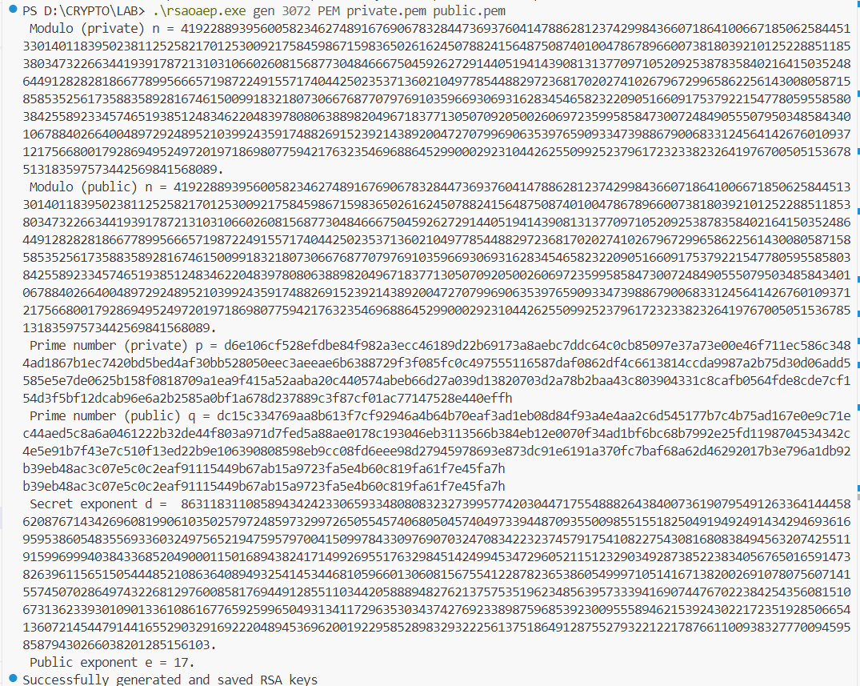

* **Encrypted text:**

* **Decrypted text:**

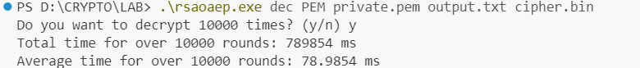

1. **Conclusion**