Test Case 1:
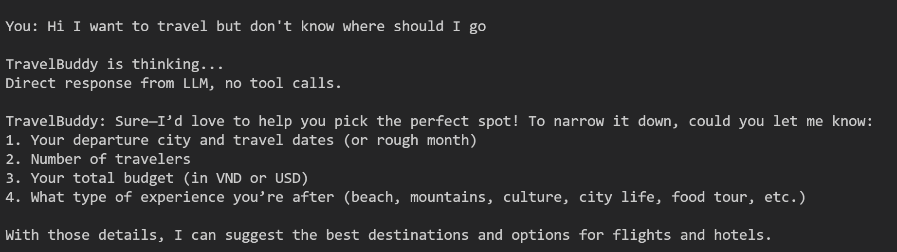
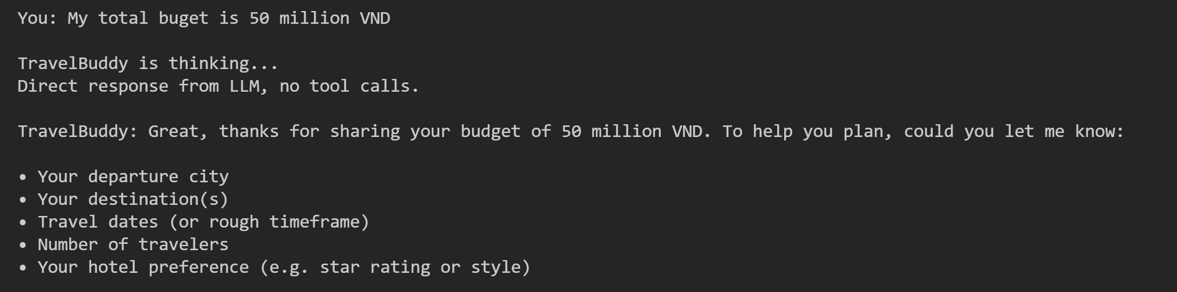

Test Case 2:
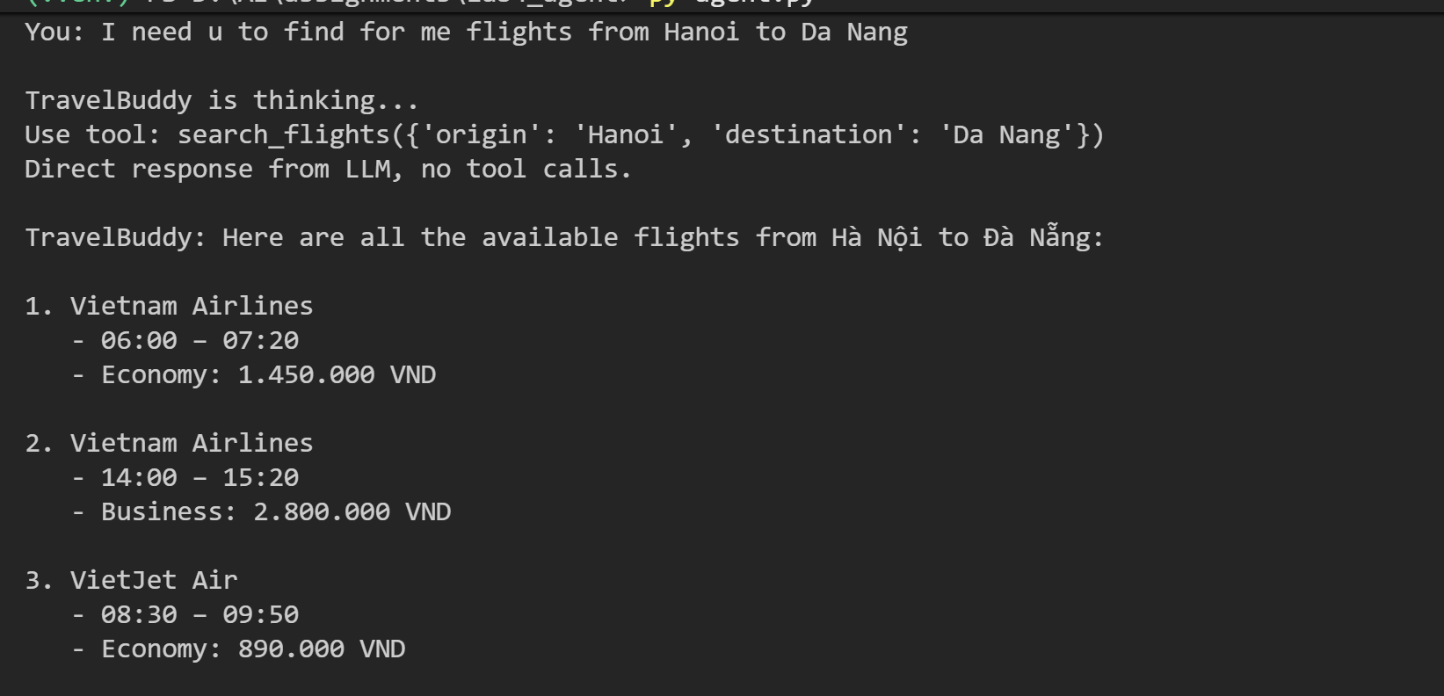


Test case 3
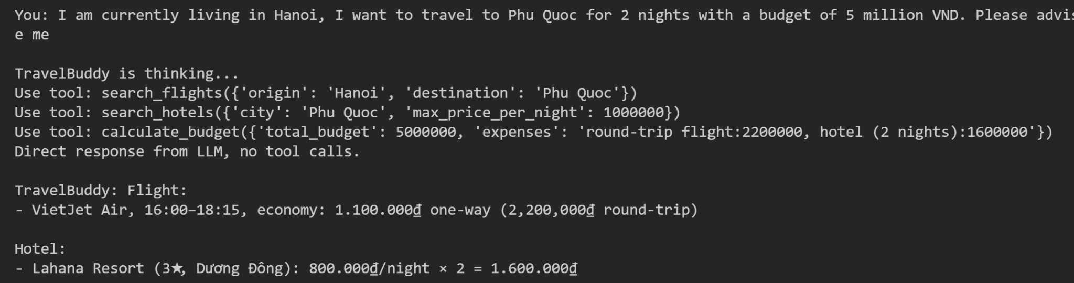
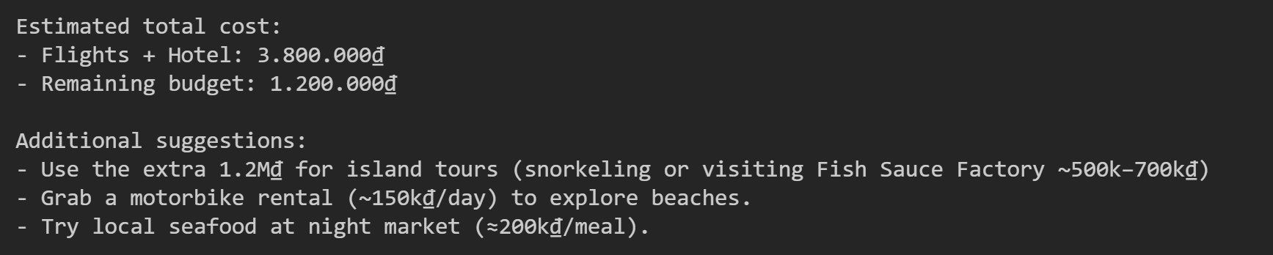
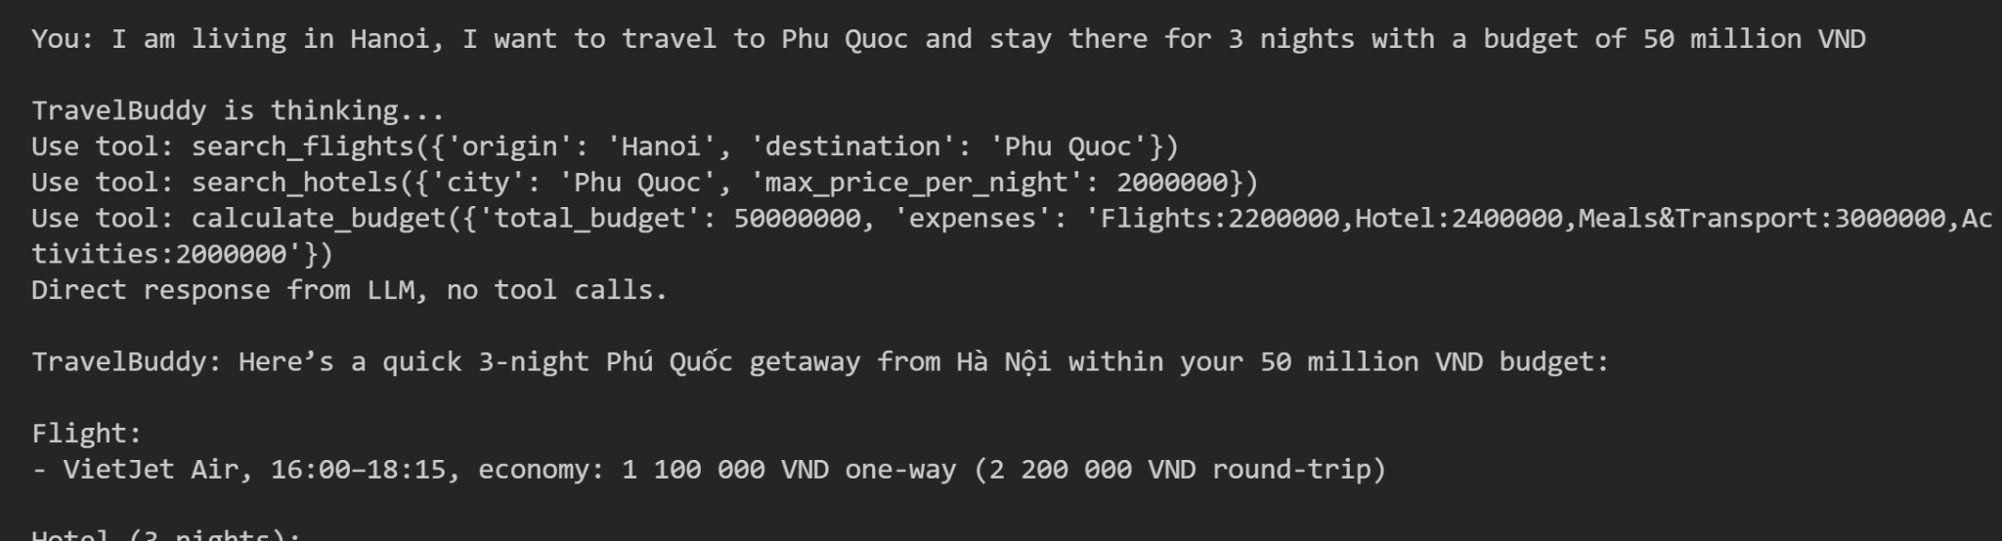
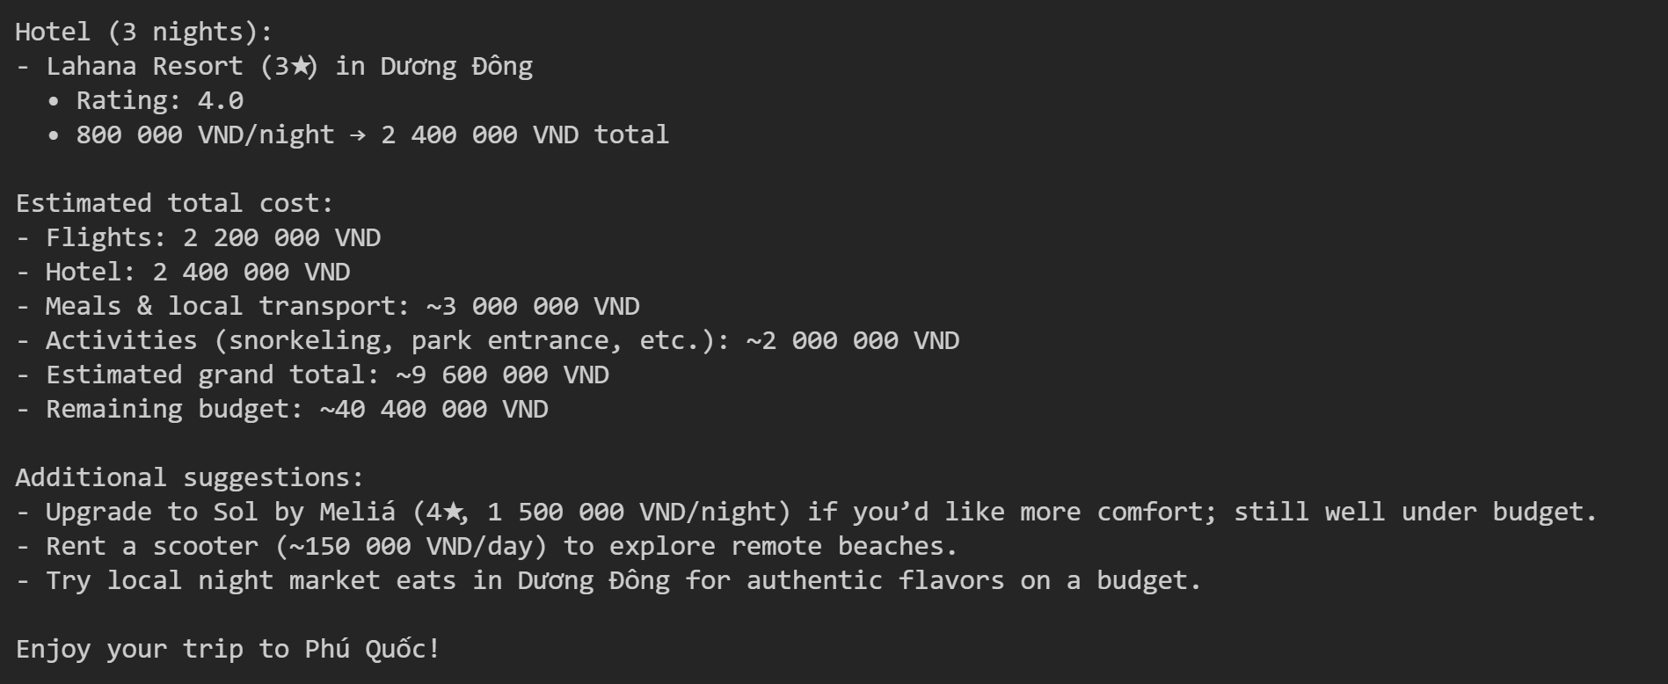

Test Case 4:


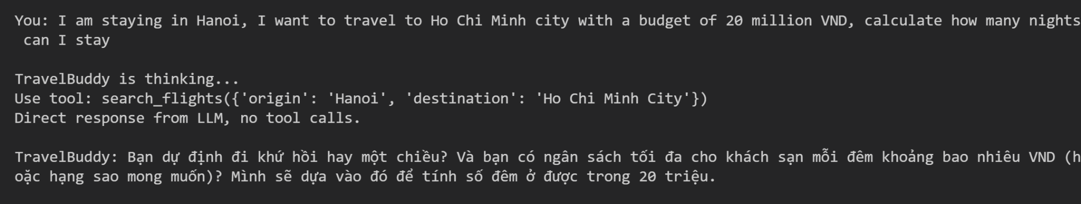
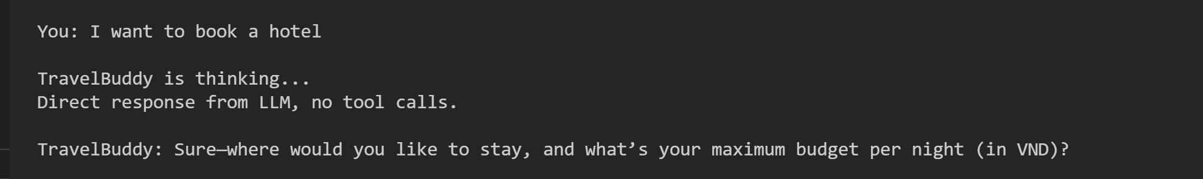
Test case 5:

