CIS 4374 Semester Project
SMART PARKING PLATFORM
WE ARE $oftware ¢orp.
Project Document – Version 7.0

October 27th, 2026

Homework 7

1. Existing Software Landscape

1.1 Market Overview
Many parking apps already allow drivers to search for parking, make reservations, and pay digitally. SpotHero, ParkWhiz and ParkMobile have made parking more convenient by allowing users to find parking before arriving at their destination.
Because many basic parking functions are already available then Smart Parking Platform should be more than just another parking search application. The proposed platform will focus on making parking part of the overall user’s destination planning process. In addition to general parking the platform will also focus on three situations where parking can strongly impact on customer experience: airport travel, events and retail shopping.
The main differentiator is retail parking. Participating retailers and shopping centers could reserve some of their parking capacity during Black Friday, holiday weekends, major sales and special events (reservations would allow customers to plan where they want to park before leaving for their destination instead of looking for a space after arriving).

1.2 Competitive Analysis
Feature | SpotHero | ParkWhiz | ParkMobile | Smart Parking Platform
Parking Search | Yes | Yes | Yes | Yes
Advance Reservation | Yes | Yes | Yes | Yes
Digital Payment | Yes | Yes | Yes | Yes
Airport Parking | Yes | Supported locations | Reservation supported | Yes
Event Parking | Yes | Yes | Yes | Yes
Destination Search | Yes | Yes | Yes | Yes
Operator Tools | Available | Available | Available | Yes
Retail Reservation Focus | Not a primary focus | Not a primary focus | Not a primary focus | Core focus
High-Demand Retail Planning | Not a primary focus | Not a primary focus | Not a primary focus | Yes
Integrated Destination Planning | Partial | Partial | Partial | Core platform direction

- The comparison shows that airport and event parking alone would not make the proposed system meaningfully different because these capabilities already exist in the market. Smart Parking will differentiate itself primarily through destination-based parking planning, retail parking reservations, and parking management for periods of unusually high demand.

1.3 Market Opportunity
Smart Parking Platform will approach parking from a destination-based perspective. Instead of requiring users to begin by searching for a specific parking garage, users can begin with the reason for their trip.
- Airport travel
- Concert or sporting event
- Retail shopping
- General destination
The platform can then provide relevant parking options based on destination, time, price, distance, and availability. The goal is to move the user's parking decision from a last-minute search toward a planned part of the trip.

1.4 Proposed Differentiation

Retail Parking Reservations
Retailers, shopping centers, grocery stores and warehouse clubs could reserve part of their parking capacity for reservations. Customers could choose where they wanted to go and when they wanted to arrive before starting the shopping trip.
This would be especially useful on Black Friday, holiday shopping weekends, grand openings and major sales. Instead of guaranteeing a number space at every location the platform might reserve access to a reservable parking zone. No need for complex physical parking infrastructure but more parking certainty for the customer.

Airport Parking Integration
Users will be able to search for airport parking using departure and return dates. Available options may include price, distance, parking duration, shuttle information, and eligible promotions. The goal is to make parking part of the user's travel-planning workflow.

Event Parking Integration
Users will be able to search for supported upcoming events and compare parking based on price, availability, and walking distance from the venue. The platform can connect reservation, payment, reminders, and navigation within the same process.

2. Vision and Scope

2.1 Company Introduction
WE ARE $oftware ¢orp. is a software development company that develops web, mobile and integrated software solutions. For Smart Parking Platform project we have Mobile Application Team, Web Application Team, Backend/API Team, Mapping & Location Services Team, Payment Integration Team and Quality Assurance & Testing Team.

2.2 Project Acquisition
WE ARE $oftware ¢orp. saw an opportunity because of a common parking problem: drivers don’t start looking for parking until they get to or approach their destination. Parking uncertainty starts the experience off on the wrong foot-travel, shopping or event. After reviewing the parking software landscape and needs of drivers, parking operators and destination partners, the company launched Smart Parking Platform project. The platform will bring together parking search, reservation, payment, navigation and management into one destination focused platform.

2.3 Project Overview
The Smart Parking Platform is a web and mobile system that helps drivers locate, plan, reserve, navigate to and pay for parking. It will have real-time parking availability on an interactive map; digital payment; reservation history and receipts; notifications and navigation assistance. Operators will have an administrative dashboard with occupancy reporting and analytics.
The platform adds to the original project requirements destination-based parking services for airport travel, events and retail locations (participating retailers).

2.4 Project Vision
“The vision of the Smart Parking Platform is to make parking a planned part of the destination experience rather than a problem drivers solve after arrival.”
The platform will connect drivers with participating parking facilities and destination partners so that parking can be planned before a trip begins. By combining availability, reservations, payments, navigation, notifications, promotions, and operator management, the system aims to reduce parking uncertainty and improve the overall destination experience.

2.5 Project Scope

In Scope
- User registration and authentication
- Vehicle profile management
- Real-time parking availability
- Interactive parking map
- Search by location and destination
- General parking reservations
- Airport parking planning and reservations
- Event parking discovery and reservations
- Retail parking reservations at participating locations
- High-demand retail reservation windows
- Digital payment processing
- Reservation history and digital receipts
- Navigation integration
- Notifications and reminders
- Eligible promotions and discounts
- Administrative dashboard
- Reservable parking inventory management
- Occupancy monitoring
- Pricing and promotion management
- Reporting and analytics
- Third-party payment integration
- External mapping and navigation integration

Out of Scope
- Construction or ownership of parking facilities
- Manufacturing parking sensors
- Operation of airport shuttle services
- Valet parking
- Vehicle repair or roadside assistance
- Parking citation enforcement
- Operation of airports, retailers, or event venues
- Guaranteed reservations at locations that do not participate in the platform
- Development of independent payment or navigation networks

3. Software Requirements Specification

3.1 Purpose
This Software Requirements Specification (SRS) defines the requirements for the Smart Parking Platform. It provides a common reference for project stakeholders and development teams and identifies the expected functionality, system characteristics, constraints, assumptions, and primary use cases.

3.2 Overall Description

3.2.1 Users
- Drivers and vehicle owners
- Retail customers
- Airport travelers
- Event attendees
- Parking facility operators
- Retail and destination partners
- System administrators
- Finance and billing personnel

3.2.2 System Environment
- Web application
- Mobile application
- Backend/API services
- External mapping and navigation services
- Third-party payment services

3.2.3 Constraints
- The project must be completed within the fixed semester timeline.
- The platform depends on third-party services and APIs.
- The platform must comply with security and privacy requirements.
- The platform must comply with applicable city ordinances and laws.
- Reservations can only be provided at participating locations.
- Real-time availability depends on data received from participating parking facilities.

3.2.4 Assumptions
- Users have internet access.
- Users have access to a supported mobile device or web browser.
- Participating facilities provide parking availability information.
- Participating partners maintain accurate parking inventory.
- Third-party payment services are available.
- External mapping services are available.
- Users permit location access when location-based functionality is required.

3.3 Functional Requirements

Account and Vehicle Management
FR1. The system shall allow users to create an account.
FR2. The system shall allow registered users to securely log in and log out.
FR3. The system shall allow users to add, edit, and remove vehicle information.

Parking Search and Availability
FR4. The system shall allow users to search for parking based on their current location.
FR5. The system shall allow users to search for parking by destination.
FR6. The system shall display participating parking locations on an interactive map.
FR7. The system shall display real-time parking availability when availability data is provided by participating facilities.
FR8. The system shall allow users to filter parking options by price, distance, and availability.

Reservations
FR9. The system shall allow users to reserve an available parking option.
FR10. The system shall allow users to select an arrival time and parking duration.
FR11. The system shall display reservation details and total cost before confirmation.
FR12. The system shall allow eligible reservations to be modified or canceled according to the parking provider's policy.

Airport Parking
FR13. The system shall allow users to search for airport parking using departure and return dates.
FR14. The system shall display available airport parking options with price, distance, and available facility services.
FR15. The system shall allow users to store travel-related information for parking reminders.

Event Parking
FR16. The system shall display supported upcoming events with available parking options.
FR17. The system shall allow users to search for parking by event or venue.
FR18. The system shall display the walking distance between an event parking location and its associated venue.

Retail Parking
FR19. The system shall allow users to identify participating retail locations that offer reservable parking.
FR20. The system shall allow users to reserve parking capacity within a designated reservable zone at participating retail locations.
FR21. The system shall display available reservation capacity by arrival time window during high-demand retail periods.
FR22. The system shall display eligible parking promotions or discounts offered by participating partners.

Payment, Notifications, and Navigation
FR23. The system shall allow users to pay for parking through supported digital payment methods.
FR24. The system shall generate digital receipts and maintain reservation and payment history.
FR25. The system shall send reservation confirmations, reminders, and relevant parking alerts.
FR26. The system shall provide navigation assistance to parking locations through an external mapping service.

Operator and Partner Management
FR27. Authorized parking operators shall be able to view current occupancy information.
FR28. Authorized operators shall be able to define parking capacity available for reservations.
FR29. Authorized partners shall be able to modify reservable capacity by date or time period.
FR30. Authorized partners shall be able to view upcoming reservations.
FR31. Authorized operators shall be able to configure parking prices.
FR32. Authorized partners shall be able to create eligible parking promotions or discounts.
FR33. The system shall provide occupancy reports to authorized operators.
FR34. The system shall provide reservation and demand analytics.
FR35. System administrators shall be able to manage user and partner accounts.

3.4 Non-Functional Requirements
NFR1 - Performance: Parking search results shall be displayed within 3 seconds under normal operating conditions.
NFR2 –-Data Update: Updated parking availability shall be reflected in the user interface within 5 seconds after new availability data is received by the platform.
NFR3 - Availability: The platform shall maintain at least 99.9% monthly uptime, excluding scheduled maintenance.
NFR4 - Scalability: The system shall support at least 10,000 concurrent users without loss of core functionality.
NFR5 - Security: Sensitive user and payment-related communications shall use encrypted network connections.
NFR6 - Credential Security: User passwords shall not be stored as plain text.
NFR7 - Usability: A logged-in user shall be able to complete a standard parking reservation within no more than five primary interaction steps after selecting a parking location.
NFR8 - Web Compatibility: The web application shall support current major versions of Chrome, Edge, Safari, and Firefox.
NFR9 - Mobile Compatibility: The mobile application shall support the iOS and Android releases designated as supported by the project team.
NFR10 - Reservation Reliability: A confirmed reservation shall be successfully stored before confirmation is displayed to the user.
NFR11 - Reservation Integrity: The system shall prevent overlapping confirmed reservations from exceeding the available reservable capacity for the same location and time period.

3.5 Use Cases

UC01: Create User Account
Actor: Driver / Vehicle Owner
Precondition: The user has internet access and does not have an existing account.
Steps:
- User selects “Create Account.”
- User enters the required information.
- User creates login credentials.
- User accepts required terms and privacy conditions.
- System validates the information.
- System creates the account.
- System confirms registration.
Postcondition: A new user account is available for login.

UC02: Add Vehicle to Profile
Actor: Registered User
Precondition: The user is logged in.
Steps:
- User opens the vehicle profile.
- User selects “Add Vehicle.”
- User enters vehicle information.
- User saves the vehicle.
- System validates and stores the information.
Postcondition: The vehicle is associated with the user's account.

UC03: Search Parking by Destination
Actor: Driver
Precondition: The user has internet access.
Steps:
- User enters a destination.
- System identifies participating parking locations nearby.
- System displays available options on a map and list.
- User reviews price, distance, and availability.
- User selects a parking option.
Postcondition: The selected parking option is available for the next applicable action.

UC04: Reserve General Parking
Actor: Driver
Precondition: The user is logged in and reservable parking is available.
Steps:
- User selects a parking location.
- User selects arrival time and duration.
- System displays availability and price.
- User selects an available option.
- User reviews the reservation.
- User confirms.
- System stores the reservation.
Postcondition: A parking reservation is created.

UC05: Cancel Parking Reservation
Actor: Registered User
Precondition: The user has an active reservation eligible for cancellation.
Steps:
- User opens reservation history.
- User selects the reservation.
- User selects “Cancel Reservation.”
- System displays the applicable cancellation policy.
- User confirms cancellation.
- System updates the reservation.
- System processes an applicable refund.
Postcondition: The reservation is canceled and its capacity is returned when applicable.

UC06: Search Airport Parking
Actor: Airport Traveler
Precondition: The user knows the airport and travel dates.
Steps:
- User selects airport parking.
- User enters the airport.
- User enters departure and return dates.
- System searches participating facilities.
- System displays price, distance, availability, and available services.
- User selects an option.
Postcondition: An airport parking option is selected for reservation.

UC07: Reserve Airport Parking
Actor: Airport Traveler
Precondition: The user is logged in and eligible airport parking is available.
Steps:
- User selects an airport parking option.
- System displays dates and total price.
- User reviews available facility information.
- User selects a payment method.
- User confirms the reservation.
- System processes payment.
- System generates confirmation.
Postcondition: Airport parking is reserved for the selected period.

UC08: Receive Airport Parking Reminder
Actor: Airport Traveler
Precondition: The user has an upcoming airport parking reservation.
Steps:
- System identifies the upcoming reservation.
- System generates a reminder.
- Reminder includes parking location and reservation time.
- System provides available navigation or facility information.
- User receives the reminder.
Postcondition: The user receives relevant information before the airport parking reservation.

UC09: Search Parking for an Upcoming Event
Actor: Event Attendee
Precondition: A supported event has participating parking options.
Steps:
- User opens event parking.
- User searches for or selects an event.
- System identifies parking near the venue.
- System displays price, availability, and walking distance.
- User compares options.
- User selects a parking location.
Postcondition: An event parking option is selected.

UC10: Reserve Event Parking
Actor: Event Attendee
Precondition: The user is logged in and parking is available for the event.
Steps:
- User selects an event parking option.
- System displays reservation details.
- User reviews walking distance and price.
- User confirms the reservation.
- User completes payment.
- System creates the reservation.
Postcondition: Parking is reserved for the selected event.

UC11: Search Reservable Retail Parking
Actor: Retail Customer
Precondition: The retail location participates in the platform.
Steps:
- User searches for a retail location.
- User selects the location.
- System displays available reservation windows.
- System displays available reservable capacity.
- System displays applicable promotions or conditions.
- User selects an arrival window.
Postcondition: A retail parking option is selected.

UC12: Reserve Retail Parking During a High-Demand Period
Actor: Retail Customer
Precondition: The user is logged in and reservable capacity is available.
Steps:
- User selects a participating retail location.
- User selects an arrival window.
- System checks designated reservable-zone capacity.
- System displays parking details and applicable fees.
- User confirms the reservation.
- System stores the reservation.
- System updates remaining reservable capacity.
Postcondition: The user receives a reservation for the designated parking zone and time window.

UC13: Apply Retail Parking Promotion
Actor: Retail Customer
Precondition: An eligible partner promotion is available.
Steps:
- User selects an eligible parking option.
- System identifies applicable promotions.
- User selects a promotion when required.
- System applies the discount or benefit.
- System updates the reservation total.
- User continues with the reservation.
Postcondition: The eligible promotion is applied.

UC14: Manage Reservable Parking Capacity
Actor: Parking Operator / Retail Partner
Precondition: The authorized operator is logged into the administrative dashboard.
Steps:
- Operator selects a managed parking location.
- Operator opens reservation capacity settings.
- Operator selects a date or time period.
- Operator enters the available reservable capacity.
- System validates the capacity.
- Operator confirms the change.
- System updates reservation inventory.
Postcondition: Reservable capacity is updated for the selected period.

UC15: View Parking Occupancy and Demand Analytics
Actor: Parking Operator / Authorized Partner
Precondition: The user has reporting and analytics permission.
Steps:
- User opens the analytics dashboard.
- User selects a parking location.
- User selects a reporting period.
- System retrieves occupancy, reservation, and demand information.
- System displays the available analytics.
- User reviews the information.
Postcondition: The authorized user can use current parking information for operational planning.

3.6 Requirements Review and Acceptance Criteria
The existing FR1–FR35 and NFR1–NFR11 remain the requirements baseline. The following acceptance checks clarify how the proposed system would behave; they are not evidence of completed implementation.
Availability and reservation: before confirming a booking, the backend rechecks participating-operator inventory for the selected time window. If the feed is unavailable or stale, the user receives an availability warning and no unverified reservation is confirmed. This supports FR7, FR9, FR20, FR21, NFR2 and NFR11.
Payment: the user sees the full price before checkout. A payment timeout or declined payment produces a clear pending or failed status, without an unverified success receipt. A unique transaction reference and reconciliation check help avoid duplicate charges. This supports FR11, FR23, FR24 and NFR10.
Privacy and access: an operator may edit only authorized parking locations. User credentials are securely hashed, sensitive connections are encrypted, and payment card details are handled by the external payment provider rather than stored by the platform. This supports FR27–FR35 and NFR5–NFR6.
Proposed user story US16: As a driver, I want to know when parking availability cannot be verified so I do not pay for an unavailable space. Acceptance: the interface shows a clear warning and blocks final confirmation until inventory is verified.
Proposed user story US17: As a driver, I want to see whether a payment succeeded, failed, or remains pending so I can avoid accidentally paying twice. Acceptance: checkout provides a status and a safe retry path only after transaction status is checked.
Proposed user story US18: As a parking operator, I want to update capacity for a specific time window so that the system does not sell more reservations than the participating facility can support. Acceptance: the new capacity is validated and changes are recorded.

4. Project Work Breakdown and Schedule
This section expands the Smart Parking Platform project plan by breaking down the system into deliverables and creating a draft schedule. The WBS is organized around major systems, modules, and features from current project requirements. The schedule is a draft and will be adjusted as the project progresses.

4.1 Work Breakdown Structure
Work Breakdown Structure. The Work Breakdown Structure (WBS) divides the Smart Parking Platform into smaller project deliverables. It is organized at three levels: major system, module, and feature.

4.1.1 WBS Review and Deliverable Controls
Account management, parking search, general and specialized reservations, payments, operator tools, and quality assurance are all part of the existing WBS scope. Numbering errors in the original WBS were standardised without removing deliverables.
In the existing System Integration and Quality Assurance workstream, acceptance testing should explicitly cover concurrent booking requests, stale parking feeds, mapping API failures, payment timeouts, operator permissions and regression testing of airport, event and retail reservations.
1. User and Account Management
1.1 User Account
1.1.1 User Registration
1.1.2 User Login and Logout
1.1.3 Account Management
1.2 Vehicle Profile
1.2.1 Add Vehicle
1.2.2 Edit Vehicle
1.2.3 Remove Vehicle
2. Parking Search and Availability
2.1 Parking Search
2.1.1 Current Location Search
2.1.2 Destination Search
2.1.3 Parking Filters
2.2 Parking Information
2.2.1 Parking Location Display
2.2.2 Real-Time Availability
2.2.3 Price and Distance Information
2.3 Interactive Map
2.3.1 Parking Map Display
2.3.2 User Location Display
2.3.3 Parking Location Selection
3. Parking Reservation System
3.1 Reservation Creation
3.1.1 Parking Selection
3.1.2 Arrival Time Selection
3.1.3 Parking Duration Selection
3.2 Reservation Management
3.2.1 Reservation Confirmation
3.2.2 Reservation Modification
3.2.3 Reservation Cancellation
3.3 Reservation Records
3.3.1 Reservation History
3.3.2 Reservation Details
3.3.3 Digital Receipt
4. Retail Parking System
4.1 Retail Parking Search
4.1.1 Participating Store Search
4.1.2 Retail Parking Availability
4.1.3 Reservation Window Display
4.2 Retail Parking Reservation
4.2.1 Arrival Window Selection
4.2.2 Reservable Zone Capacity
4.2.3 Retail Reservation Confirmation
4.3 High-Demand Parking Management
4.3.1 Holiday Parking Capacity
4.3.2 Special Shopping Event Capacity
4.3.3 Retail Parking Promotions
5. Airport Parking System
5.1 Airport Parking Search
5.1.1 Airport Selection
5.1.2 Departure and Return Dates
5.1.3 Airport Parking Comparison
5.2 Airport Parking Reservation
5.2.1 Parking Facility Selection
5.2.2 Reservation Confirmation
5.2.3 Travel Parking Information
5.3 Airport Parking Support
5.3.1 Parking Reminder
5.3.2 Facility Information
5.3.3 Navigation to Parking Facility
6. Event Parking System
6.1 Event Search
6.1.1 Upcoming Event Search
6.1.2 Venue Selection
6.1.3 Event Parking Availability
6.2 Event Parking Reservation
6.2.1 Parking Location Selection
6.2.2 Price and Distance Comparison
6.2.3 Event Parking Confirmation
6.3 Event Navigation
6.3.1 Parking Location Navigation
6.3.2 Walking Distance Information
6.3.3 Venue Direction Information
7. Payment and Promotion System
7.1 Digital Payment
7.1.1 Payment Method Selection
7.1.2 Payment Processing
7.1.3 Payment Confirmation
7.2 Promotion Management
7.2.1 Promotion Eligibility
7.2.2 Discount Application
7.2.3 Updated Reservation Total
8. Navigation and Notification System
8.1 Navigation
8.1.1 Mapping Service Integration
8.1.2 Parking Directions
8.1.3 Destination Directions
8.2 Notifications
8.2.1 Reservation Confirmation
8.2.2 Parking Reminder
8.2.3 Parking Status Alert
9. Operator and Partner Management
9.1 Parking Location Management
9.1.1 Add Parking Location
9.1.2 Edit Parking Information
9.1.3 Manage Parking Capacity
9.2 Reservation Capacity Management
9.2.1 Set Reservable Capacity
9.2.2 Adjust Capacity by Time Period
9.2.3 View Upcoming Reservations
9.3 Pricing and Promotion Management
9.3.1 Parking Price Management
9.3.2 Promotion Creation
9.3.3 Promotion Modification
10. Reporting and Analytics
10.1 Occupancy Reporting
10.1.1 Current Occupancy
10.1.2 Historical Occupancy
10.1.3 Occupancy Trends
10.2 Reservation Analytics
10.2.1 Reservation Volume
10.2.2 High-Demand Period Analysis
10.2.3 Destination Demand Analysis
10.3 Financial Reporting
10.3.1 Payment Records
10.3.2 Revenue Summary
10.3.3 Transaction Reporting
11. System Integration and Quality Assurance
11.1 External Service Integration
11.1.1 Payment Service Integration
11.1.2 Mapping Service Integration
11.1.3 Location Service Integration
11.2 System Testing
11.2.1 Functional Testing
11.2.2 Integration Testing
11.2.3 Performance and Security Testing
11.3 Final System Validation
11.3.1 User Acceptance Testing
11.3.2 Defect Resolution
11.3.3 Release Validation

4.2 Project Estimation Approach
The initial schedule uses relative estimates based on the size, complexity, dependencies, and expected effort of each major project component. At this stage, the estimates are planning estimates rather than exact predictions. Basic platform functions such as user accounts, parking search, and reservations are scheduled before specialized functions such as retail, airport, and event parking. Integration and testing are included before final release.

4.3 Project Dependencies
Several components depend on earlier components. The initial schedule mainly uses Finish-to-Start (FS) dependencies, meaning a dependent component begins after the required earlier component is completed.
ID | Project Component | Main Dependency | Type
P1 | Requirements and Project Planning | None | -
P2 | System and Interface Design | P1 | FS
P3 | User and Account Management | P2 | FS
P4 | Parking Search and Availability | P2 | FS
P5 | Parking Reservation System | P3, P4 | FS
P6 | Payment System | P5 | FS
P7 | Retail Parking System | P5 | FS
P8 | Airport Parking System | P5 | FS
P9 | Event Parking System | P5 | FS
P10 | Navigation and Notifications | P4 | FS
P11 | Operator and Partner Management | P4 | FS
P12 | Reporting and Analytics | P5, P11 | FS
P13 | System Integration and Testing | P6-P12 | FS
P14 | Final Validation and Release | P13 | FS

4.4 Draft Project Timeline
The following timeline represents the initial twelve-week development schedule. Some components are scheduled in parallel after their required dependencies have been completed.
Phase | Project Component | Duration | Planned Weeks
1 | Requirements and Project Planning | 1 week | Week 1
2 | System and Interface Design | 1 week | Week 2
3 | User and Account Management | 2 weeks | Weeks 3-4
4 | Parking Search and Availability | 2 weeks | Weeks 3-4
5 | Parking Reservation System | 2 weeks | Weeks 5-6
6 | Payment System | 2 weeks | Weeks 7-8
7 | Retail Parking System | 2 weeks | Weeks 7-8
8 | Airport Parking System | 2 weeks | Weeks 7-8
9 | Event Parking System | 2 weeks | Weeks 7-8
10 | Navigation and Notifications | 2 weeks | Weeks 7-8
11 | Operator and Partner Management | 2 weeks | Weeks 7-8
12 | Reporting and Analytics | 1 week | Week 9
13 | System Integration and Testing | 2 weeks | Weeks 9-10
14 | Final Validation and Release | 2 weeks | Weeks 11-12

4.5 Gantt Chart
The Gantt chart below shows the planned timing and overlap of the major project components across the twelve-week draft schedule.
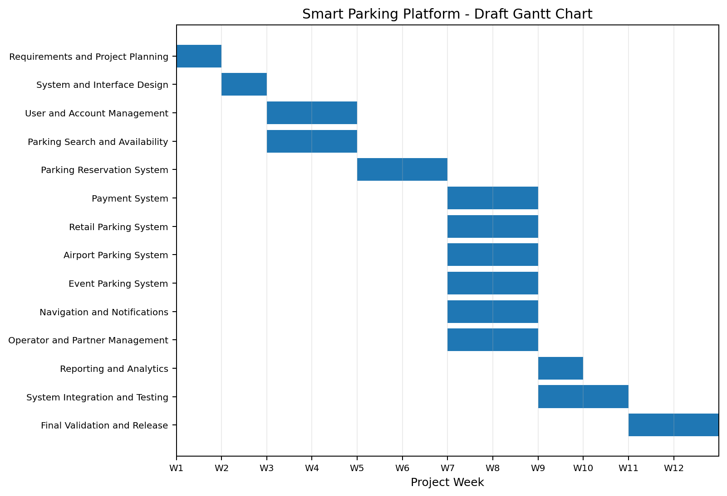

Smart Parking Platform Draft Gantt Chart

4.6 Project Milestones
Milestone | Target | Expected Result
M1: Requirements Defined | End of Week 1 | Initial requirements and project scope established
M2: System Design Ready | End of Week 2 | Initial system and interface structure established
M3: Core Parking Functions Ready | End of Week 6 | User, search, and reservation systems available
M4: Specialized Parking Functions Ready | End of Week 8 | Retail, airport, event, payment, and supporting systems available
M5: Integrated System Ready | End of Week 10 | Major components integrated and tested
M6: Final Release Ready | End of Week 12 | Final validation completed

4.7 Scheduling Risks and Considerations
This is an initial estimate and may change as the project evolves. Important scheduling risks are third-party integrations, changing requirements, and how much time system integration and testing takes. Retail parking also depends on accurate reservable capacity from participating locations; airport and event parking depend on external parking and destination information, so integration and testing time is included before final validation.

4.8 Schedule Baseline Review
The twelve-week Gantt chart and P1–P14 dependencies remain the approved planning baseline for this course exercise. The dates are estimates, not a verified report of development completion.
At the end of Week 6, review whether P3–P5 core account, search, and reservation workflows meet acceptance criteria. At Week 8, review P6–P11 payment, specialized parking, navigation, and operator work. At Week 10, review P12–P13 reporting and integration test evidence. Week 12 remains the planned final validation gate.
If any task is late, the Project Manager should record the variance in Jira, identify the dependent tasks, and decide whether to resequence work or reduce nonessential enhancements without silently changing the baseline. Actual dates and percentage complete must come from Jira, not assumptions.

5. Jira Backlog and Sprint Planning

5.1 Product Backlog
The Smart Parking Platform product backlog was created in Jira to organize the work required for the project. The backlog includes tasks for login, user and operator interfaces, backend processes, reporting, parking functions, accessibility, and other system features.

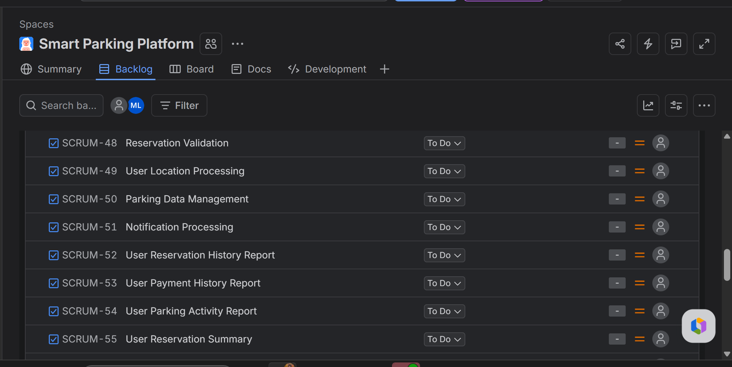
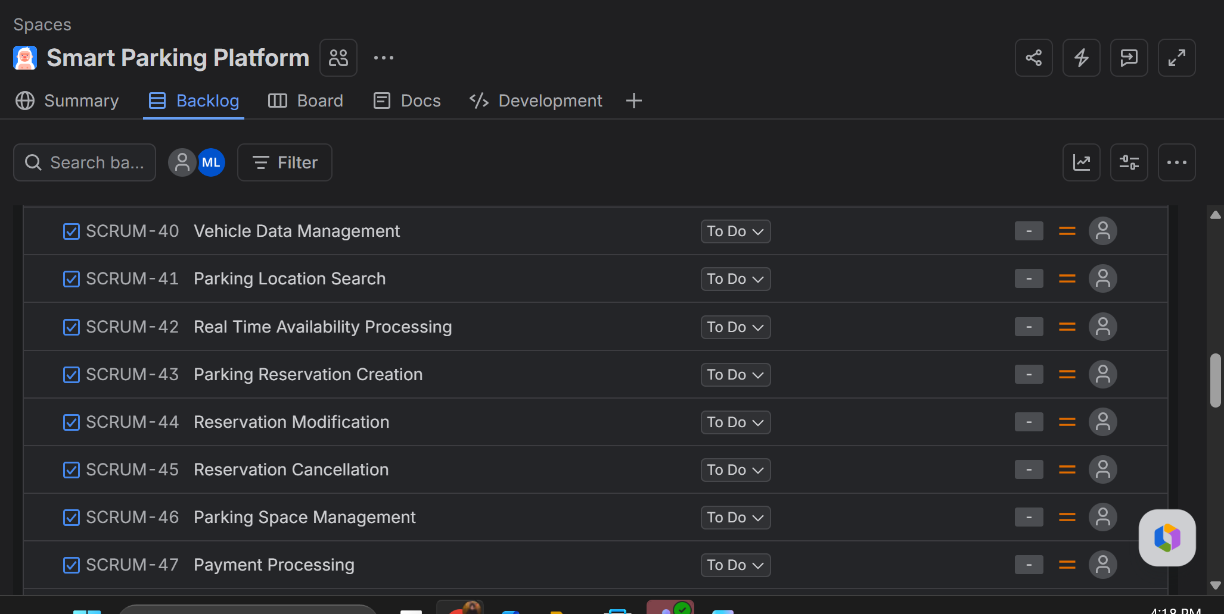
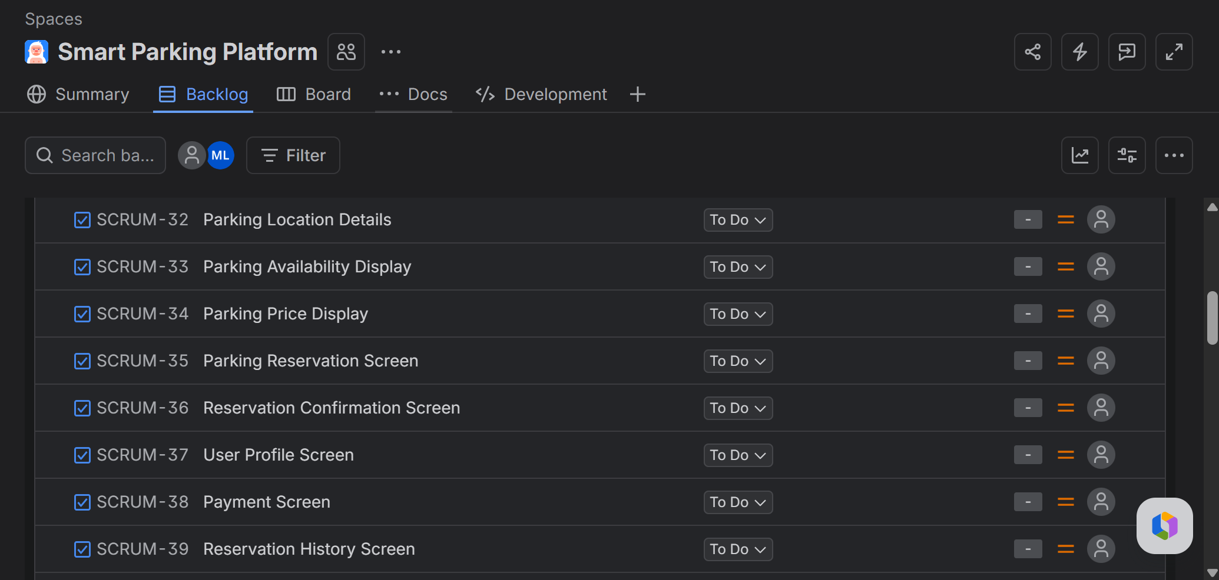
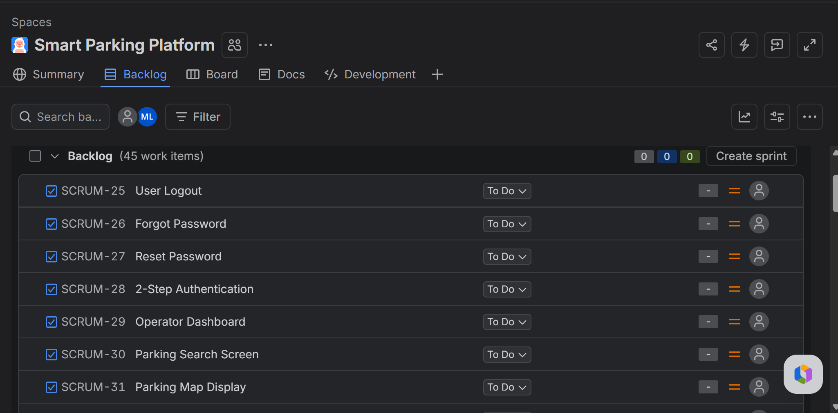

Smart Parking Platform Product Backlog in Jira

5.2 Sprint 1 Plan
Sprint 1 focuses on the initial user account and vehicle management functions. Six work items were selected from the product backlog and scheduled for the sprint from September 23 to October 7, 2026.
- User Registration
- User Login and Authentication
- User Account Management
- Add Vehicle
- Edit Vehicle
- Remove Vehicle
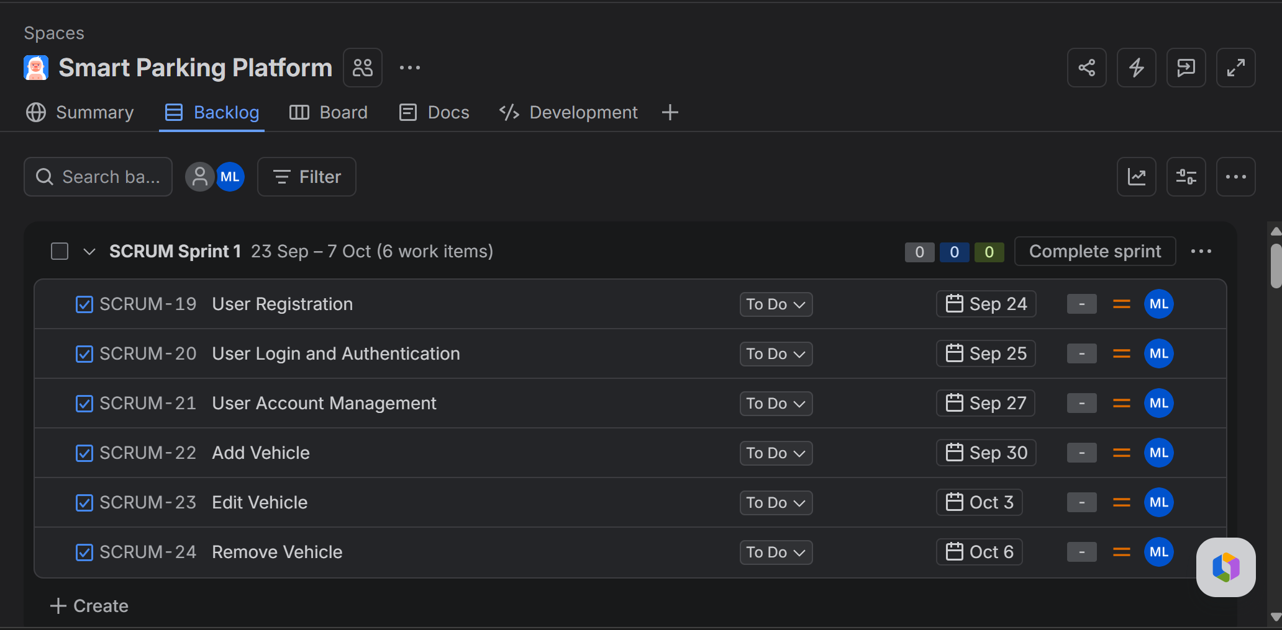
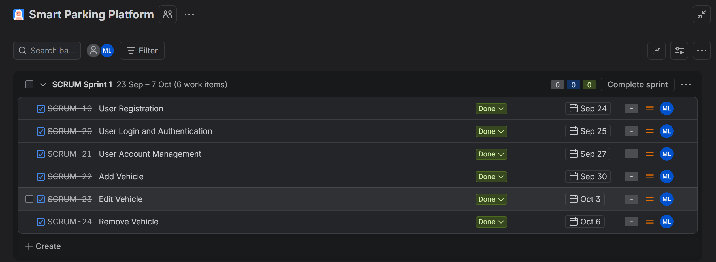

Smart Parking Platform Sprint 1 Plan in Jira

5.3 Backlog and Sprint Update for Version 6.0
The original Jira screenshots and six Sprint 1 items are preserved as historical planning evidence. Sprint 1 was scheduled for September 23 through October 7, 2026, but the document alone does not verify which issues were completed.
For the next planning review, prioritize (1) capacity validation and reservation integrity, (2) payment success, failure, and timeout handling, (3) mapping service fallback, (4) operator capacity controls, and (5) integration test coverage. Retail, airport, and event features remain in scope and should follow their existing dependencies.
Proposed Jira task: Validate parking capacity before reservation confirmation. Owner: Backend/API Developer (Dinh Le). Acceptance: two simultaneous requests cannot exceed available capacity. Status: To Do until verified.
Proposed Jira task: Handle payment timeout and duplicate retry. Owner: Payment Integration Developer (Tom Smith). Acceptance: payment status is reconciled before reservation confirmation. Status: To Do until verified.
Proposed Jira task: Handle mapping API failure. Owner: Mapping & Location Developer (Tony Stack). Acceptance: the interface shows a useful error or permitted fallback without promising live directions. Status: To Do until verified.
Proposed Jira task: Test reservation and payment error paths. Owner: QA/Test Engineer (John Peterson). Acceptance: recorded test cases cover capacity conflicts, API outages, and failed payment attempts. Status: To Do until verified.

6. Risk and Communication Management
This section identifies the major project risks for the Smart Parking Platform, assesses the most important risks in the risk register, and defines the communication between the project teams in developing the Smart Parking Platform. The risks are based on the current project scope, twelve-week schedule, external service dependencies, and the six project teams for the platform.

6.1 Risk Identification by Category
The project risks are classified as technical, schedule, financial, and people. All categories are linked to risks that could affect the current Smart Parking Platform project.

Technical Risks
- Inaccurate or delayed parking data from participating facilities may lead the platform to display spaces that are no longer available.
- External mapping or location services could be offline, experience API changes, or provide inaccurate results that affect search and navigation.
- Failure of third-party payment services could prevent users from booking reservations or receiving correct payment confirmations.
- Errors in integration between the mobile app, web app, backend APIs, reservation inventory, and external services could cause inconsistent data or failed transactions.

Schedule Risks
- Delays in third-party payment, mapping, or parking data integration could push related development and testing activities beyond planned weeks.
- If retail, airport, and event parking requirements change after development starts, the twelve-week schedule could be reworked and will be affected by that.
- Integration and system testing may take longer than the two weeks we planned in case of defects across modules.
- It is possible that core search or reservation functions will be delayed, affecting payment, specialized parking functions, reporting, and final validation because of previous work.

Financial Risks
- Usage-based fees for mapping, location, notification, or other external APIs may be higher than the project budget if the volume of transactions is higher than expected.
- Processing and transaction fees might lower platform revenue or change the pricing model.
- Uncertainties of integration failures or changes in requirements could lead to additional work and increased labor costs.
- Low participation from parking operators or retail partners could limit reservation inventory and reduce the financial value of the platform.

People Risks
- Key team members may become unavailable during the semester, leaving a skill or workload gap in a specific field.
- Poor coordination between the six development teams could lead to incompatible interfaces, duplicated work, or missed dependencies.
- Team members may have different interpretations of requirements for reservation capacity, promotions, and specialized parking workflows.
- Limited exposure to third-party APIs, security, and payment integration could slow development and increase the number of defects.

6.2 Risk Register
The risk register looks at the risks that require active tracking. Probability and impact use the five levels introduced in class: Very Low, Low, Moderate, High, and Very High for probability, and Negligible, Minor, Moderate, Major, and Catastrophic for impact. Response strategies are to Avoid, Mitigate, Transfer, or Accept.
ID | Risk Description | Category | Probability | Impact | Owner | Response | Mitigation / Contingency | Status
R1 | Parking availability data is delayed or inaccurate. | Technical | High | Major | Backend/API Team | Mitigate | Timestamps and inventory updates; indicate stale data and do not confirm when capacity can not be verified. | Open
R2 | Mapping/location API outage, change, or inaccurate result. | Technical | Moderate | Major | Mapping & Location Services Team | Mitigate | Use error handling, cached location data where appropriate, API monitoring, and a documented fallback flow. | Open
R3 | Payment service fails during reservation checkout. | Technical | Moderate | Major | Payment Integration Team | Mitigate | Use transaction status checks, retry/error handling, and confirm reservation only after payment response is completed. | Open
R4 | Cross-system integration causes inconsistent reservation or user data. | Technical | Moderate | Major | Backend/API Team | Mitigate | Define API contracts early and run integration tests before final system testing. | Open
R5 | Third-party integration work takes longer than planned. | Schedule | High | Major | Project Manager | Mitigate | Begin integration work early, monitor dependencies weekly, and use test environments or mock services if available. | Open
R6 | Requirements change after development begins. | Schedule | Moderate | Moderate | Project Manager | Avoid | Immediately review changes before adding scope; do not make non-essential changes that may jeopardize the semester deadline. | Open
R7 | Integration and testing exceed the planned two-week window. | Schedule | Moderate | Major | QA & Testing Team | Mitigate | Test modules throughout development and focus on high-risk reservation, payment, and availability workflows. | Open
R8 | External API usage or service fees exceed estimates. | Financial | Moderate | Moderate | Project Manager | Mitigate | Review API usage and costs, set service limits or alerts, and avoid unnecessary requests. | Open
R9 | Payment processing fees are higher than expected. | Financial | Low | Moderate | Payment Integration Team | Accept | Track transaction costs and include them in later pricing and financial analysis. | Open
R10 | A key team member becomes unavailable. | People | Moderate | Major | Project Manager | Mitigate | Document work in Jira and shared repositories, cross-train team members, and determine backup ownership of critical work. | Open
R11 | Teams miscommunicate interfaces or dependencies. | People | Moderate | Major | Project Manager | Mitigate | Use weekly cross-team coordination, shared requirements, Jira dependency tracking, and written interface decisions. | Open
R12 | Team lacks experience with a specialized API, payment, or security task. | People | Moderate | Moderate | Team Lead | Mitigate | Identify skill gaps early, assign research/prototyping tasks, and request peer review before integration. | Open

6.3 Risk Monitoring and Review
Risks will be reviewed during the weekly cross-team project meeting. Risk owners will report changes in probability, impact, response actions or status. New risks identified during development will be added to the register. Risks affecting the current sprint will also be discussed during team stand-ups so that corrective action can begin before the risk becomes an active issue.

6.3.1 Risk Review Triggers and Evidence
The original R1–R12 risk register, ratings, owners, responses, and Open statuses remain unchanged as the Version 5.0 baseline. The following are practical monitoring triggers for weekly reviews, not reported incidents.
R1: If operator availability data is older than the agreed refresh window or an inventory check fails, block unverified confirmations and notify the Backend/API Team. R2: If mapping requests fail repeatedly or response latency rises, log provider errors and use a documented fallback. R3: If checkout times out, check provider transaction status before allowing a retry.
R5 and R7: Compare planned and actual integration/testing tasks weekly; escalate any slippage that threatens Week 10 or Week 12 milestones. R8: Review mapping, notification, and location API request volumes against the existing $2,400 three-month API allowance. These are monitoring controls, not additional budget items.
Risk owners should document date reviewed, evidence, probability or impact changes, response action, and next review date in the existing register or linked Jira issues.

6.4 Communication Plan
Communication will be done through short team meetings, cross-team coordination, Jira updates, shared technical documentation, and milestone reporting. The goal is to keep each team focused on its work while making dependencies visible across the platform.
Team / Audience | Cadence | Primary Information | Reporting Method | Owner
Mobile Application Team | Daily stand-up, 10-15 minutes; weekly cross-team meeting | Sprint progress, UI work, mobile defects, API dependencies | Jira board, team chat, shared documentation | Team Lead / Project Manager
Web Application Team | Daily stand-up, 10-15 minutes; weekly cross-team meeting | Web UI progress, operator dashboard work, defects, API dependencies | Jira board, team chat, shared documentation | Team Lead / Project Manager
Backend/API Team | Daily stand-up, 10-15 minutes; weekly cross-team meeting | API status, database/reservation logic, integration blockers, data issues | Jira board, API documentation, team chat | Backend Team Lead / Project Manager
Mapping & Location Services Team | Three times per week; weekly cross-team meeting | Map integration, destination search, navigation, external service issues | Jira board, integration notes, team chat | Team Lead / Project Manager
Payment Integration Team | Three times per week; weekly cross-team meeting | Payment workflow, transaction status, refunds, payment service issues | Jira board, test results, team chat | Team Lead / Project Manager
Quality Assurance & Testing Team | Twice weekly during development; daily during Weeks 9-12 | Test progress, defects, regression results, release readiness | Jira defect tracking, test reports, shared documentation | QA Lead / Project Manager
All Team Leads / Project Manager | Weekly, 30-45 minutes | Dependencies, schedule, risks, scope changes, milestone status | Jira dashboard, risk register, meeting notes | Project Manager
Project Stakeholders | At major milestones and final release | High-level progress, milestone completion, major risks, approved changes | Status summary, demo, milestone report | Project Manager

6.5 Reporting and Escalation
Jira will be the central information source for backlog items, sprint work, assignments, and defect status. Team leads will summarize blockers and dependencies in the cross-team meeting every week. A technical, schedule, financial, or people risk that becomes High or Extreme, or an issue that threatens a project milestone, will be escalated to the Project Manager immediately rather than waiting for the next scheduled meeting. Major scope changes will be documented before work is updated on the active plan.

6.6 Communication Review for Version 6.0
The existing team meeting frequencies and escalation responsibilities remain unchanged. To make reporting more useful, each weekly cross-team review should produce a short written record: completed work verified in Jira, next-week commitments, blockers, risks that changed, required decisions, and owners with due dates.
For a payment incident, Tom Smith informs Dinh Le and Kayden Le promptly; for a mapping issue, Tony Stack documents the failure and its impact on parking search or navigation. John Peterson tracks related test evidence. These examples follow the existing roles and do not imply that an incident occurred.

7. Resource and Cost Management
In this section, we define the human resources, project cost estimate, cash flow budget, and responsibility assignments for Smart Parking Platform. We plan on a twelve-week schedule (the current plan), six development teams, a work breakdown structure already in place, and external mapping and payment dependencies identified in the project so far.

7.1 Roles and Resource Plan
We use a small cross-functional team for planning purposes (fictitious names of staff). The resource allocation is made for 12 weeks project time (480 hours per FTE person for full project period); members are assigned according to work already defined in mobile, web, backend/API, mapping, payment and quality assurance areas.
Role | Fictional Name | Skill Level | Allocation | Est. Hours | Rate | Labor Cost | Primary Responsibility
Project Manager | Kayden Le | Senior | 37.5% | 180 | $55 | $9,900 | Planning, coordination, scope, schedule, risk, and stakeholder reporting.
UX/UI Designer | Hy | Mid-level | 20.8% | 100 | $45 | $4,500 | User flows, mobile/web interface design and usability support
Mobile Developer | Minh Luu | Mid-level | 62.5% | 300 | $50 | $15,000 | Mobile account, search, reservation, notification, and navigation features
Web Developer | Neil L | Mid-level | 62.5% | 300 | $50 | $15,000 | Web user interface, operator dashboard, and reporting screens
Backend/API Developer | Dinh Le | Senior | 75.0% | 360 | $55 | $19,800 | APIs, reservation logic, inventory, user data, and integrations
Mapping & Location Developer | Tony Stack | Senior | 37.5% | 180 | $60 | $10,800 | Mapping API, location search, directions, and destination integration
Payment Integration Developer | Tom Smith | Senior | 33.3% | 160 | $60 | $9,600 | Payment workflow, transaction status, refunds, and payment service integration
QA/Test Engineer | John Peterson | Mid-level | 54.2% | 260 | $40 | $10,400 | Functional, integration, regression, performance, and release testing

7.2 Bottom-Up Cost Estimate
A bottom-up estimate is used because the project already has a detailed WBS and draft schedule. Labor is estimated by role using planned hours multiplied by an hourly rate. Non-labor costs are then added for infrastructure, tools, external APIs, and testing. A 10% contingency is included for known uncertainties such as integration rework, API usage variation, and additional testing.
Item | Category | Quantity | Unit Cost | Duration | Total | Notes
Project labor | Labor | 1,840 hours | Varies | 12 weeks | $95,000 | Sum of role-based labor estimates
Cloud hosting and database | Infrastructure | 3 months | $600/month | 3 months | $1,800 | Development, test environment, storage and database usage
Mapping, location, and notification APIs | Third-party APIs | 3 months | $800/month avg. | 3 months | $2,400 | Planning allowance for usage-based external services
Development and collaboration tools | Licenses & Tools | Project allowance | $1,200 | One-time | $1,200 | Repository, design, testing, and collaboration tools
Security and performance testing | Testing | Project allowance | $1,500 | Project | $1,500 | Additional security and load/performance testing allowance
Subtotal before contingency |  |  |  |  | $101,900
Contingency reserve | Reserve | 10% of subtotal | 10% | Project | $10,190 | Covers known project uncertainty
Total Budget at Completion (BAC) |  |  |  |  | $112,090 | Planned project budget

7.3 Budgeted Cashflow
The twelve-week schedule is represented as three budget months. Labor is highest during the middle month because several specialized parking systems are developed in parallel during Weeks 5 through 8. The contingency reserve is held for the final month and is used only if approved project risks require additional spending.
Period | Labor | Cloud/Infra | APIs | Tools | Testing | Contingency | Total
Month 1 (Weeks 1-4) | $28,500 | $600 | $400 | $1,200 | $0 | $0 | $30,700
Month 2 (Weeks 5-8) | $38,000 | $600 | $800 | $0 | $500 | $0 | $39,900
Month 3 (Weeks 9-12) | $28,500 | $600 | $1,200 | $0 | $1,000 | $10,190 | $41,490
Total | $95,000 | $1,800 | $2,400 | $1,200 | $1,500 | $10,190 | $112,090

7.4 Cost Assumptions and Control
- Hourly rates are planning assumptions for this course project and not actual salaries or vendor contracts.
- The estimate covers the twelve-week development project only. Long term production operations, full commercial staffing, taxes, benefits, and enterprise legal costs are not included.
- Mapping and other external API costs are treated as usage-based estimates. Actual costs could change with request volume, pricing tiers, or provider changes.
- Payment processing transaction fees are not part of the development BAC because they depend on future customer transaction volume. They remain a financial operating risk and should be tracked separately if the platform goes into production.
- Actual spending will be compared with the cost baseline in weekly project review. Material scope or budget changes must be approved by the Project Manager before the baseline is updated.

7.4.1 Cost Baseline Verification
Version 6.0 retains the original labor assignments, fictional names, hourly rates, $95,000 labor total, $1,800 cloud cost, $2,400 API allowance, $1,200 tools, $1,500 testing, $10,190 contingency, and $112,090 Budget at Completion. The three-month cash flow distribution is unchanged.
The baseline is a planning estimate, not actual expenditure. The Project Manager (Kayden Le) should compare logged hours and provider usage with planned amounts each week. Contingency is reserved for approved changes rather than automatically spent. Transaction processing fees remain outside the development BAC as already stated in Section 7.4.
For budget review, record Planned Cost, Actual Cost, Variance = Actual Cost minus Planned Cost, and an explanation of significant differences. Actual cost fields remain unreported until supporting records are available.

7.5 RACI Matrix
The RACI matrix defines who is responsible for the major components of the project. R stands for Responsible for performing work; A stands for Accountable for the final result; C stands for Consulted, and I stands for Informed. Each component has one Accountable role so ownership stays clear.
Project Component | PM | UX | Mobile | Web | Backend | Map | Payment | QA
Requirements & Project Planning | A | C | C | C | C | C | C | I
System & Interface Design | A | R | C | C | C | C | I | I
User & Account Management | A | C | R | R | R | I | I | C
Parking Search & Availability | A | C | R | R | R | R | I | C
Parking Reservation System | A | C | R | R | R | I | C | C
Payment System | C | I | C | C | C | I | A/R | C
Retail Parking System | A | C | R | R | R | I | C | C
Airport Parking System | A | C | R | R | R | C | C | C
Event Parking System | A | C | R | R | R | C | C | C
Navigation & Notifications | C | C | R | R | R | A | I | C
Operator & Partner Management | A | C | I | R | R | I | I | C
Reporting & Analytics | A | C | I | R | R | I | C | C
System Integration & Testing | C | I | C | C | R | C | C | A
Final Validation & Release | A | I | C | C | C | C | C | R

7.5.1 RACI Application Review
The original RACI matrix is retained without changing its role assignments. Each of P1–P14 has one Accountable role in the existing matrix. The Project Manager coordinates dependencies, while the accountable role approves the relevant deliverable.
Operational examples: Tom Smith is accountable and responsible for the payment system; Tony Stack is accountable for navigation and notifications; John Peterson is accountable for system integration and testing; Kayden Le is accountable for final validation and release. Before closing Jira tasks, the responsible contributor should attach appropriate review or test evidence.

7.6 Resource and Cost Plan Summary
The resource plan shows the skills required for the current Smart Parking Platform scope without assuming a large enterprise organization. The bottom-up estimate gives us a planned Budget at Completion of $112,090 ($101,900 subtotal + $10,190 contingency). RACI matrix connects the same project components used in the WBS and schedule to role ownership. Resource plan, cost baseline, cash flow, and RACI matrix all together give us a practical basis for controlling work during the remaining project cycle.

8. Team and Stakeholder Management
This section builds on the existing project scope, 12-week schedule, communication plan, resource assignments, and RACI matrix. Stakeholder classifications are planning assessments for this course project, not verified statements of any organization’s formal authority. The staff names and allocations follow the fictional planning team identified in Section 7.1.

8.1 Stakeholder Analysis: Power–Interest Grid
Stakeholders are classified according to their influence over project decisions and their interest in the platform’s results. This assessment reflects the proposed system, its external dependencies, and the engagement model described in Sections 2, 6, and 7.
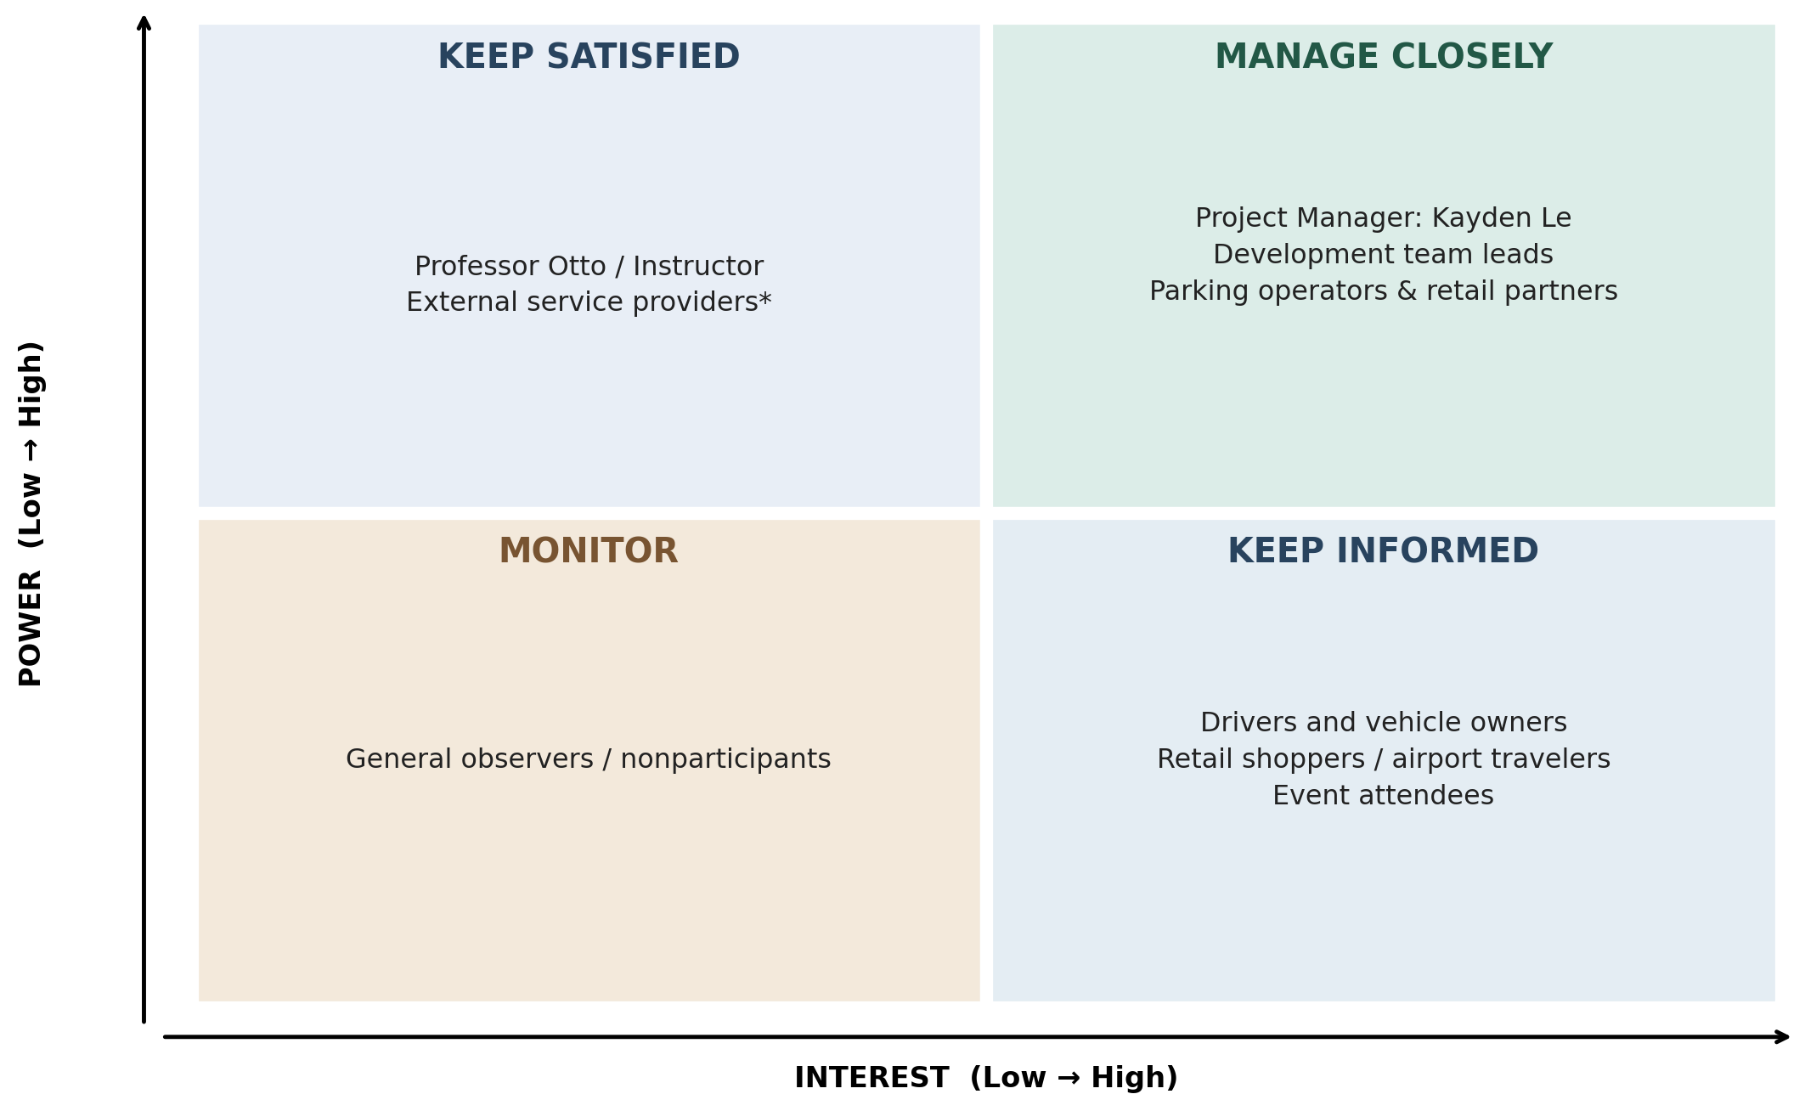
Figure 8.1. Proposed stakeholder power–interest grid for Smart Parking Platform.
Stakeholder | Power / Interest | Engagement approach
Project Manager (Kayden Le) | High / High | Manage closely. Review milestones, scope, risks, dependencies, cost and decisions weekly.
Six development teams and leads | High / High | Manage closely. Coordinate API contracts, Jira tasks, blockers, integration and acceptance evidence.
Parking facility operators and retail/destination partners | High / High | Manage closely. Validate capacity, reservation windows, pricing, promotions and partner requirements.
Professor Otto / course instructor | High / Moderate | Keep satisfied. Provide required milestone artifacts, status updates and final deliverables.
External mapping and payment service providers | High / Low to Moderate (assumed) | Keep satisfied. Monitor API access, service changes, usage, integration requirements and outages.
Drivers, retail shoppers, airport travelers and event attendees | Low / High | Keep informed. Collect feedback on search, availability, booking, payment and usability.
General observers / nonparticipating facilities | Low / Low | Monitor. Reassess involvement if they become prospective users or partners.

Note: No named investors or signed commercial sponsors appear in Version 6.0, so neither is presented as a confirmed stakeholder. The instructor and external provider categories are classified provisionally for this academic exercise.

8.2 Team Charter
Team Name: WE ARE $oftware ¢orp. | Smart Parking Platform Project Team
Charter Element | Team Agreement
Purpose / Mission | Coordinate the design, implementation planning, integration and validation of the Smart Parking Platform, making parking part of users’ destination planning.
Shared Goals | Deliver core account, search and reservations; specialized retail, airport and event parking; payment, mapping, operator tools and QA within the approved 12-week planning baseline.
Team Structure | Project Manager Kayden Le; UX/UI Designer Hy; Mobile Developer Minh Luu; Web Developer Neil L; Backend/API Developer Dinh Le; Mapping & Location Developer Tony Stack; Payment Integration Developer Tom Smith; QA/Test Engineer John Peterson. These are the planned resource roles in Section 7.1.
Roles and Accountability | Use the existing RACI matrix (Section 7.5). The PM coordinates overall schedule and scope; functional accountable owners review and approve their deliverables.
Communication | Use Jira as the system of record; short stand-ups for mobile, web and backend; three check-ins per week for mapping and payment; QA reviews twice per week, daily in Weeks 9–12; weekly 30–45 minute cross-team meeting.
Working Norms | Record updates, dependencies, decisions and defects in shared tools; raise blockers promptly; make evidence-based claims about implementation progress and test results.
Decision-Making | Seek input from affected functional owners for routine integration decisions. Escalate material scope, budget or schedule changes to the Project Manager before changing the approved baseline.
Conflict Resolution | Discuss disagreements using requirements, RACI ownership and test evidence. Aim for collaborative resolution; escalate unresolved issues or milestone threats to the Project Manager.
Risk and Issue Escalation | Escalate High or Extreme risks, and issues that threaten milestones, immediately rather than waiting for the weekly meeting (Section 6.5).
Success Measures | Documented deliverables aligned with FR1–FR35 and NFR1–NFR11, validated reservation integrity and payment handling, recorded QA evidence, and final deliverables reviewed at Week 12.

Team charter status: Proposed team working agreement for Homework 7, based on the Version 6.0 plan. This document does not assert that all team members have signed or formally approved the charter.

8.3 Project Charter
Charter Element | Project Definition
Project Name | Smart Parking Platform
Organization | WE ARE $oftware ¢orp.
Project Manager | Kayden Le (fictional planning role in Section 7.1)
Business Need | Parking is often searched for near arrival, creating uncertainty. A destination-first platform can help drivers plan parking before traveling.
Project Objective | Plan and develop a web and mobile parking platform combining search, current participating-facility availability, reservations, payment, navigation, alerts and an operator dashboard.
Primary Differentiator | Retail reservation windows and reservable zones during high-demand shopping periods, alongside airport and event parking planning.
In Scope | User/vehicle accounts; parking discovery and maps; general, retail, airport and event reservations; payments; notifications; navigation integration; promotions; operator inventory controls; reporting; integration and testing.
Out of Scope | Parking facility construction or ownership; sensor manufacturing; shuttle/valet operations; vehicle repair; citation enforcement; independent payment or navigation networks; unsupported-location booking guarantees.
Major Stakeholders | Project manager and development teams, operators, retail/destination partners, drivers and other end users, instructor and third-party service providers.
Schedule / Milestones | 12-week planning baseline: Week 1 requirements; Week 2 design; Week 6 core functions; Week 8 specialized features; Week 10 integration; Week 12 final validation.
Budget at Completion | Planned BAC: $112,090, consisting of a $101,900 subtotal and $10,190 contingency. This is an academic estimate rather than actual expenditure.
Key Risks | Stale parking inventory, mapping/API outages, payment failures, integration defects, schedule slippage, variable API fees and cross-team coordination.
Success Criteria | Demonstrate intended functional scope against FR1–FR35; assess NFR1–NFR11; test capacity and payment failures; complete integration/acceptance evidence and final project validation.
Constraints / Assumptions | Fixed semester timeline; external service dependencies; participation and accurate operator inventory; security, privacy and applicable laws; customer connectivity.
Approval / Status | Proposed academic project charter. Formal sponsor authorization is not documented in Version 6.0.

8.4 Stakeholder Communication and Governance
The Project Manager will use the weekly cross-team meeting to document verified progress, next-week commitments, blockers, altered risks, needed decisions, and accountable owners. User and operator feedback should be recorded as requirements or backlog evidence. High-impact technical failures involving payment, capacity, or mapping will be routed to responsible owners and QA, consistent with Sections 6.4–6.6. The grid will be reviewed whenever a stakeholder’s actual power or interest changes.

