Bài 1

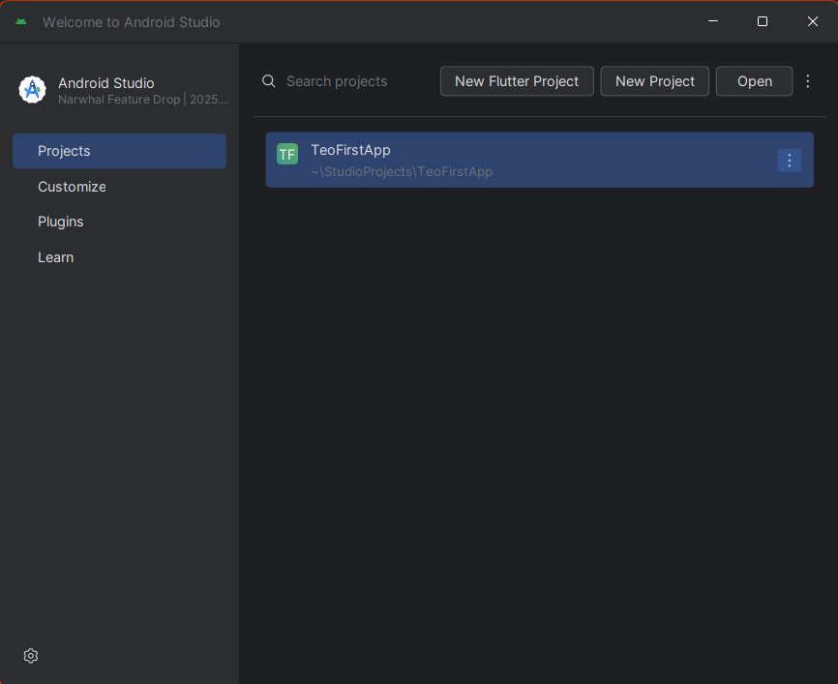

Bài 2

**MainActivity.java**

package com.example.teofirstapp;  
  
import android.os.Bundle;  
  
import androidx.activity.EdgeToEdge;  
import androidx.appcompat.app.AppCompatActivity;  
import androidx.core.graphics.Insets;  
import androidx.core.view.ViewCompat;  
import androidx.core.view.WindowInsetsCompat;  
  
public class MainActivity extends AppCompatActivity {  
  
 @Override  
 protected void onCreate(Bundle savedInstanceState) {  
 super.onCreate(savedInstanceState);  
 EdgeToEdge.*enable*(this);  
 setContentView(R.layout.*activity_main*);  
 ViewCompat.*setOnApplyWindowInsetsListener*(findViewById(R.id.*main*), (v, insets) -> {  
 Insets systemBars = insets.getInsets(WindowInsetsCompat.Type.*systemBars*());  
 v.setPadding(systemBars.left, systemBars.top, systemBars.right, systemBars.bottom);  
 return insets;  
 });  
 }  
}

**AndroidManifest.xml**

<?xml version="1.0" encoding="utf-8"?>  
<manifest xmlns:android="http://schemas.android.com/apk/res/android"  
 xmlns:tools="http://schemas.android.com/tools">  
  
 <application  
 android:allowBackup="true"  
 android:dataExtractionRules="@xml/data_extraction_rules"  
 android:fullBackupContent="@xml/backup_rules"  
 android:icon="@mipmap/ic_launcher"  
 android:label="@string/app_name"  
 android:roundIcon="@mipmap/ic_launcher_round"  
 android:supportsRtl="true"  
 android:theme="@style/Theme.TeoFirstApp">  
 <activity  
 android:name=".MainActivity"  
 android:exported="true">  
 <intent-filter>  
 <action android:name="android.intent.action.MAIN" />  
  
 <category android:name="android.intent.category.LAUNCHER" />  
 </intent-filter>  
 </activity>  
 </application>  
  
</manifest>

**activity_main.xml**

<?xml version="1.0" encoding="utf-8"?>  
<androidx.constraintlayout.widget.ConstraintLayout xmlns:android="http://schemas.android.com/apk/res/android"  
 xmlns:app="http://schemas.android.com/apk/res-auto"  
 xmlns:tools="http://schemas.android.com/tools"  
 android:id="@+id/main"  
 android:layout_width="match_parent"  
 android:layout_height="match_parent"  
 tools:context=".MainActivity">  
  
 <TextView  
 android:layout_width="wrap_content"  
 android:layout_height="wrap_content"  
 android:text="chao bac Teo!"  
 app:layout_constraintBottom_toBottomOf="parent"  
 app:layout_constraintEnd_toEndOf="parent"  
 app:layout_constraintStart_toStartOf="parent"  
 app:layout_constraintTop_toTopOf="parent" />  
  
</androidx.constraintlayout.widget.ConstraintLayout>

Kết quả:

