Lab 10 - 11. Ứng dụng truyện cười

PHẦN 1 – XÂY DỰNG MÀN HÌNH SPLASH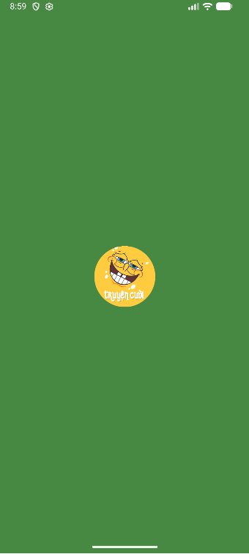
Bước 1: Xây dựng giao diện màn hình m000_frg_splash được quản lý bởi M000SplashFrg
m000_frg_splash:
<?xml version="1.0" encoding="utf-8"?>
<FrameLayout xmlns:android="http://schemas.android.com/apk/res/android"
xmlns:tools="http://schemas.android.com/tools"
android:layout_width="match_parent"
android:layout_height="match_parent"
android:background="@color/greenMid">
<ImageView
android:layout_width="200dp"
android:layout_height="100dp"
android:layout_gravity="center"
android:src="@drawable/ic_splash"
tools:ignore="ContentDescription" />
</FrameLayout>

M000SplashFrg:
package com.techja.truyencuoi;
import android.os.Bundle;
import android.os.Handler;
import android.view.LayoutInflater;
import android.view.View;
import android.view.ViewGroup;
import androidx.fragment.app.Fragment;
public class M000SplashFrg extends Fragment {
@Override
public View onCreateView(LayoutInflater inflater, ViewGroup container, Bundle savedInstanceState) {
initViews();
return inflater.inflate(R.layout.m000_frg_splash, container, false);
}
private void initViews() {
new Handler().postDelayed(this::gotoM001Screen, 2000);
}
private void gotoM001Screen() {
((MainActivity) getActivity()).gotoM001Screen();
}
}

Bước 2: Xây dfing đối tượng StoryEntity để định nghĩa 1 truyện cười
package com.funix.truyencuoi;
public class StoryEntity {
private final String topicName;
private final String name;
private final String content;
public StoryEntity(String topicName, String name, String content) {
this.topicName = topicName;
this.name = name;
this.content = content;
}
public String getTopicName() {
return topicName;
}
public String getName() {
return name;
}
public String getContent() {
return content;
}
}
Bước 3: Xây dựng giao diện màn hình activity_main được quản lý bởi MainActivity
activity_main
<?xml version="1.0" encoding="utf-8"?>
<LinearLayout xmlns:android="http://schemas.android.com/apk/res/android"
xmlns:tools="http://schemas.android.com/tools"
android:id="@+id/ln_main"
android:orientation="horizontal"
android:layout_width="match_parent"
android:layout_height="match_parent"
tools:context=".MainActivity">
</LinearLayout>

MainActivity:
package com.techja.truyencuoi;
import android.os.Bundle;
import androidx.appcompat.app.AppCompatActivity;
import androidx.fragment.app.Fragment;
import com.example.lab10_11_test.M002StoryFrg;
import com.funix.truyencuoi.StoryEntity;
import java.util.ArrayList;
import java.util.List;
public class MainActivity extends AppCompatActivity {
private String topicName;
@Override
protected void onCreate(Bundle savedInstanceState) {
super.onCreate(savedInstanceState);
setContentView(R.layout.activity_main);
showFrg(new M000SplashFrg());
}
private void showFrg(Fragment frg) {
getSupportFragmentManager().beginTransaction()
.replace(R.id.ln_main, frg, null)
.commit();
}
public void gotoM001Screen() {
getSupportFragmentManager().beginTransaction()
.replace(R.id.ln_main, new M001TopicFrg(), null)
.commit();
}
public void gotoM002Screen(String topicName) {
this.topicName = topicName;
M002StoryFrg frg = new M002StoryFrg();
frg.setTopicName(topicName);
showFrg(frg);
}
public void backToM001Screen() {
gotoM001Screen();
}
public void gotoM003Screen(ArrayList<StoryEntity> listStory, StoryEntity story) {
M003DetailStoryFrg frg = new M003DetailStoryFrg();
frg.setData(topicName, listStory, story);
showFrg(frg);
}
}

PHẦN 2 – DANH SÁCH CHỦ ĐỀ TRUYỆN

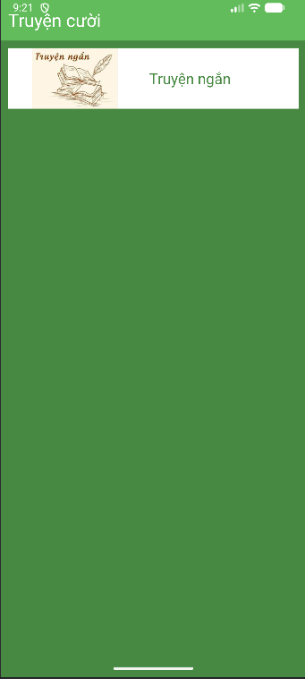
Bước 1: Tạo file res/layout/item_topic.xml có nội dung sau:
<?xml version="1.0" encoding="utf-8"?>
<LinearLayout xmlns:android="http://schemas.android.com/apk/res/android"
xmlns:tools="http://schemas.android.com/tools"
android:layout_width="match_parent"
android:layout_height="wrap_content"
android:background="@color/white"
android:layout_marginBottom="10dp"
tools:ignore="UseCompoundDrawables">
<ImageView
android:id="@+id/iv_topic"
android:layout_width="180dp"
android:layout_height="82dp"
android:src="@drawable/ic_congai"
tools:ignore="ContentDescription"/>
<TextView
android:id="@+id/tv_topic"
android:layout_width="match_parent"
android:layout_height="match_parent"
android:layout_marginStart="10dp"
android:fontFamily="sans-serif"
android:gravity="center_vertical"
android:text="@string/txt_congai"
android:textColor="@color/greenMid"
android:textSize="20sp" />
</LinearLayout>
Bước 2: Tạo file res/layout/m001_frg_topic.xml có nội dung sau:
<?xml version="1.0" encoding="utf-8"?>
<LinearLayout xmlns:android="http://schemas.android.com/apk/res/android"
android:layout_width="match_parent"
android:layout_height="match_parent"
android:background="@color/greenMid"
android:orientation="vertical">
<include layout="@layout/actionbar_home" />
<ScrollView
android:layout_width="match_parent"
android:layout_height="match_parent">
<LinearLayout
android:id="@+id/ln_topic"
android:layout_width="match_parent"
android:layout_height="wrap_content"
android:orientation="vertical"
android:padding="10dp" />
</ScrollView>
</LinearLayout>
Bước 3: Tạo file res/layout/actionbar_home.xml có nội dung sau:
<?xml version="1.0" encoding="utf-8"?>
<LinearLayout
xmlns:android="http://schemas.android.com/apk/res/android"
xmlns:app="http://schemas.android.com/apk/res-auto"
android:layout_width="match_parent"
android:layout_height="56dp"
android:background="@color/greenLight"
android:orientation="horizontal">
<ImageView
android:id="@+id/iv_back"
android:layout_width="56dp"
android:layout_height="56dp"
android:layout_marginStart="10dp"
android:padding="10dp"
android:src="@drawable/ic_back"
android:visibility="gone"
app:tint="@color/white"
android:layout_marginLeft="10dp" />
<TextView
android:id="@+id/tv_name"
android:layout_width="match_parent"
android:layout_height="match_parent"
android:layout_marginStart="10dp"
android:gravity="center_vertical"
android:text="Truyện cười "
android:textColor="@color/white"
android:textSize="24sp"
android:layout_marginLeft="10dp" />
</LinearLayout>
Bước 4: Xây dựng M001TopicFrg quản lý m001_frg_topic
package com.techja.truyencuoi;
import android.content.Context;
import android.graphics.BitmapFactory;
import android.os.Bundle;
import android.view.LayoutInflater;
import android.view.View;
import android.view.ViewGroup;
import android.widget.ImageView;
import android.widget.LinearLayout;
import android.widget.TextView;
import androidx.fragment.app.Fragment;
public class M001TopicFrg extends Fragment implements View.OnClickListener {
private Context mContext;
@Override
public View onCreateView(LayoutInflater inflater, ViewGroup container, Bundle savedInstanceState) {
View rootView = inflater.inflate(R.layout.m001_frg_topic, container, false);
initViews(rootView);
return rootView;
}
@Override
public void onAttach(Context context) {
super.onAttach(context);
mContext = context;
}
private void initViews(View v) {
LinearLayout lnMain = v.findViewById(R.id.ln_topic);
lnMain.removeAllViews();
try {
String[] listItem = mContext.getAssets().list("photo");
for (String fileName : listItem) {
String name = fileName.substring(0, fileName.indexOf("."));
View vTopic = LayoutInflater.from(mContext).inflate(R.layout.item_topic, null);
ImageView ivTopic = vTopic.findViewById(R.id.iv_topic);
TextView tvTopic = vTopic.findViewById(R.id.tv_topic);
ivTopic.setImageBitmap(
BitmapFactory.decodeStream(mContext.getAssets().open("photo/" + fileName))
);
tvTopic.setText(name);
lnMain.addView(vTopic);
LinearLayout.LayoutParams params =
(LinearLayout.LayoutParams) vTopic.getLayoutParams();
params.bottomMargin = 40;
vTopic.setLayoutParams(params);
vTopic.setTag(name);
vTopic.setOnClickListener(this);
}
} catch (Exception e) {
e.printStackTrace();
}
}
@Override
public void onClick(View v) {
((MainActivity) getActivity()).gotoM002Screen((String) v.getTag());
}
}
PHẦN 3 – DANH SÁCH TRUYỆN & MÀN CHI TIẾT
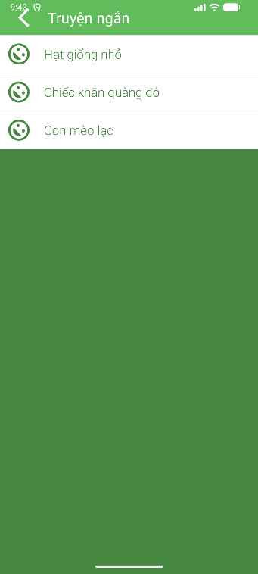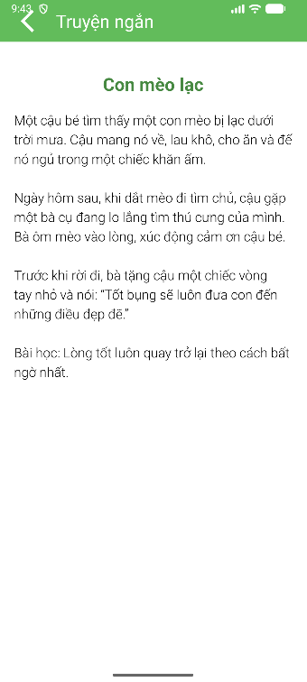

Bước 1: Tạo file res/layout/item_story.xml có nội dung sau:
<?xml version="1.0" encoding="utf-8"?>
<LinearLayout xmlns:android="http://schemas.android.com/apk/res/android"
xmlns:app="http://schemas.android.com/apk/res-auto"
xmlns:tools="http://schemas.android.com/tools"
android:layout_width="match_parent"
android:layout_height="wrap_content"
android:background="@color/white"
android:orientation="vertical"
tools:ignore="UseCompoundDrawables">
<TableRow
android:layout_width="match_parent"
android:layout_height="wrap_content">
<ImageView
android:layout_width="60dp"
android:layout_height="60dp"
android:padding="10dp"
android:rotation="45"
android:src="@drawable/ic_face"
app:tint="@color/greenMid"
tools:ignore="ContentDescription"/>
<TextView
android:id="@+id/tv_story"
android:layout_width="match_parent"
android:layout_height="match_parent"
android:layout_marginStart="10dp"
android:fontFamily="sans-serif-light"
android:gravity="center_vertical"
android:text="@string/txt_story"
android:textColor="@color/greenMid"
android:textSize="20sp" />
</TableRow>
<View
android:layout_width="match_parent"
android:layout_height="0.5dp"
android:background="#e5e5e5" />
</LinearLayout>
Bước 2: Tạo file res/layout/m002_frg_story.xml có nội dung sau:
<?xml version="1.0" encoding="utf-8"?>
<LinearLayout xmlns:android="http://schemas.android.com/apk/res/android"
xmlns:app="http://schemas.android.com/apk/res-auto"
xmlns:tools="http://schemas.android.com/tools"
android:layout_width="match_parent"
android:layout_height="wrap_content"
android:background="@color/white"
android:orientation="vertical"
tools:ignore="UseCompoundDrawables">
<TableRow
android:layout_width="match_parent"
android:layout_height="wrap_content">
<ImageView
android:layout_width="60dp"
android:layout_height="60dp"
android:padding="10dp"
android:rotation="45"
android:src="@drawable/ic_face"
app:tint="@color/greenMid"
tools:ignore="ContentDescription"/>
<TextView
android:id="@+id/tv_story"
android:layout_width="match_parent"
android:layout_height="match_parent"
android:layout_marginStart="10dp"
android:fontFamily="sans-serif-light"
android:gravity="center_vertical"
android:text="@string/txt_story"
android:textColor="@color/greenMid"
android:textSize="20sp" />
</TableRow>
<View
android:layout_width="match_parent"
android:layout_height="0.5dp"
android:background="#e5e5e5" />
</LinearLayout>
Bước 3: Tạo file res/layout/item_detail_story.xml có nội dung sau:
<?xml version="1.0" encoding="utf-8"?>
<LinearLayout xmlns:android="http://schemas.android.com/apk/res/android"
android:layout_width="match_parent"
android:layout_height="match_parent"
android:orientation="vertical"
android:padding="10dp">
<TextView
android:id="@+id/tv_name"
android:layout_width="match_parent"
android:layout_height="wrap_content"
android:layout_marginTop="20dp"
android:gravity="center"
android:padding="10dp"
android:text="Vừa ǎn vừa nói"
android:textColor="@color/greenMid"
android:textSize="24sp"
android:textStyle="bold" />
<ScrollView
android:layout_width="match_parent"
android:layout_height="match_parent">
<LinearLayout
android:layout_width="match_parent"
android:layout_height="wrap_content"
android:orientation="vertical">
<TextView
android:id="@+id/tv_content"
android:layout_width="match_parent"
android:layout_height="wrap_content"
android:fontFamily="sans-serif-light"
android:gravity="center_vertical"
android:lineSpacingExtra="5dp"
android:padding="10dp"
android:text="Nội dung truyện"
android:textColor="@color/black"
android:textSize="18sp" />
</LinearLayout>
</ScrollView>
</LinearLayout>

Bước 4: Tạo file res/layout/m003_frg_detail_story.xml có nội dung sau:
<?xml version="1.0" encoding="utf-8"?>
<LinearLayout xmlns:android="http://schemas.android.com/apk/res/android"
android:layout_width="match_parent"
android:layout_height="match_parent"
android:background="@color/white"
android:orientation="vertical">
<include layout="@layout/actionbar_home" />
<androidx.viewpager.widget.ViewPager
android:id="@+id/vp_story"
android:layout_width="match_parent"
android:layout_height="match_parent"/>
</LinearLayout>

Bước 5: Xây dựng đối tượng StoryAdapter để định nghĩa 1 item truyện cười trong danh sách truyện
package com.techja.truyencuoi;
import android.content.Context;
import android.view.LayoutInflater;
import android.view.View;
import android.view.ViewGroup;
import android.widget.TextView;
import androidx.recyclerview.widget.RecyclerView;
import com.funix.truyencuoi.StoryEntity;
import java.util.ArrayList;
import java.util.List;
public class StoryAdapter extends RecyclerView.Adapter<StoryAdapter.StoryHolder> {
private final ArrayList<StoryEntity> listStory;
private final Context mContext;
public StoryAdapter(ArrayList<StoryEntity> listStory, Context mContext) {
this.listStory = listStory;
this.mContext = mContext;
}
@Override
public StoryHolder onCreateViewHolder(ViewGroup parent, int viewType) {
View view = LayoutInflater.from(mContext).inflate(R.layout.item_story, parent, false);
return new StoryHolder(view);
}
@Override
public void onBindViewHolder(StoryAdapter.StoryHolder holder, int position) {
StoryEntity item = listStory.get(position);
holder.tvName.setTag(item);
holder.tvName.setText(item.getName());
}
@Override
public int getItemCount() {
return listStory.size();
}
public class StoryHolder extends RecyclerView.ViewHolder {
TextView tvName;
public StoryHolder(View itemView) {
super(itemView);
tvName = itemView.findViewById(R.id.tv_story);
itemView.setOnClickListener(v -> {
((MainActivity)mContext).gotoM003Screen(listStory, (StoryEntity)tvName.getTag());
});
}
}
}

Bước 6: Xây dựng đối tượng DetailStoryAdapter để quản lý danh sách các truyện cười
package com.techja.truyencuoi;
import android.content.Context;
import android.view.LayoutInflater;
import android.view.View;
import android.view.ViewGroup;
import android.widget.TextView;
import androidx.annotation.NonNull;
import androidx.viewpager.widget.PagerAdapter;
import com.funix.truyencuoi.StoryEntity;
import java.util.List;
public class DetailStoryAdapter extends PagerAdapter {
private final List<StoryEntity> listStory;
private final Context mContext;
public DetailStoryAdapter(List<StoryEntity> listStory, Context mContext) {
this.listStory = listStory;
this.mContext = mContext;
}
@Override
public Object instantiateItem(ViewGroup container, int position) {
View view = LayoutInflater.from(mContext).inflate(R.layout.item_detail_story, container,
false);
StoryEntity item = listStory.get(position);
TextView tvName = view.findViewById(R.id.tv_name);
TextView tvContent = view.findViewById(R.id.tv_content);
tvName.setTag(item);
tvName.setText(item.getName());
tvContent.setText(item.getContent());
container.addView(view);
return view;
}
@Override
public int getCount() {
return listStory.size();
}
@Override
public boolean isViewFromObject(View view, Object object) {
return view.equals(object);
}
@Override
public void destroyItem(ViewGroup container, int position, Object object) {
container.removeView((View) object);
}
}

Bước 7: Xây dựng đối tượng M002StoryFrg để quản lý danh sách các danh mục truyện cười
package com.example.lab10_11_test;
import android.content.Context;
import android.os.Bundle;
import android.view.LayoutInflater;
import android.view.View;
import android.view.ViewGroup;
import android.widget.TextView;
import androidx.fragment.app.Fragment;
import androidx.recyclerview.widget.LinearLayoutManager;
import androidx.recyclerview.widget.RecyclerView;
import com.funix.truyencuoi.StoryEntity;
import com.techja.truyencuoi.MainActivity;
import com.techja.truyencuoi.R;
import com.techja.truyencuoi.StoryAdapter;
import java.io.BufferedReader;
import java.io.IOException;
import java.io.InputStreamReader;
import java.util.ArrayList;
public class M002StoryFrg extends Fragment {
private Context mContext;
private ArrayList<StoryEntity> listStory;
private String topicName;
private StoryEntity currentStory;
@Override
public View onCreateView(LayoutInflater inflater, ViewGroup container, Bundle savedInstanceState) {
View rootView = inflater.inflate(R.layout.m002_frg_story, container, false);
initViews(rootView);
return rootView;
}
@Override
public void onAttach(Context context) {
super.onAttach(context);
mContext = context;
}
private void initViews(View v) {
v.findViewById(R.id.iv_back).setVisibility(View.VISIBLE);
v.findViewById(R.id.iv_back).setOnClickListener(v1 -> backToM001Screen());
((TextView) v.findViewById(R.id.tv_name)).setText(topicName);
RecyclerView rv = v.findViewById(R.id.rv_story);
ArrayList<StoryEntity> listStory = readStory();
StoryAdapter adapter = new StoryAdapter(listStory, mContext);
rv.setAdapter(adapter);
rv.setLayoutManager(new LinearLayoutManager(mContext));
}
private ArrayList<StoryEntity> readStory() {
ArrayList<StoryEntity> listStory = new ArrayList<>();
BufferedReader reader;
String mLine = "";
try {
reader = new BufferedReader(
new InputStreamReader(
mContext.getAssets().open("story/" + topicName + ".txt"), "UTF-8"
)
);
do {
String title = reader.readLine();
if (title == null) break;
String content = "";
do {
mLine = reader.readLine();
content += mLine + "\n";
} while (!mLine.contains("','0');"));
content = content.replace("','0');", "");
StoryEntity storyEntity = new StoryEntity(topicName, title, content);
listStory.add(storyEntity);
} while (mLine != null);
} catch (IOException e) {
}
return listStory;
}
public void setTopicName(String topicName) {
this.topicName = topicName;
}
private void backToM001Screen() {
((MainActivity) getActivity()).backToM001Screen();
}
}
Bước 8: Xây dựng đối tượng M003DetailStoryFrg để quản lý các truyện cười
package com.techja.truyencuoi;
import android.content.Context;
import android.os.Bundle;
import android.view.LayoutInflater;
import android.view.View;
import android.view.ViewGroup;
import android.widget.TextView;
import androidx.fragment.app.Fragment;
import androidx.viewpager.widget.ViewPager;
import com.funix.truyencuoi.StoryEntity;
import java.util.ArrayList;
public class M003DetailStoryFrg extends Fragment {
private Context mContext;
private ArrayList<StoryEntity> listStory;
private String topicName;
private StoryEntity currentStory;
@Override
public View onCreateView(LayoutInflater inflater, ViewGroup container, Bundle savedInstanceState) {
View rootView = inflater.inflate(R.layout.m003_frg_detail_story, container, false);
initViews(rootView);
return rootView;
}
@Override
public void onAttach(Context context) {
super.onAttach(context);
mContext = context;
}
private void initViews(View v) {
v.findViewById(R.id.iv_back).setVisibility(View.VISIBLE);
v.findViewById(R.id.iv_back).setOnClickListener(v1 -> backToM002Screen());
((TextView) v.findViewById(R.id.tv_name)).setText(topicName);
ViewPager vp = v.findViewById(R.id.vp_story);
DetailStoryAdapter adapter = new DetailStoryAdapter(listStory, mContext);
vp.setAdapter(adapter);
vp.setCurrentItem(listStory.indexOf(currentStory), true);
}
private void backToM002Screen() {
((MainActivity) getActivity()).gotoM002Screen(topicName);
}
public void setData(String topicName, ArrayList<StoryEntity> listStory, StoryEntity currentStory) {
this.currentStory = currentStory;
this.topicName = topicName;
this.listStory = listStory;
}
}

