Bài tập 1: Trong bài luyện tập 1, viết code để mỗi khi chạy lên sẽ ra một màu nền khác nhau
và 1 icon khác nhau.
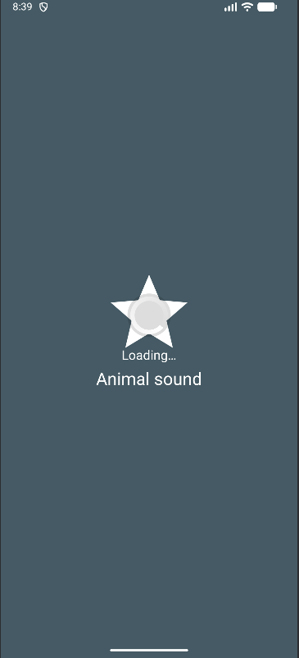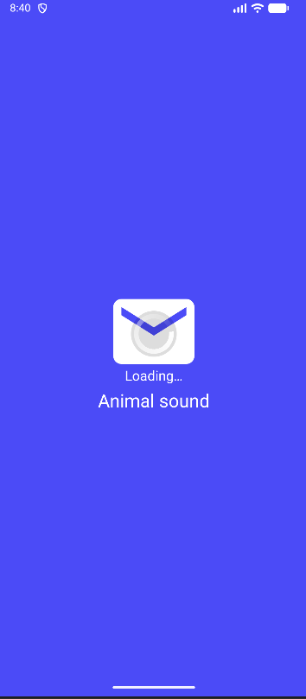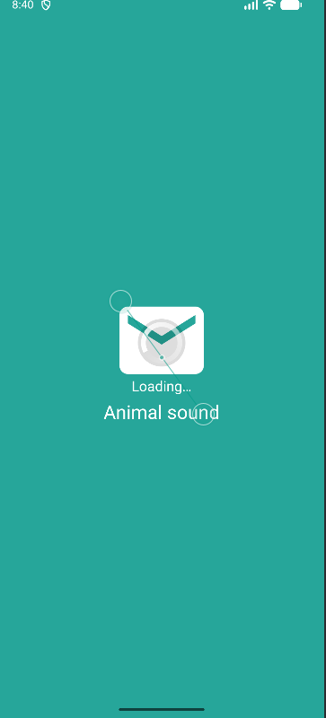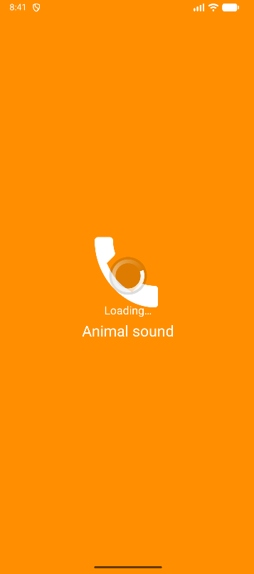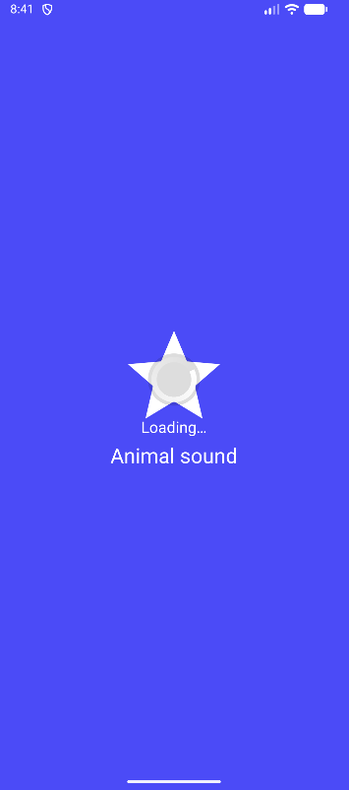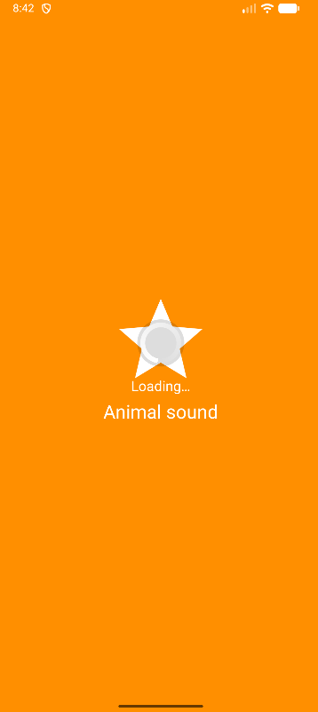
M000ActSplash.java:
package com.example.animalsound;
import android.os.Bundle;
import android.widget.ImageView;
import android.widget.LinearLayout;
import androidx.appcompat.app.AppCompatActivity;
import androidx.core.content.ContextCompat;
import java.util.Random;
public class M000ActSplash extends AppCompatActivity {
private final int[] colors = {
R.color.indigo,
R.color.green_600,
R.color.amber_600,
R.color.pink_500,
R.color.blue_grey
};
private final int[] icons = {
R.drawable.ic_penguin,
R.drawable.ic_star,
R.drawable.ic_phone,
R.drawable.ic_email
};
@Override
protected void onCreate(Bundle savedInstanceState) {
super.onCreate(savedInstanceState);
setContentView(R.layout.m000_act_splash);
LinearLayout root = findViewById(R.id.rootSplash);
ImageView img = findViewById(R.id.imgSplash);
Random random = new Random();
int colorId = colors[random.nextInt(colors.length)];
int iconId = icons[random.nextInt(icons.length)];
root.setBackgroundColor(ContextCompat.getColor(this, colorId));
img.setImageResource(iconId);
}
}
m000_act_splash.xml:
<?xml version="1.0" encoding="utf-8"?>
<FrameLayout xmlns:android="http://schemas.android.com/apk/res/android"
android:layout_width="match_parent"
android:layout_height="match_parent"
android:background="@color/purple_700">
<LinearLayout
android:id="@+id/rootSplash"
android:layout_width="match_parent"
android:layout_height="match_parent"
android:gravity="center"
android:orientation="vertical"
android:padding="24dp">
<ImageView
android:id="@+id/imgSplash"
android:layout_width="128dp"
android:layout_height="128dp" />
<TextView
android:layout_width="wrap_content"
android:layout_height="wrap_content"
android:layout_marginTop="10dp"
android:text="@string/txt_splash_title"
android:textColor="@color/white"
android:textSize="24sp" />
</LinearLayout>
<!-- include layout loading -->
<include layout="@layout/item_loading" />
</FrameLayout>

Bài tập 2: Trong bài luyện tập 2, sử dụng Custom ProgressBar để làm giao diện đẹp hơn.

M001ActLoading.java:
package com.example.animalsound;
import android.os.Bundle;
import androidx.appcompat.app.AppCompatActivity;
public class M001ActLoading extends AppCompatActivity {
@Override
protected void onCreate(Bundle savedInstanceState) {
super.onCreate(savedInstanceState);
setContentView(R.layout.item_loading);
}
}

item_loading.xml:
<LinearLayout xmlns:android="http://schemas.android.com/apk/res/android"
android:layout_width="match_parent"
android:layout_height="match_parent"
android:gravity="center"
android:orientation="vertical">
<ProgressBar
android:layout_width="60dp"
android:layout_height="60dp"
android:indeterminate="true"
android:indeterminateDrawable="@drawable/progress_circular" />
<TextView
android:layout_width="wrap_content"
android:layout_height="wrap_content"
android:layout_marginTop="12dp"
android:text="@string/txt_loading"
android:textColor="@color/white"
android:textSize="18sp"/>
</LinearLayout>

Bài tập 3: Lập trình để khi bấm vào icon thì chuyển về cuộc gọi, sử dụng Intent.
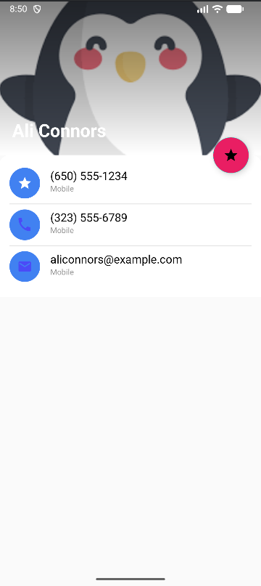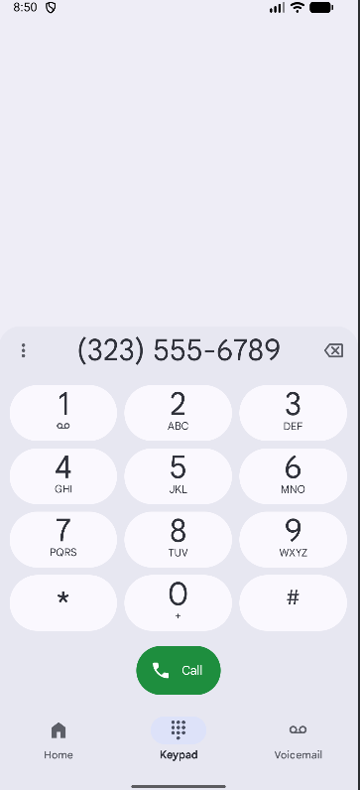
M001ActProfile.java:
// M001ActProfile.java
package com.example.animalsound;
import android.content.Intent;
import android.net.Uri;
import android.os.Bundle;
import android.widget.ImageView;
import android.widget.TextView;
import androidx.appcompat.app.AppCompatActivity;
public class M001ActProfile extends AppCompatActivity {
@Override
protected void onCreate(Bundle savedInstanceState) {
super.onCreate(savedInstanceState);
// PHẢI là layout m001_act_profile
setContentView(R.layout.m001_act_profile);
ImageView ivCall = findViewById(R.id.ivCall);
TextView tvPhone2 = findViewById(R.id.tvPhone2);
ivCall.setOnClickListener(v -> {
String phone = tvPhone2.getText().toString();
Intent intent = new Intent(Intent.ACTION_DIAL, Uri.parse("tel:" + phone));
startActivity(intent);
});
}
}

m001_act_profile.xml:
<?xml version="1.0" encoding="utf-8"?>
<FrameLayout xmlns:android="http://schemas.android.com/apk/res/android"
android:layout_width="match_parent"
android:layout_height="match_parent"
android:background="@color/gray_light">
<!-- Cột chính -->
<LinearLayout
android:layout_width="match_parent"
android:layout_height="match_parent"
android:orientation="vertical">
<!-- Header ảnh -->
<FrameLayout
android:id="@+id/header"
android:layout_width="match_parent"
android:layout_height="240dp">
<ImageView
android:layout_width="match_parent"
android:layout_height="match_parent"
android:scaleType="centerCrop"
android:src="@drawable/bg_avatar" />
<!-- scrim để chữ sáng rõ -->
<View
android:layout_width="match_parent"
android:layout_height="match_parent"
android:background="@drawable/bg_header_scrim" />
<TextView
android:id="@+id/tvName"
android:layout_width="wrap_content"
android:layout_height="wrap_content"
android:layout_gravity="bottom|start"
android:layout_margin="20dp"
android:text="@string/txt_name"
android:textColor="@color/white"
android:textSize="28sp"
android:textStyle="bold"/>
</FrameLayout>
<!-- Panel trắng bo góc giống card -->
<LinearLayout
android:id="@+id/panel"
android:layout_width="match_parent"
android:layout_height="wrap_content"
android:background="@drawable/bg_panel_top_round"
android:orientation="vertical">
<!-- Hàng 1: sao + số 1 -->
<LinearLayout
android:layout_width="match_parent"
android:layout_height="wrap_content"
android:orientation="horizontal"
android:paddingTop="8dp"
android:paddingBottom="8dp">
<ImageView
android:layout_width="48dp"
android:layout_height="48dp"
android:background="@drawable/bg_oval"
android:padding="12dp"
android:src="@drawable/ic_star"
android:tint="@color/white" />
<LinearLayout
android:layout_width="0dp"
android:layout_height="wrap_content"
android:layout_marginStart="16dp"
android:layout_weight="1"
android:orientation="vertical">
<TextView
android:layout_width="match_parent"
android:layout_height="wrap_content"
android:text="@string/txt_phone1"
android:textColor="@color/black"
android:textSize="18sp" />
<TextView
android:layout_width="match_parent"
android:layout_height="wrap_content"
android:text="@string/txt_title_mobile"
android:textColor="@color/gray_mid"
android:textSize="12sp" />
</LinearLayout>
</LinearLayout>
<!-- Divider -->
<View
android:layout_width="match_parent"
android:layout_height="1dp"
android:background="#E0E0E0" />
<!-- Hàng 2: phone + số 2 (có thể bấm gọi) -->
<LinearLayout
android:layout_width="match_parent"
android:layout_height="wrap_content"
android:orientation="horizontal"
android:paddingTop="8dp"
android:paddingBottom="8dp">
<ImageView
android:id="@+id/ivCall"
android:layout_width="48dp"
android:layout_height="48dp"
android:background="@drawable/bg_oval"
android:padding="12dp"
android:src="@drawable/ic_phone"
android:tint="@color/indigo" />
<LinearLayout
android:layout_width="0dp"
android:layout_height="wrap_content"
android:layout_marginStart="16dp"
android:layout_weight="1"
android:orientation="vertical">
<TextView
android:id="@+id/tvPhone2"
android:layout_width="match_parent"
android:layout_height="wrap_content"
android:text="@string/txt_phone2"
android:textColor="@color/black"
android:textSize="18sp" />
<TextView
android:layout_width="match_parent"
android:layout_height="wrap_content"
android:text="@string/txt_title_mobile"
android:textColor="@color/gray_mid"
android:textSize="12sp" />
</LinearLayout>
</LinearLayout>
<!-- Divider -->
<View
android:layout_width="match_parent"
android:layout_height="1dp"
android:background="#E0E0E0" />
<!-- Hàng 3: email -->
<LinearLayout
android:layout_width="match_parent"
android:layout_height="wrap_content"
android:orientation="horizontal"
android:paddingTop="8dp"
android:paddingBottom="8dp">
<ImageView
android:layout_width="48dp"
android:layout_height="48dp"
android:background="@drawable/bg_oval"
android:padding="12dp"
android:src="@drawable/ic_email"
android:tint="@color/indigo" />
<LinearLayout
android:layout_width="0dp"
android:layout_height="wrap_content"
android:layout_marginStart="16dp"
android:layout_weight="1"
android:orientation="vertical">
<TextView
android:layout_width="match_parent"
android:layout_height="wrap_content"
android:text="@string/txt_email"
android:textColor="@color/black"
android:textSize="18sp" />
<TextView
android:layout_width="match_parent"
android:layout_height="wrap_content"
android:text="@string/txt_title_mobile"
android:textColor="@color/gray_mid"
android:textSize="12sp" />
</LinearLayout>
</LinearLayout>
</LinearLayout>
<!-- đệm dưới cho an toàn -->
<View
android:layout_width="match_parent"
android:layout_height="24dp"/>
</LinearLayout>
<!-- Nút tròn hồng (FAB) chồng lên mép ảnh/panel) -->
<com.google.android.material.floatingactionbutton.FloatingActionButton
android:id="@+id/fabFav"
android:layout_width="wrap_content"
android:layout_height="wrap_content"
android:layout_gravity="end|top"
android:layout_marginEnd="20dp"
android:layout_marginTop="212dp"
android:src="@drawable/ic_star"
android:tint="@color/white"
android:contentDescription="@null"
android:clickable="false"
android:focusable="false"
android:backgroundTint="@color/pink_500" />
</FrameLayout>

Bài tập 4: Tạo màn hình chính MainActivity để chuyển qua và chuyển về giữa các màn hình
ở các phần luyện tập.
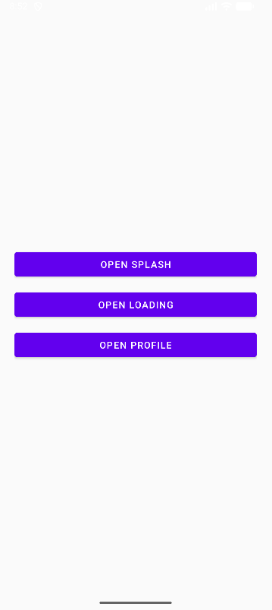
MainActivity.java:
package com.example.animalsound;
import android.content.Intent;
import android.os.Bundle;
import android.widget.Button;
import androidx.appcompat.app.AppCompatActivity;
public class MainActivity extends AppCompatActivity {
@Override
protected void onCreate(Bundle savedInstanceState) {
super.onCreate(savedInstanceState);
setContentView(R.layout.activity_main);
Button btnSplash = findViewById(R.id.btnSplash);
Button btnLoading = findViewById(R.id.btnLoading);
Button btnProfile = findViewById(R.id.btnProfile);
btnSplash.setOnClickListener(v -> startActivity(new Intent(this, M000ActSplash.class)));
btnLoading.setOnClickListener(v -> startActivity(new Intent(this, M001ActLoading.class)));
btnProfile.setOnClickListener(v -> startActivity(new Intent(this, M001ActProfile.class)));
}
}

activity_main.xml:
<?xml version="1.0" encoding="utf-8"?>
<LinearLayout xmlns:android="http://schemas.android.com/apk/res/android"
android:layout_width="match_parent"
android:layout_height="match_parent"
android:orientation="vertical"
android:gravity="center"
android:background="@color/gray_light"
android:padding="24dp">
<Button
android:id="@+id/btnSplash"
android:layout_width="match_parent"
android:layout_height="wrap_content"
android:text="@string/open_splash"/>
<View android:layout_width="match_parent" android:layout_height="12dp"/>
<Button
android:id="@+id/btnLoading"
android:layout_width="match_parent"
android:layout_height="wrap_content"
android:text="@string/open_loading"/>
<View android:layout_width="match_parent" android:layout_height="12dp"/>
<Button
android:id="@+id/btnProfile"
android:layout_width="match_parent"
android:layout_height="wrap_content"
android:text="@string/open_profile"/>
</LinearLayout>

