Lab 1. Cơ bản với Android Studio (4 tiết)
Bài tập 1: Hoàn thiện các chức năng của một máy tính, có các phép +, -, *, /, %
Phép + (cộng)
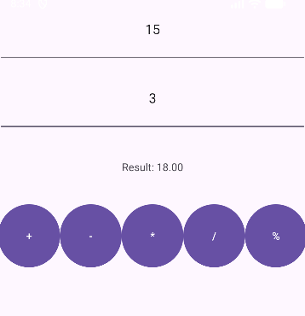

Phép – (trừ)
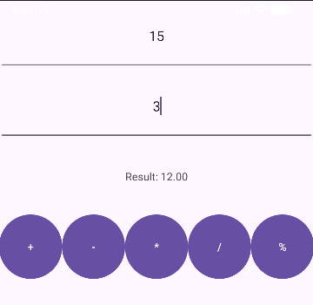

Phép * (nhân)
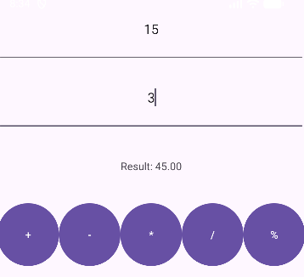

Phép / (chia)
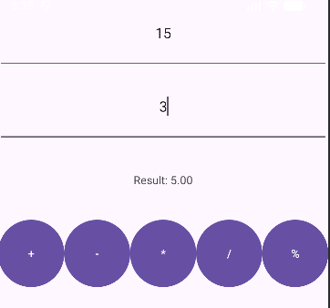

Phép % (lấy phần dư)
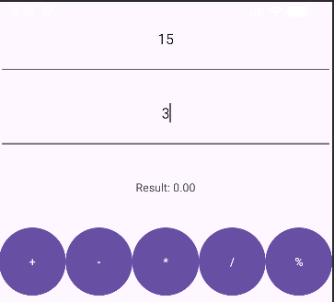

MainActivity.java:
package com.example.firstprogram;
import android.os.Bundle;
import android.view.View;
import android.widget.Button;
import android.widget.EditText;
import android.widget.TextView;
import android.widget.Toast;
import androidx.activity.EdgeToEdge;
import androidx.appcompat.app.AppCompatActivity;
import androidx.core.graphics.Insets;
import androidx.core.view.ViewCompat;
import androidx.core.view.WindowInsetsCompat;
public class MainActivity extends AppCompatActivity {
EditText txtX, txtY; // Nhập X, Y
TextView txtResult; // Hiển thị kết quả
Button btnPlus , btnMinus, btnMultiply, btnDivide, btnModulo;
@Override
protected void onCreate(Bundle savedInstanceState) {
super.onCreate(savedInstanceState);
setContentView(R.layout.activity_main);
initControl();
}
private void initControl() {
txtX = findViewById(R.id.txtX);
txtY = findViewById(R.id.txtY);
txtResult = findViewById(R.id.txtResult);
btnPlus = findViewById(R.id.btnPlus);
/*
btnPlus.setOnClickListener(new View.OnClickListener() {
@Override
public void onClick(View v) {
int x = Integer.parseInt(txtX.getText().toString());
int y = Integer.parseInt(txtY.getText().toString());
int result = x + y;
txtResult.setText(String.valueOf(result));
}
});
*/
btnMinus = findViewById(R.id.btnMinus);
btnMultiply = findViewById(R.id.btnMultiply);
btnDivide = findViewById(R.id.btnDivide);
btnModulo = findViewById(R.id.btnModulo);
// Gán sự kiện click cho từng nút
btnPlus.setOnClickListener(v -> performOperation('+'));
btnMinus.setOnClickListener(v -> performOperation('-'));
btnMultiply.setOnClickListener(v -> performOperation('*'));
btnDivide.setOnClickListener(v -> performOperation('/'));
btnModulo.setOnClickListener(v -> performOperation('%'));
}
private void performOperation(char operator) {
try {
String xStr = txtX.getText().toString();
String yStr = txtY.getText().toString();
if (xStr.isEmpty() || yStr.isEmpty()) {
Toast.makeText(this, "Please enter both X and Y", Toast.LENGTH_SHORT).show();
return;
}
double x = Double.parseDouble(xStr);
double y = Double.parseDouble(yStr);
double result = 0;
switch (operator) {
case '+':
result = x + y;
break;
case '-':
result = x - y;
break;
case '*':
result = x * y;
break;
case '/':
if (y == 0) {
Toast.makeText(this, "Cannot divide by zero", Toast.LENGTH_SHORT).show();
return;
}
result = x / y;
break;
case '%':
if (y == 0) {
Toast.makeText(this, "Cannot modulo by zero", Toast.LENGTH_SHORT).show();
return;
}
result = x % y;
break;
}
txtResult.setText(String.format("Result: %.2f", result));
} catch (NumberFormatException e) {
Toast.makeText(this, "Invalid input. Please enter numbers", Toast.LENGTH_SHORT).show();
}
}
}

activity_main.xml:
<?xml version="1.0" encoding="utf-8"?>
<LinearLayout
xmlns:android="http://schemas.android.com/apk/res/android"
xmlns:tools="http://schemas.android.com/tools"
android:layout_width="match_parent"
android:layout_height="match_parent"
android:orientation="vertical"
android:weightSum="10"
tools:context=".MainActivity">
<EditText
android:id="@+id/txtX"
android:layout_width="match_parent"
android:layout_height="0dp"
android:layout_weight="1"
android:gravity="center"
android:hint="Enter X"
android:inputType="number" />
<EditText
android:id="@+id/txtY"
android:layout_width="match_parent"
android:layout_height="0dp"
android:layout_weight="1"
android:gravity="center"
android:hint="Enter Y"
android:inputType="number" />
<TextView
android:id="@+id/txtResult"
android:layout_width="match_parent"
android:layout_weight="1"
android:layout_height="0dp"
android:gravity="center"
android:text="@string/result" />
<LinearLayout
android:layout_width="match_parent"
android:layout_height="0dp"
android:orientation="horizontal"
android:weightSum="5"
android:layout_weight="1">
<Button
android:id="@+id/btnPlus"
android:layout_width="0dp"
android:layout_height="match_parent"
android:layout_weight="1"
android:text="@string/plus" />
<Button
android:id="@+id/btnMinus"
android:layout_width="0dp"
android:layout_height="match_parent"
android:layout_weight="1"
android:text="@string/minus" />
<Button
android:id="@+id/btnMultiply"
android:layout_width="0dp"
android:layout_height="match_parent"
android:layout_weight="1"
android:text="@string/multiply" />
<Button
android:id="@+id/btnDivide"
android:layout_width="0dp"
android:layout_height="match_parent"
android:layout_weight="1"
android:text="@string/divide" />
<Button
android:id="@+id/btnModulo"
android:layout_width="0dp"
android:layout_height="match_parent"
android:layout_weight="1"
android:text="@string/modulo" />
</LinearLayout>
</LinearLayout>

2. Dự án sử dụng Camera
Giao diện:

Kết quả sau khi chụp:


MainActivity.java:
package com.example.firstprogram;
import android.Manifest;
import android.content.Intent;
import android.content.pm.PackageManager;
import android.graphics.Bitmap;
import android.os.Bundle;
import android.provider.MediaStore;
import android.view.View;
import android.widget.Button;
import android.widget.EditText;
import android.widget.ImageView;
import android.widget.TextView;
import android.widget.Toast;
import androidx.annotation.Nullable;
import androidx.activity.EdgeToEdge;
import androidx.appcompat.app.AppCompatActivity;
import androidx.core.app.ActivityCompat;
import androidx.core.content.ContextCompat;
import androidx.core.graphics.Insets;
import androidx.core.view.ViewCompat;
import androidx.core.view.WindowInsetsCompat;
public class MainActivity extends AppCompatActivity {
Button btnCamera;
ImageView imgPhoto;
private static final int CAMERA_REQUEST_CODE = 100;
private static final int CAMERA_PERMISSION_CODE = 200;
@Override
protected void onCreate(Bundle savedInstanceState) {
super.onCreate(savedInstanceState);
setContentView(R.layout.activity_main);
//Dự án chụp ảnh
imgPhoto = findViewById(R.id.imgPhoto);
btnCamera = findViewById(R.id.btnCamera);
btnCamera.setOnClickListener(new View.OnClickListener() {
@Override
public void onClick(View v) {
// 🔹 Kiểm tra quyền CAMERA trước khi mở
if (ContextCompat.checkSelfPermission(MainActivity.this, Manifest.permission.CAMERA)
!= PackageManager.PERMISSION_GRANTED) {
ActivityCompat.requestPermissions(MainActivity.this,
new String[]{Manifest.permission.CAMERA}, CAMERA_PERMISSION_CODE);
} else {
openCamera();
}
}
});
}
private void openCamera() {
Intent intent = new Intent(MediaStore.ACTION_IMAGE_CAPTURE);
startActivityForResult(intent, CAMERA_REQUEST_CODE);
}
@Override
protected void onActivityResult(int requestCode, int resultCode, @Nullable Intent data) {
if (requestCode == 100 && resultCode == RESULT_OK && data != null) {
Bitmap bitmap = (Bitmap) data.getExtras().get("data");
imgPhoto.setImageBitmap(bitmap);
}
super.onActivityResult(requestCode, resultCode, data);
}
}

activity_main.xml:
<?xml version="1.0" encoding="utf-8"?>
<LinearLayout
xmlns:android="http://schemas.android.com/apk/res/android"
xmlns:tools="http://schemas.android.com/tools"
android:layout_width="match_parent"
android:layout_height="match_parent"
android:orientation="vertical"
android:weightSum="10"
tools:context=".MainActivity">
<!-- Dự án chụp ảnh -->
<Button
android:id="@+id/btnCamera"
android:layout_width="match_parent"
android:layout_weight="1"
android:text="Chụp ảnh"
android:layout_height="0dp" />
<ImageView
android:src="@drawable/photo"
android:id="@+id/imgPhoto"
android:layout_width="match_parent"
android:layout_height="0dp"
android:layout_weight="5" />
</LinearLayout>

Bài tập 2: Xây dựng một ứng dụng cho phép mỗi khi người dùng nhấn nút thì xuất một số ngẫu nhiên ra màn hình.
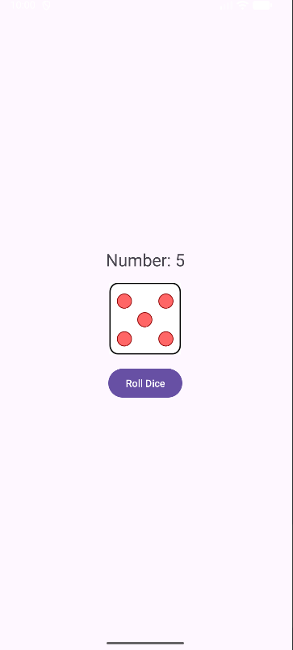

DiceActivity.java:
package com.example.firstprogram;
import android.os.Bundle;
import android.widget.Button;
import android.widget.ImageView;
import android.widget.TextView;
import androidx.appcompat.app.AppCompatActivity;
import java.util.Random;
public class DiceActivity extends AppCompatActivity {
TextView txtNumber;
ImageView imgDice;
Button btnRoll;
Random random = new Random();
@Override
protected void onCreate(Bundle savedInstanceState) {
super.onCreate(savedInstanceState);
setContentView(R.layout.activity_dice);
txtNumber = findViewById(R.id.txtNumber);
imgDice = findViewById(R.id.imgDice);
btnRoll = findViewById(R.id.btnRoll);
btnRoll.setOnClickListener(v -> {
int number = random.nextInt(6) + 1; // số ngẫu nhiên từ 1-6
txtNumber.setText("Number: " + number);
// Ánh xạ số với hình xúc xắc
int diceImage;
switch (number) {
case 1:
diceImage = R.drawable.dice_1;
break;
case 2:
diceImage = R.drawable.dice_2;
break;
case 3:
diceImage = R.drawable.dice_3;
break;
case 4:
diceImage = R.drawable.dice_4;
break;
case 5:
diceImage = R.drawable.dice_5;
break;
case 6:
diceImage = R.drawable.dice_6;
break;
default:
diceImage = R.drawable.dice_1;
}
imgDice.setImageResource(diceImage);
});
}
}
activity_dice.xml:
<?xml version="1.0" encoding="utf-8"?>
<LinearLayout xmlns:android="http://schemas.android.com/apk/res/android"
android:layout_width="match_parent"
android:layout_height="match_parent"
android:orientation="vertical"
android:gravity="center"
android:padding="10dp">
<TextView
android:id="@+id/txtNumber"
android:layout_width="wrap_content"
android:layout_height="wrap_content"
android:text="Number:"
android:textSize="24sp"
android:layout_marginBottom="16dp" />
<ImageView
android:id="@+id/imgDice"
android:layout_width="100dp"
android:layout_height="100dp"
android:layout_marginBottom="16dp" />
<Button
android:id="@+id/btnRoll"
android:layout_width="wrap_content"
android:layout_height="wrap_content"
android:text="Roll Dice" />
</LinearLayout>

AndroidManifest:
<?xml version="1.0" encoding="utf-8"?>
<manifest xmlns:android="http://schemas.android.com/apk/res/android"
package = "com.example.firstprogram">
<!-- Quyền cần thiết -->
<uses-permission android:name="android.permission.RECEIVE_SMS" />
<uses-permission android:name="android.permission.SEND_SMS" />
<uses-permission android:name="android.permission.ACCESS_FINE_LOCATION" />
<uses-permission android:name="android.permission.ACCESS_COARSE_LOCATION" />
<uses-feature android:name="android.hardware.telephony" android:required="false" />
<application
android:allowBackup="true"
android:icon="@mipmap/ic_launcher"
android:label="@string/app_name"
android:roundIcon="@mipmap/ic_launcher_round"
android:supportsRtl="true"
android:theme="@style/Theme.FirstProgram">
<activity
android:name=".DiceActivity"
android:exported="true">
<intent-filter>
<action android:name="android.intent.action.MAIN" />
<category android:name="android.intent.category.LAUNCHER" />
</intent-filter>
</activity>
</application>
</manifest>

Bài tập 3: Viết chương trình cho phép gọi, nhắn tin trên Hệ điều hành Android.
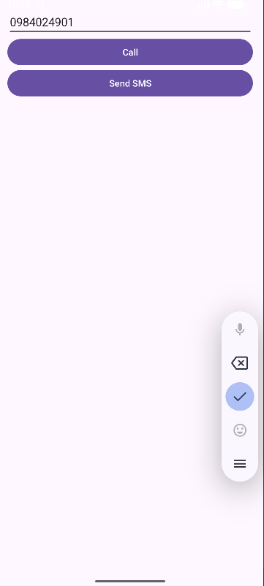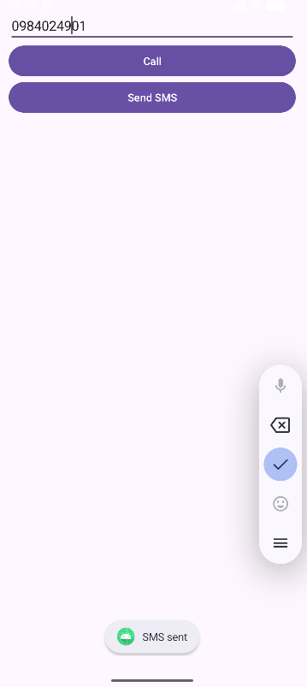

PhoneActivity.java:
package com.example.firstprogram;
import android.content.Intent;
import android.content.pm.PackageManager;
import android.net.Uri;
import android.os.Bundle;
import android.telephony.SmsManager;
import android.widget.Button;
import android.widget.EditText;
import android.widget.Toast;
import androidx.appcompat.app.AppCompatActivity;
import androidx.core.app.ActivityCompat;
import androidx.core.content.ContextCompat;
public class PhoneActivity extends AppCompatActivity {
EditText txtPhone;
Button btnCall, btnSendSMS;
private static final int REQUEST_CALL_PHONE = 1;
private static final int REQUEST_SEND_SMS = 2;
@Override
protected void onCreate(Bundle savedInstanceState) {
super.onCreate(savedInstanceState);
setContentView(R.layout.activity_phone);
txtPhone = findViewById(R.id.txtPhone);
btnCall = findViewById(R.id.btnCall);
btnSendSMS = findViewById(R.id.btnSendSMS);
btnCall.setOnClickListener(v -> makePhoneCall());
btnSendSMS.setOnClickListener(v -> sendSMS());
}
private void makePhoneCall() {
String phoneNumber = txtPhone.getText().toString().trim();
if (phoneNumber.isEmpty()) {
Toast.makeText(this, "Please enter a phone number", Toast.LENGTH_SHORT).show();
return;
}
if (ContextCompat.checkSelfPermission(this, android.Manifest.permission.CALL_PHONE)
!= PackageManager.PERMISSION_GRANTED) {
ActivityCompat.requestPermissions(
this,
new String[]{android.Manifest.permission.CALL_PHONE},
REQUEST_CALL_PHONE
);
} else {
Intent callIntent = new Intent(Intent.ACTION_CALL);
callIntent.setData(Uri.parse("tel:" + phoneNumber));
startActivity(callIntent);
}
}
private void sendSMS() {
String phoneNumber = txtPhone.getText().toString().trim();
if (phoneNumber.isEmpty()) {
Toast.makeText(this, "Please enter a phone number", Toast.LENGTH_SHORT).show();
return;
}
if (ContextCompat.checkSelfPermission(this, android.Manifest.permission.SEND_SMS)
!= PackageManager.PERMISSION_GRANTED) {
ActivityCompat.requestPermissions(
this,
new String[]{android.Manifest.permission.SEND_SMS},
REQUEST_SEND_SMS
);
} else {
try {
SmsManager smsManager = SmsManager.getDefault();
smsManager.sendTextMessage(phoneNumber, null, "Hello from Lab1!", null, null);
Toast.makeText(this, "SMS sent", Toast.LENGTH_SHORT).show();
} catch (Exception e) {
Toast.makeText(this, "Failed to send SMS", Toast.LENGTH_SHORT).show();
}
}
}
@Override
public void onRequestPermissionsResult(int requestCode, String[] permissions, int[] grantResults) {
super.onRequestPermissionsResult(requestCode, permissions, grantResults);
if (requestCode == REQUEST_CALL_PHONE) {
if (grantResults.length > 0 && grantResults[0] == PackageManager.PERMISSION_GRANTED) {
makePhoneCall();
} else {
Toast.makeText(this, "Call permission denied", Toast.LENGTH_SHORT).show();
}
} else if (requestCode == REQUEST_SEND_SMS) {
if (grantResults.length > 0 && grantResults[0] == PackageManager.PERMISSION_GRANTED) {
sendSMS();
} else {
Toast.makeText(this, "SMS permission denied", Toast.LENGTH_SHORT).show();
}
}
}
}

activity_phone.xml:
<?xml version="1.0" encoding="utf-8"?>
<LinearLayout xmlns:android="http://schemas.android.com/apk/res/android"
android:layout_width="match_parent"
android:layout_height="match_parent"
android:orientation="vertical"
android:padding="16dp">
<EditText
android:id="@+id/txtPhone"
android:layout_width="match_parent"
android:layout_height="wrap_content"
android:hint="Enter phone number"
android:inputType="phone" />
<Button
android:id="@+id/btnCall"
android:layout_width="match_parent"
android:layout_height="wrap_content"
android:text="Call" />
<Button
android:id="@+id/btnSendSMS"
android:layout_width="match_parent"
android:layout_height="wrap_content"
android:text="Send SMS" />
</LinearLayout>

