

**COURSE E-COMMERCE**

**SYSTEM**

Software Requirements Specification

Version 2  
<Date>

| **SWP391** | |
| --- | --- |
| **Group Members** | Trần Quang Minh |
| **Supervisor** |  |

– Hanoi, Summer 2023 –

# Revision History

|  |  |  |  |
| --- | --- | --- | --- |
| **Date** | **Description** | **Author** | **Comments** |
| 23/05/2023 | Version 1 | Trần Quang Minh  Trần Quang Minh |  |
| 30/5/2023 | Version 2 | Trần Quang Minh |  |

# Document Approval

The following Software Requirements Specification has been accepted and approved by the following:

|  |  |  |  |
| --- | --- | --- | --- |
| **Signature** | **Printed Name** | **Title** | **Date** |
|  | Trần Quang Minh | Leader |  |
|  |  |  |  |

# Table of content

**REVISION HISTORY II**

**DOCUMENT APPROVAL II**

**TABLE OF CONTENT III**

**1. INTRODUCTION 1**

1.1 Overview 1

1.2 Purpose 1

1.3 Scope 1

1.4 Definitions, Acronyms, and Abbreviations 2

**2. GENERAL DESCRIPTION 2**

2.1 Product Perspective 2

2.2 Product Functions 2

2.3 User Characteristics 2

2.4 General Constraints 3

**3. SPECIFIC REQUIREMENTS 3**

3.1 External Interface Requirements 3

*3.1.1 User Interfaces 3*

*3.1.2 Hardware Interfaces 3*

*3.1.3 Software Interfaces 3*

*3.1.4 Communications Interfaces 3*

3.2 Functional Requirements 3

*3.2.1 System Functional Overview 3*

*3.2.2 Create customer account 5*

*3.2.3 <<Feature Name 2>> 6*

*3.2.3 <<Feature Name 3>> 6*

3.3 Use Cases 6

*3.2.1 Use Case Overview 7*

*3.2.2 Use Case Admin 8*

*3.2.3 Use Case 3 8*

*3.2.4 Use Case 4 8*

*3.2.5 Use Case 5 8*

3.4 Non-Functional Requirements 8

*3.4.1 Performance 8*

*3.4.2 Availability 9*

*3.4.3 Security 9*

3.5 Inverse Requirements 9

3.6 Design Constraints 9

3.7 Logical Database Requirements 9

3.8 Other Requirements 9

**A. APPENDICES 9**

A.1 Business Rule 9

A.2 References 10

# Introduction

**1.1 Overview**

Welcome to Website The COURSE E-ComMerce SYSTEM(TCES) - where you can find top programming courses to develop your skills. We are committed to providing you with high-quality courses from industry-leading experts.

With the remarkable advancement of technology and the digital revolution, programming has become an essential skill for many professions. At Website TCES, we understand that learning programming can be challenging, especially for beginners. Therefore, we have created a convenient, flexible, and effective learning platform to help you progress quickly.

Website TCES offers a variety of diverse programming courses, including popular programming languages such as Python, JavaScript, Java, C++, and various development platforms like web, mobile, and desktop. You can easily search and select courses that align with your personal goals.

At Website TCES, we place special emphasis on delivering quality content. The courses are designed by experienced experts, ensuring that you learn the latest knowledge and cutting-edge programming techniques. You will have opportunities to apply your knowledge through exercises, real-life projects, and high-quality reference materials.

Additionally, Website TCES provides a strong support community to assist you throughout your learning journey. You can exchange ideas, ask questions, and share experiences with other members in the community, building professional networks and enhancing your communication skills.

Start your programming journey today with Website TCES! We believe that with our support, you can develop programming skills confidently and effectively.

## 1.2 Purpose

The COURSE E-COMMERCE SYSTEM(TCES) system consists of an Administrator Web site and a Client Web site. The Admin page supports Admins and Employees as a fully functional CMS website in CRUD for Products, Accounts,...

The Client's Website will have various software components, such as the main page, product listing, shopping cart, checkout process, and user profile management. User interfaces should be created to be easy to use, intuitive, and in line with modern web design standards. In addition, they should be responsive to different devices and ensure a consistent experience across the entire site.

This Software Requirements Specification illustrates, in clear terms, the main uses of the system and the required functionality specified by our customers. The intended audience of this document is us

Main customers of Computer E-Commerce System: Mr. Nguyen Thanh Y - SWP391 Instructor and members of SE1715-NET SUMMER 2023, as well as other students studying SE1715 will request permission to access the materials there.

## 1.3 Scope

The scope of Programming Courses (TCES) in relation to course sales is to provide a comprehensive and user-friendly platform for users to browse, select and purchase programming courses.

The site will feature an extensive catalog of programming courses, covering a variety of programming languages, frameworks, and platforms. Each course will have a dedicated page with detailed information, including course syllabus, instructor details, prerequisites, duration, and reviews from previous students.

The TCES website will provide a streamlined and secure checkout process, allowing users to easily add the desired courses to their cart and proceed with the payment. Multiple payment options will be available to satisfy different user preferences.

User accounts will be created for registered users, allowing them to track their course progress, access purchased courses and receive updates on new course releases or events upcoming. Users will have the ability to rate and review the courses they have completed, providing valuable feedback to other future learners.

Overall, TCES's selling point is to create a seamless and enjoyable experience for users, empowering them to explore and gain programming skills through the high-quality courses offered on the web. communication.

## 1.4 Definitions, Acronyms, and Abbreviations

|  |  |
| --- | --- |
| SRS | Software Requirements Specifications |
| BR | Business Rule |
| UI | User Interface |
| N/A | Not applicable, not available |
| Use Case(s) | Diagram describe system requirements |

# 2. General Description

## 2.1 Product Perspective

• The Course E-Comerce System website project is a new stand-alone product focused on delivering online training tailored specifically for programming and software development. It is designed as a comprehensive platform that provides programming courses, resources, and interactive learning activities for people who want to improve their programming skills or enter the field of software development.

• This product is not a successor to the product line or a replacement for the existing system, but an independent programming education platform. It is designed to meet the growing demand for online programming courses and provide a flexible and easy-to-use learning environment for learners of different skill levels.

## 2.2 Product Functions

- In Client Site:

+ Store and process customer information

+ Store and process product information

+ Manage purchases through the website

+ Perform search and data retrieval operations

+ Check out

- In Admin Site:

+ Staff Account Management

+ Customer Account Management

+ Product Management

+ Order Management

## 2.3 User Characteristics

This section of the SRS will describe the general end-user characteristics of the project to sell course online that will affect specific requirements.

User classes:

A. Customers:

● Frequency of use: Use often or occasionally.

● Functions used: Use many functions of the product, including course view, add to cart, purchase and manage personal accounts.

● Security and privileges: Standard user rights with access to basic features and personal account management.

● Experience: Diversity in users.

● Related Features: Offers a user-friendly interface, seamless browsing and purchasing experience, secure payment options, and personal account management.

B. System administrator:

● Frequency of use: Use occasionally.

● Functions used: User account management, access control and system settings. For example, add, edit and delete products, search for products, manage employees (decentralized)

● Security and privileges: Permission to manage user accounts and system configuration.

● Experience: Professional experience and clear knowledge of system administration.

● Related characteristics: Features of user management, access control based on different roles in the system

We should always prioritize requests based on the importance of each user class. Regular customers are the most important user classes for this product, as they are the primary users and an important factor in driving sales and user engagement. Meanwhile, system administrators play an important role in system management, but their requirements may not be as important as that of ordinary customers.

## 2.4 General Constraints

# - Consistency in coding style, documentation practices, and naming conventions should be maintained to facilitate future maintenance and support.

# - The system should incorporate appropriate security measures to protect sensitive customer data, ensure secure transactions, and prevent unauthorized access.

# - The system should be designed to operate within the specified hardware constraints, including timing and memory requirements.

## 2.5 Assumptions and Dependencies

- The user should have sufficient knowledge about computers.

- The computer should have an internet connection and Internet server capabilities.

- The users know the English language, as the interface will be provided in English.

# 3. Specific Requirements

## 3.1 External Interface Requirements

### 3.1.1 User Interfaces

• UI-1: The website's interface is designed to be user friendly and easy to use.

• UI-2: The screen layout is designed for ease of use and implementation by the user.

• UI-3: The main colors of the website are blue and black.

### 3.1.2 Hardware Interfaces

* *No hardware interfaces have been identified.*

### 3.1.3 Software Interfaces

* *The website does not integrate other commercial software*

### 3.1.4 Communications Interfaces

* The web browser will automatically log out if the user does not use the system within 10 seconds

## 3.2 Functional Requirements

*This section describes specific features of the software project. If desired, some requirements may be specified in the use-case format and listed in the Use Cases Section.*

### 3.2.1 System Functional Overview

#### 3.2.1.1 Screens Flow

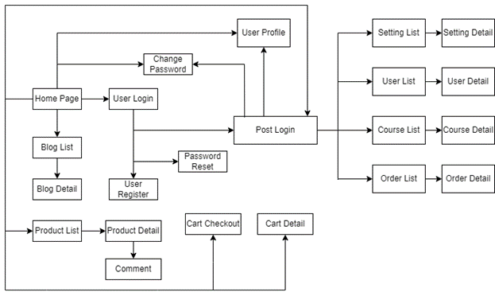

#### 3.2.1.2 Screen Descriptions

| **#** | **Feature** | **Screen** | **Description** |
| --- | --- | --- | --- |
| 1 | Common | Home Page | Home Screen shows general information about the system |
| 2 | Common | User Login | Screen for users to log into the system |
| 3 | Admin | Password Reset | Screen for all role change password of the account |
| 4 | Common | User Register | Screen for all role register account |
| 5 | Common | User Profile | Screen for users to view or edit their profile |
| 6 | Common | Change Password | Screen for all role change password of the account |
| 7 | Admin | Setting List | Screen for admin to view the roles of accounts |
| 8 | Admin | Setting Detail | Screen for admin edit the roles of accounts |
| 9 | Admin | User List | Screen show list of user |
| 10 | Admin | User Details | Screen show to edit and view all user in the system |
| 11 | Admin | Course List | Screen show list of course ịn the system |
| 12 | Admin | Course Details | Screen show to edit and view all course by Admin |
| 13 | Common | Product List | Screen shows all the courses in the system |
| 14 | Common | Product Details | Screen shows details of all the courses available in the system |
| 15 | Common | Cart Details | Screen show details of courses added to cart |
| 16 | Common | Cart Checkout | Screen show transfer information for payment and amount to be paid |
| 17 | Admin | Order List | Displays orders that have been paid, cancelled, registered courses, registered classes. |
| 18 | Admin | Order Details | Screen display management details of orders |
| 19 | Common | Comment | Screen display comment of user |

#### 3.2.1.3 Screen Authorization

|  |  |  |  |  |
| --- | --- | --- | --- | --- |
| **Screen** | **Admin** | **Employee** | **Customer** | **Guest** |
| Account Management | X |  |  |  |
| Create Account | X |  |  |  |
| Edit Account | X | X |  |  |
| Remove Account | X |  |  |  |
| Customer Management | X | X | X |  |
| Create Customer |  |  | X |  |
| Edit Customer | X | X | X |  |
| Order Management | X | X | X |  |
| Create order |  |  | X |  |
| Edit order | X | X | X |  |
| Remove order |  |  | X |  |
| Product Management | X | X |  |  |
| Create Product | X | X |  |  |
| Edit Product | X | X |  |  |
| Remove Product | X | X |  |  |
| View Product | X | X | X | X |
| Search Product | X | X | X | X |
| Search Order | X | X |  |  |

#### 3.2.1.4 Non-Screen Functions

#### 3.2.1.5 Entity Relationship Diagram

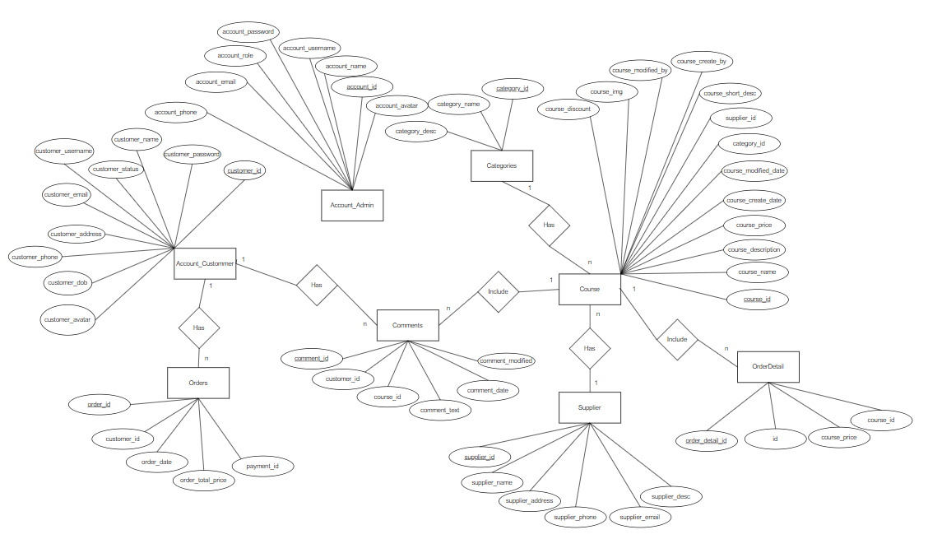

#### 3.2.1.6 Entities Description

|  |  |  |
| --- | --- | --- |
| **#** | **Entity** | **Description** |
| 1 | Combo | Includes a collection of courses so users can sign up for them all |
| 2 | Customer | When users buy goods without logging in, they need to fill in the information below |
| 3 | Package | Is a course that users can learn |
| 4 | User | Information who can register and purchase courses |
| 5 | Feedback | Is the feedback, reviews of users for the system |
| 6 | Order | When the user adds a course to buy to the cart |
| 7 | Coupon | When the user wants to add a discount code to the course he is about to buy |
| 8 | Post | Posts related to courses that users may be interested in |
| 9 | Slide | Users can see the homepage for more information about the course |
| 10 | Webcontact | When users have questions or need support, they will send information to the system so that the support person will support that. |

### 3.2.2 Common

#### 3.2.2.1 Home page

|  |  |  |  |
| --- | --- | --- | --- |
| **Name:** | **Home Page** | | |
| Created By: | QuanDD | Date Created: | 15/5/2023 |
| Primary Actor: | Common | Secondary Actors: | N/A |
| Priority: | High | Frequency of Use: | Usually |
| Trigger: | Click Logo of system | | |
| Description: | Home Screen shows general information about the system | | |
| Preconditions: | N/A | | |
| Post-conditions: |  | | |
| Normal Flow: | Display popular categories, popular course, about us and slogan on home page | | |
| Exceptions: |  | | |
| Business Rules: |  | | |
| Assumptions: | N/A | | |

#### 3.2.2.2 Sign In and Sign up

|  |  |  |  |
| --- | --- | --- | --- |
| **Name:** | **Sign In and Sign up** | | |
| Created By: | MinhTQ | Date Created: | 15/5/2023 |
| Primary Actor: | Guest | Secondary Actors: | N/A |
| Priority: | High | Frequency of Use: | Usually |
| Trigger: | The actor wants to sign in to the Website | | |
| Description: | This feature allows actor to login the system or sign up | | |
| Preconditions: | | | |
| Post-conditions: | Success: Redirect to home page  Fail: The system shows error message corresponding to error code | | |
| Normal Flow: | |  |  |  | | --- | --- | --- | | Step | Actor Action | System Response | | 1 | In Log in page, Actor inputs username and password |  | | 2 | Actor clicks “Log in” | System redirects to the home page | | | |
|  | |  |  |  | | --- | --- | --- | | Step | Actor Action | System Response | | 1 | In sign Up page, Actor inputs name, username, password, email, address, phone and date of birth | | | 2 | Actor clicks “Sign up” button | System redirects to the log in page and print the message |   3   |  |  |  | | --- | --- | --- | | Step | Actor Action | System Response | | 1 | In Log in page, Actor clicks “forgot password” | System shows a box input and message | | 2 | Actor inputs email of account thay want to reset password | System redirects to the OTP page |  |  |  |  | | --- | --- | --- | | Step | Actor Action | System Response | | 1 | In OTP page, enter the OTP has been sent in user email | System shows a form contains:   * Input OTP textbox | | 2 |  |  | | 3 |  |  | | 4 |  |  | | 5 |  |  | | | |
| Exceptions: | |  |  |  | | --- | --- | --- | | No | Cause | System Response | | 1 | The username,password,  Email or phone is not correct format | System informs error message to remind user inputs correct format | | 2 | The username or password is not correct | System informs “username or password is incorrect” | | 3 | Username exist | System informs “username is exist” | | 4 | Incorrect OTP | System informs “OTP is | | | |
| Business Rules: | * Password is not empty and between 6 and 32 characters and have special characters and have at least a digit * Phone have 10 digits * Email have @ | | |
| Assumptions: | * Actor’s internet connection is available | | |

### 3.2.3 Admin

#### 3.2.3.1 View Course List

|  |  |  |  |
| --- | --- | --- | --- |
| **Name:** | **View Couse List** | | |
| Created By: | QuanDD | Date Created: | 22/05/2023 |
| Primary Actor: | Admin | Secondary Actors: | N/A |
| Priority: | High | Frequency of Use: | Usually |
| Trigger: | The actor wants to see a list of all courses. | | |
| Description: | This feature allows the actor to see a list of all courses to easily manage it. | | |
| Preconditions: | The actor must login to their account as “Admin” role | | |
| Post-conditions: | Success: System returned list of courses.  Fail: System shows message error. | | |
| Normal Flow: | |  |  |  | | --- | --- | --- | | Step | Actor Action | System Response | | 1 | In the home page, click on the “Course Manage” on the navigation bar. | System returned list all of courses. | | | |
| Alternative Flow: | N/A | | |
| Exceptions: | |  |  |  | | --- | --- | --- | | No | Cause | System Response | | 1 | There are no courses available | System informs “no data” | | | |
| Business Rules: | N/A | | |
| Assumptions: | * Actor’s internet connection is available | | |

#### 3.2.3.2 View Course Detail

|  |  |  |  |
| --- | --- | --- | --- |
| **ID and Name:** | **UC-04: View Course Detail** | | |
| Created By: | QuanDD | Date Created: | 22/05/2023 |
| Primary Actor: | Admin | Secondary Actors: | N/A |
| Priority: | High | Frequency of Use: | Often |
| Trigger: | The actor wants to view detailed information about Course. | | |
| Description: | This feature allows actor to view details such as ID course, name, description, … | | |
| Preconditions: | The actor must login to their account as “Admin” role. | | |
| Post-conditions: | Success: Show detail information of course. | | |
| Normal Flow: | |  |  |  | | --- | --- | --- | | Step | Actor Action | System Response | | 1 | In the home page, click on the “Course Manage” on the navigation bar. | System returned list all of courses. | | 2 | Actor clicks on the eye icon button on the “Manage course” screen | The system redirects to the course details page. The website displays detailed information about the candidate such as:description, price, category, discount.... | | | |
| Alternative Flow: | N/A | | |
| Exceptions: | N/A | | |
| Business Rules: | Actors can only view. | | |
| Assumptions: | Actor’s internet connection is available | | |

#### 3.2.3.3 Search Course

|  |  |  |  |
| --- | --- | --- | --- |
| **Name:** | **Search Course** | | |
| Created By: | QuanDD | Date Created: | 22/05/2023 |
| Primary Actor: | Admin | Secondary Actors: | N/A |
| Priority: | Normal | Frequency of Use: | Often |
| Trigger: | The actor wants to search for course. | | |
| Description: | This feature allows actors to search by genre. | | |
| Preconditions: | The actor must login to their account as “Admin” role. | | |
| Post-conditions: | Success: The system shows a list of course in search. | | |
| Normal Flow: | |  |  |  | | --- | --- | --- | | Step | Actor Action | System Response | | 1 | In the home page, click on the “Course Manage” on the navigation bar. | System returned list all of courses. | | 2 | Actor clicks on the “search” button or search icon. | System show the list of course by genre. | | | |
| Alternative Flow: | N/A | | |
| Exceptions: | N/A | | |
| Business Rules: | N/A | | |
| Assumptions: | Actor’s internet connection is available | | |

#### 3.2.3.4 View Order List

|  |  |  |  |
| --- | --- | --- | --- |
| **Name:** | **View Order List** | | |
| Created By: | QuanDD | Date Created: | 22/05/2023 |
| Primary Actor: | Admin | Secondary Actors: | N/A |
| Priority: | High | Frequency of Use: | Usually |
| Trigger: | The actor wants to see a list of all order. | | |
| Description: | This feature allows the actor to see a list of all orders to easily manage it. | | |
| Preconditions: | The actor must login to their account as “Admin” role | | |
| Post-conditions: | Success: System returned list of courses.  Fail: System shows message error. | | |
| Normal Flow: | |  |  |  | | --- | --- | --- | | Step | Actor Action | System Response | | 1 | In the home page, click on the “Order Manage” on the navigation bar. | System returned list all of order. | | | |
| Alternative Flow: | N/A | | |
| Exceptions: | |  |  |  | | --- | --- | --- | | No | Cause | System Response | | 1 | There are no order available | System informs “no data” | | | |
| Business Rules: | N/A | | |
| Assumptions: | * Actor’s internet connection is available | | |

#### 3.2.3.5 View Order Detail

|  |  |  |  |
| --- | --- | --- | --- |
| **Name:** | **View Order Detail** | | |
| Created By: | QuanDD | Date Created: | 22/05/2023 |
| Primary Actor: | Admin | Secondary Actors: | N/A |
| Priority: | High | Frequency of Use: | Often |
| Trigger: | The actor wants to view detailed information about order. | | |
| Description: | This feature allows actor to view details such as course name, image, price, … | | |
| Preconditions: | The actor must login to their account as “Admin” role. | | |
| Post-conditions: | Success: Show detail information of order. | | |
| Normal Flow: | |  |  |  | | --- | --- | --- | | Step | Actor Action | System Response | | 1 | In the home page, click on the “Order Manage” on the navigation bar. | System returned list all of order. | | 2 | Actor clicks on the eye icon button on the “Order Manage” screen | The system redirects to the order details page. The website displays detailed information about the candidate such as: course name, image, price, … | | | |
| Alternative Flow: | N/A | | |
| Exceptions: | N/A | | |
| Business Rules: | Actors can only view. | | |
| Assumptions: | Actor’s internet connection is available | | |

#### 3.2.3.6 Search Order

|  |  |  |  |
| --- | --- | --- | --- |
| **Name:** | **Search Order** | | |
| Created By: | QuanDD | Date Created: | 22/05/2023 |
| Primary Actor: | Admin | Secondary Actors: | N/A |
| Priority: | Normal | Frequency of Use: | Often |
| Trigger: | The actor wants to search for order. | | |
| Description: | This feature allows actors to search by genre. | | |
| Preconditions: | The actor must login to their account as “Admin” role. | | |
| Post-conditions: | Success: The system shows a list of order in search. | | |
| Normal Flow: | |  |  |  | | --- | --- | --- | | Step | Actor Action | System Response | | 1 | In the home page, click on the “Order Manage” on the navigation bar. | System returned list all of orders. | | 2 | Actor clicks on the “search” button or search icon. | System show the list of order by genre. | | | |
| Alternative Flow: | N/A | | |
| Exceptions: | N/A | | |
| Business Rules: | N/A | | |
| Assumptions: | Actor’s internet connection is available | | |

#### 3.2.3.7 Create Account Admin

|  |  |  |  |
| --- | --- | --- | --- |
| **Name:** | **Create Account Admin** | | |
| Created By: | QuanDD | Date Created: | 24/05/2023 |
| Primary Actor: | Admin | Secondary Actors: | N/A |
| Priority: | High | Frequency of Use: | Sometime |
| Trigger: | The admin click to button “Create new account” to create new account in admin account manager page | | |
| Description: | This feature allows admin create new account (only username, password, name and role) | | |
| Preconditions: | Use admin account with role is admin | | |
| Post-conditions: | Success: Redirect to admin account manager page with new account created  Fail: The system shows error message corresponding to error code | | |
| Normal Flow: | |  |  |  | | --- | --- | --- | | Step | Actor Action | System Response | | 1 | In create page, Actor inputs username, name, password and choose role of new account create |  | | 2 | Actor clicks “Create” button | System redirects to the admin account manager page with new account created | | | |
| Alternative Flow: | None | | |
| Exceptions: | |  |  |  | | --- | --- | --- | | No | Cause | System Response | | 1 | The username existed | System informs error message to remind admin input other username | | 2 | The name, username or password is not fill | System informs error message to remind admin input | | 3 | Password not correct format | System informs error message to remind admin input password by format | | | |
| Business Rules: | * Username and password is not empty * Password must contain at least one number and one uppercase and lowercase letter, and at least 8 or more characters | | |
| Assumptions: | * Admin’s internet connection is available | | |

#### 3.2.3.8 Delete Account Admin

|  |  |  |  |
| --- | --- | --- | --- |
| **Name:** | **Delete Account Admin** | | |
| Created By: | NgocVD | Date Created: | 24/05/2023 |
| Primary Actor: | Admin | Secondary Actors: | N/A |
| Priority: | High | Frequency of Use: | Sometime |
| Trigger: | The admin click to icon trash to delete an account in admin account manager page | | |
| Description: | This feature allows admin delete an account | | |
| Preconditions: | Use admin account with role is admin | | |
| Post-conditions: | Success: Redirect to admin account manager page with an account u want deleted  Fail: The system shows error message corresponding to error code | | |
| Normal Flow: | |  |  |  | | --- | --- | --- | | Step | Actor Action | System Response | | 1 |  | Web alert message confirm delete account | | 2 | Actor clicks “OK” | System redirects to the admin account manager page with account deleted | | | |
| Alternative Flow: | |  |  |  | | --- | --- | --- | | Step | Actor Action | System Response | | 1 |  | Web alert message confirm delete account | | 2 | Actor clicks “Hủy” | System redirects to the admin account manager page with nothing change | | | |
| Exceptions: | None | | |
| Business Rules: | None | | |
| Assumptions: | * Admin’s internet connection is available | | |

#### 3.2.3.9 Update Account Admin

|  |  |  |  |
| --- | --- | --- | --- |
| **Name:** | **Update Account Admin** | | |
| Created By: | NgocVD | Date Created: | 24/05/2023 |
| Primary Actor: | Admin | Secondary Actors: | N/A |
| Priority: | High | Frequency of Use: | Sometime |
| Trigger: | The admin click to icon pen to update an account info login in admin account manager page | | |
| Description: | This feature allows admin update an account login info such as: username, password and role | | |
| Preconditions: | Use admin account with role is admin | | |
| Post-conditions: | Success: Redirect to admin account manager page with that account updated  Fail: The system shows error message corresponding to error code | | |
| Normal Flow: | |  |  |  | | --- | --- | --- | | Step | Actor Action | System Response | | 1 | In update page, Actor can change username, password and choose role of account want to update |  | | 2 | Actor clicks “Update” button | System redirects to the admin account manager page with account updated | | | |
| Alternative Flow: | |  |  |  | | --- | --- | --- | | Step | Actor Action | System Response | | 1 | In update page, Actor can change username, password and choose role of account want to update |  | | 2 | Actor clicks “Cancel” button | System redirects to the admin account manager page with nothing change | | | |
| Exceptions: | |  |  |  | | --- | --- | --- | | No | Cause | System Response | | 1 | The username existed | System informs error message to remind admin input other username | | 2 | The name, username or password is not fill | System informs error message to remind admin input | | 3 | Password not correct format | System informs error message to remind admin input password by format | | | |
| Business Rules: | * Username and password is not empty * Password must contain at least one number and one uppercase and lowercase letter, and at least 8 or more characters | | |
| Assumptions: | * Admin’s internet connection is available | | |

#### 3.2.3.10 View Profile Account Admin

|  |  |  |  |
| --- | --- | --- | --- |
| **Name:** | **View Profile Account Admin** | | |
| Created By: | NgocVD | Date Created: | 24/05/2023 |
| Primary Actor: | Admin | Secondary Actors: | N/A |
| Priority: | High | Frequency of Use: | Sometime |
| Trigger: | The admin click to icon info to view account profile in admin account manager page | | |
| Description: | This feature allows admin view an account profile such as:name, email, phone, role, avatar, role and introduce | | |
| Preconditions: | Use admin account with role is admin | | |
| Post-conditions: | Success: Redirect to profile page with that account data  Fail: The system shows error message corresponding to error code | | |
| Normal Flow: | |  |  |  | | --- | --- | --- | | Step | Actor Action | System Response | | 1 | In profile page, Actor only can view info such as:   * Name * Email * Phone * Role * Avatar * Introduce |  | | | |
| Alternative Flow: | None | | |
| Exceptions: | None | | |
| Business Rules: | None | | |
| Assumptions: | * Admin’s internet connection is available | | |

#### 3.2.3.11 View Account Customer

|  |  |  |  |
| --- | --- | --- | --- |
| **Name:** | **View Account Customer** | | |
| Created By: | NgocVD | Date Created: | 22/05/2023 |
| Primary Actor: | Admin | Secondary Actors: | N/A |
| Priority: | High | Frequency of Use: | Usually |
| Trigger: | The actor wants to see a list of all account customer. | | |
| Description: | This feature allows the actor to see a list of all account customer to easily manage it. | | |
| Preconditions: | The actor must login to their account as “Admin” role | | |
| Post-conditions: | Success: System returned list of account customer.  Fail: System shows message error. | | |
| Normal Flow: | |  |  |  | | --- | --- | --- | | Step | Actor Action | System Response | | 1 | In the home page, click on the “Account Customer” on the navigation bar. | System returned list all of account customer. | | | |
| Alternative Flow: | N/A | | |
| Exceptions: | |  |  |  | | --- | --- | --- | | No | Cause | System Response | | 1 | There are no courses available | System informs “no data” | | | |
| Business Rules: | N/A | | |
| Assumptions: | * Actor’s internet connection is available | | |

#### 3.2.3.12 Change status

|  |  |  |  |
| --- | --- | --- | --- |
| **Name:** | **Change status** | | |
| Created By: | NgocVD | Date Created: | 20/06/2023 |
| Primary Actor: | Admin | Secondary Actors: | N/A |
| Priority: | High | Frequency of Use: | Sometime |
| Trigger: | The admin click to icon “lock” or “unlock”to change status of account customer | | |
| Description: | This feature allows admin change status a account | | |
| Preconditions: | Use admin account with role is admin | | |
| Post-conditions: | Success: Redirect to account customer page with a account has be changed status  Fail: The system shows error message corresponding to error code | | |
| Normal Flow: | |  |  |  | | --- | --- | --- | | Step | Actor Action | System Response | | 1 |  | Web alert message confirm change status account | | 2 | Actor clicks “OK” | System redirects to account customer page with a account has be changed status | | | |
| Alternative Flow: | |  |  |  | | --- | --- | --- | | Step | Actor Action | System Response | | 1 |  | Web alert message confirm delete account | | 2 | Actor clicks “Hủy” | System redirects to the manager page with nothing change | | | |
| Exceptions: | None | | |
| Business Rules: | None | | |
| Assumptions: | * Admin’s internet connection is available | | |

#### 3.2.3.13 Create New Course

|  |  |  |  |
| --- | --- | --- | --- |
| **Name:** | **Create New Couse** | | |
| Created By: | QuanDD | Date Created: | 22/05/2023 |
| Primary Actor: | Admin | Secondary Actors: | N/A |
| Priority: | High | Frequency of Use: | Often |
| Trigger: | The actor wants to create new course. | | |
| Description: | This feature allows actor to create new course to the list of all courses. | | |
| Preconditions: | The actor must login to their account as “Admin” role. | | |
| Post-conditions: | Success: System created new course.  Fail: System shows message error. | | |
| Normal Flow: | |  |  |  | | --- | --- | --- | | Step | Actor Action | System Response | | 1 | In the home page, click on the “Course Manage” on the navigation bar | System returned list all of courses. | | 2 | The actor click on “Create” button on “Course Manage” screen. | System shows a form of adding information of course including name, description, price, category name, supplier name, description short, image course & discount | | 3 | Actor clicks on “Create Course” | System returned list all of courses including newly created courses. | | | |
| Alternative Flow: | N/A | | |
| Exceptions: | Notice if there is not at least one course | | |
| Business Rules: | The data cannot be empty. | | |
| Assumptions: | Actor’s internet connection is available | | |

#### 3.2.3.14 Update Course

|  |  |  |  |
| --- | --- | --- | --- |
| **Name:** | **Update Couse** | | |
| Created By: | QuanDD | Date Created: | 22/05/2023 |
| Primary Actor: | Admin | Secondary Actors: | N/A |
| Priority: | High | Frequency of Use: | Often |
| Trigger: | The actor wants to update course. | | |
| Description: | This feature allows actor to update course to the list of all courses. | | |
| Preconditions: | The actor must login to their account as “Admin” role. | | |
| Post-conditions: | Success: System update course.  Fail: System shows message error. | | |
| Normal Flow: | |  |  |  | | --- | --- | --- | | Step | Actor Action | System Response | | 1 | In the home page, click on the “Course Manage” on the navigation bar. | System returned list all of courses. | | 2 | Actor clicks the pen icon button on the “Manage course” screen.. | System shows a form of update information of course including name, description, price, category name, supplier name, description short, image course & discount | | 3 | Actor clicks on “Update Course” | System returned list all of courses. | | | |
| Alternative Flow: | N/A | | |
| Exceptions: | Notice if there is not at least one course | | |
| Business Rules: | The data cannot be empty. | | |
| Assumptions: | Actor’s internet connection is available | | |

#### 3.2.3.15 Delete Course

|  |  |  |  |
| --- | --- | --- | --- |
| **Name:** | **Delete Couse** | | |
| Created By: | QuanDD | Date Created: | 22/05/2023 |
| Primary Actor: | Admin | Secondary Actors: | N/A |
| Priority: | Normal | Frequency of Use: | Often |
| Trigger: | The actor wants to delete the course. | | |
| Description: | This feature allows actor to delete a course created by admin. | | |
| Preconditions: | The actor must login to their account as “Admin” role. | | |
| Post-conditions: | Success: The system displays the list of courses that have not been deleted. | | |
| Normal Flow: | |  |  |  | | --- | --- | --- | | Step | Actor Action | System Response | | 1 | In the home page, click on the “Course Manage” on the navigation bar. | System returned list all of courses. | | 2 | Actor clicks on the trash can icon button on the “Manage course” screen. | The system displays the list of courses that have not been deleted. | | | |
| Alternative Flow: | N/A | | |
| Exceptions: | Notice if there is not at least one course | | |
| Business Rules: | If an Actor has deleted a course, he cannot delete it again. | | |
| Assumptions: | Actor’s internet connection is available | | |

#### 3.2.3.16 Edit Status Order

|  |  |  |  |
| --- | --- | --- | --- |
| **Name:** | **Edit Status Order** | | |
| Created By: | QuanDD | Date Created: | 22/05/2023 |
| Primary Actor: | Admin | Secondary Actors: | N/A |
| Priority: | High | Frequency of Use: | Often |
| Trigger: | The actor wants to edit status of order. | | |
| Description: | This feature allows actor to change status. | | |
| Preconditions: | The actor must login to their account as “Admin” role. | | |
| Post-conditions: | Success: System returns to Order Management | | |
| Normal Flow: | |  |  |  | | --- | --- | --- | | Step | Actor Action | System Response | | 1 | In the home page, click on the “Order Manage” on the navigation bar. | System returned list all of order. | | 2 | Change the status by selecting in the column status. |  | | | |
| Alternative Flow: | N/A | | |
| Exceptions: | There are no order available -> System informs “no data” | | |
| Business Rules: | N/A | | |
| Assumptions: | Actor’s internet connection is available | | |

### 3.2.4 User

#### 3.2.4.1 Add to cart

|  |  |  |  |
| --- | --- | --- | --- |
| **Name:** | **Add to cart** | | |
| Created By: | MinhTQ | Date Created: | 24/05/2023 |
| Primary Actor: | Customer | Secondary Actors: | N/A |
| Priority: | High | Frequency of Use: | Sometime |
| Trigger: | The User wants to add course to cart | | |
| Description: | This feature allows the User to add the Product he has selected to the cart | | |
| Preconditions: | User has signed in as “Customer” | | |
| Post-conditions: | Success: The Product is add to the cart | | |
| Normal Flow: | On client home page or course page, click on Add to cart from any product, System will add that product to cart. | | |
| Alternative Flow: | N/A | | |
| Exceptions: | N/A | | |
| Business Rules: | Customer can add as many course as they want | | |
| Assumptions: | User’s internet connection is available | | |

#### 3.2.4.2 Remove from cart

|  |  |  |  |
| --- | --- | --- | --- |
| **Name:** | **Remove from cart** | | |
| Created By: | MinhTQ | Date Created: | 24/05/2023 |
| Primary Actor: | Customer | Secondary Actors: | N/A |
| Priority: | High | Frequency of Use: | Sometime |
| Trigger: | The User wants to remove the Course from the Cart | | |
| Description: | This feature allows Users to remove the Course that they have chosen to buy from cart | | |
| Preconditions: | User has signed in as “Customer” and has picked some Course | | |
| Post-conditions: | Success: The Product is removed from the cart. | | |
| Normal Flow: | 1. On client home page, click on View Cart label, System redirect you to page show you course had been picked.   2. Click remove button, the course you’ve chosen will be removed from the cart. | | |
| Alternative Flow: | N/A | | |
| Exceptions: | N/A | | |
| Business Rules: | Customer can add as many course as they want | | |
| Assumptions: | User’s internet connection is available | | |

#### 3.2.4.3 Confirm Order

|  |  |  |  |
| --- | --- | --- | --- |
| **Name:** | Confirm order(s) | | |
| Created By: | MinhTQ | Date Created: | 17/05/2023 |
| Primary User: | Customer | Secondary Users: | N/A |
| Priority: | High | Frequency of Use: | Often |
| Trigger: | The User wants to buy course. | | |
| Description: | This feature allows User to make order for the Course they have chosen in carts | | |
| Preconditions: | ● The User must login to their account as “Customer” role  ● The User has set payment and agree to terms. | | |
| Post-conditions: | Success: System redirect to order details and checkout | | |
| Normal Flow: | In Cart Page, click on place order | | |
| Exceptions: | N/A | | |
| Business Rules: | N/A | | |
| Assumptions: | User’s internet connection is available | | |

#### 3.2.4.4 View Profile

|  |  |  |  |
| --- | --- | --- | --- |
| **Name:** | View Profile | | |
| Created By: | MinhTQ | Date Created: | 24/05/2023 |
| Primary Actor: | Customer | Secondary Actors: | N/A |
| Priority: | High | Frequency of Use: | Sometime |
| Trigger: | The User wants to view their profile | | |
| Description: | This feature allows the User to view their profile | | |
| Preconditions: | User has signed in as “Customer” | | |
| Post-conditions: | Success: System redirect to Profile page to show all information of this customer | | |
| Normal Flow: | On client home page, click on “Manage my account” | | |
| Alternative Flow: | N/A | | |
| Exceptions: | N/A | | |
| Business Rules: | N/A | | |
| Assumptions: | User’s internet connection is available | | |

#### 3.2.4.5 Change Password

|  |  |  |  |
| --- | --- | --- | --- |
| **Name:** | Change Password | | |
| Created By: | MinhTQ | Date Created: | 24/05/2023 |
| Primary Actor: | Customer | Secondary Actors: | N/A |
| Priority: | High | Frequency of Use: | Sometime |
| Trigger: | The User wants to change their password | | |
| Description: | This feature allows the User to change their password | | |
| Preconditions: | User has signed in as “Customer” | | |
| Post-conditions: | Success: System redirect to ChangePassword page | | |
| Normal Flow: | On Profile page, click on “Change Password” button | | |
| Alternative Flow: | N/A | | |
| Exceptions: | If the old pass is in an incorrect value, the system displays “Wrong old password”  If the new pass is in an incorrect format or unavailable, the system displays “Please input right validate of password.” | | |
| Business Rules: | N/A | | |
| Assumptions: | User’s internet connection is available | | |

#### 3.2.4.6 View list all course

|  |  |  |  |
| --- | --- | --- | --- |
| **Name:** | **View list all course** | | |
| Created By: | QuanDD | Date Created: | 14/06/2023 |
| Primary Actor: | User,Guest | Secondary Actors: | N/A |
| Priority: | Normal | Frequency of Use: | Usually |
| Trigger: | The actor wants to see a list of all courses. | | |
| Description: | Actor can view category of all course. | | |
| Preconditions: | N/A | | |
| Post-conditions: | N/A | | |
| Normal Flow: | |  |  |  | | --- | --- | --- | | Step | Actor Action | System Response | | 1 | Actor clicks on All Course | System returned list all of course. | | 2 | Actor can choose category or sort by course price. | System returned list course of category or sort by course price. . | | | |
| Alternative Flow: | N/A | | |
| Exceptions: | Notice if there is not at least one course | | |
| Business Rules: | N/A | | |
| Assumptions: | Actor’s internet connection is available | | |

#### 3.2.4.7 Search Course

|  |  |  |  |
| --- | --- | --- | --- |
| **Name:** | **Search course** | | |
| Created By: | QuanDD | Date Created: | 14/06/2023 |
| Primary Actor: | User,Guest | Secondary Actors: | N/A |
| Priority: | Normal | Frequency of Use: | Usually |
| Trigger: | The actor wants to search for course. | | |
| Description: | This feature allows actors to search by genre. | | |
| Preconditions: | N/A | | |
| Post-conditions: | N/A | | |
| Normal Flow: | |  |  |  | | --- | --- | --- | | Step | Actor Action | System Response | | 1 | In menu Actor clicks on the “search” button or search icon. | System show the list of course by genre. | | | |
| Alternative Flow: | N/A | | |
| Exceptions: | Notice if there is not at least one course | | |
| Business Rules: | N/A | | |
| Assumptions: | Actor’s internet connection is available | | |

#### 3.2.4.8 Add Comment

|  |  |  |  |
| --- | --- | --- | --- |
| **Name:** | **Add Comment** | | |
| Created By: | QuanDD | Date Created: | 14/06/2023 |
| Primary Actor: | User | Secondary Actors: | N/A |
| Priority: | Normal | Frequency of Use: | Usually |
| Trigger: | The actor wants to review the course. | | |
| Description: | This feature allows actors comment. | | |
| Preconditions: | The actor must login to their account as “User” role | | |
| Post-conditions: | N/A | | |
| Normal Flow: | |  |  |  | | --- | --- | --- | | Step | Actor Action | System Response | | 1 | In the course details, the actor can comment and press the submit button | System show the list comment. | | | |
| Alternative Flow: | N/A | | |
| Exceptions: | N/A | | |
| Business Rules: | N/A | | |
| Assumptions: | Actor’s internet connection is available | | |

#### 3.2.4.9 Update Comment

|  |  |  |  |
| --- | --- | --- | --- |
| **Name:** | **Update Comment** | | |
| Created By: | QuanDD | Date Created: | 14/06/2023 |
| Primary Actor: | User | Secondary Actors: | N/A |
| Priority: | Normal | Frequency of Use: | Usually |
| Trigger: | The actor wants to update review the course. | | |
| Description: | This feature allows actors update comment. | | |
| Preconditions: | The actor must login to their account as “User” role | | |
| Post-conditions: | N/A | | |
| Normal Flow: | |  |  |  | | --- | --- | --- | | Step | Actor Action | System Response | | 1 | In the course details, the actor clicks on the pen icon | the caption the actor wants to edit will appear. | | 2 | Press update | Go back to comment list | | | |
| Alternative Flow: | N/A | | |
| Exceptions: | N/A | | |
| Business Rules: | N/A | | |
| Assumptions: | Actor’s internet connection is available | | |

#### 3.2.4.10 View List Comment

|  |  |  |  |
| --- | --- | --- | --- |
| **Name:** | **View List Comment** | | |
| Created By: | QuanDD | Date Created: | 14/06/2023 |
| Primary Actor: | User,Guest | Secondary Actors: | N/A |
| Priority: | Normal | Frequency of Use: | Usually |
| Trigger: | Actors want to see reviews from other people. | | |
| Description: | This feature allows actors view comment. | | |
| Preconditions: | The actor must login to their account as “User” role | | |
| Post-conditions: | N/A | | |
| Normal Flow: | |  |  |  | | --- | --- | --- | | Step | Actor Action | System Response | | 1 | Click any course | In the course details, the actor can see reviews from other people. | | | |
| Alternative Flow: | N/A | | |
| Exceptions: | N/A | | |
| Business Rules: | N/A | | |
| Assumptions: | Actor’s internet connection is available | | |

#### 3.2.4.11 Delete Comment

|  |  |  |  |
| --- | --- | --- | --- |
| **Name:** | **Delete Comment** | | |
| Created By: | QuanDD | Date Created: | 14/06/2023 |
| Primary Actor: | User | Secondary Actors: | N/A |
| Priority: | Normal | Frequency of Use: | Often |
| Trigger: | The actor wants to delete review the course. | | |
| Description: | This feature allows actors delete comment. | | |
| Preconditions: | The actor must login to their account as “User” role | | |
| Post-conditions: | N/A | | |
| Normal Flow: | |  |  |  | | --- | --- | --- | | Step | Actor Action | System Response | | 1 | In the course details, Actor clicks on the trash can icon button | The system displays the list comment that have not been deleted. | | | |
| Alternative Flow: | N/A | | |
| Exceptions: | N/A | | |
| Business Rules: | N/A | | |
| Assumptions: | Actor’s internet connection is available | | |

#### 3.2.4.12 Course Purchased

|  |  |  |  |
| --- | --- | --- | --- |
| **Name:** | **Course Purchased** | | |
| Created By: | QuanDD | Date Created: | 28/06/2023 |
| Primary Actor: | User | Secondary Actors: | N/A |
| Priority: | Normal | Frequency of Use: | Usually |
| Trigger: | The actor wants to see a list of courses purchased. | | |
| Description: | This feature allows actors see a list of courses purchased. | | |
| Preconditions: | The actor must login to their account as “User” role | | |
| Post-conditions: | N/A | | |
| Normal Flow: | |  |  |  | | --- | --- | --- | | Step | Actor Action | System Response | | 1 | Actor clicks button “My Course” | The system displays the list of courses purchased.(can filter by category) | | | |
| Alternative Flow: | N/A | | |
| Exceptions: | N/A | | |
| Business Rules: | N/A | | |
| Assumptions: | Actor’s internet connection is available | | |

#### 3.2.4.12 Content Of The Course

|  |  |  |  |
| --- | --- | --- | --- |
| **Name:** | **Content Of The Course** | | |
| Created By: | QuanDD | Date Created: | 28/06/2023 |
| Primary Actor: | User | Secondary Actors: | N/A |
| Priority: | Normal | Frequency of Use: | Usually |
| Trigger: | The actor wants to see the content of the purchased course. | | |
| Description: | This feature allows actors see the content of the purchased course. | | |
| Preconditions: | The actor must login to their account as “User” role | | |
| Post-conditions: | N/A | | |
| Normal Flow: | |  |  |  | | --- | --- | --- | | Step | Actor Action | System Response | | 1 | Actor clicks button “My Course” | The system displays the list of courses purchased.(can filter by category) | | 2 | Select a course that you want to view content. | The system display content of course. | | | |
| Alternative Flow: | N/A | | |
| Exceptions: | N/A | | |
| Business Rules: | N/A | | |
| Assumptions: | Actor’s internet connection is available | | |

## 3.3 Use Cases

*[A use case (UC) describes a sequence of interactions between a system and an external actor that results in the actor being able to achieve some outcome of value. The names of use cases are always written in the form of a verb followed by an object. Select strong, descriptive names to make it evident from the name that the use case will deliver something valuable for some user]*

**Actor(s)**

| **#** | **Actor** | **Description** |
| --- | --- | --- |
| 1 | Admin | Full authority, focus on system administration (configuration, users, ..) |
| 2 | Employee | Overall management of the organisation operations |
| 3 | User | Monitor and write articles, product information packs |
| 4 | Guest | Support user in implementing Course |

**Diagram(s)**

*[Provide the UC diagram(s) to show the actor-UCs and UC-UC relationships like the sample below. You can have multiple UC diagrams for the system]*

### 3.2.1 Use Case Overview

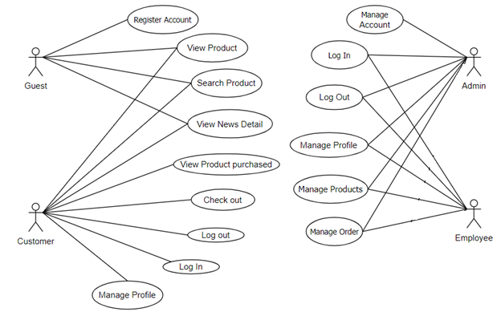

### 3.2.2 Use Case Admin

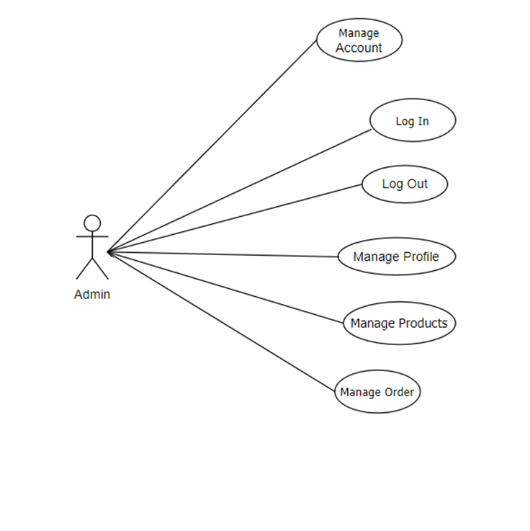

### 3.2.3 Use Case Employee

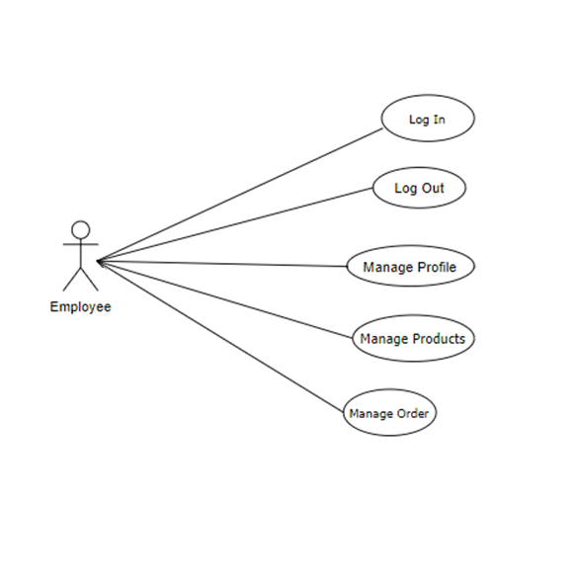

### 3.2.4 Use Case Client

### 

## 3.4 Non-Functional Requirements

Non-functional requirements may exist for the following attributes. Often these requirements must be achieved at a system-wide level rather than at a unit level. State the requirements in the following sections in measurable terms (e.g., 95% of transaction shall be processed in less than a second, system downtime may not exceed 1 minute per day, > 30 day MTBF value, etc).

### 3.4.1 Performance

Responsive: The website should load quickly and respond promptly to user actions.

Google Integration: The website allows users to log in and register with google verified account.

### 3.4.2 Compatibility

Browser compatibility: The website should be compatible with popular web browsers, ensuring consistent functionality and appearance across different platforms.

Device compatibility: The website should be responsive and optimized for various devices, including desktops, Computers, tablets, and mobile phones.

### 3.4.3 Security

Data protection: User data, including personal and financial information, should be securely stored and transmitted using encryption and secure protocols.

Authentication and authorization: Proper mechanisms should be in place to verify user identities and control access to sensitive data and functionality.

### 3.4.4 Maintainability

Modularity: The website should be designed in a modular manner, making it easier to maintain, update, and add new features.

Documentation: Comprehensive documentation should be provided to aid in future maintenance and troubleshooting efforts.

## 3.5 Design Constraints

*The programming language is Java and the server is Tomcat 10.*

*The programming language to manage relational databases is MSSQL with Microsoft SQL Server Management Studio 18.*

*The system shall use the current corporate standard Oracle database engine.*

*All HTML code shall conform to the HTML 5.0 standard.*

# A. Appendices

## A.1 Business Rule

* BR-01 Full name must be 1-50 characters and contain no special characters.
* BR-02 Users can only access information that belongs to them, except administrator.
* BR-03 Content manager only signs in with the account provided by the administrator.
* BR-04 Each user has exactly one role.
* BR-05 Each email is only registered for an account.
* BR-06 Email must be in the correct format: “abc123@gmail.com”.
* BR-07 Username must be unique.
* BR-08 Username does not contain spaces and special characters.
* BR-09 The length of the username must be between 4-20 characters.
* BR-10 Password must be encrypted.
* BR-11 Password length must be between 4-20 characters and contain no spaces.
* BR-12 When changing the password, the user must enter the old password.
* BR-13 Phone can only contain 10 digits and start with 0.
* BR-14 Date of birth must be before current time.
* BR-15 All managed lists must be displayed with pagination.
* BR-16 Fields marked with an asterisk (*) cannot be left blank.
* BR-17 When reset the password, the user must enter the email so that system can send verify code.
* BR-18 When register account, the user must enter the password twice.

## A.2 References

* IEEE Recommended Practice for Software Requirements Specifications," in IEEE Std 830-1998, vol., no., pp.1-40, 20 Oct. 1998
* IEEE Guide for Developing System Requirements Specifications," in IEEE Std 1233-1996, vol., no., pp.1-30, 22 Dec. 1996.