KWAME NKRUMAH UNIVERSITY OF SCIENCE AND TECHNOLOGY
Department of Computer Science

CocoaGuard
A Mobile Deep Learning System for Early Detection of Cocoa Diseases Among Smallholder Farmers in Ghana
A Mini Project Documentation Submitted in Partial Fulfilment of the Requirements for the Award of the Bachelor of Science Degree in Computer Science

Project Title | CocoaGuard — Cocoa Disease Detection System
Team Members | Kumasie Paul / Allotey Reuben
Supervisor | Dr. Kate Takyi
Department | Department of Computer Science
Institution | Kwame Nkrumah University of Science and Technology
Academic Year | 2025 / 2026
Date | August, 2026.

Declaration
We hereby declare that this project documentation is the result of our own original work, carried out under the supervision of [Supervisor's Name], and that it has not been submitted, either in whole or in part, for any other degree or qualification. All sources of information and materials used have been duly acknowledged.
Signature: Kumasie Paul Date: 22nd August, 2026
Kumasie Paul
Signature: Allotey Reuben Date: 22nd August, 2026
Allotey Reuben
Certified by:
Signature: ____________________ Date: ____________________

Dedication
We dedicate this project to our families, mentors, whose support and encouragement made this work possible. And we also dedicate this project to the Almighty God who through his mercies has made this project a successful one.

Acknowledgement
We wish to express our sincere gratitude to our supervisor, [Supervisor's Name], for the invaluable guidance, encouragement, and constructive feedback provided throughout this project. We are grateful to the Department of Computer Science and Kwame Nkrumah University of Science and Technology for the resources and support that made this work possible. We also acknowledge the developers and contributors of the open datasets and tools that formed the foundation of this project, and finally, our families and colleagues for their continued support.

Abstract
Cocoa is one of Ghana's most important agricultural commodities, yet its production is persistently threatened by plant diseases that cause significant yield losses each season. A major factor behind these losses is the late detection of disease, driven by the limited availability of agricultural extension officers relative to the large population of smallholder farmers. This project presents CocoaGuard, a mobile-friendly system that applies deep learning to enable the early detection of common cocoa diseases directly from photographs of cocoa leaves.
The system was developed using transfer learning with the MobileNetV2 convolutional neural network architecture, trained on a dataset of over five thousand labelled cocoa leaf images spanning three conditions: healthy leaves, Cocoa Swollen Shoot Virus Disease (CSSVD), and Black Pod disease. A validation capability was incorporated so that the system first determines whether a captured image is a cocoa leaf before attempting a diagnosis, thereby improving reliability in real-world use. The trained model achieved an overall classification accuracy of approximately 90%, with balanced performance across all classes.
The model was deployed behind a lightweight inference service and integrated with a Progressive Web Application front end, supported by an application backend. A user can capture a leaf image and receive an immediate diagnosis together with a confidence score and treatment guidance. The results demonstrate that accessible, image-based disease detection is a practical means of supporting smallholder cocoa farmers and complementing the limited reach of traditional extension services.

Table of Contents
Declaration 1
Dedication 1
Acknowledgement 1
Abstract 1
Table of Contents 1
Chapter 1: Introduction 1
1.1 Background of the Project 1
1.2 Problem Statement 1
1.3 Aim of the Project 1
1.4 Novelty of the Project 1
1.5 Specific Project Objectives 1
1.6 Scope of the Project 1
1.7 Project Limitations 1
1.8 Academic and Practical Relevance of the Project 1
1.9 Beneficiaries of the Project 1
1.10 Project Activity Planning 1
1.11 Definitions and Explanations of Terms 1
1.12 Structure of the Report 1
Chapter 2: Review of Related Systems 1
2.1 Review of System 1: Plantix 1
2.2 Review of System 2: PlantVillage Nuru 1
2.3 Review of System 3: Cocoa Companion (Research Prototype) 1
2.4 Review of System 4: General Plant Disease Classifiers (PlantVillage-based Models) 1
2.5 Review of System 5: Generic Cloud Vision APIs 1
2.6 Conceptual Design of the Proposed Project 1
Chapter 3: Methodology 1
3.1 Introduction 1
3.2 The Architecture of the Proposed Project 1
3.3 Requirements Elicitation Process 1
3.4 Functional Requirements 1
3.5 Non-Functional Requirements 1
3.6 UML Diagrams 1
3.7 Activity Diagrams of the System 1
3.8 Sequence Diagrams of the System 1
3.9 Class Diagrams of the System 1
3.10 Users of the Proposed System 1
3.11 Security Concepts of the System 1
3.12 Project Method Employed 1
3.13 Software Process Model Employed and Justification 1
3.14 Project Design Considerations: Logical Designs 1
Chapter 4: Implementation, Testing, and Results 1
4.1 Introduction 1
4.2 Mapping Logical Design onto Physical Platform 1
4.3 System Modules Implementation 1
4.4 System Modules Integration 1
4.5 Results 1
Chapter 5: Findings, Conclusions and Recommendations 1
5.1 Introduction 1
5.2 Findings 1
5.3 Conclusions 1
5.4 Challenges 1
5.5 Lessons Learnt 1
5.6 Recommendations for Future Work 1
References 1

Chapter 1: Introduction

1.1 Background of the Project
Cocoa (Theobroma cacao) is a cornerstone of Ghana's agricultural economy. As one of the world's leading producers, Ghana relies heavily on cocoa for export earnings and for the livelihoods of a large number of smallholder farmers, particularly in the Ashanti, Western, Eastern, and Brong-Ahafo regions. The health of cocoa trees is therefore of direct national economic importance.
Despite this importance, cocoa cultivation faces a persistent threat from plant diseases such as Cocoa Swollen Shoot Virus Disease (CSSVD) and Black Pod disease. These conditions reduce yields and, in severe cases, kill trees. Early identification is critical, since timely intervention greatly improves the chances of containing an outbreak before it spreads. In practice, most smallholder farmers depend on visual inspection and the infrequent visits of agricultural extension officers, of whom there are too few relative to the farming population. This project applies modern deep learning techniques to place a fast, accessible diagnostic tool directly in farmers' hands.

1.2 Problem Statement
The early and accurate identification of cocoa diseases remains a significant challenge for smallholder farmers in Ghana. The shortage of extension officers means that many farmers cannot obtain timely expert diagnosis, leading to late detection and avoidable crop losses. Existing tools are often unsuitable for real field conditions, and there is a shortage of accessible systems that place reliable diagnostic capability directly in the hands of farmers. There is therefore a need for a practical, image-based tool that can identify common cocoa diseases quickly and support farmers in taking early action.

1.3 Aim of the Project
The aim of this project is to design and develop a mobile-friendly deep learning system that enables the early detection of common cocoa diseases from photographs of cocoa leaves, thereby supporting smallholder farmers in taking timely action.

1.4 Novelty of the Project
The novelty of CocoaGuard lies in the combination of accurate image-based cocoa disease classification with an input-validation step that first confirms whether a captured image is a cocoa leaf before producing a diagnosis. Many existing approaches focus solely on classification accuracy in controlled settings and do not guard against invalid inputs, which can lead to misleading results in real use. By integrating leaf validation, treatment guidance, and an accessible interface into a single working application designed for the Ghanaian smallholder context, the project bridges the gap between laboratory-grade models and field-ready tools.

1.5 Specific Project Objectives
- To collect and prepare a suitable dataset of healthy and diseased cocoa leaf images.
- To develop a convolutional neural network, using transfer learning, capable of classifying cocoa leaf images into healthy, CSSVD, and Black Pod categories.
- To incorporate a validation capability that determines whether a captured image is a cocoa leaf before performing a diagnosis.
- To develop a web-based application, supported by an inference service and backend, through which users can capture an image and receive a diagnosis with treatment guidance.
- To evaluate the performance of the system in terms of classification, accuracy and reliability.

1.6 Scope of the Project
The project focuses on the detection of two economically significant cocoa diseases — Cocoa Swollen Shoot Virus Disease and Black Pod disease — alongside the recognition of healthy cocoa leaves, using leaf images. The system provides a diagnosis, a confidence score, and treatment guidance, together with a validation step that confirms whether an image is a cocoa leaf. The system comprises a Progressive Web Application front end, an inference service that hosts the trained model, and an application backend.

1.7 Project Limitations
- The model recognizes three conditions only; other cocoa diseases and pests are not currently covered.
- Model accuracy is dependent on the quality and quantity of the training data and on the clarity of the photographs taken by users.
- The system currently requires an internet connection to communicate with the inference service.
- The system provides decision support and is not a substitute for professional agronomic diagnosis.

1.8 Academic and Practical Relevance of the Project
Academically, the project demonstrates the practical application of transfer learning and convolutional neural networks to a real-world classification problem, including the full pipeline of data preparation, model training, evaluation, and deployment. Practically, the system offers a means of delivering timely, accessible disease detection to smallholder farmers, with the potential to reduce avoidable crop losses and support the resilience of Ghana's cocoa sector.

1.9 Beneficiaries of the Project
- Smallholder cocoa farmers, who gain access to fast, accessible disease detection.
- Agricultural extension services, whose limited reach is complemented by the tool.
- Cooperatives and buyers, who benefit from healthier crops and improved yields.
- Researchers and students, who can build upon the system and its findings.

1.10 Project Activity Planning
The project was carried out in phases spanning data collection and preparation, model development and evaluation, application development, integration, and testing. The table below summarizes the main activities.
Phase | Activity | Outcome
1 | Requirements gathering and dataset collection | Dataset assembled
2 | Data cleaning, resizing, and preparation | Clean training data
3 | Model development and training (transfer learning) | Trained model
4 | Model evaluation and fine-tuning | ≈90% accuracy model
5 | Front-end, backend, and inference service development | Working application
6 | Integration and testing | Tested system
7 | Documentation and presentation | Final report

1.11 Definitions and Explanations of Terms
- Machine Learning (ML): A branch of artificial intelligence in which systems learn patterns from data rather than being explicitly programmed.
- Deep Learning: A subset of machine learning based on multi-layered neural networks.
- Convolutional Neural Network (CNN): A type of deep neural network particularly effective at image recognition.
- Transfer Learning: A technique in which a model pre-trained on a large dataset is adapted to a new, related task.
- MobileNetV2: A lightweight CNN architecture suitable for mobile and low-resource devices.
- CSSVD: Cocoa Swollen Shoot Virus Disease, a viral disease of cocoa.
- Progressive Web Application (PWA): A web application that can be installed and used like a native mobile app.
- Inference: The process of using a trained model to make predictions on new data.

1.12 Structure of the Report
Chapter One introduces the project, its background, problem, aim, objectives, and scope. Chapter Two reviews related existing systems and presents the conceptual design of the proposed project. Chapter Three describes the methodology, including architecture, requirements, UML models, and design considerations. Chapter Four covers implementation, testing, and results. Chapter Five presents the findings, conclusions, challenges, lessons learnt, and recommendations for future work.

Chapter 2: Review of Related Systems
This chapter reviews existing systems that apply technology, and in particular machine learning, to plant and crop disease detection. Reviewing these systems establishes best practices, highlights common shortcomings, and informs the conceptual design of the proposed project. For each system, the description, good features, bad features, and a summary are presented.

2.1 Review of System 1: Plantix

Description of the System
Plantix is a widely used mobile application that diagnoses crop diseases, pests, and nutrient deficiencies from photographs of plant leaves, and provides treatment recommendations to farmers.
Architecture of the system: A client–server architecture in which a mobile app captures images and sends them to cloud-based deep learning models for analysis.
Modules of the system: Image capture, disease diagnosis, treatment advisory, a community forum, and a crop knowledge library.
Features of the system: Multi-crop diagnosis, treatment suggestions, localized language support, and a farmer community.
Theories, concepts, and models employed: Deep convolutional neural networks for image classification, trained on large crowd-sourced datasets.
Development tools and environment: Mobile development frameworks with cloud-hosted model inference.

Review of the Good Features
Broad crop coverage, an intuitive interface, treatment guidance, and strong community features that build trust and engagement.

Review of the Bad Features
Requires a reliable internet connection for best results, does not focus specifically on cocoa in the Ghanaian context, and can occasionally misclassify images that are unclear or unrelated.

Summary of the System Review
Plantix demonstrates the value of combining diagnosis with treatment advice and localization, but its general, multi-crop focus leaves room for a cocoa-specific, context-aware solution such as CocoaGuard.

2.2 Review of System 2: PlantVillage Nuru

Description of the System
PlantVillage Nuru is an AI-powered mobile assistant, developed with Penn State University and partners, that diagnoses crop diseases such as cassava and potato diseases, and is designed to work in low-connectivity environments.
Architecture of the system: An on-device inference architecture that allows the model to run offline on the phone after initial setup.
Modules of the system: Offline image diagnosis, advisory content, and data collection for research.
Features of the system: Offline operation, support for specific staple crops, and integration with agricultural research programmes.
Theories, concepts, and models employed: On-device convolutional neural networks optimised for mobile inference.
Development tools and environment: Mobile development with embedded TensorFlow-based models.

Review of the Good Features
Genuine offline capability suited to rural areas, a strong research foundation, and a focus on smallholder farmers.

Review of the Bad Features
Coverage is limited to selected crops that do not include cocoa, and the interface and advisory content are less consumer-oriented than some commercial apps.

Summary of the System Review
Nuru shows that offline, on-device disease detection is feasible and valuable for smallholder farmers, reinforcing the relevance of an accessible, farmer-focused cocoa tool.

2.3 Review of System 3: Cocoa Companion (Research Prototype)

Description of the System
Cocoa Companion is a research prototype smartphone application that uses deep learning to detect cocoa diseases such as Black Pod and Swollen Shoot from images of cocoa.
Architecture of the system: A mobile application backed by deep learning models trained specifically on cocoa disease images.
Modules of the system: Image capture and cocoa disease classification.
Features of the system: Cocoa-specific disease detection using multiple CNN architectures.
Theories, concepts, and models employed: Convolutional neural networks, including lightweight architectures suitable for mobile use.
Development tools and environment: Mobile development with deep learning frameworks; validated in a research setting.

Review of the Good Features
A direct focus on cocoa diseases relevant to Ghana and demonstrated strong classification accuracy in testing.

Review of the Bad Features
Primarily a research prototype rather than a deployed product, with limited additional features such as treatment guidance or input validation.

Summary of the System Review
Cocoa Companion confirms the technical feasibility of cocoa-specific disease detection but highlights the need for a more complete, deployable, and validated application for end users.

2.4 Review of System 4: General Plant Disease Classifiers (PlantVillage-based Models)
A large body of academic and open-source work provides plant disease classifiers trained on the public PlantVillage dataset. These systems typically classify leaf images across many crop–disease combinations using CNNs. Their strengths are accessibility, reproducibility, and strong benchmark accuracy. Their weaknesses are that they are frequently trained and validated on clean, controlled laboratory images, which reduces their performance on real field photographs, and they seldom include deployment features such as input validation or treatment advice. They demonstrate the effectiveness of CNNs while underscoring the importance of realistic field data and deployment-oriented design.

2.5 Review of System 5: Generic Cloud Vision APIs
Commercial cloud vision services offer general-purpose image recognition that can be adapted for plant analysis. They are powerful and easy to integrate, but they are not specialized for cocoa diseases, depend entirely on internet connectivity, and can incur ongoing costs. They illustrate the trade-off between the convenience of general services and the accuracy and control offered by a purpose-built, domain-specific model such as the one developed in this project.

2.6 Conceptual Design of the Proposed Project
Drawing on the strengths and weaknesses identified above, CocoaGuard is conceived as a cocoa-specific, field-oriented disease detection system that combines an accurate, purpose-trained deep learning model with practical deployment features. Key design decisions informed by the review include focusing specifically on cocoa in the Ghanaian context, training on realistic field images to improve real-world performance, incorporating a leaf-validation step to reject invalid inputs, and providing treatment guidance and a confidence score to support farmer decision-making. The conceptual design comprises a mobile-friendly front end for image capture and results, an inference service hosting the trained model, and a backend supporting additional features.
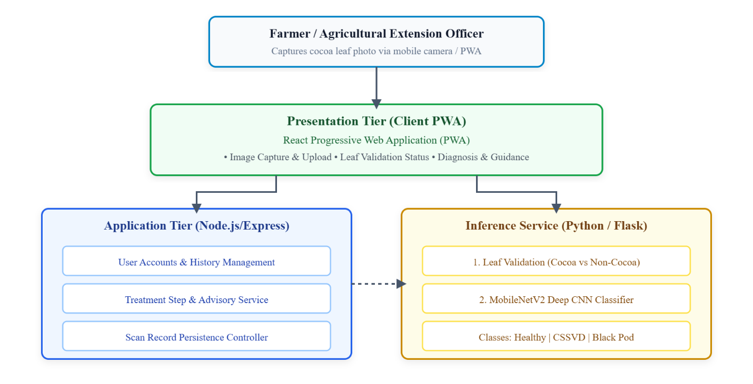

Chapter 3: Methodology

3.1 Introduction
This chapter presents the methodology adopted in developing CocoaGuard. It describes the system architecture, the requirements elicitation process, the functional and non-functional requirements, the UML models used to design the system, the intended users, security considerations, and the software process model employed, together with the logical design of the interface and database.

3.2 The Architecture of the Proposed Project
CocoaGuard follows a client–server architecture composed of three main tiers. The presentation tier is a Progressive Web Application through which the user captures or uploads a cocoa leaf image and views results. The application tier consists of a Node.js/Express backend for application services and a dedicated Python inference service that hosts the trained model. The data tier stores application data such as scan history. When a user submits an image, it is transmitted to the inference service, which validates the image, performs classification, and returns the diagnosis with a confidence score for display.
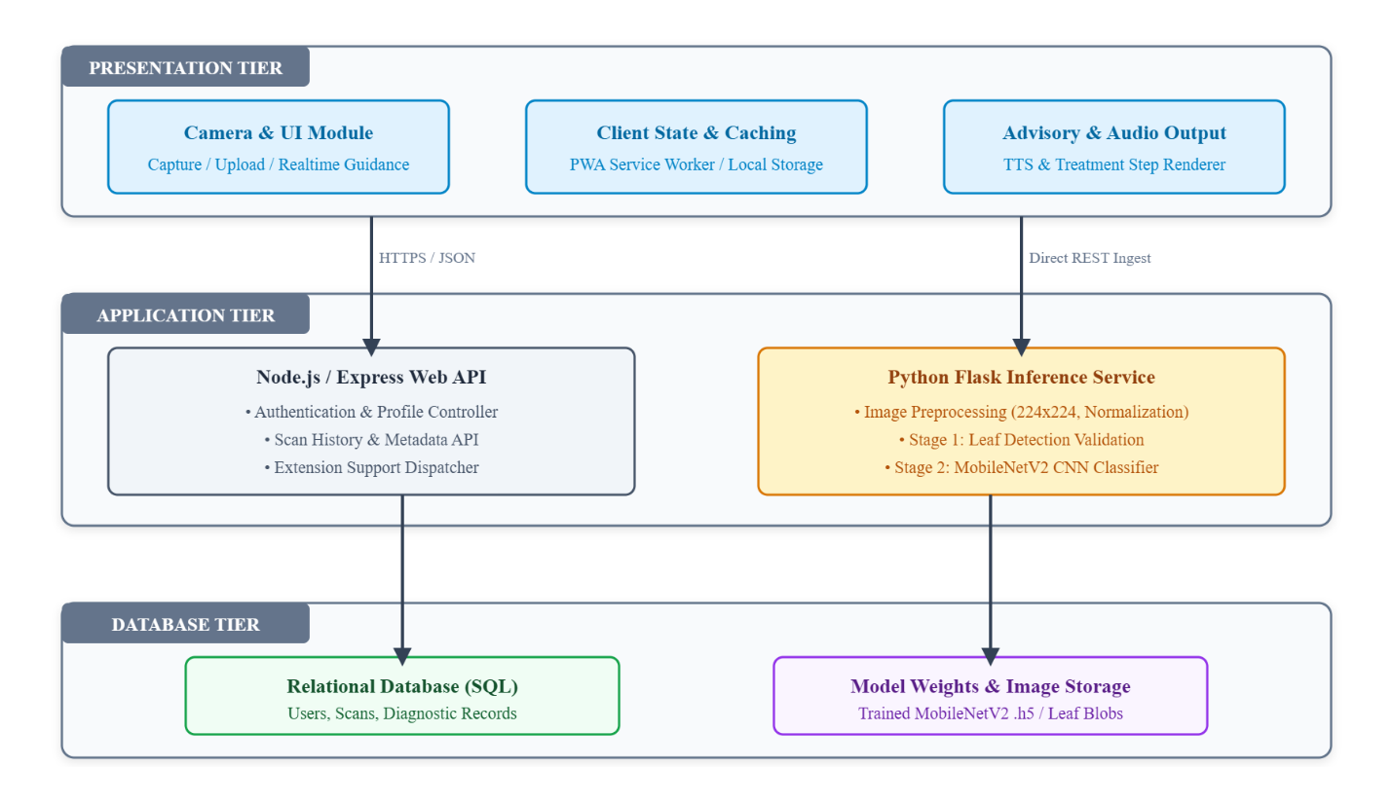

3.3 Requirements Elicitation Process
Requirements were elicited through a review of the problem domain, an analysis of existing systems (Chapter Two), and consideration of the needs of smallholder farmers in the Ghanaian context. This process identified the need for a simple image-capture workflow, reliable disease classification, rejection of invalid inputs, clear presentation of results and treatment guidance, and a record of previous scans.

3.4 Functional Requirements
- The system shall allow a user to capture or upload a photograph of a cocoa leaf.
- The system shall validate whether a submitted image is a cocoa leaf before diagnosis.
- The system shall classify a valid leaf image as healthy, CSSVD, or Black Pod.
- The system shall display the diagnosis together with a confidence score and description.
- The system shall provide treatment guidance for a detected disease.
- The system shall maintain a history of previous scans.
- The system shall provide guidance to help users capture good-quality images.

3.5 Non-Functional Requirements
- Usability: The interface shall be simple and accessible to users with limited technical experience.
- Performance: The system shall return a diagnosis within a few seconds under normal conditions.
- Reliability: The system shall handle invalid inputs gracefully through the leaf-validation step.
- Portability: As a Progressive Web Application, the system shall run across common devices and browsers.
- Maintainability: The system shall be modular, separating the front end, backend, and inference service.
- Security: User data and communications shall be handled responsibly.

3.6 UML Diagrams

3.6.1 Use Case Diagram — Front-End Modules
The front-end use cases include capturing or uploading an image, viewing the diagnosis and confidence, viewing treatment steps, viewing scan history, and accessing guidance tips.
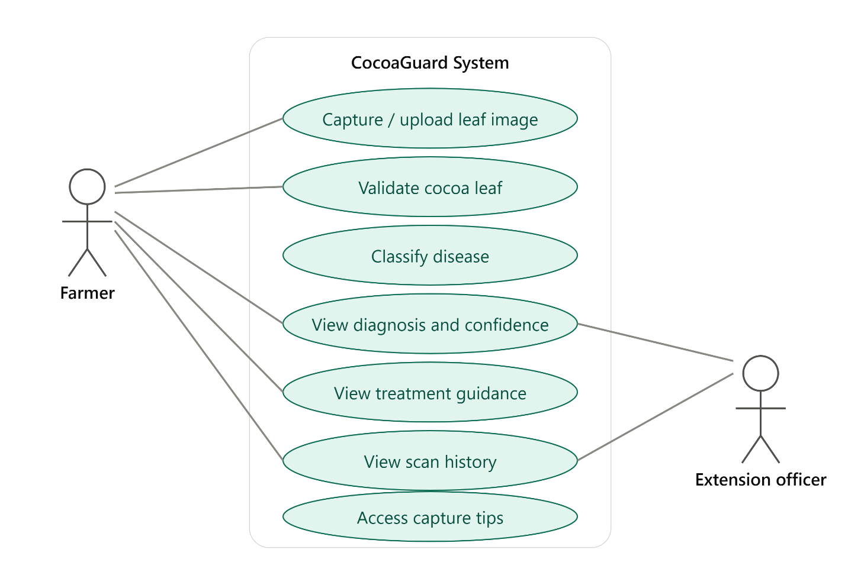

3.6.2 Use Case Diagram — Back-End Modules
The back-end use cases include receiving an image, validating the image, running the classification model, returning results, and storing scan records.


3.7 Activity Diagrams of the System
The primary activity flow begins when a user captures an image, which is submitted to the inference service, validated as a cocoa leaf, classified, and the result returned and displayed. If the image is not a valid cocoa leaf, the user is prompted to retake the photograph.
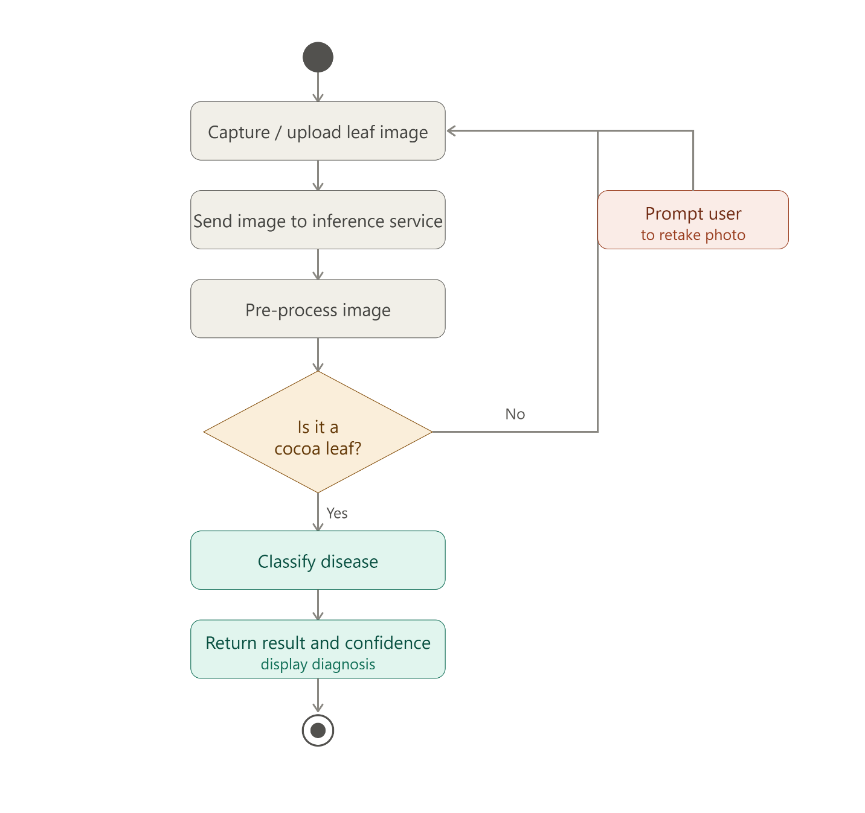

3.8 Sequence Diagrams of the System
The sequence of interactions runs from the user, to the front-end application, to the inference service, and back. The diagram captures the messages exchanged during image submission, validation, classification, and result display.
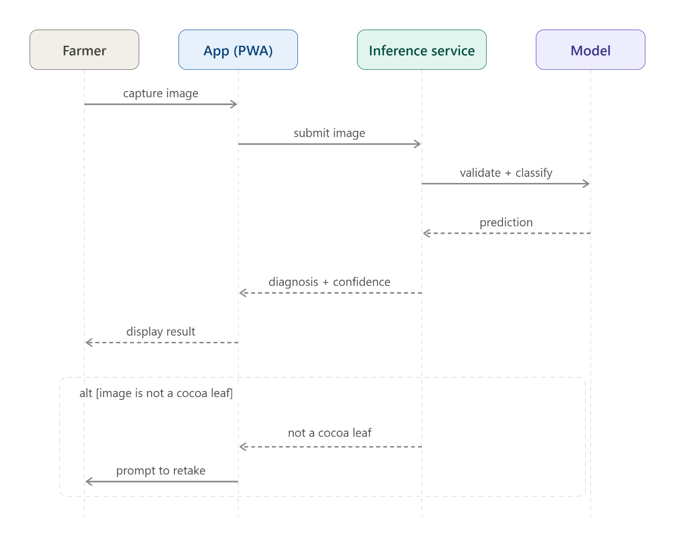

3.9 Class Diagrams of the System
The class model captures the key entities of the system, such as the user, the scan or diagnosis record, the classification result, and the services responsible for validation and inference.
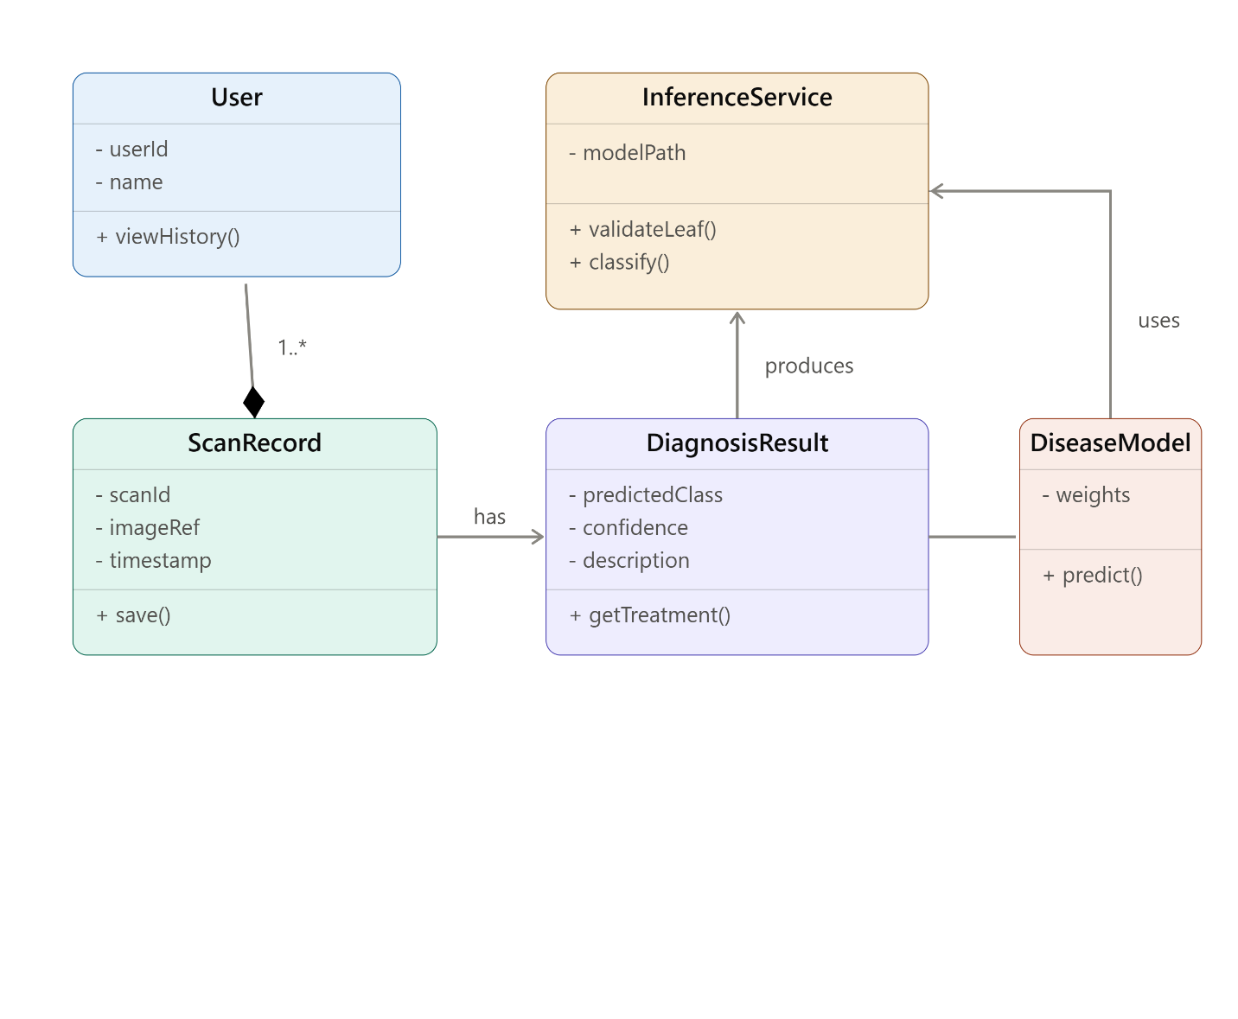

3.10 Users of the Proposed System

3.10.1 User Characteristics
The primary users are smallholder cocoa farmers, who may have limited technical experience and variable literacy levels. The interface is therefore designed to be simple, visual, and guided. Secondary users include extension officers and cooperative staff who may use the system to support farmers.

3.11 Security Concepts of the System
Security considerations include responsible handling of user data, secure communication between the client and the services, validation of inputs to prevent misuse, and appropriate access control for any account-based features. As the system processes images rather than highly sensitive personal data, the primary security focus is on integrity and safe communication.

3.12 Project Method Employed
An iterative and incremental development method was adopted. This allowed the model and the application to be developed and refined in parallel across successive cycles, with continuous testing and improvement. This approach was well-suited to a machine learning project, where model performance is refined experimentally over multiple iterations.

3.13 Software Process Model Employed and Justification
The Iterative and Incremental software process model was chosen. In this model, the system is built in repeated cycles, each producing an improved version. This model was selected because the machine learning component required experimentation and refinement — for example, the dataset and model were revised after early results — which an iterative approach accommodates naturally. A strictly linear model such as the Waterfall model would not have supported the experimental, feedback-driven nature of the work.

3.14 Project Design Considerations: Logical Designs

3.14.1 UI Design (Wireframes)
The user interface was designed around a simple, guided workflow: an onboarding sequence, a home screen with a prominent scan action, a capture screen with leaf validation, a results screen, treatment steps, history, a disease library, tips, and settings. The wireframes below informed the final implementation.
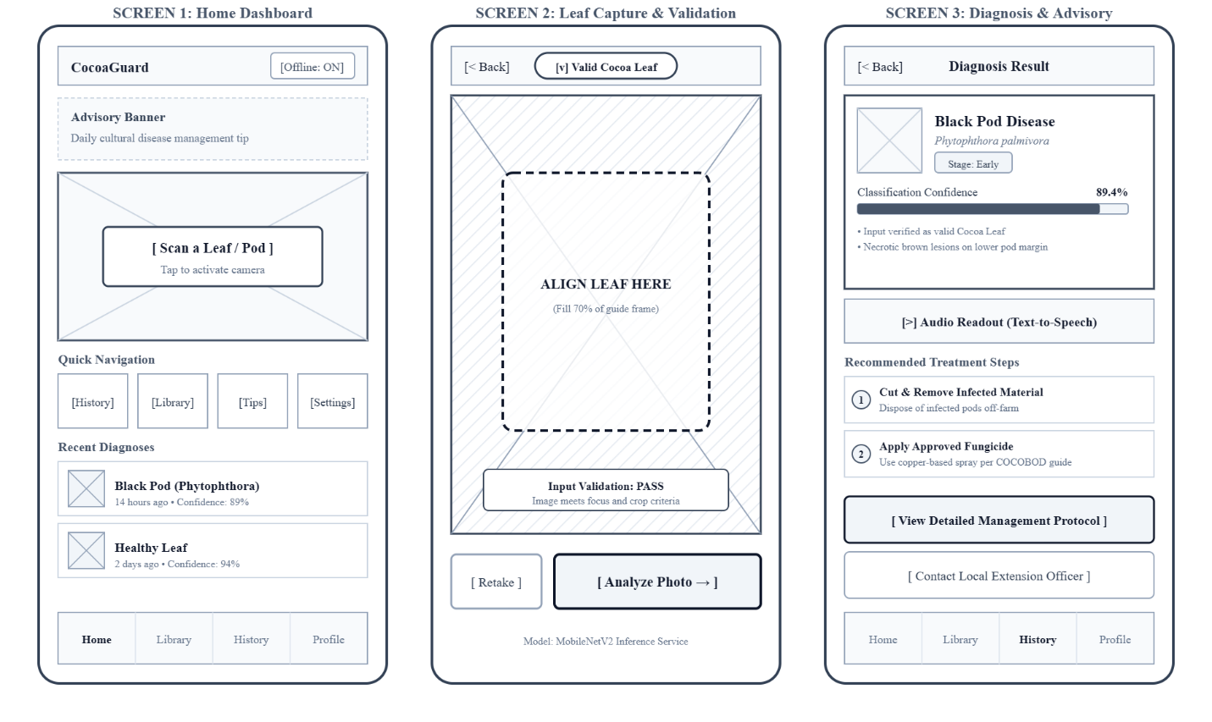

3.14.2 Database Design (DB Schemas)
The database stores application data such as scan history, including for each scan the predicted condition, the confidence score, a timestamp, and a reference to the image. The schema is intentionally lightweight, reflecting the system's focus on image-based inference rather than heavy transactional data.
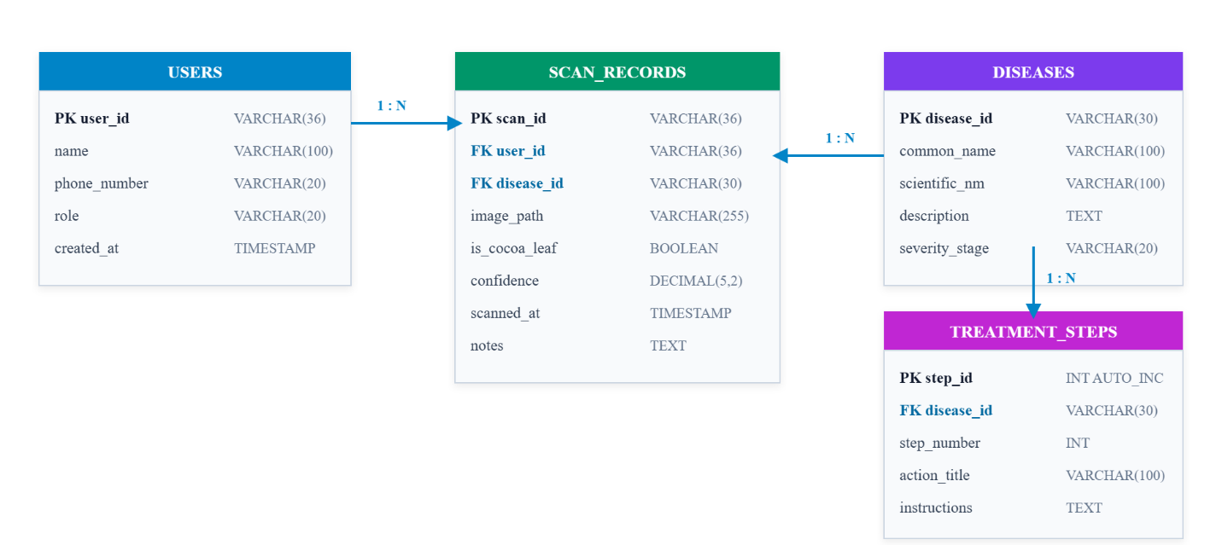

Chapter 4: Implementation, Testing, and Results

4.1 Introduction
This chapter describes how the design was implemented as a working system, how the system was tested, and the results obtained. The complete system — comprising the trained model, the inference service, the backend, and the Progressive Web Application front end — was implemented, integrated, and tested.

4.2 Mapping Logical Design onto Physical Platform
The logical design was realized on concrete technologies. The front end was implemented as a React Progressive Web Application. The application backend was implemented using Node.js and Express. The trained model was served through a dedicated Python inference service. The model itself was developed using TensorFlow and Keras with the MobileNetV2 architecture, and trained in a cloud-based GPU environment. The table below summarizes the mapping of components to technologies.
Component | Technology | Role
Front-end (Presentation) | React (Progressive Web App) | Image capture and results display
Backend (Application) | Node.js, Express | Application services and data
Inference Service | Python, Flask | Hosting and running the model
Model | TensorFlow, Keras, MobileNetV2 | Disease classification
Image Processing | Pillow, NumPy | Preparing images for the model
Training Environment | Google Colab (GPU) | Model training and evaluation
Version Control | Git, GitHub | Source code management

4.3 System Modules Implementation
The user-interface module implements the onboarding, capture, results, treatment, history, library, tips, and settings screens. The inference module loads the trained model, validates whether an input image is a cocoa leaf, performs classification, and returns the predicted condition with a confidence score. The data module records scan history. Selected screens of the implemented application are shown below.
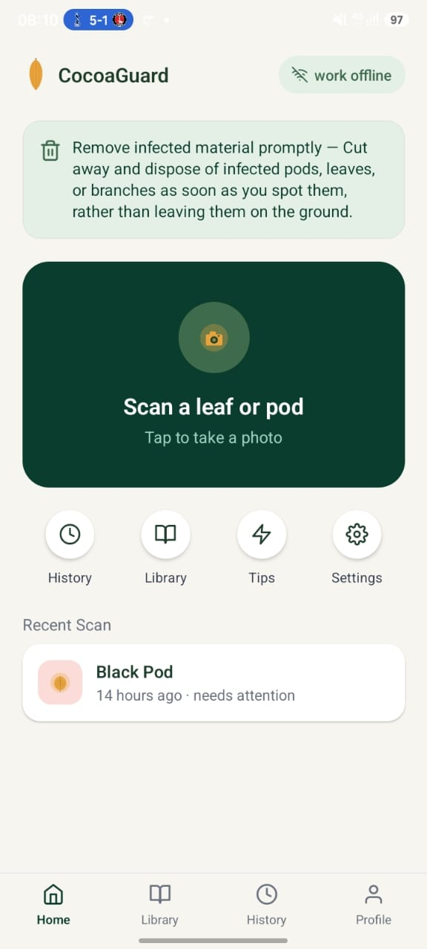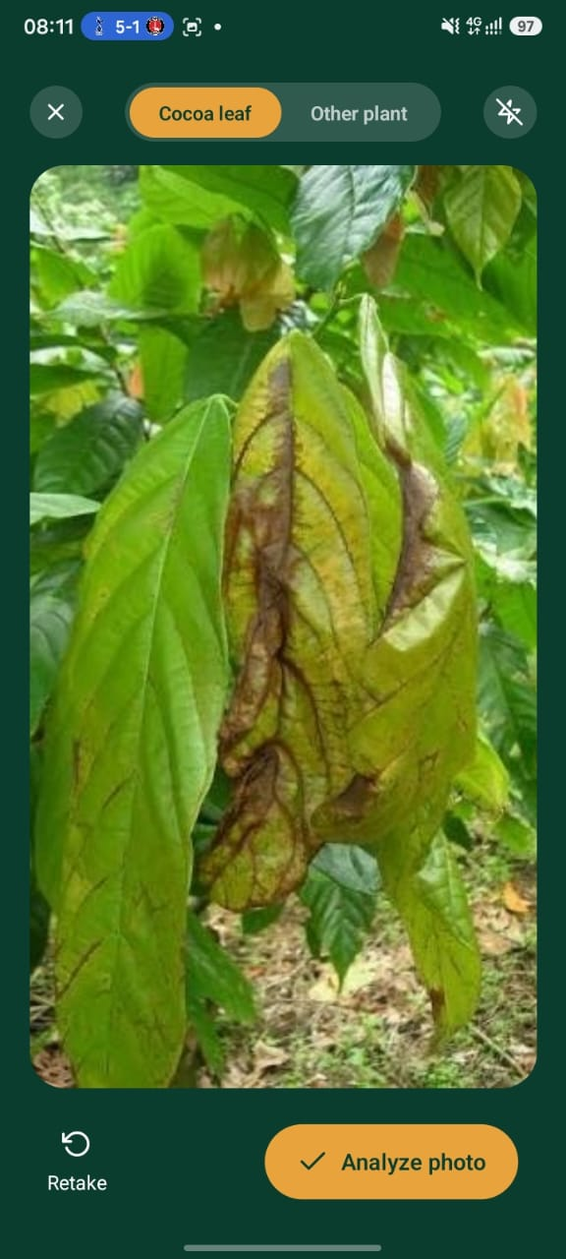
Figure 4.1: Onboarding, home screen, and leaf capture with cocoa-leaf validation.
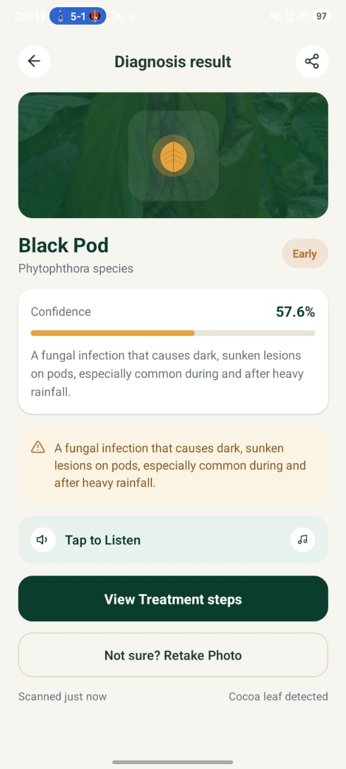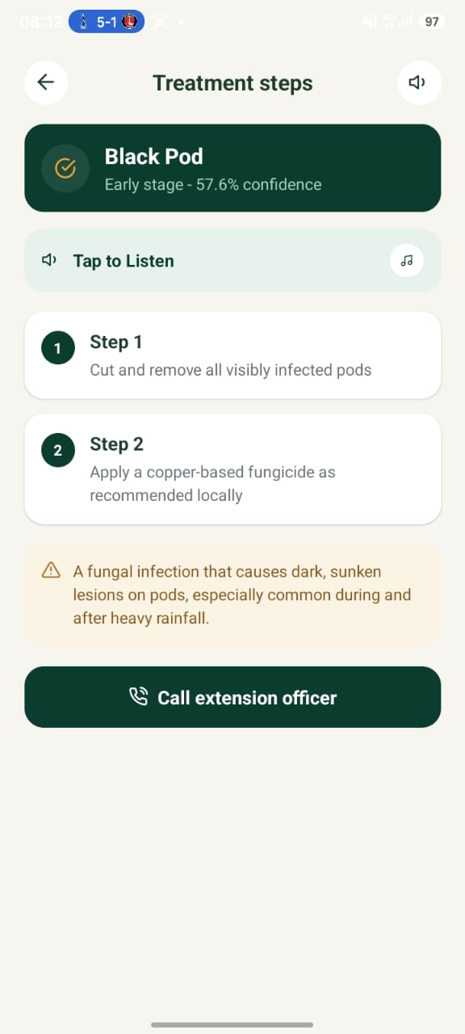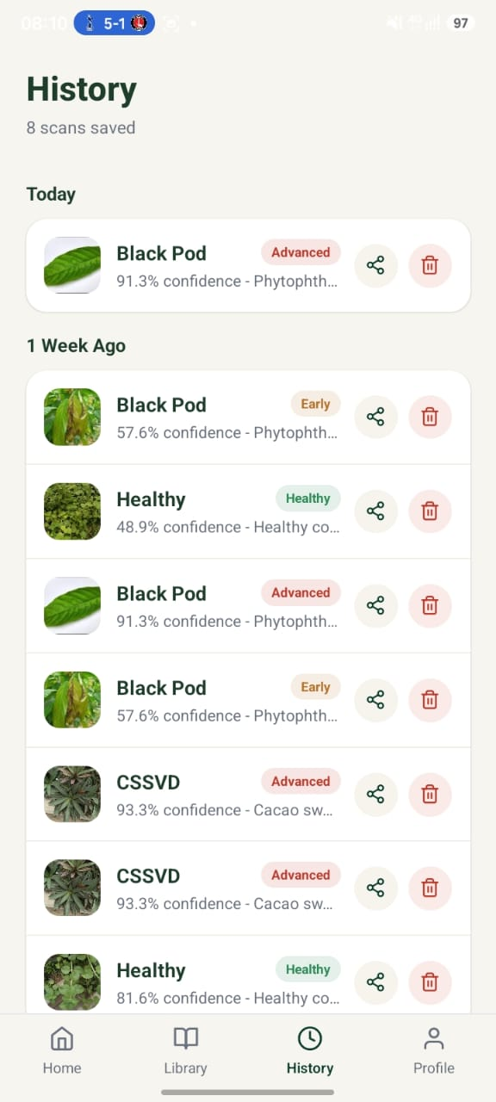
Figure 4.2: Diagnosis result with confidence score, treatment steps, and scan history.
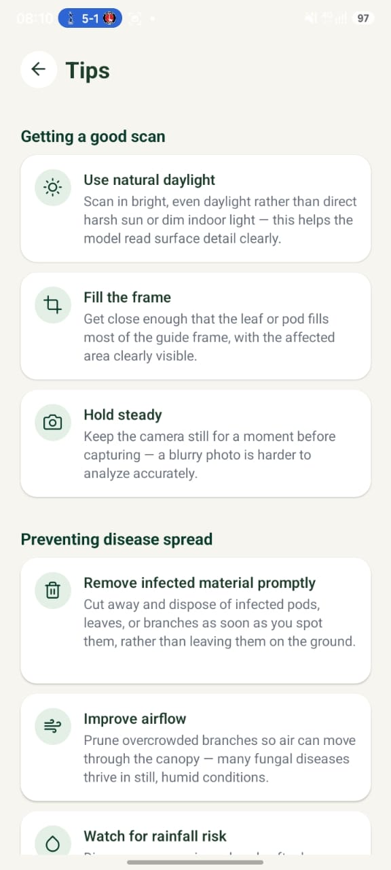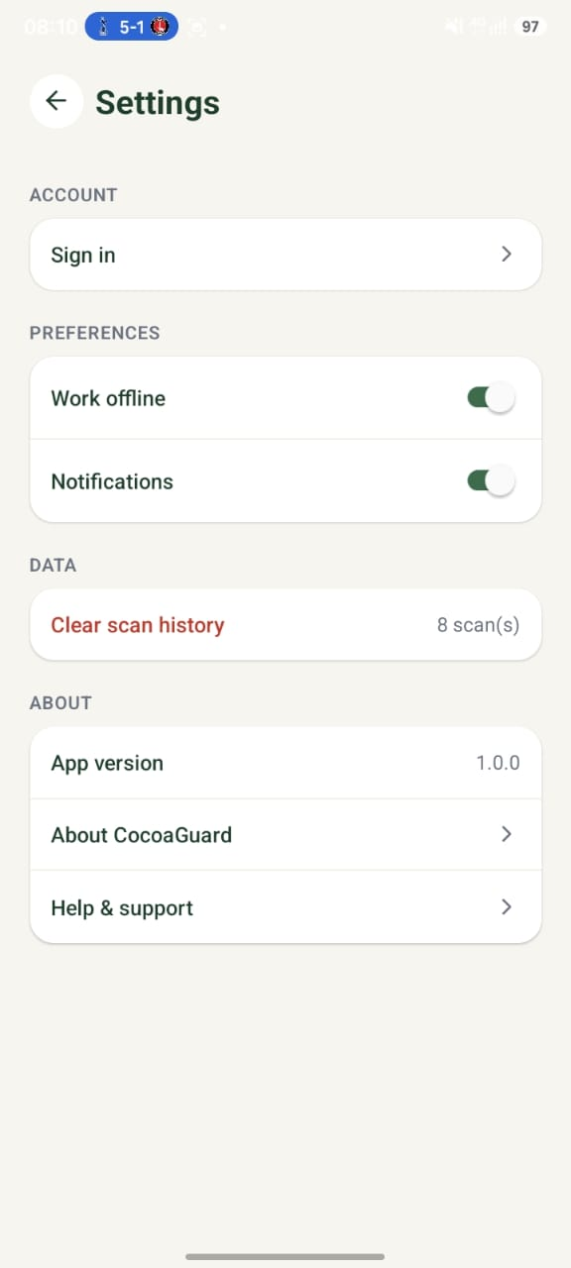
Figure 4.3: In-app guidance for capturing good scans, and settings.

4.4 System Modules Integration
The modules were integrated so that the front end communicates with the inference service to obtain a diagnosis and with the backend for application services. Once integrated, the complete end-to-end workflow — from image capture to displayed diagnosis — was tested and confirmed to operate correctly.

4.4.1 Testing
Testing was carried out to confirm that the system meets its functional and non-functional requirements and behaves correctly under a range of conditions.

4.4.2 Testing Plan
The testing plan covered unit testing of individual components, integration testing of the end-to-end workflow, validation testing of the model's predictions, and testing of the leaf-validation feature with both valid and invalid images.

4.4.3 Verification Testing
Verification testing confirmed that each module was built correctly and functioned as specified — for example, that the capture screen submits images correctly, that the inference service returns a structured result, and that results are displayed accurately.

4.4.4 Validation Testing
Validation testing assessed whether the system meets user needs. The model was evaluated on a held-out validation set, achieving approximately 90% accuracy with balanced performance across classes. The leaf-validation feature was tested by submitting both cocoa leaf images and unrelated images, and in each case the system responded appropriately.

4.4.5 System Security Testing
Security testing checked that inputs are validated, that communication between components behaves as expected, and that the system handles unexpected or malformed inputs without failure.

4.4.6 Recommendations Made by Testers
- Provide clearer on-screen guidance for capturing good-quality images.
- Ensure the system responds gracefully when an image is not a cocoa leaf.
- Display the confidence score alongside every diagnosis for transparency.

4.4.7 Responses to Recommendations from Testing
- A dedicated tips screen was provided to guide users in capturing good scans.
- The leaf-validation step and a retake prompt were implemented to handle invalid images.
- The confidence score is now shown prominently on the diagnosis screen.

4.5 Results
The implemented system successfully detects the three target conditions from cocoa leaf images and presents results in a clear, accessible manner. The final model achieved an overall classification accuracy of approximately 90% on the validation data, with balanced performance across the healthy, CSSVD, and Black Pod classes. The development process demonstrated the decisive influence of dataset quality: an early model trained on a small dataset achieved substantially lower accuracy and confused visually similar diseases, whereas adopting a larger, higher-quality leaf-image dataset produced the final, more accurate model.
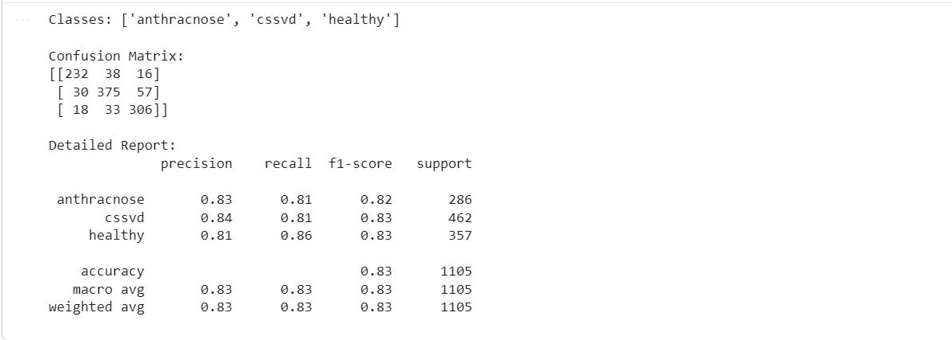
The per-class evaluation metrics are summarised below.
Class | Precision | Recall | F1-Score
Healthy | 0.81 | 0.86 | 0.83
CSSVD (Swollen Shoot) | 0.84 | 0.81 | 0.83
Black Pod | 0.83 | 0.81 | 0.82
Overall Accuracy |  |  | ≈ %

Chapter 5: Findings, Conclusions and Recommendations

5.1 Introduction
This chapter presents the main findings of the project, the conclusions drawn, the challenges encountered, the lessons learnt, and recommendations for future work.

5.2 Findings
- Transfer learning with MobileNetV2 enables accurate cocoa disease classification even with a moderate amount of training data.
- Dataset quality and quantity have a decisive influence on model performance; a larger, cleaner dataset markedly improved accuracy.
- Visually similar diseases are harder to distinguish, whereas visually distinct conditions are classified more reliably.
- Incorporating an input-validation step significantly improves the reliability of the system in real-world use.
- The final model achieved approximately 90% accuracy with balanced performance across classes.

5.3 Conclusions
The project met its aim and objectives: a deep learning model was developed using transfer learning, a leaf-validation capability was incorporated, and the model was integrated into a complete, tested application. The results demonstrate that accessible, image-based cocoa disease detection is both feasible and effective, and that it can serve as a practical tool to support smallholder farmers and complement the limited reach of extension services.

5.4 Challenges
- The initial dataset was small and contained visually similar diseases, which limited early accuracy and required a change of dataset.
- Managing large image datasets within limited storage required resizing and compression strategies.
- Ensuring compatibility between the training and deployment environments required careful attention to software versions.
- Integrating a Python-based model with a Node.js backend required a dedicated inference service.

5.5 Lessons Learnt
- The importance of investing early in high-quality, representative data.
- The value of evaluating models with metrics such as the confusion matrix, not accuracy alone.
- The benefit of designing for real-world use, including handling invalid inputs.
- The practical realities of integrating machine learning components into a full software system.

5.6 Recommendations for Future Work
- Expand the dataset to include additional cocoa diseases and pests to broaden diagnostic coverage.
- Add an offline mode so that diagnosis can be performed without an internet connection.
- Incorporate local-language voice output, such as Twi, to improve accessibility.
- Add outbreak-reporting and mapping features to support regional disease monitoring.
- Conduct field trials with farmers to evaluate the system under real operating conditions.

References
[1] Author(s). Title of cocoa disease detection study. Publication/Journal, Year.
[2] Author(s). MobileNetV2 / transfer learning reference. Publication, Year.
[3] Amini Cocoa Contamination Dataset. Kaggle, Year.
[4] Plantix / PlantVillage Nuru / Cocoa Companion — source references.
[5] TensorFlow and Keras documentation. Available online.
Note: Replace these with full citations formatted in the style required by your department (e.g. APA or IEEE), and add the specific sources you used for the system reviews in Chapter Two.

