EE Summer Project Log
Raspberry Pi Pico 2 W EE Lab Tool
Final integrated documentation update - 27 August 2026
Power/Energy Monitor | RC Analyzer | Diode Analyzer | MCU Telemetry | Source Test | Fault Monitoring | Logging/Export
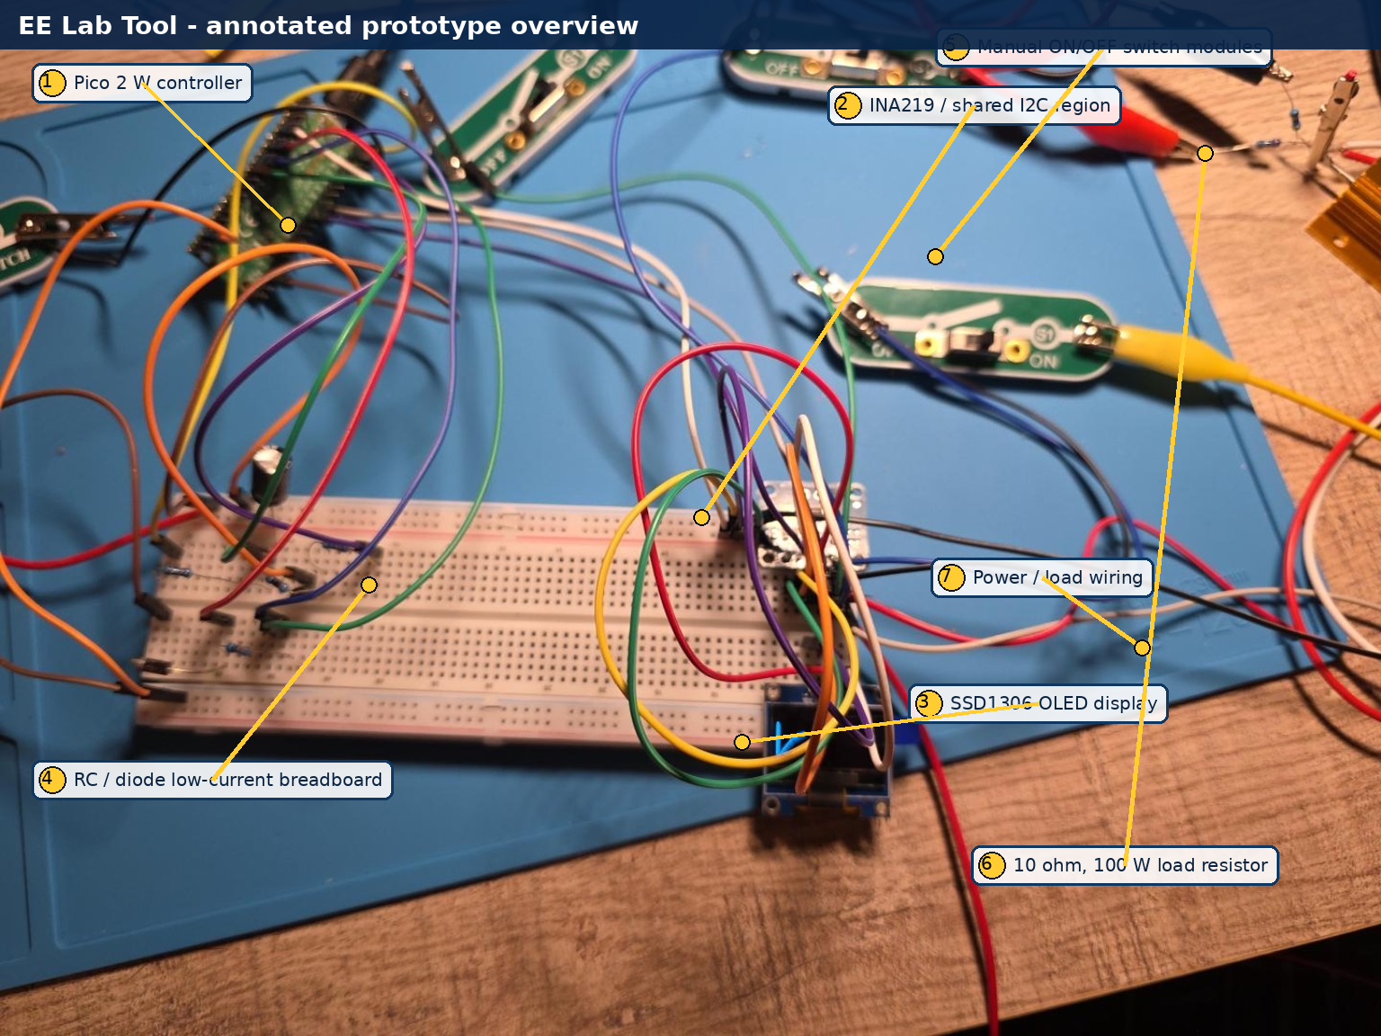
Cover figure. Sanitized and annotated final prototype overview.
Repository target: Mini34/pico-2w-power-transient-analyzer

Executive summary
The Pico 2 W EE Lab Tool is a self-contained embedded instrumentation platform that grew from a DC power-monitoring proof of concept into a five-mode laboratory instrument with a Wi-Fi dashboard. The final working prototype combines calibrated power and energy measurement, RC transient characterization, diode testing, internal MCU-temperature telemetry, guided source characterization, threshold/fault monitoring, persistent experiment logging, and CSV/JSON export.
The project emphasizes measurement integrity. Defective INA219 modules, contradictory readings, ground-reference error, jumper/contact resistance, calibration outliers, RC wiring interactions, diode excitation-method errors, and an invalid negative source-resistance fit were investigated rather than hidden. The final documentation therefore records both successful results and the reasoning used to accept or reject measurements.
The dashboard and all software-side roadmap features were verified by the user. Automated electronic load stepping and a hardware cutoff stage remain future hardware work. The current Source Test is guided/manual, and its negative-resistance example is retained only as an invalid-result case that the repository should flag explicitly.

Current capability status
Capability | Status | Technical scope
Power / Energy Monitor | Complete | Live V/I/P, mAh, Wh, min/peak/average statistics, OLED pages, dashboard, session logging.
RC Analyzer | Complete | Automated charge/discharge, live OLED curves, tau and capacitance, dashboard traces, logging.
Diode Analyzer | Complete with method boundary | Steady-DC single test is quantitative; PWM I-V sweep is display-only.
Wi-Fi dashboard | Complete | Live cards, charts, mode/state, history, exports, system status.
MCU temperature telemetry | Complete | Internal die telemetry; not ambient; intentionally idle in STARTUP/MENU.
Experiment logging/export | Complete | Power, RC, diode, source, and fault records; CSV/JSON downloads.
Fault/threshold monitoring | Complete as software monitoring | No hardware cutoff/protection stage.
Guided Source Test | Implemented; validation open | Manual point capture and regression work; negative-Rs results are invalid and flagged.

Verified architecture and pin map
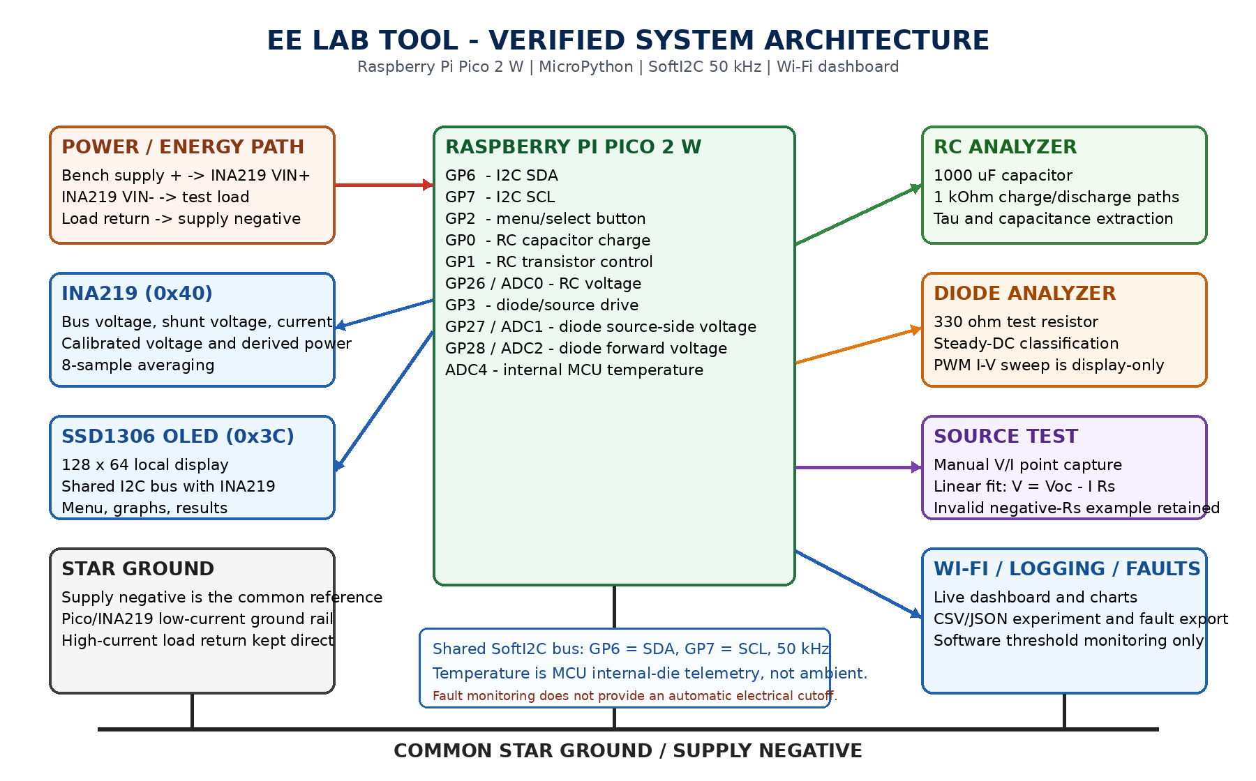
Figure 1. Verified system architecture. Exact firmware uses SoftI2C at 50 kHz on GP6/GP7.
Pico resource | Function
GP0 | RC capacitor charge
GP1 | RC transistor control / discharge path
GP2 | menu/select button, active low
GP3 | diode test source / PWM sweep drive
GP6 | I2C SDA
GP7 | I2C SCL
GP26_ADC0 | RC capacitor voltage
GP27_ADC1 | diode source-side voltage
GP28_ADC2 | diode forward voltage
ADC4 | RP2350 internal temperature sensor

Calibration and measurement integrity
- Final voltage equation: V_cal = 0.98896 * V_raw - 0.03531 V. Fit quality R-squared approximately 0.999975.
- The accepted calibration residuals were approximately plus/minus 3 mV, near the practical resolution of the INA219 bus-voltage path.
- Direct R100 shunt measurement gave 30.1-30.2 mV, corresponding to approximately 0.301-0.302 A; the INA219 reported approximately 0.300 A. No current correction factor was justified.
- Star grounding reduced ground-reference error from approximately 86 mV to approximately 0.2 mV.
- Three parallel temporary positive jumpers reduced positive-path drop from approximately 0.39 V to approximately 0.076 V. Contact and wiring losses remain real components of the prototype.
- Alligator clips were experimentally worse than the curled/stripped-wire load connection in the earlier high-current tests, reinforcing that visible connector size is not a guarantee of low contact resistance.

1. Hardware bring-up and soldering
Soldered Pico and INA219 headers, recovered from oxidized-tip and breadboard/contact issues, and established stable power and ground rails.
Evidence
- Pico 3V3 measured approximately 3.22-3.26 V
- Shared I2C bus ultimately detected both devices
Decision / next step: Continue with GP6/GP7 shared I2C and preserve one-step-at-a-time physical verification.
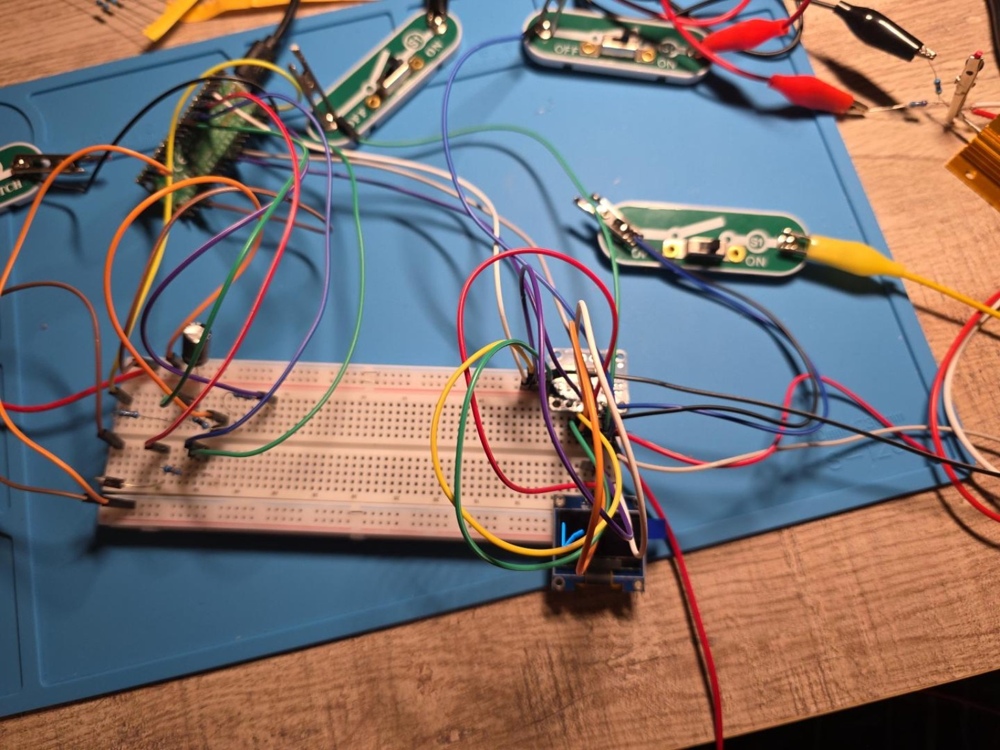
Figure 1. Overall prototype overview showing the complete Pico 2 W EE Lab Tool on the work mat, including the breadboard, external switch modules, OLED, and surrounding test wiring.

2. I2C and module diagnosis
Separated communication faults from measurement faults. A scan returned [60, 64], proving OLED 0x3C and INA219 0x40 communication.
Evidence
- First INA219 produced implausible bus voltage despite valid current
- Third tested module produced realistic bus-voltage data
Decision / next step: Reject defective/noncompliant modules rather than calibrating around hardware failure.

3. Power-monitor calibration and wiring integrity
Moved from a 500 ohm load to a 10 ohm, 100 W load, quantified real connection losses, implemented star grounding, and fitted the voltage calibration.
Evidence
- Ground-reference error reduced from approximately 86 mV to approximately 0.2 mV
- Positive-path drop reduced from approximately 0.39 V to approximately 0.076 V using three parallel temporary jumpers
- Voltage fit R^2 approximately 0.999975
Decision / next step: Treat parasitic resistance as a physical circuit element; do not calibrate it away.
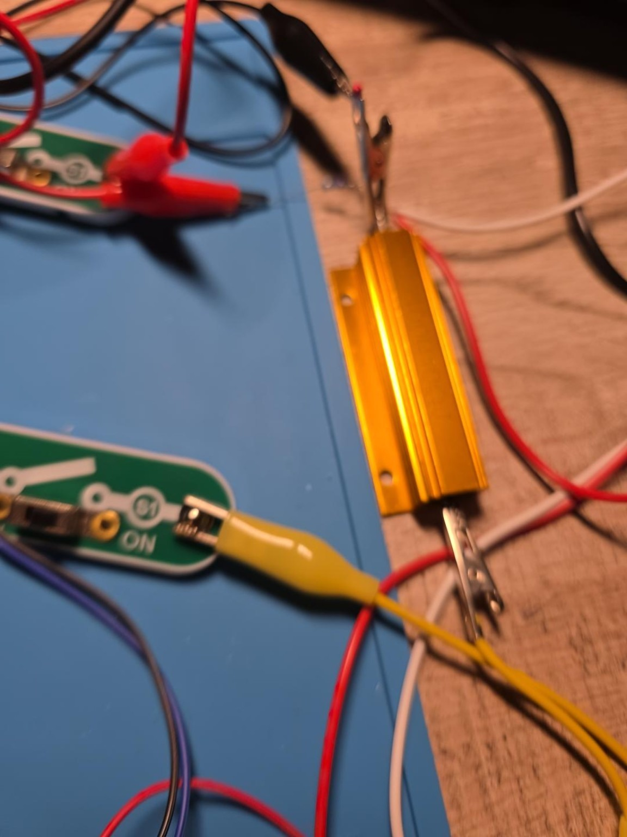
Figure 8. 10 ohm, 100 W aluminum power resistor used as the principal high-current load.

4. Current-channel verification
Rejected an inconsistent multimeter 10 A range result and measured directly across the INA219 R100 shunt.
Evidence
- 30.1-30.2 mV across 0.1 ohm implies approximately 0.301-0.302 A
- INA219 simultaneously reported approximately 0.300 A
Decision / next step: No software current scale factor is justified.

5. Power and energy analyzer
Extended the Power Monitor with charge and energy integration, minimum/peak statistics, running averages, elapsed time, OLED pages, dashboard state, and end-of-session logging.
Evidence
- Final dashboard example: 2.996 V, 0.469 A, 1.404 W
- 9.70 mAh and 0.0292 Wh over a 103 s example session
Decision / next step: Power/Energy Monitor accepted as a completed subsystem.
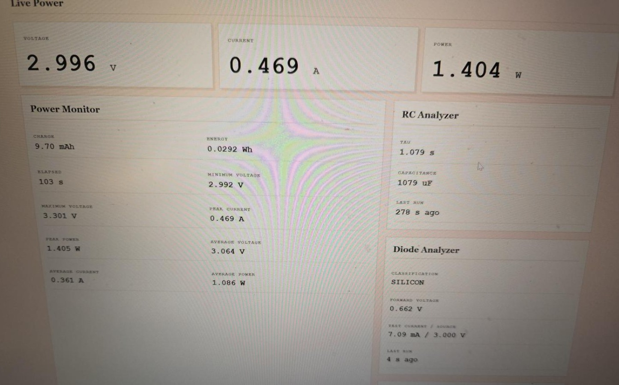
Figure 21. Sanitized dashboard view showing live voltage/current/power, Power Monitor session statistics, RC Analyzer results, and the silicon-diode result.

6. RC analyzer
Built a 2N2222-controlled RC charge/discharge network using a 1000 uF capacitor and 1 kOhm paths. Added live OLED curves, 1/e crossing interpolation, capacitance calculation, dashboard traces, and result logging.
Evidence
- Measured tau approximately 1.076-1.079 s
- Calculated capacitance approximately 1076-1079 uF
- Charge curve agreed with the 63.2% first-order checkpoint
Decision / next step: RC Analyzer accepted as a completed subsystem.
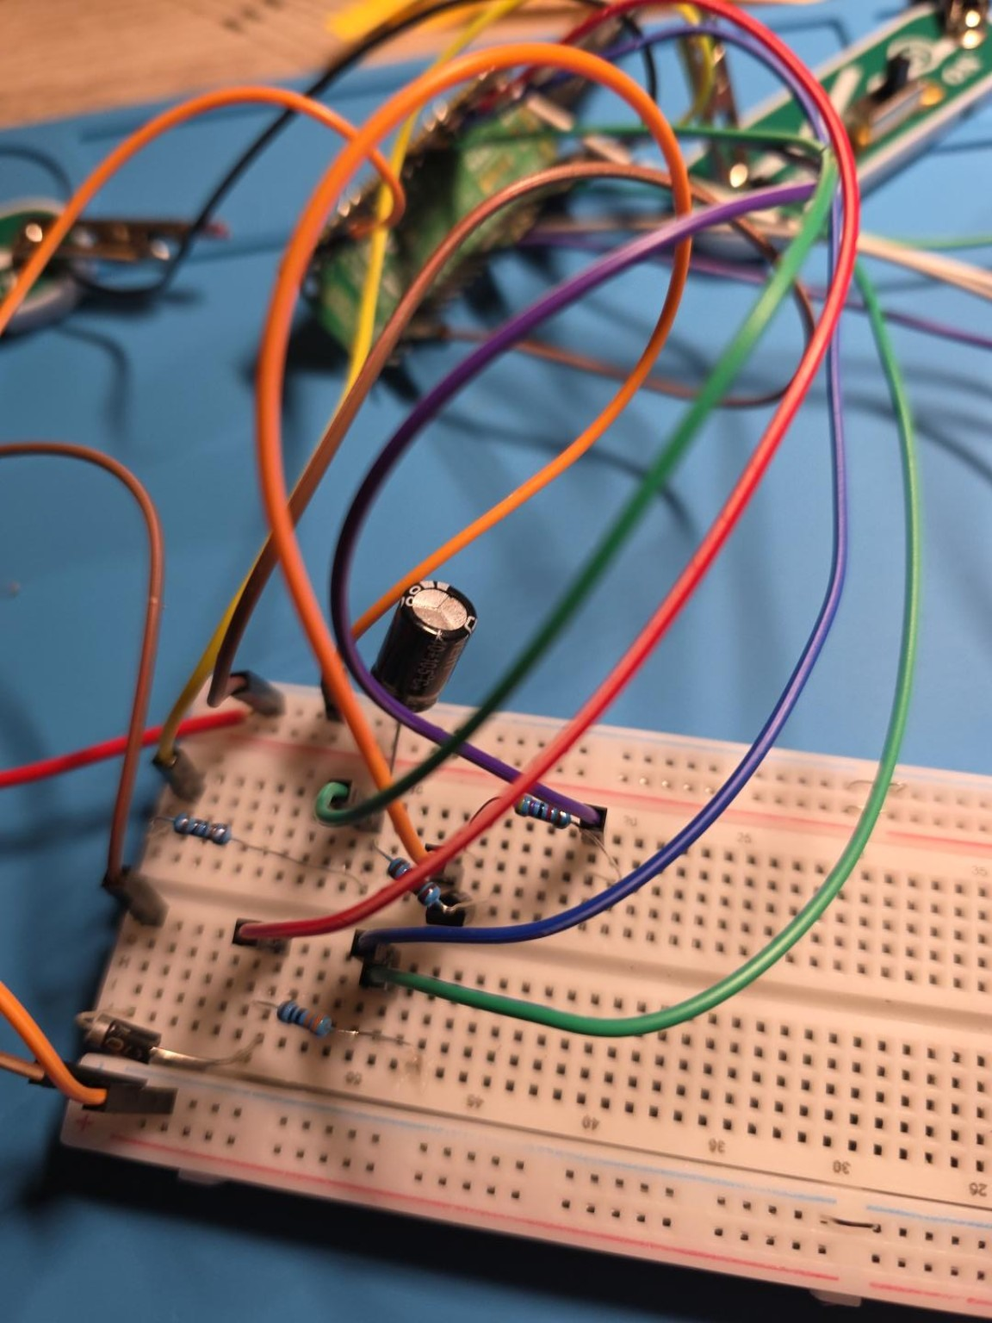
Figure 3. RC analyzer section close-up showing the 1000 uF electrolytic capacitor, resistors, transistor, and ADC/control wiring.

7. Diode analyzer
Added settled single-point diode measurement and a PWM-driven I-V visualization. Corrected an early method error by restricting classification to the settled DC result.
Evidence
- 1N4007 silicon example: Vf approximately 0.662 V at 7.09 mA from a 3.000 V source
- 1N5819 Schottky example: Vf approximately 0.248 V at 8.20 mA from a 2.954 V source
- I-V sweep displays 15 points but is not used for quantitative classification
Decision / next step: Single-test classification is quantitative; PWM sweep is visualization-only until an analog source is validated.
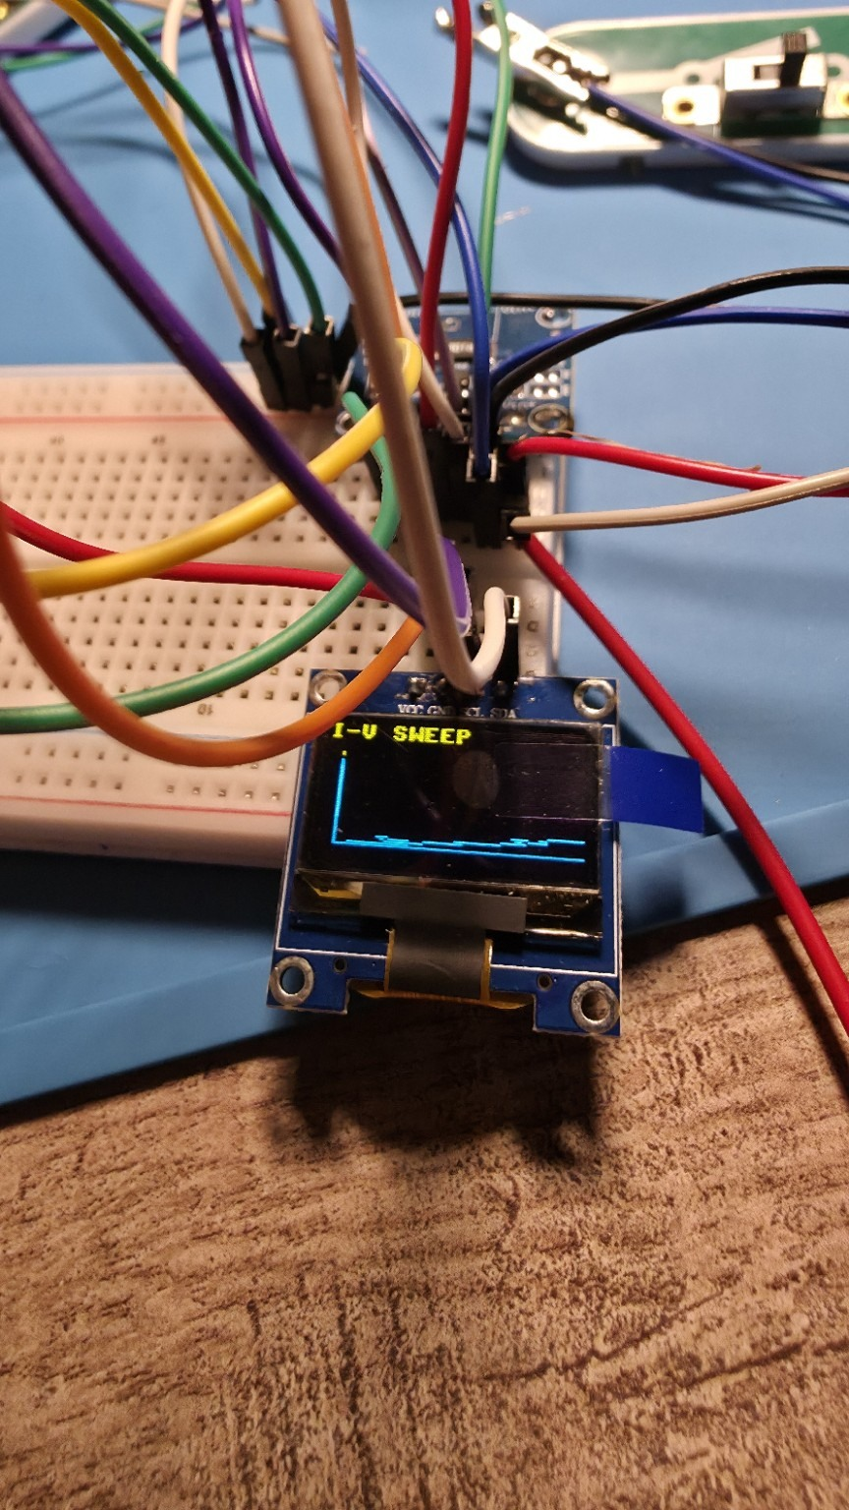
Figure 15. OLED I-V sweep visualization from the Diode Analyzer.

8. Unified instrument UI
Combined Power, RC, Diode, MCU Temperature, and Source Test modes into one startup/menu workflow controlled by one active-low button.
Evidence
- Short press navigates/pages; long press selects/returns
- OLED screens and photographed menu/result pages verified
Decision / next step: Routine operation no longer depends on separate Thonny scripts.
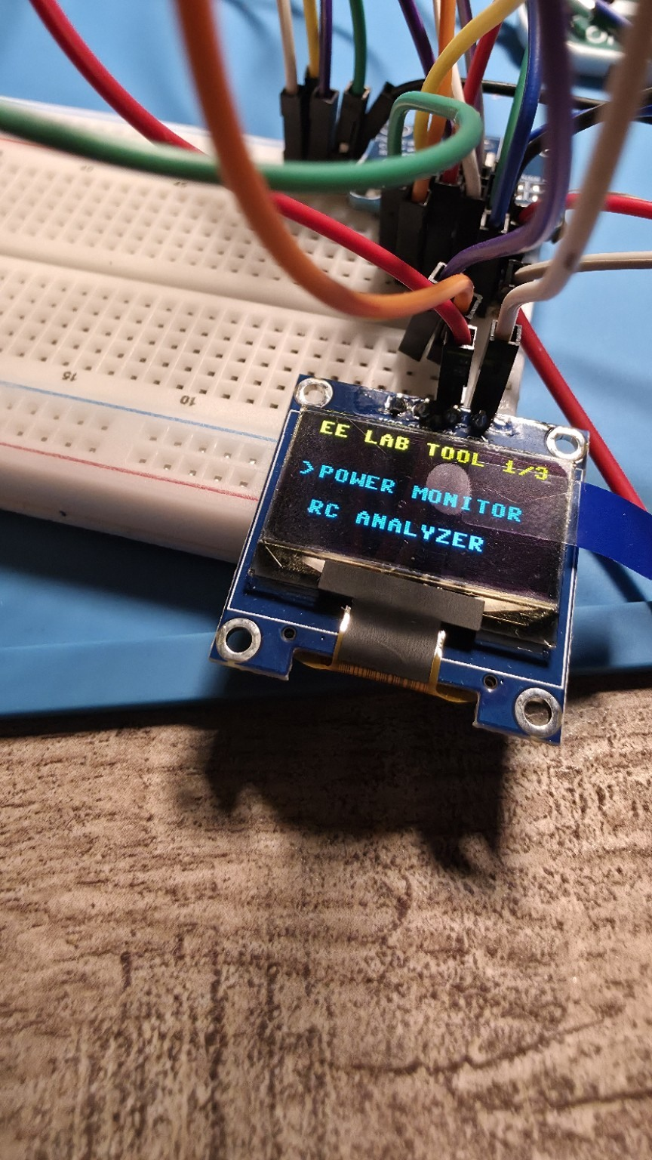
Figure 11. OLED main-menu page showing the unified EE LAB TOOL interface and analyzer selection.

9. Wi-Fi dashboard
Integrated Wi-Fi connection management, shared instrument state, HTTP serving, live status cards, power history, RC traces, diode results, source-test state, MCU telemetry, and logs.
Evidence
- Dashboard connected and served on the local network
- User verified all live panels and charts
Decision / next step: Networking/dashboard support treated as a completed subsystem.
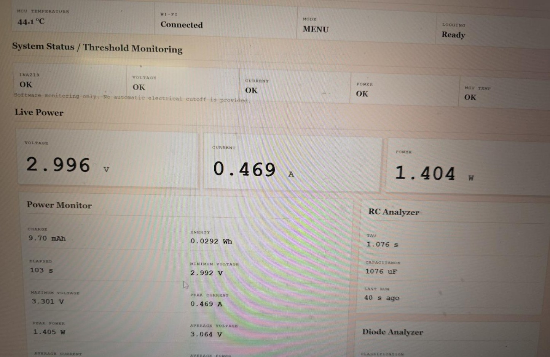
Figure 10. Sanitized dashboard overview showing MCU temperature, Wi-Fi status, threshold monitoring, live power, Power Monitor statistics, and RC Analyzer results.

10. MCU temperature telemetry
Read ADC4 with 16-sample averaging every five seconds when the instrument is in an active mode. Corrected TEMP_VREF to 3.24 V and exposed the reading to OLED/dashboard state.
Evidence
- Stable readings approximately 45.53-45.68 C
- ADC approximately 0.6739-0.6741 V, raw approximately 13630-13635
Decision / next step: Label as MCU/internal-die temperature, not ambient. Preserve the intentional pause in STARTUP and MENU.
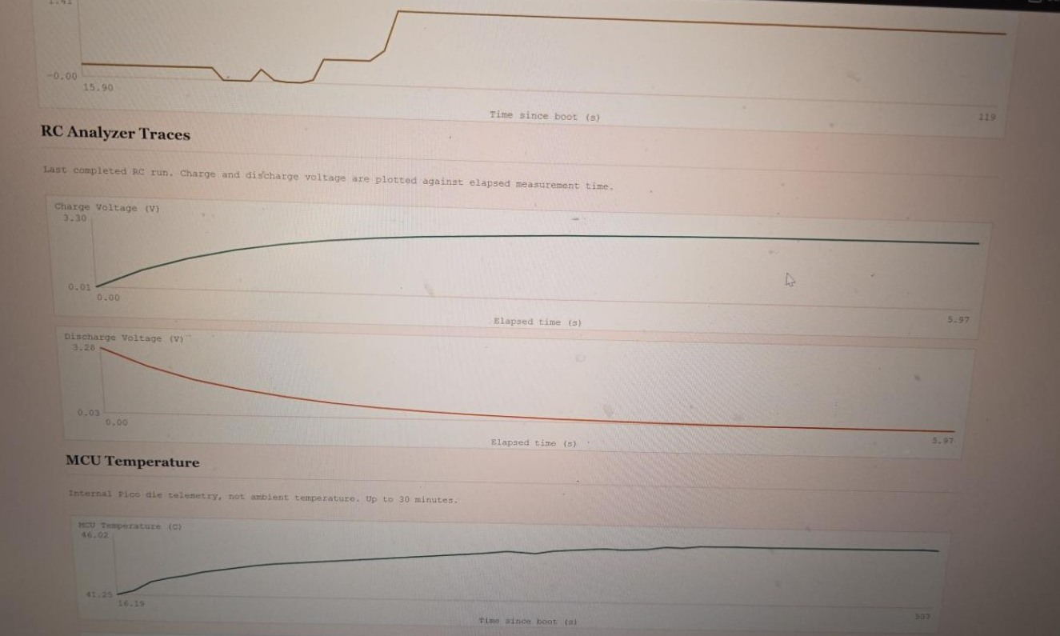
Figure 24. Sanitized dashboard view showing RC traces, MCU internal-die temperature history, and experiment/fault export controls.

11. Experiment logging and export
Added persistent completed-test summaries for power sessions, RC tests, diode single tests, diode I-V sweeps, source tests, and faults. Added dashboard history plus CSV/JSON downloads.
Evidence
- Experiment table displays type, status, uptime, and summaries
- Separate experiment/fault CSV and JSON export controls verified
Decision / next step: Logging/export accepted as a completed software subsystem.
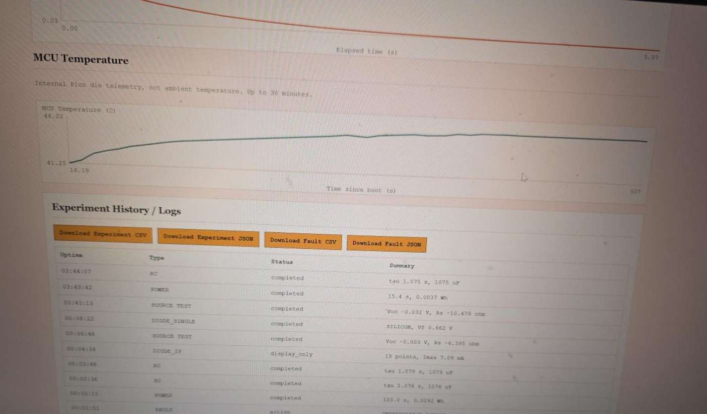
Figure 25. Sanitized dashboard view showing MCU temperature history and the experiment-history table with CSV/JSON export controls.

12. Guided Source Test
Added manual capture of multiple INA219 V/I operating points and a reusable linear-fit backend for Voc, source resistance, and R^2.
Evidence
- Point acceptance and duplicate rejection photographed
- One three-point test returned Voc -0.003 V, Rs -6.395 ohm, R^2 1.000
Decision / next step: Retain mode as guided/manual. Flag negative resistance as invalid; add stronger capture workflow and fit validation before treating results as physical.
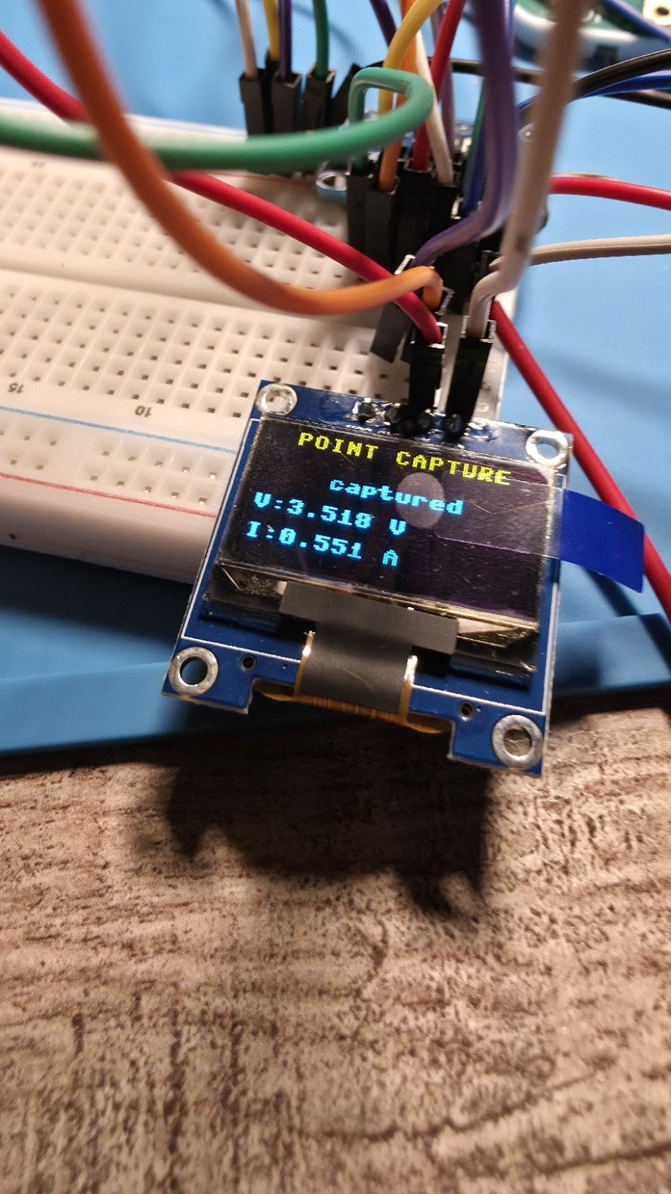
Figure 13. OLED Point Capture confirmation with the measured voltage and current for an accepted source-test point.

13. Fault and threshold monitoring
Added configurable software monitoring for undervoltage, overcurrent, excessive power, MCU temperature, and INA219 disconnect/restoration, with state transitions and event logging.
Evidence
- System status dashboard verified
- UNDERVOLTAGE_ACTIVE example appears in history
Decision / next step: State clearly that this is monitoring only; no hardware cutoff is presently installed.

Figure 10. Sanitized dashboard overview showing MCU temperature, Wi-Fi status, threshold monitoring, live power, Power Monitor statistics, and RC Analyzer results.

14. Final photographic/documentation capture
Captured the full hardware setup, close-ups of the controller, RC section, switches, load resistor, harness, OLED workflows, dashboard charts, telemetry, and logs. Sanitized screen photos to remove laptop branding, browser chrome, bookmarks, tabs, and local IP information.
Evidence
- 26 sanitized photographs in the final appendix
- Annotated overview, exact architecture diagram, and conceptual 3D visual prepared
Decision / next step: Use photos as engineering evidence with captions explaining what each image proves.
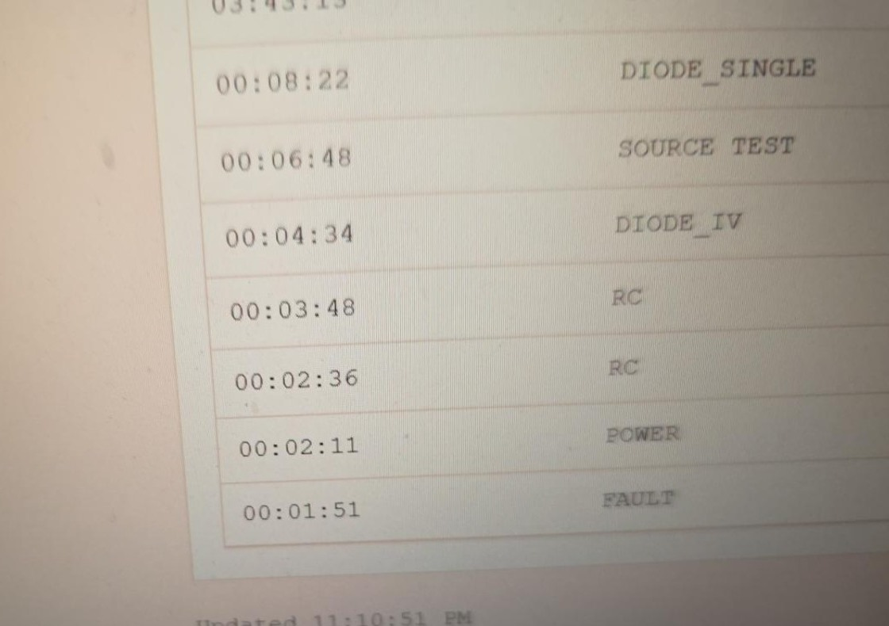
Figure 26. Sanitized close-up of the experiment-history table and update timestamp.

Final measured examples
Subsystem | Photographed/verified example | Interpretation
Power / Energy | 2.996 V, 0.469 A, 1.404 W; 9.70 mAh; 0.0292 Wh over 103 s | Working live measurement and session statistics.
RC Analyzer | Tau 1.076-1.079 s; capacitance 1076-1079 uF | Consistent with the nominal 1000 uF / 1 kOhm network and component tolerance.
Silicon diode | Vf about 0.662 V at 7.09 mA from a 3.000 V source | Correct steady-DC SILICON classification.
Schottky diode | 1N5819 Vf about 0.248 V at 8.20 mA from a 2.954 V source | Validated Schottky comparison point.
MCU temperature | Approximately 45.53-45.68 C in the stable test; dashboard approximately 41.25-46.02 C | Internal die telemetry only; not ambient.
Source Test | Voc -0.003 V, Rs -6.395 ohm, R-squared 1.000, 3 points | Mathematically linear but physically invalid for the assumed source model; must be flagged.

Firmware and dashboard architecture
The supplied integrated main file coordinates hardware acquisition and modular services. The exact working copies of all imported modules must be exported from the active project workspace to GitHub. The current module set is:
- main.py
- instrument_state.py
- wifi_manager.py
- web_server.py
- experiment_logger.py
- fault_monitor.py
- source_characterizer.py
- ssd1306.py
Timing-sensitive RC and diode acquisitions suppress web/temperature service calls. Temperature sampling is intentionally disabled in STARTUP and MENU because continuous idle measurement was unwanted. Optional-service import and runtime failures are caught so that the core instrument can continue operating.

Known limitations and future hardware work
- Source Test can return a mathematically perfect but physically invalid negative source resistance when captured points or current direction do not represent the assumed V = Voc - I Rs model. Negative Rs must be rejected or clearly marked invalid.
- The diode PWM I-V sweep averages a pulsed waveform and is display-only. Steady-DC single-test data remains the classification source.
- MCU temperature is the RP2350 internal die temperature, not ambient temperature.
- Fault monitoring is software monitoring and logging only; it does not provide a hardware safety cutoff.
- High-current prototype wiring and clip/contact resistance remain measurable. Final construction should use robust low-resistance terminals/conductors.
- Automated electronic load stepping is not yet implemented. Current Source Test is guided/manual until MOSFET/load-bank hardware is added.
- Temperature sampling is intentionally deferred in STARTUP and MENU to avoid continuous background measurements when idle.
Future hardware work should proceed directly to a properly rated 3.3 V logic-level MOSFET switched-load bank if automated load stepping is desired. The small manual switches can remain as low-current circuit selectors, but their contact rating must be known before using them in the several-hundred-milliamp load path.

Final documentation and GitHub update package
This final package updates the prior repository snapshot without erasing its historical record. It includes a replacement README, a comprehensive Markdown log, a machine-readable JSON log, final DOCX/PDF documentation, a complete sanitized photo appendix, design assets, the current main.py, and explicit Codex instructions for completing the repository update with the remaining exact working firmware modules.
All current dashboard photos were cropped to remove laptop branding, browser tabs/bookmarks, the photographed local IP address, and unrelated user-interface content.

Appendix A - Complete sanitized photographic record
All 26 uploaded photographs are included below. Captions state what is visible and why the image matters. Full-resolution images are also provided separately in the photo appendix PDF and image directory.

Figure 1. Overall prototype overview showing the complete Pico 2 W EE Lab Tool on the work mat, including the breadboard, external switch modules, OLED, and surrounding test wiring. Privacy action: none required.
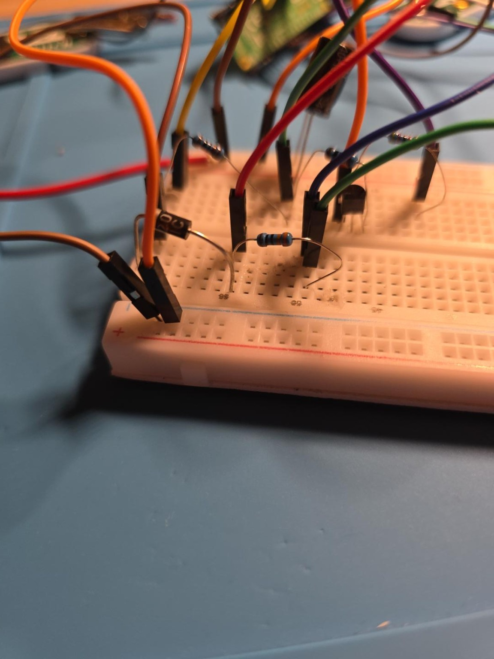
Figure 2. Close-up of the low-current breadboard test area, preserving component placement and jumper routing around the transistor/resistor network. Privacy action: none required.


Figure 3. RC analyzer section close-up showing the 1000 uF electrolytic capacitor, resistors, transistor, and ADC/control wiring. Privacy action: none required.
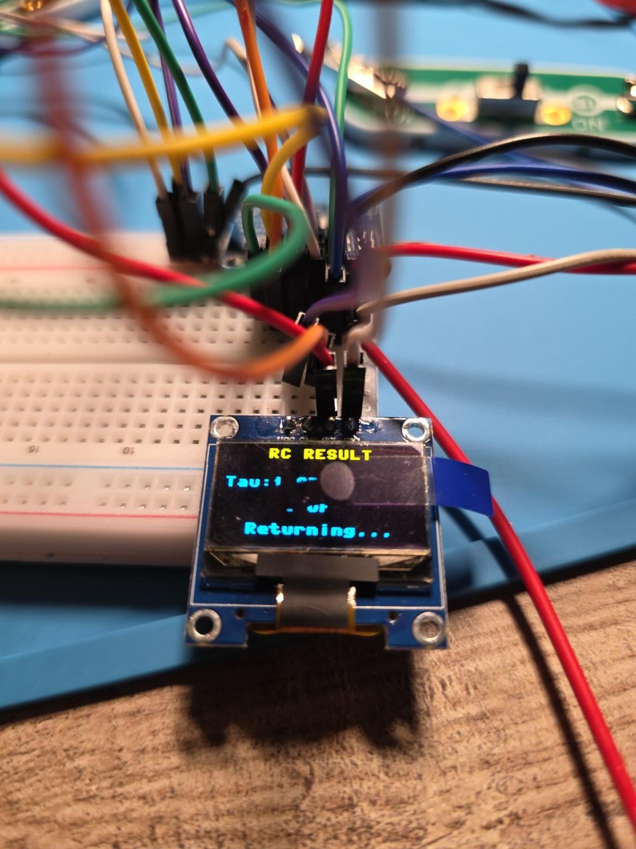
Figure 4. OLED RC Analyzer result screen documenting a successful measured time constant and capacitance result. Privacy action: none required.

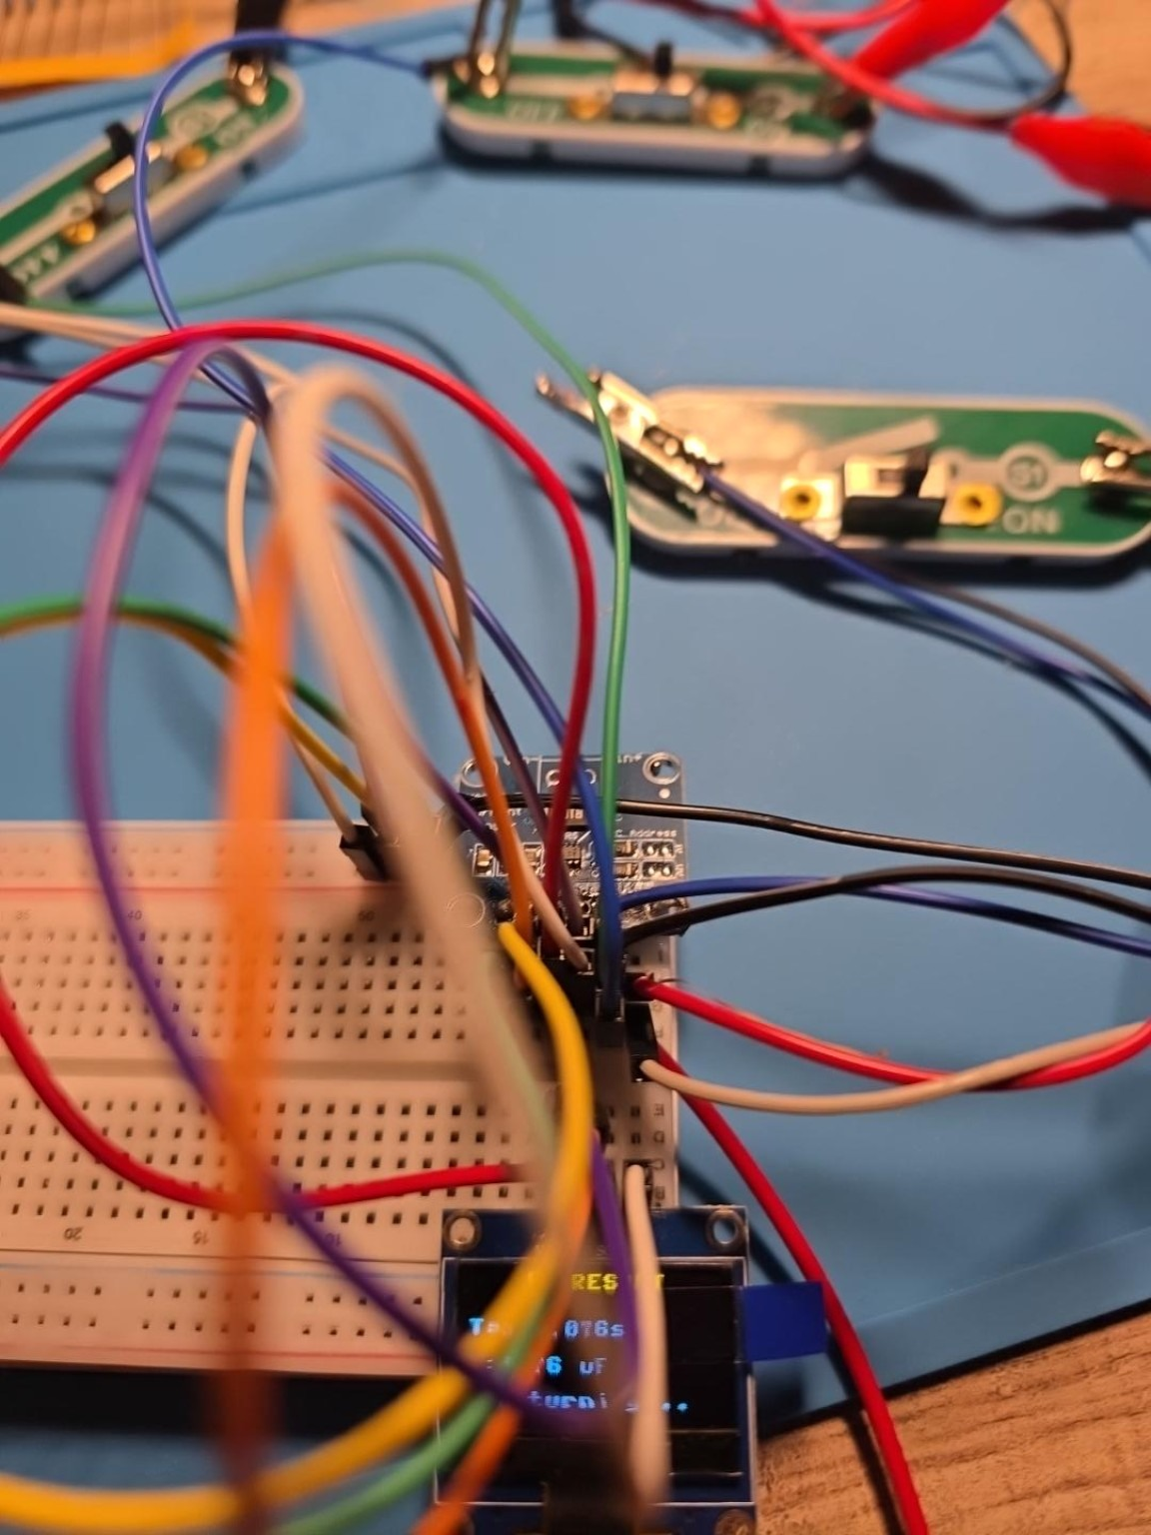
Figure 5. Top-side close-up of the Pico 2 W, INA219/OLED interconnections, and dense shared-bus/control wiring. Privacy action: none required.
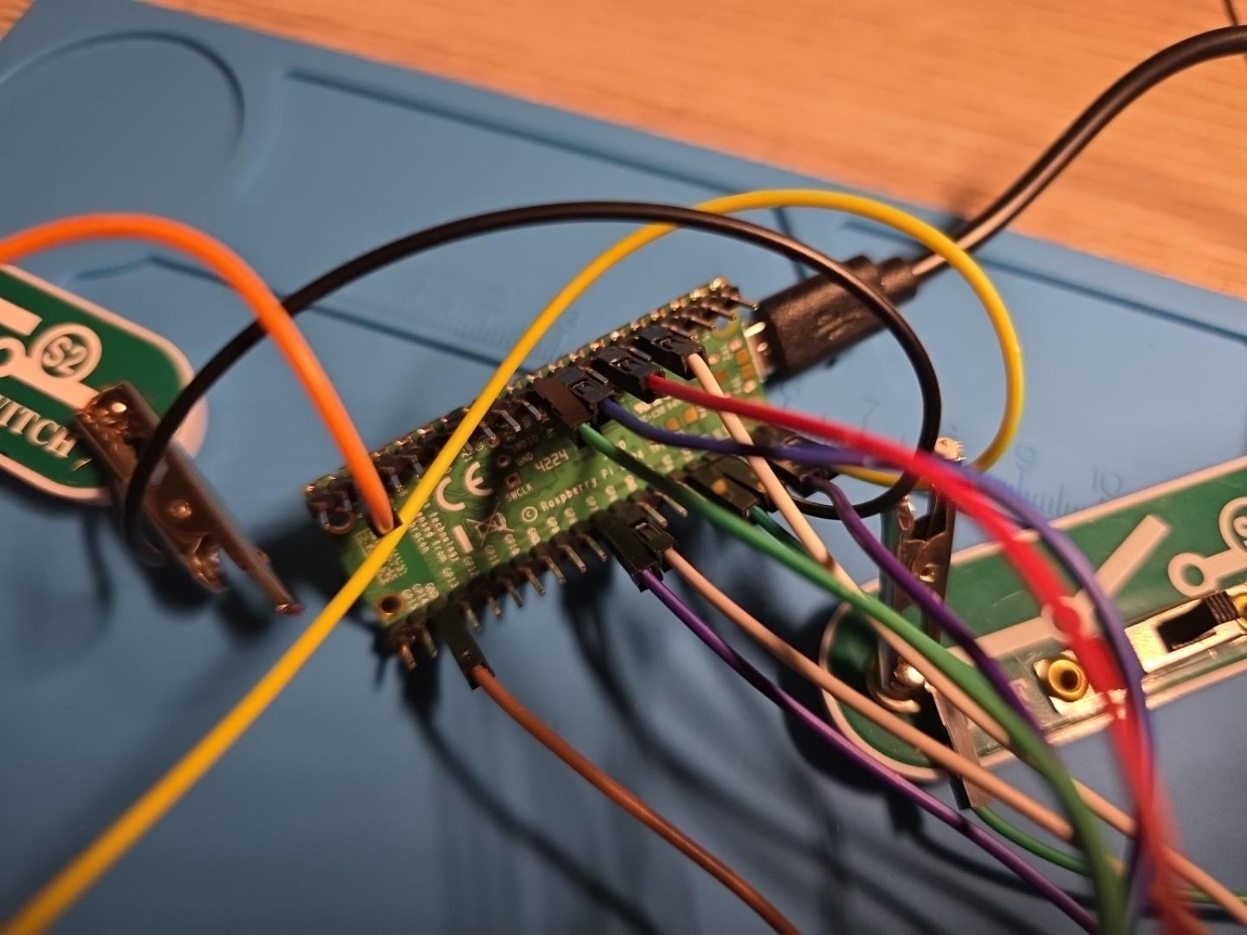
Figure 6. Raspberry Pi Pico 2 W controller close-up documenting the header connections used by the integrated instrument. Privacy action: none required.

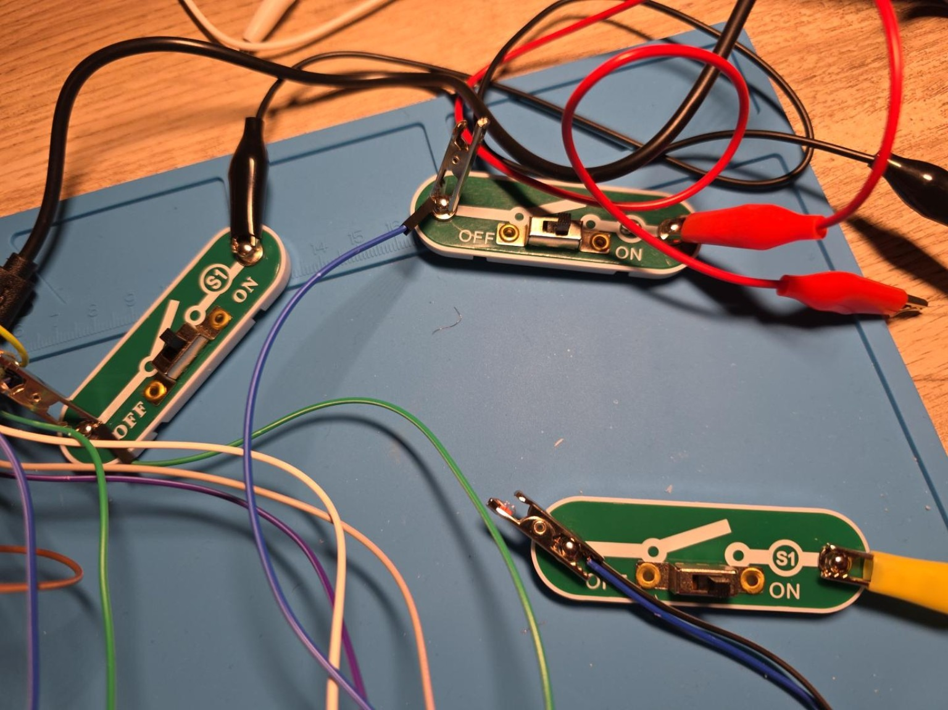
Figure 7. Manual ON/OFF switch modules and alligator-clip wiring used as physical circuit selectors/bypass elements during testing. Privacy action: none required.

Figure 8. 10 ohm, 100 W aluminum power resistor used as the principal high-current load. Privacy action: none required.

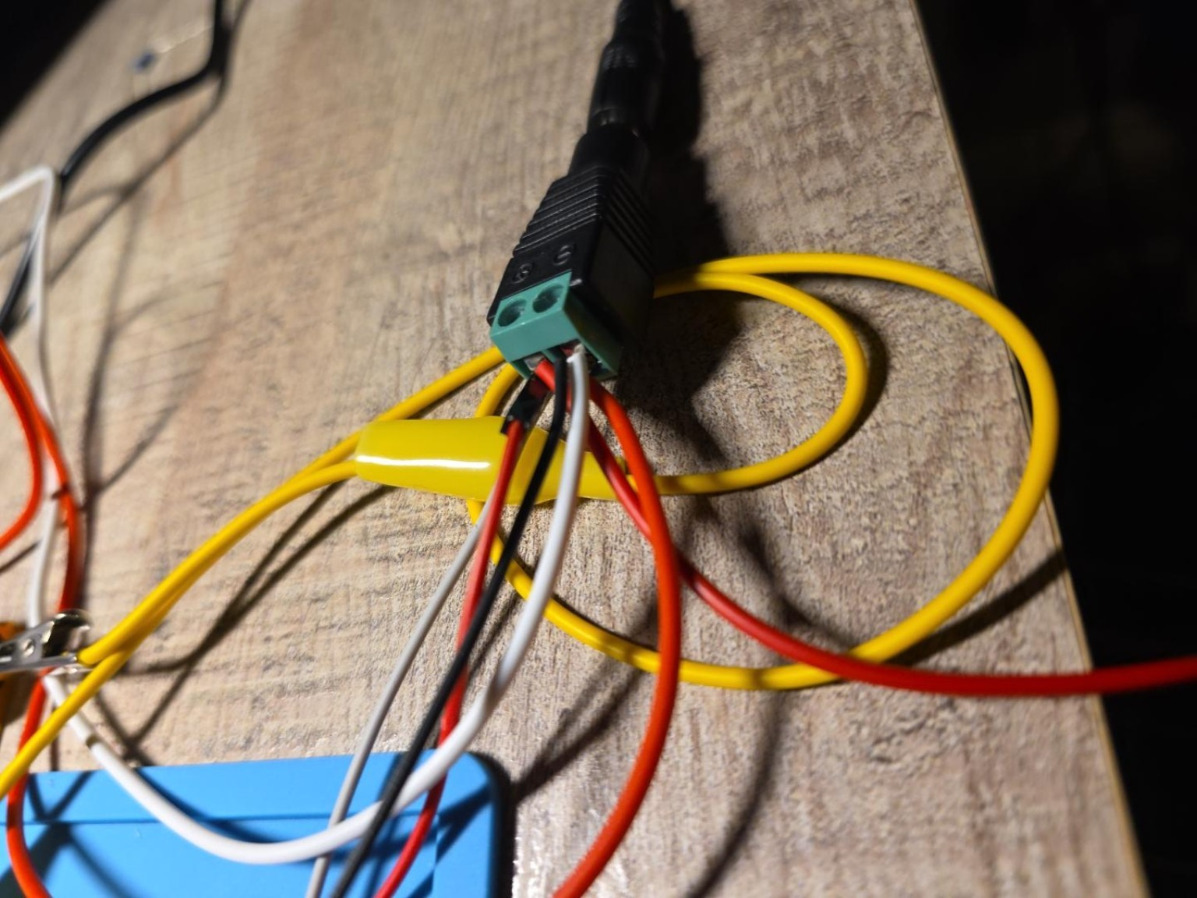
Figure 9. Screw-terminal power-harness breakout and multi-conductor wiring used for detachable source/load connections. Privacy action: none required.

Figure 10. Sanitized dashboard overview showing MCU temperature, Wi-Fi status, threshold monitoring, live power, Power Monitor statistics, and RC Analyzer results. Privacy action: cropped to remove browser/laptop identifiers.


Figure 11. OLED main-menu page showing the unified EE LAB TOOL interface and analyzer selection. Privacy action: none required.
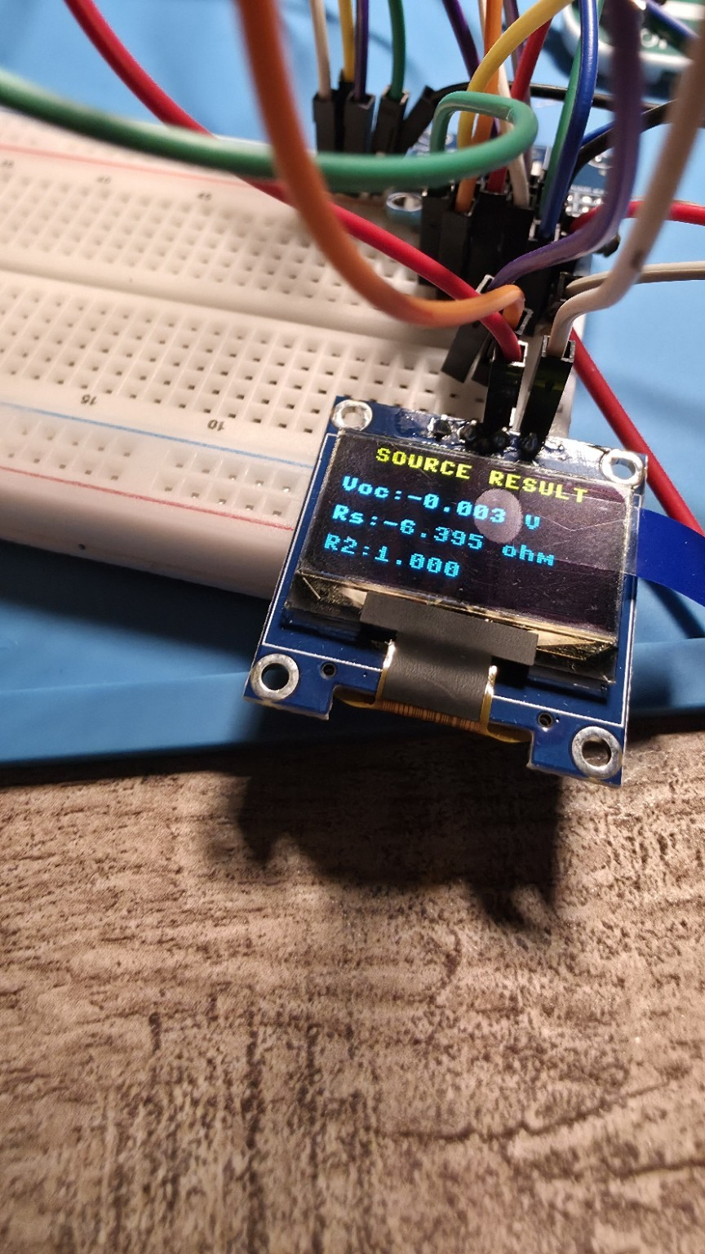
Figure 12. OLED Source Test result screen. The photographed negative source-resistance result is retained as a validation issue, not accepted as a physical source model. Privacy action: none required.


Figure 13. OLED Point Capture confirmation with the measured voltage and current for an accepted source-test point. Privacy action: none required.
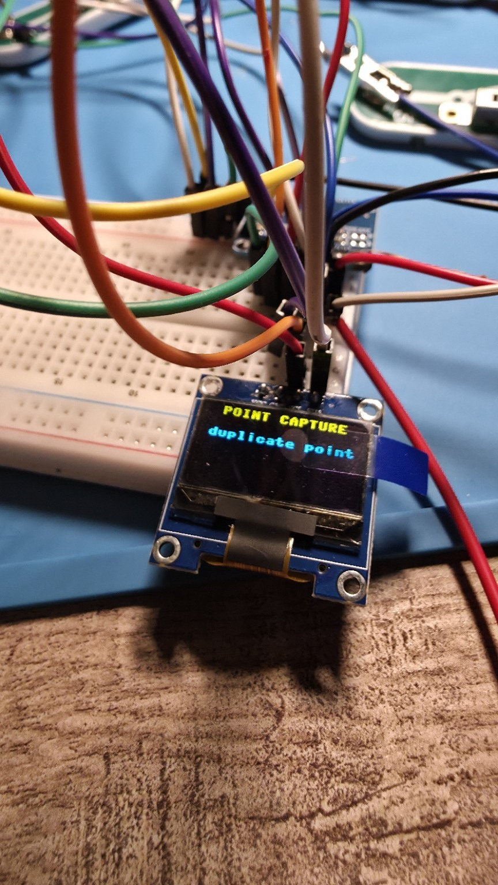
Figure 14. OLED duplicate-point rejection message demonstrating source-test data-quality screening. Privacy action: none required.


Figure 15. OLED I-V sweep visualization from the Diode Analyzer. Privacy action: none required.
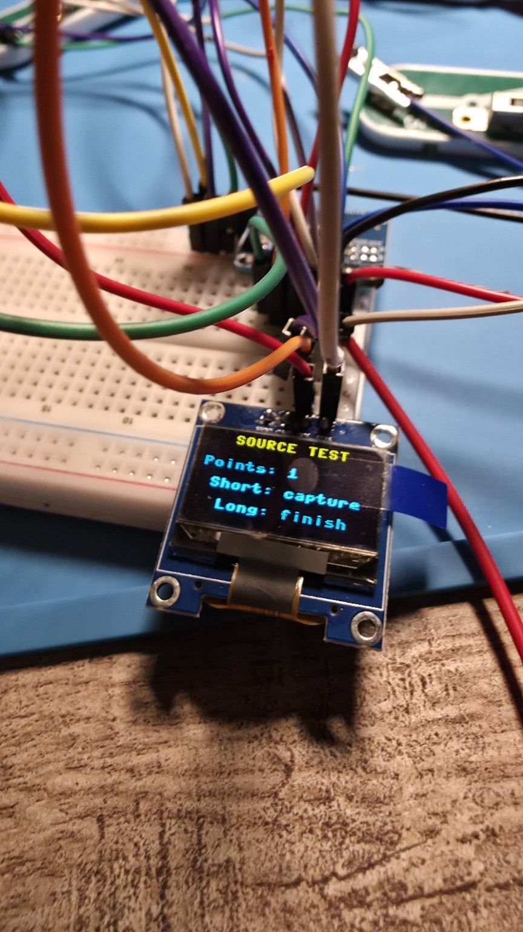
Figure 16. OLED Source Test collection screen showing the current point count and short/long press controls. Privacy action: none required.

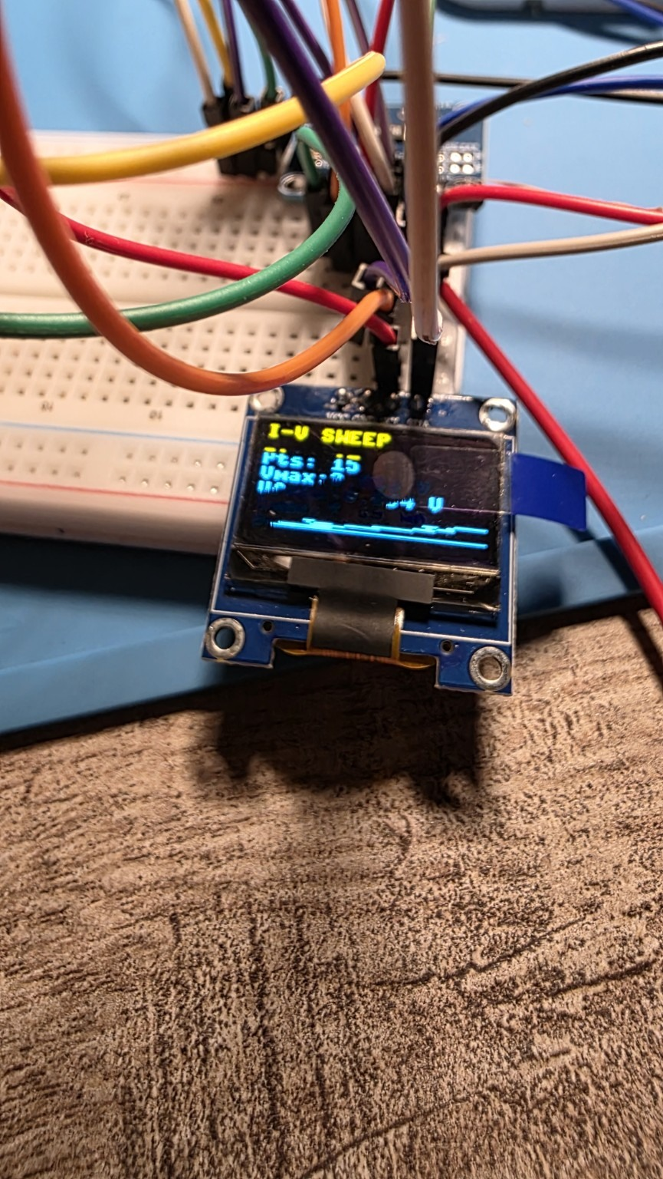
Figure 17. OLED I-V sweep numerical/statistical page documenting the captured sweep summary. Privacy action: none required.
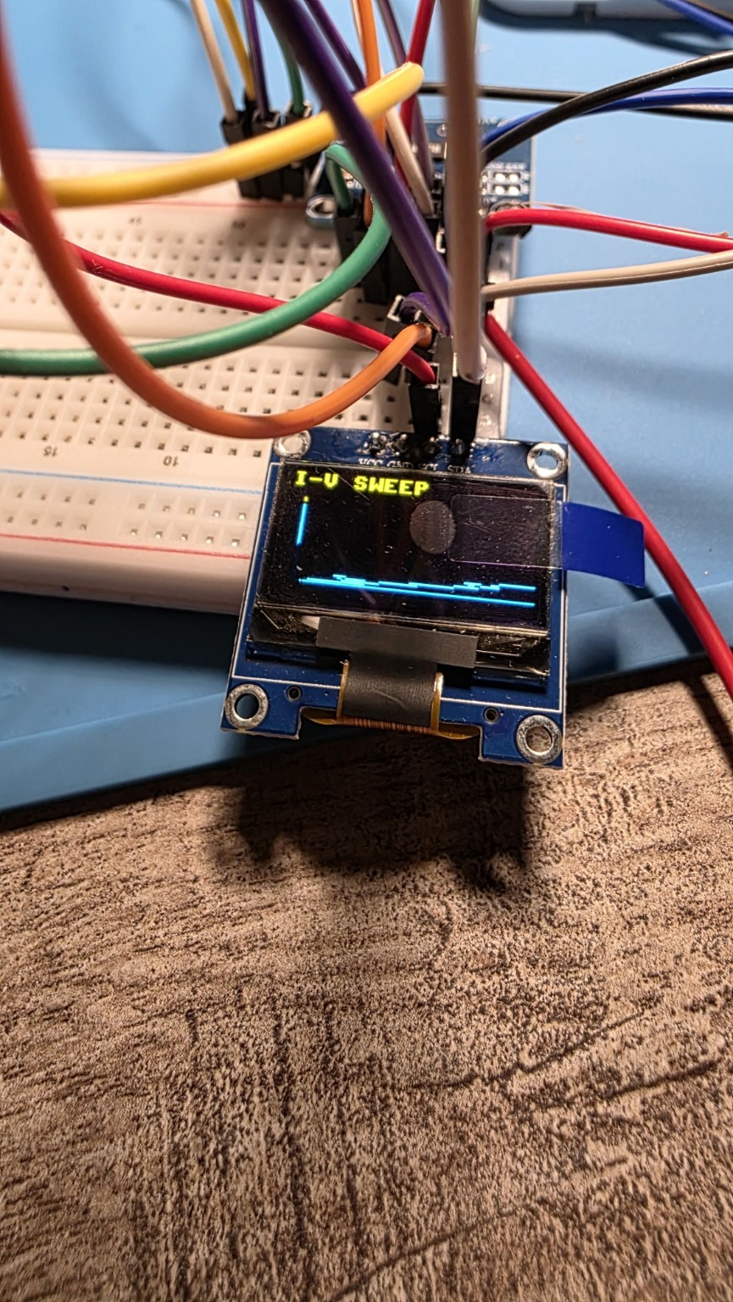
Figure 18. OLED I-V sweep graph, alternate captured frame. Privacy action: none required.

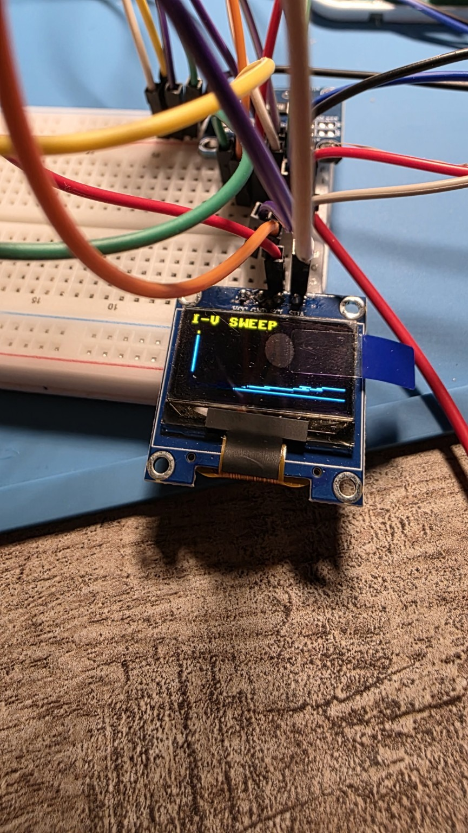
Figure 19. OLED I-V sweep graph, alternate captured frame preserving the displayed curve. Privacy action: none required.
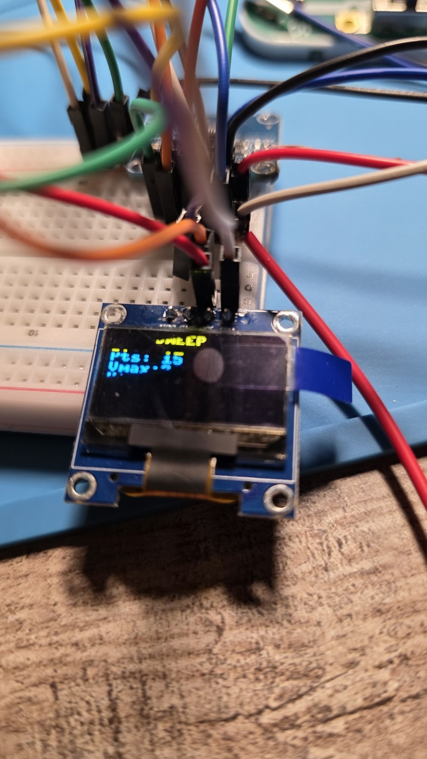
Figure 20. OLED I-V sweep statistics/graph frame documenting the embedded visualization workflow. Privacy action: none required.


Figure 21. Sanitized dashboard view showing live voltage/current/power, Power Monitor session statistics, RC Analyzer results, and the silicon-diode result. Privacy action: cropped to remove browser/laptop identifiers.
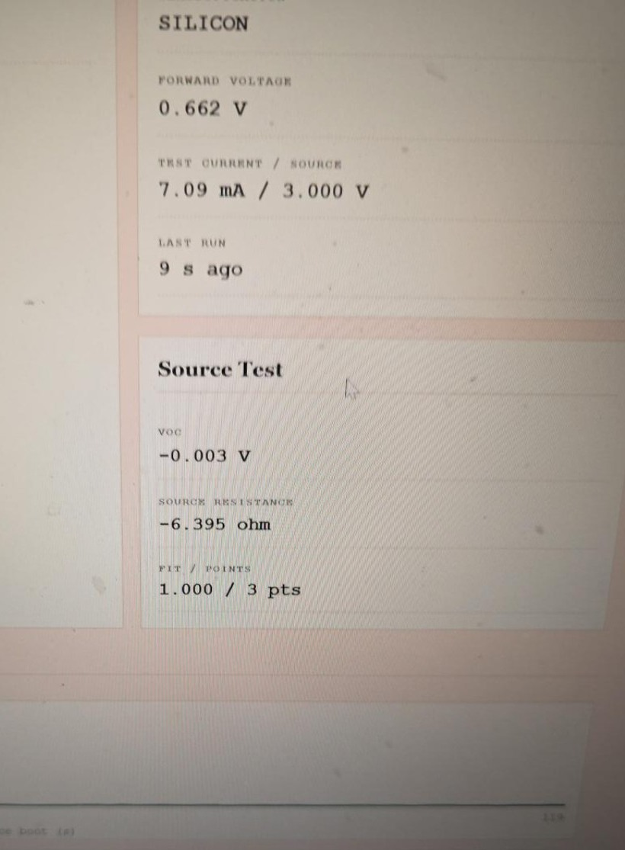
Figure 22. Sanitized dashboard close-up showing the silicon-diode result and the three-point Source Test fit that produced a negative resistance and therefore requires validation. Privacy action: cropped to remove browser/laptop identifiers.

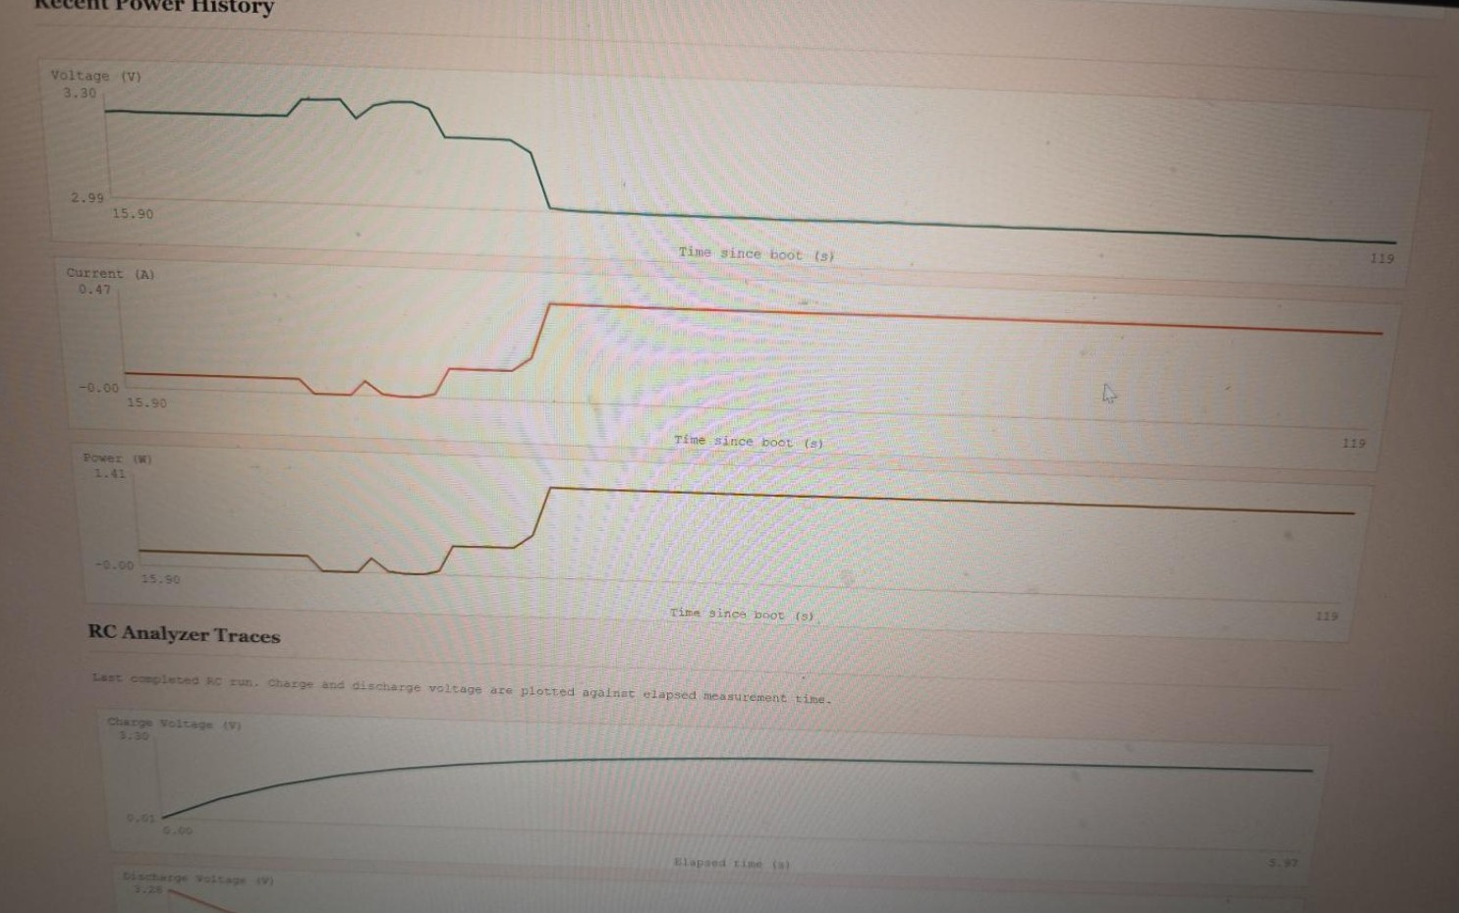
Figure 23. Sanitized dashboard charts showing recent voltage/current/power history and RC charge/discharge traces. Privacy action: cropped to remove browser/laptop identifiers.

Figure 24. Sanitized dashboard view showing RC traces, MCU internal-die temperature history, and experiment/fault export controls. Privacy action: cropped to remove browser/laptop identifiers.


Figure 25. Sanitized dashboard view showing MCU temperature history and the experiment-history table with CSV/JSON export controls. Privacy action: cropped to remove browser/laptop identifiers.

Figure 26. Sanitized close-up of the experiment-history table and update timestamp. Privacy action: cropped to remove browser/laptop identifiers.

Appendix B - Digital design assets

Annotated real-prototype overview.

Exact 2D architecture and pin map.
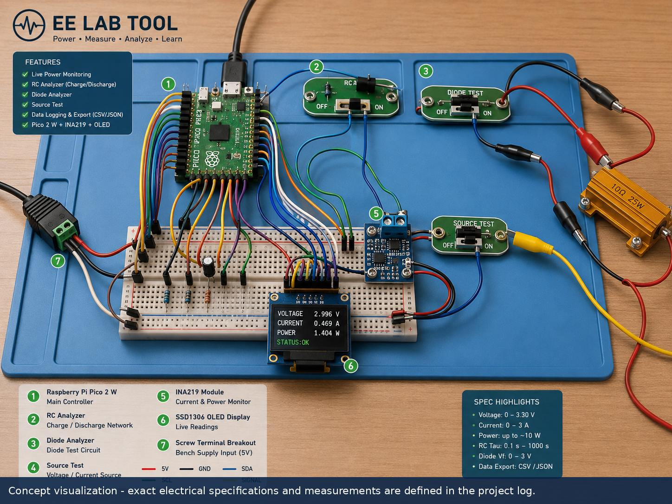
Conceptual 3D/isometric visualization; exact specifications remain those in the text.
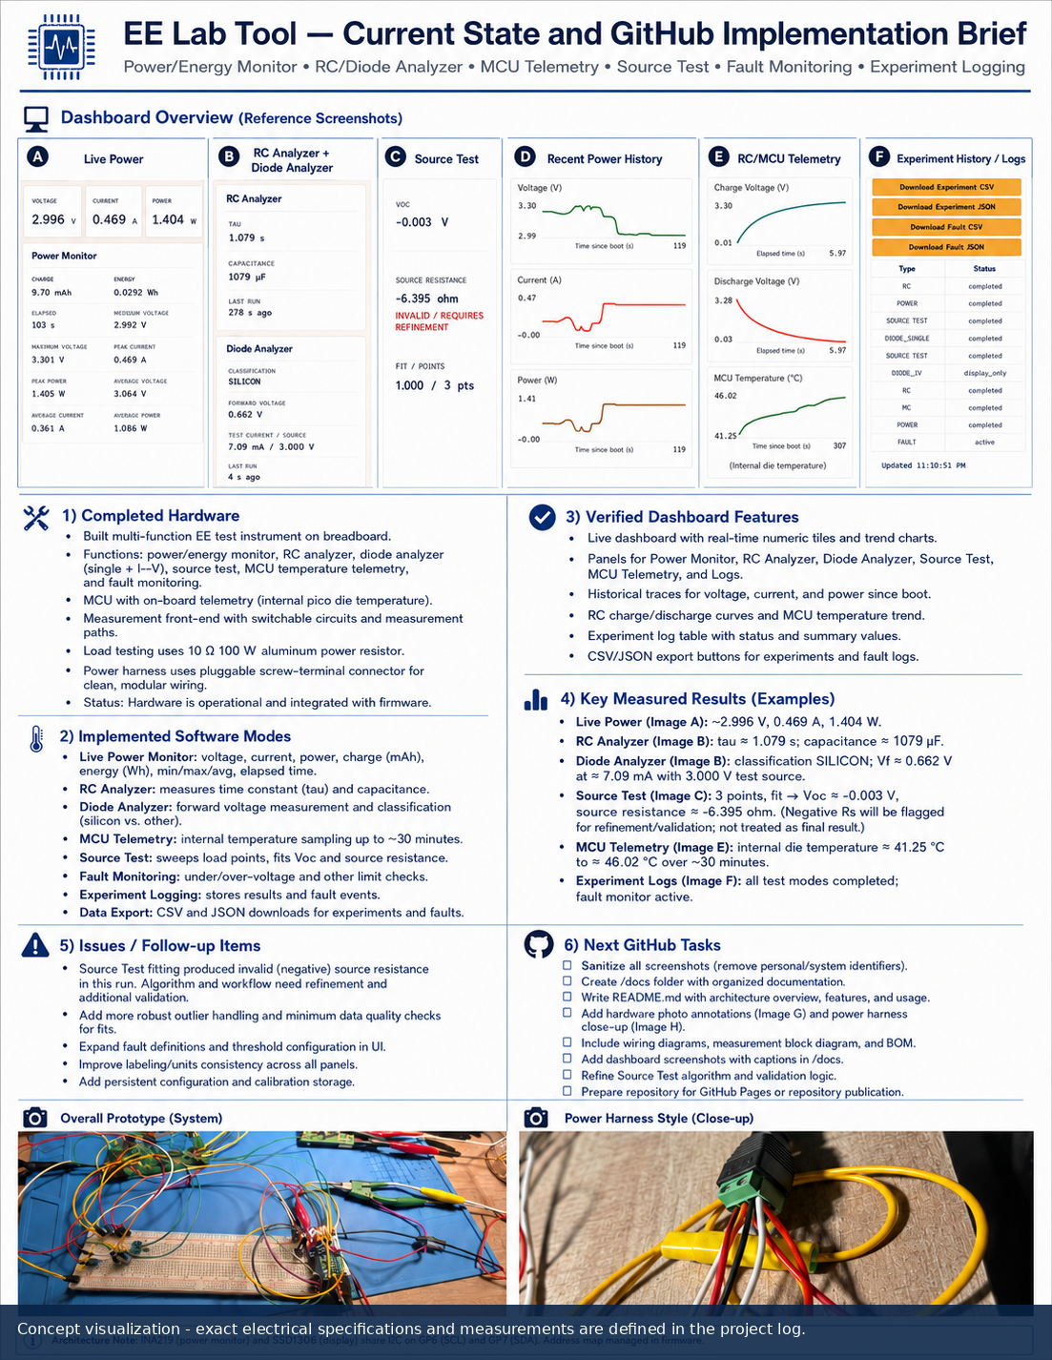
Conceptual one-page technical brief visual.
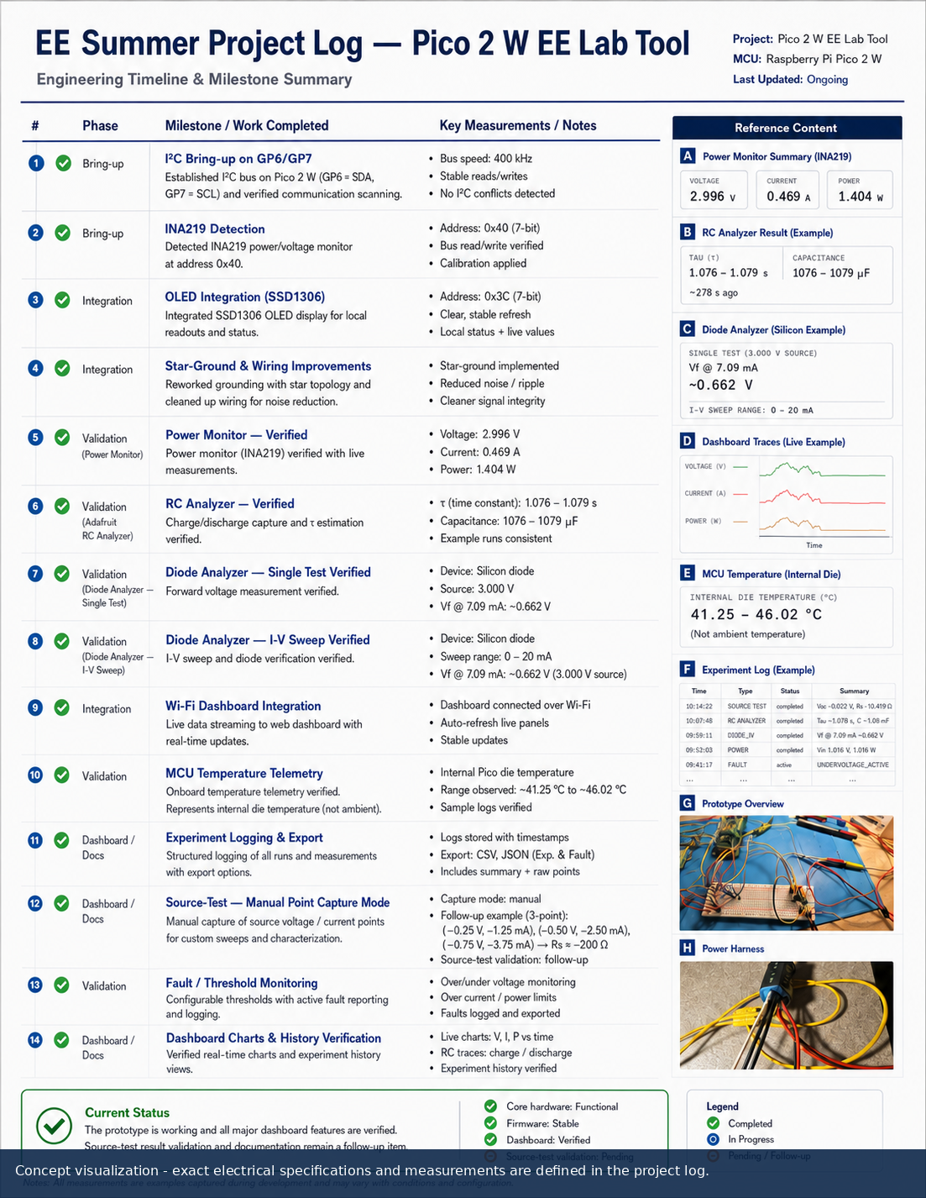
Conceptual project timeline visual.

