EE Summer Project Log
Raspberry Pi Pico 2 W Power & Transient Analyzer
Current focus: measurement integrity, circuit diagnosis, calibrated power monitoring, and embedded transient characterization
Status | Working calibrated power monitor + automated BJT-controlled RC transient analyzer
Controller | Raspberry Pi Pico 2 W
Sensors / display | INA219 power monitor + 128×64 I²C OLED + Pico GP26/ADC0 transient measurement
Load | 100 W, 10 Ω, J (±5%) aluminum power resistor; low-ohm two-wire DMM readings are contact/lead sensitive
Working wiring strategy | Low-current ground rail tied to supply negative + parallel high-current conductors for the temporary prototype
GitHub export updated: 24 August 2026
This document is intended to be extended as the project develops. Future entries should preserve measurements, photos, failed hypotheses, successful diagnostics, and the reasoning behind each wiring or code revision.

Application-ready engineering summary
Designed and iteratively validated a Raspberry Pi Pico 2 W-based DC power-analysis and transient-characterization platform using an INA219 current/voltage monitor, SSD1306 OLED, Pico ADC, and BJT-controlled RC network. The project emphasizes measurement integrity and experimental reasoning: I2C diagnostics, independent multimeter validation, parasitic-resistance analysis, grounding topology, five-point voltage calibration, outlier rejection, direct verification of the INA219 R100 shunt, transistor pinout identification, and theory-versus-measurement RC analysis. The system now combines calibrated steady-state power measurement with an automated RC analyzer that acquires, graphs, and estimates component behavior in real time.
- Embedded systems: MicroPython on Raspberry Pi Pico 2 W; shared I2C bus on GP6/GP7; direct INA219 register access; OLED UI; sample averaging and diagnostic telemetry.
- Instrumentation and validation: five-point voltage calibration with independent multimeter references; independent validation near 3.78 V; current channel checked directly across the INA219 R100 shunt (30.1-30.2 mV -> approximately 0.301-0.302 A).
- Circuit analysis: quantified real wiring/contact losses using Vdrop = IR; reduced ground-reference error from roughly 86 mV to roughly 0.2 mV; reduced positive-path drop from roughly 0.39 V to roughly 0.076 V by redesigning the current path.
- Engineering diagnosis: rejected a defective INA219 module, rejected an anomalous calibration point after repetition, distinguished sensor error from parasitic wiring loss, and identified resistor-lug contact resistance as the dominant remaining prototype limitation.
- Embedded analysis extension: completed a 2N2222-controlled 1000 uF RC analyzer with Pico ADC sampling, automated charge/discharge control, live OLED curves, 1/e time-constant extraction, and capacitance estimation. Future work includes energy integration (mAh/Wh), automated load-step tests, and late-stage USB-source characterization.

1. Project objective and present architecture
The project is being developed as a small DC power-monitoring platform. The Pico 2 W reads an INA219 over I²C, calculates current and power, and displays live values on an OLED. The project has deliberately progressed from a low-current proof-of-concept load to a higher-current power-resistor load so that wiring resistance, shunt behavior, grounding, and calibration can be observed rather than treated as ideal.
Bench supply + → INA219 VIN+ → INA219 VIN− → nominal 10 Ω load → Bench supply −
│
Pico reads INA219 over I²C
│
OLED displays V / I / P

Hardware presently in use
- Raspberry Pi Pico 2 W, powered/programmed over USB.
- 128×64 SSD1306-compatible OLED on the shared I²C bus.
- INA219 breakout board with R100 (0.1 Ω) onboard shunt resistor.
- Bench DC power supply.
- One 100 W, 10 Ω, J (±5%) aluminum power resistor installed as the active test load. Early two-wire DMM readings were about 10.3–10.4 Ω; later the shorted meter leads themselves read about 0.6 Ω and the resistor re-read about 10.1 Ω, demonstrating that low-ohm two-wire measurements are strongly affected by lead/contact resistance.
- A second matching 100 W, 10 Ω power resistor is available for later experiments.
- Breadboard and Dupont jumper wiring; the high-current positive path currently uses three parallel jumpers as a temporary resistance-reduction measure.

Key electrical relationships used during diagnosis
- Ohm’s law: I = V / R. It was used repeatedly as a consistency check, but the project later recognized that a two-wire handheld-meter resistance reading near 10 Ω contains non-negligible lead/contact resistance. Final current verification therefore used the INA219 board’s R100 shunt directly.
- Power: P = VI. Power consistency was used as a secondary check on voltage/current pairs.
- Interconnect drop: Vdrop = IR. Unexpected voltage differences between the bench terminals, INA219 VIN+, VIN−, and ground were converted into effective unwanted series resistance.
- INA219 bus-voltage measurement is referenced at VIN− relative to INA219 GND; therefore it is not automatically equal to the bench-supply terminal voltage when wiring/shunt losses exist.

2. Diagnostic chronology and circuit-analysis record
I²C communication established: An I²C scan returned [60, 64], corresponding to OLED address 0x3C and INA219 address 0x40. This separated bus-level communication problems from measurement problems.
OLED confirmed independently: A direct write test and subsequent SSD1306 display output proved that the OLED could share the bus successfully. This prevented the display from being blamed for later INA219 measurement faults.
First live measurement exposed a contradiction: The OLED showed approximately 0.18 V, 8.80 mA, and 1.6 mW while the external source and 500 Ω test load implied several volts at the load. The current was plausible but the bus voltage was not.
Multimeter reference disproved the first INA219 bus reading: VIN− measured about 4.76 V relative to INA219 GND, while the INA219 bus register reported about 0.184 V. Reconfiguration and a 50 kHz bus test did not fix the discrepancy. Reducing the supply to about 3 V produced only about 0.12 V from the bus register, confirming a device-specific fault rather than a code scaling error.
Replacement-module screening: A second replacement was not detected on I²C. A third INA219 returned [60, 64] and produced a realistic bus reading (about 3.36–3.38 V against a 3.30 V multimeter reference). The project continued with this third module.
Low-current calibration succeeded: Using the 500 Ω load, the third module was linearly calibrated and validated. This established the calibration workflow before the project moved to a much larger load current.
Power resistor introduced: The aluminum resistor was identified as 100 W, 10 Ω, J. At roughly 3 V it drew about 0.29–0.30 A and dissipated about 0.86–0.91 W, giving a much more demanding and informative test condition. Initial resistance measurements were around 10.3–10.4 Ω, but later lead-resistance checks showed that these low-ohm readings should be treated as approximate rather than as the primary calibration standard.
Ground-reference loss discovered: Under the higher current load, the INA219 GND-to-supply-negative difference measured about 86 mV. That is too large for a precision reference and explained part of the apparent sensor error.
Star grounding implemented: The load return, INA219 GND, and the breadboard/Pico ground were reorganized around the bench supply negative terminal. The measured INA219-ground-to-supply-negative difference fell from about 86 mV to about 0.2 mV on the 200 mV meter range.
Positive-path resistance quantified: At roughly 0.42 A, the original thin-jumper path lost about 0.39 V between bench supply + and INA219 VIN+, equivalent to roughly 0.93 Ω of unwanted series resistance. Two parallel jumpers reduced the drop to about 0.10 V; three reduced it further to about 0.076 V. This demonstrated that a significant part of the earlier “sensor error” was actually real wiring/contact loss.
Five-point voltage calibration collected after wiring stabilization: After the ground and positive-path revisions, five accepted raw/actual voltage pairs were collected. An anomalous high-voltage point was deliberately rejected only after a repeat measurement showed the anomaly was not reproducible.
Independent validation passed: At an independent point near 3.78 V, the calibrated INA219 settled around 3.774–3.786 V while the multimeter read 3.78 V. The final voltage calibration is therefore considered validated for the present wiring and load range.

3. Quantitative findings

Wiring and grounding losses
Condition | Measured drop | Approx. current | Interpretation
Original positive path, one thin jumper | ~0.39 V | ~0.42 A | ≈0.93 Ω effective unwanted series resistance
Two parallel positive jumpers | ~0.10 V | ~0.42 A | ≈0.24 Ω effective path resistance
Three parallel positive jumpers | ~0.076 V | ~0.42 A | ≈0.18 Ω effective path resistance
INA219 GND to supply − before star ground | ~0.086 V | ~0.29 A load condition | Ground reference contaminated by shared high-current return path
INA219 GND to supply − after star ground | ~0.0002 V | ~0.29–0.42 A load range | Ground-reference error essentially removed at meter resolution

Accepted five-point voltage calibration
Actual multimeter V | Average RAW INA219 V | Fit-predicted V | Residual
3.070 | 3.1389 | 3.06894 | -1.06 mV
3.500 | 3.5778 | 3.50299 | +2.99 mV
3.650 | 3.7235 | 3.64708 | -2.92 mV
4.000 | 4.0827 | 4.00232 | +2.32 mV
4.410 | 4.4936 | 4.40868 | -1.32 mV
Final calibration equation: Vcal = 0.98896 × Vraw − 0.03531 V
Fit quality: R² ≈ 0.999975; calibration-point residuals are approximately ±3 mV or less. The INA219 bus-voltage register itself has a 4 mV step size, so this is near the practical resolution limit of the chosen measurement path.

Current-channel verification
- Direct R100 shunt test: 30.1–30.2 mV measured across the 0.1 Ω shunt implies approximately 0.301–0.302 A; INA219 reported about 0.300 A.
- External VIN+ to VIN− measurement: approximately 41.9 mV, larger than the R100-only drop. The excess ~11.7–11.8 mV is parasitic module/header/contact loss rather than shunt voltage sensed by the INA219 ADC.
- Multimeter 10 A range cross-check: about 0.43 A was reported, but this contradicted both the direct R100 measurement and the INA219 reading and was rejected as an unsuitable calibration reference for this setup.
Conclusion: the INA219 current channel is independently verified to within roughly 1–2 mA at ~0.30 A using a direct measurement across R100. No current scale correction is presently justified; remaining error is dominated by component/meter uncertainty and prototype contact resistance.

4. Current software configuration
The current monitor uses direct register access rather than an INA219 library. This keeps the calibration path explicit and makes raw values available for diagnosis.
INA219 = 0x40
V_SLOPE = 0.98896
V_OFFSET = -0.03531
SHUNT_OHMS = 0.1
SAMPLES = 8
raw_voltage = (raw_bus >> 3) * 0.004
voltage = (raw_voltage * V_SLOPE) + V_OFFSET
current_A = ((raw_shunt_signed * 0.01) / SHUNT_OHMS) / 1000.0
power_W = voltage * current_A
Why averaging was added: The code now averages several INA219 samples before updating the OLED. This reduces visible jitter while retaining a sufficiently fast update rate for steady-state load testing. The raw voltage remains printed to Thonny so future anomalies can be separated into sensor, calibration, or wiring effects.

Present wiring practice to preserve
SUPPLY − (common reference)
├─ direct high-current return conductor(s) from power-resistor side
└─ breadboard blue rail → Pico GND + INA219 GND / low-current electronics
(rail-to-supply− measured ≈0.2 mV)
SUPPLY +
└─ three parallel temporary jumpers → INA219 VIN+
INA219 VIN−
└─ parallel temporary conductors → nominal 10 Ω power resistor → SUPPLY −
Note: resistor-lug/contact drops remain material and are measured separately; they are not calibration error.
For a final build, the three parallel Dupont jumpers should preferably be replaced by a single short, appropriately sized conductor and a more robust terminal connection. The parallel-jumper arrangement is retained because it is a measured improvement for the current prototype, not because it is the preferred permanent construction.

5. Photographic evidence and diagnostic significance
The photos are treated as measurement evidence, not merely illustrations. Each image is tied to the diagnosis or design decision it supported.
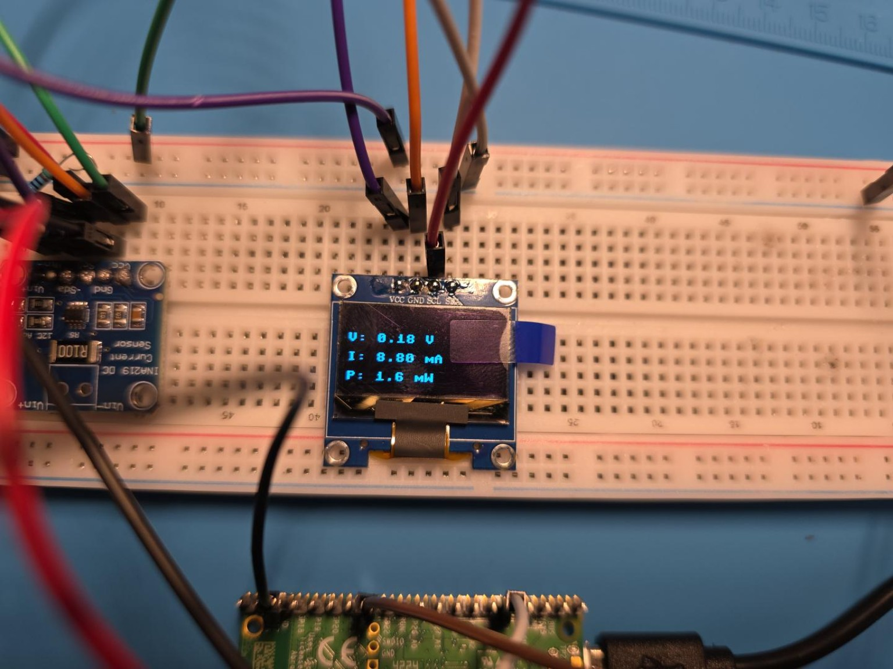
Figure 1. Early live OLED test: approximately 0.18 V, 8.80 mA, 1.6 mW.
Diagnostic significance: This image captured the first major contradiction. The current was close to the expected value for the original 500 Ω test load, but the voltage was implausibly low. That asymmetry directed the diagnosis toward the INA219 bus-voltage channel rather than the entire I²C system or the OLED.
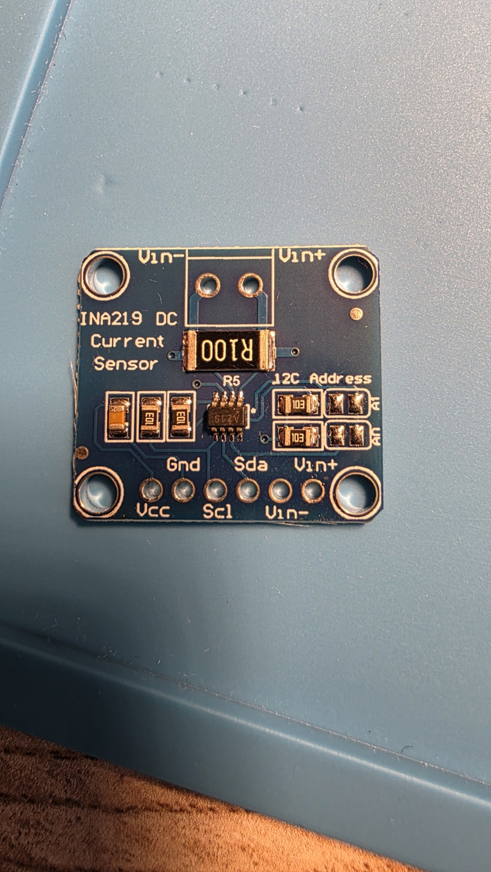
Figure 2. INA219 breakout, component side.
Diagnostic significance: The photo documents the R100 shunt resistor, VIN+/VIN− labels, GND/VCC/SDA/SCL connections, and I²C-address pads. The R100 marking confirmed a nominal 0.1 Ω shunt, supporting the direct current calculation from measured shunt voltage.
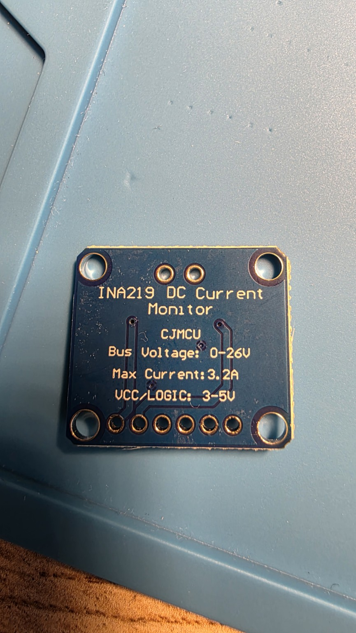
Figure 3. INA219 breakout, rear markings.
Diagnostic significance: The rear silkscreen identifies the board as an INA219 DC current monitor and states the nominal 0–26 V bus range, 3.2 A maximum-current claim, and 3–5 V logic supply range. These markings were used as a hardware sanity check while investigating the first defective/noncompliant module.
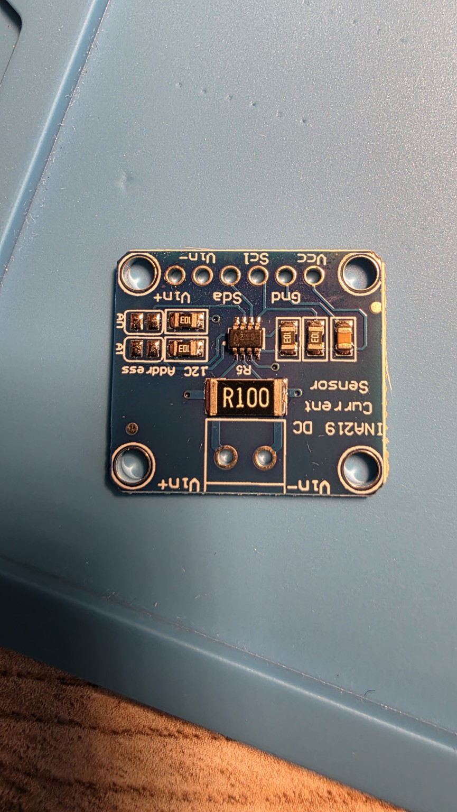
Figure 4. Alternate INA219 component-side angle.
Diagnostic significance: This additional angle preserves the physical condition and soldered layout of the module during troubleshooting. It is particularly useful when revisiting connector orientation or address-pad state later in the project.

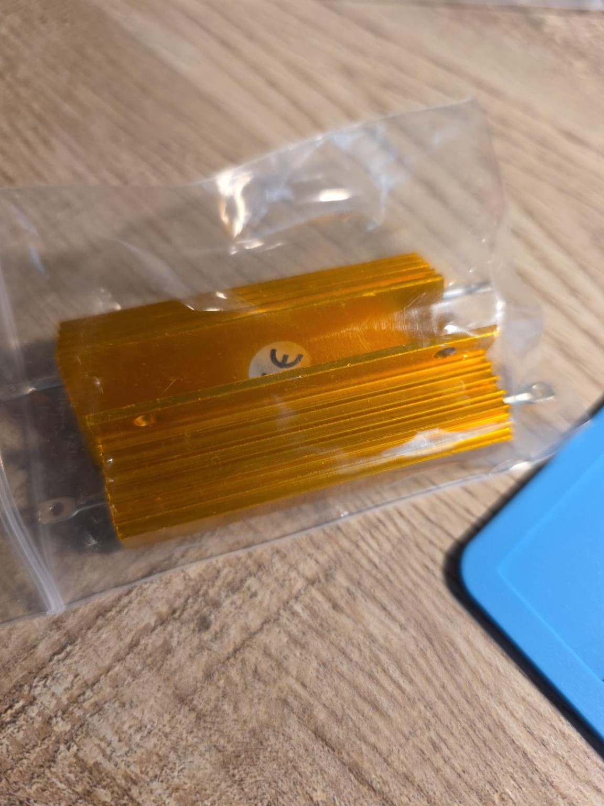
Figure 5. Aluminum-bodied power resistors as received.
Diagnostic significance: The large finned aluminum package explains why this load can dissipate watts of heat more safely than a small quarter-watt resistor. The project owns two of these resistors, enabling later series/parallel or comparative load experiments.
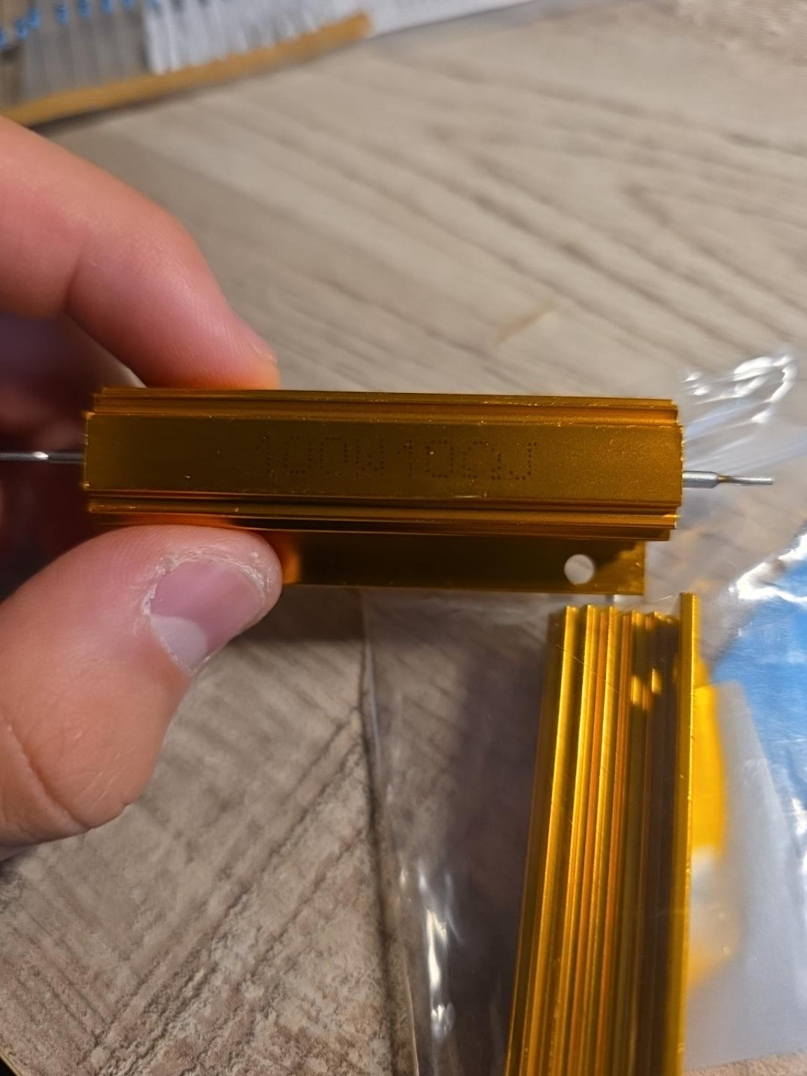
Figure 6. Power-resistor body marking.
Diagnostic significance: The resistor was identified as 100 W, 10 Ω, J (±5%). Early two-wire multimeter measurements clustered around 10.3–10.4 Ω, but later the meter leads shorted at about 0.6 Ω and the resistor re-read about 10.1 Ω. This photo therefore documents the nominal component specification, while the measurement sequence demonstrates why low-resistance two-wire DMM readings must be corrected or treated cautiously. Final current verification used the INA219 R100 shunt directly instead.

6. Diagnostic lessons from this phase
- Separate communication from measurement. I²C detection and OLED operation can be correct while an ADC channel or module is defective. The project benefited from isolating bus communication, display communication, raw-register reads, and physical voltage measurements.
- Use a multimeter as an independent reference. Direct measurements at INA219 GND, VIN+, and VIN− prevented software calibration from masking real wiring faults.
- Measure voltage drops across connections, not only node voltages. Measuring supply+ to VIN+ directly exposed approximately 0.39 V of positive-path loss that would have been easy to misinterpret as sensor error.
- Ground is not automatically “zero” under load. The 86 mV ground-reference difference under the power-resistor load demonstrated how shared return paths corrupt precision measurements. Star grounding reduced this to about 0.2 mV.
- A calibration point can be wrong even when it looks plausible. The anomalous high point was rejected only after a repeat measurement contradicted it. Repeating questionable points prevented an outlier from distorting the regression.
- Cross-check with physics, then improve the reference. The nominal 10 Ω resistor provided a strong first-pass Ohm’s-law consistency check, but the later 0.6 Ω shorted-lead reading showed that the handheld meter’s two-wire resistance measurement was not accurate enough to serve as a current-calibration standard. Direct R100 shunt-voltage measurement provided the stronger reference.
- Prototype interconnects become components at higher current. At ~0.42 A, thin jumpers and breadboard contacts produced measurable resistance. The three-jumper test was effectively a parallel-resistance experiment and showed a substantial reduction in path drop.

7. Current status and next steps
- Voltage calibration is validated for the present third INA219, star-ground wiring, and high-current load arrangement.
- Current channel independently verified: a direct multimeter measurement across the INA219 board’s R100 shunt gave 30.1–30.2 mV while the INA219 reported about 0.300 A. With a nominal 0.1 Ω shunt, the external measurement implies approximately 0.301–0.302 A, so no current calibration correction is presently justified.
- The power calculation is derived as calibrated VIN− bus voltage × independently verified current. This represents load-side power downstream of the INA219 shunt, including any downstream wiring/contact losses in the load path.
- The OLED and INA219 share I²C successfully on GP6 (SDA) and GP7 (SCL) using SoftI2C at 50 kHz.
- Three parallel positive jumpers remain a temporary prototype measure; a thicker direct conductor/terminal connection is preferred for final construction.
At that stage, the recommended next technical step was to preserve the validated voltage calibration and verified current channel, improve the temporary high-current resistor-lug connections when suitable hardware became available, then proceed to a new functional subsystem without disturbing the measurement topology. That recommendation led directly to the separate BJT-controlled RC analyzer documented later in this log.

8. Current-channel verification and contact-resistance diagnosis
A direct current check using the multimeter’s 10 A range produced an implausible ~0.43 A result while the INA219 reported ~0.29–0.30 A. Rather than calibrating to this disagreement, the current path was tested at the INA219 shunt itself.
With the multimeter returned to DC millivolts and placed directly across the R100 shunt resistor, the measured drop was 30.1–30.2 mV. Since R100 is nominally 0.1 Ω, Ohm’s law gives approximately 0.301–0.302 A. At the same time the INA219 reported ~0.300 A. The agreement is within roughly 1–2 mA and is comparable to component and meter uncertainty, so the INA219 current channel is accepted without an additional software scale factor.
A separate measurement across the module’s external VIN+ and VIN− terminals gave ~41.9 mV. The ~11.7–11.8 mV excess above the R100-only drop is therefore real parasitic voltage loss in the module/header/contact path, not shunt voltage seen by the INA219 ADC. At ~0.30 A this corresponds to roughly 39 mΩ of additional series resistance.
The high-current power-resistor connections were also isolated. Approximately 0.136 V was measured between INA219 VIN− and the resistor’s VIN−-side lug, while ~0.06 V was measured on the resistor-return connection. These drops explain why voltage measured directly across the resistor was lower than VIN−-to-ground bus voltage. They should not be “calibrated away”; they are genuine contact/wiring losses.
Alligator clips were experimentally worse than the curled/stripped-wire connection: representative drops increased to roughly 0.22 V and 0.14 V on the two sides. This is a useful reminder that a mechanically larger connection can still have higher electrical contact resistance when actual metal-to-metal contact area or clamping pressure is poor.
The blue-rail reference itself remained good after the grounding rearrangement: approximately 0.2 mV was measured between the rail near INA219 GND and the power-supply negative terminal on the 200 mV range. This supports keeping Pico GND and INA219 GND on the low-current ground rail while reserving direct/high-current return paths for the load.
Engineering conclusion: voltage calibration is validated, current measurement is independently verified, and the dominant remaining metrology limitation is temporary contact resistance in the prototype high-current load wiring. Final construction should replace improvised lug connections with low-resistance clamped or properly terminated conductors.

Future project-log entry format
Date / stage
Circuit change
Code change
Measured values
Expected values / calculation
Diagnosis / hypothesis
Photo(s) and what they prove
Decision / next step
Logging rule for future sessions: Preserve not only the final wiring/code, but also failed hypotheses, anomalous measurements, repeated tests, and the reason a result was accepted or rejected. Photos should be captioned with both what is visible and why the image mattered to the diagnosis. Continue recording direct voltage-drop measurements across individual interconnects when higher-current behavior changes, because contact resistance has proven to be a material circuit element in this prototype.

9. Expansion planning, component inventory, and layout consolidation
After the measurement subsystem reached a stable state, the project shifted from repeated sensor calibration toward system expansion. The selected direction is to preserve the validated power-monitor core and add controlled experiments that demonstrate embedded control, transistor switching, transient analysis, energy integration, and eventual USB-source characterization.

Selected transistor inventory and intended use
- General-purpose NPN devices retained for immediate work: 2N2222, 2N3904, C1815/2SC1815, C945/2SC945, S9013, and S9014. The 2N2222 and 2N3904 are preferred for Pico-controlled LED and RC discharge experiments.
- Complementary / PNP devices: 2N3906, A1015/2SA1015, S9012, S9015, and S8550. These support high-side and complementary BJT experiments.
- Higher-current BJT candidate: S8050 (with S8550 as its PNP complement). It is the best available BJT candidate for moderate-current switching, although a logic-level MOSFET would still be preferable for efficiently switching the approximately 0.4-0.5 A power-resistor load.
- High-voltage small-signal devices stored for later: 2N5551, MPSA42, 2N5401, and MPSA92.
- No logic-level MOSFET was found in the present transistor assortment; the next extension will therefore use BJTs for low-current control and transient experiments rather than forcing a BJT into an inefficient high-current power-switch role.

Planned high-value extensions
- Automated RC transient experiment: use a Pico GPIO and 2N2222/2N3904 to charge or discharge an electrolytic capacitor through a known resistor, log voltage/current versus time, compare with the exponential RC model, and estimate the time constant or capacitance experimentally.
- Energy analyzer: integrate current and power over elapsed time to report mAh and Wh, plus peak current, minimum voltage, and average power.
- Automated load-step test: use a transistor-controlled low-current auxiliary load to create repeatable step changes and characterize supply recovery and capacitor smoothing.
- USB-source characterization near final integration: use the USB-A screw-terminal breakout as a standardized source interface to compare the available 5.0 V/3.1 A and 5.2 V/2.4 A adapters. This is intentionally postponed until later so the current adjustable-supply wiring does not need to be dismantled prematurely.
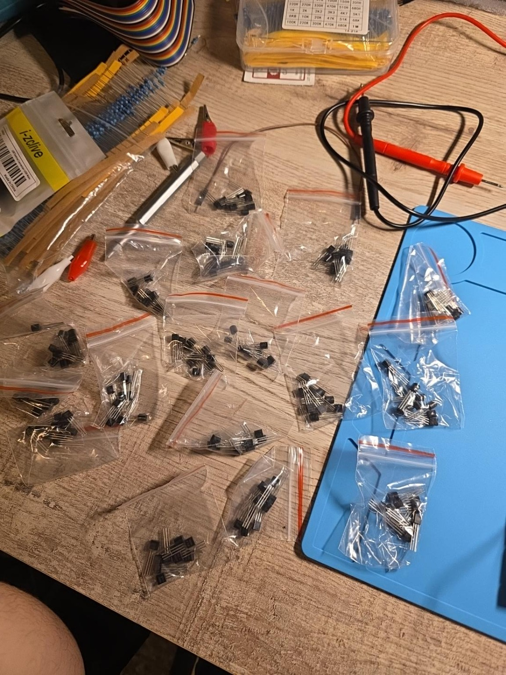
Figure 7. TO-92 transistor assortment during component inventory.
Diagnostic/design significance: The inventory exercise established which devices are suitable for low-current Pico-controlled switching (notably 2N2222 and 2N3904), which are complementary PNP devices, and which should be reserved for high-voltage work. The absence of a logic-level MOSFET informed the decision to keep the main high-current power-resistor path manually controlled while using BJTs for lower-current experimental control.
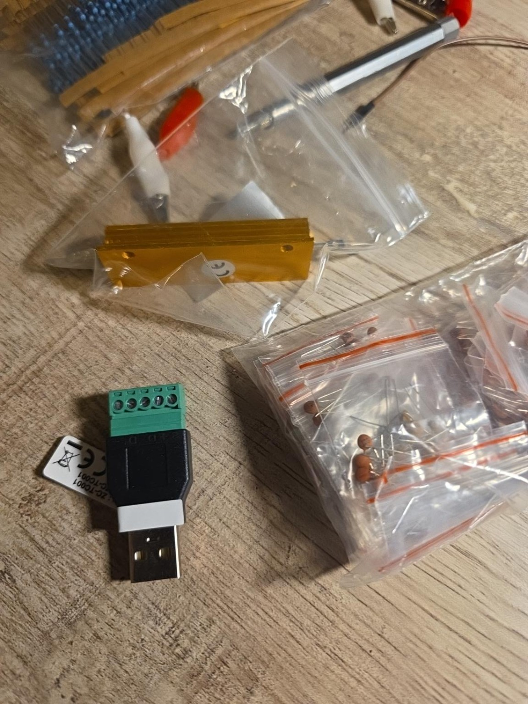
Figure 8. USB-A screw-terminal breakout with passive-component inventory.
Design significance: The USB breakout is reserved for a late-stage source-characterization mode. Its + and - terminals will provide the power path, while D+ and D- remain unused initially. This extension will allow comparison of real USB adapters without sacrificing the adjustable bench supply that is more useful for controlled development and voltage sweeps.

10. Layout reorganization and post-move fault recovery
The breadboard was reorganized to free space for the next transistor/RC stage while preserving the high-current INA219 and power-resistor path on the right side. The OLED was planned to remain in the lower area, beneath the INA219, while the central/left breadboard region remains available for new low-current control circuitry.
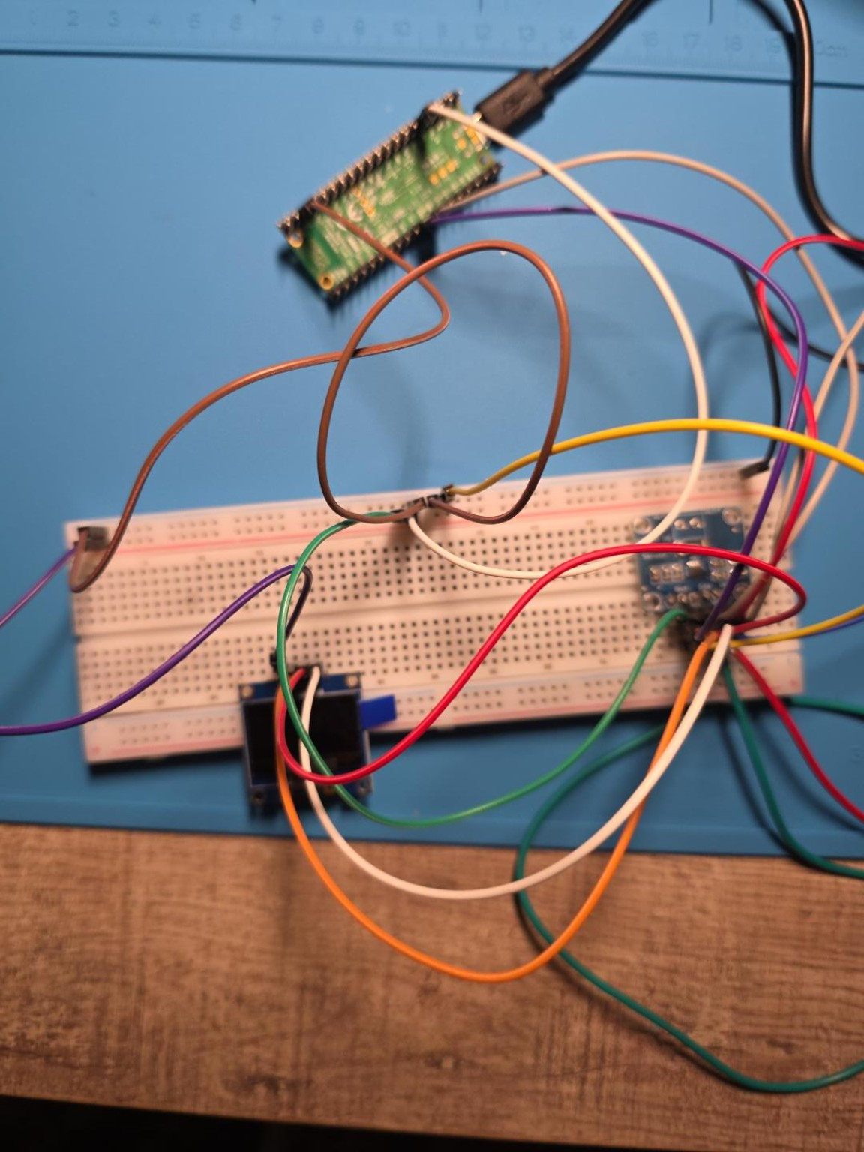
Figure 9. Pre-consolidation breadboard layout before creating space for transistor/RC circuitry.
Diagnostic/design significance: The photograph documents the physical layout before consolidation. Large signal-wire loops occupied the central area, while the INA219 remained constrained to the right by the external power-resistor connection. The reorganization objective was therefore to shorten low-current signal wiring and free central breadboard area without disturbing the validated high-current path.

I2C fault introduced during reorganization
- After moving components, the program raised OSError: [Errno 19] ENODEV. Because the system had worked immediately before the move, the fault was treated as a physical interconnect problem rather than a software regression.
- The recovery procedure returned to a minimal I2C scan, with the expected device addresses [60, 64] corresponding to OLED 0x3C and INA219 0x40.
- The wiring review found that INA219 VCC had accidentally been moved onto the blue ground rail. This left the sensor unpowered and directly explained the ENODEV condition.
- Correct wiring was re-established as INA219 VCC -> Pico 3.3 V rail, GND -> common ground rail, SDA -> GP6, and SCL -> GP7. This incident reinforces the value of reducing a complex failure to a minimal bus-level diagnostic after physical rework.

Current project state for GitHub export
- Core power monitor is validated: calibrated bus voltage, independently verified shunt current, calculated power, OLED display, and serial diagnostic output.
- Dominant remaining hardware limitation is prototype interconnect/contact resistance, not INA219 ADC accuracy. Final construction should replace temporary Dupont/curl connections in high-current paths with proper clamped or terminalized conductors.
- Development source remains the adjustable supply. USB-source characterization is intentionally deferred until late-stage integration.
- RC transient subsystem is now operational and independently debugged. The next active build phase is energy accumulation / load-step characterization while preserving the validated power-monitor core; USB-source characterization remains intentionally deferred until late-stage integration.

11. BJT-controlled RC transient analyzer
The next project extension deliberately avoided disturbing the validated high-current INA219 path. A separate low-current RC network was built from a 1000 uF, 10 V electrolytic capacitor, two 1 kOhm resistors, a 4.7 kOhm base resistor, and a 2N2222 NPN transistor. The Pico 2 W controls charging and discharging while GP26/ADC0 measures capacitor voltage. This adds time-domain circuit analysis and automated component characterization to the steady-state power-monitoring platform.

11.1 Component selection and theoretical design
- Capacitor: 1000 uF, 10 V electrolytic. The 10 V rating is safely above the 3.3 V Pico-domain experiment.
- Charge path: GP0 -> 1 kOhm -> capacitor positive node. The capacitor negative terminal is connected to common Pico ground.
- ADC measurement: GP26 / ADC0 is tied directly to the capacitor positive node.
- Discharge path: capacitor positive -> second 1 kOhm -> 2N2222 collector -> emitter -> ground.
- Base drive: GP1 -> 4.7 kOhm -> 2N2222 base. The resistor limits GPIO base current and allows the Pico to control the discharge switch safely.
With R = 1 kOhm and C = 1000 uF, the nominal RC time constant is tau = RC = 1.0 s. This was selected deliberately so that the Pico can sample the exponential waveform cleanly at ~100 ms intervals.
RC transient wiring (Pico USB power only)
GP0 ---- 1 kOhm ----+---- capacitor + ---- GP26 / ADC0
|
+---- 1 kOhm ---- C 2N2222
E ---- GND
GP1 ---- 4.7 kOhm ------------------- B
capacitor - ------------------------------- GND
2N2222 pinout, flat face toward observer: Left = E, Middle = B, Right = C

11.2 Experimental identification of the 2N2222 pinout
The transistor pinout was not assumed from package appearance. The middle lead was first identified as the base using the multimeter diode-test function: red-on-middle produced approximately 0.600 V to the right lead and 0.603 V to the left lead, while the reverse polarities did not conduct normally. Collector and emitter were then distinguished using a low-current 3.3 V test circuit. With the flat face toward the observer and Left = E / Middle = B / Right = C, the transistor pulled VCE down to approximately 45.9 mV. Reversing the outer leads produced about 2.08 V. This large contrast confirmed the working pinout experimentally rather than relying on an uncertain clone/package datasheet.
Flat-face lead | Identified terminal | Evidence
Left | Emitter (E) | Correct orientation gave VCE ~45.9 mV; reversed outer leads gave ~2.08 V.
Middle | Base (B) | Diode drops ~0.603 V to left and ~0.600 V to right with red probe on middle.
Right | Collector (C) | Completes the low-VCE correct switching orientation.

11.3 Wiring faults and diagnostic process
The first RC run produced an exponential-looking waveform but with physically incorrect limits: charging plateaued near 1.93 V instead of approaching 3.3 V, and the apparent time constant was closer to ~0.5 s. Inspection suggested that the GP26/capacitor charge node and the GP1/4.7 kOhm base-drive connection had been touching. This partially turned the discharge transistor on during charging, effectively placing competing charge/discharge paths across the capacitor.
- Fault signature: charge approached ~1.93 V rather than ~3.3 V; discharge stalled around ~0.55 V after 6 s.
- Diagnosis: unintended contact between the capacitor/ADC node and transistor base-drive wiring caused the transistor to conduct during the charging phase.
- After rewiring, charging correctly approached ~3.29 V, but the initial discharge did not occur; the capacitor still began near ~3.13 V.
- GP1 was isolated and tested directly. The Pico pin produced ~3.26 V when commanded HIGH, proving the GPIO and firmware were correct.
- The GP1 jumper also produced ~3.26 V when isolated, localizing the remaining fault to the breadboard/base-drive connection rather than the Pico.
- After the base-drive path was restored, the complete charge/discharge cycle behaved as predicted.

11.4 Successful RC response and theory comparison
The successful run began after a 5 s transistor-controlled reset with the capacitor at approximately 0.011 V. Charging then rose monotonically toward ~3.29 V; discharging fell exponentially toward ~0.03 V over 6 s. The measured curves closely match first-order RC theory.
Quantity | Measured | Theoretical / reference | Interpretation
Initial reset voltage | ~0.011 V | ~0 V | 2N2222 discharge reset is working.
Final charge voltage | ~3.287-3.291 V | Pico logic high ~3.3 V | Charge path reaches expected supply limit.
Charge voltage at 1.0 s | ~2.055 V | ~2.08 V for 63.2% of 3.29 V | Close agreement with tau ~ 1 s.
Discharge voltage at 1.0 s | ~1.278 V from 3.291 V | ~1.21 V for V0/e | Consistent with tau slightly above 1 s.
Estimated charge tau | ~1.03 s | 1.00 s nominal | Within a few percent of design value.
Estimated discharge tau | ~1.06 s | 1.00 s nominal | Includes resistor/capacitor tolerance and transistor/path resistance.
Estimated capacitance | ~1.05 mF (~1050 uF) | Rated 1000 uF | Plausible electrolytic tolerance; demonstrates component characterization.
The theoretical charging checkpoint is especially useful: at one time constant, a first-order RC network reaches approximately 63.2% of its final voltage. For a 3.29 V final level, this is about 2.08 V; the Pico measured ~2.055 V at 1.0 s. The close agreement converts the circuit from a simple demonstration into a quantitative validation of the RC model.

11.5 OLED visualization and automatic analysis
- During charging, the OLED draws the rising exponential curve live while displaying elapsed time and capacitor voltage.
- During discharge, the OLED draws the falling exponential curve live.
- The final visualization shows charge and discharge traces side-by-side, making their complementary exponential behavior visible without a computer.
- Firmware detects the discharge V0/e crossing, interpolates the time constant, and estimates capacitance using C = tau / R.
- Thonny serial output remains available as a raw-data/debug channel, while the OLED provides a self-contained demonstration interface.
Successful RC analyzer sequence:
Reset capacitor -> live CHARGE curve -> live DISCHARGE curve -> dual-curve OLED summary -> tau / capacitance result

Figure 10. Electrolytic and ceramic capacitor assortment used to select the RC test component.
Design significance: The 1000 uF, 10 V electrolytic was selected because its large capacitance produces a ~1 s time constant with a 1 kOhm resistor, slow enough for clean Pico ADC sampling while remaining safely within the 3.3 V operating range.
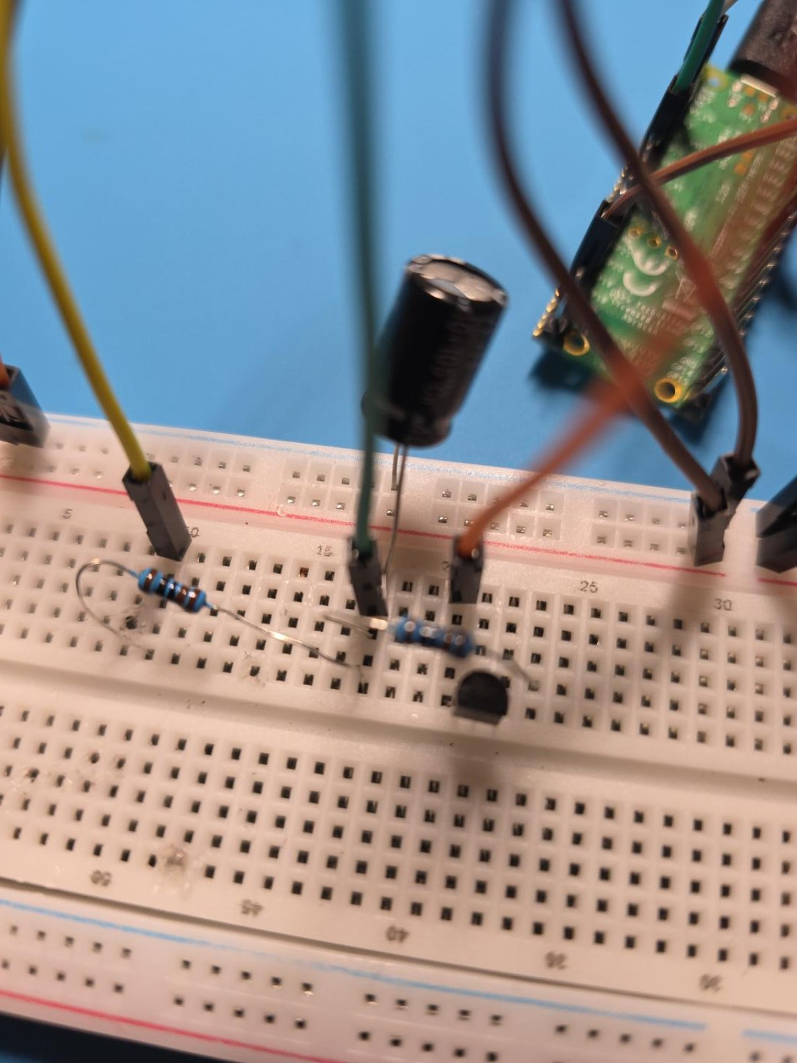
Figure 11. Breadboard layout after adding the RC/transistor subsystem.
Design significance: The photograph documents the separation of the low-current RC analyzer from the existing INA219/power-monitoring hardware. This preserves the validated measurement core while adding a second experimental subsystem.
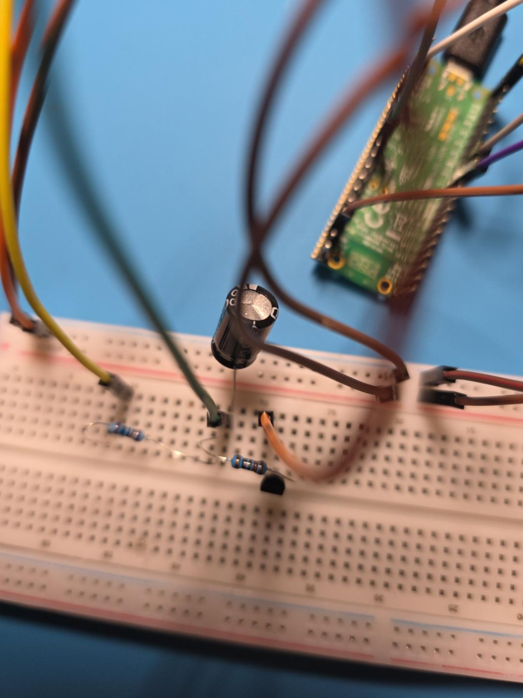
Figure 12. RC network close-up showing capacitor, resistors, and transistor region.
Diagnostic significance: This view records the physical placement used during the wiring-debug phase. It is especially relevant because unintended contact between adjacent resistor/node wiring initially caused the charging and discharge paths to interfere.
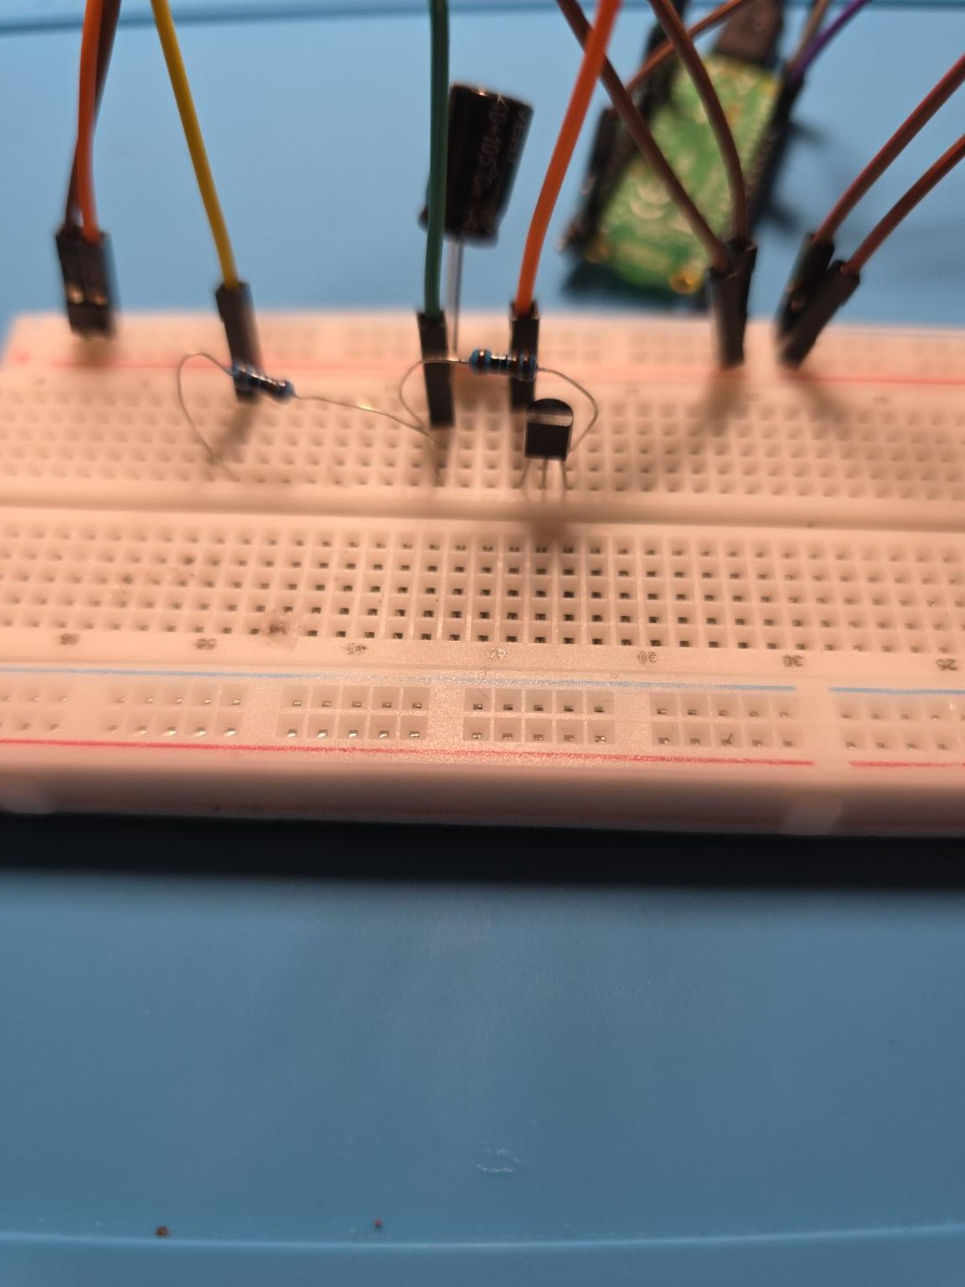
Figure 13. Alternate close-up of the RC analyzer wiring.
Diagnostic significance: The alternate angle preserves component orientation and routing around the 2N2222 and capacitor, supporting later reconstruction of the experiment and pin/node assignments.

12. Initial GitHub export state
The project is now mature enough for an initial public-facing repository export. The export should preserve both polished outcomes and the engineering process: firmware, wiring notes, calibration constants, accepted/rejected measurements, photographs, and the diagnostic reasoning that connected each observation to a circuit-level hypothesis.
- Steady-state subsystem: calibrated INA219 voltage, independently verified current, OLED power display, and diagnostic serial telemetry.
- Transient subsystem: 2N2222-controlled RC charge/discharge, Pico ADC acquisition, live OLED charge/discharge plots, automatic time-constant extraction, and capacitance estimation.
- Engineering-process evidence: defective-module screening, star-ground redesign, parasitic wiring/contact resistance measurements, outlier rejection, transistor pinout identification, and iterative breadboard fault localization.
- Repository-ready artifacts: README, Markdown project log, firmware source files, selected figure assets, and the full DOCX engineering log.
Recommended next capability after the initial export: add energy integration (mAh and Wh) and a repeatable auxiliary load-step experiment. USB source characterization remains reserved for late-stage integration so the current bench-supply wiring does not need to be dismantled prematurely.

