Task 3

Exemple 1 :

I printed a message.
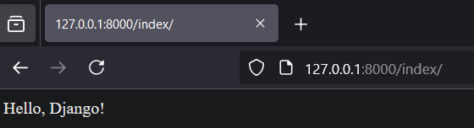
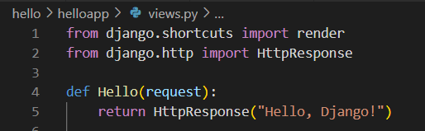
Using this file.

Exemple 2 :
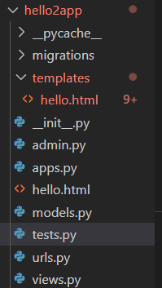
My template is filled with errors :
But after editing settings, view and both urls, in the end it still works properly.


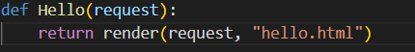

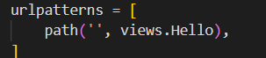

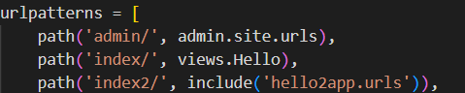

I got some Tcp trafic doing it.
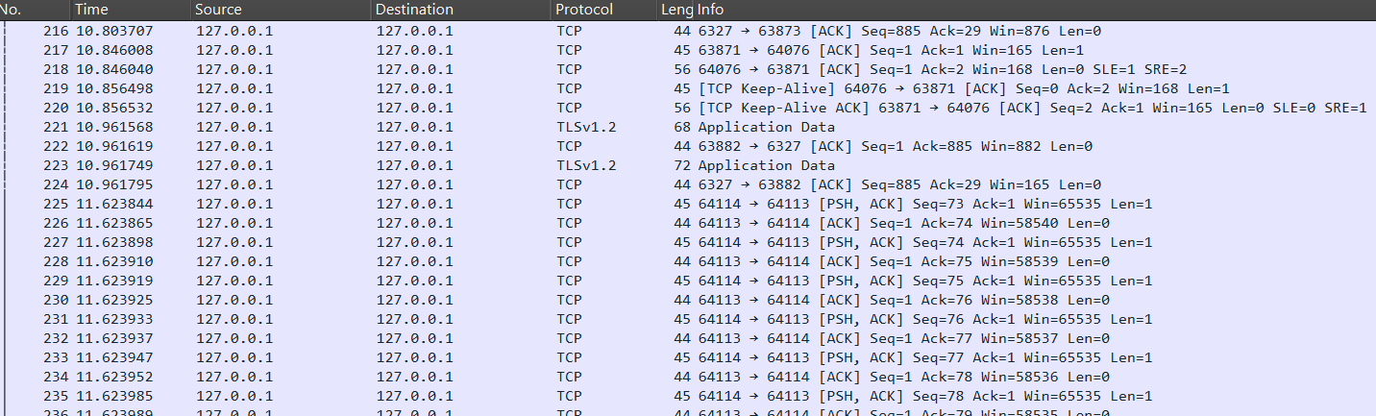
You can check my code on github but i wasn’t able to make exemple working even with videos. Also i never found the html on ortus.

