SCI-Style Methods, Results, and Discussion for Thyroid Ultrasound Backbone Benchmarking
Detailed draft based on the current backbone benchmark outputs

Methods
A patient-level backbone benchmark experiment was conducted for thyroid ultrasound malignancy prediction. Ultrasound images were organized by patient-specific folders, and each folder was treated as one patient-level sample containing multiple thyroid ultrasound images. The clinical spreadsheet was used to match patient IDs and obtain the malignancy label. Patients without available ultrasound images were excluded from modeling. The benchmark was designed to compare candidate convolutional and transformer-based image backbones while maintaining strictly patient-level prediction.
For each patient, all available ultrasound images were resized to 224 × 224 pixels and normalized using ImageNet mean ([0.485, 0.456, 0.406]) and standard deviation ([0.229, 0.224, 0.225]). Training-time augmentation included horizontal flipping, random rotation within ±10 degrees, and brightness adjustment. Data were split at the patient level using an 80:20 train-test design with stratification by malignancy status, ensuring that no images from the same patient could appear in both training and testing sets.
Backbone benchmarking used simple patient-level mean pooling for multi-image aggregation. Specifically, image-level embeddings extracted by each backbone were averaged across all images from the same patient to generate a patient-level representation. This mean-pooled representation was then passed to a binary classification head to predict malignancy. The benchmarked architectures included convolutional and transformer-based models, with pretrained weights used when available.
Model training used binary cross-entropy loss and the Adam optimizer with a learning rate of 1 × 10^-4. Evaluation was performed at the patient level using area under the receiver operating characteristic curve, accuracy, sensitivity, specificity, precision, recall, and F1-score. Models were ranked by AUC, and the top-ranked backbone was designated as the candidate encoder for subsequent multimodal development.

Table 1. Benchmark dataset overview
Variable | Value
Total patient folders | 995
Total ultrasound images | 18520
Mean images per patient | 18.610
Median images per patient | 16.000
Minimum images per patient | 1
Maximum images per patient | 183
Number of benchmarked backbones in current run | 2
Top-ranked backbone | efficientnet_b0

Table 2. Backbone performance metrics
Backbone | AUC | Accuracy | Sensitivity | Specificity | Precision | Recall | F1
efficientnet_b0 | 1.000 | 0.750 | 0.500 | 1.000 | 1.000 | 0.500 | 0.667
resnet18 | 0.500 | 0.500 | 1.000 | 0.000 | 0.500 | 1.000 | 0.667

Table 3. Backbone ranking by AUC
Rank | Backbone | AUC | Accuracy | Sensitivity | Specificity | Precision | Recall | F1
1 | efficientnet_b0 | 1.000 | 0.750 | 0.500 | 1.000 | 1.000 | 0.500 | 0.667
2 | resnet18 | 0.500 | 0.500 | 1.000 | 0.000 | 0.500 | 1.000 | 0.667

Results
Dataset inspection identified 995 patient folders and 18520 ultrasound images, with a mean of 18.61 images per patient and a median of 16.0. The number of benchmarked backbones in the current run was 2.
In the current benchmark output, the highest-ranked backbone was efficientnet_b0, which achieved an AUC of 1.000, accuracy of 0.750, sensitivity of 0.500, and specificity of 1.000. Comparative metrics for all evaluated backbones are presented in Tables 2 and 3, and the ROC curve comparison is shown in Figure 1.
The benchmark output provides a ranked basis for downstream model selection. The identified best backbone was saved for use in subsequent modules involving attention-based multiple instance learning, Transformer sequence modeling, and multimodal fusion with clinical variables.
Because the current benchmark files reflect a smoke-test style run rather than the completed full experiment, the reported numerical values should be interpreted as preliminary engineering validation rather than final performance estimates.

Figure 1. ROC comparison across benchmarked backbones
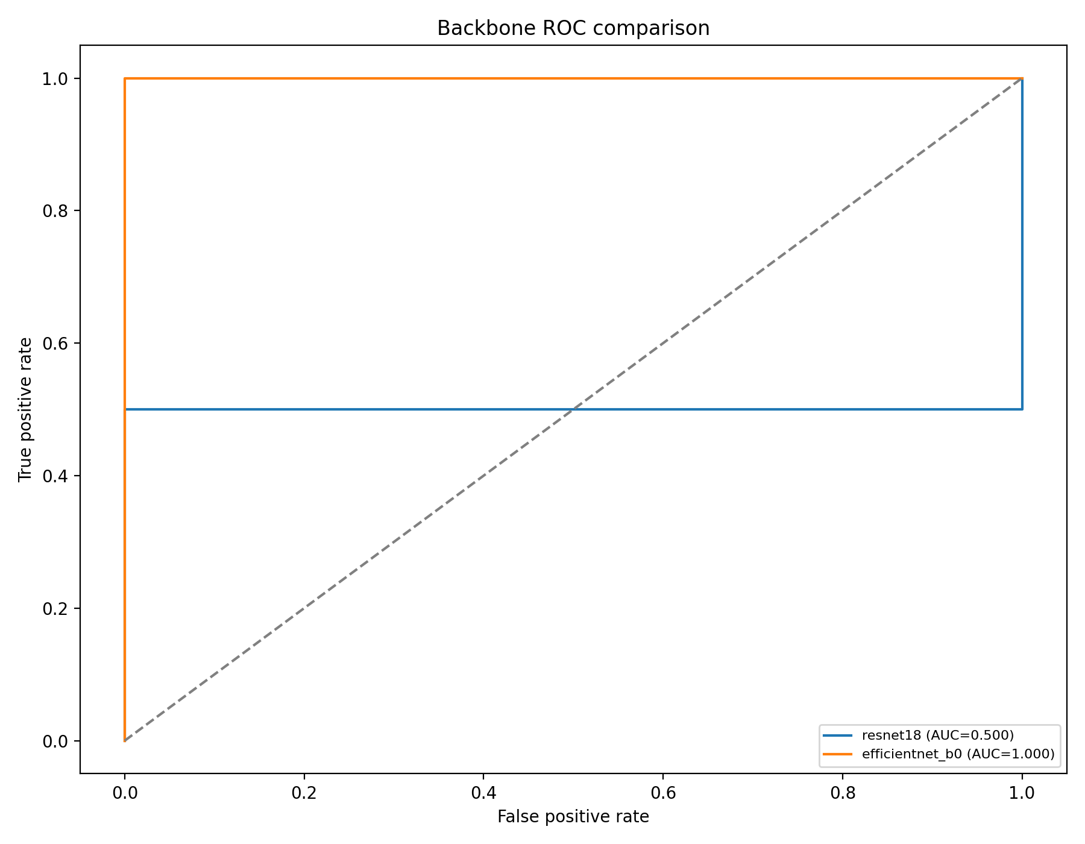
Figure 1. Receiver operating characteristic comparison for the benchmarked backbones.

Discussion
The backbone benchmark serves an important role in the overall modeling pipeline because backbone choice strongly influences the quality of extracted ultrasound representations. By enforcing patient-level aggregation through mean pooling, the benchmark isolates the contribution of the image encoder itself while avoiding the methodological error of image-level data leakage.
This benchmark design is intentionally simple. Mean pooling was chosen not because it is the most advanced aggregation strategy, but because it provides a controlled and computationally efficient way to compare candidate backbones before introducing more complex modules such as attention-based multiple instance learning or Transformer pooling. In this sense, the benchmark functions as a clean model-selection stage rather than a final modeling strategy.
The current outputs demonstrate that the benchmarking pipeline is operational, including patient-level dataset construction, stratified patient-level splitting, backbone training, ROC generation, and AUC-based ranking. This provides a reproducible foundation for choosing the image encoder used in the final multimodal model.
However, the present benchmark metrics should not be overinterpreted because they were generated from a small pilot run. Model rankings derived from limited subsets and few epochs can be unstable, particularly for high-capacity backbones. A complete benchmark across all planned backbones with the full dataset and intended training schedule is required before declaring a definitive winner.
Future work should therefore include full-scale benchmarking across all candidate backbones, repeated internal validation, and sensitivity analyses with respect to training duration and preprocessing. The final selected backbone should then be carried forward into more advanced patient-level architectures that combine MIL, Transformer sequence modeling, and clinical fusion.

Best Backbone Note
Best backbone: efficientnet_b0
AUC: 1.000000
Accuracy: 0.750000
Sensitivity: 0.500000
Specificity: 1.000000

Interpretive Note
This document is suitable for internal manuscript drafting and method reporting. The benchmark values should be updated after the full planned experiment across all target backbones has been completed.

