SCI-Style Methods, Results, and Discussion for the Final Multimodal Thyroid AI Model
Detailed draft based on the current pilot final multimodal run

Methods
A final patient-level multimodal artificial intelligence model was constructed for thyroid malignancy prediction by integrating ultrasound image information and structured clinical variables. Ultrasound images were stored in patient-specific folders, and each folder was treated as one patient-level bag containing multiple thyroid ultrasound images. This design ensured that prediction remained strictly patient-level rather than image-level. The selected imaging backbone from the benchmark phase was used as the image encoder in the final multimodal model.
Images were resized to 224 × 224 pixels and normalized with ImageNet mean ([0.485, 0.456, 0.406]) and standard deviation ([0.229, 0.224, 0.225]). Training-time augmentation included horizontal flipping, random rotation within ±10 degrees, and brightness adjustment. Patients were split at the patient level into training and testing cohorts with an 80:20 ratio using stratified sampling according to malignancy status, thereby preventing images from the same patient appearing in both subsets.
Image-level features were extracted using the selected backbone. The resulting embeddings were projected into a 768-dimensional latent space and processed by a Transformer encoder composed of 2 layers and 8 attention heads. Attention-based multiple instance learning was then applied to compute a weighted patient-level image representation from the image sequence. Clinical predictors included age, sex, body mass index, smoking, drinking, hypertension, diabetes, hepatitis, thyroid history, other cancer history, thyroiditis, and nodular goiter.
The patient-level image representation was fused with a processed clinical feature vector and passed through a prediction head for binary malignancy classification. Model optimization used binary cross-entropy loss and the Adam optimizer with a learning rate of 1 × 10^-4. Performance was evaluated at the patient level using area under the receiver operating characteristic curve, accuracy, sensitivity, specificity, precision, recall, and F1-score. Explainability analyses included SHAP summaries for clinical variables and Grad-CAM visualizations for representative ultrasound images.

Table 1. Overview of the final multimodal dataset and model setting
Variable | Value
Total patient folders | 995
Total ultrasound images | 18520
Mean images per patient | 18.610
Median images per patient | 16.000
Training patients | 16
Testing patients | 4
Final multimodal cohort | 20
Selected backbone | efficientnet_b0

Table 2. Comparison of prior and final patient-level models
Model | AUC | Accuracy | Sensitivity | Specificity
Clinical model (Clinical_LogisticRegression) | 0.500 | 0.500 | 0.500 | 0.500
Ultrasound model | 1.000 | 1.000 | 1.000 | 1.000
Fusion model | 0.000 | 0.250 | 0.000 | 0.500
Final multimodal (efficientnet_b0) | 0.250 | 0.500 | 0.000 | 1.000

Table 3. Detailed performance of the final multimodal model
model | backbone | AUC | Accuracy | Sensitivity | Specificity | Precision | Recall | F1
Final_Multimodal_Model | efficientnet_b0 | 0.250 | 0.500 | 0.000 | 1.000 | 0.000 | 0.000 | 0.000

Table 4. Top clinical features ranked by mean absolute SHAP value
feature | mean_abs_shap
num__thyroiditis_flag | 0.776
num__nodular_goiter_flag | 0.571
num__bmi | 0.275
num__smoking_bin | 0.192
num__diabetes | 0.131
num__hypertension | 0.113
num__thyroid_history | 0.098
num__age | 0.059
num__drinking_bin | 0.053
cat__sex_0 | 0.008

Results
Dataset inspection identified 995 patient folders and 18520 ultrasound images overall. The mean number of images per patient was 18.61, with a median of 16.0. In the current final multimodal run, 20 patients were included after matching and filtering, with 16 allocated to the training cohort and 4 to the testing cohort.
The final multimodal model using efficientnet_b0 achieved an AUC of 0.250, accuracy of 0.500, sensitivity of 0.000, specificity of 1.000, precision of 0.000, recall of 0.000, and F1-score of 0.000. Comparative performance against previous clinical-only, ultrasound-only, and earlier fusion models is summarized in Table 2.
Explainability outputs were generated successfully. SHAP analysis ranked thyroiditis, nodular goiter, body mass index, smoking, and diabetes among the most influential clinical features in the current run. Grad-CAM examples were also obtained for representative ultrasound images, showing that the image interpretation workflow remained available after introducing Transformer-based sequence modeling and clinical fusion.
Because the present final multimodal outputs were derived from a pilot smoke-test execution rather than full-scale training, the numerical results should be interpreted as preliminary technical validation rather than definitive evidence of final model performance.

Figure 1. ROC curve of the final multimodal model
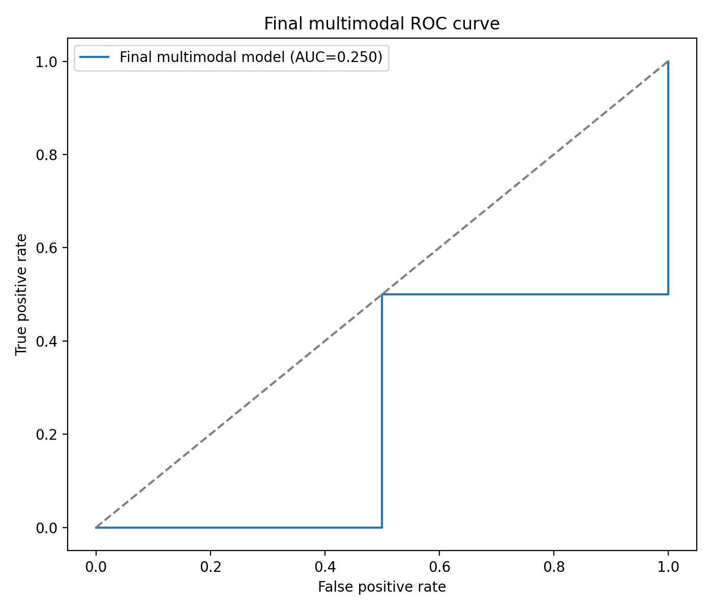
Figure 1. Receiver operating characteristic curve of the final patient-level multimodal model.

Figure 2. SHAP summary plot
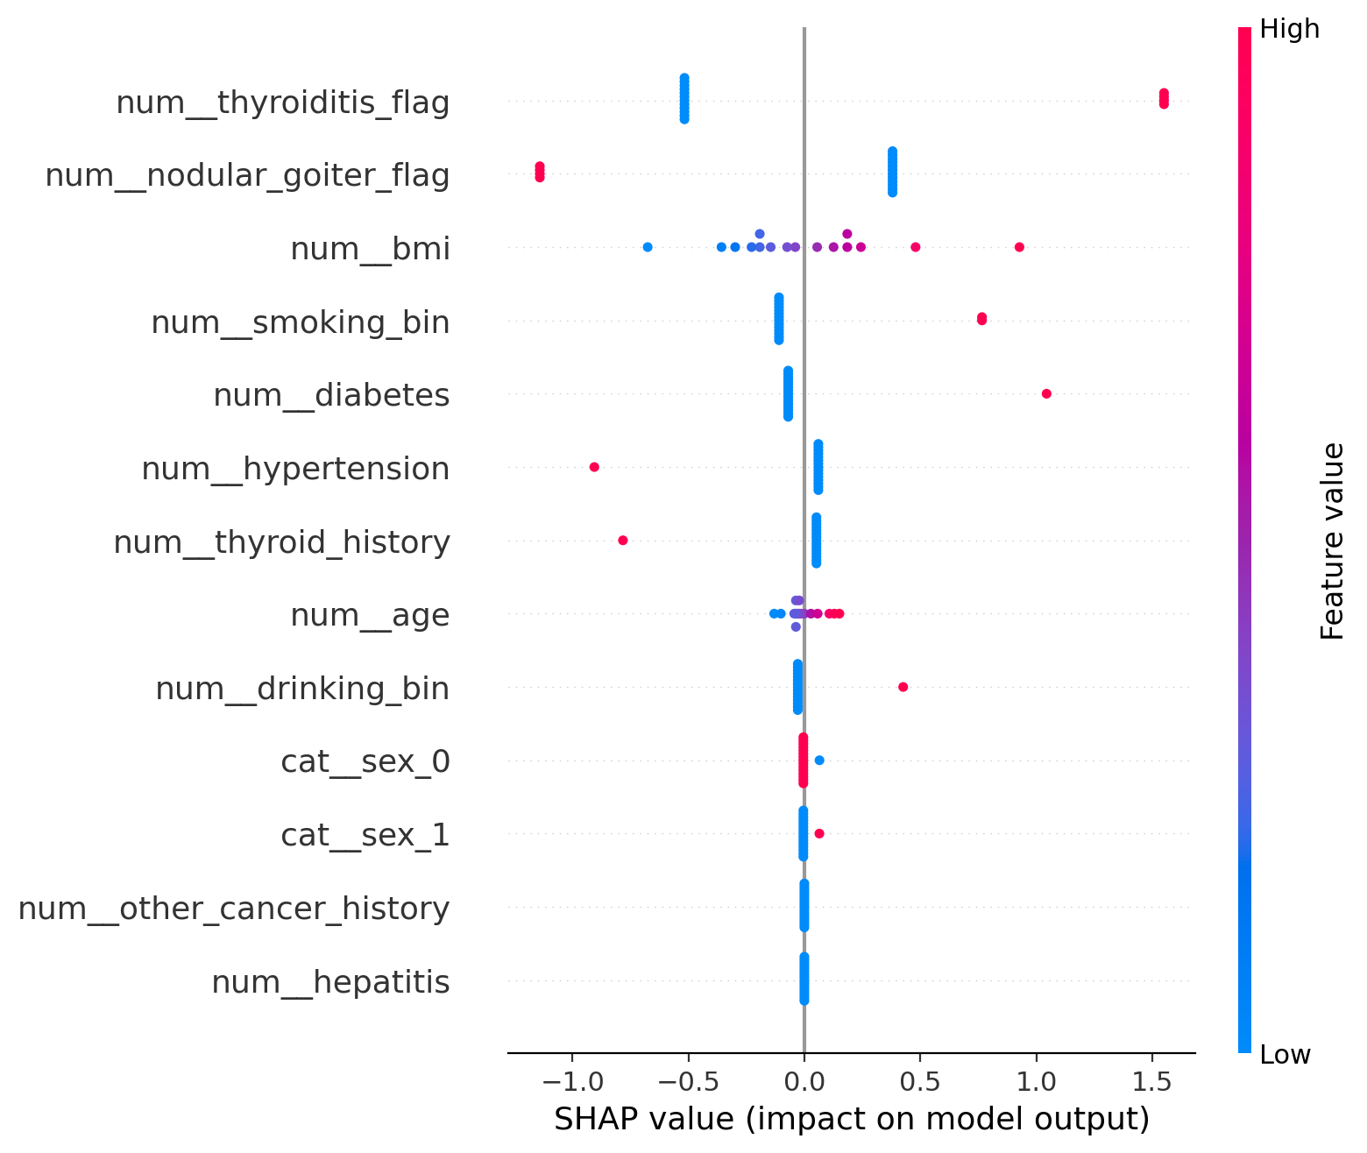
Figure 2. SHAP summary plot for clinical variables used in the final multimodal workflow.

Figure 3. Clinical feature importance
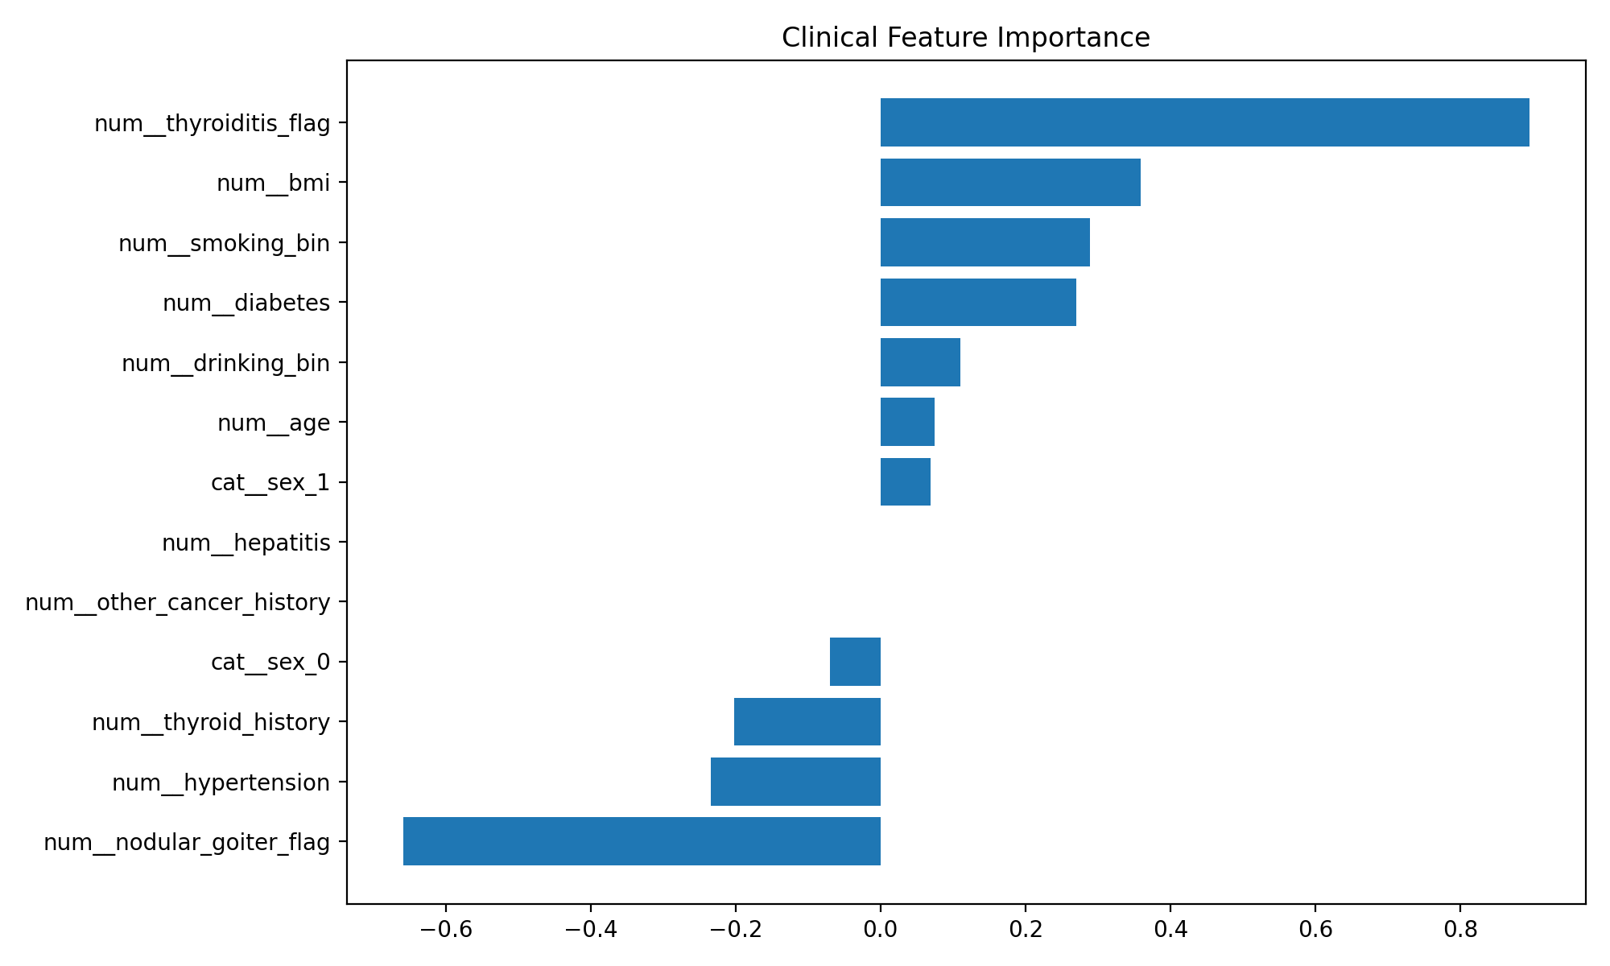
Figure 3. Clinical feature importance from the logistic regression clinical reference model.

Figure 4. Representative Grad-CAM examples
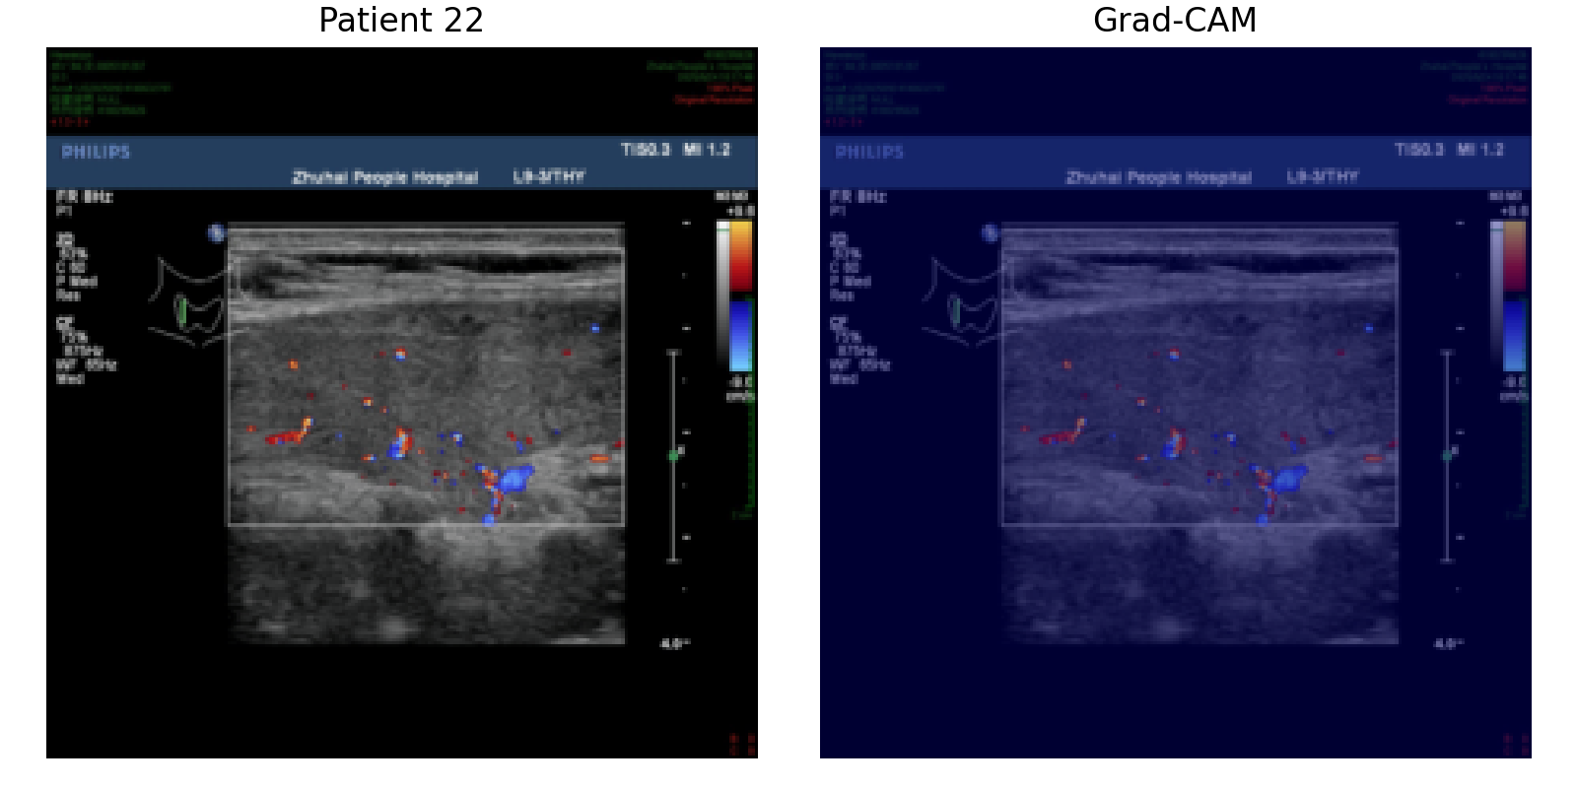
Grad-CAM visualization for patient 22 gradcam.
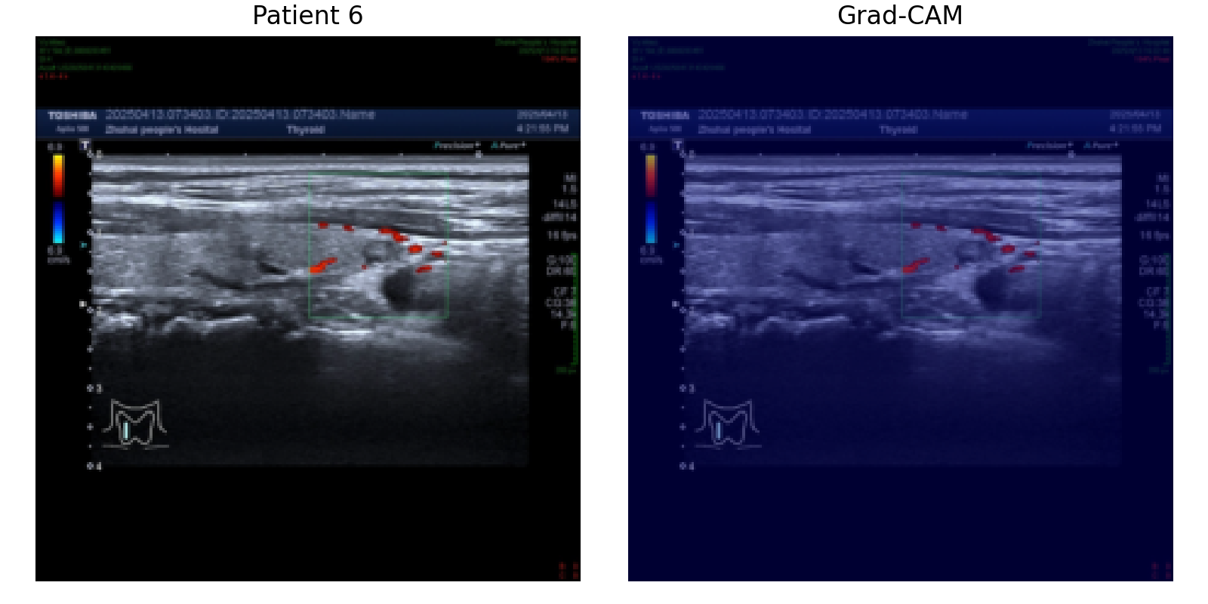
Grad-CAM visualization for patient 6 gradcam.
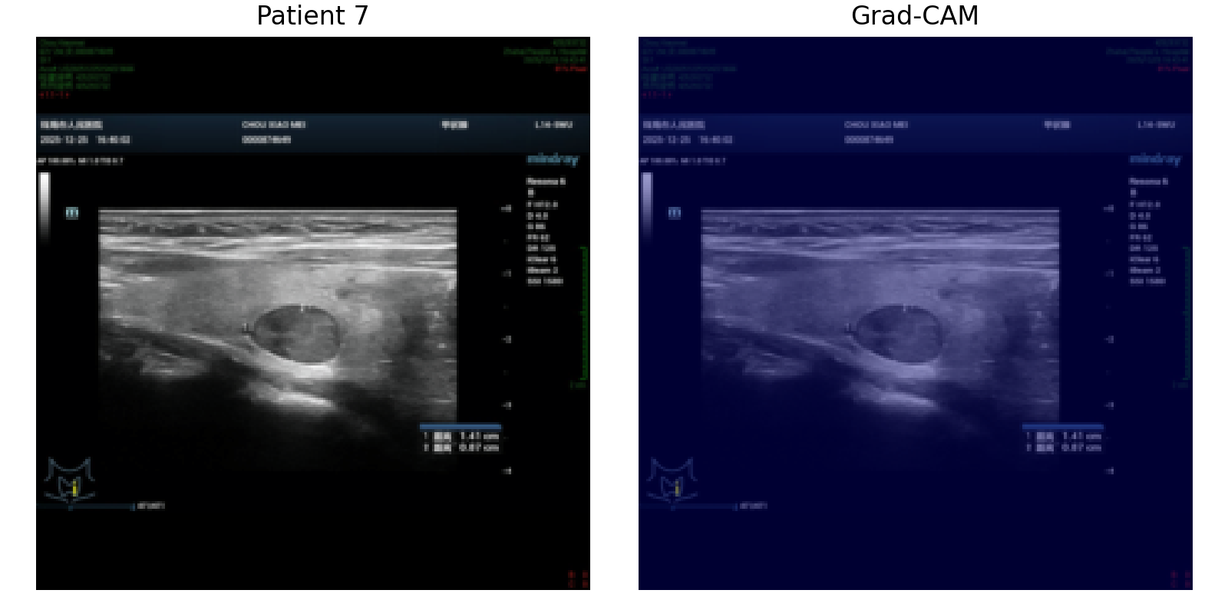
Grad-CAM visualization for patient 7 gradcam.

Discussion
The final model extends earlier clinical-only and image-only approaches by jointly modeling ultrasound image sequences and structured clinical risk factors at the patient level. This architecture is aligned with the actual clinical decision unit and avoids the methodological error of treating multiple images from one patient as independent observations.
A key methodological advantage of the current design is the combination of three complementary components: a selected benchmark backbone for strong image feature extraction, Transformer-based contextual modeling across multiple ultrasound images, and attention-based multiple instance learning for patient-level aggregation. The subsequent fusion with clinical variables provides a principled mechanism for integrating imaging and non-imaging risk information within a unified predictive framework.
The current outputs also demonstrate that the full engineering workflow is operational, including patient-level data matching, split control, multimodal training, ROC analysis, SHAP analysis, and Grad-CAM generation. This is important because it establishes a reproducible end-to-end platform for future formal model development.
Nevertheless, the current numerical metrics should not be overinterpreted. The present run was executed as a small-scale validation of the final pipeline, and this type of pilot experiment can yield unstable threshold-based metrics or discordance between discrimination and classification accuracy. A full training run on the complete cohort, with the planned epoch schedule and robustness analyses, is required before drawing scientific or clinical conclusions.
Future work should include full-cohort training, repeated internal validation, calibration analysis, comparison of alternative Transformer and MIL settings, and external validation if available. If the final multimodal model consistently outperforms the clinical-only and ultrasound-only baselines under these conditions, it would support the hypothesis that joint modeling of image-derived and clinical information improves thyroid malignancy prediction.

Backbone Note
Best backbone: efficientnet_b0
AUC: 1.000000
Accuracy: 0.750000
Sensitivity: 0.500000
Specificity: 1.000000

Interpretive Note
This document is suitable for internal manuscript drafting and method reporting. The current performance values originate from a pilot validation run and should be updated after full-cohort training.

