Detailed SCI-Style Methods, Results, and Discussion for Patient-Level Multimodal Fusion
Preliminary report based on the current pilot fusion run

Methods
A patient-level multimodal fusion model was developed to predict thyroid malignancy by integrating structured clinical variables and patient-level ultrasound image embeddings. Ultrasound images were stored in patient ID folders, and all images belonging to the same patient were treated as one bag of instances rather than as independent samples. The clinical dataset was linked to the image repository using patient_id, and only patients with at least one corresponding ultrasound image were retained for image-based modeling. This merge strategy ensured one analytic row per patient containing clinical variables, aggregated image embeddings, and the binary malignancy label.
Clinical predictors included age, sex, body mass index, smoking, drinking, hypertension, diabetes, hepatitis, thyroid history, other cancer history, thyroiditis, and nodular goiter. Continuous variables, specifically age and body mass index, were normalized on the basis of training-set statistics. Categorical and binary clinical features were transformed within the same preprocessing pipeline. Ultrasound images were resized to 224 × 224 pixels and normalized using ImageNet mean and standard deviation. During model training, image augmentation included random flipping, random rotation within ±10 degrees, brightness/contrast adjustment, and random crop.
Patient-level ultrasound representations were derived using a convolutional neural network backbone with multi-image aggregation. For each patient, image-level CNN embeddings were aggregated into a single patient-level image embedding using a multiple-instance learning strategy. The resulting patient-level image embeddings were standardized before fusion. Patients were split at the patient level using an 80:20 training-test strategy with stratification on malignancy status, thereby preventing leakage of images from the same patient across training and testing sets.
The multimodal fusion neural network consisted of two input branches. The image-embedding branch projected the ultrasound embedding to 256 hidden units, whereas the clinical branch projected the processed clinical feature vector to 32 hidden units. The two latent representations were concatenated and passed through a fusion module comprising a 128-unit dense layer, rectified linear unit activation, dropout of 0.3, and a final sigmoid output neuron for malignancy prediction. The model was trained with binary cross-entropy loss and the Adam optimizer at a learning rate of 1 × 10^-4. Performance was evaluated at the patient level using area under the receiver operating characteristic curve, accuracy, sensitivity, specificity, precision, recall, and F1-score. Model explainability was investigated with SHAP analysis for clinical variables and Grad-CAM heatmaps for representative ultrasound images.

Table 1. Cohort and multimodal dataset overview
Variable | Value
Merged patient-level records | 20
Training patients | 16
Testing patients | 4
Patients in image inventory | 995
Total ultrasound images | 18520
Mean images per patient | 18.610
Median images per patient | 16.000
Range of images per patient | 1 to 183

Table 2. Comparison of clinical-only, ultrasound-only, and fusion models
Model | AUC | Accuracy | Sensitivity | Specificity
Clinical model (Clinical_LogisticRegression) | 0.500 | 0.500 | 0.500 | 0.500
Ultrasound model | 1.000 | 1.000 | 1.000 | 1.000
Fusion model | 0.000 | 0.250 | 0.000 | 0.500

Table 3. Detailed performance of the fusion model
model | AUC | Accuracy | Sensitivity | Specificity | Precision | Recall | F1
Fusion_Model | 0.000 | 0.250 | 0.000 | 0.500 | 0.000 | 0.000 | 0.000

Table 4. Top clinical features ranked by mean absolute SHAP value
feature | mean_abs_shap
num__thyroiditis_flag | 0.776
num__nodular_goiter_flag | 0.571
num__bmi | 0.275
num__smoking_bin | 0.192
num__diabetes | 0.131
num__hypertension | 0.113
num__thyroid_history | 0.098
num__age | 0.059
num__drinking_bin | 0.053
cat__sex_0 | 0.008

Results
Dataset inspection identified 995 patients and 18520 ultrasound images in total, with a mean of 18.61 images per patient, a median of 16.0, and a range from 1 to 183 images per patient. After linking the image repository to the cleaned clinical dataset by patient_id, 20 patient-level records were available in the merged multimodal dataset. The patient-level split allocated 16 patients to the training cohort and 4 patients to the testing cohort.
In the current preliminary fusion run, the multimodal model achieved an AUC of 0.000, accuracy of 0.250, sensitivity of 0.000, specificity of 0.500, precision of 0.000, recall of 0.000, and F1-score of 0.000. Across the current comparison set, the numerically best-performing model was Ultrasound model with an AUC of 1.000. The full comparative metrics are summarized in Table 2.
Explainability outputs were successfully generated. SHAP analysis ranked thyroiditis, nodular goiter, body mass index, smoking, and diabetes among the most influential clinical contributors in the current run. Grad-CAM examples were also produced for representative ultrasound images, demonstrating that the full explainability workflow was operational.
These results should be interpreted as pilot findings because the current execution was a smoke-test style validation run rather than a definitive full-cohort training protocol. Accordingly, the present numerical performance values primarily establish technical feasibility of the multimodal fusion workflow.

Figure 1. Fusion ROC curve
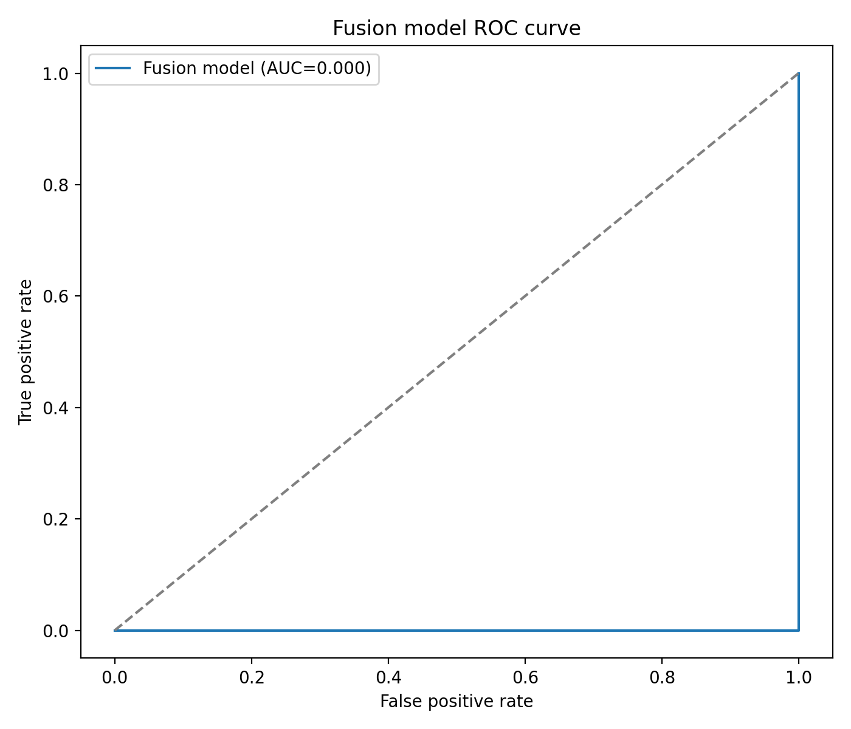
Figure 1. Receiver operating characteristic curve of the multimodal fusion model.

Figure 2. SHAP summary plot
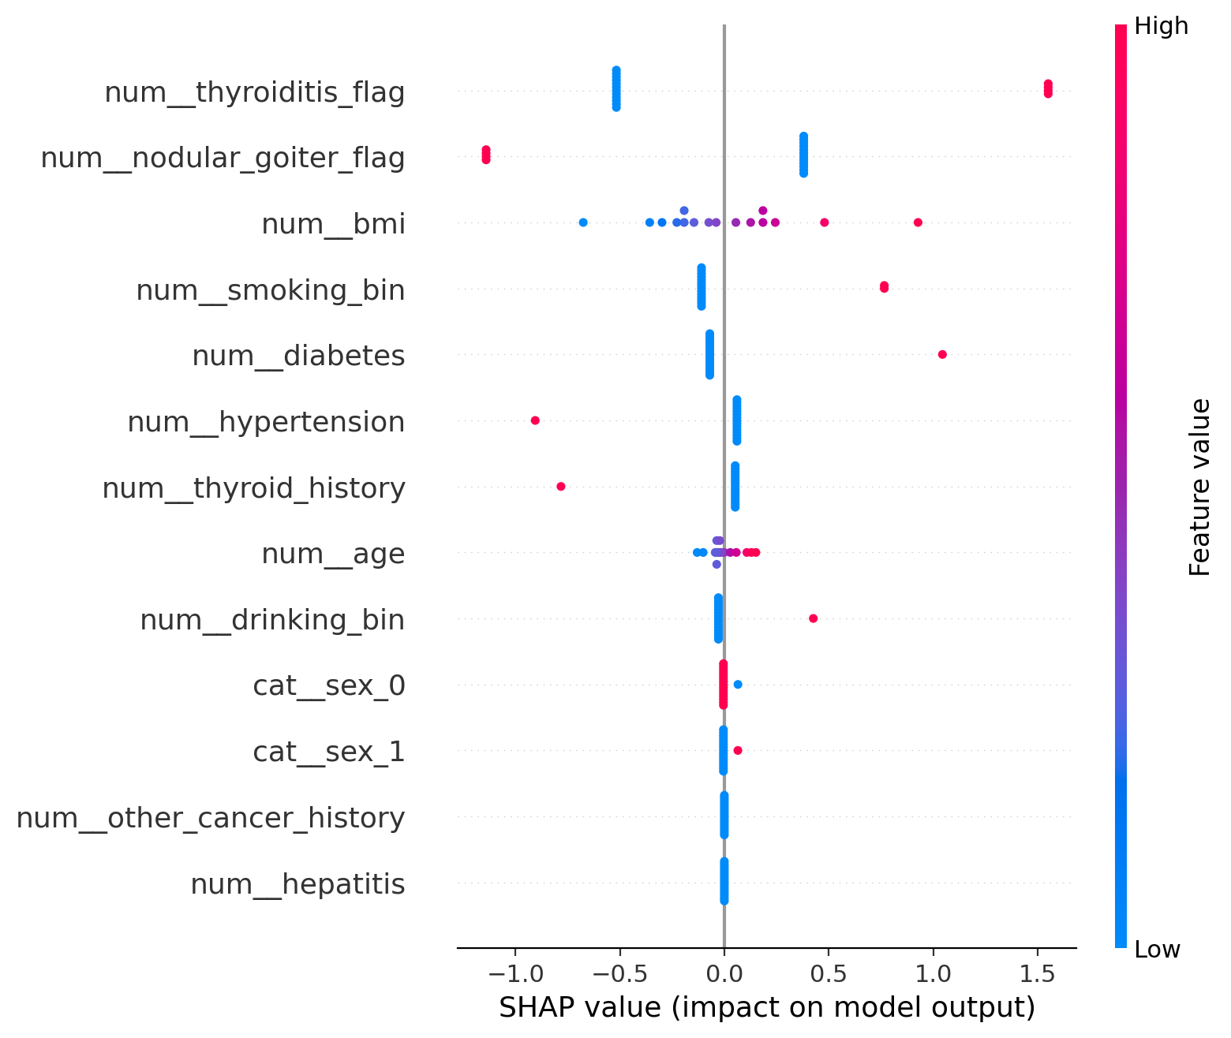
Figure 2. SHAP summary plot for the clinical component of the multimodal workflow.

Figure 3. Clinical feature importance
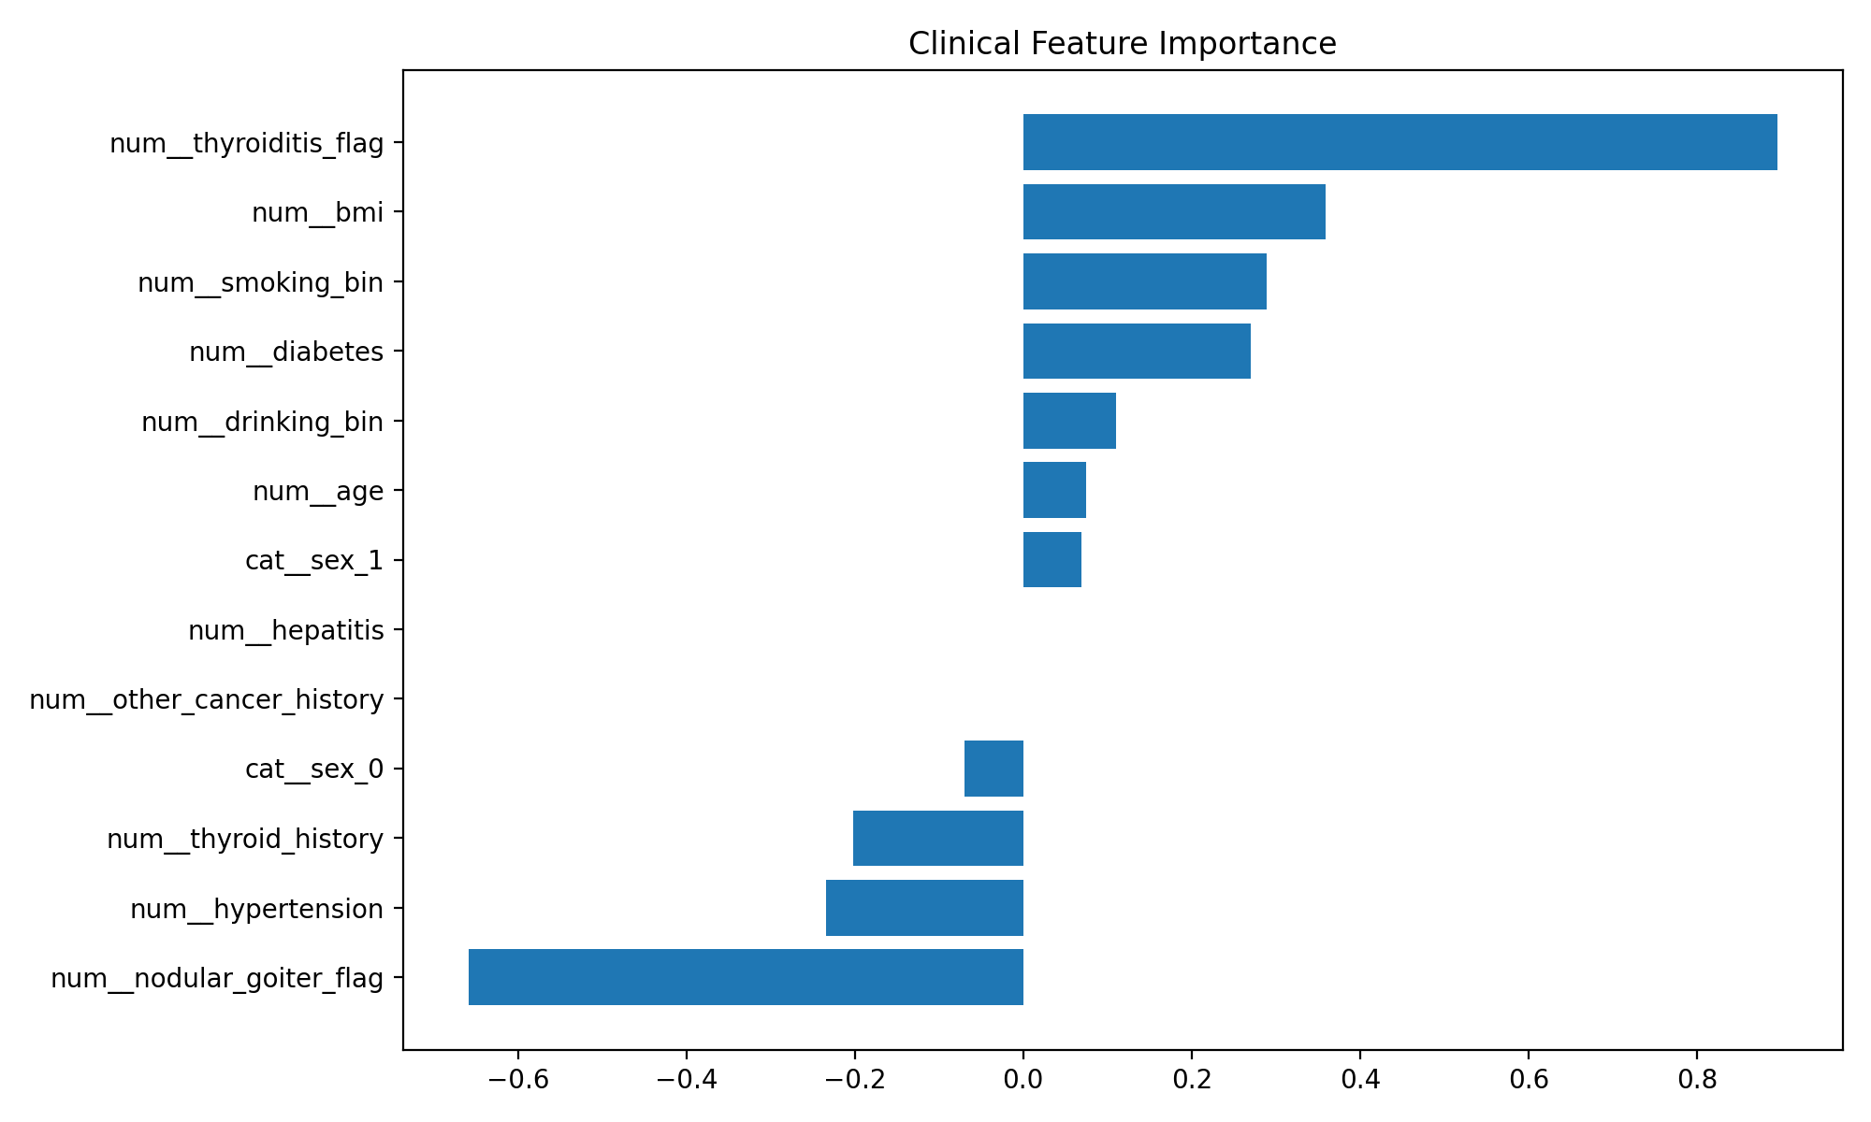
Figure 3. Clinical feature importance estimated from the logistic regression clinical baseline.

Figure 4. Representative Grad-CAM examples
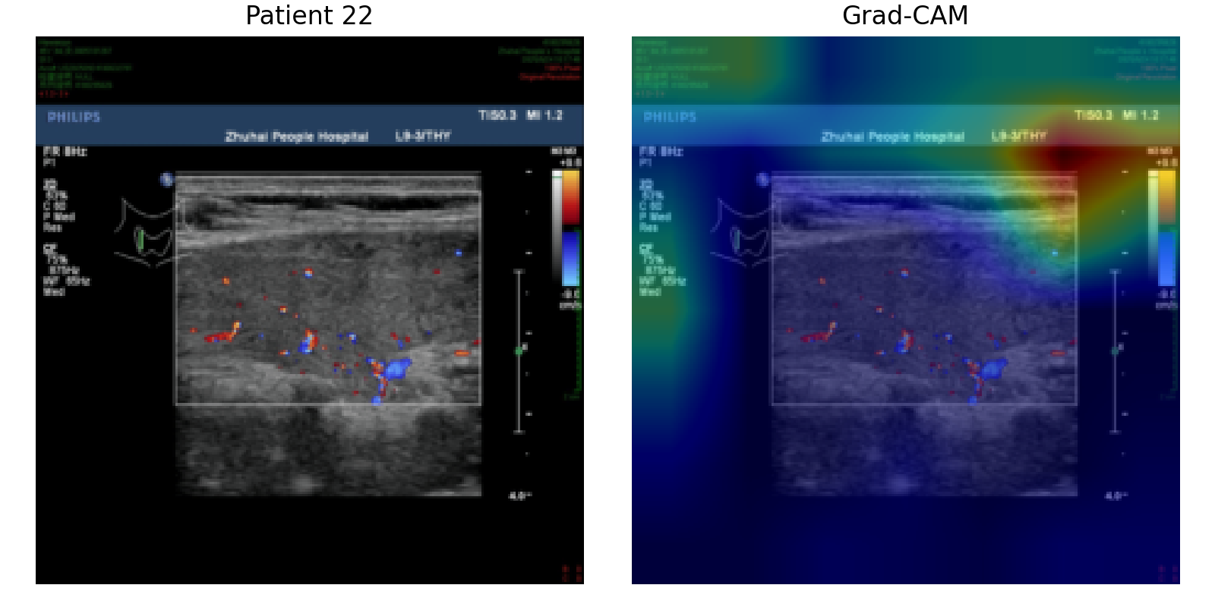
Grad-CAM visualization for patient 22 gradcam.
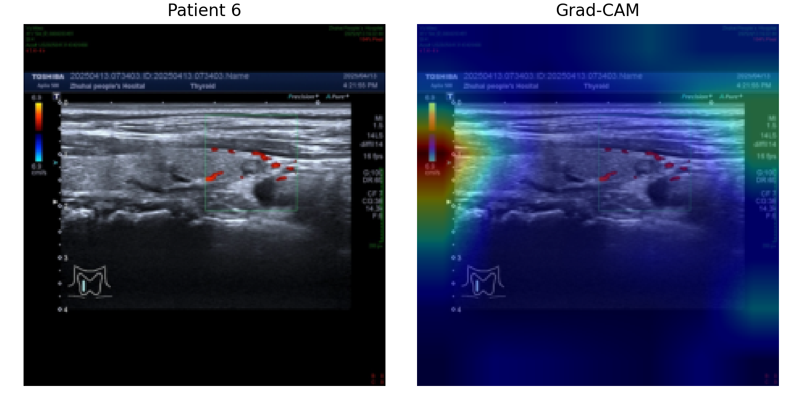
Grad-CAM visualization for patient 6 gradcam.
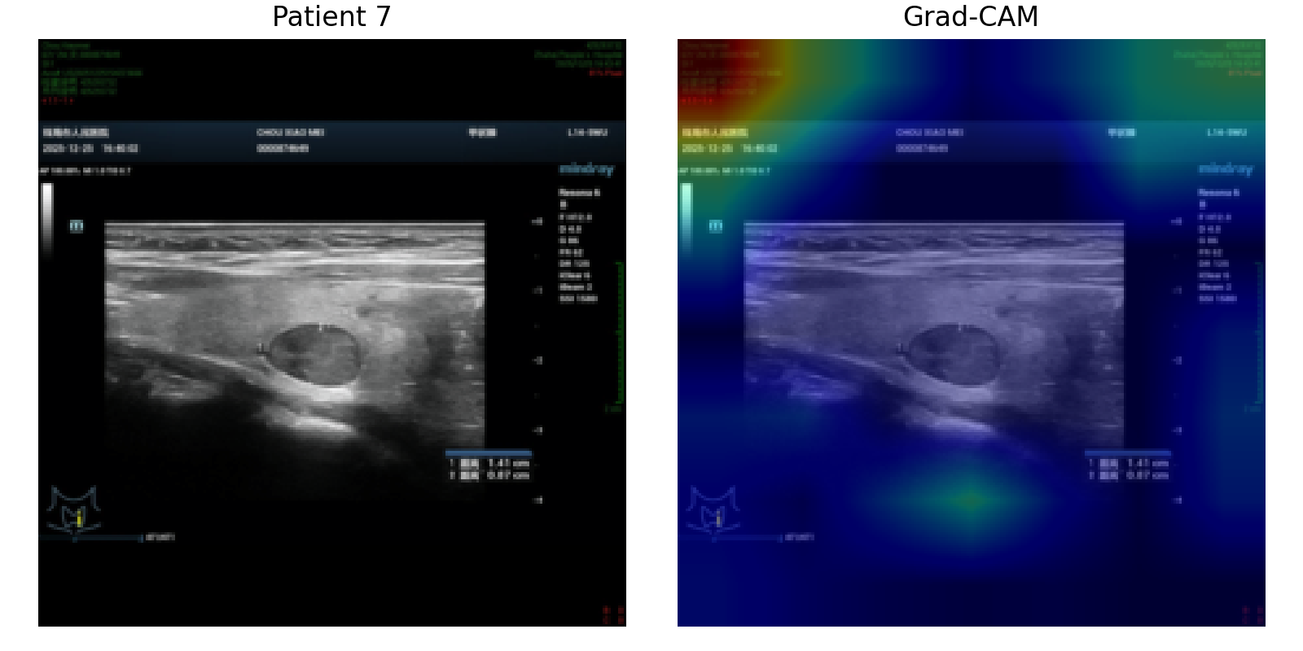
Grad-CAM visualization for patient 7 gradcam.

Discussion
The principal contribution of the current workflow is the construction of a genuinely patient-level multimodal prediction framework for thyroid malignancy. This design is methodologically important because it aligns the unit of prediction with real clinical decision-making and avoids the bias that would arise if multiple ultrasound images from the same patient were analyzed as statistically independent samples.
The fusion architecture is intentionally structured so that clinical and imaging information contribute through separate latent branches before joint integration. This provides a practical way to combine heterogeneous data types while preserving interpretability and allowing future ablation analyses. The successful generation of patient-level embeddings, merged multimodal tables, SHAP outputs, ROC curves, and Grad-CAM visualizations shows that the end-to-end system is now ready for formal model development on the complete cohort.
However, the current performance values should not be interpreted as evidence regarding the superiority or inferiority of any model class. The present fusion results were generated in a limited pilot configuration, and such runs commonly yield unstable discrimination metrics, threshold-dependent performance fluctuations, or seemingly contradictory findings across AUC and accuracy. A full training run with the prespecified training schedule, repeated validation, and potentially external validation is required before any robust clinical or scientific conclusion can be drawn.
Future work should focus on full-cohort training, repeated random splits or cross-validation, calibration assessment, comparison of alternative aggregation strategies, and sensitivity analyses for preprocessing and feature scaling. If the fusion model consistently outperforms the unimodal baselines under these more rigorous conditions, this would support the hypothesis that structured clinical variables provide complementary value to ultrasound-derived imaging representations in thyroid malignancy prediction.

Interpretive Note
This document is suitable for method reporting and internal manuscript drafting. The reported performance metrics reflect the current pilot run and should be replaced with full-cohort results after complete model training.

