**EVENT NEST**

T.E. mini-project report submitted in partial fulfilment of the requirements of the degree of

Information Technology

by

|  |  |
| --- | --- |
| Name of the Student | GR no |
| Prem Mishra |  |
| Astha Pal | 213122 |
| Kusum Jha | 213128 |
| Inshirah Ansari | 213110 |

Under the guidance of

Prof. Sneha Sankhe



# Department of Information Technology Theem College of Engineering, Boisar Boisar Chilhar Road, Boisar (E), Palghar

University of Mumbai

2023-2024

# CERTIFICATE

## This is to certify that the T.E. Mini project entitled “EVENT NEST” is a bonafide work of “Prem Mishra (), Astha Pal (), Kusum Jha

**() Inshirah Ansari ()”** submitted to the University of Mumbai in partial fulfilment of the requirement for the award of the degree of **“Information Technology”** during the academic year 2023-24.

Prof. Sneha Sankhe Prof. Rinkal Ba

Guide Project Coordinator

Prof. Sneha Sankhe Dr. Riyazoddin Siddiqui

Head of Department Principal

## T. E. Mini Project Report Approval

This Mini project synopsis entitled **EVENT NEST** by **Prem Mishra(), Astha Pal (), Kusum Jha(), Inshirah Ansari ()** approved for the degree of Information Technology from University of Mumbai.

INTERNAL EXAMINER. EXTERNAL EXAMINER

Date:

Place:

## Declaration

We declare that this written submission represents our ideas in our own words and where others' ideas or words have been included, we have adequately cited and referenced the original sources. We also declare that we have adhered to all principles of academic honesty and integrity and have not misrepresented or fabricated or falsified any idea/data/fact/source in our submission. We understand that any violation of the above will be cause for disciplinary action by the Institute and can also evoke penal action from the sources which have thus not been properly cited or from whom proper permission has not been taken when needed.

Date:

## Abstract

The events industry is expanding rapidly, and having an effective online platform is critical for event organizers and participants alike. This project aims to develop a feature-rich event management website that leverages modern web development technologies to streamline event creation, registration, and engagement.

The frontend of the website is built using React, a widely-used JavaScript library for building interactive user interfaces. React's component-based structure enables the creation of a responsive and dynamic user experience. Users will be able to seamlessly browse events, filter search results, register for events, and view detailed event information through an intuitive and visually appealing interface.

On the backend, the project employs **Express.js**, a minimal and flexible Node.js web application framework, for handling server-side operations. Combined with **Yarn** as a package manager, Express.js provides a scalable and efficient server environment, ensuring high-performance responsiveness. **Prisma**, an innovative database toolkit, is used to manage database operations, enabling type-safe and auto-completed queries and mutations, thus enhancing productivity and security.

The database is powered by **MongoDB**, a NoSQL database known for its scalability, flexibility, and seamless integration with the Express.js backend. MongoDB's document-based structure is ideal for storing and retrieving event-related data, ensuring quick and efficient data access.

The organization of this report is as follows.

**Chapter 1: Introduction**

This chapter introduces the **EventNest** platform, covering the motivation behind the project, problem definition, project goals, and scope. It explains the increasing need for a comprehensive event management system and how EventNest aims to solve current challenges.

**Chapter 2: Literature Survey**

This chapter provides a review of the background and similar event management platforms. It also outlines various online event management systems and tools, and their shortcomings, providing insight into the development of EventNest’s unique interface and feature set.

**Chapter 3: System Architecture and Design**

This chapter outlines the architecture of **EventNest**, detailing the technologies and frameworks used in both frontend and backend implementations. It also describes the proposed system design, including database management, data flow, and user interaction workflows.

**Chapter 4: System Design**

This chapter presents essential diagrams to demonstrate system activities. **EventNest's** architecture is illustrated through ER diagrams, use cases, and class diagrams, helping to visualize the functionality and relationships between different components of the system.

**Chapter 5: Result and Discussion**

This chapter showcases screenshots of the **EventNest** platform, including user registration, event creation, and admin functionalities. It discusses the platform’s performance, user feedback, and the key challenges encountered during development.

**Chapter 6: Conclusion and Future Scope**

This chapter summarizes the project's outcome, lessons learned, and areas where further work can be done. It discusses how **EventNest** can be enhanced with features like real-time event tracking, AI-powered suggestions, advanced analytics, and future integrations with external services for greater scalability.

# List of Contents

**Sr. No Contents Pg. No**

List of contents…………………………………………………….. i

List of Figures……………………………………………………... iii

Acronyms………………………………………………………….. iv

## Chapter -1 Introduction………………………………………………………. 1

1.1 An overview…………………………………………………......... 1

1.2 Motivation…………………..…………………………………….. 1

1.3 Problem Definition.………………………………………………. 2

1.4 Aim of Project…………………………………………………….. 2

1.5 Scope of Project…………………………………………………... 2

**Chapter-2 Literature Survey………………………………………………… 3**

2.1 Background……………………………………………………….. 3-4

## Chapter -3 System Architecture …………..………………..……………….. 5

3.1 Introduction……………………………………….………………. 5

3.2 Design……………………………………………………………… 5

3.2.1 Requirement Analysis…….………………………………………. 6

3.2.2 System Architecture (Model Design) …………………………… 6

3.3 Proposed System …………………………………………………. 7

## Chapter -4 System design……………………………………………………. 8

4.1 Introduction...………………………………………………….…. 8

4.2 ER diagram………………………………………………………… 9

4.3 Use Case Diagram……………………………………………….. 10

4.4 Class Diagram……………………………………………………... 11

**Chapter-5 Result and Discussion……………………………………………. 12**

**Chapter-6 Conclusion and Future Scope…………………………………… 17**

**References………………………………………………………… 19**

# List of Figures

**Sr. No Figures Pg. No**

Fig. 3.1 Block Diagram…….……………….………...…..…………..….. 6

Fig. 3.2 Proposed System Diagram………………………………………. 7

Fig.4.1 ER-Diagram……………………………………………………... 9

Fig.4.2 Use Case Diagram……………………………….………………. 10

Fig.4.3 Class Diagram……………………………..…………………….. 11

Fig.5.1 Sign Up page…………………………………..………………… 13

Fig.5.2 Home page……………………...………..……………………… 13

Fig.5.3 Property Page….………………..………..……………………… 14

Fig.5.4 Property Deatails………………….…….……..………………… 15

Fig.5.5 Add Property…………....………….……..………...…………… 16

**Acronyms**

**HTML 5-Hyper Text Markup Language version 5 CSS 3-Cascading style Sheet version 3 UML-Unified Modelling Language Er-diagram – Entity Relation diagram**

# Chapter 1

## Introduction

### 1.1 An overview

The project involves the development of a modern real estate website that utilizes cutting-edge technologies for both the frontend and backend. The website is built using React for the frontend, offering a responsive and interactive user interface. Users can easily browse property listings and explore detailed information.To enhance the user experience, the website integrates maps for displaying property addresses, nearby amenities, and neighborhood details. This map-based approach provides valuable insights to potential buyers.

### 1.2 Motivation

The motivation behind this project is to modernize the real estate industry by leveraging state-ofthe-art technology. Real estate transactions are often complex and labor-intensive, causing inconvenience and inefficiencies for both buyers and sellers. By developing an advanced real estate website, we aim to simplify property searches, enhance location awareness, and streamline data management, ultimately improving the overall real estate experience.

### 1.3 Problem Definition

The real estate industry's digital presence. Traditional real estate processes suffer from information overload, inefficient data management, and a lack of engaging user experiences. Property buyers struggle to make informed decisions due to limited location understanding, while real estate professionals face challenges in managing property data. To address these issues, the project aims to develop a real estate website that utilizes React for a user-friendly frontend, integrates maps for location visualization, deploys MongoDB for efficient data storage, employs Express.js and Prisma for streamlined backend operations, and enhances performance and dependency management with Yarn. The project's primary goal is to bridge the gap between outdated industry practices and modern technology, creating a platform that simplifies property searches, improves location awareness, and enhances data management for real estate professionals and consumers alike.

### 1.4 Aim of Project

* To Learn working with HTML, CSS and JavaScript.
* To understand the react and apply it in project. • To learn how to use mongodb to store the data.
* To Create a modern MERN stack website.

### 1.5 Scope of Project

Scope of this project involves potential enhancements such as implementing advanced search and recommendation algorithms to personalize property suggestions for users, incorporating augmented reality (AR) features for virtual property tours, and expanding to a mobile application for on-the-go property exploration. Additionally, integrating blockchain technology for secure and transparent property transactions, and facilitating user reviews and ratings for properties and agents can further enrich the platform. These advancements will make the real estate website even more competitive, engaging, and aligned with emerging industry trends.

**Chapter 2**

# Literatur Survey

## 2.1 Background

This project is rooted in the intersection of real estate technology and web development. In recent years, the real estate industry has undergone a significant transformation, with a growing emphasis on digital solutions to streamline processes and enhance the user experience. Studies and industry reports have highlighted the challenges faced by property buyers and sellers, including the overwhelming abundance of information, difficulties in understanding property locations, and inefficiencies in data management. Additionally, the rising demand for interactive and map-based platforms in real estate has been well-documented. React, with its component-based architecture, is recognized as a powerful tool for creating responsive user interfaces, and its application in real estate websites has been increasingly explored. Meanwhile, the integration of mapping technology for property visualization has gained traction, improving location-awareness and assisting users in making informed decisions. The choice of MongoDB, an agile NoSQL database, is backed by literature citing its suitability for storing and retrieving real estate data efficiently. Express.js, Prisma, and Yarn are well-established technologies within the web development ecosystem, offering solutions for efficient backend operations and dependency management.This project aligns with the trends identified in the literature, aiming to address the challenges in the real estate industry by capitalizing on these technologies to create a comprehensive and user-friendly real estate platform. By combining the insights from these sources with innovative web development practices, this project intends to deliver a solution that not only enhances the user experience but also simplifies data management for real estate professionals, thereby contributing to the ongoing evolution of the industry.

**Chapter 3**

# System Architecture

## Introduction

Embarking on the journey of revamping the Real Estate website requires a solid foundation, and at the core of this transformation lies the intricacies of the system architecture. The system architecture serves as the blueprint that defines how different components of the website will interact, ensuring efficiency, scalability, and a seamless user experience. This introduction provides a glimpse into the architectural framework that will underpin the future of our digital presence, emphasizing the thoughtful design and integration of technologies to meet the diverse needs of user’s.

### 3.1 Design

Design of the project is done by the using React it helped to make an interactive and modern website that uses simple design and attractive colour palettes.

#### 3.2.1. Requirement Analysis

Below mentioned names of hardware and software is used for making and creating the report and presentation of the project.

##### Hardware Requirements

* Windows 11 or latest version
* 8GB RAM
* Intel core processor i3
* 100GB free Hard Disk
* Wi-Fi Router
* Laptop

##### Software Requirements

* Visual Studio
* HTML 5
* CSS 3
* JavaScript
* React
* Mongodb • Expressjs

#### 3.2.2. System Architecture

A real estate website's system architecture comprises several key components and layers to deliver its functionality. At its core is the User Interface (UI) layer, where users can browse listings, make inquiries, and manage their accounts. The Application layer processes user requests and houses business logic, handling functions like property searches, user authentication, and listing management



Sign Up



Property



Add Propery



Home

Figure 3.2.2: Block Diagram

### 3.3 Proposed System

Through this proposed system we had explained what are steps of the starting our website. The details of user should be entered on the sign up or on first page of the website.Then the home page will appear on the screen.From the home page we can search for property and also can add property having two different dashboard for it.Also while visiting the property page there will be a map where you can locate the property address.

Sign Up page

ty page

Proper

Multple

Property page

Property

Details

map

Add P

roperty

dash

board

Property

Addres

Property

Description

property

image

Home

Page

Figure 3.3: Proposed System Diagram

**Chapter 4**

# System Design

## 4.1 Introduction

During analysis, the focus is on what needs to be done, independent of how it is done. During design, decisions are made about how the problem will be solved, first at high level, then at increasingly detailed levels. System design is the first design stage in which the basic approach to solving the problem is selected. During system design, the overall structure and style are decided. The system architecture is the overall organization of the system into components called subsystems. The architecture provides the context in which more detailed decisions are made in later design stages. By making high level decisions that apply to the entire system, the system designer partitions the problem into subsystems so that further work can be done by several designers working independently on different subsystems.

## 4.2 ER Diagram

An Entity-Relationship (ER) diagram for a real estate website depicts the essential data structure and relationships between key entities. These typically include "Property" (with details like type, price, and features), "User" (representing buyers, sellers, and agents), "Listing" (containing property descriptions and prices), and "Location" (capturing geographical data like addresses and zip codes). The diagram showcases how users interact with properties, create listings, and engage with the platform, providing a clear visual representation of the website's underlying data model.

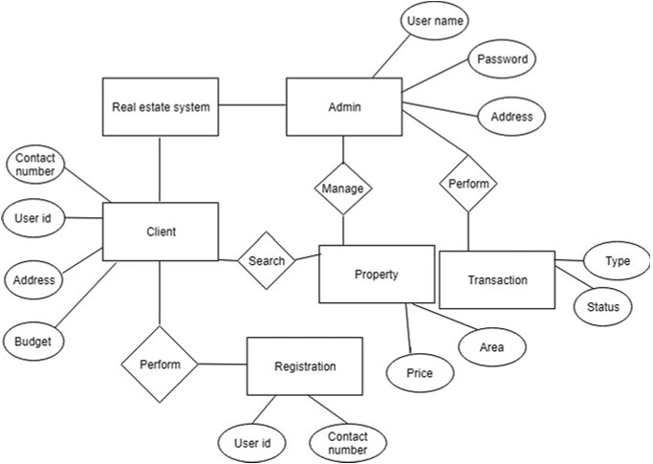

Figure 4.2: ER-Diagram of Real Estate Website

## 4.3 Use case Diagram

he primary actors, such as "Buyers," "Sellers," and "Admins," are represented along with the key use cases they engage in. These use cases typically include property search, listing creation, user registration, inquiry submission, and admin management. The diagram serves as a visual map of how various users interact with the website and the essential functionalities it offers, aiding in the understanding of user roles and system features.

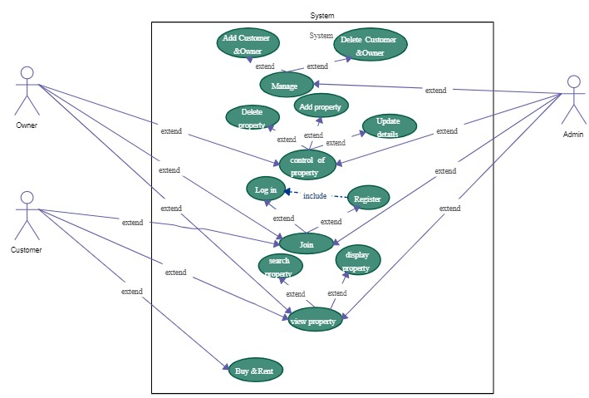

Figure 4.3: Use Case Diagram of Real Estate Website

## 4.4 Class Diagram

It typically includes classes like "Property," "User," "Listing," and "Location," each with their associated attributes and methods. Relationships are established between these classes, representing how users own listings, how properties are linked to locations, and how users can inquire about properties. This visual representation helps in understanding the data structure and object-oriented design of the website, facilitating effective development and maintenance of the platform.

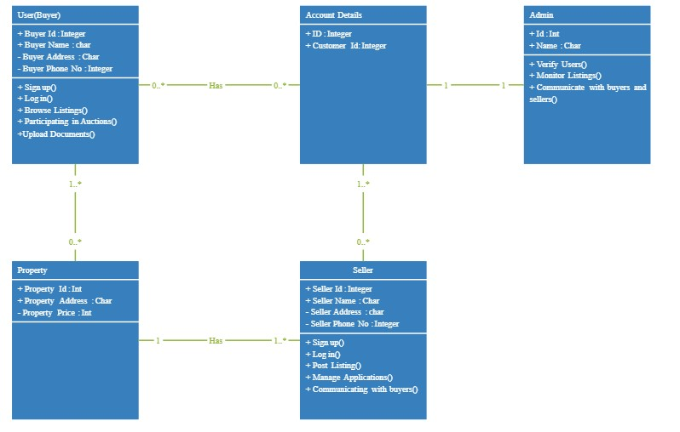

Figure 4.4: Class Diagram of Real Estate Website

**Chapter 5**

# Result and Discussion

We have successfully created a website of Real Estate. The website contains multiple pages build using react the pages are home page,property page where all the properties are listed,add property page where the seller can upload the address,image and discription of the property.The special feature of the website is that it contains map where the seller can locate the property and can get the overview of the surrounding.The seller can book the visit to the property and also can add the property in the wishlist.

**5.1 Screenshot of Sign up page of real estate website.**

Firstly the user has to signUp or login to the website using the user_id and password.The user_id and password is saved in the mongodb database also known as nosql database.as soon as the user logins the user is directed to the home page of the website.

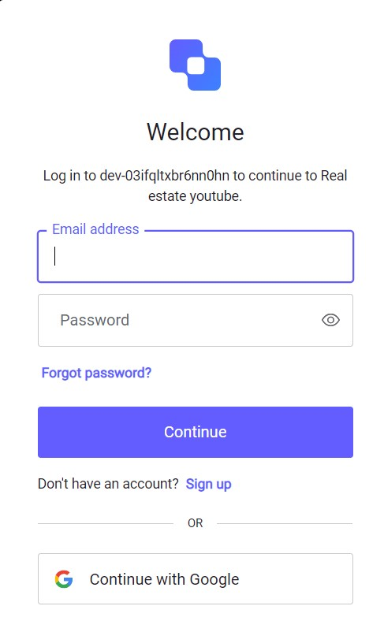

Figure 5.1 Screenshot Sign up Page of real estate website

**5.2 Screenshot of Home page.**

After signup the home page appears where the user can see the popular properties and have a search bar where the user can search for the location of where he wants to buy the property Home page also contains the property and add property page.

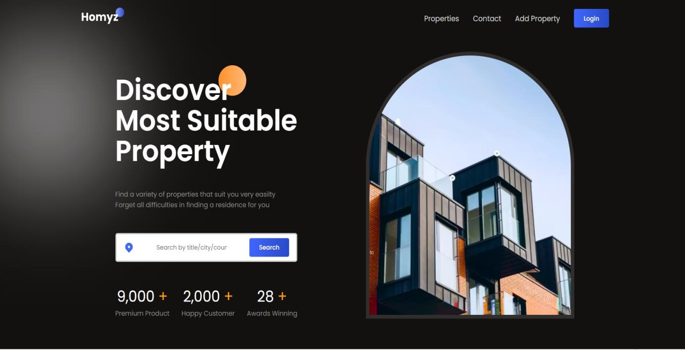

Figure 5.2 Screenshot Home Page

## 5.3 Screenshot of Property Page

Property page consist of list of properties and a search bar where user can search for the location or for the property and this page is only usefull for buyer and user can add property to their favourite.

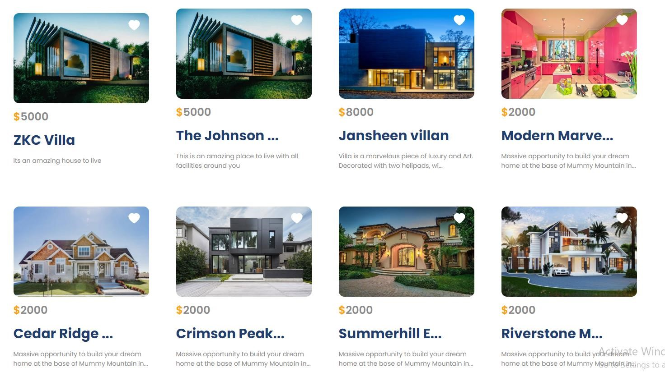

Figure 5.3 Screenshot of Property Page

## 5.4 Screenshot of Property Description

Property Description contains the address and description of property and maps where user can locate the property and book visit button to visit the property

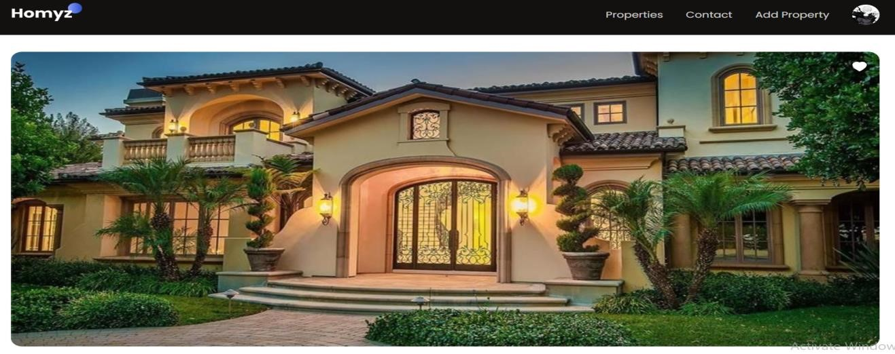

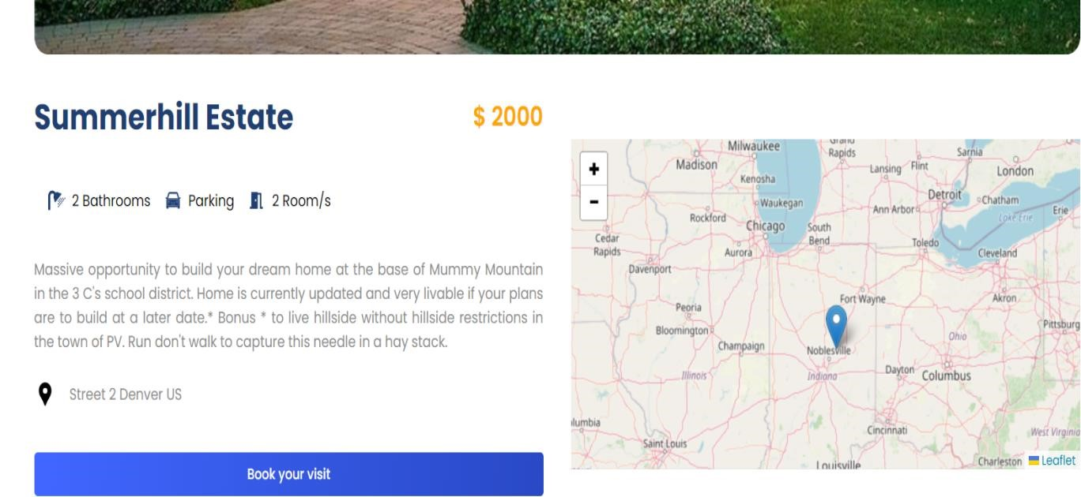

Figure 5.4 Screenshot of Property Description

## 5.5 Screenshot of Add Property dashboard

On this page the seller adds the property to the website by entering the address of the property and the maps will point the loaction of the property on the map.

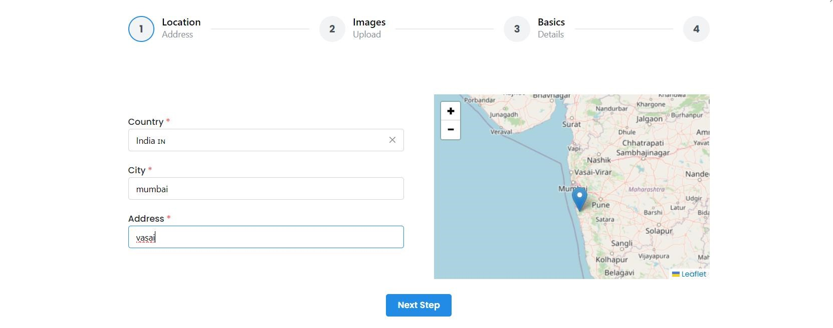

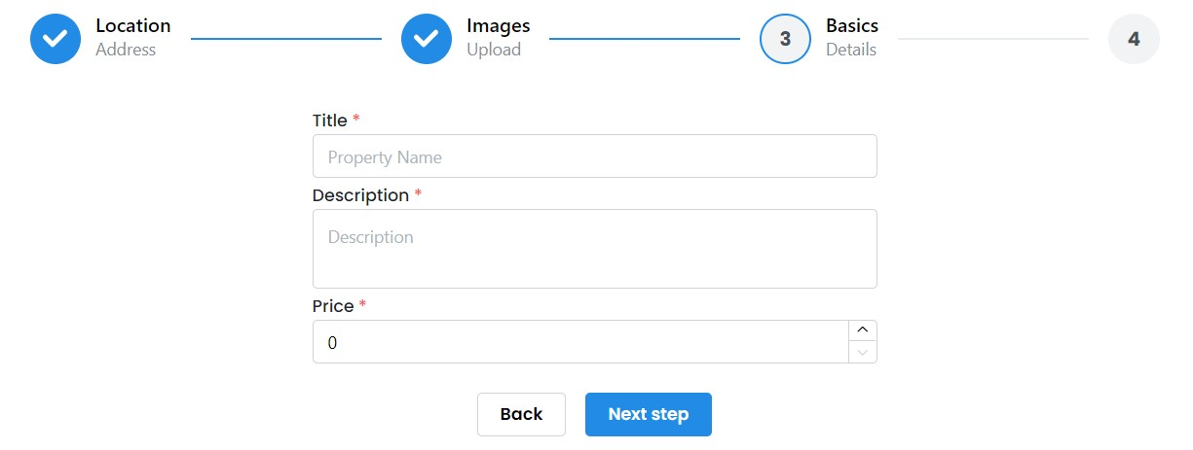

Figure 5.5 Screenshot of Add Property dashboard

# Chapter 6 Conclusion and Future Scope

## 6.1 Conclusion

In this real estate project represents a significant step towards the modernization and enhancement of the real estate industry. The development of a sophisticated website, blending cutting-edge technologies, aims to address long-standing challenges in the field. By creating a user-friendly and interactive platform with React, incorporating maps for location visualization, leveraging MongoDB for efficient data management, and streamlining backend operations with Express.js and Prisma, this project strives to transform the property buying and selling experience. It bridges the gap between traditional practices and contemporary technology, simplifying property searches, enhancing location awareness, and improving data management. The future prospects for this project include the potential integration of advanced features like recommendation algorithms, augmented reality, and blockchain technology, setting the stage for a more informed and efficient real estate ecosystem.

## 6.2 Future Scope

The future scope for this real estate project is ripe with potential for expansion and innovation. One promising avenue is the implementation of advanced search and recommendation algorithms, harnessing the power of artificial intelligence to offer users personalized property suggestions based on their preferences and search history. Augmented reality (AR) integration is another exciting prospect, where users could enjoy immersive virtual property tours, allowing them to experience and visualize properties in unprecedented ways. Expanding the project to include a mobile application would provide users with on-the-go property exploration, catering to the mobile-centric preferences of today's consumers. The integration of blockchain technology for secure and transparent property transactions could instill trust and efficiency in the buying and selling process. Furthermore, enabling user reviews and ratings for properties and agents would enhance the platform's information depth and credibility. Data analytics tools could offer users insights into property market trends and neighborhood dynamics. Expanding the platform to encompass different regions and markets would make it more versatile and adaptable to diverse user needs. Additionally, improving accessibility features and considering the integration of IoT devices for real-time property information would further enrich the platform's capabilities. These future developments aim to keep the real estate website at the forefront of technological innovation, ensuring that it remains a valuable and competitive resource in the ever-evolving real estate landscape.

## References

1. HTML & CSS: Design and Build Web Sites, book by Jon Duckett
2. A beginner’s guide to HTML, CSS, JavaScript, and Web Graphics, book by Jennifer Niederst

Robbins

1. MagicBricks real estate website [https://www.magicbricks.com](https://www.magicbricks.com/)
2. International Journal of Research Publication and Reviews, Vol 4, no 4, pp 3430-3432, April

2023, “Research Paper on Real Estate”

## Acknowledgement

We would like to express our gratitude towards our principal **Dr.Riyazoddin Siddiqui** for giving us this great opportunity to do a project on **Real Estate Website**. We would also like to express our sincere thanks to the HOD of IT department **Prof. Sneha Sankhe** and our guide **Prof. Sneha Sankhe** and to our project co-ordinator **Prof. Simran Patil**, for their valuable guidance and support in completing our project. Without their support and suggestions, this project would not have been completed.

**Nagesh Giri(213110)**

**Anurag Mishra(213119)**

### Hariom Shukla(213128) Saurabh Mishra(213122)