prac1.R

tully

2020-03-05

############### prac1.R ###################  
# set the number of significant figures for output  
options(digits=3, show.signif.stars=F)  
# Read data from data file (acid.txt) and store in R in a data frame (acid.df)  
acid.df<-read.table("acid.txt",header=T)  
# list names of variables  
print(names(acid.df))

## [1] "acid" "fungus"

# list first 3 lines of dataframe  
print(head(acid.df,3))

## acid fungus  
## 1 0 33.3  
## 2 0 31.0  
## 3 3 29.8

#######################################  
# Plot the data   
plot(fungus ~ acid, data=acid.df)  
# Fit a linear model with response variable fungus and predictor acid  
acidreg.lm <- lm(fungus ~ acid, data=acid.df)  
# Summarise the fitted model.  
# Obtain the regression coefficients together with  
# their standard deviations, t- and P- values.  
print(summary(acidreg.lm))

##   
## Call:  
## lm(formula = fungus ~ acid, data = acid.df)  
##   
## Residuals:  
## Min 1Q Median 3Q Max   
## -4.285 -0.907 0.491 1.292 2.414   
##   
## Coefficients:  
## Estimate Std. Error t value Pr(>|t|)  
## (Intercept) 31.7816 0.8327 38.2 3.6e-12  
## acid -0.7498 0.0537 -14.0 6.9e-08  
##   
## Residual standard error: 1.94 on 10 degrees of freedom  
## Multiple R-squared: 0.951, Adjusted R-squared: 0.946   
## F-statistic: 195 on 1 and 10 DF, p-value: 6.89e-08

# Produce the Analysis of Variance table  
print(anova(acidreg.lm))

## Analysis of Variance Table  
##   
## Response: fungus  
## Df Sum Sq Mean Sq F value Pr(>F)  
## acid 1 733 733 195 6.9e-08  
## Residuals 10 38 4

#######################################  
# Add the least squares line to the plot  
abline(acidreg.lm)  
legend(13, 30, legend="fungus = 31.7 - 0.75 acid ")

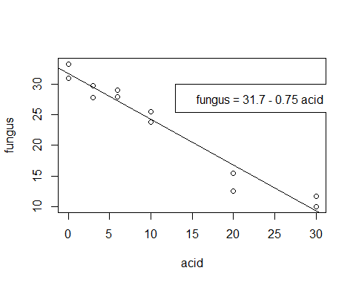

#Confidence intervals for regression parameters  
print(confint(acidreg.lm, level=0.95))

## 2.5 % 97.5 %  
## (Intercept) 29.926 33.64  
## acid -0.869 -0.63

# Diagnostic plots   
# plot all on one page  
par(mfrow=c(2,2))  
plot(acidreg.lm, which=1:4)

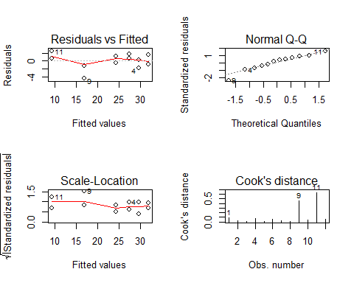

# test for normally distrubted residuals  
print(shapiro.test(acidreg.lm$residuals))

##   
## Shapiro-Wilk normality test  
##   
## data: acidreg.lm$residuals  
## W = 0.9, p-value = 0.4

#predict the mean fungal growth and  
# the 95% CI when acid conc. = 15  
# Note use of new=data.frame to indicate values of X  
preds<-predict(acidreg.lm,new=data.frame(acid=15), interval="confidence", level=0.95)  
print(preds)

## fit lwr upr  
## 1 20.5 19.2 21.8