Sri Lanka Institute of Information Technology



Assignment 1

MLB_WD_03.02_07

Online Medical Portal

**Internet and Web Technologies – IT1100**

B.Sc. (Hons) in Information Technology

**Group Details**

Group Number: MLB_WD_03.02_07

Project Title: Online Medical Portal

|  |  |  |  |  |
| --- | --- | --- | --- | --- |
|  | **Student ID** | **Student Name** | **Email** | **Contact Number** |
| 1 | IT22157928 | VIDUSHAN A. A. D. D. N | it22157928@my.sliit.lk | 0711609534 |
| 2 | IT22209320 | MIURANGA W.A. R | it22209320@my.sliit.lk | 0770528901 |
| 3 | IT22130716 | MUNASINGHE M.A.M.C | it22130716@my.sliit.lk | 0772611121 |
| 4 | IT22100320 | SOMASUNDARA M.M | it22100320@my.sliit.lk | 0702420420 |
| 5 | IT22081766 | A.M.C. PRAMOD ARIYASENA | it22081766@my.sliit.lk | 0775078338 |

# **Introduction**

Welcome to our online medical portal, your go-to resource for all your healthcare requirements. Our platform aims to be your go-to source for trustworthy and complete medical materials in a time where information is easily accessible at our fingertips. We are here to provide you with knowledge and connect you with the appropriate resources, whether you're looking for advice on symptoms, looking to find a trained healthcare expert, or looking to remain up to date on the latest developments in the medical sector.

Accessibility and convenience are crucial in the fast-paced world of today. Your busy lifestyle was taken into consideration while designing our online medical site, which offers a user-friendly layout that enables you to access crucial healthcare information whenever and wherever you need it. The day of scheduling appointments and searching the internet for fragmented, occasionally false information is long gone. For all of your medical questions and concerns, we provide a single point of contact.

The abundance of medical knowledge you have access to is one of the pillars of our platform. In order to guarantee authenticity and relevance, our information is carefully selected by a group of skilled healthcare professionals and specialists. Our vast collection of articles, videos, and infographics will give you insightful information and practical guidance whether you're looking for knowledge on common illnesses, complicated medical disorders, or preventive care guidelines.

Beyond knowledge, we recognise the value of communicating with qualified medical specialists. Our web provides a thorough network of reputable healthcare professionals, ranging from general practitioners to experts in numerous sectors. Finding the best healthcare provider for your requirements is made simpler by the availability of internet tools that allow you to quickly search for doctors in your region, read patient reviews, and schedule appointments.

Our major priority at our online medical site are your health and wellbeing. Because we firmly think that informed people make better decisions, we are here to help you along your healthcare journey. We cordially invite you to explore our site and make it your go-to resource in your pursuit of better health, whether you're looking for information, a healthcare provider, or simply to connect with a like-minded community. Greetings from a world of information, assistance, and enhanced health.

# **Personas**

* 1st Persona – Patient

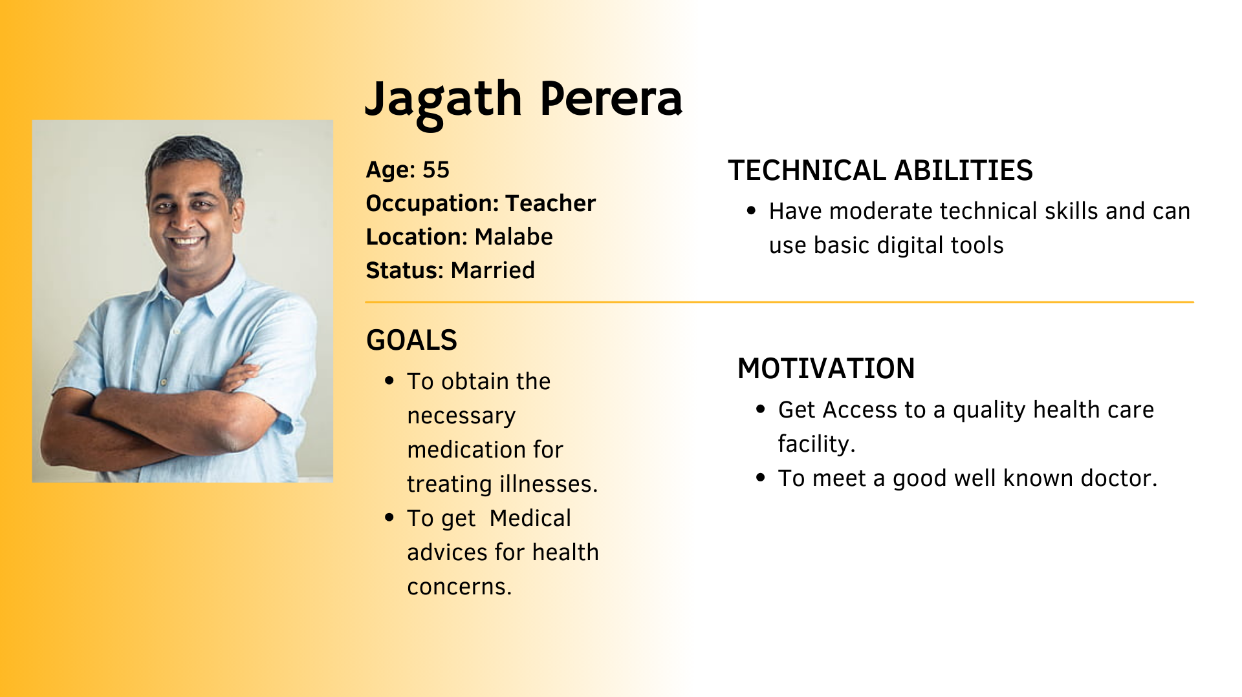

* 2nd Persona – Customer Support

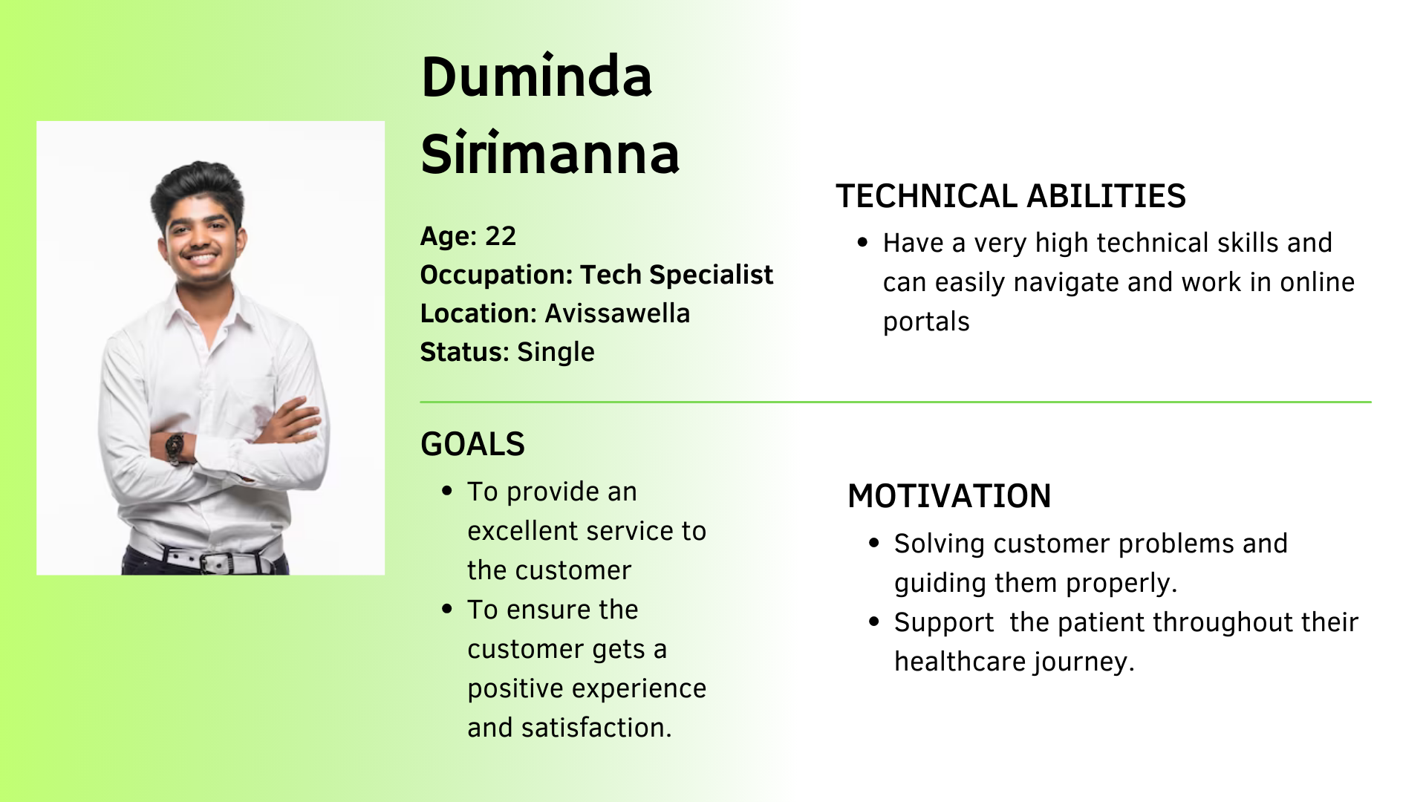

* 3rd Persona – Pharmacist

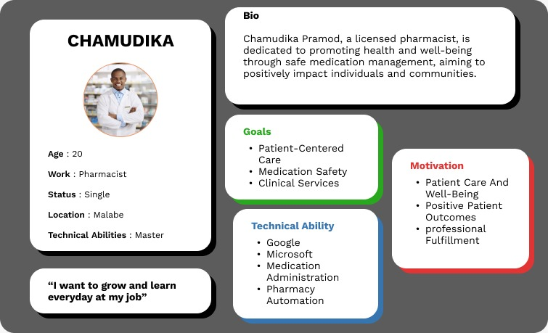

* 4th Persona – Doctor

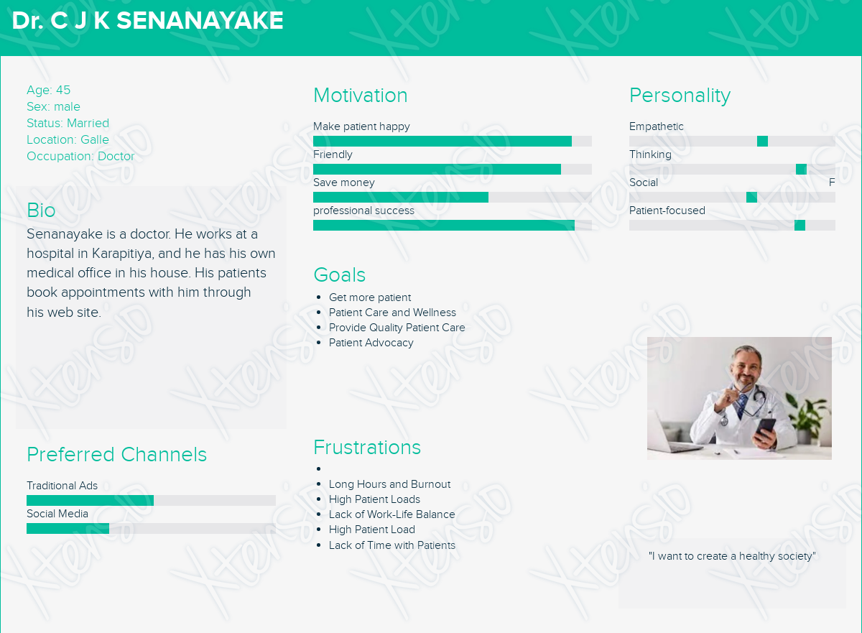

* 5th Persona – Administrator

# **User Journeys**

* Patient User Journey

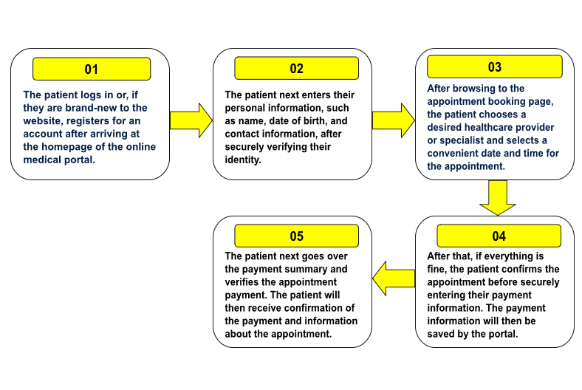

* Customer Support User Journey

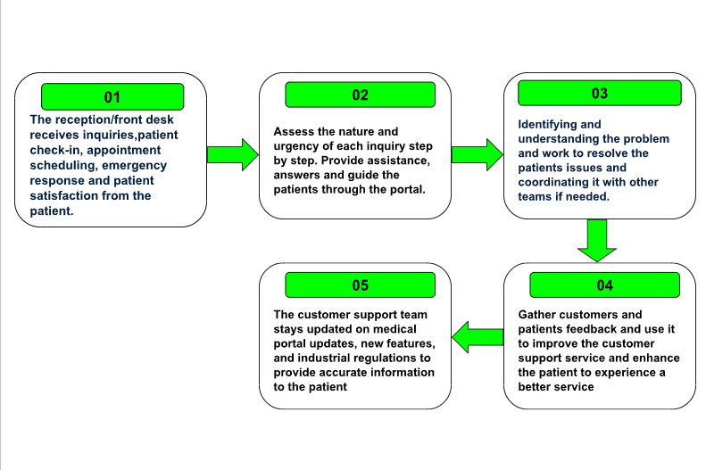

* Pharmacist User Journey

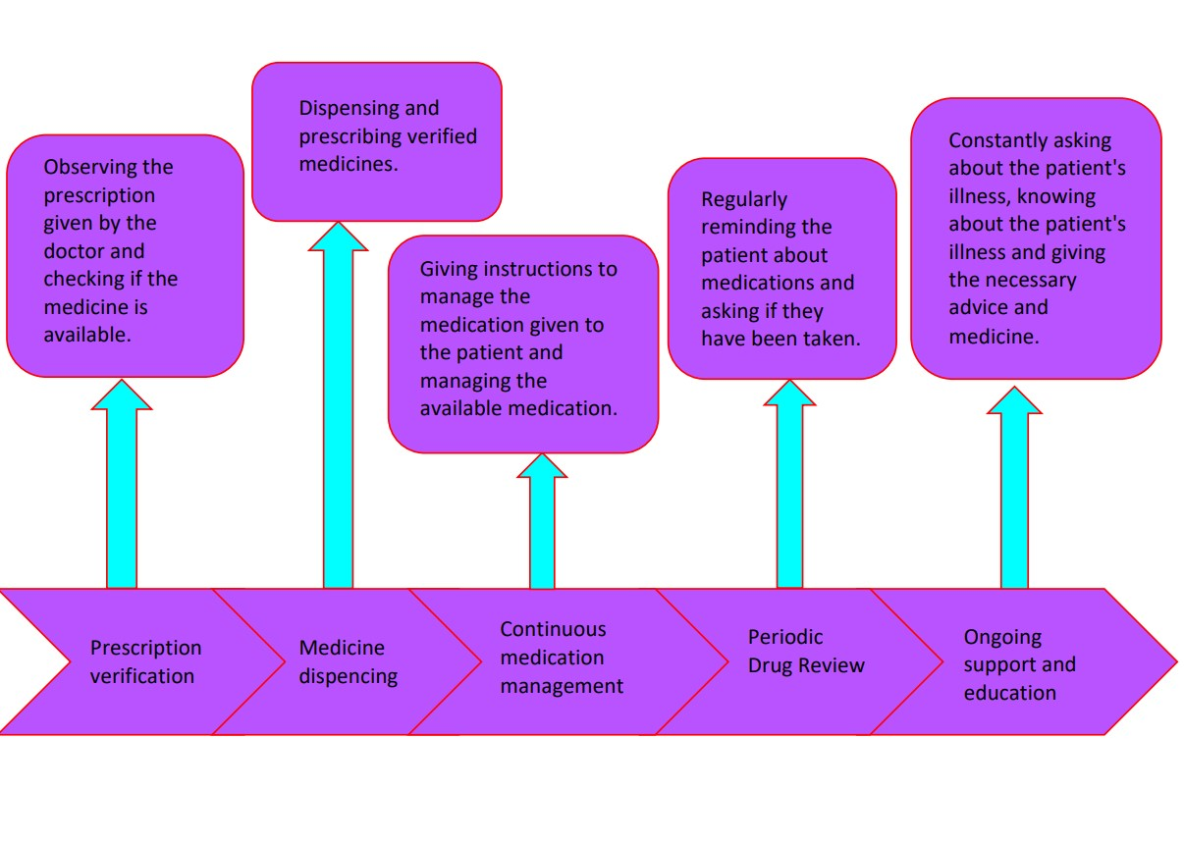

* Doctor User Journey

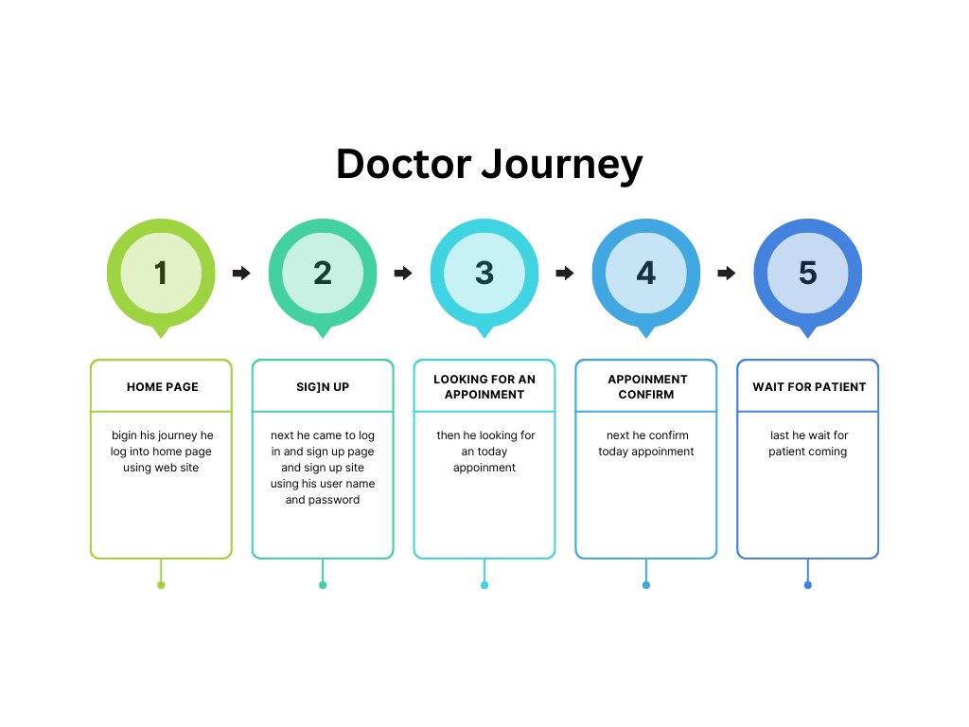

* Administrator User Journey

# **Wire Frames**

* Home Page

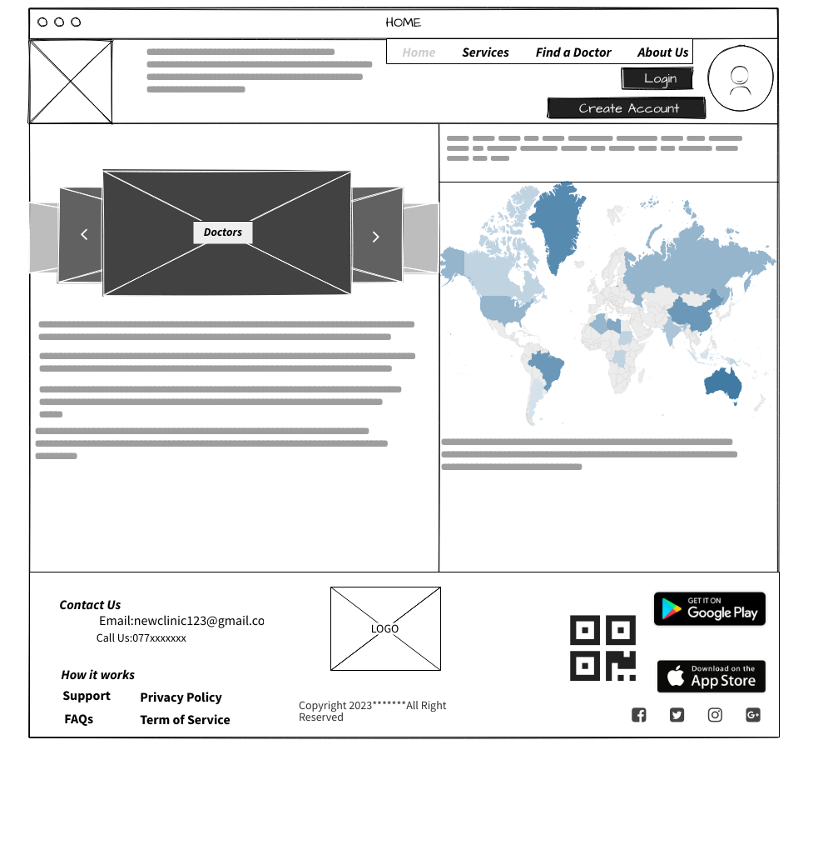

* Registration Page

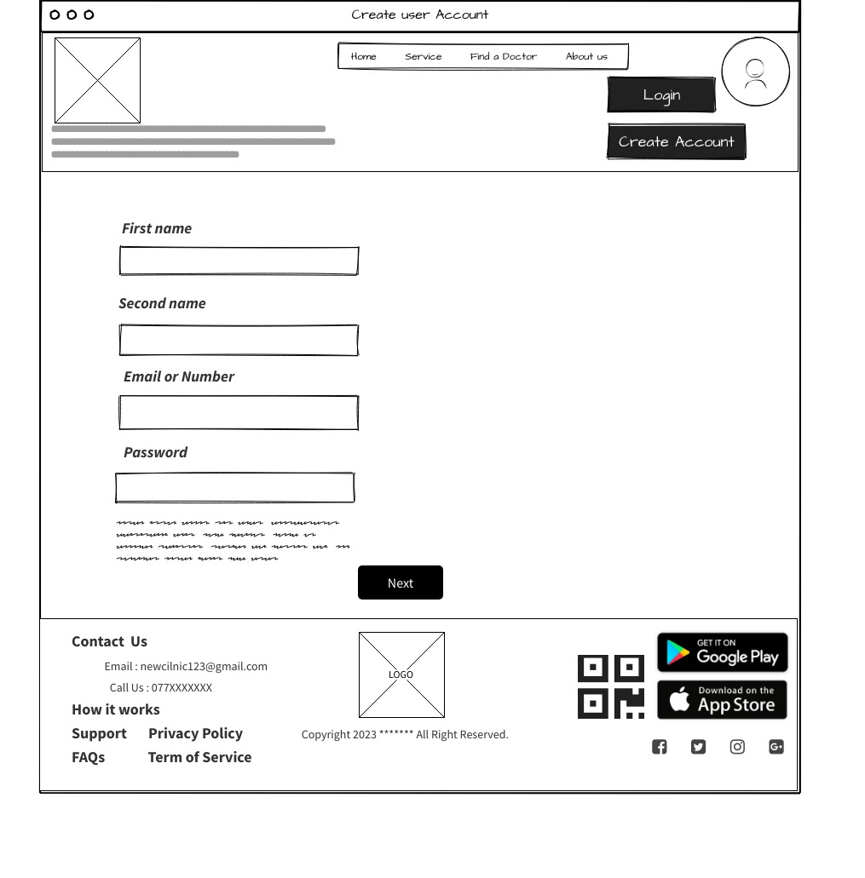

* Login Page

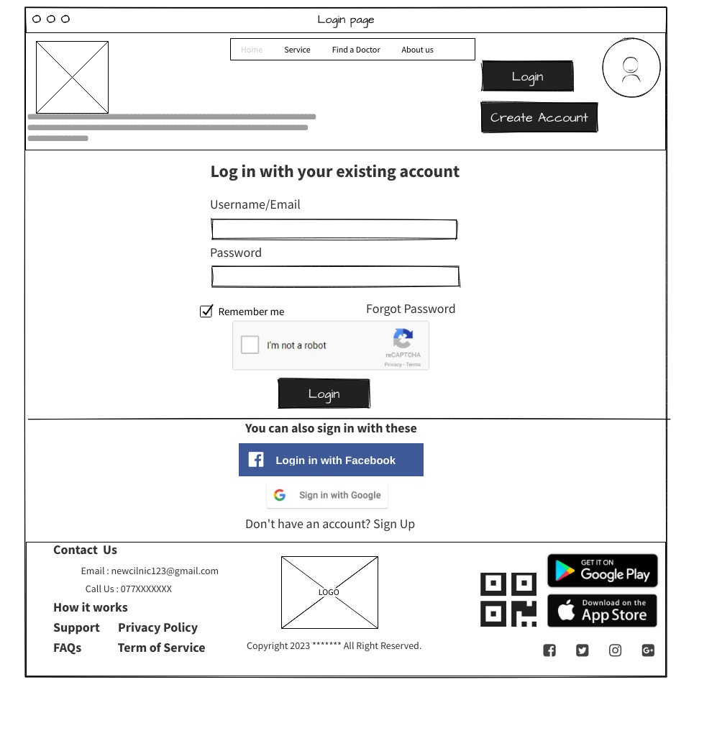

* User Account Page

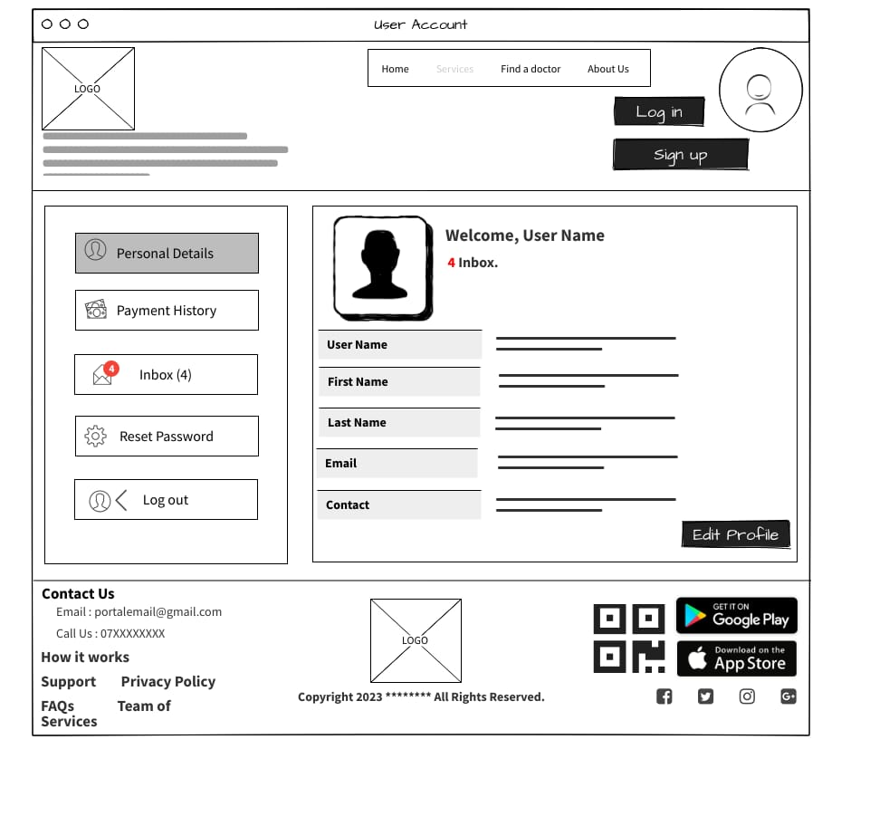

* Find a Doctor

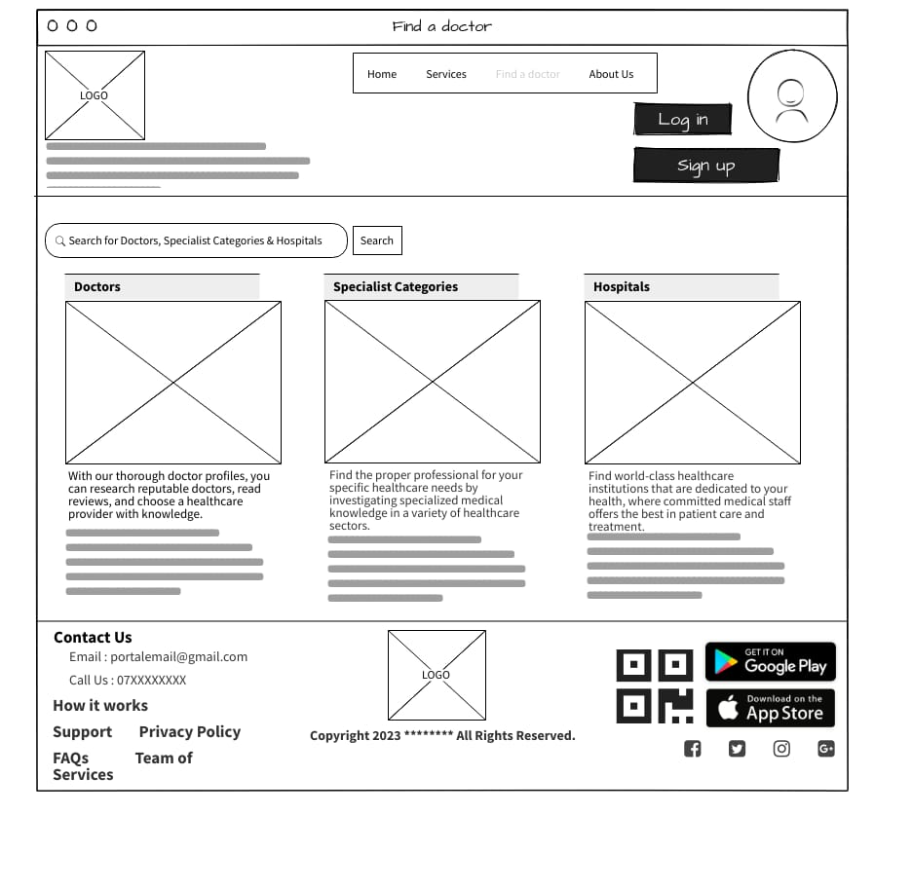

* Servers

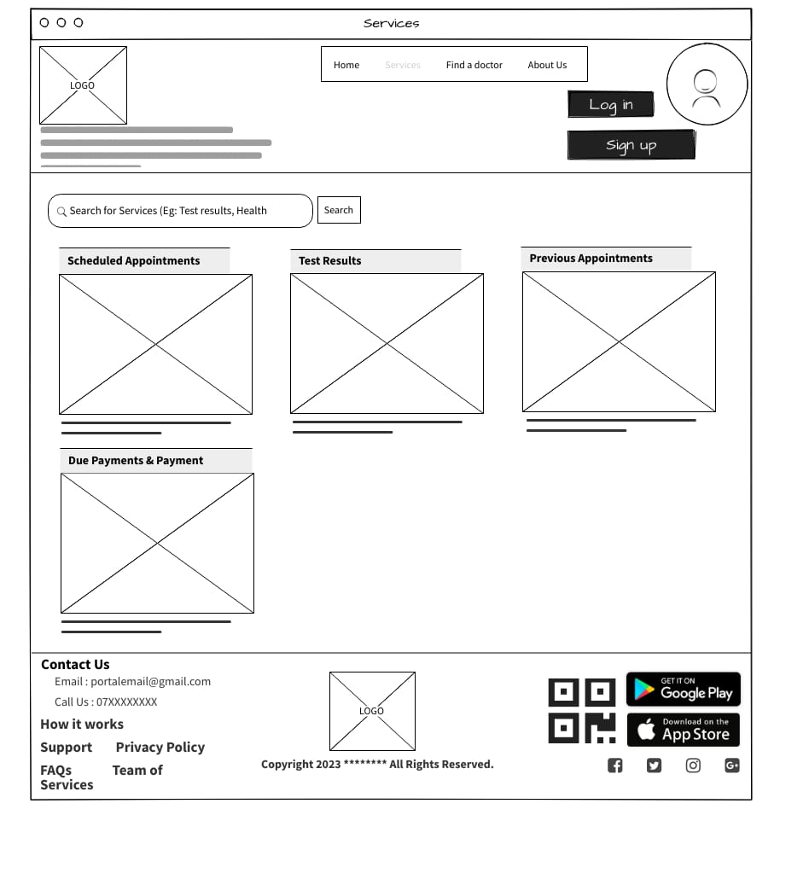

* Payments

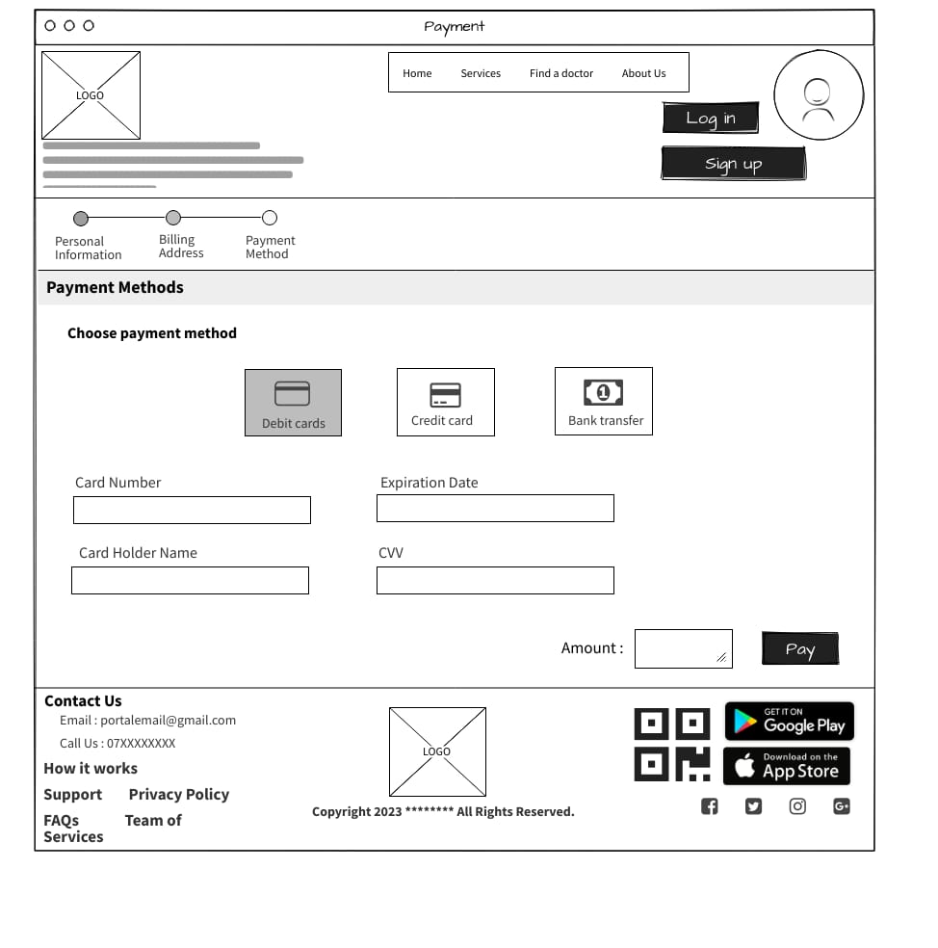

* Contact Us

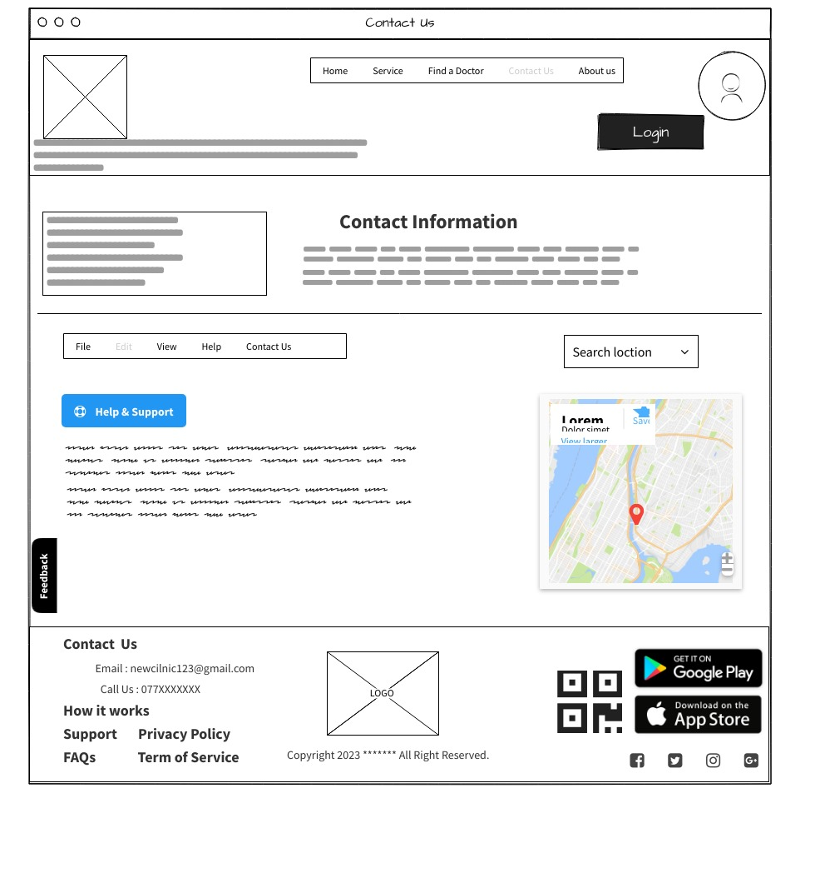

* About Us

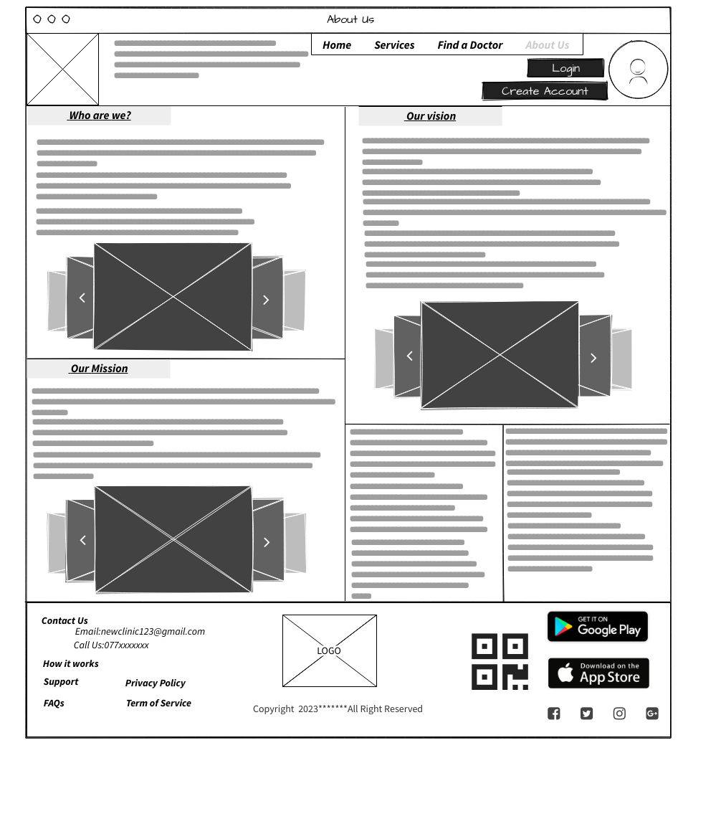

# **Individual Contribution**

|  |  |  |  |
| --- | --- | --- | --- |
|  | **Student ID** | **Student Name** | **Individual Contribution** |
| 1 | IT22157928 | VIDUSHAN A A D D N | * Persona: Doctor * User Journey: Doctor Journey * Wireframe: Home Page   About Us Page |
| 2 | IT22209320 | MIURANGA W A R | * Persona: Administrator * User Journey: Administrator Journey * Wireframe: Create Account Page   Login Page |
| 3 | IT22130716 | MUNASINGHE M A M C | * Persona: Patient * User Journey: Patient Journey * Wireframe: User Account Page   Find a Doctor Page |
| 4 | IT22100320 | SOMASUNDARA M M | * Persona: Customer Support * User Journey: Customer Support Journey * Wireframe: Payment Page   Servers Page |
| 5 | IT22081766 | A M C PRAMOD ARIYASENA | * Persona: Pharmacist * User Journey: Pharmacist Journey * Wireframe: Contact Page |