Table of Contents

Acknowledgement 2

1.0 Introduction 3

1.1 Case Study 3

1.2 Goal and Requirement 4

1.3 Requirement Specification 4

1.4 Document Features 5

2.0 Project Plan 6

3.0 Design 8

3.1 Cloud Design Patterns 8

Transient Fault Handling Application Block 10

3.2 Architectural Diagram 12

3.3 Design Considerations Secure Link 14

3.4 Modeling 17

4.0 Implementation 23

4.1 Publishing Application to Azure 23

5.0 Scale & Availability 46

5.1 Scale 47

6.0 Test Plan & Testing Discussion (Functional and Performance) 47

8.0 Conclusion 57

9.0 References 58

References 58

# Acknowledgement

Firstly, As the developer I would to thank DR. Kalai Anand for sharing a lot of knowledge about Microsoft azure platform and also about Microsoft product, with his guidance and knowledge as developer I managed to overcome my obstacles and also experienced many up and downs. As developer it cultivates the developing skills in me.t would be very useful for my future undertakings as well. Besides that, I would to thank my family member who always to motivate and support me and not forgetting my classmates who shared their ideas and helped in development also.

# 1.0 Introduction

The Website is about the Princess Cruise and Cunard Line which is founded from British Company, where it operates as the major cruise ship in the world ranking. Those mentioned companies bring around 1.5 million annually via its luxury ships. It offers 115 cruise journeys which sails to seven continents and 350 ports globally, where the Cunard emphases Atlantic Ocean and Mediterranean Sea. These both been owned by the Carnival corporation and its headquarters is established in Valencia, Calfornia.This company made a decision that wants to outsource it’s IT infrastructure in order to develop a website for their customers.

As the assigned developer, my task will be to analyst, plan, design, develop and deploy plus maintain the deployed system. The system will be developing thru Microsoft visual 2015. However, the deployment will be done thru Microsoft Azure as the deployment platform.

## Case Study

The case study of this project is designing, developing and deploying the “Princess Cruise and Cunard Line Web services”. The company operates around the global with almost 1.5 million passengers thru 115 cruise itineraries which sails to seven continents with its 20 luxury cruise ships, while Cunard emphasis on the Atlantic Ocean and Mediterranean Sea. This both companies are basically owned by the Carnival corporation in the Valencia, California, headquarters.

There few requirements that developer has to focus on it, which is features such as customers could be able to select the cabin with the rating scale. The cruise operator is being outsourced its IT infrastructure, and operated IT professionals. It wanted to provide a platform which could be able to offer an affordable, convenient to handle and also highly scalable plus available.

Firstly, the company wanted to emphasizes on its deploying the reservation solution and also on-premises platform which could be utilized in the web hosting system. However, the idea was declined due the demand of building new website has to be high-availability infrastructure when it come across the two data center’s due to the uncertainty on the scalability and also the workload.  
  
Visual Studio 2015 will be utilized as for the designing, development and also the deployment. However, for the deployment Microsoft Azure will be used. Besides that, for designing part will be importing the HTML, CSS in order to produce good and quality design.

## 1.2 Goal and Requirement

* Provision

The developer has to ensure that application can be established in the Microsoft Azure Portal.

* Maintainability

The Developer has assured that application could be upgraded and perform its other maintenance on its other tasks while the cruise customer/users or operator is utilizing the system.

* Monitoring

The developer should be monitor the web application all the time and also detect the defects and debug the defect. The monitoring will be handled by the cruise operator. Therefore, the developer also has to monitor on the business process such as those available services by the cruise.

* Availability

The developer has to assured that the application will functioning constantly and fulfilled the requirement of the Service Legal Agreement(SLA).

* Scalability

The application should be able to scale according to the demand it meets.

## 1.3 Requirement Specification

The developer is required to design and develop a web solution which is based on single tenant. It has to meet the below requirement.

|  |  |  |
| --- | --- | --- |
| No | Requirement | Type |
| 1 | The availability to view of the system and view | Non-functional |
| 2 | The active directory | Non-functional |
| 3 | Offer well-structured business | Functional |
| 4 | Provide the search function | Functional |
| 5 | Publish | Non-functional |
| 6 | Able to change, edit or change | Functional |
| 7 | Able to view the services along the prices | functional |
| 8 | The displayed could be view | Non-functional |
| 9 | The payment | Functional |
| 10 | The features of the system | Functional |

## 1.4 Document Features

* The documentation has to list down all the possible outcomes of the technology which has been utilized in developing and deploying the application by the developer.
* Diagram is needed to illustrate the overall functionality of the system.
* Applying test cases to encounter the bugs and error will be debugged by the developer and improvise the system.

The documentation of this project is to give a clear picture to the users to understand the utilization of Microsoft azure Portal and services that been provided in order to develop the website and meets the requirement of the project. Besides that, the amount of technical tools that been utilized in the development of application and deployment by the developer will be listed down below.

The tools that been utilized by the developer in developing the system:

* Windows 10 Professional Service Pack 1 along 64-bit operating system
* Microsoft Visual Studio 2015
* Programming languages .Net, C#, CSS, HTML
* Microsoft Word 2016 (Documentation Purpose)
* Microsoft Visio Professional 2016(Draw Diagram)
* Microsoft Azure development portal (Deployment and publish the application).

# 2.0 Project Plan

The project plan for Prince Cruise and its British based Counterpart for Cunard Line is operating the biggest Cruise ship in the world. As a big type of organization sure that they will

The Project plan for The Prince Cruise and British which is based on match part of Cunard Line operations which is the major Cruise ship service provides globally. The type of prestigious company wants to ensure that they will a quality web application services for their customers and also for the internal business operations in order to keep track of the information accurately. The system must be a very god scalability, availability, functionality, user friendly based interface for the users and also operators. The system should be able to store the data in the database for the internal users. Therefore, avoid data leakage to unauthorized users. The security of application must be designed well.

Next, the system requirement, specification, system cost and duration of the development will be brainstormed by the developer and the developer will be listing down the assumption of the system.  
The customers should be able to view the provided services and could select the cabin they wanted according the availability. To access all the active directory, operators should be to edit, change and update the system. The displayed services should be appeared in the system. The system needs to require new customers for registration and will be stored in the database. So every time the users wants to access to the system, they have to use the username and password and also for operators who manages the system. The main purpose behind this is ensure the security element behind the system

The system also has to meet the requirement of the business and offer a well-structured business. Besides that, the administration part of the system will be developed by the ASP.NET Web form to allow the administrator to handle the system for instance updating, inserting new data and adding new user account into the system. The developer will design and develop the system with the integration of Microsoft azure service platform via the Microsoft Visual Studio 2015 along with the programming languages such as HTML, CSS, C# and .Net.

Moreover, the customer will be able to make changes to the selection that have been made by them either deleting or selection on new services. After completion of the process users could be able to view the features and services on the dashboard of the application.

Lastly, the system had to assure that it will be lodge the important access functionality based on the users. The system also had to cover the reliability and accuracy by avoiding the downtime problems on the websites.

# 3.0 Design

## 3.1 Cloud Design Patterns

There are 24 number of design patterns which are available. Each of the design patterns has its own way in solving the common problems in the design. The developer should be wise in picking up the design patterns according to the system to solve specific reasons. Design patterns brings great flexibility of cloud based solution. There are 9 categories of design patterns which are basic patterns, Patterns for high availability, Patterns for processing Dynamic content, Patterns for uploading data, Patterns for relational database, patterns for batch processing, patterns for operation and maintenance and lastly will be patterns for network. The below table is about the design patterns that been implemented in the system by the developer which has met the requirement of the system as well (Anon., 2014).

|  |  |
| --- | --- |
| Design Pattern | Description |
| The Cache-aside | The Cache aside pattern is utilized to load data on demand into a cache from a data store. And also improvise the performance plus maintain the consistency between data which is seized in cache and the data in the basic data stores. |
| The Compensating transaction | Performs the undo thru series of methods and also Operations that track on the eventual consistency model which are frequently found in cloud-hosted applications which contrivance into complex business processes and workflows. |
| The Competing consumer | This pattern ensures that users could process the request received on the same channel, where it optimizes throughput across the multiple messages, |
| The Federated identify | Delegates the authentication by an external identity provider and also simplifies the development plus improve the user experience in utilizing the application. |
| The Queue based load leaving | This pattern reduces the effect of peaks hours in demand based on availability and also the responsiveness for the service and task. |

### Transient Fault Handling Application Block

Different applications require different fault handlings, therefore different services could have different transient faults as well (angeline, 2014).The transient Fault handling application block make the developers to the application strong thru implementing the robust transient fault handling logic. (angeline, 2014).This Transient Fault Handling Application Block captures the data information during the fault occurs. Following is the transient faults.

* SQL Azure
* Azure Service Bus
* Azure Storage
* Azure Caching Service

And for the retry strategies will be,

* Incremental
* Fixed Interval
* Exponential back-off

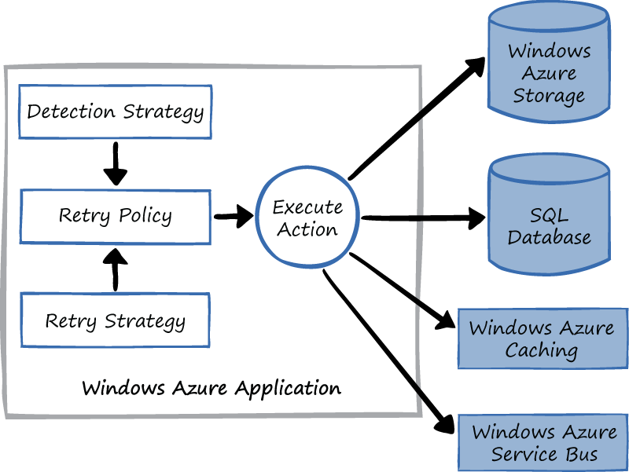

Diagram: The Transient Fault handling application block

The above diagram illustrates The Transient Fault handling application block which utilized from the Microsoft azure application.

1. Detection Strategy   
   to detect the error that found in the HTTP which directly sends the information to the retry policy.

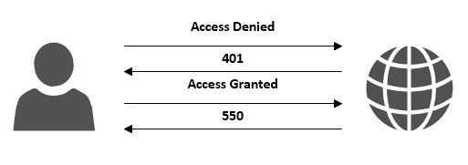

Figure 2 : Retry for the HTTP services

1. The Retry Policy

Checks the execution action via the Microsoft Azure service. For instances executing date from the data storage. where it is required to quality and scalable operation of Prince Cruise & Cunard Line. The Retry policy is vital in testing the code of the system in order to overcome the error and faulty that may occur during the process.

1. Retry strategy

To run again in case any fault is being detected in the system.

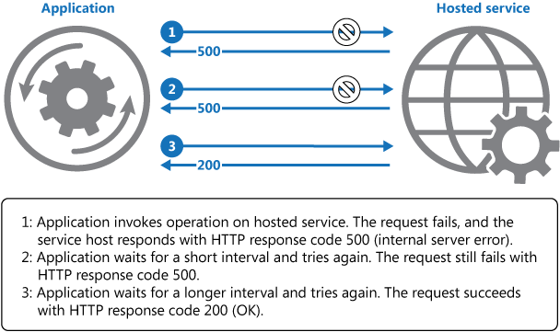

Diagram 3: The Retry strategy   
The Transient fault handling block will be replaced by the Transient fault handling framework. Which covers the HttpStatusCodeServiceUnavaible and some other status code.

## 3.2 Architectural Diagram



Diagram 4 : The complete system of Resource Group



Diagram 5: The Architecture of the system

# 3.3 Design Considerations Secure Link

The developer has utilized Microsoft Visual 2015 for the web development technology with the support of HTML,CSS,ASP.net programming languages for the front-end and however for the back-end will be the ASP.Net, where instruction is prearranging the action and instructions. Therefore, ASP.Net is been offers the users to accomplish post back and page postings. This will enhance the secures for the application and also for the users furthermore allows to perform better operating system which encourages to increase the amount of the users of the page.

Case 1: Customer can search for the available docking place of cruise and room.

Show Docking Cruise and available room

Search for the docking cruise and Room

Case 2: Providing the price for user.

Show the information of required action

Enter and click the menu

The Scenario Case 1 describes that customer able to search for the available location of the cruise, travel location point and also display the available rooms to the customers.

However, the scenario case 2 describes that users has to enter the required credentials or the user could click the menu where the action will be pop-out in the display screen.

Data Operation

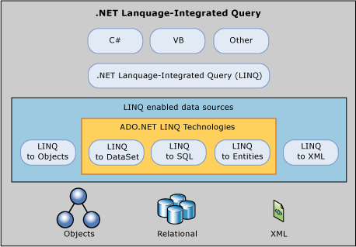  
 Figure 6: The Query use for the Data Operation

For this project, the developer is required to utilize the Data Access Framework to function the database which functions in Language-Integrated (LINQ) where it’s a feature inserted to C# and however the Visual Basic which supports the LINQ.LINQ utilized for the Prince Cruise and Cunard Line which requires the query as the vital to it. However, the XML page used to execute the page without error. However, the SQL connected to the database in the operation that involves the customers and operators.

Active Directory

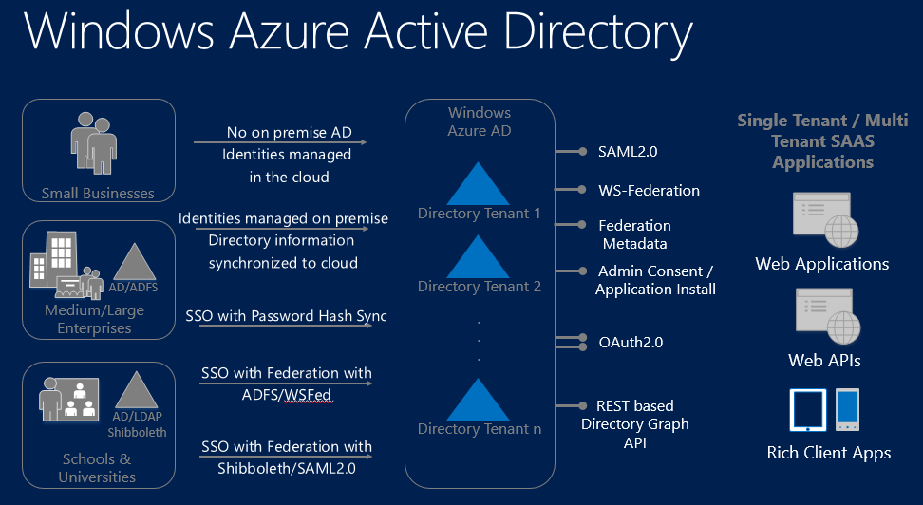

Figure 7 : Active directory of Windows Azure

The Windows Azure Active Directory is considered as Multi-tenant cloud grounded application directory and where it addresses the management services. The AD allows the developer to develop the application which provides the application to connect the first class management solution where it will be utilized by the users of prince cruise and Cunard line. The staff of the organization will be utilizing the directory on the premises, where for customers the other directory will be allowed to utilized but unauthorized access is not allowed to utilize the directories. The SQL will be injected to the login page where it leads to the main access to the website application. With the directory, it assures the users to access with their username and password for verification and validation. For instances, the user is from Malaysia will be automatically directed to the nearest endpoint of the access to the website.

* 1. Modeling   
     Use-case diagram



Diagram Use case

Use case description

|  |  |
| --- | --- |
| Use Case ID | UID001 |
| Name | Active Directory |
| Summary | User/ Customer able to utilize the Active Directory in order to access the system. |
| Priority | High priority |
| Pre-condition | 1. Access into the system’s main page |
| Post-condition | User will log in with active directory and where the service will be displayed in occur. |
| Actors | 1. User (Customer) |
| Main Scenario | |  |  | | --- | --- | | step | Action | | 1. | access with the existing Active Directory | | 2. | Active Directory authenticated user. | | 3. | Show the service features | |
| Alternative scenario | |  |  | | --- | --- | | Step | Branching Action | | 1. | Inacceptable Active directory by user or information didn’t displayed | | 2. | Displays the Error message (pop-outs) | | 3. | System reminders the user to re-enter valid Active directory for the information. | |

|  |  |
| --- | --- |
| Use Case ID | UID002 |
| Name | Show/Display |
| Summary | User (Customer) are able to see the service of cruise docking line and room service. |
| Priority | High priority |
| Pre-condition | 1. Accessible to use the website services. |
| Post-condition | Able to see the services and information’s of the company. |
| Actors | 1. User (Customer) |
| Main Scenario | |  |  | | --- | --- | | step | Action | | 1. | Accessible service and information to view. | | 2. | Available to enter information in the search and other activity | | 3. | Display/shows result | |

|  |  |
| --- | --- |
| Use Case ID | UID003 |
| Name | Changes & Updates |
| Summary | The User of Cruise and Cunard Line operator are able to modify and update their services. |
| Priority | High priority |
| Pre-condition | 1. Access with their directory 2. Make modification if required then completed with update. |
| Post-condition | User Operator can login into their directory in order to modify or do alternation. |
| Actors | 1. User (Operator Cruise and Cunard Line) |
| Main Scenario | |  |  | | --- | --- | | step | Action | | 1. | Access with their own directory. | | 2. | modify the information if required if no. | | 3. | Add or delete the record if required. | |
| Alternative scenario | |  |  | | --- | --- | | Step | Branching Action | | 1. | Does not provide enough credential which can’t be proceed. | | 2. | Invalid entry will display error message | |

|  |  |
| --- | --- |
| Use Case ID | UID004 |
| Name | Submission |
| Summary | The user of customer could perform booking for once is agreed by online payment. The booking information will be kept to operator to generate report. |
| Priority | High priority |
| Pre-condition | 1. (Customer) able to check the date, timing and service before booking then once is confirmed they will make payment in online or account transfer. 2. (Operator) able receive the booking information and also payment for customer. Then the information will be tracked down record purposes. |
| Post-condition | (Customer) capable for booking yet cancellation can be done within two days from the date register in.  (Operator) able to collect the booking information from customer in case the customer wants to cancel the booking ,they will receive an information(Message) that within the two day and the payment can be refund. |
| Actors | 1. (Customer) 2. (Operator) |
| Main Scenario | |  |  | | --- | --- | | step | Action | | 1. | Accessible to book the service. | |
| Alternative scenario | |  |  | | --- | --- | | Step | Branching Action | | 1. | Cancelation within two days of the registration | | 2. | Payment can be refund | |

3.4.3 Sequence Diagram



# 4.0 Implementation

## 4.1 Publishing Application to Azure

The deploying process integrates with the Window Azure for the web deployment and publish the application. The Project name is PCBCL for the Prince Cruise Cunrad line. As the developer of this project is ensure the user(s) are able to utilize the web application without any hassles.

The very first task of deploying is to create the data resources group under the PCBCL name, then create an app service plan for Europe and Asia.

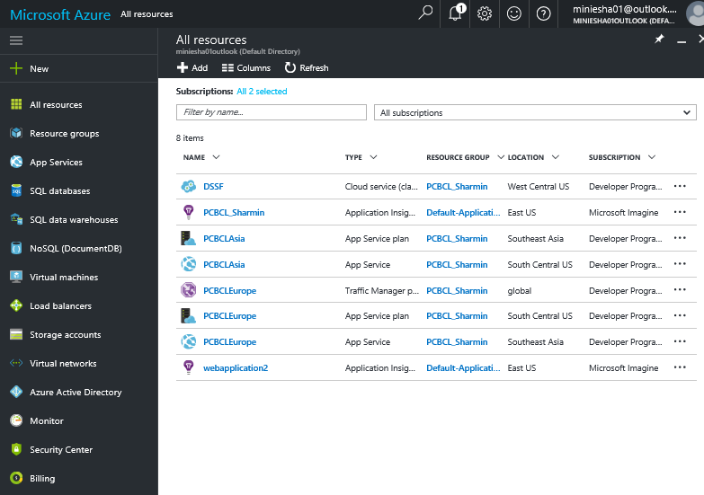

Create Resource group

Step 2: Click on the Add at the resource group in order to create new group.

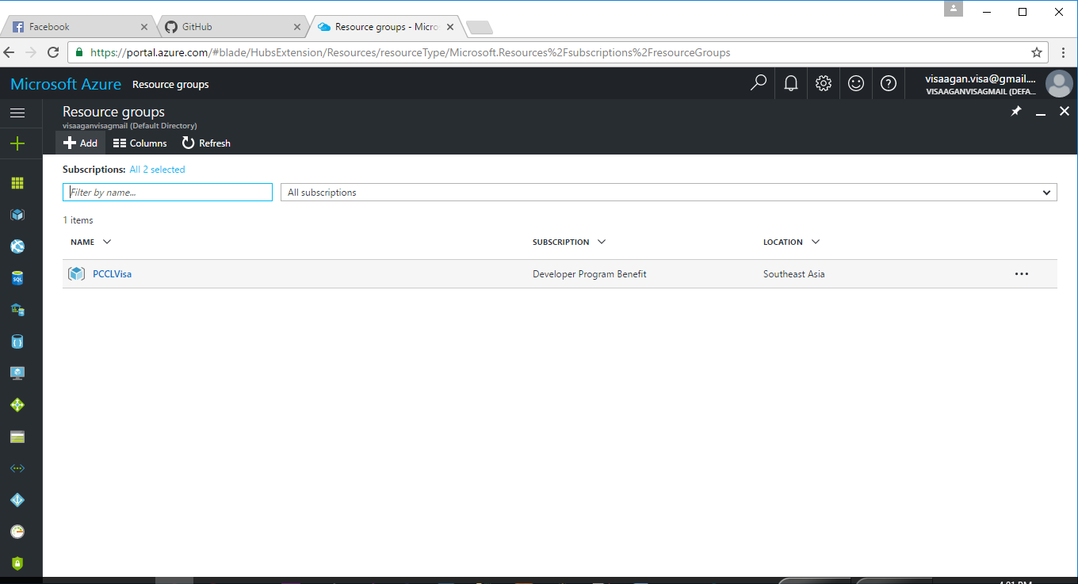

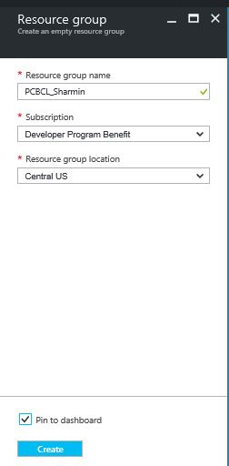

Step 3 : Create name of PCBCL as the resource group name and then select resource group location where central US is been chosen.

Following Is the process, shows the completion of **resource group**.

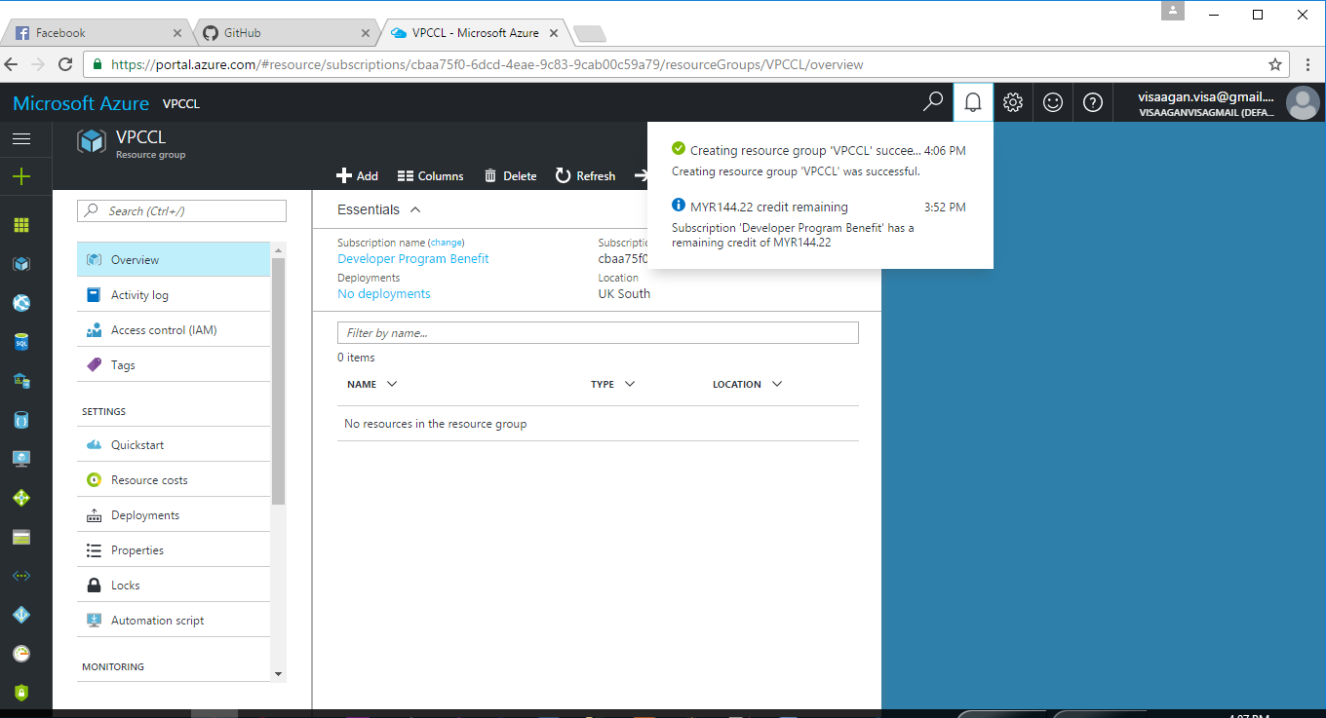

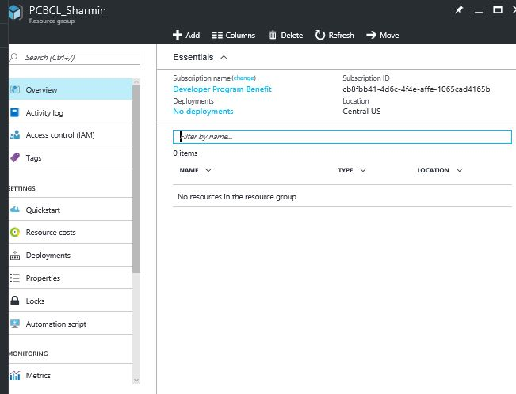

After the successful resource name PCBCL creation.

After this, the developer is required to create **App Service plan.**  
Step 1: Developer has to refer to left side of the menu panel, click on App Service for this application to be deployed.

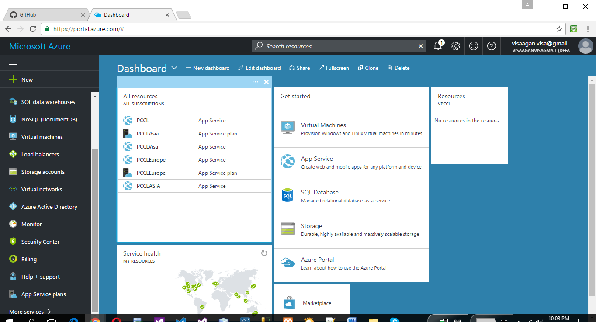

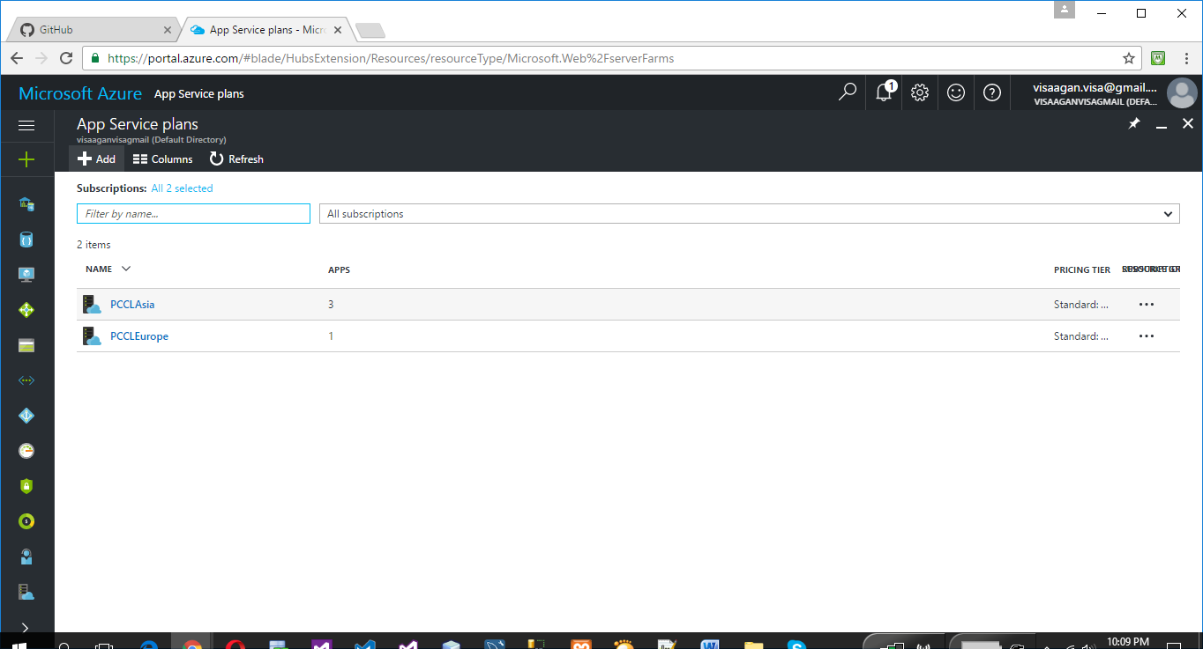

Step 2: Create app services plan for Asia and Europe:  
 Asia

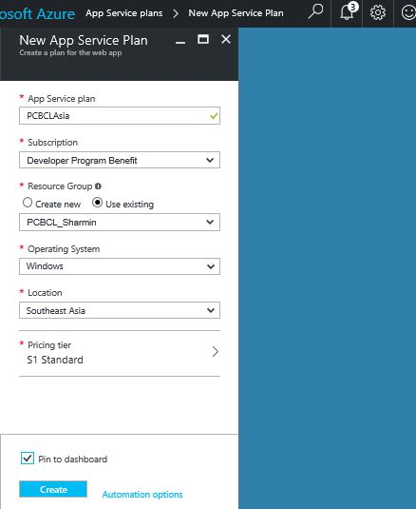

**Europe**:

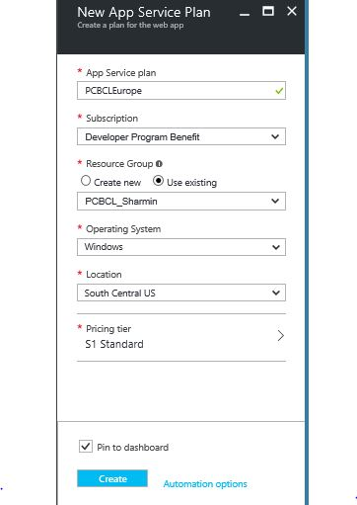

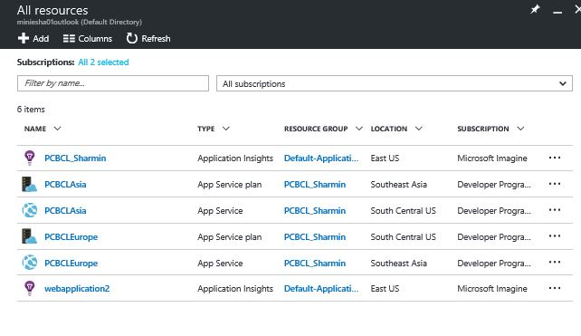

After successful creation New App Plan service.

Next is Instance, create instances for Asia and Europe as well

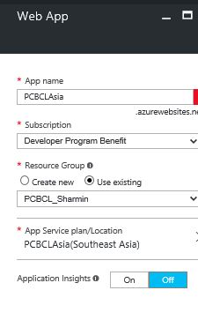

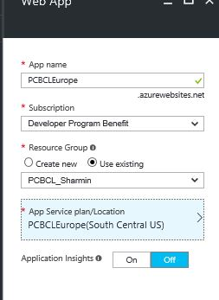  
instances creation for Europe.

Next will be the Instance performance report

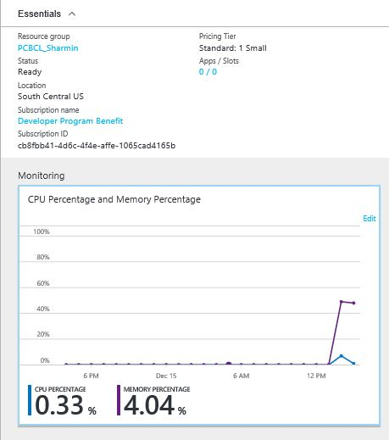  
Asia instances report

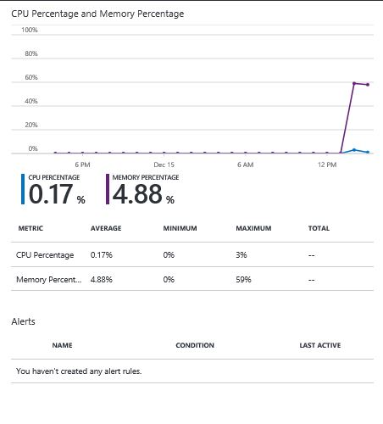  
Instances report for Europe

**Creating Web services**

Step 1: On the left panel, click on the App services

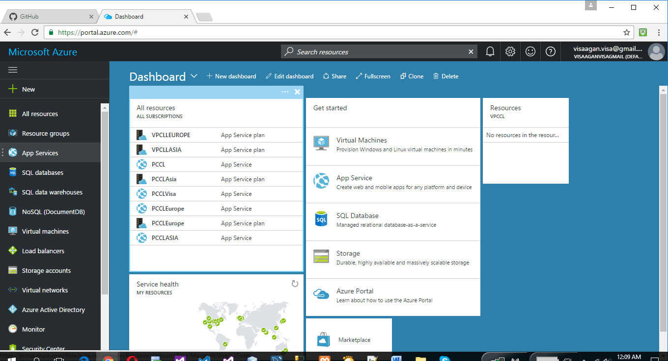  
  
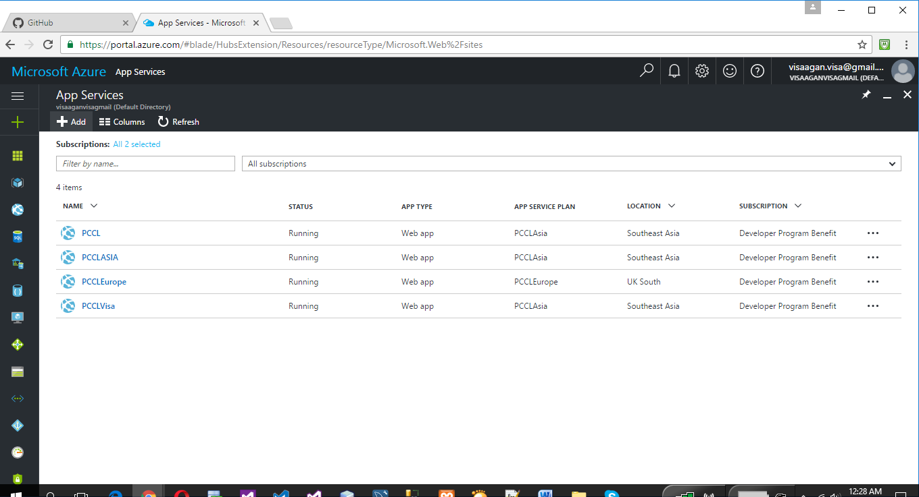

Step 2 : Create app Services as the below , select on what type of App services one prefers;

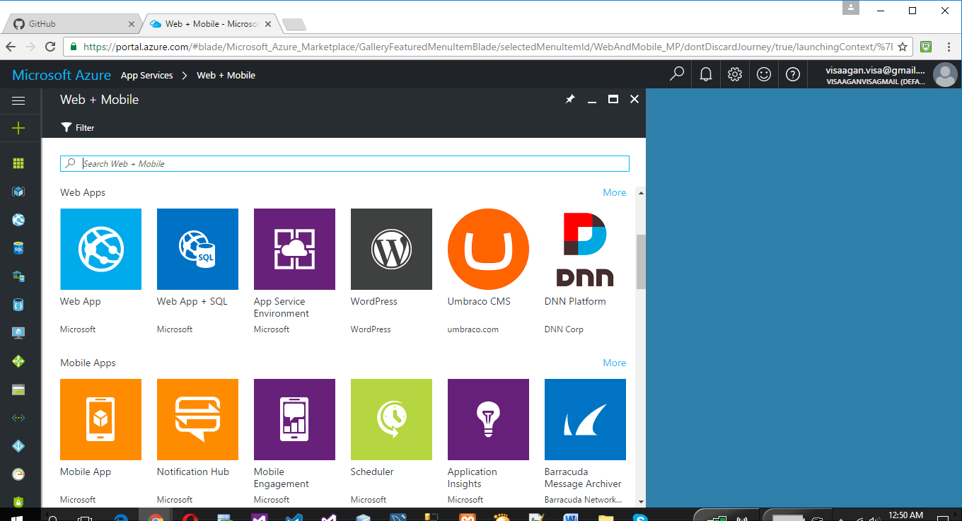

Step 3 : Create Web app for two different location , as for the Asia and Europe :  
Asia

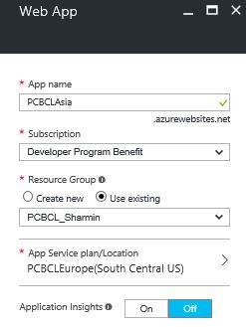

After successful creation of web services , it will be directed dashboard(Overall View)  


**Create Cloud Services**

**Step1: In the left panel menu, click on the cloud services application and create as the below**

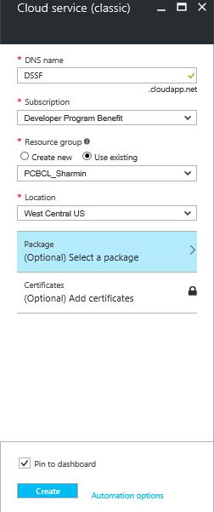

Next step will be creating the of DNS which is DSSF and select the resource group as the “already existing group”

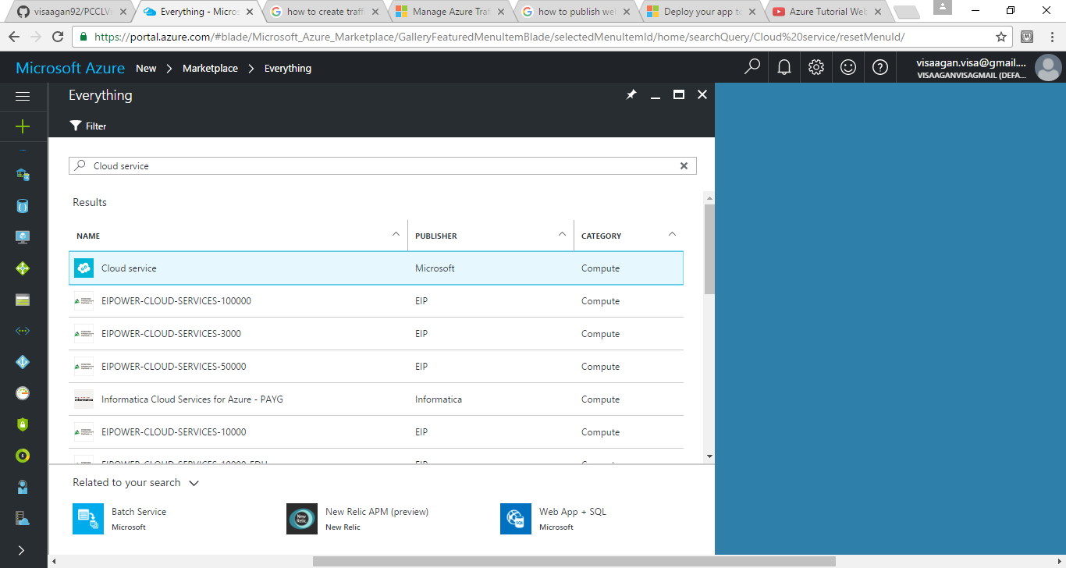

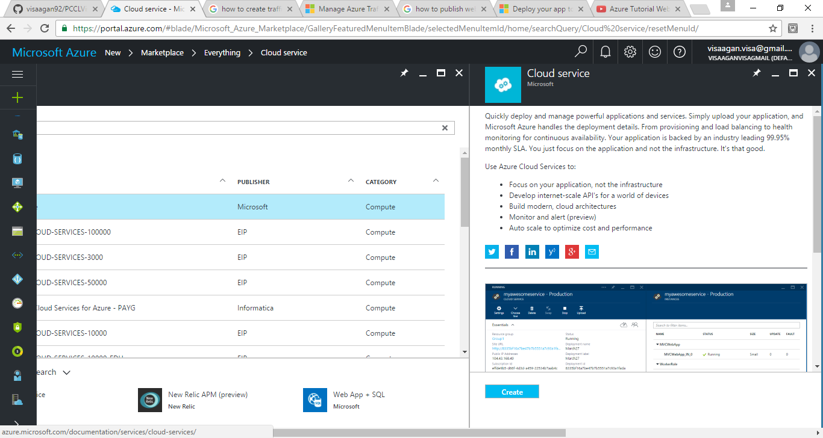

After successful creation of ***cloud services,***  
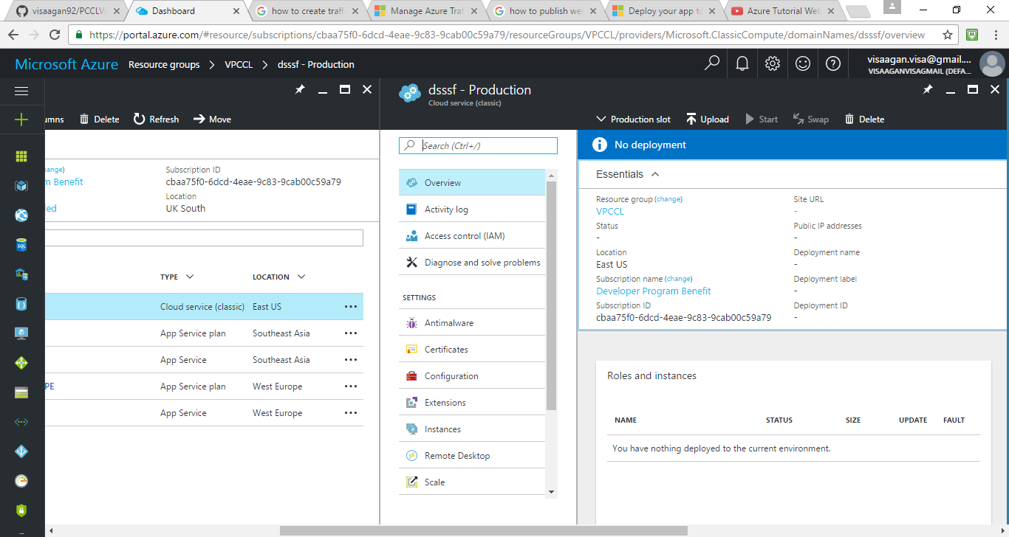

**Create Traffic Manager**

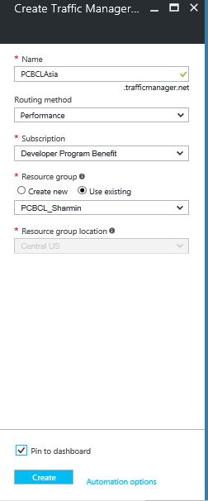

**Traffic manager for Asia**

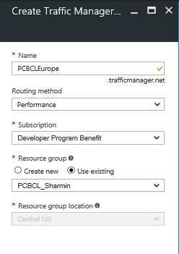

**Traffic manager for Europe**

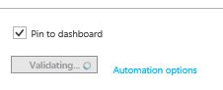

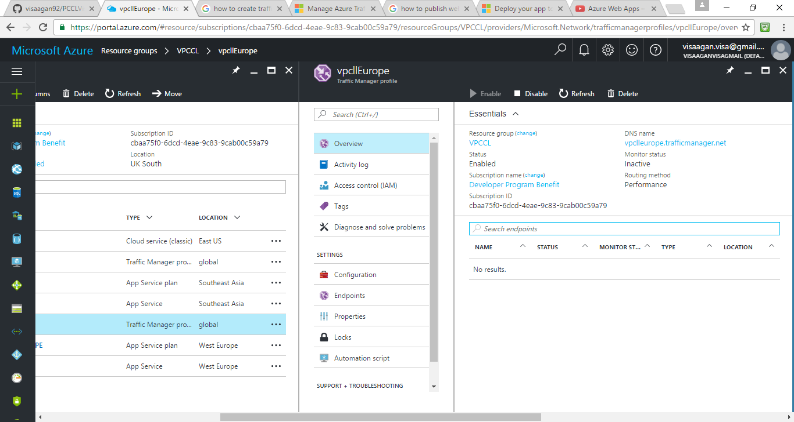 **successfully created.**

**Next will be creating SQL  
 Step 1 : Create SQL by using the left panel of azure portal**

**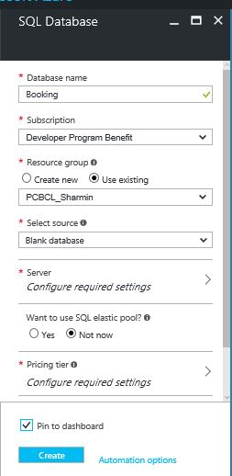  
Step 2 : create database name as “booking” and add the valid value for the username and password for the security purpose and make sure to select the basic tier for this project which is 22.21**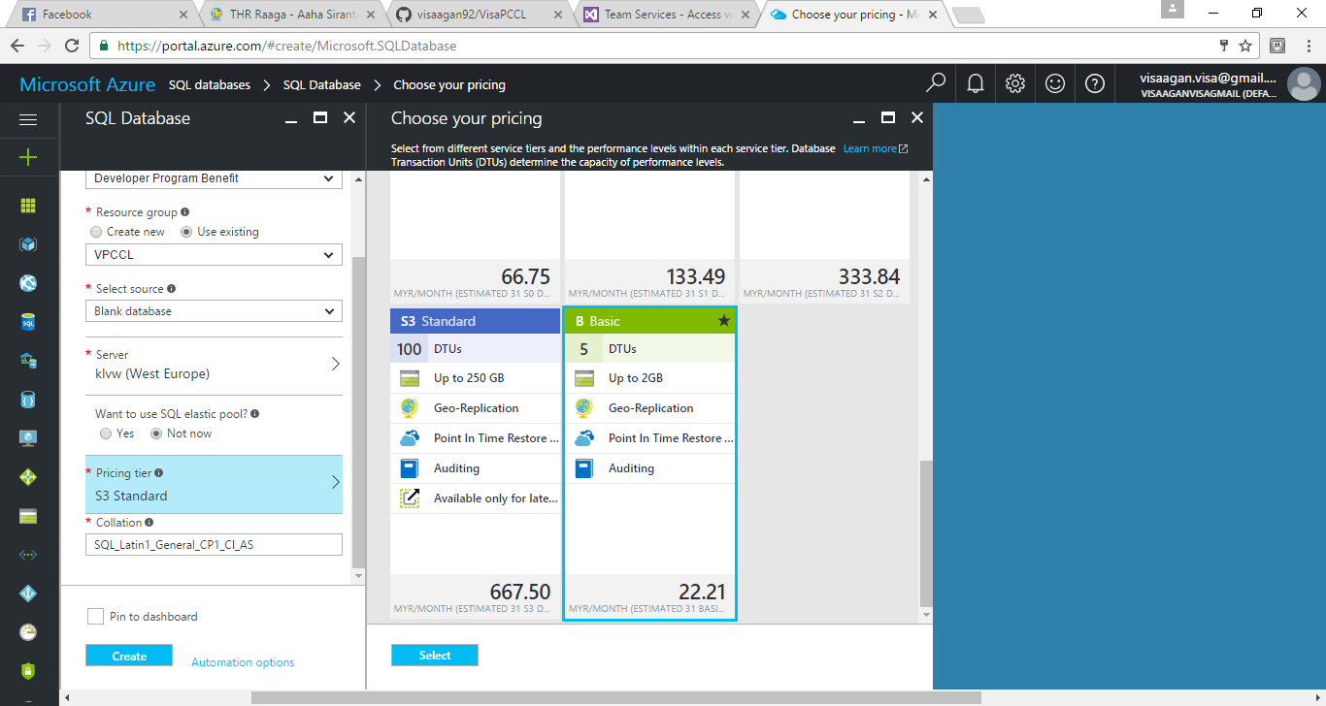

**Active Directory and identification  
  
Step 1 : Select on Azure Active directory as below:**

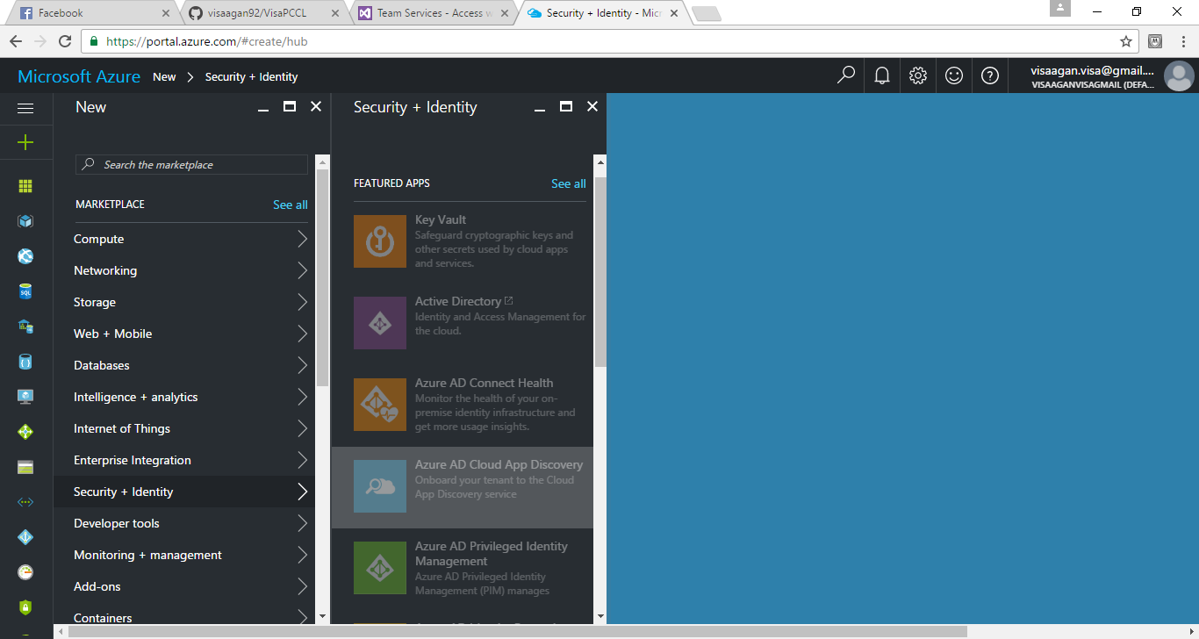

**Step 2 : Create user**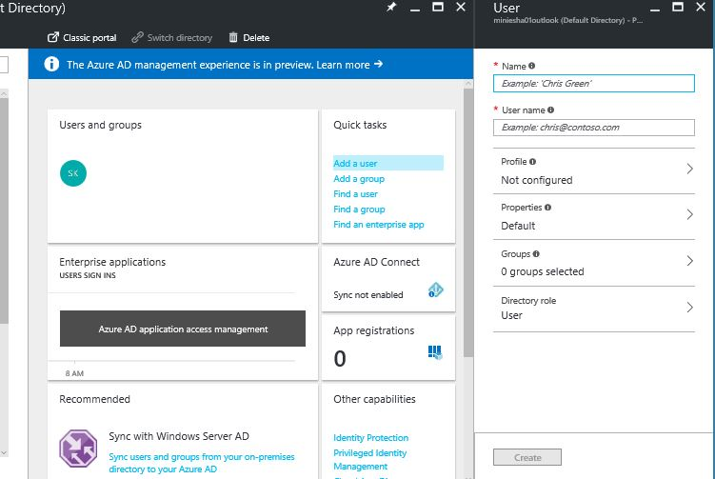

**C:\Users\EndUser\Desktop\Azure storyboard\user emplyee.JPG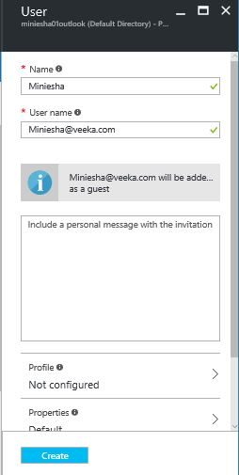  
This creation is for the customers, who has limited accessibility administrator.**

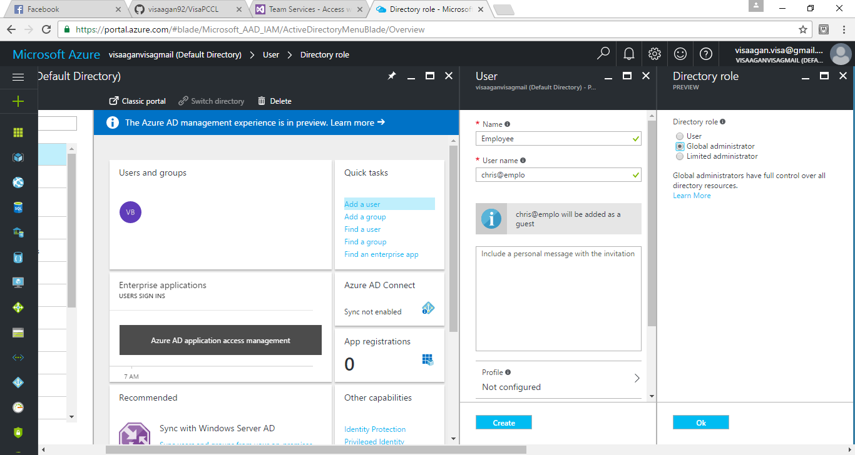 **however, for the Employee the accessibility is global administrator.**

**Publishing in the azure via utilizing Visual Studio**

**Step 1 : After creating application in visual studio, publish the website application in azure , shown below: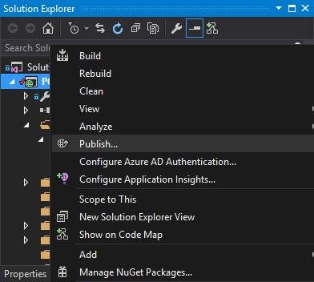 Step 2 : Then few steps of solution has to go through in case of using azure application to publish the website application.**

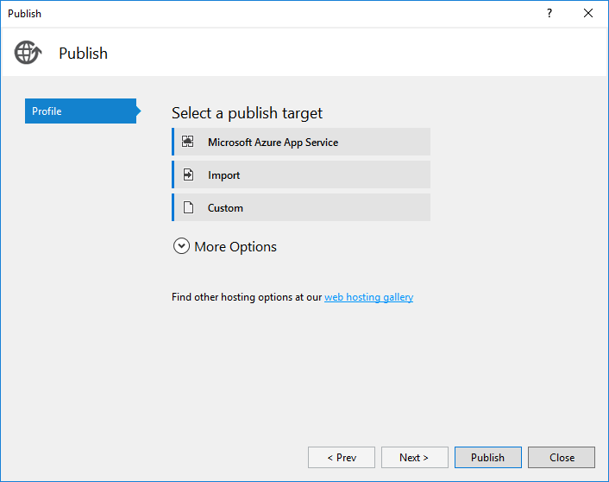

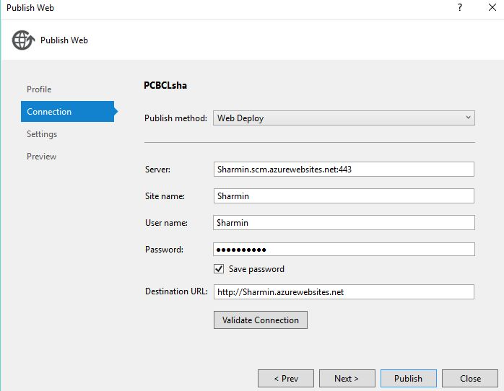

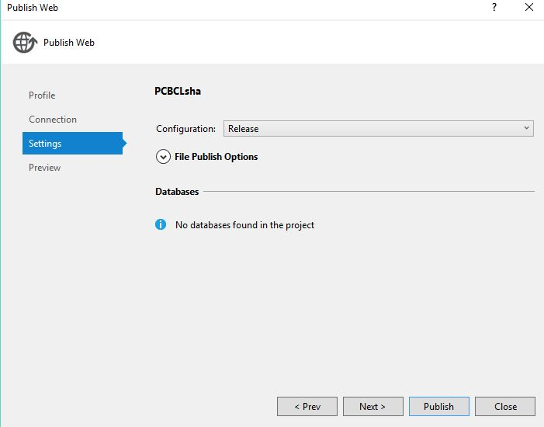

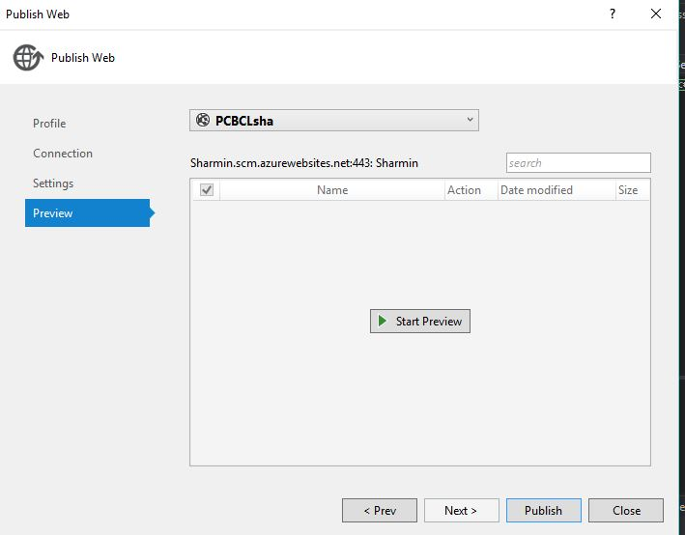

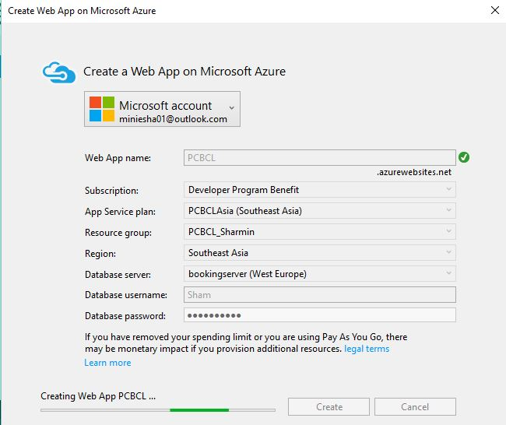

# 5.0 Scale & Availability

## 5.1 Scale

I have implemented three types of scale in my application, which are Standard, Free and shared mode for the website. I utilized standard mode for my application. The advantages are authentication element for developing application users. Basically for most of the functions I used standard mode except for the database is basic due to limitation of payment.

Europe:

5.2 Availability

The application that been created runs in the Europe and Asia regions. By delegating the availability to few locations could enhance the application availability for the user access without facing any hassle.

## 6.0 Test Plan & Testing Discussion (Functional and Performance)

In the test plan, will testing the Azure Original Performance test tools to perform the   
 system testing throughput where the average response time per second and for the CPU   
 processing time and memory it needs working.

6.1 Test plan   
This test can be carried when 100 peoples access the system within one minutes.

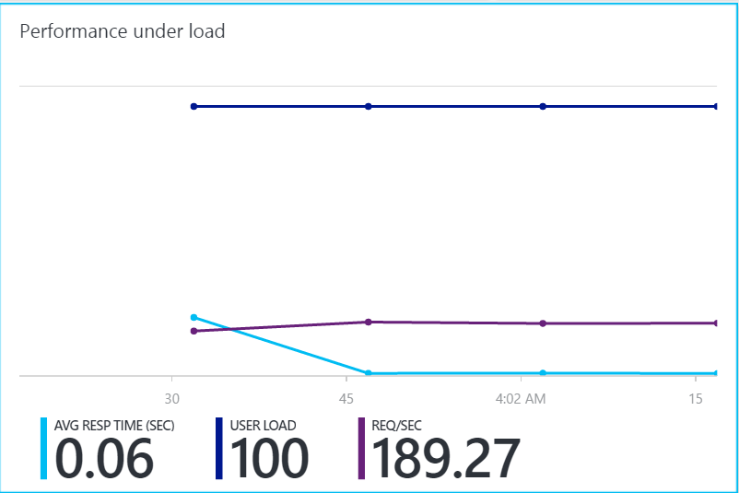

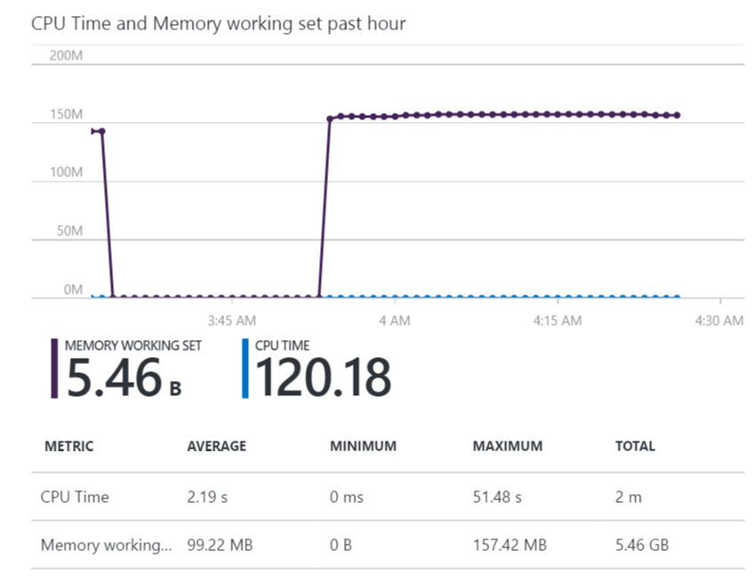

6.2 Test 2

This test conducted for 300 people access the system within one minutes.

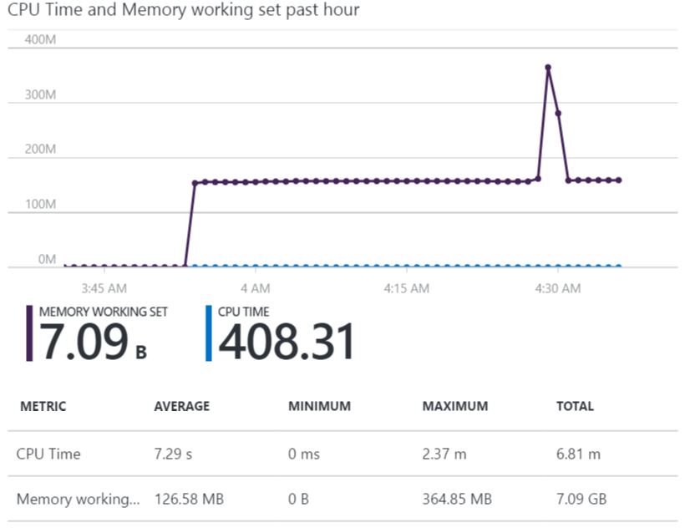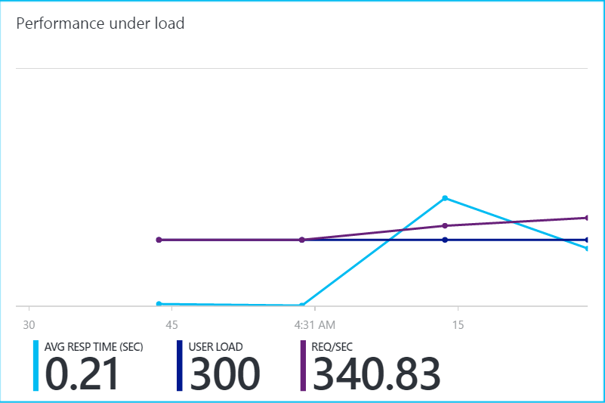

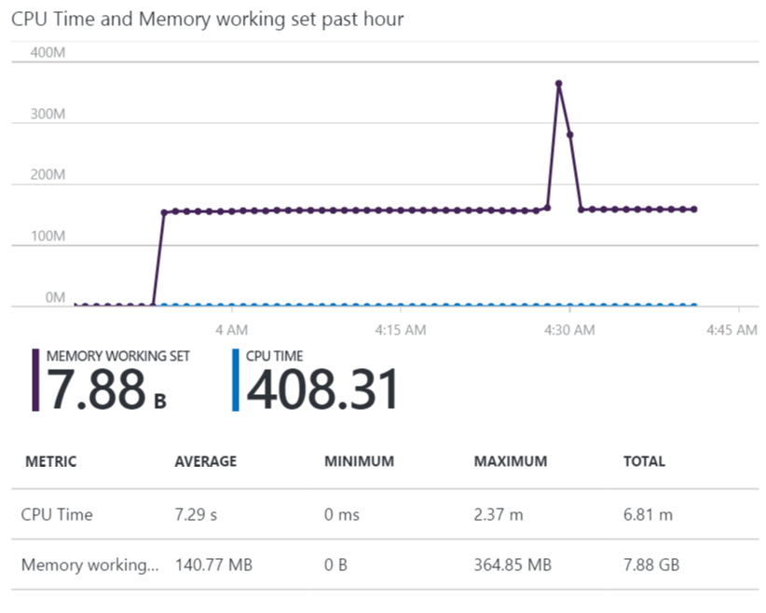6.3 Test 3   
This Test was done for 500 people who access the system within one minute.  
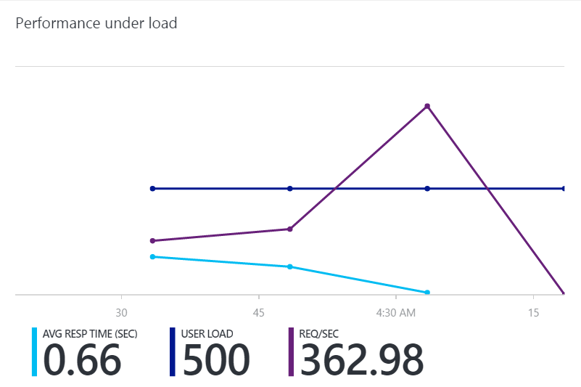

5.4 Test 4   
This test will be conducted with access of 700 users to the system within one minutes.

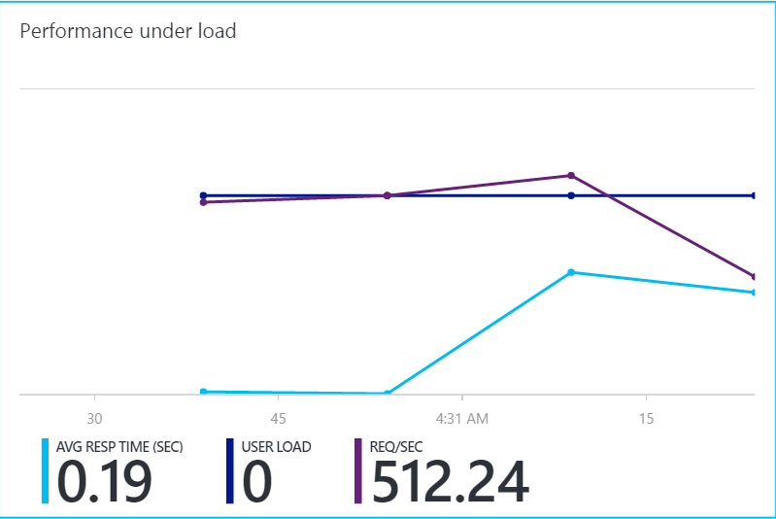

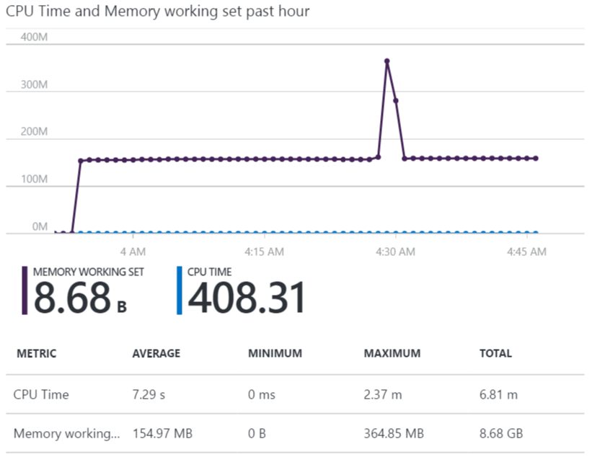

6.5 Test plan 5

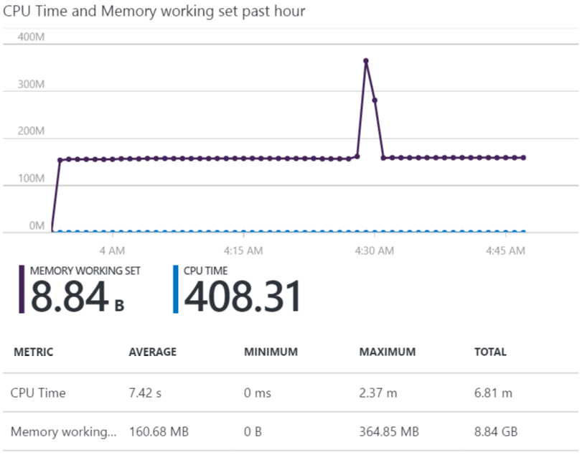This test for the 1000 users who accesses the system within one minute.



6.6 Overview of the test result

|  |  |
| --- | --- |
| Number of clients over 1 min | Average Response Time (Sec) |
| 100 | 0.06 |
| 300 | 0.21 |
| 500 | 0.66 |
| 700 | 0.19 |
| 1000 | 0.8 |

The result gives a clear picture that, has the number of users accessing the system increases has the responses time also increases. The response time can be improved by utilizing the other tier rather than selecting the standard mode, basic and standard ones. Due to some internet connectivity issues, we can see that 700 clients has the faster response time than 500 clients which was tested. The test must be conducted in the same internet speed. Conclusion, as the client’s accesses increases the responses time also will be slower.

7.0 Critical Evaluation and Conclusions

7.1 Critical Evaluation

The critical evaluation on this project will be, where it consumes more time in solving the problems where it can affect the performance quality of the developer. Besides that, in this section will be discussing the technology tools and resources for instance visual studio 2015 and Microsoft Azure Cloud platform which was applied to the websites application. Hence the developer has exposed to many different criteria which is suitable in evaluating the websites project.

Provisioning

The Princess Cruise and Cunard Line system will be provisioning; the developer get to know that Azure has the ability to provision the websites for the multiple -users to ensure that every users has their own authority in order to access the websites application at the same time without any traffic congestion.

Maintainability

The second evaluation of Princess Cruise and Cunard Line System is the maintainability, where evaluating will have based on the version updates of the websites. After the new release the developer has to check on the code functions of the website applications and also checking on the bugs and fix it, Where the azure cloud platform allows the tester to do testing in the same environment and provides the accurate.

Monitoring

Princess Cruise and Cunard Line system will be monitoring, the developer has used the Microsoft Azure online for performance testing which aids developer to improve the system and also identify the problem in the system. Besides that, it also monitors the memory usage and response time of users access the system.

Availability

The fourth evaluation Princess Cruise and Cunard Line system will be availability, the main goal of this module required is the developer has to create a website application and published to the Microsoft Azure. Azure aids to do the auto scaling to offer availability of the websites constantly without any breakdown error. Besides that, Azure also allows the users to set up multiple location based cloud services in order to address the performance issues and availability of the system for the users.

Scalability

The last valuation will be the Princess Cruise and Cunard Line system scalability, where the developer has discovered that scaling is important element websites application as the system meets the demand. For instance, database storage has the scalability, where in Azure SQL database allows to scalable storages.

## 8.0 Conclusion

The project has been successfully published to the Microsoft Services. Users are able to view the websites thru web browsers which connected to internet connectivity. There been few testing parts which was used to test the performance of the website application. Setting up the traffic managers to recognize the user’s location and lead the user to the nearest server in order to improve availability of the Princess Cruise and Cunard Line website.

As the developer, I have learned many things regarding developing websites by using the Visual Studio 2015, MySQL and Microsoft Azure. In the conclusion, Microsoft azure cloud platform had offered plenty of services and resources. Azure provides an excellent service in scaling and upgrading the system. Besides that, it also allows for any alterations if the system functions, coding and structure of the development,

# 9.0 References

# References

angeline, 2014. *msdn.microsoft.* [Online]   
Available at: https://msdn.microsoft.com/en-us/library/hh680934(v=pandp.50).aspx  
[Accessed 29 11 2016].

Anon., 2014. *msdn microsoft.* [Online]   
Available at: https://msdn.microsoft.com/en-us/library/dn568099.aspx  
[Accessed 6 12 2016].

1. Azure, M., 2015. *Azure Storage Client Library Retry Policy Recommendations.* [Online]   
   Available at: http://azure.microsoft.com/blog/2014/05/22/azure-storage-client-library-retry-policy-recommendations/  
   [Accessed 23 November 2016].
2. Msdn.microsoft.com. (2016). *3 – Moving to Microsoft Azure Cloud Services*. [online] Available at: https://msdn.microsoft.com/en-us/library/ff803371.aspx [Accessed 17 November. 2016].
3. Msdn.microsoft.com. (2016). *4 – Moving to Microsoft Azure SQL Database*. [online] Available at: https://msdn.microsoft.com/en-us/library/ff803375.aspx [Accessed 17 November. 2016].
4. Azure.microsoft.com. (2016). *Create an ASP.NET MVC app with auth and SQL DB and deploy to Azure App Service*. [online] Available at: https://azure.microsoft.com/en-us/documentation/articles/web-sites-dotnet-deploy-aspnet-mvc-app-membership-oauth-sql-database/# [Accessed 17 November. 2016].
5. Azure.microsoft.com. (2016). *Deploy an ASP.NET web app to Azure App Service, using Visual Studio*. [online] Available at: https://azure.microsoft.com/en-us/documentation/articles/web-sites-dotnet-get-started/ [Accessed 17 November . 2016].
6. Brisebois, A., 2015. *Transient Fault Handling Application Block & Enterprise Library 6.* [Online]   
   Available at: https://alexandrebrisebois.wordpress.com/2013/10/16/transient-fault-handling-application-block-enterprise-library-6/  
   [Accessed 28 November 2016].

Janalta, 2015. *LINQ (Language Integrated Query).* [Online]   
Available at: http://www.techopedia.com/definition/3827/language-integrated-query-