Market Analysis and Reliability Evaluation
EV Fast Charging 2026–2028
Prepared for: | Leadership Team — Mid-Size DC Fast-Charging Operator
Date: | 26 September 2026
Classification: | Internal
Scope: | Public DC fast charging for passenger cars — United Kingdom, United States, EU Core (Germany and France)
Sources: | IEA Global EV Data 2024 [Dataset, 2023]; UK Public Rapid and Ultra-Rapid DC Fast-Charging Market Report [Research: UK report]; US Public DC Fast-Charging Market Attractiveness for Mid-Size Entrants [Research: US report]; Market Attractiveness and Competitive Intensity: Germany and France High-Power DC Charging [Research: DE/FR report]

Bottom Line
The UK offers the strongest risk-adjusted opportunity for a mid-size DC fast-charging operator’s 2026–2028 expansion, driven by a binding ZEV mandate, a CMA-ordered motorway-site opening, and itemised government funding totalling over £1 billion — provided the operator can secure grid connections and tolerate low near-term utilisation.

SECTION A: MARKET ANALYSIS

A.1 Definitional Note
⚠️ Definition Mismatch Warning
Charger definitions differ across all sources and are not directly comparable. Each figure is labelled with its threshold throughout this document.

Source | Definition Used | Coverage
IEA Global EV Data 2024 | >22 kW (includes some AC Type 2 units) | Dataset baseline [Dataset, 2023]
UK DfT / Zapmap | 50 kW+ | UK research [Research: UK report, Jul 2026]
US AFDC | DC fast-charging ports (broadly comparable to IEA) | US research [Research: US report, Sep 2026]
Germany Bundesnetzagentur | All DC fast chargers | DE/FR research [Research: DE/FR report, Jul 2026]
France Avere-France | 150 kW+ HPC only | DE/FR research [Research: DE/FR report, Feb 2025]

A.2 Market Comparison Table — Dataset Baseline vs. Latest Research
Metric | United Kingdom | United States | Germany | France
IEA 2023 BASELINE (Dataset, >22 kW)
EV car stock (BEV+PHEV+FCEV) | ~1,580,000 | ~4,800,000 | ~2,500,000 | ~1,570,000
Public fast chargers (>22 kW) | ~10,000 | ~43,000 | ~21,000 | ~20,000
EVs per fast charger | 158 | 112 | 119 | 79
EV sales share (all plug-ins) | 24% | 10% | 24% | 25%
LATEST RESEARCH (2025–2026)
Latest fast-charger count | 28,887 (50 kW+, Jul 2026) | 75,000+ (DC fast, Jul 2026) | 54,341 (DC fast, Jul 2026) | 31,335 (150 kW+ HPC only, Feb 2025)
Charger definition used | 50 kW+ (DfT) | DC fast ports (AFDC) | DC fast (Bundesnetzagentur) | 150 kW+ HPC (Avere-France)
Latest BEV sales share | ~25% YTD H1 2026;  ~29.8% YTD Aug 2026 | ~6–7% BEV mid-2026 | 19.1% BEV (full-year 2025) | 20.0% BEV (2025); +62.9% YoY H1 2026
Utilisation signal | ~8% (~2 hrs/day) — Zapmap avg for ALL UK public chargers (not rapid-only). Not directly comparable with US figure. | ~16% (just above ~15% breakeven) | Not available in sources (payback est. 6–12 yrs) | Not available in sources (payback est. 6–12 yrs)
Table 1: Market Comparison — IEA 2023 Baseline [Dataset, 2023] vs. Latest Research. Charger definitions differ across columns and are not directly comparable. UK utilisation figure covers all public chargers, not rapid-only.

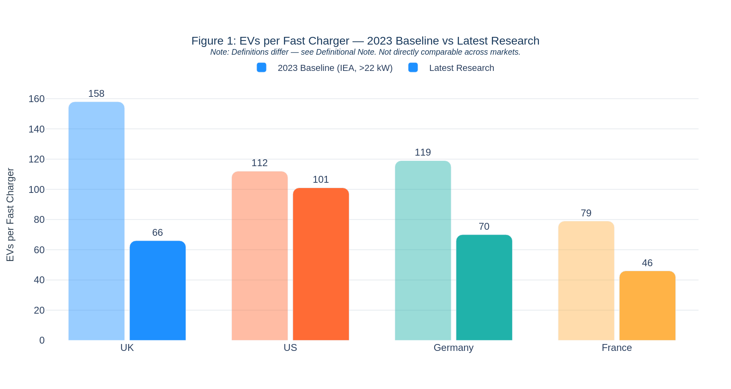
Figure 1: EVs per Fast Charger — 2023 Baseline vs. Latest Research. Note: Charger definitions differ across markets — ratios are directionally indicative only. Sources: [Dataset, 2023]; [Research: UK report, Jul 2026]; [Research: US report, 2025–26]; [Research: DE/FR report, 2025–26].

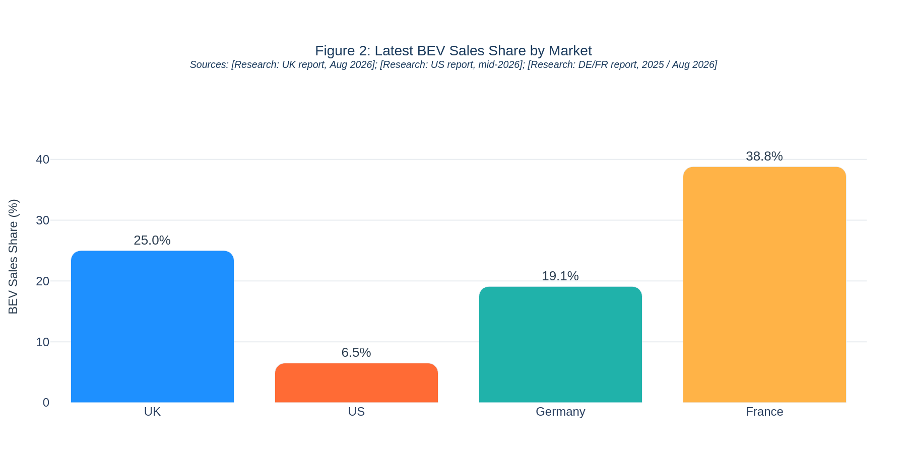
Figure 2: Latest BEV Sales Share by Market. UK: ~25% YTD H1 2026 [Research: UK report, SMMT, Aug 2026]; US: ~6–7% mid-2026 [Research: US report]; Germany: 19.1% full-year 2025 [Research: DE/FR report]; France: 38.8% Aug 2026 [Research: DE/FR report, Avere-France].

A.3 Competitive Landscape Summary
The following table summarises the leading operators in each market, ranked by fast-charger count with their approximate share or absolute port total. All figures are point-in-time: UK mid-2026, US September 2026, Germany end-2024, France May 2025. M&A activity since these dates may have altered rankings.

United Kingdom (50 kW+, mid-2026) — [Research: UK report, mid-2026]
Operator | Fast Chargers | Approx. Share | Notes
MFG EV Power | ~2,838 total | ~10% | Largest by 50 kW+ count
InstaVolt | ~2,600+ | ~9% | Rapid expansion; £460M+ raised by top 3 independents
Tesla Supercharger | ~1,500–2,000 | ~6–7% | Ultra-rapid; partially open to non-Tesla
Osprey | ~1,500+ | ~5–6%
BP Pulse | Subset of 5,398 total | ~4–5% | Mixed speed portfolio
Gridserve | — | ~3–4% | 2022 CMA undertaking: exclusive MSA rights not enforceable after Nov 2026 (~two-thirds of MSAs)
Ionity | — | ~2% | Ultra-rapid hubs; premium positioning
Concentration signal | 100–150 CPOs, consolidating. Top 5 hold ~⅓ of total public market; top 15 hold 58%.

United States (DC Fast, Sep 2026) — [Research: US report, AFDC, Sep 2026]
Operator | Ports | Share | Notes
Tesla Supercharger | 37,995 | 49.8% | Down from 54.6% (Jul 2025); sub-$45K/stall cost advantage
Electrify America | 5,936 | 7.8% | VW-backed; national footprint
EVgo | 5,246 | 6.9% | Urban focus
ChargePoint | 4,937 | 6.5% | Network platform model
Red E Charge | 2,141 | 2.8%
IONNA | 1,458 | 1.9% | Automaker-backed consortium; targeting 30,000 sites
Other Networks | 12,382 | 16.2% | Grew +44% YoY — market fragmenting
Concentration signal | Tesla ~50% but declining. “Other” category grew 44% YoY vs 20% for top-10 — market fragmenting.

Germany (HPC, end-2024) — [Research: DE/FR report, end-2024]
Operator | HPC Points | Notes
EnBW | 6,005 | Market leader
Tesla | 3,110
Aral Pulse / bp | 2,317 | Petrol-station network leverage
Allego | 1,541 | Taken private by Meridiam for $1.5B; consolidation signal
Ionity | 1,084 | Motorway hubs; automaker-backed
Concentration signal | Moderate-to-high concentration; top 5 hold substantial majority. Grocery-retailer subsidised charging compresses margins.

France (HPC, May 2025) — [Research: DE/FR report, May 2025]
Operator | HPC Points | Notes
Tesla | 3,019
TotalEnergies | 1,543 | Leads on motorways: 850 pts, 380 MW capacity
Electra | 1,504 | Urban/commercial hubs
Ionity | 688 | Motorway hubs
Fastned | 265 | Highway focus; Dutch origin
Concentration signal | More fragmented than Germany. Segmented by location (motorway vs. urban). TotalEnergies dominant on motorways; urban corridors more open.

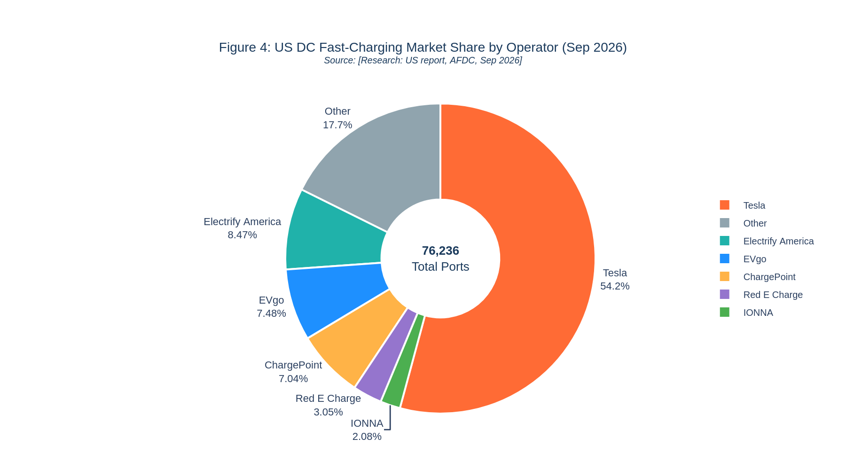
Figure 3: US DC Fast-Charging Market Share by Operator (Sep 2026). Source: [Research: US report, AFDC, Sep 2026]

A.4 Key Trends and Signals
This section examines where the 2024–2026 research confirms or contradicts the 2023 IEA dataset. Each observation is labelled with its source.

Demand Trajectory

United Kingdom — Confirms and Accelerates
The dataset recorded a 24% all-plug-in EV sales share in 2023 [Dataset, 2023], covering BEV+PHEV. Research confirms continued acceleration: 19.6% BEV-only in 2024, 23.4% BEV-only in 2025, and ~25% YTD through H1 2026, reaching ~29.8% YTD through August 2026 [Research: UK report, SMMT/Car Magazine]. Note: The dataset figure (24%, BEV+PHEV) and research figures (BEV-only) cover different powertrains and are not directly comparable. Both show strong demand.
- The ZEV mandate requires 52% zero-emission new-car sales by 2028 and 100% by 2035, providing a regulatory demand floor [Research: UK report, UK Gov].
- Actual BEV share is running 5–8 percentage points below mandate targets; the mandate entered formal government review in August 2026 [Research: UK report, SMMT/UK Gov].

United States — Contradicts IEA Projections
The dataset showed 10% EV sales share in 2023 [Dataset, 2023]. The IEA STEPS scenario projected ~20% by 2025. Actual 2025 BEV share was only 7.7–10%. Following the expiration of the $7,500 federal tax credit in September 2025, BEV share surged to 12% in September 2025 (pre-expiry rush), then collapsed to <6% by Q4 2025. Mid-2026 registrations are down ~31% YoY — roughly half the IEA STEPS projection pace [Research: US report].

Germany — Volatile but Recovering
The dataset showed 24% all-plug-in EV sales share in 2023 [Dataset, 2023]. BEV share dipped to 13.5% in 2024 after the Umweltbonus subsidy ended abruptly in December 2023, then rebounded to a record 19.1% BEV-only in 2025 [Research: DE/FR report, VDA].

France — Confirms and Accelerates Strongly
The dataset showed 25% all-plug-in EV sales share in 2023 [Dataset, 2023]. BEV share reached 20.0% in 2025 and BEV registrations surged +62.9% YoY in H1 2026 [Research: DE/FR report, ACEA], the strongest demand momentum of all four markets. BEV share hit 38.8% in August 2026 [Research: DE/FR report, Avere-France].

Infrastructure Supply — All Markets Outpacing 2023 Trajectory
Charger deployment has outpaced fleet growth in all four markets, compressing EVs-per-charger ratios. This is positive for drivers but creates utilisation pressure for operators. The ratios below are directionally indicative only because the 2023 and latest-research denominators use different charger definitions.
Market | 2023 Ratio  (>22 kW) | Latest Ratio  (definition varies) | Notes
United Kingdom | 158 EVs/charger | ~66 BEVs/50 kW+  (Jul 2026) | Different definitions: IEA >22 kW vs DfT 50 kW+
United States | 112 EVs/charger | ~96–106 (2024–25) | DC fast definitions broadly comparable
Germany | 119 EVs/charger | ~71 (Jul 2025) | Both use DC fast; Bundesnetzagentur threshold not confirmed vs IEA
France | 79 EVs/charger | ~46 (Feb 2025) | Stricter definition: IEA >22 kW vs Avere-France 150 kW+ HPC only — ratios not comparable
Table 2: EVs per Fast Charger — 2023 Baseline vs. Latest Research. Sources: [Dataset, 2023]; [Research: UK report, DfT, Jul 2026]; [Research: US report, AFDC]; [Research: DE/FR report, Bundesnetzagentur/Avere-France].

Utilisation and Economics
UK: The Zapmap average for all UK public chargers (not rapid-only) is ~8% (~2 hrs/day) [Research: UK report, Zapmap]. This figure is not directly comparable with the US DC fast utilisation figure.
US: DC fast utilisation is ~16%, reported as barely above the ~15% breakeven threshold [Research: US report].
Germany / France: Utilisation data is not available in our sources. Payback periods are estimated at 6–12 years for both markets.

A.5 Opportunities and Risks
Market | Key Opportunities | Key Risks
United Kingdom | - ZEV mandate: 52% by 2028, 100% by 2035 — regulatory demand floor  - 2022 CMA undertaking: Gridserve cannot enforce exclusive MSA rights after Nov 2026, covering ~two-thirds of MSAs — a once-in-a-decade site window [Research: UK report]  - Underserved regions: Northern Ireland (19.3 rapid/100K), London (27.9), Yorkshire & the Humber (36.6), North East (37.1) vs UK avg 41.7 [Research: UK report, DfT Jul 2026]  - Itemised government funding: LEVI £381M (mostly slow on-street); £400M Spending Review 2025 (strategic road network); Ofgem £300M Green Recovery Scheme (network upgrades at 37 MSAs)  - Industry consolidation creating M&A targets; top operators raised £460M+ | - All-public-charger utilisation ~8% (Zapmap); profitability timeline uncertain  - Grid connection queue average 5.5 years [Research: UK report]  - 87x increase in grid standing charges since 2022 [Research: UK report]  - 20% VAT vs 5% domestic; ~10x price premium over home charging  - ZEV mandate under formal government review (Aug 2026) — binary outcome uncertainty
United States | - Largest absolute fleet: ~4.8M EVs in 2023 [Dataset, 2023]  - Market fragmenting: "Other" networks grew +44% YoY vs 20% for top-10 [Research: US report, AFDC]  - State-level funding: CA $55M+, NY $28.5M+ [Research: US report]  - Infrastructure 32% below IEA STEPS target — structural gap remains [Research: US report] | - Tax-credit expiry (Sep 2025) collapsed BEV share to ~6–7%; mid-2026 registrations down ~31% YoY (single-sourced) [Research: US report]  - Tesla holds ~50% with sub-$45K/stall cost advantage [Research: US report]  - IONNA (automaker-backed) targeting 30,000 sites; demand charges can consume >90% of electricity costs  - $504M NEVI funds repurposed Mar 2026; NACS+CCS1 dual-connector adds capex [Research: US report]
Germany | - Largest EU BEV fleet: ~2.03M BEVs (Jan 2026) [Research: DE/FR report]  - Deutschlandnetz policy framework provides deployment support [Research: DE/FR report]  - Median ad-hoc price €0.59/kWh provides revenue potential; DC fast share of total public charging rose from 13% to 26% [Research: DE/FR report] | - EVs-per-charger ratio already at ~71 — infrastructure gap closing fast [Research: DE/FR report]  - EnBW + Tesla dominate; Allego take-private ($1.5B) signals consolidation favouring scale  - Grocery-retailer subsidised charging compresses ad-hoc margins [Research: DE/FR report]
France | - Strongest BEV momentum: +62.9% YoY H1 2026 [Research: DE/FR report, ACEA]; 38.8% BEV share Aug 2026 [Research: DE/FR report, Avere-France]  - More fragmented operator landscape than Germany — suits mid-size entrant  - ADVENIR + France 2030 subsidies >€800M; ADVENIR programme runs to 2030 [Research: DE/FR report, Avere-France]  - Motorway master plan creates concession pipeline [Research: DE/FR report] | - TotalEnergies entrenched on motorways (850 pts, 380 MW) [Research: DE/FR report]  - Lower absolute fleet size (~1.3M BEVs) vs Germany [Research: DE/FR report]  - IEA baseline >22 kW vs Avere-France 150 kW+ — true DC fast stock is larger than HPC-only count; payback est. 6–12 years
Table 3: Opportunities and Risks by Market. Sources: [Research: UK report]; [Research: US report]; [Research: DE/FR report].

A.6 Supporting Evidence

Dataset Evidence — IEA Global EV Data 2024 (Historical through 2023)
- UK: ~1.58M EVs, ~10,000 fast chargers (>22 kW), 158 EVs/charger, 24% all-plug-in sales share [Dataset, 2023]
- US: ~4.8M EVs, ~43,000 fast chargers (>22 kW), 112 EVs/charger, 10% all-plug-in sales share [Dataset, 2023]
- Germany: ~2.5M EVs, ~21,000 fast chargers (>22 kW), 119 EVs/charger, 24% all-plug-in sales share [Dataset, 2023]
- France: ~1.57M EVs, ~20,000 fast chargers (>22 kW), 79 EVs/charger, 25% all-plug-in sales share [Dataset, 2023]
- IEA STEPS scenario: ~42M US EVs by 2030 [Dataset, projection]. Note: IEA projections are scenario outputs, not forecasts, and predate key policy changes (US credit expiry Sep 2025; German Umweltbonus cancellation Dec 2023).

External Research Evidence (2025–2026)
- UK: BEV parc grew from ~1.33M (end-2024) to ~2.1M (mid-2026) — a 58% increase, not a doubling (see Section B.3, Claim A). 50 kW+ chargers nearly tripled to 28,887. Top 3 independent operators raised £460M+ [Research: UK report].
- US: 75,000+ DC fast ports by mid-2026, but 32% below IEA STEPS target. Tesla share declining below 50%. National DC fast utilisation ~16%. Growth decelerating in 2026 (see Section B.3, Claim B) [Research: US report, AFDC].
- Germany: DC fast chargers grew from ~21,000 (2023 IEA baseline) to 54,341 by Jul 2026 (+159%). BEV share recovered to 19.1% in 2025 [Research: DE/FR report, Bundesnetzagentur/VDA].
- France: 31,335 HPC points (150 kW+) by Feb 2025, +58% YoY. BEV sales +62.9% in H1 2026. ADVENIR subsidy programme runs to 2030 [Research: DE/FR report, Avere-France/ACEA].

A.7 Confidence and Limitations
Overall Confidence: MEDIUM
Directional conclusions are well-supported by official statistics (IEA, SMMT, AFDC, Bundesnetzagentur, ACEA), but three material weaknesses reduce precision: inconsistent charger definitions across markets, a factually incorrect “doubled” claim in the UK report, and an internal inconsistency in the US report’s growth-rate headline. See Section B for full evaluation.

Limitations
- Charger definitions differ across sources (IEA >22 kW; UK DfT 50 kW+; France Avere-France 150 kW+ HPC; US AFDC DC fast). These cannot be compared directly — each figure is labelled with its definition throughout.
- Utilisation data is incomplete. Only the UK (all-public-charger average, Zapmap) and US (DC fast) have published figures. Germany and France utilisation is absent from our sources.
- IEA projections for 2025+ are scenario outputs, not forecasts, and predate the US tax-credit expiration (Sep 2025) and the German Umweltbonus cancellation (Dec 2023). Actual trajectories have diverged materially.
- Competitive landscape data is point-in-time (UK mid-2026, US Sep 2026, Germany end-2024, France May 2025) and may not reflect the most recent M&A or deployment changes.
- This analysis does not cover home/workplace charging, commercial vehicles, investment/financial modelling, or predictions beyond 2030.

SECTION B: RELIABILITY EVALUATION

This section evaluates the five most decision-relevant insights from the Market Analysis, fact-checks three specific claims from the research reports, states an overall confidence level, and logs all corrections applied during review. Every figure retains its source label.

B.1 Five Most Decision-Relevant Insights — Reliability Table
# | Insight | Dataset Evidence | Research Evidence | Gaps / Assumptions | Source Quality | Timeliness | Conf.
1 | Infrastructure outpacing fleet growth in all markets, compressing EVs-per-charger ratios (UK: 158→66; DE: 119→71; FR: 79→46; US: 112→96-106) | UK: 158 ratio [Dataset, 2023]. DE: 119 [Dataset, 2023]. FR: 79 [Dataset, 2023]. US: 112 [Dataset, 2023]. | UK ~66 (Jul 2026, DfT). DE ~71 (Jul 2025, Bundesnetzagentur). FR ~46 (Feb 2025, Avere-France). US ~96-106 (AFDC). | Charger definitions differ across all comparisons. Fleet denominator shifts between BEV+PHEV (dataset) and BEV-only (some research). No utilisation data for DE/FR. | Official statistics (IEA, DfT, Bundesnetzagentur, Avere-France, AFDC) — all high quality. | 2023 (IEA) → Jul 2026 (DfT) | MED
2 | Tesla dominates US DC fast charging (~50%, 37,995 of 76,236 ports) but share is declining; "Other" category growing fastest (+44% YoY) | ~43K total US fast chargers in 2023 [Dataset, 2023]. No operator breakdown in dataset. | Tesla 49.8% (Sep 2026), down from 54.6% (Jul 2025). "Other" grew 44% YoY [Research: US report, AFDC]. | No revenue or utilisation per operator. AFDC data is self-reported. Tesla open-access share not broken out. | AFDC (industry tracker) — high quality for port counts; self-reported, minor lags possible. | Jul 2025 → Sep 2026 | MED+
3 | UK BEV sales running 5-8pp below ZEV mandate targets (2026), with mandate under formal government review (Aug 2026) | UK EV sales share: 24% (all plug-ins, BEV+PHEV) [Dataset, 2023]. Note: not comparable to BEV-only research figures. | BEV-only shares: 19.6% (2024), 23.4% (2025), ~25% H1 2026 [Research: UK report, SMMT]. ZEV targets: 28% (2025), 33% (2026), 52% (2028) [Research: UK report, UK Gov]. Gap vs target: -5.6pp (2026 est.) | Dataset (24%, BEV+PHEV) and research (BEV-only) cover different powertrains — not directly comparable. Mandate review outcome unknown. Compliance flexibilities mean enforcement is softer than headline gap suggests. | Official statistics (SMMT, UK Gov legislation) — high quality. | 2023 (Dataset) → Aug 2026 (UK Gov review) | MED
4 | US EV demand collapsed after the $7,500 federal tax credit expired Sep 2025; BEV share fell below 6% by Q4 2025; registrations down ~31% YoY mid-2026 | US EV sales share: 9.5% (all plug-ins) [Dataset, 2023]. IEA STEPS: ~42M US EVs by 2030 [Dataset, projection]. | BEV share hit 12% Sep 2025, collapsed to <6% Q4 2025. Mid-2026 registrations -31% YoY. US ~half IEA STEPS pace [Research: US report]. | The 31% YoY decline is single-sourced. No month-by-month data in dataset. No data on state incentive offset of federal credit loss. | IEA projections (official scenario, not forecast); registration data from industry press (medium quality — specific sourcing unclear for 31% figure). | 2023 (Dataset) → mid-2026 (US report) | MED
5 | France shows strongest near-term BEV momentum (+62.9% YoY H1 2026, 38.8% share Aug 2026), with >€800M in subsidies (ADVENIR to 2030) and fragmented competitive landscape | France ~1.57M EVs (BEV+PHEV), ~20K fast chargers (>22 kW), ~16% BEV sales share [Dataset, 2023]. | BEV registrations +62.9% YoY H1 2026 [Research: DE/FR report, ACEA]. Aug 2026 BEV share 38.8% [Avere-France]. ADVENIR + France 2030 >€800M; ADVENIR runs to 2030 [Avere-France]. Installation pace -27% H1 2026 [TechTimes]. | 62.9% is ACEA EU-wide; France-specific breakdown may differ. -27% installation slowdown is single-sourced (tech press). No utilisation data. Subsidy continuation beyond 2027 uncertain. | ACEA (official industry body — high quality); Avere-France (official EV association — high quality); TechTimes for -27% (tech press — medium quality). | 2023 (Dataset) → Aug 2026 (Avere-France) | MED
Table 4: Reliability Assessment of Five Key Insights. Conf. = Confidence level. MED = Medium; MED+ = Medium-High. Insight 3 corrected: UK 2023 dataset figure is 24% (BEV+PHEV) — not comparable to BEV-only research figures; no dip claim made.

B.2 Notes on the Reliability Table
- Definitional mismatches are the single biggest reliability risk. The IEA dataset uses >22 kW; the UK research uses 50 kW+; France uses 150 kW+; the US uses all DC fast ports. These are not comparable, and the analysis flags this throughout.
- Utilisation data is thin. Only the UK provides a concrete figure (~8%, all public chargers, Zapmap — not rapid-only). Germany, France, and the US DC fast utilisation data are absent or narrow, making revenue-per-charger estimates speculative.
- Single-source risk affects the US demand collapse figure (31% YoY decline) and France's installation slowdown (-27%). Neither has independent corroboration in the available materials.
- IEA projections for 2025+ are scenario outputs, not forecasts. The analysis labels them correctly, but actual deployment has already diverged materially (US: 32% below IEA STEPS target).

B.3 Arithmetic Fact-Checks of Three Specific Claims

Claim A — UK BEV Parc “Doubled” from ~1.33M to ~2.1M
Verdict: Does NOT hold. The word “doubled” overstates growth by a significant margin.
Data Point | Claimed | Arithmetic Check
End-2024 BEV parc | ~1.33 million [Research: UK report, SMMT] | Accepted as baseline
Mid-2026 BEV parc | ~2.1 million [Research: UK report, Electrive] | Accepted as latest figure
Growth factor | Report executive summary: "doubled" | 2.1 ÷ 1.33 = 1.58× → a 58% increase. A true doubling would require ~2.66M by mid-2026. CLAIM FAILS.
The UK report’s executive summary says the parc “doubled from ~1.3 million to over 2.1 million.” This is arithmetically incorrect. The body text is more careful (saying “expanded rapidly”), but the executive summary headline is misleading. The growth is genuinely rapid (+58%) and directionally significant; only the word “doubled” is wrong.

Claim B — US DC Fast Ports Growing “30–35% Per Year” with ~68,000 (End-2025) and 76,236 (Sep 2026)
Verdict: Partially holds — true for 2024→2025 only; NOT for latest period. Internal inconsistency in the report.
Period | From | To | Growth Rate & Verdict
2023 → 2024 | ~43,000 | ~50,428 | +17.3% — BELOW the 30-35% claim
2024 → 2025 | ~50,428 | ~68,000 | +34.8% — WITHIN 30-35% range ✓
2025 → Sep 2026 (~9 months) | ~68,000 | 76,236 | +12.1% in 9 months, annualising to ~16.5% — well below 30%. DECELERATING.
The “30–35% annually” claim in the report executive summary is based on the 2024→2025 period and is accurate for that year. However, the report’s own data shows growth decelerating sharply in 2026. The same report provides both the 30–35% claim and the 68K/76K figures, creating an internal inconsistency that is not reconciled. A reader relying only on the executive summary headline would materially overestimate current trajectory.
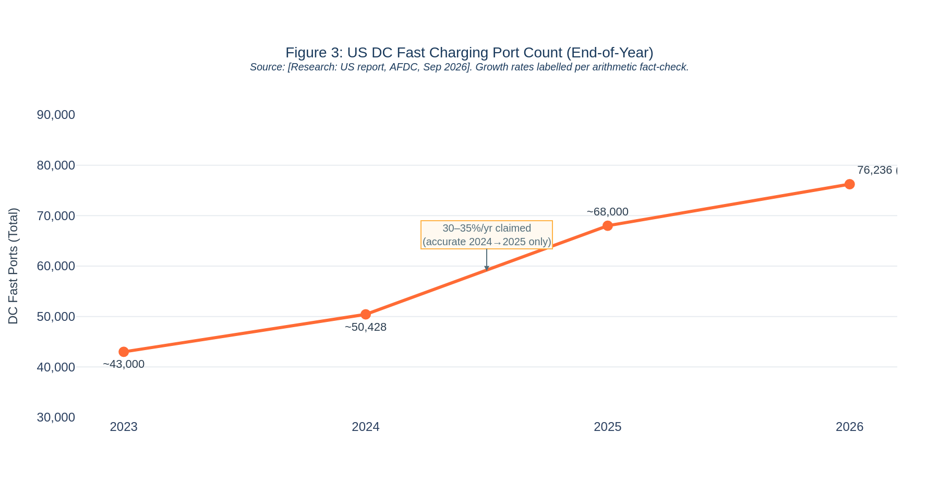
Figure 4: US DC Fast Charging Port Count Growth 2023–2026 (End-of-Year). The 30–35%/yr claim applies only to the 2024→2025 period; growth is decelerating in 2026. Source: [Research: US report, AFDC, Sep 2026].

Claim C — Germany: ~119 EVs per Fast Charger (2023) → ~71 (mid-2025)
Verdict: Arithmetically plausible, but with a definitional caveat.
Data Point | Figures Used | Arithmetic & Assessment
2023 ratio | ~2.5M EVs (BEV+PHEV) ÷ ~21,000 fast chargers (>22 kW) [Dataset, 2023] | 2,500,000 ÷ 21,000 = 119 EVs/charger ✓ Confirmed
Mid-2025 ratio | ~2.85M EVs (est.) ÷ 40,777 DC fast pts (Bundesnetzagentur, Jul 2025) [Research: DE/FR report] | 2,850,000 ÷ 40,777 = ~70 — consistent with report’s ~71 ✓
Definitional caveat | IEA >22 kW vs Bundesnetzagentur DC fast | The 2023 denominator uses IEA’s >22 kW definition. The mid-2025 denominator uses Bundesnetzagentur’s DC fast count. The report does not confirm these are identical thresholds. If they match, the arithmetic holds. The report flags this issue for France but NOT for Germany.

B.4 Overall Confidence Level
OVERALL CONFIDENCE: MEDIUM
Directional conclusions are well-supported by official statistics (IEA, SMMT, AFDC, Bundesnetzagentur, ACEA), but three material weaknesses — (1) inconsistent charger definitions across markets, (2) the UK report’s factually incorrect “doubled” claim, and (3) the US report’s internal inconsistency between its “30–35% growth” headline and its own decelerating data — mean that a decision-maker should treat specific figures with caution and request definitional alignment before using them in a business case.

Remaining Limitations
- No utilisation or revenue-per-charger data for Germany, France, or the US DC fast segment — the single most important metric for an operator’s investment case is largely absent.
- No independent verification of operator market-share figures beyond AFDC (US) and industry trackers (EU) — these are self-reported.
- IEA 2025+ projections are scenarios, not forecasts, and actual deployment is already diverging materially (US: 32% below IEA STEPS target).
- The analysis does not cover commercial vehicle charging, which could compete for grid capacity and site locations.
- All three research reports were produced in 2025–2026; the dataset baseline is 2023 — a 2–3 year gap that the reports bridge with external evidence of varying quality.

B.5 Corrections Log — Applied During Review
The following five corrections were identified and applied by the reviewer to the Market Analysis before the Leadership Brief was finalised. All corrected versions appear in this document.
# | Item | Original Text | Correction Applied
1 | UK 2023 EV sales share | Cited as 22.3% [Dataset, 2023]; compared with BEV-only 19.6% (2024), implying a demand dip. | Corrected to 24% [Dataset, 2023] (BEV+PHEV, all plug-ins). Removed dip claim: the 24% (BEV+PHEV) and 19.6% (BEV-only) cover different powertrains and are not directly comparable.
2 | UK underserved regions | Listed as Northern Ireland, Scotland, and Wales without per-100K figures. | Corrected to: Northern Ireland (19.3 rapid/100K), London (27.9), Yorkshire & the Humber (36.6), North East (37.1) vs UK avg 41.7 [Research: UK report, DfT Jul 2026]. Scotland removed (59.1 = best-served); Wales removed.
3 | UK utilisation scope | ~8% utilisation cited alongside US ~16% as if directly comparable DC fast figures. | Clarified: ~8% (~2 hrs/day) is the Zapmap average for ALL UK public chargers, not rapid-only. Explicitly labelled as not directly comparable with the US ~16% DC fast figure.
4 | UK government funding & Gridserve MSA change | "Over £1B government funding." Gridserve described as MSA exclusivity expiring Nov 2026. | Itemised: LEVI £381M (mostly slow on-street) + £400M Spending Review 2025 (strategic road network) + Ofgem £300M Green Recovery Scheme (37 MSAs). Gridserve: 2022 CMA undertaking not to enforce exclusive MSA rights after Nov 2026, covering ~two-thirds of MSAs.
5 | France ADVENIR end date | ADVENIR mentioned without end date. | Added: ADVENIR programme now runs to 2030 per Avere-France [Research: DE/FR report, Avere-France].
Table 5: Corrections Log. All five corrections applied in full to this document and to the Leadership Brief v2.

Scope reminder: This document covers public DC fast charging for passenger cars only. It does not constitute investment advice. No payback, NPV, or IRR figures are presented. Sources are labelled [Dataset, year] or [Research: report, date] throughout. Cross-market comparisons involving charger ratios should be treated as directionally indicative only due to definitional differences across national sources.

