 

# project report template

## implementing crm for result tracking of a candidate with internal marks

##### 1.1 OVERVIEW

Administrator should be able to create all base data including semester,candidate course and lecturer details ,dean who is the one of the lecturer should be the only one with ability to update internal results ,re-evaluation can be initialized by candidate for all internal results.now only dean update the marks after re-evaluation

##### 1.1 purpose

Saving time of the candidate who wants tracking internal marks by using implementing crm application for result of internal marks .reduce the paper filling as much as the customer expecting,enduring the safety of the candidate and parts of many verification

##### 2.problem definition and design thinking

**Reduce the paper costing and fulfill the the customer expectation. Ensuring the safety of the the customers and parties of many verification.**

**2.1 EMPATHY MAP**

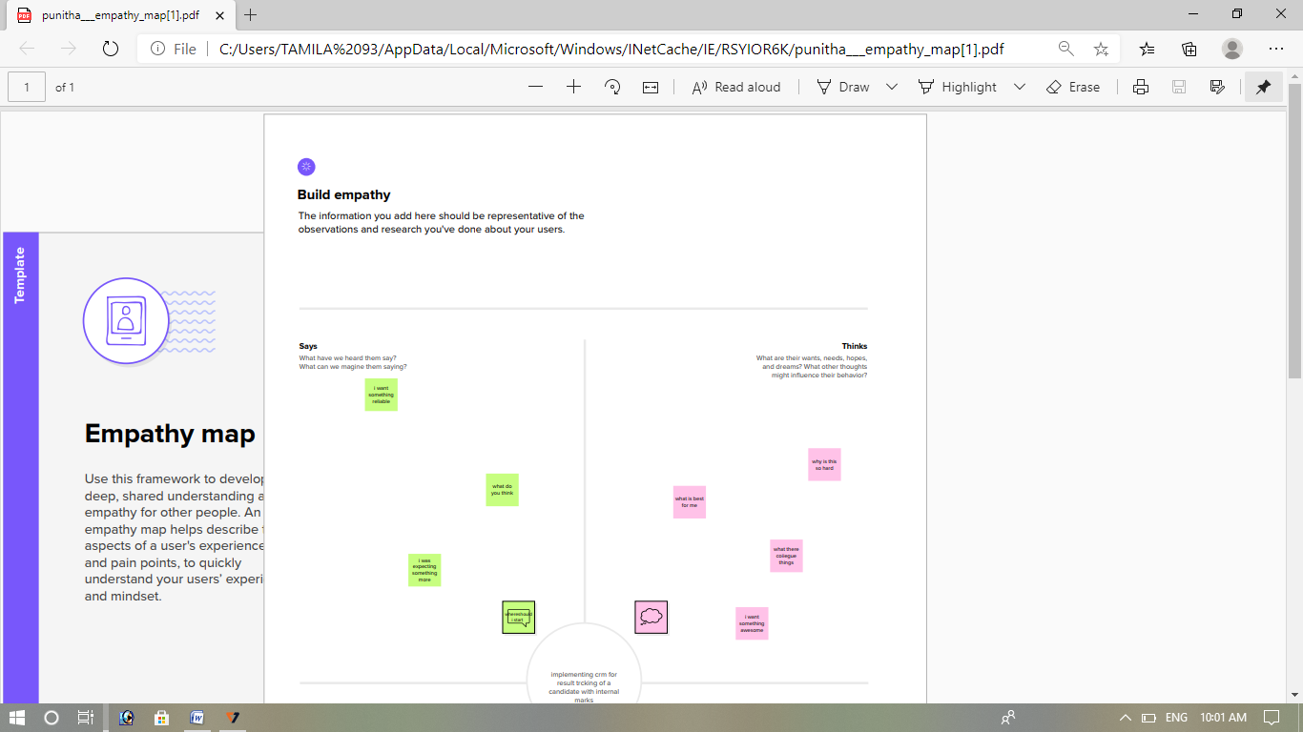

**2.2 IDEATION& BRAINSTORMING**

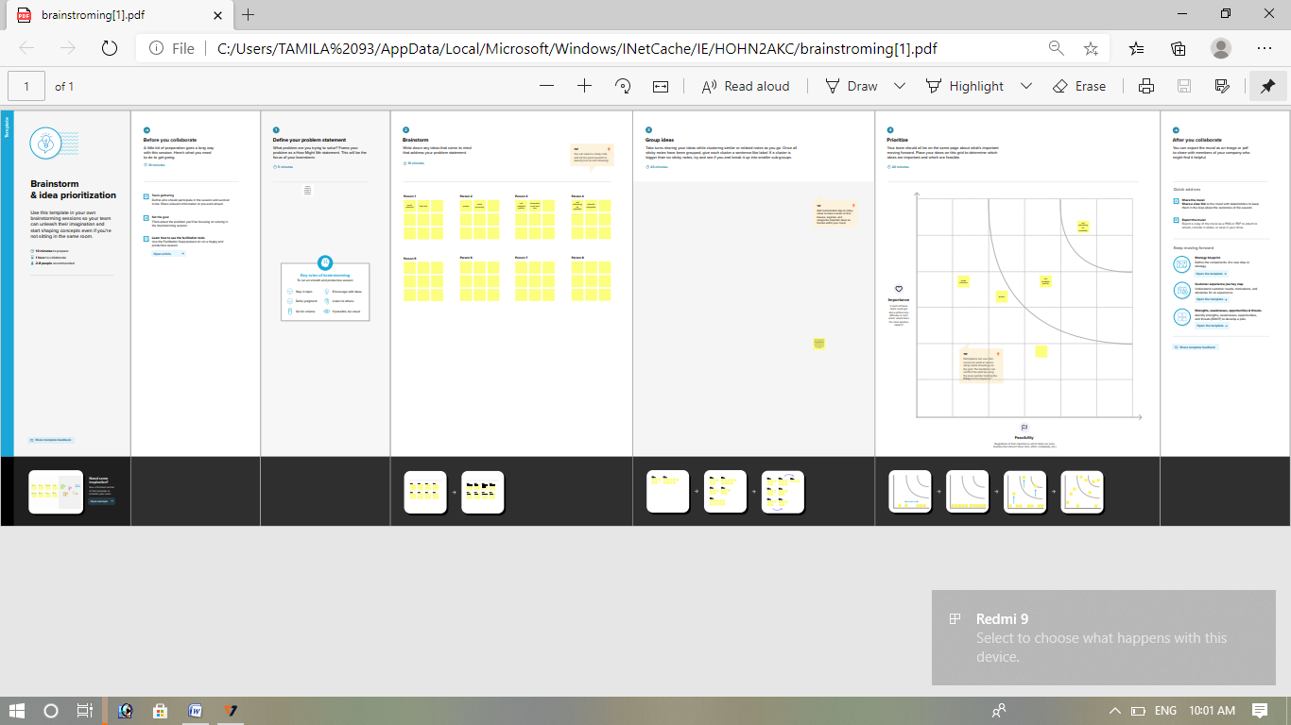

##### RESULT

3.1 DATA MODEL

|  |
| --- |
|  |

|  |  |  |  |  |  |  |  |  |  |  |  |  |  |  |  |  |  |  |  |  |  |  |  |  |  |  |  |  |  |  |  |  |  |  |  |  |  |  |  |  |  |  |  |  |  |  |  |  |  |  |
| --- | --- | --- | --- | --- | --- | --- | --- | --- | --- | --- | --- | --- | --- | --- | --- | --- | --- | --- | --- | --- | --- | --- | --- | --- | --- | --- | --- | --- | --- | --- | --- | --- | --- | --- | --- | --- | --- | --- | --- | --- | --- | --- | --- | --- | --- | --- | --- | --- | --- | --- |
| |  |  | | --- | --- | | OBJECT NAME | FIELDS IN THE OBJECT |  |  |  |  |  |  |  |  |  | | --- | --- | --- | --- | --- | --- | --- | --- | | SEMESTER | |  |  | | --- | --- | | FIELD LABEL | DATA TYPE | | SEMESTER NAME | TEXT | | COURSE | LOOK UP | | | CANDIDATE | |  |  | | --- | --- | | FIELD LABEL | DATA TYPE | | CANDIDATE NAME | TEXT | | CANDIDATE ID | TEXT | | SEMESTER NAME | TEXT | | INTERNAL RESULTS | LOOK UP | | | COURSE DETAILS | |  |  | | --- | --- | | FIELD LABEL | DATA TYPE | | COURSE NAME | TEXT | | | LECTURER DETAILS | |  |  | | --- | --- | | FIELD LABEL | DATA TYPE | | LECTURER ROLE | TEXT | | LECTURER NAME | TEXT | | COURSE ID | TEXT | | COURSE | LOOKUP | | | INTERNAL RESUILTS | |  |  | | --- | --- | | FIELD LABEL | DATA TYPE | | CANDIDATE ROLE | TEXT | | COURSE ID | TEXT | | MARKS | TEXT | | |

##### ACTIVITY&SCREENSHOT

##### 1.CREATION OF SALESFORCE PLATFORM

##### GO to developer,salesforce.com and click on sign up.Enter your username and password that you just created.After log in this page which you will see. C:\Users\TAMILA 93\AppData\Local\Microsoft\Windows\INetCache\Content.Word\IMG-20230422-WA0082(1).jpg2.creation of the custom object:semester

Creation of objects for candidate internal result card.for this candidate internal result card .we need to create 5 objects i.e semester,candidate,course details, lecturer details , internal results.the below steps will assist you in creating those objects.

Click on the gear icon and then select set up .click on objectmanager tab just beside the the home tab . after all steps ,have a look on the extreme right you will find a creare dropdowm and click custom object

You will navigate to the custom object definition edit where you to give the object name.

The label name semester and plural names semesters and data type is text then click allow search,allow reports then click next.

Then click on next you navigate to new custom object tab where you select tab style and click on next.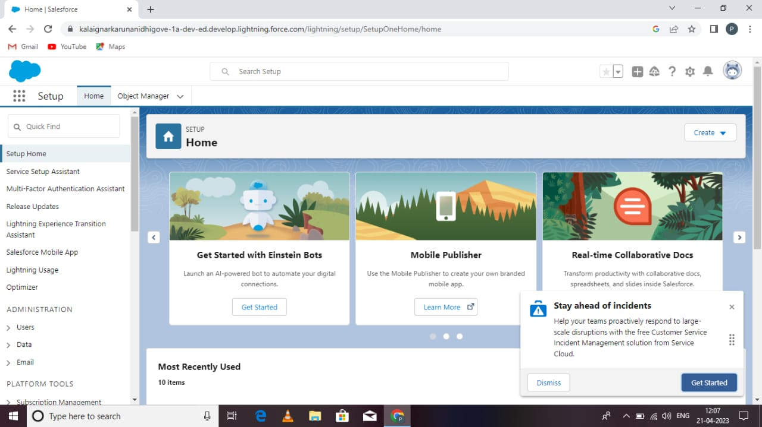

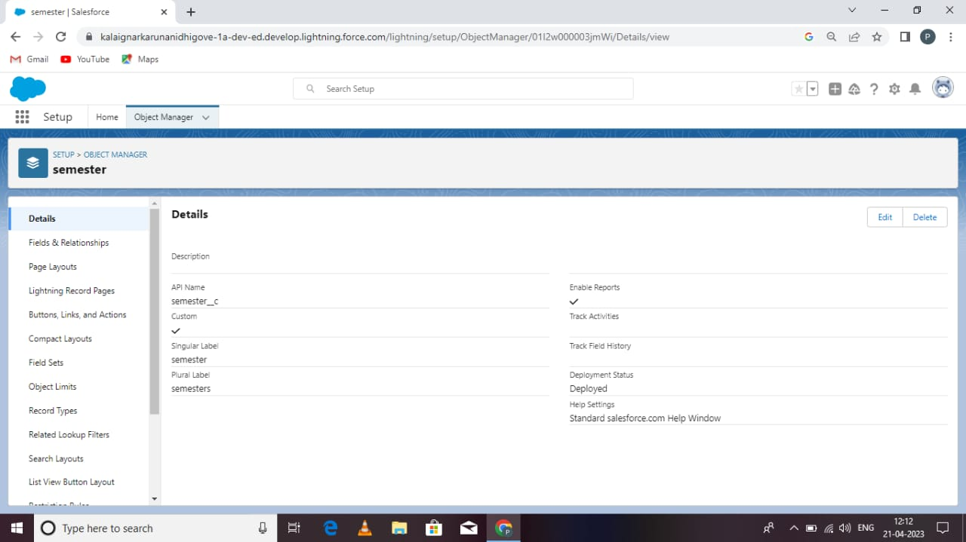

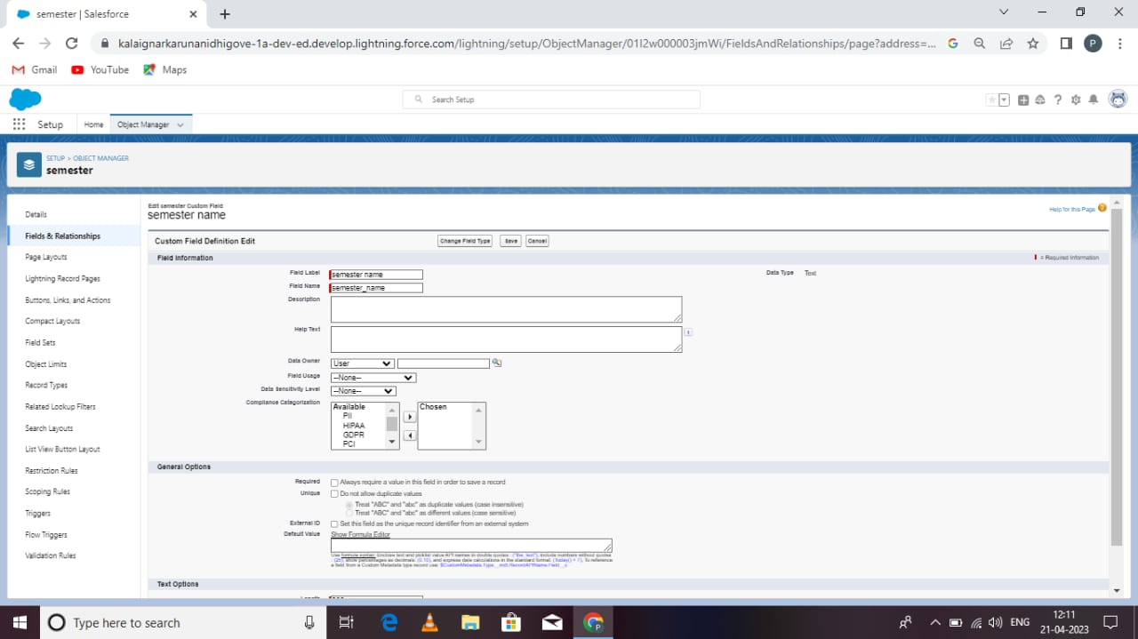

##### custom object :candidate

Navigate to set up and select the object manager at the tob of the right corner there you find the create custom object .

You will navigate to custom object definition edit where you can give the object name .

Lable name is candidate and plural name is candidates and enter the data type as text.

Select allow search,allow report then click next . then you can go to the new custom object tab and click on next.

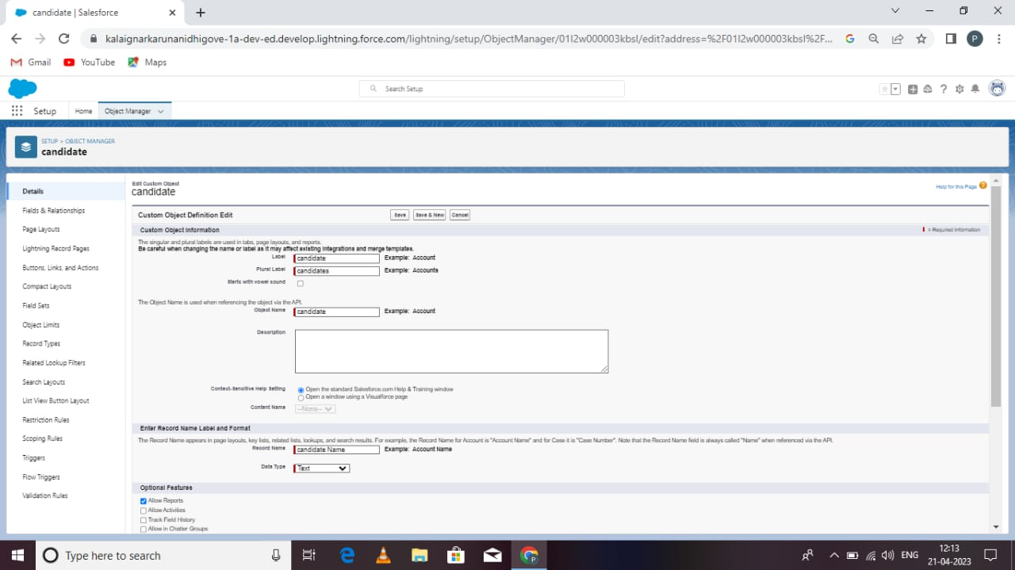

##### custom object: course details

Navigate to the set up and select object manager. At the top of the right corner you can find the create custom object. You will navigate to the custom object definition edit.

where you have to given the object name.

The label name has course and plural label is course.and data type is texts then allow reports,allow search and click next.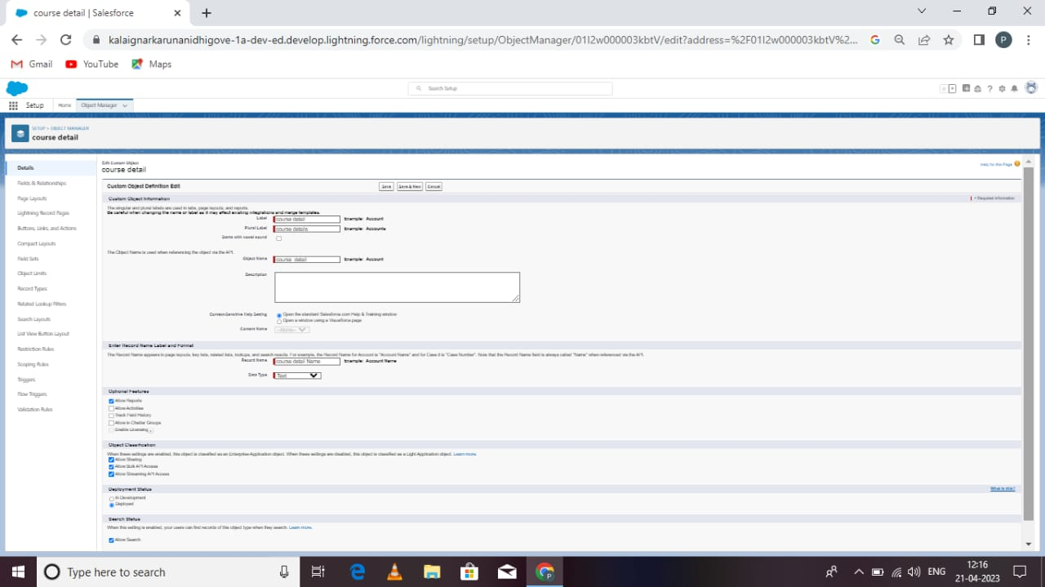

##### custom object :lecturer details

Navigate to the setup and select the object manager .at the top of the right corner side there you can find the new custom object.

You will navigate to the custom object definition edit where you can give the name.

The label name is lecturer details and the label plural name is lecturer details and enter the data type is text.

Then click on the next you will navigate to new custom object tab where you have to select tab style and click on next.

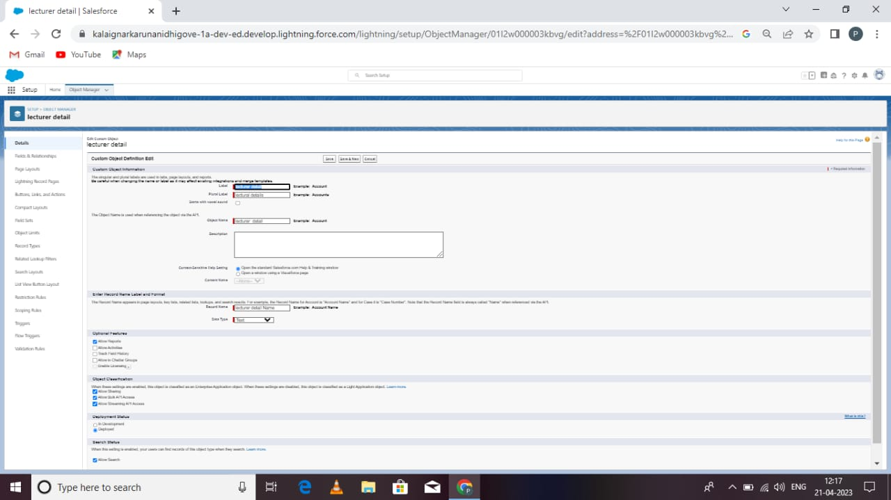

##### custom object:internal results

Navigate to setup an select object manager.at the top of the right side there you can find create custom object.you will navigate to custom object definition edit where you have to given the object name.the label name has internal results an data type has text.

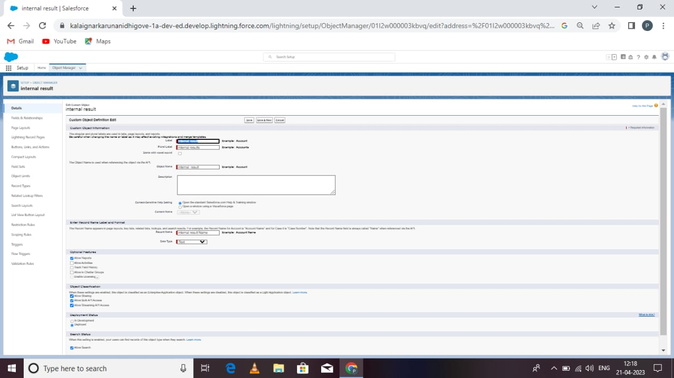

##### custom tabs:

Now create new custom tab.under custom object tabs. Click new .for object ,select semester.for tab click any icon. Leave all as defauld as is click next,next,and save.

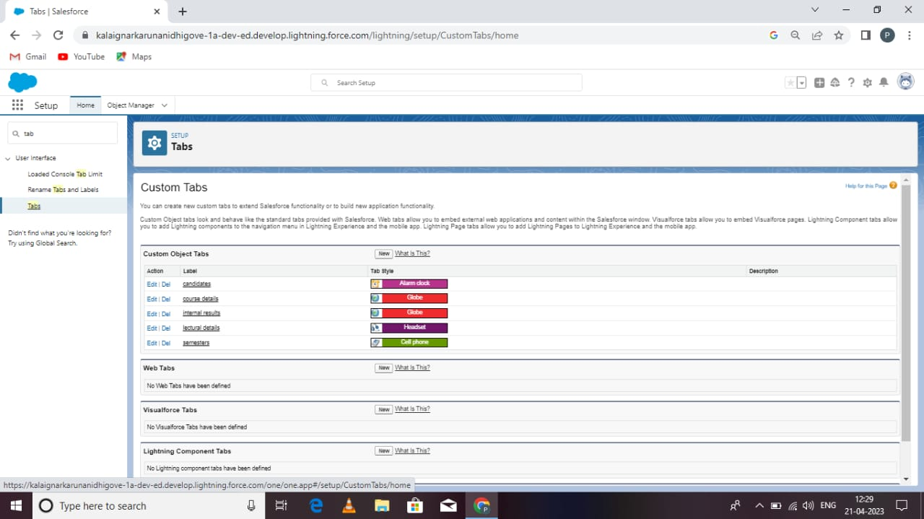

##### field&relationship:semester

Click gear icon and select set up .this launches set up in a new tab.

Click the object manager tab next to home.select semester. Select fields&relationships from the left navigation. An click new.

Now ready to make new cutom field.let’s to this.

Select text as a data typethen click next.for the field label,enter semester name.click next,next,then save.

##### custom field:candidate

##### C:\Users\TAMILA 93\Pictures\Screenshots\punitha\IMG-20230422-WA0077(1).jpg

##### custom field:course datails

##### C:\Users\TAMILA 93\Pictures\Screenshots\punitha\IMG-20230422-WA0141.jpg

##### custom field:internal results

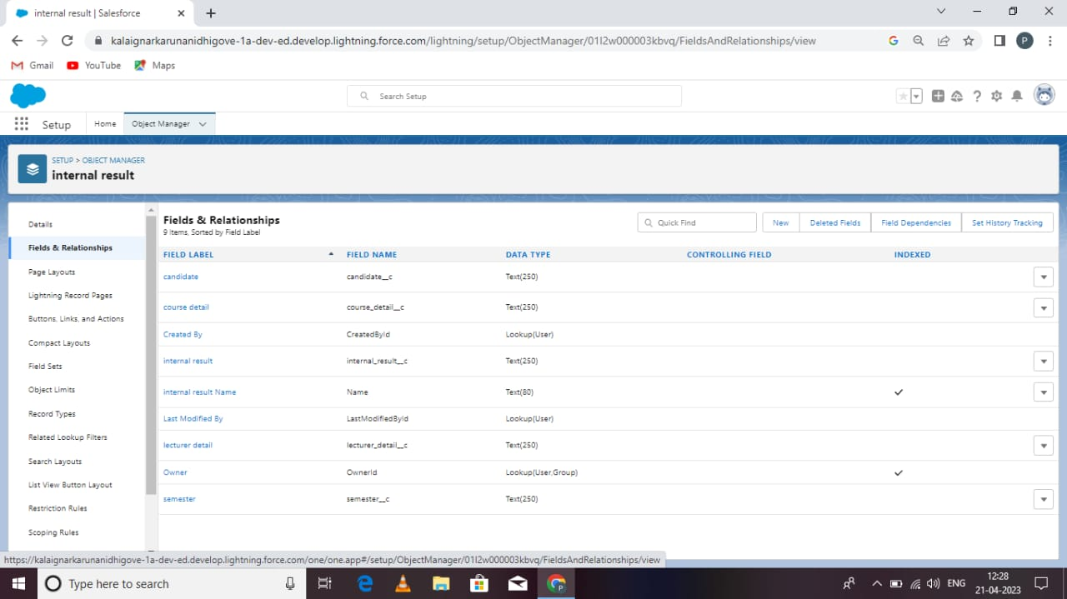

##### lightning app

Apps in the salesforce are a group that helps tha application functionby working together as a unit.it has a name ,a logo,an a particular set of the tabs. The simplest apps usally just had two tabs.

From setup,enter app manager in the quick find and select app manager.click new lightning app.enter candidate internal reslt card as app name .

Under the app options,leave the default selections and click next.unter utility items,leave as is and click next.fro available items ,select semester,candidate,course details,lecturer details ,internal marks and move them to selected items . click next.

From available profiles select system administrator and move it to selecte items.click save &finish. 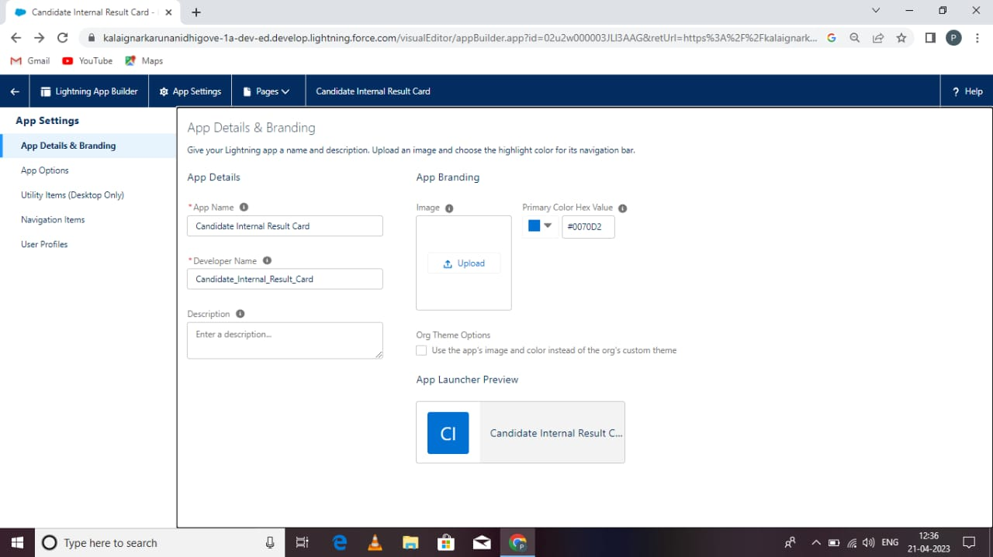

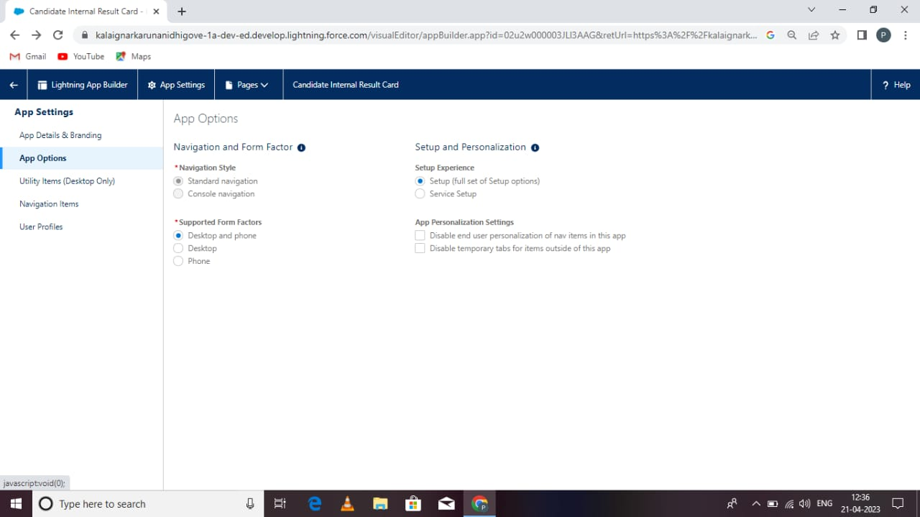

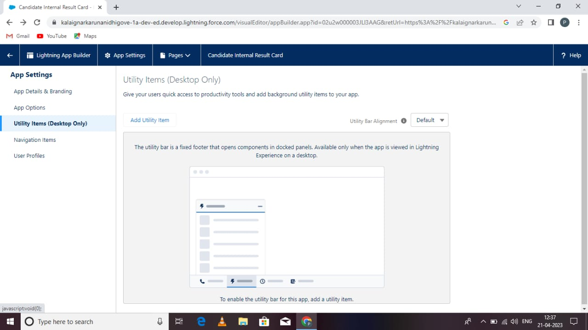

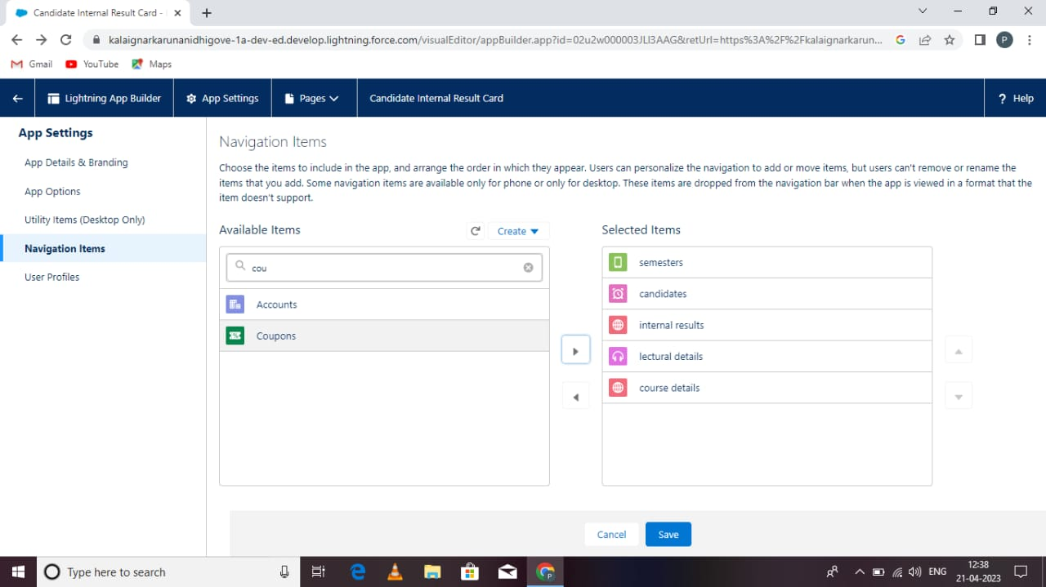

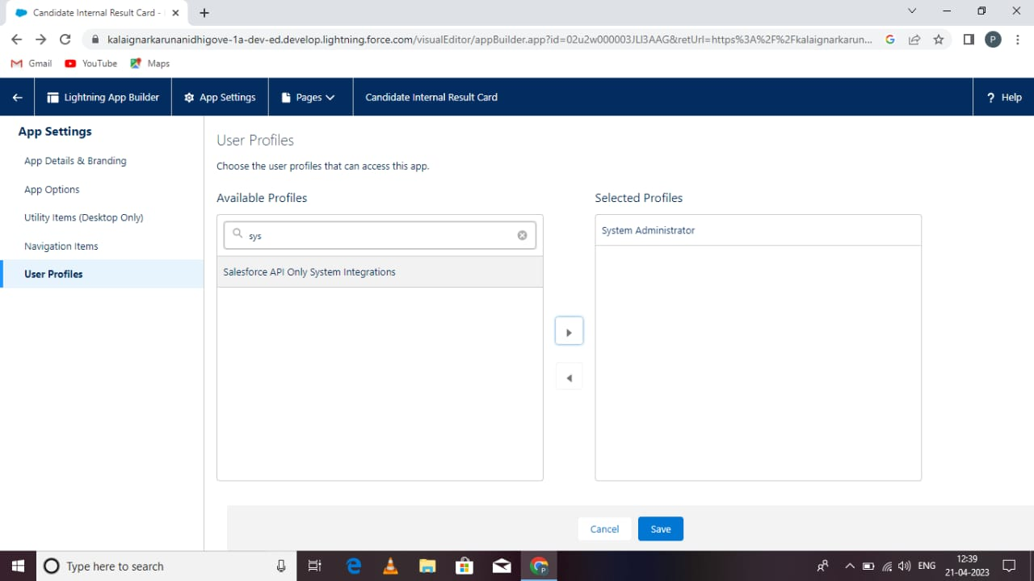

##### users:

A user is anyone who login to salesforce .users are the employee of he company sch as sales ref,managers,and IT specialist, who need access to the sompany records. Every users in salesforce has a user account.

From the set up in the quick find box,enter users,click new users.

Enter username and your email id,and unique username in the form of an email address.select role none.select user licence as salesforce.select profile as salesforce user.

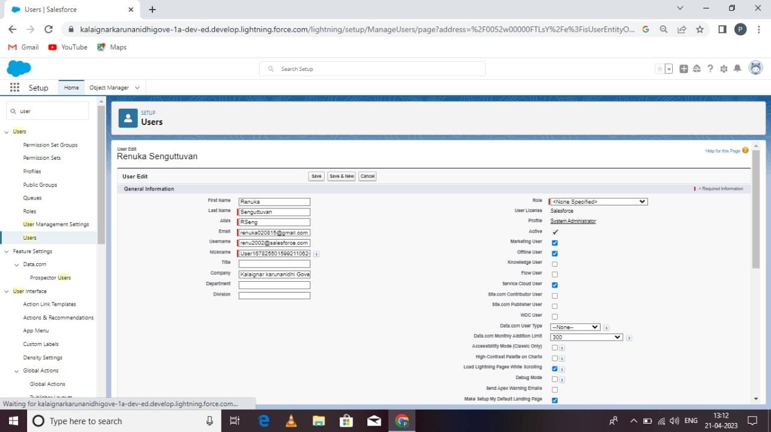

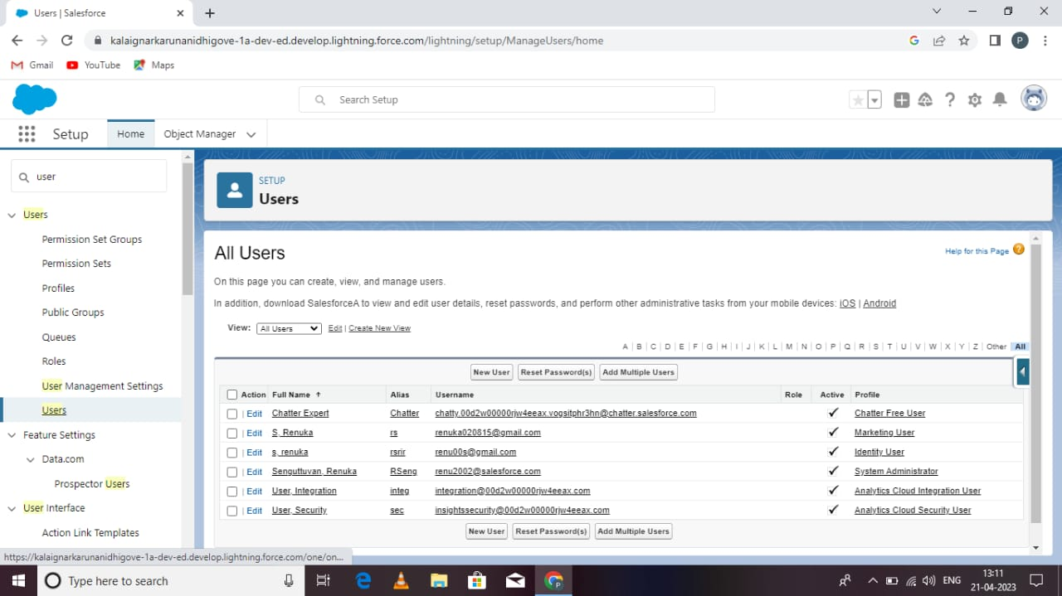

##### reports

From reports tab, click new reports.select report type as candidate with candidates marks.and click next.

Customarise your report save or run it.

##### C:\Users\TAMILA 93\Pictures\punitha\IMG-20230422-WA0098.jpg

##### dashboards

From the reports click new dashboard. Click new dashboard. Name your dashboard candidate board. Leave all as defalt click+component.for report, select candidate marks by stags. Click next. For display as,select vertical bar chartand click add.click save an done.

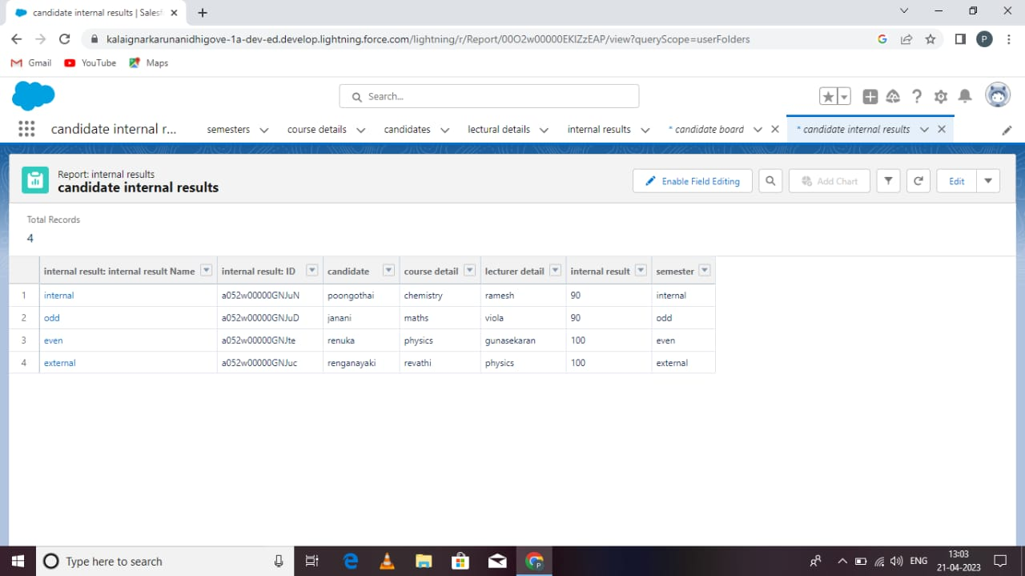

##### trailhead profile public url:

TEAM LEADER:M.Punitha

[https://trailblazer.me/id/plashmi121](https://trailblazer.me/id/plakshmi121)

TEAM MEMBER:2:T.Ragumathunisha

<https://trailblazer.me/id/nrahuman>

TEAM MEMBER.3:Renganayaki

<https://trailblazer.me/id/rsrirengavattan>

TEAM MEMBER:S.Renuka

<https://trailblazer.me/id/renus43>

##### 5.advantages

IT facilitates things by giving you an the customer,ease of the communication.organised data and improved customer service. Processing fast.saving time. Not much paper work.

##### disadvantages

High cost

Too little time

Bad data quality

Lack of communication

Limited communication

Internet connection are problem

##### applications

Tracking your candidate is more important so you can learned your candidate or services more effectively to them. Candidate internal mark tracking is tactic to allows the business owner to know about their candidate are, where they studie who lectured them and so more.

##### conclusion

By using the implementing crm for result tracking, we should tracking and manage the internal marks easily.

It is a beneficial and useful one for the customers .

save the time and easily manage the data and not wasting time for searching files.

##### future scope

The scope of CRM includes a wide range of activities from managing candidate contact information

In future that implementing CRM of tracking more updated and advanced technology