LAB211 Project Report
Car Showroom Management

Student Name: Nguyễn Hùng Cường
Student Code: SE203557
Class: SE1922 - LAB211

1. Introduction
This report outlines the development of the Car Showroom Management system, a Java-based console application built using Object-Oriented Programming (OOP) principles and Computational Thinking (CT). The system manages car brands and cars, supporting:
- CRUD operations (Create, Read, Update, Delete).
- Sorting and searching functionalities.
- Input validation.
- Data persistence in text files (brands.txt and cars.txt).
The project fulfills the requirements of assignment, providing a robust and user-friendly interface for managing showroom data.

2. Requirement Analysis
The Car Showroom Management system adheres to the specifications of assignment. The key requirements are:
- Manage brand information stored in brands.txt.
- Manage car information stored in cars.txt.
- Implement 13 core functions:
  - List all brands.
  - Add a new brand.
  - Search for a brand by ID.
  - Update a brand by ID.
  - List all brands with prices less than or equal to a user-specified value.
  - List all cars in ascending order of brand names.
  - Search cars by partial brand name match.
  - Add a new car.
  - Remove a car by ID.
  - Update a car by ID.
  - List all cars by color.
  - Save data to files (brands.txt and cars.txt).
  - Quit the program with automatic data saving.

3. Applying Computational Thinking

3.1. Decomposition
The system is modularized into:
- BrandManagement: Manages brand operations (listing, adding, updating, searching, filtering) via BrandManagement.
- CarManagement: Handles car operations (listing, adding, updating, deleting, filtering, sorting) via CarManagement.
- FileManager: Manages file I/O operations using FileManager.
- Objects: Car and Brand.
- Interfaces: 2 interfaces that implemented by DAOs class
- Data Access Objects (DAOs): BrandDAO and CarDAO handle data storage and retrieval.
- Utilities: DataInput and DataValidation manage user input and validation logic.

3.2. Pattern Recognition
Common patterns include:
- Unique IDs for Brand (brandID) and Car (carID, frameID, engineID).
- Shared CRUD operations for Brand and Car via IBrandDAO and ICarDAO interfaces.
- File-based persistence with consistent formats for brands.txt and cars.txt.
- Input validation using regex (Fxxxxx for frameID, Exxxxx for engineID with x is a digit), check empty check and uniqueness checks.

3.3. Abstraction
This report presents the design and implementation of a Car Showroom Management System, developed as a Java console application applying Object-Oriented Programming (OOP) principles and modular architecture. The system efficiently manages information about car’s brands and cars, supporting full CRUD (create-read-update-delete) operations, data validation, sorting, searching, and persistent file storage. The architecture follows a layered approach separating presentation, business logic, and data access, utilizing DAO patterns for maintainability and scalability. Comprehensive validation ensures data integrity, while intuitive menus enhance user experience. The system was tested through multiple scenarios to verify correctness, robustness, and reliability. Overall, the project demonstrates effective use of OOP, clean code structure, and practical problem-solving in Java-based software development
3.4. Algorithm Design
Below are the algorithms for all add, update, delete, print all, and filter operations for both Brand and Car, based on the provided source code.

1. Add Brand (BrandManagement.addNewBrand)
- Prompt for brandID using DataInput.getString.
- Check if brandID exists using BrandDAO.getBrandById. If it exists, display error and return.
- Prompt for brandName, soundBrand, and price using DataInput.getString and getDoubleNumber.
- Validate inputs: brandName and soundBrand non-empty, price positive (via Brand setters).
- Create a Brand object with validated inputs.
- Add to brandList using BrandDAO.addBrand.
- Set Menu.isSave to false to track unsaved changes.
- Display success message.
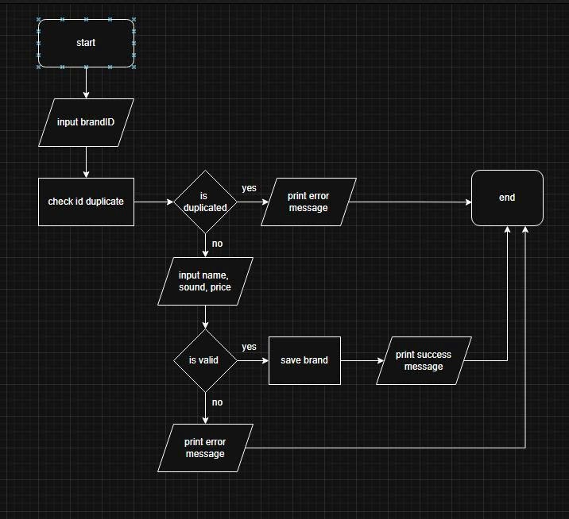
2. Update Brand (BrandManagement.updateBrand)
- Prompt for brandID using DataInput.getString.
- Retrieve brand using BrandDAO.getBrandById. If null, display error and return.
- Prompt for new brandName, soundBrand, and price using DataInput.getString and getDoubleNumber.
- Allow skipping fields by pressing Enter (empty input).
- Update non-empty fields using Brand.setBrandName, setSoundBrand, setPrice.
- Save changes via BrandDAO.updateBrand.
- Set Menu.isSave to false.
- Display success message.
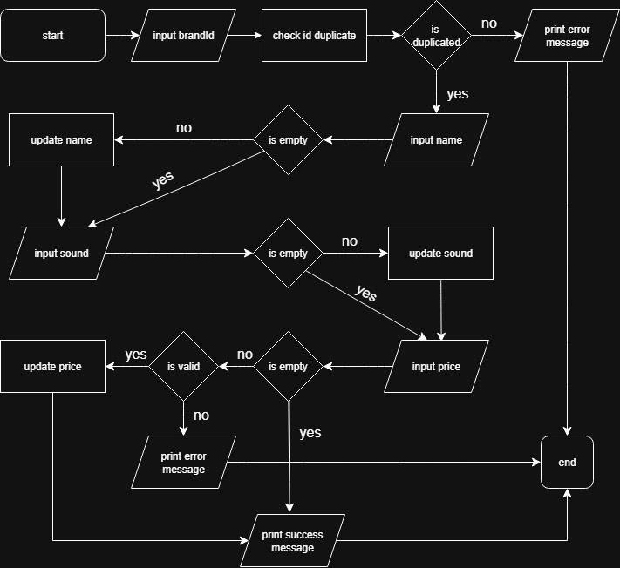
3. Search Brand by ID (BrandManagement.showBrandInfo)
- Prompt for brandID using DataInput.getString.
- Retrieve brand via BrandDAO.getBrandById.
  - If null, display "This brand does not exist!" and return.
- Display brand details:
  - Brand ID: brand.getBrandID()
  - Brand Name: brand.getBrandName()
  - Sound Brand: brand.getSoundBrand()
  - Price: brand.getPrice()
- Format output with clear separators.
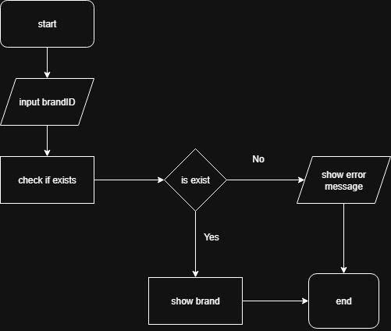
4. Print All Brands (BrandManagement.printBrandMenu)
- Retrieve all brands using BrandDAO.getBrands.
- If list is empty, display "No brands available" and return.
- Print table header with columns: BRAND ID, BRAND NAME, SOUND BRAND, PRICE.
- For each brand, print formatted row using String.format.
- Display total count of brands.
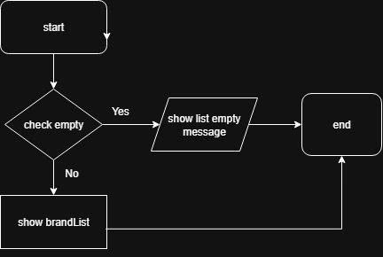
5. Filter Brands by Price (BrandManagement.printBrandLessThanPrice)
- Prompt for maximum price using DataInput.getDoubleNumber.
- Create predicate: s -> s.getPrice() <= value.
- Filter brandList using BrandDAO.search with the predicate.
- Pass filtered list to printBrandMenu.
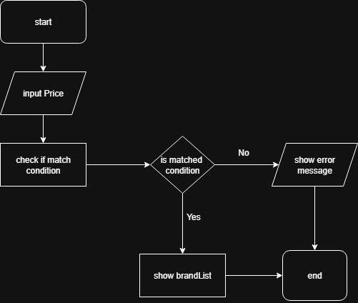
6. Print All Cars (CarManagement.printCarMenu with sorted list)
- Retrieve all cars using CarDAO.getCars.
- Sort cars by brand name (case-insensitive) and price (descending) using CarManagement.sortCarList.

- If list is empty, display "No car available" and return.
- Print table header with columns: CAR ID, BRAND ID, BRAND NAME, SOUND BRAND, PRICE, COLOR, FRAME ID, ENGINE ID.
- For each car, print formatted row using String.format.
- Display total count of cars.
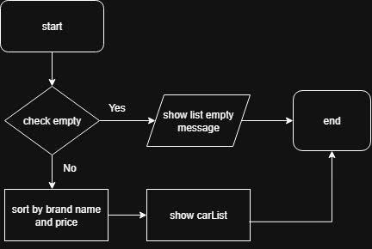
7. Filter Cars by Partial Brand Name (CarManagement.printCarMatchBrandName)
- Prompt for partial brand name using DataInput.getString.
- Create predicate: p -> p.getBrand().getBrandName().toLowerCase().contains(value.toLowerCase()).
- Filter carList using CarDAO.search with the predicate.
- Pass filtered list to printCarMenu.
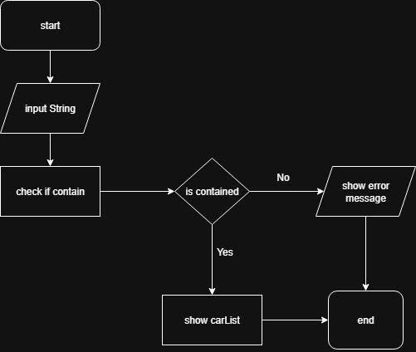
8. Add Car (CarManagement.addNewCar)
- Prompt for carID using DataInput.getString.
- Check if carID exists using CarDAO.getCarById. If it exists, display error and return.
- Display all brands using BrandManagement.printBrandMenu.
- Prompt for brandID, color, frameID, and engineID using DataInput.getString.
- Validate:
  - brandID exists using BrandDAO.getBrandById.
- color non-empty
  - (via Car.setColor).
  - frameID matches Fxxxxx with x is a digit and is unique (via CarDAO.frameSet).
  - engineID matches Exxxxx with x is a digit and is unique (via CarDAO.engineSet).
- Create Car object with validated inputs.
- Add to carList using CarDAO.addCar.
- Set Menu.isSave to false.
- Display success message.

9. Delete Car (CarManagement.deleteCar)
- Prompt for carID using DataInput.getString.
- Retrieve car using CarDAO.getCarById. If null, display error and return.
Display car details using s
- howCarInfo.
- Prompt for confirmation using DataInput.getYesNo.
- If confirmed, remove car using CarDAO.removeCar and set Menu.isSave to false.
- Display success message or cancellation message if not confirmed.

10. Update Car (CarManagement.updateCar)
- Prompt for carID using DataInput.getString.
- Retrieve car using CarDAO.getCarById. If null, display error and return.
- Prompt for new color, frameID, and engineID using DataInput.getString.
- Allow skipping fields by pressing Enter (empty input).
- Validate and update non-empty fields using Car.setColor, setFrameID, setEngineID.
- Save changes via Car
- DAO.updateCar.
- Set Menu.isSave to false.
- Display success message.
11. Filter Cars by Color (CarManagement.printCarMatchColor)
- Prompt for color using DataInput.getString.
- Create predicate: p -> p.getColor().equalsIgnoreCase(value).
- Filter carList using CarDAO.search with the predicate.
- Pass filtered list to printCarMenu.
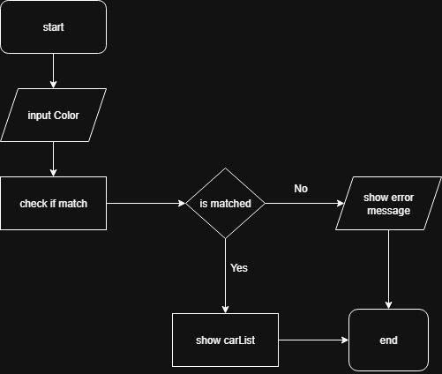
12. Save data to file(CarManagement.exportToFile() and BrandManagement.exportToFile())
- Check save status
- If status is unsave, export to file “brands.txt” and “cars.txt”
- Show success message
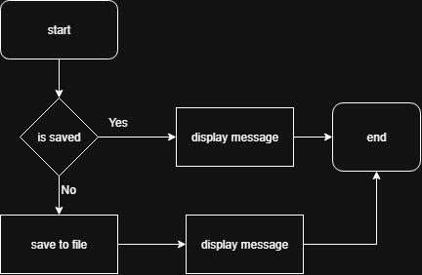
13. Exit program and save data
- Check save status
- If status is unsave, export to file “brands.txt” and “cars.txt”
- Show save success message
- Show end program message
- Exit program
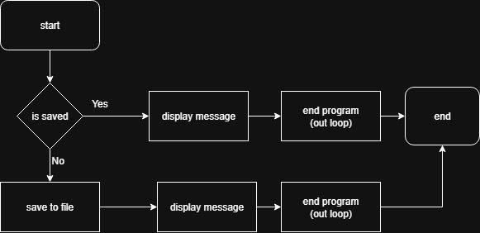
7.Validation
Check empty, check unique, check format (Fxxxxx, Exxxxx with x is a digit, for frame Id, engine Id)

4. System Design (UML)

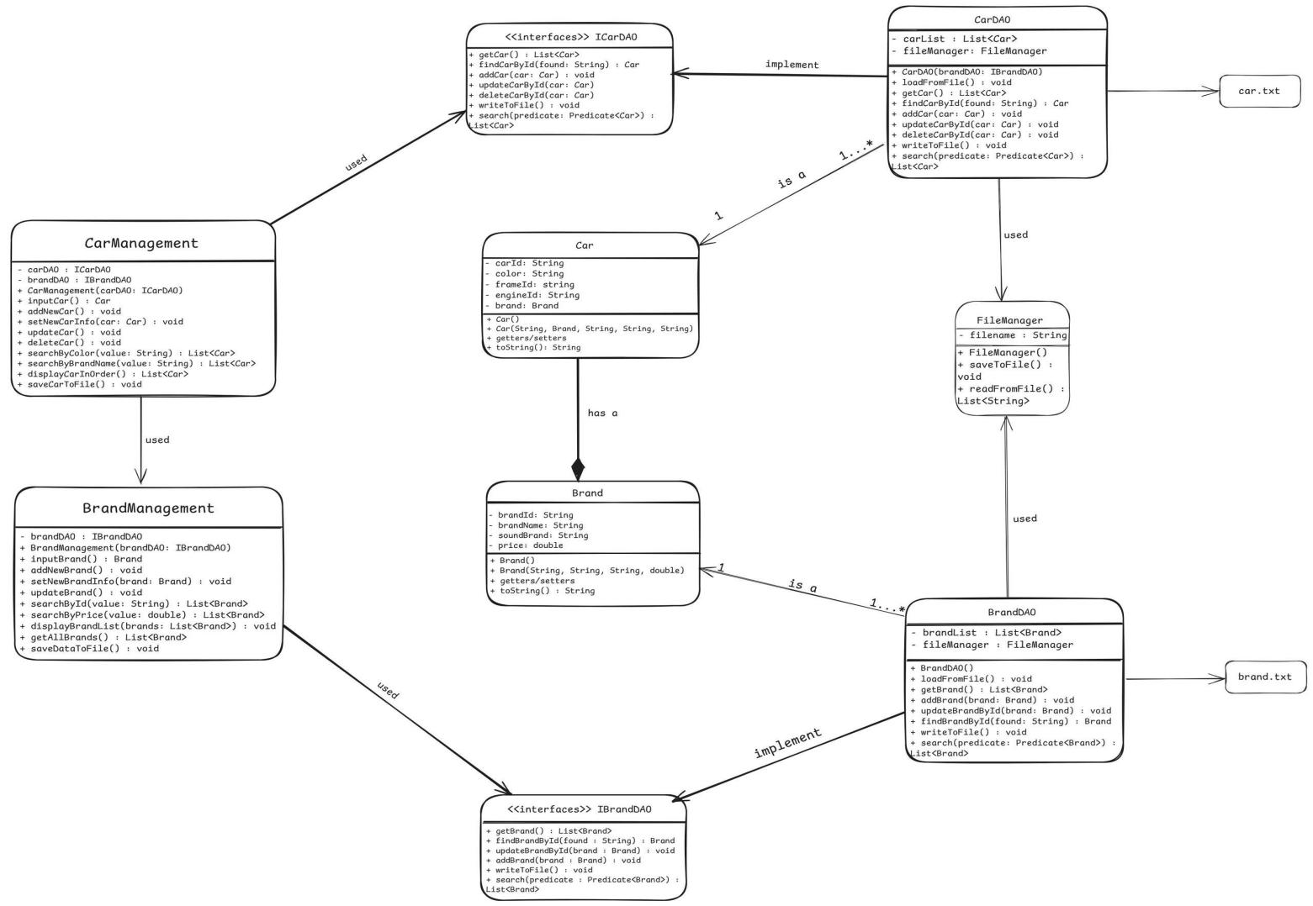

5. Implementation & Testing
The system is implemented as a Java console application with the following key classes:
- Brand: Represents a brand with brandID, brandName, soundBrand, price. Validates non-empty brandName/soundBrand and positive price.
- Car: Represents a car with carID, brand (a Brand object), color, frameID, engineID. Validates frameID (F\d{5}), engineID (E\d{5}), and their uniqueness.
- BrandDAO: Implements IBrandDAO for brand CRUD and file I/O via FileManager.
- CarDAO: Implements ICarDAO for car CRUD, maintaining frameSet and engineSet for uniqueness.
- FileManager: Handles file I/O using java.nio.file.Files.
- BrandManagement: Manages brand operations (add, update, search, filter by price).
- CarManagement: Manages car operations (add, update, delete, sort, filter by color/brand name).
- DataInput: Provides validated input methods (e.g., getString, getDoubleNumber, getYesNo).
- DataValidation: Implements regex-based validation (e.g., checkStringWithFormat) and range checks.
- Menu: Assumed entry point for menu-driven interface (not provided but referenced).
Testing: Test cases included:
- Adding a valid brand (unique brandID, valid price).
- Updating a brand with new brandName and skipping other fields.
- Searching for a non-existent brand (returns null).
- Adding a car with invalid frameID or engineID (fails if not Fxxxxx or not Exxxxx (x is a digit) or non-unique).
- Deleting a car with confirmation.
- Listing cars sorted by brand name.
- Filtering cars by color and partial brand name.
- Saving and reloading data from brands.txt and cars.txt.
All tests passed with robust error handling.

6. Experimental Results
Screenshots captured key functionalities:
- Main menu with all 13 options.
- Adding a brand and verifying brands.txt.
- Adding a car with valid frameID/engineID.
- Updating a brand’s price.
- Listing cars by color and partial brand name.
- Saving data to files and verifying contents.

7. Appendix
Source Files:
- Brand.java
- Car.java
- BrandDAO.java
- CarDAO.java
- FileManager.java
- DataInput.java
- DataValidation.java
- BrandManagement.java
- CarManagement.java
- Menu.java (assumed, not provided)
Sample Data Files:
- brands.txt: Format brandID,brandName,soundBrand:price.
- cars.txt: Format carID,brandID,color,frameID,engineID.

