1. Let be a distorted signal with a base frequency of 3.3 MHz, sampled with 100 MHz and 10 MHZ, the resulting spectrum for both cases is shown next:

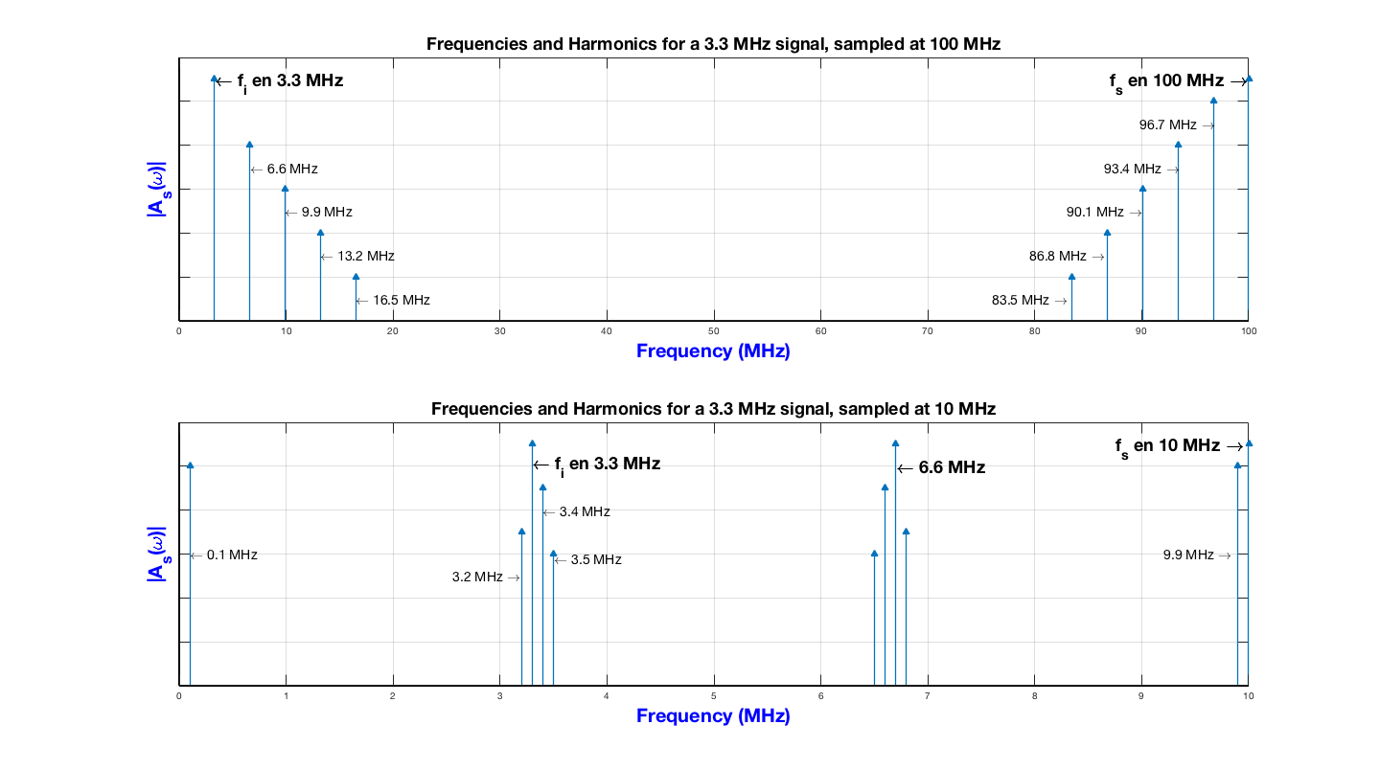

For the first part, where 100 MHz is used, the fourth harmonic rises at 16.5 MHz. Considering this as the BandWidth (BW) required for the signal, once can easily see that a fs of 100 MHz meets the requirements of the Shannon-Nyquist criteria, which is bigger than twice the BW.

On the other hand, the second case uses fs at 10 MHz, which doesn’t meet the Shannon-Nyquist requirement and therefore aliases are introduced at the original band-based spectrum. On my personal case, the calculation of each of the aliases using the analytic procedure of the author Pelgrom [1:9][1] and the graphical method provide the same result, which is the expected one.

1. Let be a signal sampled with 1 MHz. Before sampling, the Vrms value is 10μV and the BW is equal to 10 MHz. According to Class 1 of the current course, the white noise in general is increased on a sampled signal by a factor of 2BWnoise / fs. This leads to the next calculation:
$${whiteNoise}_{\begin{aligned}after \\ sampling\end{aligned}}=\left( {{2BW}_{noise}}/{f_{s}}\right){× whiteNoise}_{\begin{aligned}before \\ sampling\end{aligned}}$$

$${whiteNoise}_{\begin{aligned}after \\ sampling\end{aligned}}=\left({2×10 MHz}/{1MHz}\right)×10μV$$

$${whiteNoise}_{\begin{aligned}after \\ sampling\end{aligned}}=200μV$$

2. As on part 1) the signal of 10 kHz has a BW of around 50 kHz (on the fourth harmonic), and the fs is 44 kHz which causes aliases to appear. The respective graphic, first showing the harmonics and then the aliases is shown next:

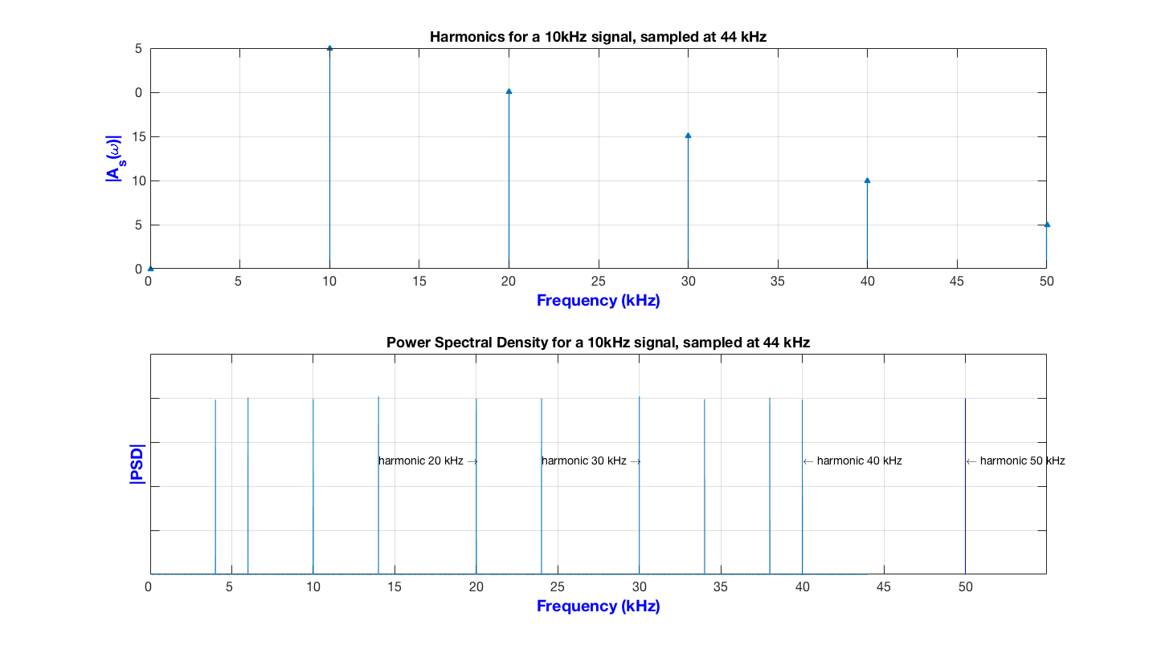

1. The implemented block diagram for this section was the next one: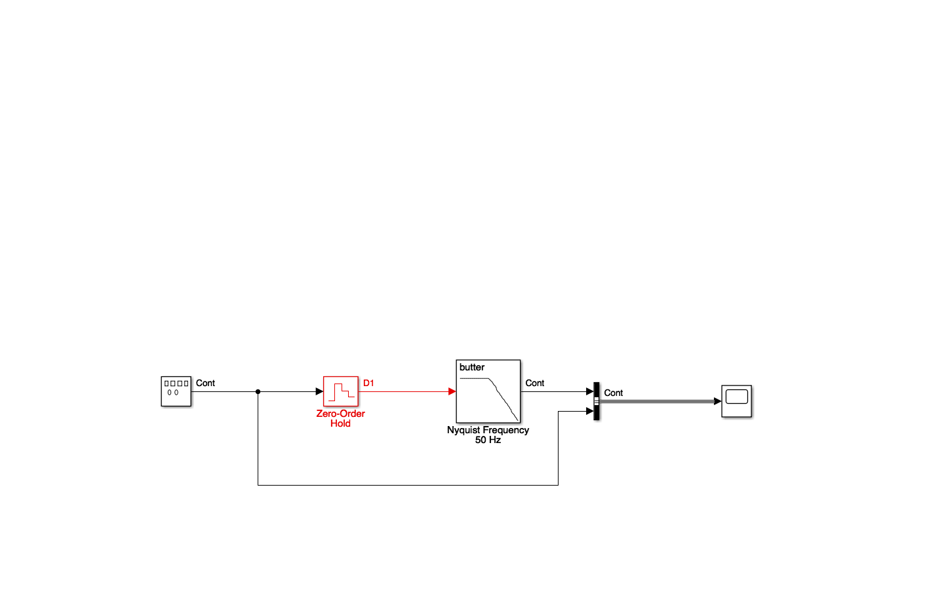

It consists of a Sine signal generator that changes it frequency, a ZOH sampling at 100 Hz, a Butterworth order 8 filter with a Frequency of Nyquist set at 50 Hz and a scope that observes the input and output of the system. The simulation was split in three sections: use a very low generator frequency, use a similar or equal frequency than Nyquist and another one using a 1.3x the Nyquist frequency on the generation. The results and their analysis:

* 15 Hz on the Sine Generator

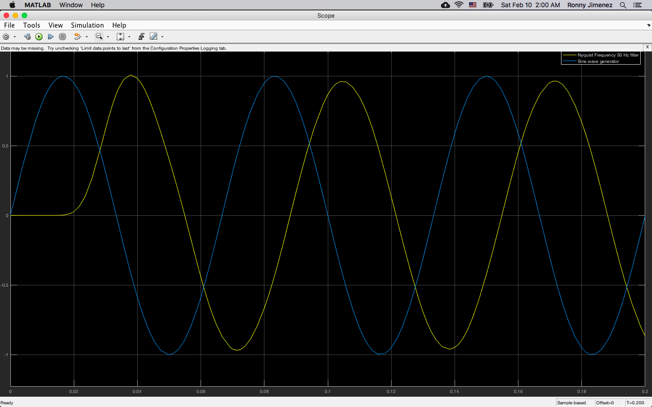

As the Nyquist frequency is 50 Hz and the input frequency is 15 Hz, the Shannon-Nyquist criteria is accomplished. This allows the signal to be reconstructed exactly as the origin. The only aspect to note is the phase translation.

* 45 Hz on the Sine Generator:

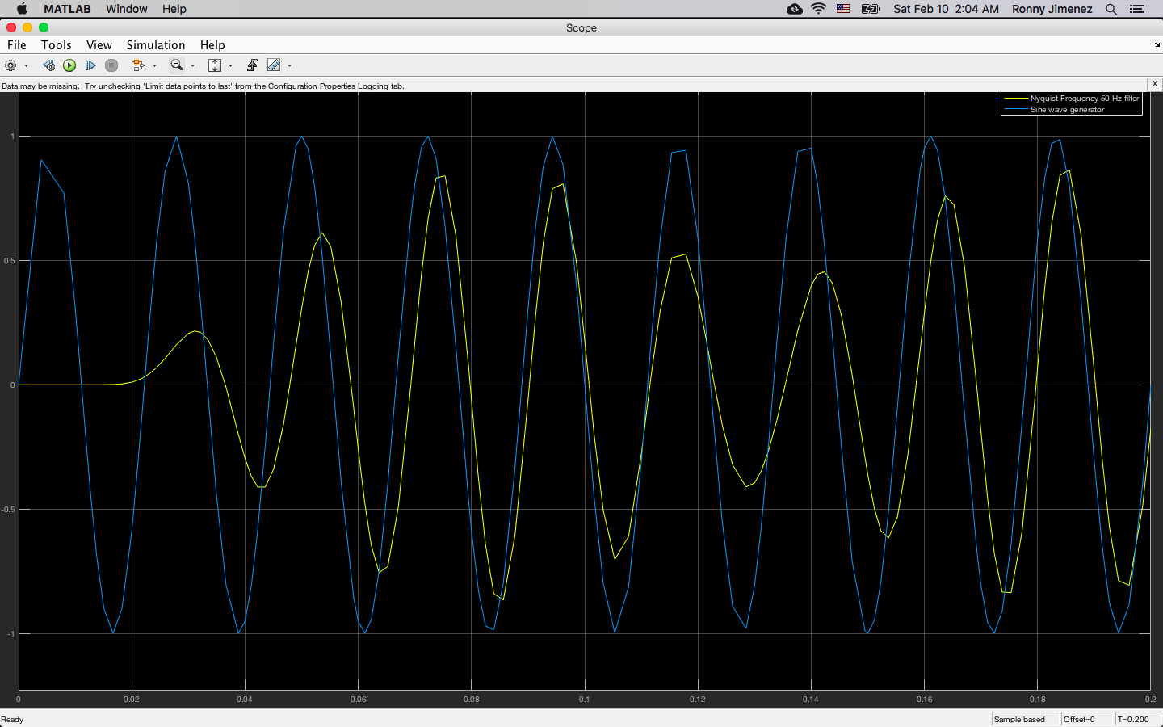

The frequency on this case is too close to the Nyquist frequency. This way it is not guaranteed the signal is reconstructed faithfully, in fact, the image shows how information is lost in amplitude, where it is poor compared to the original signal and the fidelity of the reconstruction is compromised. The frequency is not that bad, although some phase translations would make the extraction of the information complicated.

* 65 Hz on the Sine generator

On this case, we not only face changes on the amplitude of the output, but also the frequency of the reconstructed signal varies. Here, the reconstruction would be basically impossible in terms of fidelity of the input signal. The output can be interpreted completely as another signal with null or incredible poor fidelity regarding the input. (Image shown on the next page)

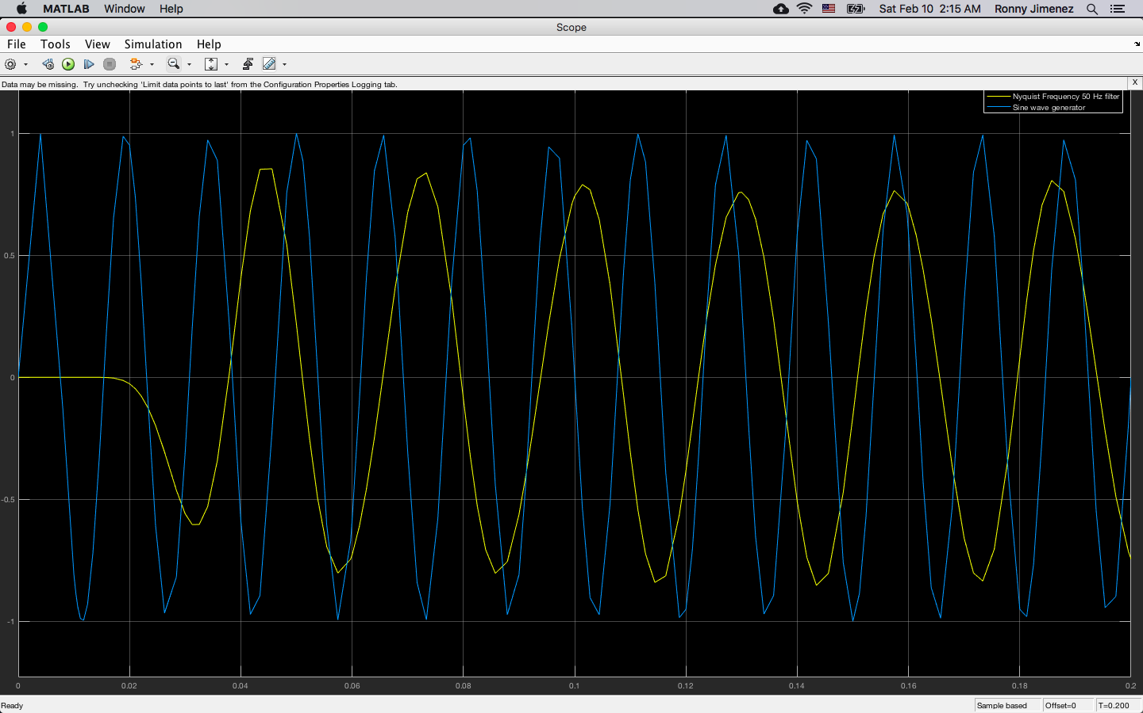

1. Pelgrom, Marcel. **Analog to Digital Conversion**, page 9, *nfs x ifin* equation