On this experiment, the PSoC was used on the project CE95277 with some modifications to perform 2000 samples and the proper capture of those on the PC using PuTTY, a general purpose serial console installed for this type of work. A specific signal from a csv file is loaded onto the schematic, as shown on the next image:

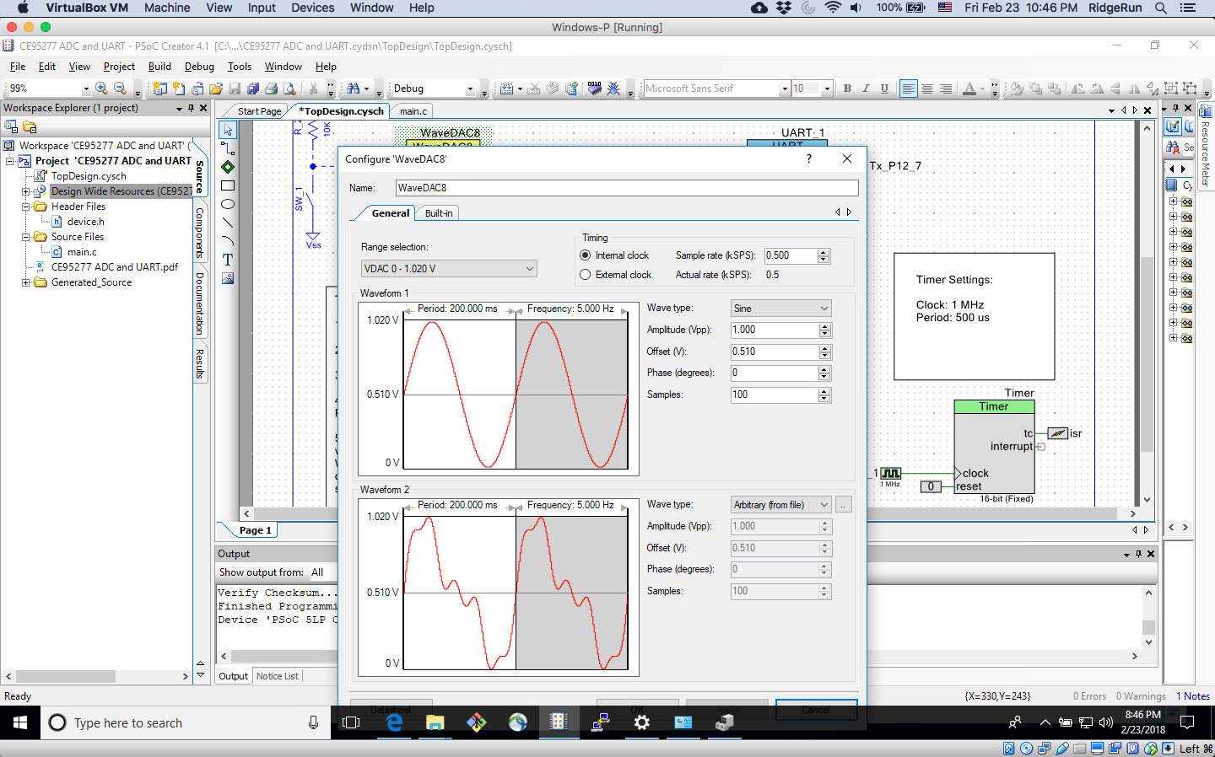

**Figure 1.** Waveform2 to be injected on the WaveDAC

With the signal shown on the Waveform 2, I proceed to modify the main.c file to capture the 2000 samples. The modification was small and it consisted of creating a counter, initialized in 0, and increment this variable on 1 everytime a new DAC value is ready to be read.

The image that shows this small modifications is the following:

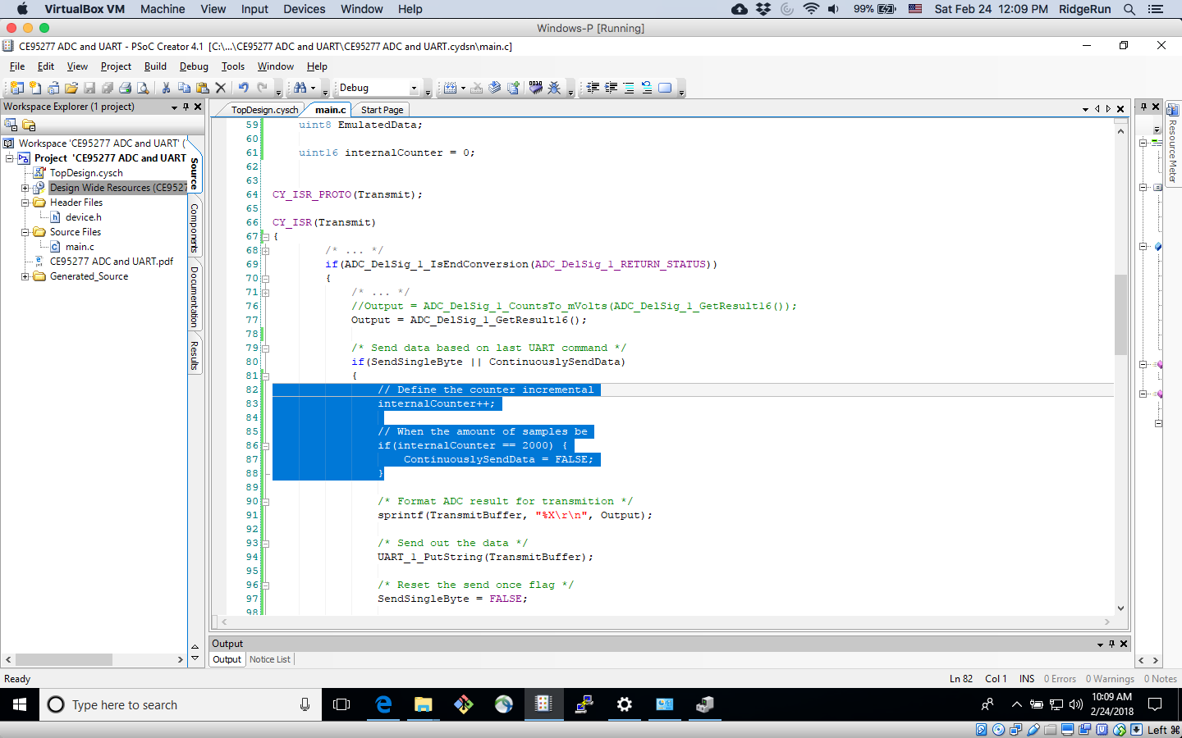

**Figure 2.** Waveform2 to be injected on the WaveDAC

With the above **Figure 2**, the PSoC is programmed. On the runtime, the PuTTY terminal is launched and the key S or s is pressed. When this happens, the PSoC sends out to the PC, the values gotten on each iteration after the process. With those, I imported them on MatLab and created a plot. In theory, the output should be the very similar (exactly the same on a perfect world) to the input. This can be seen on the **Figure 3**, where the output of 2000 samples is plotted against time.

Afterwards, the Power Spectral Density, using the Fast Fourier Transform is performed to obtain the graphic shown on **Figure 4**.

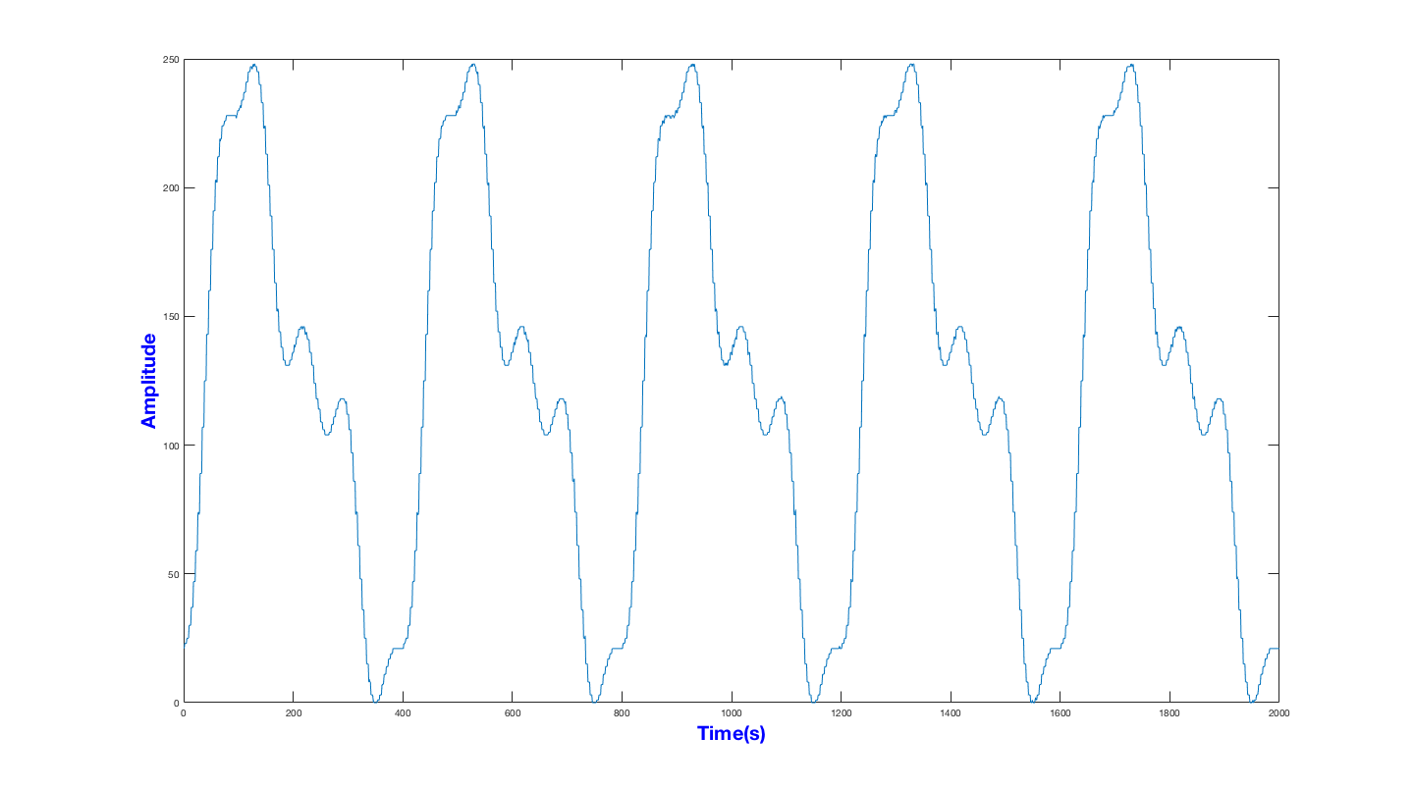

**Figure 3.** Output of the system

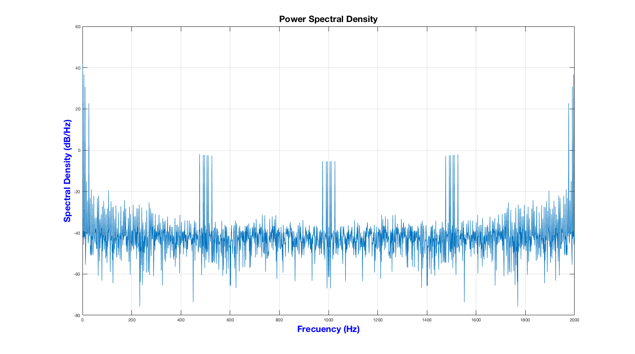

**Figure 4.** Power Spectral Density of the output signal on Figure 3