On this practice, the PSoC was used to filter a signal using a Butterworth 8th-order filter. This was set to have a cut-off frequency of 20 Hz. Another FIR Blanckman filter was used for comparison purposes.

Besides, a Frequency Divider (Clock Divider) was put on the schematic and used on the code in order to provide a range of frequencies to be test. In a case where this frequency divider would not exist, then the user would have to manually change the values of the WaveDAC manually, which could result in a time consuming tasks and not efficient at all.

The set up of the Schematic is shown next:

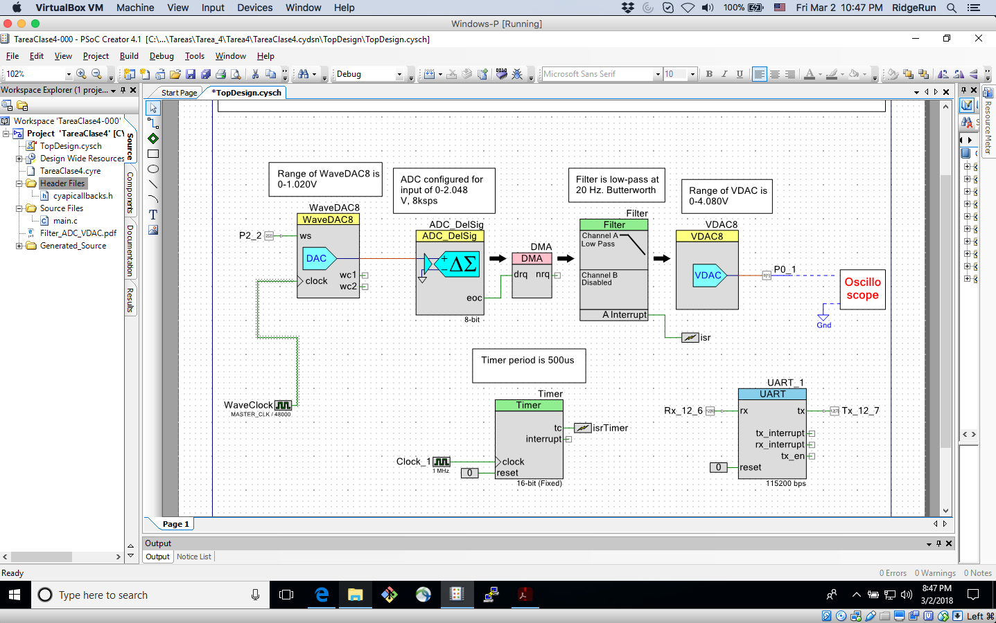

**Figure 1.** Schematic to be implemented on the PSoC

Then the DAC was set as on the next image:

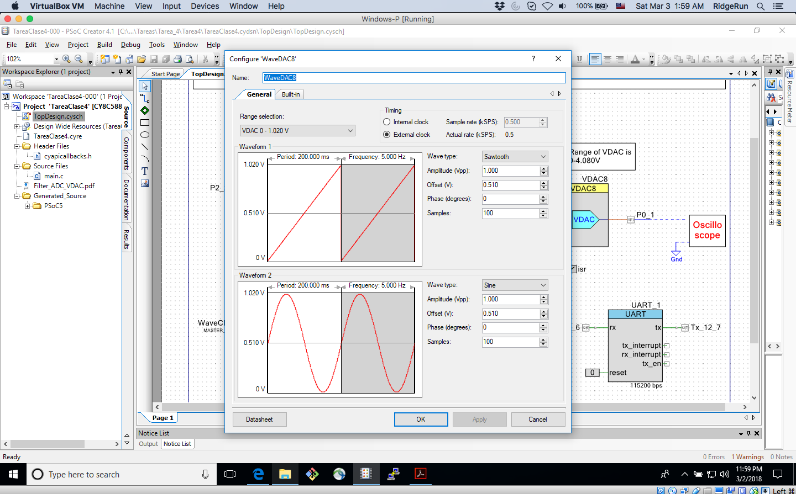

**Figure 2.** WaveDAC8 element configured with the Sawtooth and Sine signal

With all the configurations and the changes done on the code to capture 2000 samples and use the proper Division on the Clock, using the given API, as seen on the **Figure 3.**

**Table 1** shows the values used on the ClockDivider to set the proper desired Frequency.

It was proceed to capture the information for the Butterworth filter. After MatLab graphed, what was obtained is the next set of images shown on **Figure 4.**

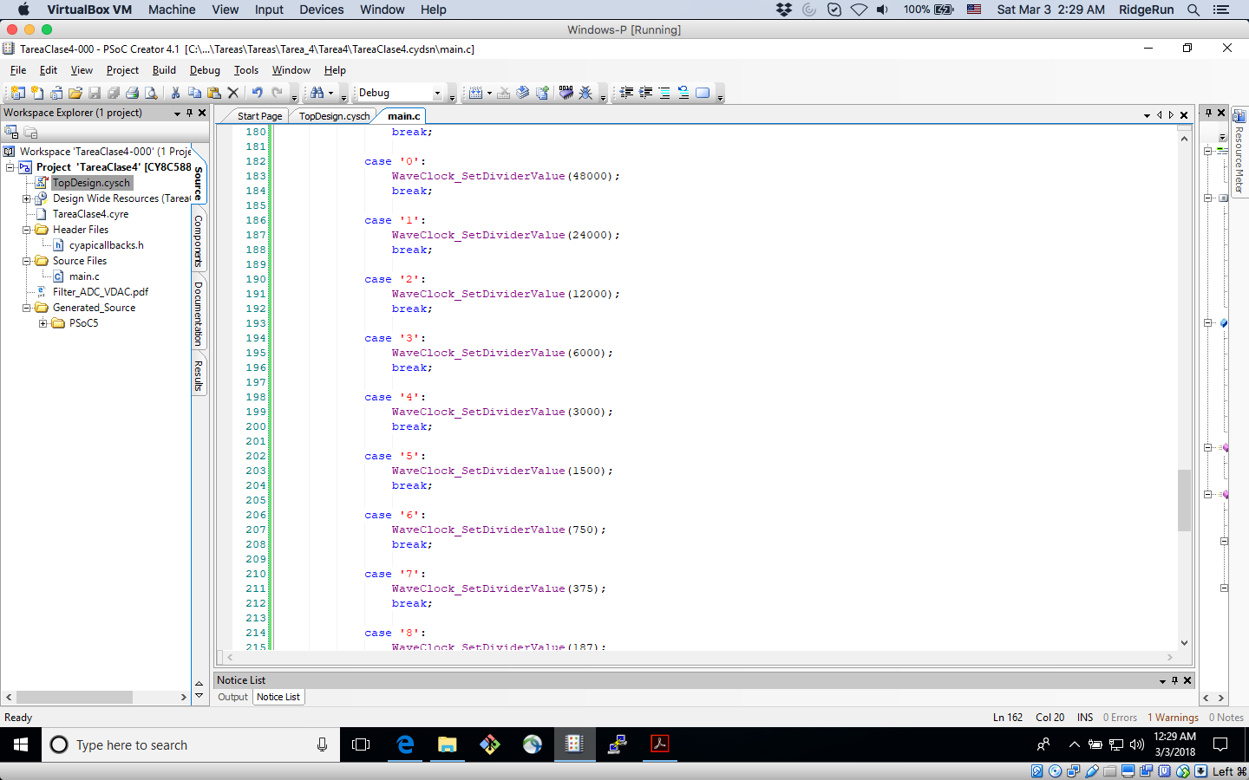

**Figure 3.** Code changes to capture 2000 samples and configure the Clock Divider depending on the entry number

|  |  |  |  |  |  |  |  |  |  |  |
| --- | --- | --- | --- | --- | --- | --- | --- | --- | --- | --- |
| **Character (string)** | 0 | 1 | 2 | 3 | 4 | 5 | 6 | 7 | 8 | 9 |
| **Frequency (Hz)** | 5 | 10 | 15 | 20 | 25 | 30 | 35 | 40 | 45 | 50 |
| **ClockDivider Value** | 48000 | 24000 | 12000 | 6000 | 3000 | 1500 | 750 | 375 | 187 | 94 |

**Table 1.** Value set on the ClockDivider and its respective frequency

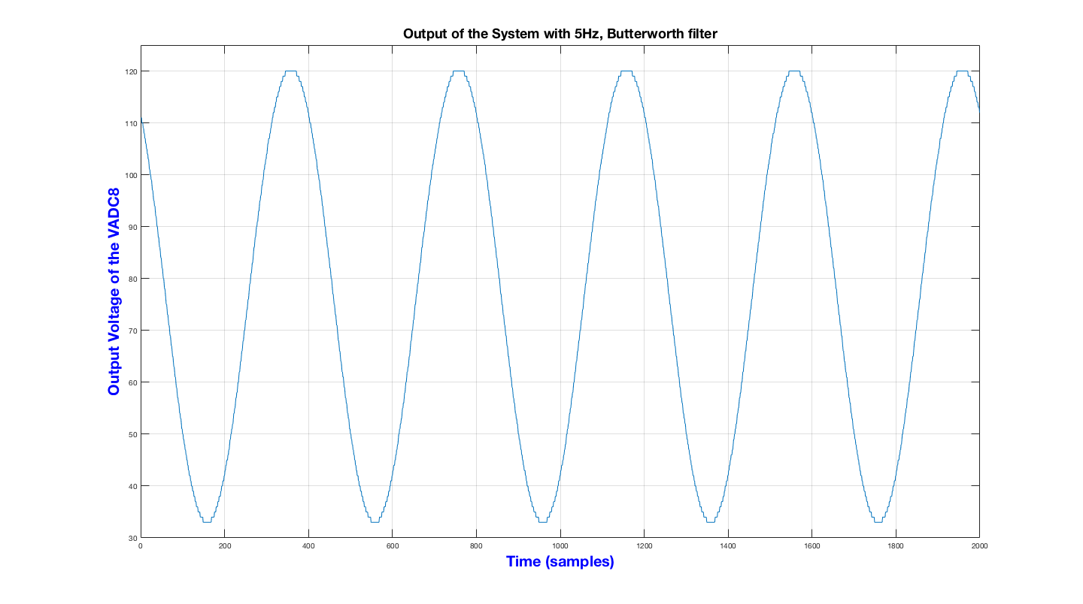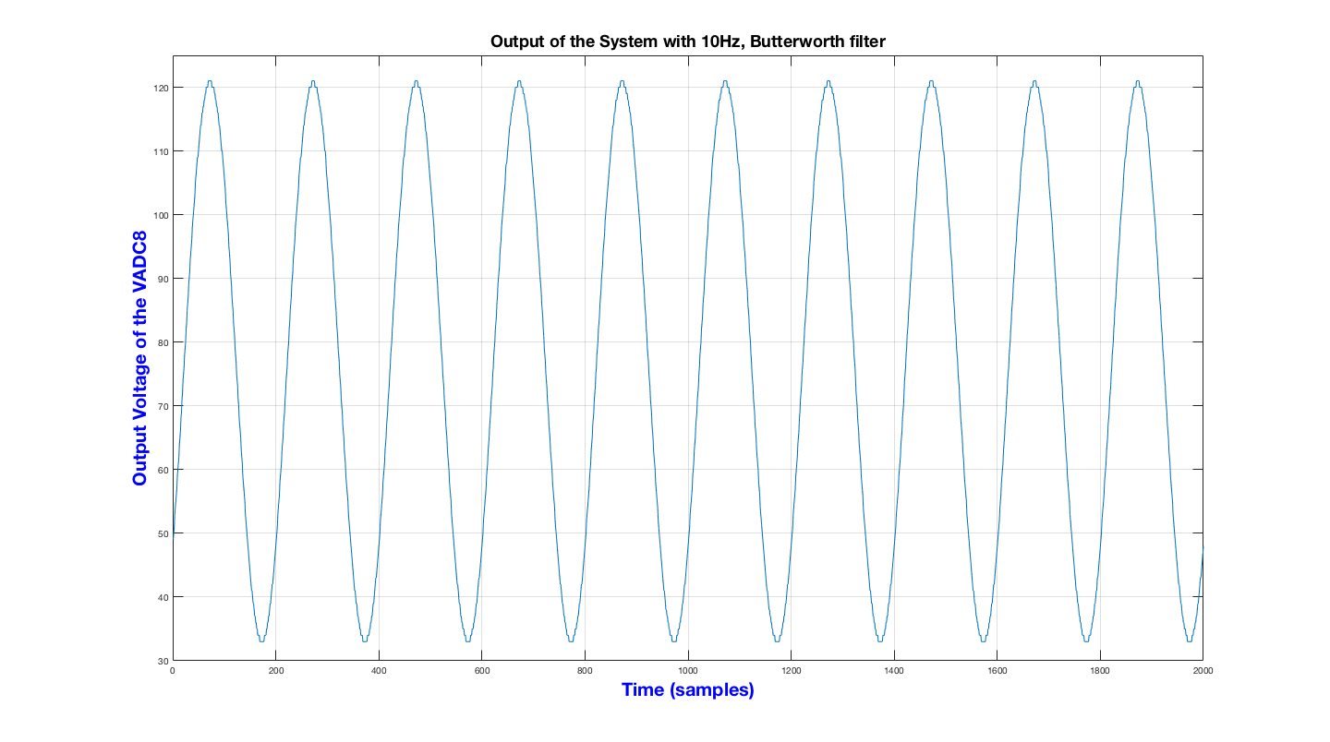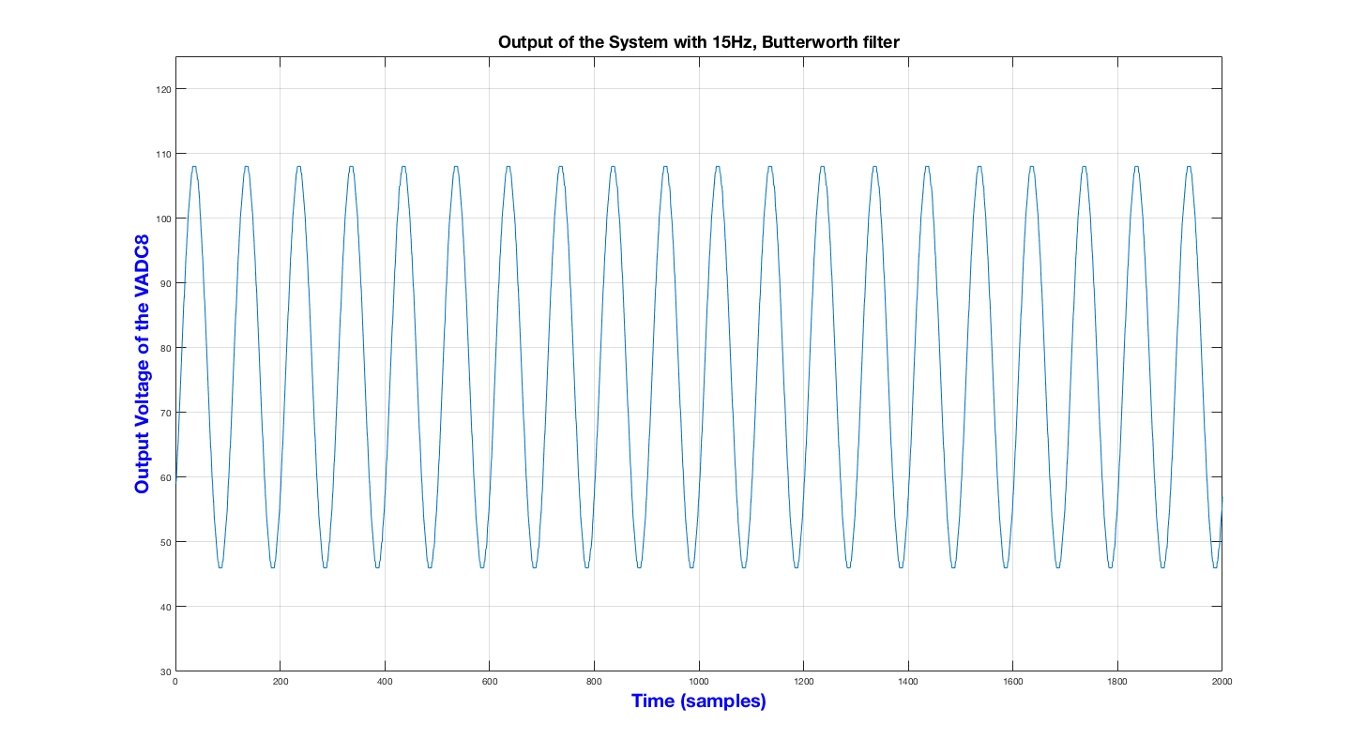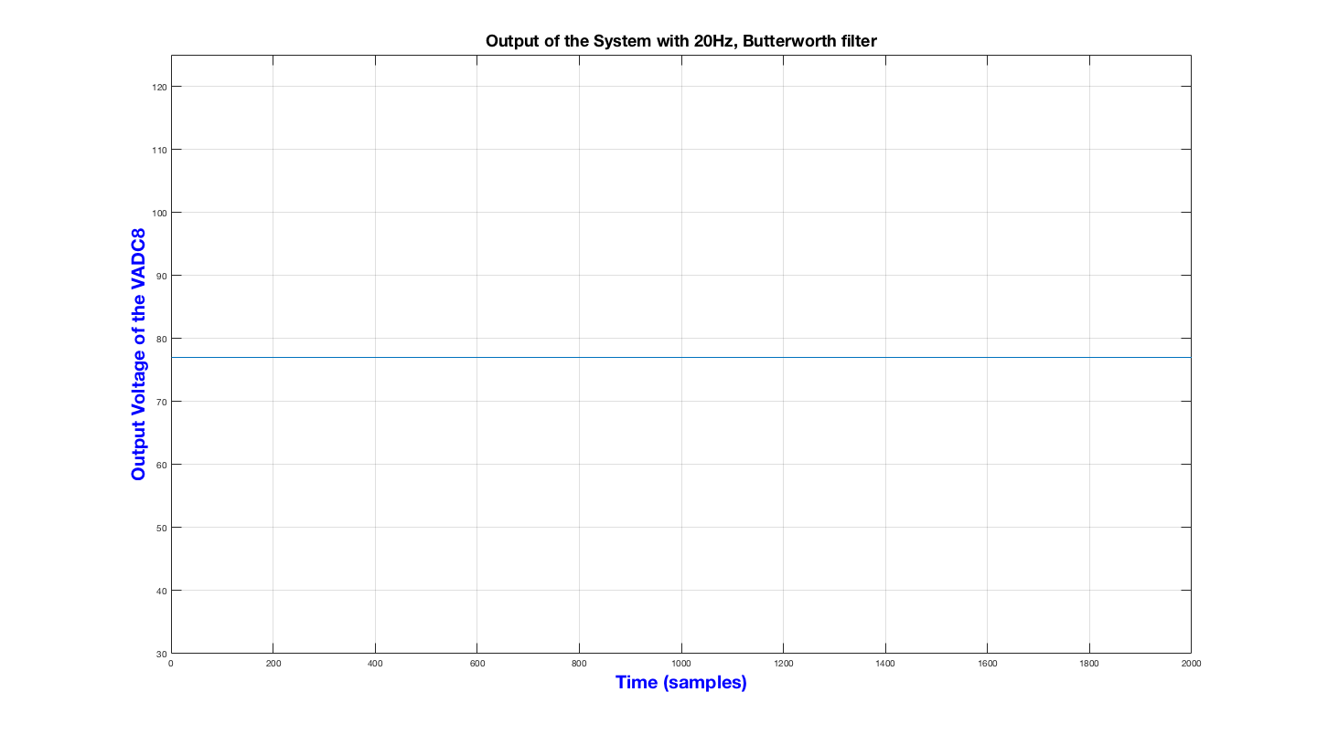

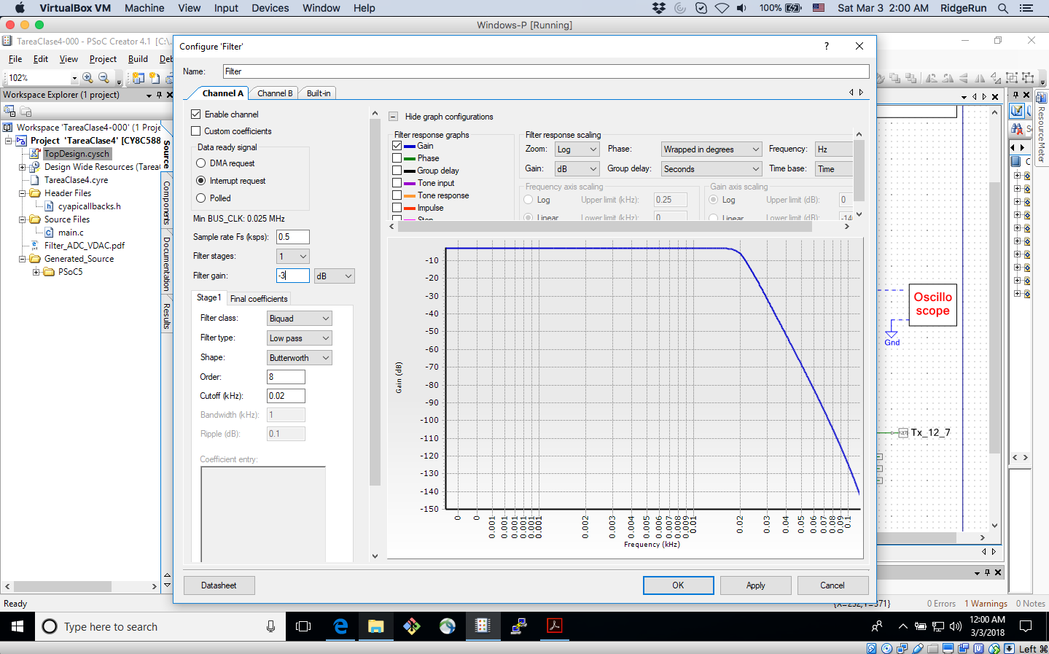

**Figure 4.** Butterworth filtering and reconstruction using the output of the System and Matlab

A comparison using a Blanckman FIR 2 stages filter, was set, the next set of images of Figure 5 show the results.

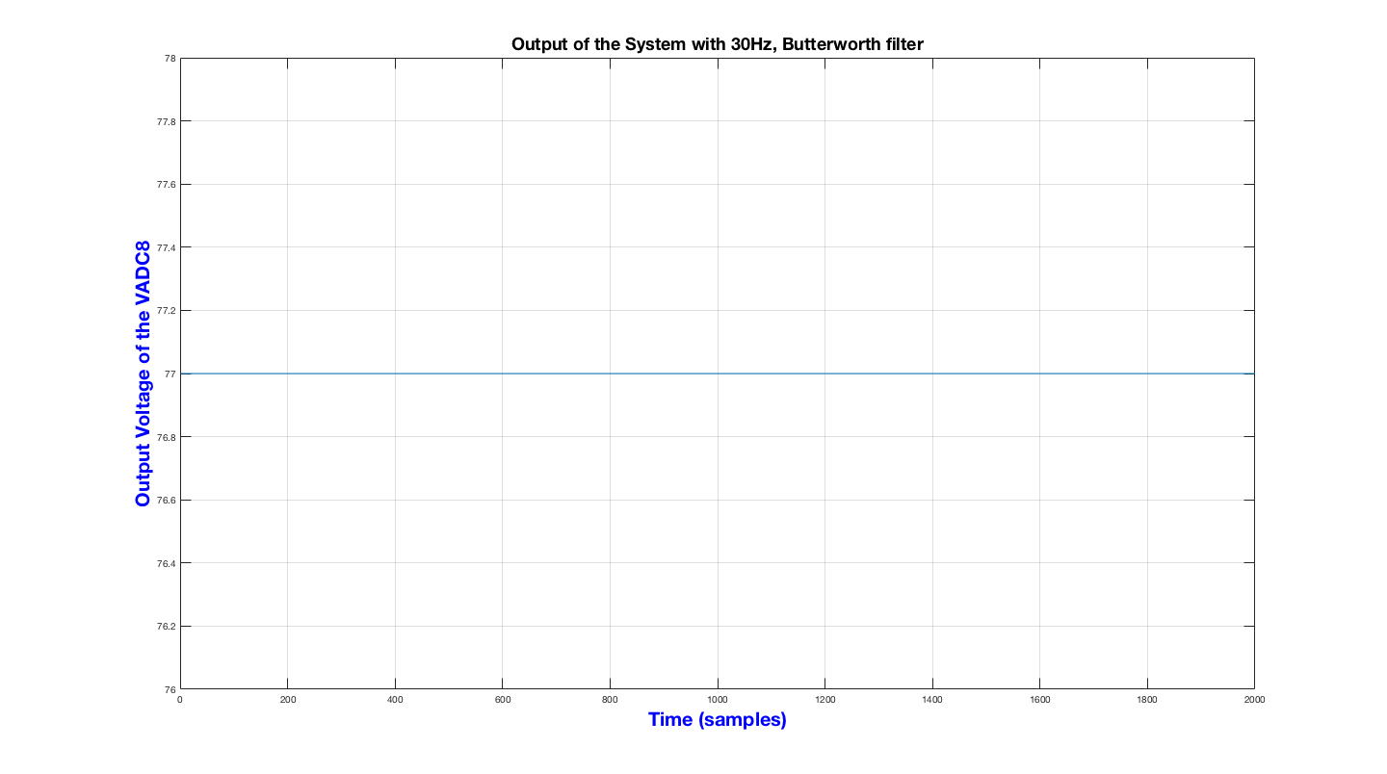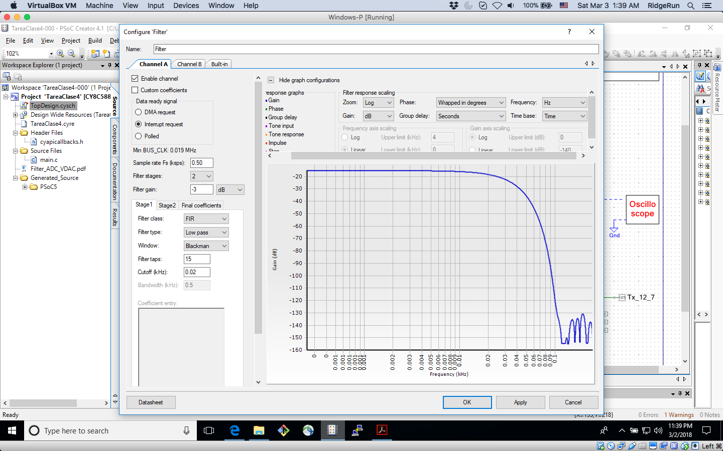

**Figure 5.** FIR with a Blackman filter and reconstruction using the output of the System and Matlab

One can easily identify that using the Blanckman filter, didn’t result on the best results, as even a high frequencies (compared to the cut-off frequency of the Filters) there still signals that can be retrieved from the system. On the other hand, the Butterworth filter used, had a good attenuation at the cut-off frequency, which translated in non-frequency signals at the cut-off and even higher. For simplification purposes, the graphics of the Butterworth filter at frequencies higher than 20 Hz were not included, as they are the same as this last plot.