MAPD722 -

Mobile Web Development

Milestone 1

Mock-ups and Requirements Analysis

Group 6

Member:

Pui Yee Ng

Cole Anam

Project Description

We are going to reuse and improve the REST API service built in last semester for a Patient Clinical Data management application for the health care providers (i.e. nurses and doctors) in hospitals. In this project, we will build a mobile client for the REST API using **Flutter**. This app will allow health care providers to create patients and their clinical data, view patient data to track and monitor patient records. Health care providers can view the detailed clinical data for an individual patient in this app. Also, health care providers can find out any patients in critical condition through this app.

* This app can store the following clinical data:
  + Date/time, Type of Data, Reading/Value
  + Data Type:
    - Blood Pressure (X/Y mmHg)
    - Respiratory Rate (X/min)
    - Blood Oxygen Level (X%)
    - Heartbeat Rate (X/min)

# Mockups and Requirements

* Add Patient:

Add new patient with patient’s First Name, Last Name, Date of Birth, Gender, Department, Doctor and Additional Notes. A patient ID will be automatically generated by the API.

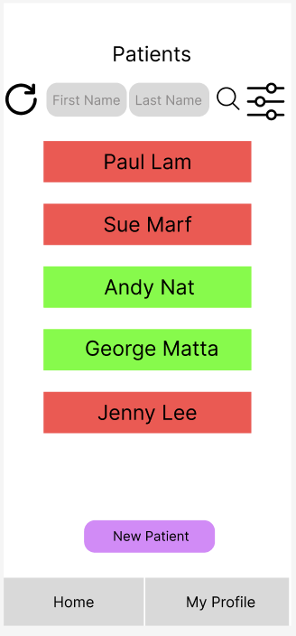 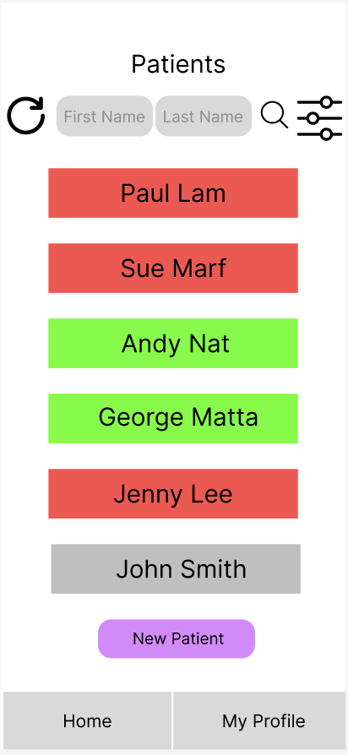

* View Specific Patient:

View specific patient’s basic information including Full Name, Gender, Date of Birth, Address, Department, Doctor, and additional notes.

* List all Patients:

List all patients with their names and health condition indicated by colour (Critical: RED, Normal: Green, No Health Record: Grey)

* Edit Specific Patient’s Basic Information:

Edit Patient’s basic information including First Name, Last Name, Date of Birth, Gender, Department, Doctor, and Additional Notes.

* Delete Patient’s Basic Information Record and All of its Respective Clinical Data:

Delete selected patient’s record and all his respective clinical data will be deleted.

* Search Patients by First Name or Last Name:

Search Patients by First Name or Last Name, or with both First Name and Last Name

* Add Patient Clinical Data Record:

Add patient’s clinical data which includes Date/time, Type of Data, Reading/Value

Data Type:

* Blood Pressure (X/Y mmHg)
* Respiratory Rate (X/min)
* Blood Oxygen Level (X%)
* Heartbeat Rate (X/min)

* View Patient Clinical Data Records:

View patient’s clinical data which includes Date/time, Type of Data, Reading/Value, Condition.

Data Type:

* Blood Pressure (X/Y mmHg)
* Respiratory Rate (X/min)
* Blood Oxygen Level (X%)
* Heartbeat Rate (X/min)

User can also view every historical clinical data of every individual patient.

* Edit Patient clinical condition

Change the Test, Reading, and Date Recorded fields of an existing clinical condition

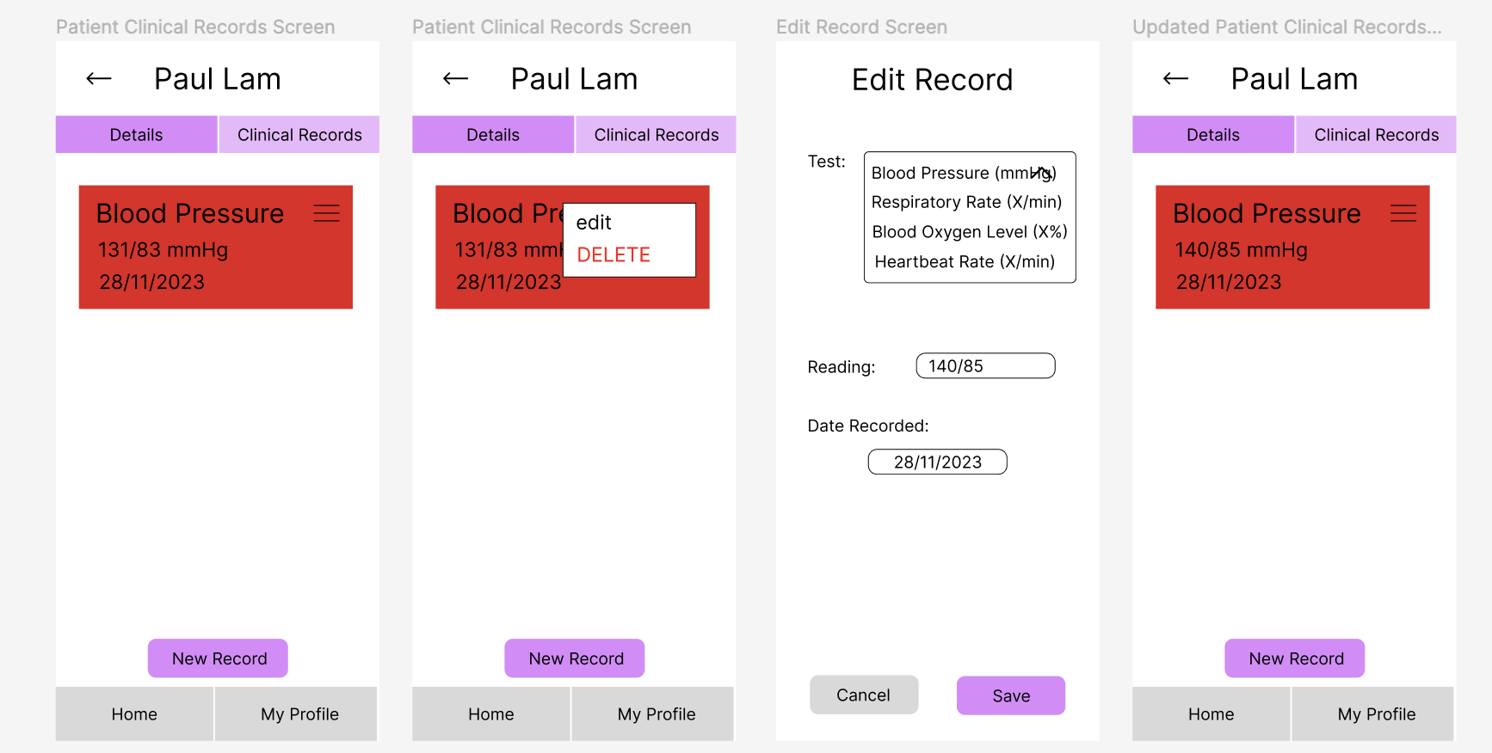

* Delete patient clinical record

Deleting a patient’s clinical record will ask the user for confirmation

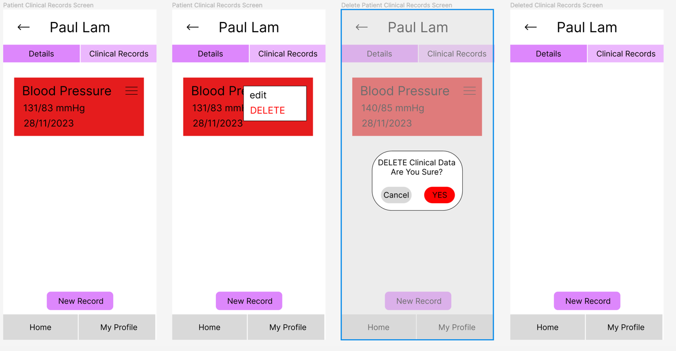

* View Patients by condition

Filter and show patients with critical condition in a list view.

