MAPD712 -

Web Techs - Mobile Platforms

Milestone 1

Mockups and Requirements Analysis

Group 7

Member:

Pui Yee Ng

Cole Anam

# Table of Contents

Table of Contents 2

Project Description 3

Mockups and Requirements 4

# Project Description

We are going to design a REST API service for a Patient Clinical Data management application for the health care providers (i.e. nurses and doctors) in hospitals. In this project, we will build a mobile client for the REST API using React-native. This app will allow health care providers to create patients and their clinical data, view patient data to track and monitor patient records. Health care providers can view the detailed clinical data for an individual patient in this app. Also, health care providers can find out any patients in critical condition through this app.

This app can store the following clinical data:

* Date/time, Type of Data, Reading/Value
* Data Type:
  + Blood Pressure (X/Y mmHg)
  + Respiratory Rate (X/min)
  + Blood Oxygen Level (X%)
  + Heartbeat Rate (X/min)

# Mockups and Requirements

* Add Patient:

Add new patient with patient’s First Name, Last Name, Date of Birth, Gender, and additional notes. A patient ID will be automatically generated by the API.

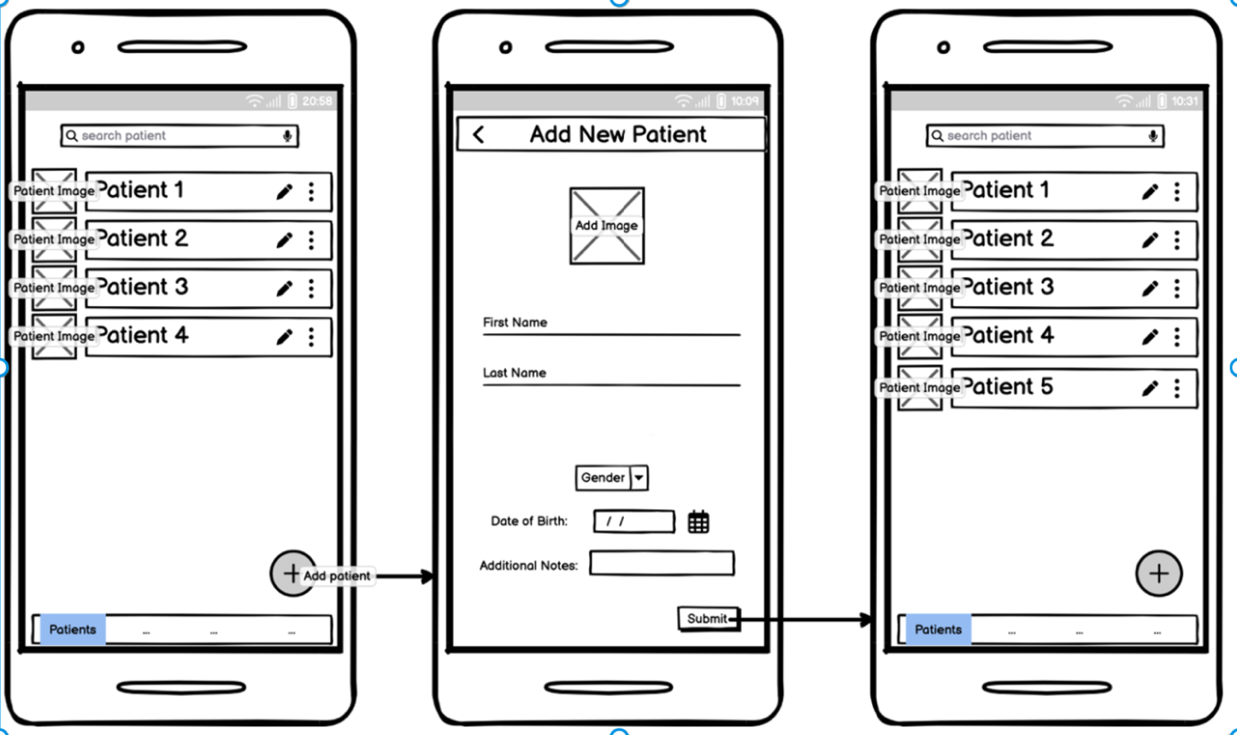

* View Specific Patient:

View specific patient’s basic information including Patient ID, Name, Age, Date of Birth, Gender, Condition and additional notes.

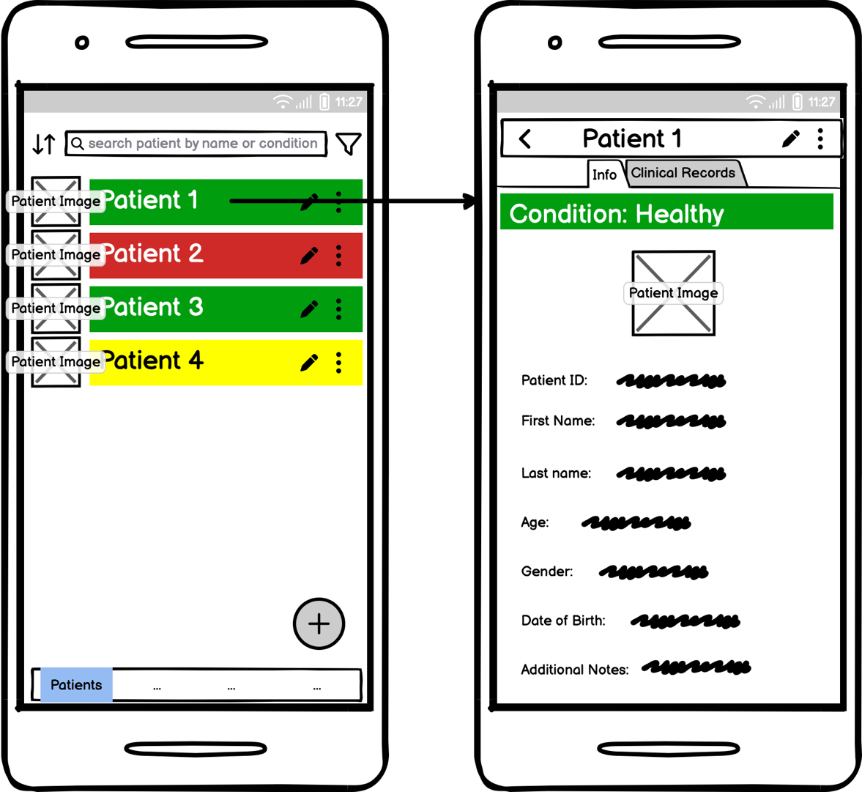

* List all Patients:

List all patients with their names, images and the edit and delete options.

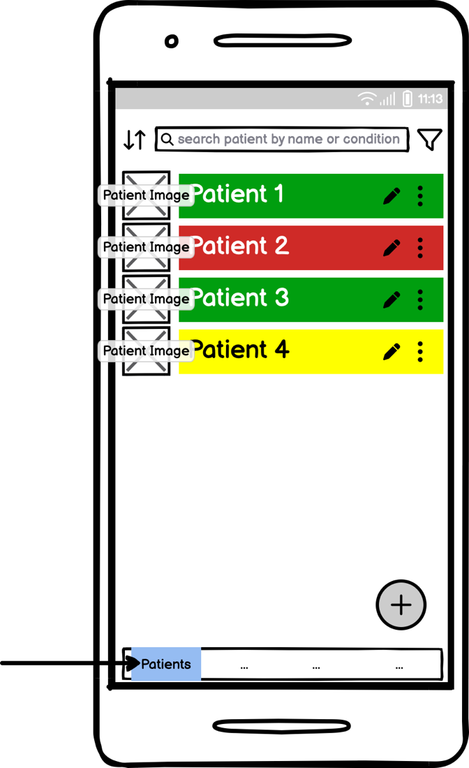

* Add Patient Clinical Data Record:

Add patient’s clinical data which includes Date/time, Type of Data, Reading/Value

Data Type:

* + Blood Pressure (X/Y mmHg)
  + Respiratory Rate (X/min)
  + Blood Oxygen Level (X%)
  + Heartbeat Rate (X/min)

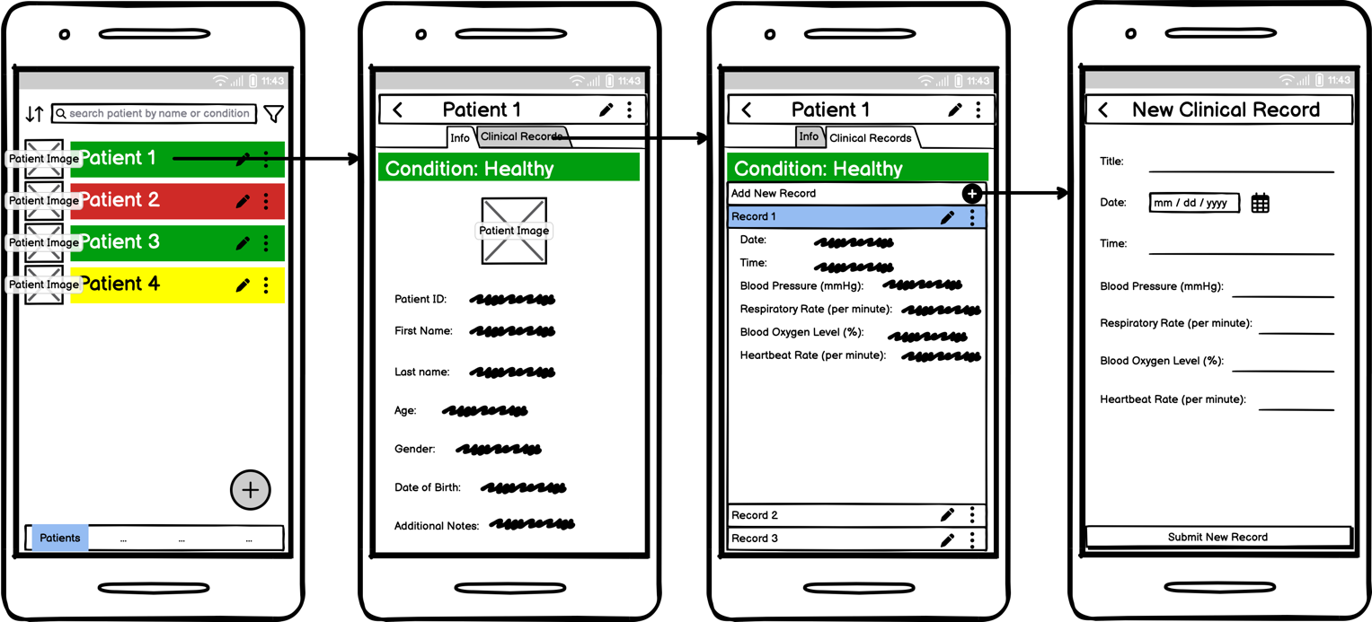

* View Patient Clinical Data Records:

View patient’s clinical data which includes Date/time, Type of Data, Reading/Value, Condition.

Data Type:

* + Blood Pressure (X/Y mmHg)
  + Respiratory Rate (X/min)
  + Blood Oxygen Level (X%)
  + Heartbeat Rate (X/min)

User can also view every historical clinical data of every individual patient.

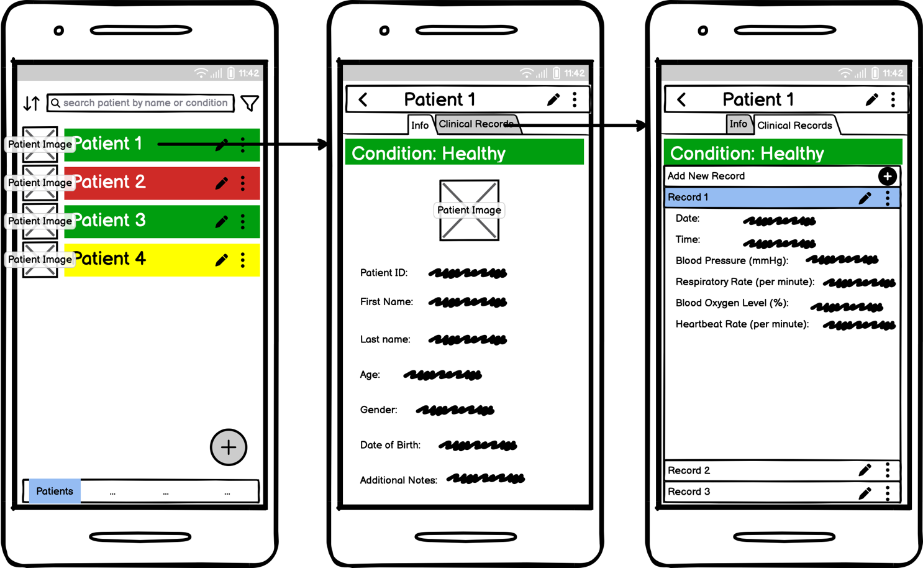

* View Patients with critical condition

Filter and show patients with critical condition in a list view.

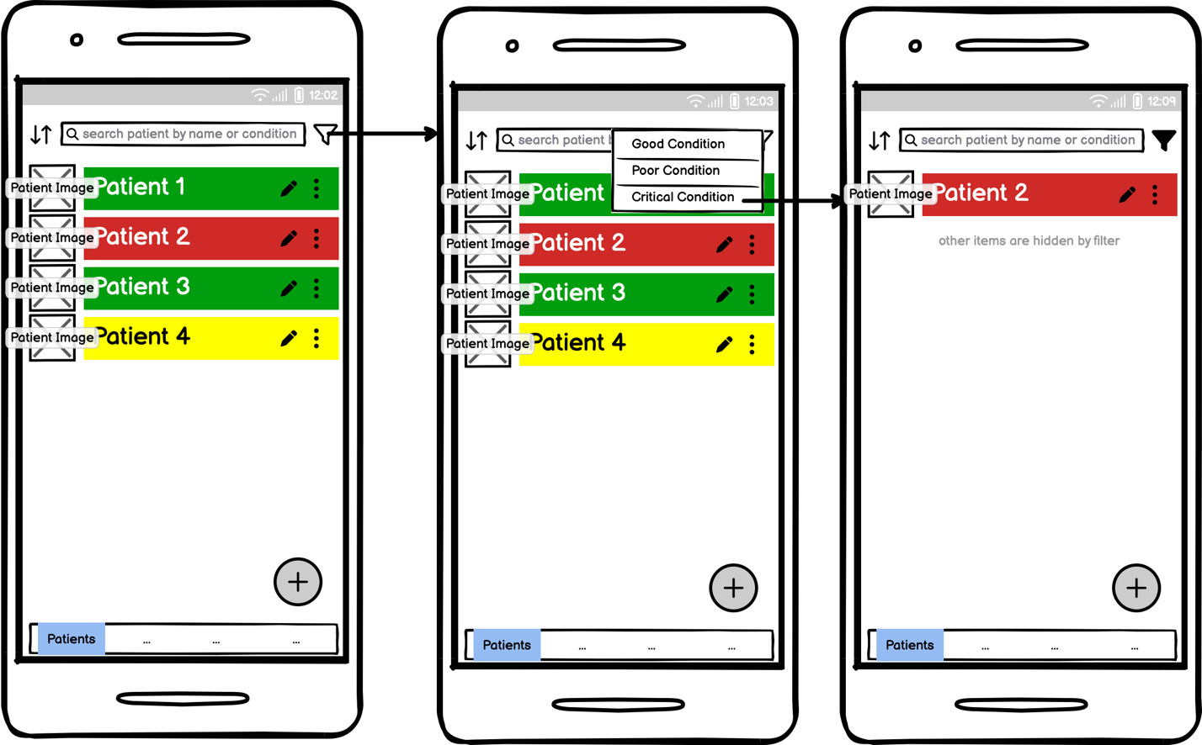

* Edit Patients’ Basic Information

Edit Patient’s basic information including Name, Age, Date of Birth, Gender, and additional notes.

* Edit Patients’ Clinical Data Records

Edit patient’s clinical data which includes Date/time, Type of Data, Reading/Value

Data Type:

* + Blood Pressure (X/Y mmHg)
  + Respiratory Rate (X/min)
  + Blood Oxygen Level (X%)
  + Heartbeat Rate (X/min)

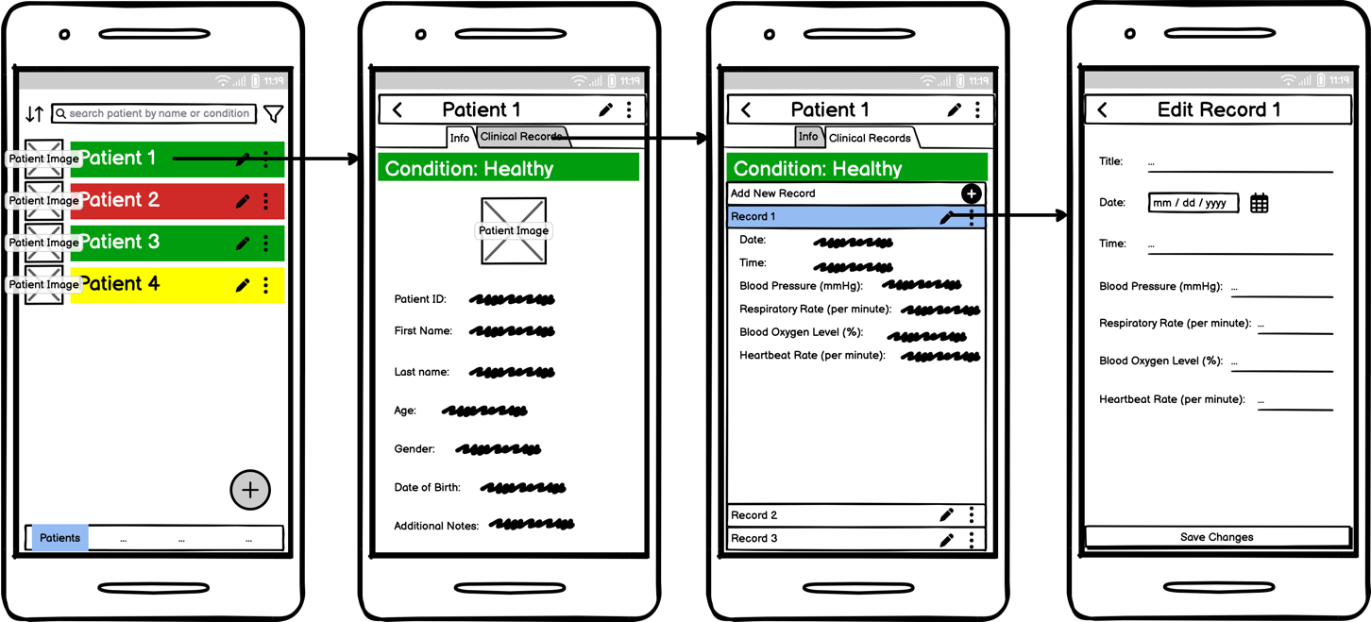

* Delete Patient’s Basic Information Record and All of its Respective Clinical Data

Delete selected patient’s record and all his respective clinical data will be deleted.

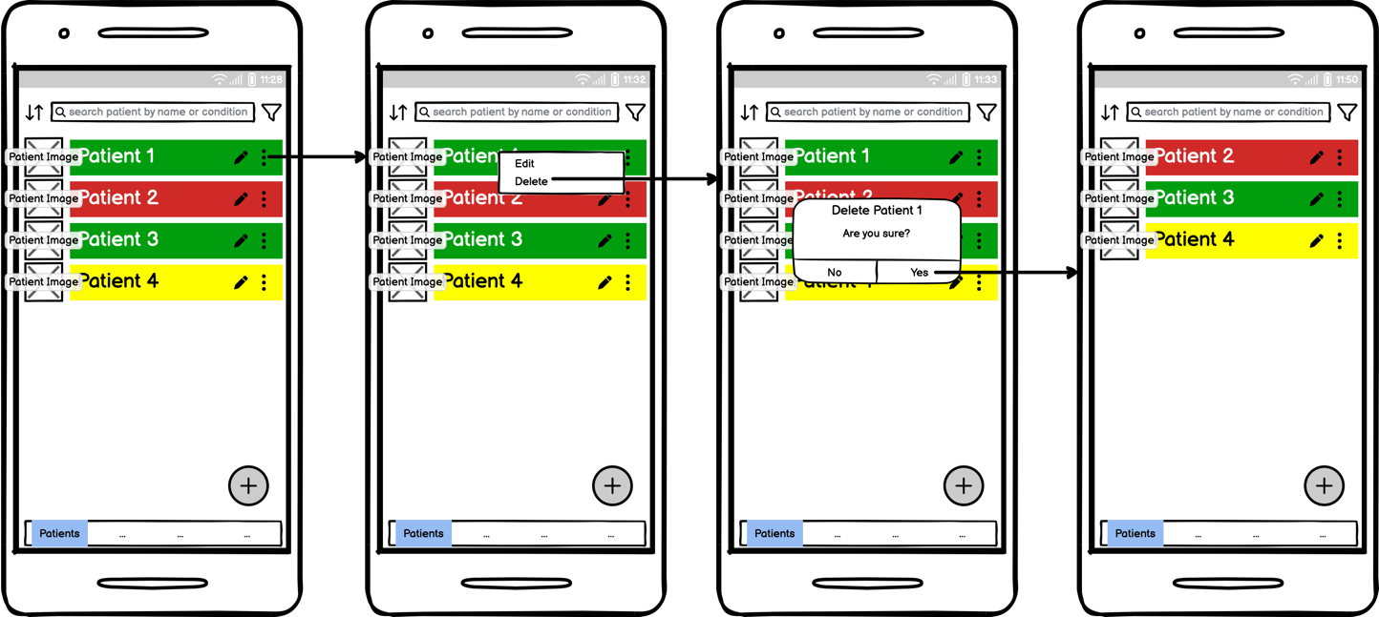

* Delete Specific Clinical Data Record of a Specific Patient

Health care providers can delete specific clinical data record of a specific patient.

