**Exercise:**

Calculate the regular polygon area with a side length and sides numbers.

**Regular Polygon Area:**

Area = side_numbers * ($\frac{base* height}{2}$)

**Inputs:** side length; side numbers.

Where side_length and side_numbers € positive R.

**Outputs:** A positive number € R.

**Mathematic-logic Model:**

Calculate Apoteto:

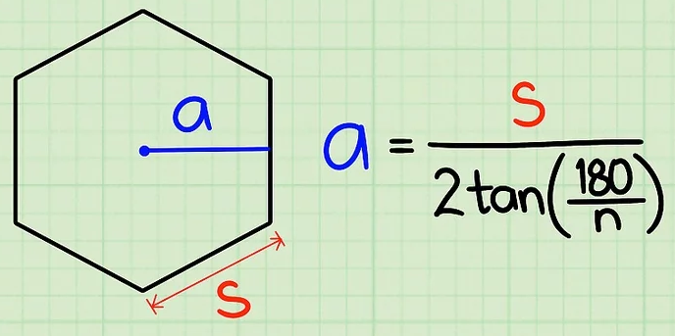

Where:

* a = apoteto
* s = side
* n = side numbers

Calculate Triangle Area:

Area = ($\frac{base* height}{2}$)

Where:

* base = side
* height = apoteto

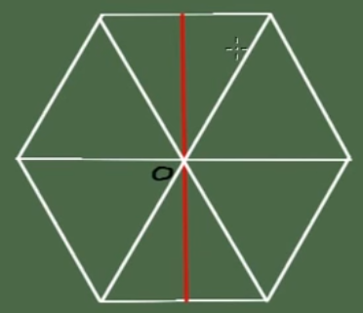

Area of Regular Polygon:

Area = side_numbers * ($\frac{side* Apoteto}{2}$)

**Conditions:**

Ifside == 0 or side_numbers ==0

Area of regular polygon is 0? So, it is not possible to calculate the area of regular polygon.

**Algorithm:**

Calculate_Polygon_Area (side, side_numbers): polygon_Area

1. Read side, side_numbers
2. Apoteto = Calculate_Apoteto (side, side_numbers): Apoteto
3. Triangle_Area = Calculate_Triangle_Area (side, Apoteto): Triangle_Area
4. Polygon_Area = Multiplication (side_numbers, Triangle_Area): polygon_Area
5. Show Area (Polygon_Area)

Calculate_Apoteto (side, side_numbers): Apoteto

1. Return ($\frac{side}{2*tan⁡(\frac{180}{side_numbers})}$)

Calculate_Triangle_Area (side, Apoteto): Triangle_Area

1. Return ($\frac{side*Apoteto}{2}$))

Multiplication (num1, num2): polygon_Area

1. Return (num1 * num2)