Algorithm: Given 2 points in a Cartesian plane (extreme points related to a diagonal) of the triangle rectangle. Calculate its area

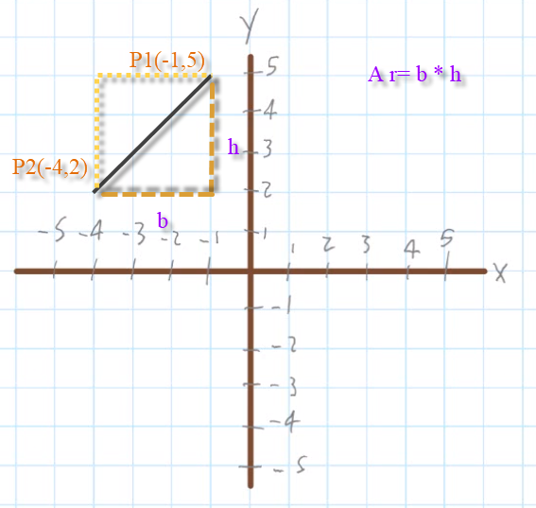

P1(x1,y1)

P2(x2,y2)

b = |x2-x1|

h= |y1-y2|

A rectangle= b \* h

Algorithm

1. Read P1(x1, y1)
2. Read P2 (X2,y2)
3. Calculate base b(x2,x1)
4. Calculate high h (y1, y2)
5. Calculate area rectangle a (b,h)
6. Show area a

CalculateBase(x2, x1)

b = abs|x2-x1|

CalculateHigh(y1,y2)

h = abs|y2-y1|

CalculateRectangleArea(b,h)

a = b \* h