***EVALUATION OF MODERN VISUAL SLAM METHODS***

*Arthur Huletski, Dimitry Kartashov & Kirill Krinkin*

*Artificial Intelligence and Natural Language and Information Extraction, Social Media and Web Search FRUCT Conference (AINL-ISMW FRUCT), 2015, IEEE*

* Compares recent (2013 -2015) open source visual SLAM algorithms.
* SLAM methods can be classified on the basis of:
  + Type of sensors used
  + Output map type
* Metrics in the SLAM area that do not depend upon the sensors or the output map types. These metrics allow to estimate performance and quality of an algorithm:
  + Localization Accuracy: It is the root mean square error (RMSE) between the robots position predicted by the SLAM algorithm and the ground truth data.
  + Dataset processing time: Computational effectiveness of an algorithm.
  + Peak memory consumption: Estimate memory requirements of the algorithms.
  + Camera Frame processing time (FPS): Desirable to process camera video stream in real time to timely react to environmental changes.
  + Map Quality:
  + Robustness: Ability of the algorithm to not degrade localization accuracy over the long time and ability to work in any environment.
  + Convergence: Time required to minimize localization error after last localization procedure.
* Algorithms picked for evaluation in this paper:
  + ORB-SLAM
  + OpenRat SLAM
  + LSD-SLAM
  + 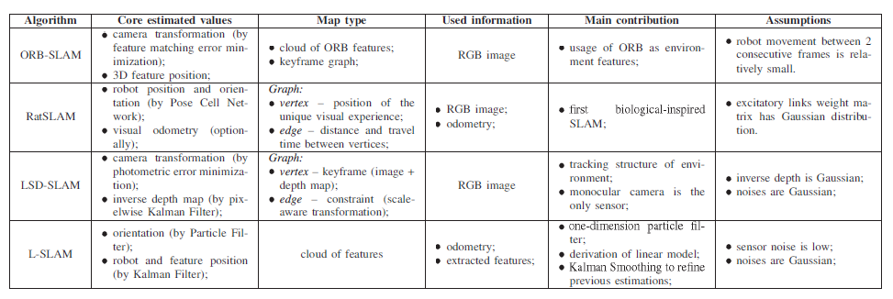L-SLAM
* Observations and Conclusions made:
  + Rat SLAM is not accurate and fast enough
  + LSD SLAM is very non-deterministic and also tracking was lost
  + ORB SLAM requires manual adjustment of the trajectory scale. The adjusted trajectory is very accurate, but posterior scale adjustment is unacceptable for robots that work in real life environments.
* Drawbacks of the Algorithms:
  + Method that estimates camera transformation should have at least medium level on noise (Rat SLAM drawback)
  + Should be scale-aware (ORB-SLAM drawback)
  + In case of tracking loss, the algorithm should use some fall back strategy instead of giving up (LSD-SLAM drawback)