**Project Description**

FindSomePot, A marijuana dispensary Directory. A Yelp like site but for marijuana. Free for users to sign up or just view/find local businesses. Users can favorite, rate and review a business. Business owners can claim their page in the business listing.

**Requirements**

**Data requirements**

Data of all available dispensaries across US filtered by sate/city/zip/type

**3rd Party API**

API for best approach on users who use public data

Otreeba.com  
 strains.evanbuee.com  
 neobi.io

API pull & configuration of data into Bubble.is

**Flow**

**Prompts**

21+ age prompts, only on United States & age with DOB entry

**User Features**

Users have option to upload profile photo for their business, rate, favorite a location, share links and social media channels, can write review on business(available when logged in)

**User Registration**

**Requirements**

Email

Full name

Dob must be over 21

Agree to Terms of Services & Privacy Policy

Email confirmation of enrollment

**User Dashboard**

Can view all their favorite locations

View reviews they’ve placed

Place and update their photo

**Optional**

Photo upload

Favorite method of consuming

Open text field to choose from dropdown options

Favorite Strain: rapid.com/raygorodskij/api/Strain

**User controls**

Change password

Invite a friend to use service?

Deactivate/delete account

**Business registration**

Verify location information by the system offering the option to claim your business listing by initiating a phone call to the business with a code they enter on the site, If their business isn’t listed, we should have an option where it says “Help us to improve our listings. If the business you are looking for is not listed here, just add it(upload menu(v2 or v3))

**Development Phase**

* Design
* Navigation
* Registration
* User Profile
* Uploading pictures
* Review and rating
* Api integration
* Geolocation
* Filter Integration

**Timeline**

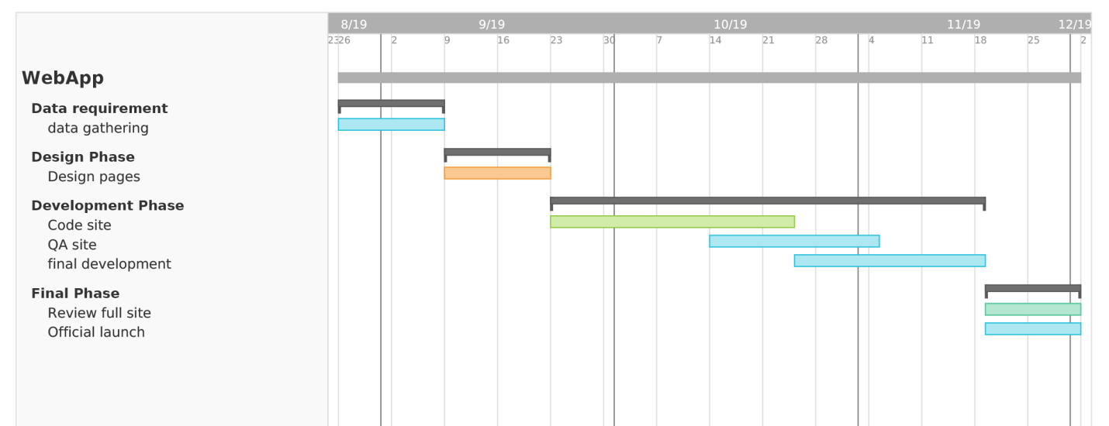

**Budget**

* Sign in/sign up/registration: 30–40 hours, $300+
* Geolocation: roughly 70–100 hours up to $800+
* Uploading pictures and videos: 40–80 hours, $400+
* Filter Integration: 30+ hours, $500+
* Reviews and Rating: 40–80 hours, $500+
* User profile: 30–34 hours, $500+
* User Features:30-40 $500