Predicting Daily Realized Volatility
Analysis report | Minjun Cho

1. Summary
This report models the daily realized volatility (realized_vol) of 20 stocks from March 2023 to May 2024, using stock characteristics and market-wide variables. The target is positive and right-skewed, and its variance grows with its level. I selected the variables with a linear model (forward selection, AIC), added two transformed terms and one interaction, and compared seven candidate models with a walk-forward validation. The final model is a Gamma GLM with a log link. [FILL: cross-validation RMSE of the Gamma model __ vs baseline __; holdout RMSE __ vs baseline __] The main drivers are market-wide conditions (vix_prev, credit_spread), the size of the stock (market_cap_bn) and event days (earnings_day, fomc_day, opex_day).

2. Data and split
The data has three tables: stock_days (one row is one stock on one day), tickers (stock information) and market (market conditions of each day). I merged them on ticker and date, which gives 5,805 rows and 27 columns: the target realized_vol, 9 numeric and 14 categorical predictors, 2 date columns and 1 ID column. Since the data is time-dependent, I split it by time instead of randomly: the first 80% of the days are the development part (2023-03-01 to 2024-02-13, 4,640 rows), and the last 20% are the holdout (2024-02-14 to 2024-05-08, 1,165 rows). Every choice below was made on the development part only, and the holdout was opened once, at the end.

3. Exploratory analysis
Target. realized_vol has a mean of 33.72, a median of 31.39, a minimum of 10.46, a maximum of 192.6 and a standard deviation of 13.89. It is positive and right-skewed, and its monthly mean decreases over time, from about 37 in March 2023 to about 29 in February 2024 (Figure 1). The Utilities sector has clearly the lowest values, and the Tech sector has the highest median and the widest spread.
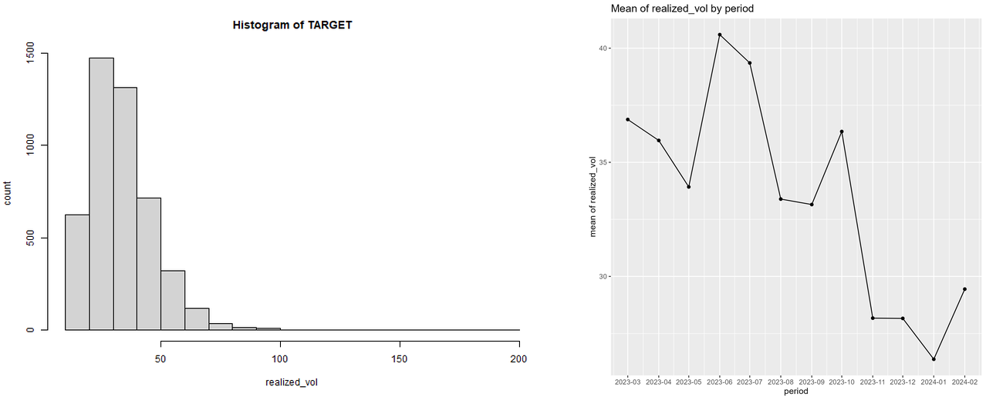
Figure 1. Left: histogram of realized_vol. Right: monthly mean of realized_vol.
Predictors. credit_spread, vxn_prev and vix_prev are strongly and positively correlated (0.91 to 0.98). Because my goal is prediction, I kept them as long as the model performs well out of sample. sector and sector_code carry the same information, and sector_code has no missing values, so I kept sector_code as a categorical variable.
Missing values. The largest shares are premarket_vol_k (6.1%), short_interest_pct (5.4%), cap_class (5.1%) and pe_ratio (5.0%). vix_prev is missing if and only if vxn_prev is missing. In the development part, 1,127 rows have at least one missing value. The rows with a missing premarket_vol_k look similar to the other rows (for example, the mean of the target is 33.55 vs 33.22), so I treated the missingness as having no special meaning. I filled numeric variables with the mean of the observed values in the past 60 days, and categorical variables with the most frequent value. Only past information is used, to avoid leakage.

4. Modeling steps
4.1 Variable selection. I used a linear regression of the target and compared forward and backward selection with AIC and BIC (Table 1). Forward and backward selection gave the same result for each criterion. I used forward AIC (10 variables), because AIC keeps more variables, which is better when the goal is prediction: market_cap_bn, vix_prev, earnings_day, premarket_vol_k, news_flag, fomc_day, macro_alert, weekday, opex_day and credit_spread.
Method | Variables | AIC | BIC | Adj. R²
forward_AIC | 10 | 33296.9 | 33516.0 | 0.6015
forward_BIC | 8 | 33317.3 | 33504.2 | 0.5993
backward_AIC | 10 | 33296.9 | 33516.0 | 0.6015
backward_BIC | 8 | 33317.3 | 33504.2 | 0.5993
full | 24 | 33309.4 | 33599.3 | 0.6013
Table 1. Variable selection results (smaller AIC and BIC are better).
4.2 Diagnostics and transformations. The residuals of the selected linear model show two problems (Figure 2). The target is right-skewed, which appears as a deviation in the upper tail of the Q-Q plot, and the variance of the residuals increases with the fitted value. A Box-Cox analysis gave a lambda hat of −0.22. The nearest simple value is 0, so I used log(realized_vol). The Box-Cox transformation is y(λ) = (y^λ − 1) / λ for λ ≠ 0, and log(y) for λ = 0. After the log transformation, the Q-Q plot is much closer to a straight line. For the predictors, I added log(premarket_vol_k) and vix_prev², because they improved the AIC.
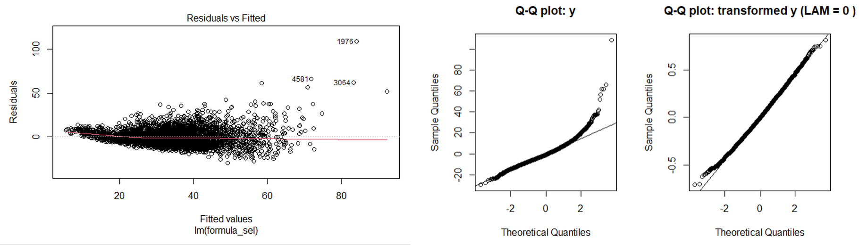
Figure 2. Left: residuals vs fitted values of the selected lm (the spread widens as the fitted value increases). Middle: Q-Q plot of the residuals on the original scale. Right: the same Q-Q plot after the log transformation.
Checkpoint: reading a coefficient. In the linear model on the log scale, when the first variable X₁ = market_cap_bn increases by one unit (1 billion dollars), log(realized_vol) increases by β̂₁, with the other variables fixed. That is, realized_vol is multiplied by exp(β̂₁). [FILL: β̂₁ = __, exp(β̂₁) = __]
4.3 Outliers and interaction. I flagged the rows with an absolute standardized residual above 3 as outlier candidates: [FILL: n] rows, spread over the whole period and not concentrated on one date. They look like genuine observations, not data errors, so I kept them. Since RMSE reacts strongly to large errors, I report MAE next to it. For the interactions, I added one pair at a time and used the F-test. I kept vix_prev × market_cap_bn (p < 0.0001): the slope of realized_vol on vix_prev is different for stocks with different market capitalization.

5. Candidate models and validation
I compared seven models that use the same variables, transformations and interaction, so that the differences come from the model type: a baseline (the mean of the training target), lm (on the log of the target), lasso, ridge, glm (Gamma family, log link, on the original target), mixed (lm with a random intercept for each stock) and glmm (the Gamma GLM with a random intercept for each stock). To compare them on unseen data, I used walk-forward validation: I train on the last 60 days, predict the next 7 days, and move the window forward by 7 days. All the predictions are collected and scored together. A model only sees days before the days it predicts, so there is no leakage. The main score is RMSE. MAE, MAPE, R² and Bias are also reported, in the original units of the target.

6. Results
Model | RMSE | MAE | MAPE (%) | R² | Bias
baseline
lm
lasso
ridge
glm
mixed
glmm
Table 2. Cross-validation scores of the candidate models (smaller RMSE, MAE and MAPE are better). [FILL: scores]
Final model. [FILL: the best candidate by cross-validation RMSE, and the RMSE of the Gamma model vs the baseline] I chose the Gamma GLM with a log link as the final model for three reasons. First, the variance of the residuals grows with the mean, which matches the Gamma family, where the variance is proportional to the mean squared. Second, the target is positive and right-skewed, and the log link keeps the predictions positive. Third, the log link gives multiplicative effects that are easy to interpret: when X₁ increases by one unit, the expected realized_vol is multiplied by exp(β̂₁). Since market_cap_bn is also in the interaction with vix_prev, the factor is exp(β̂₁ + β̂_int × vix_prev). [FILL: the factor at vix_prev = about 16.9: __]
Holdout. [FILL: holdout RMSE of the Gamma model __ vs baseline __ and cross validation __; similar / worse because __]

7. Limitations and next steps
Every step was run once, in a fixed order, so I did not compare all the combinations of the steps. The history is short (about 14 months) and there is only one holdout period of about three months, so the result may not cover other market conditions. The window length (60 days) was not tuned, and the missing values are filled in a simple way. As next steps, I would try more flexible models (for example, tree-based models), check whether the residuals are correlated over time and, if so, add lagged features of the target, tune the window length, and test the sensitivity of the results to the outliers.

