Daytime Maximum Temperature

Main Model Summary
Daytime Maximum Temperature - Main Model (95%)
Parameter | Posterior Mean | Est. Error | 95% Lower CI | 95% Upper CI
(Intercept) | 33.313 | 0.649 | 31.904 | 34.594
midshield_binomial | -0.179 | 0.500 | -1.230 | 0.824

Posterior Predictive Check
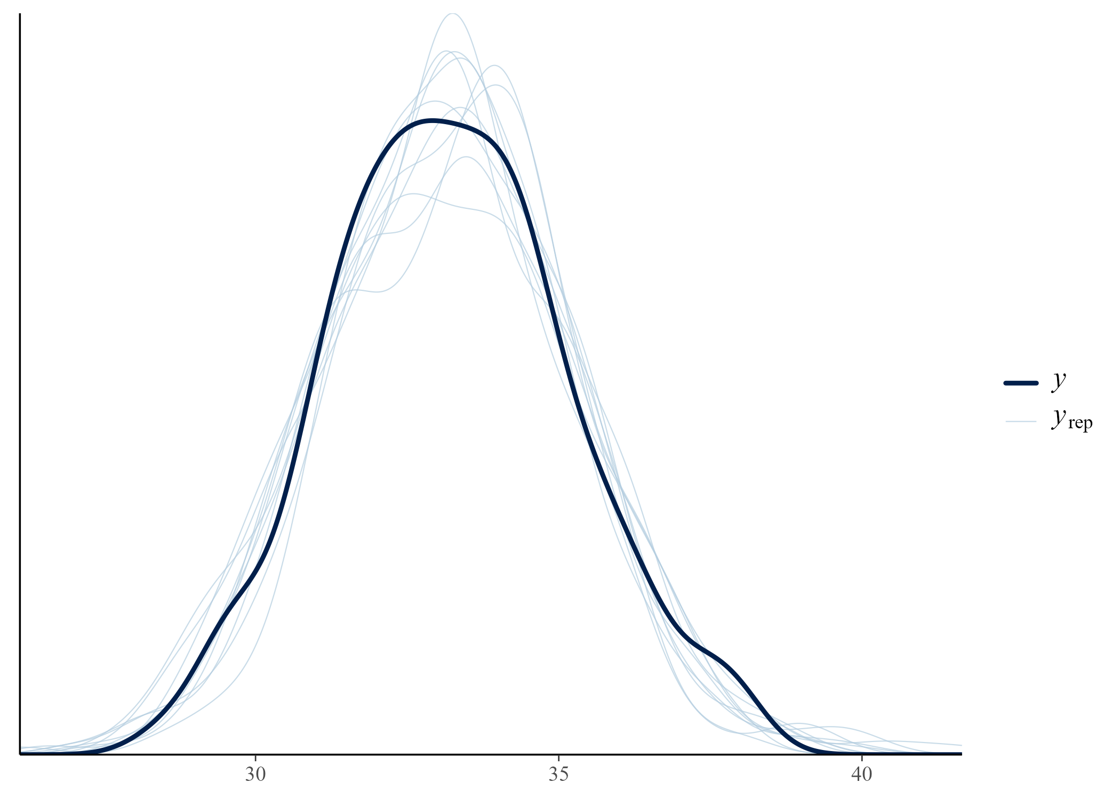

Sensitivity Analyses
Daytime Maximum Temperature - max_T2_90
Parameter | Posterior Mean | Est. Error | 95% Lower CI | 95% Upper CI
(Intercept) | 32.099 | 0.631 | 30.885 | 33.567
midshield_binomial | -0.148 | 0.480 | -1.107 | 0.800
Daytime Maximum Temperature - max_T2_99
Parameter | Posterior Mean | Est. Error | 95% Lower CI | 95% Upper CI
(Intercept) | 34.934 | 0.777 | 33.277 | 36.490
midshield_binomial | -0.263 | 0.583 | -1.540 | 0.778
Daytime Maximum Temperature - max_T2
Parameter | Posterior Mean | Est. Error | 95% Lower CI | 95% Upper CI
(Intercept) | 36.106 | 0.826 | 34.186 | 37.596
midshield_binomial | -0.320 | 0.613 | -1.575 | 0.765

Sensitivity Comparison Plot
