Daytime Maximum Temperature (Total Period)

Main Bayesian Model Summary (Fixed & Random Effects)
Daytime Maximum Temperature (Total Period) - Main Model
Parameter | Posterior Mean | Est. Error | 95% Lower CI | 95% Upper CI
Intercept (Grand Mean) | 33.322 | 0.640 | 32.033 | 34.660
midshield_binomial | -0.183 | 0.509 | -1.270 | 0.793
SD (Intercept: dist_wall) | 0.501 | 0.422 | 0.035 | 1.620
SD (Intercept: div) | 0.365 | 0.349 | 0.015 | 1.310
SD (Intercept: treatment) | 0.838 | 0.550 | 0.216 | 2.347
SD (Residual) | 1.911 | 0.080 | 1.763 | 2.077

Posterior Predictive Check: Distribution
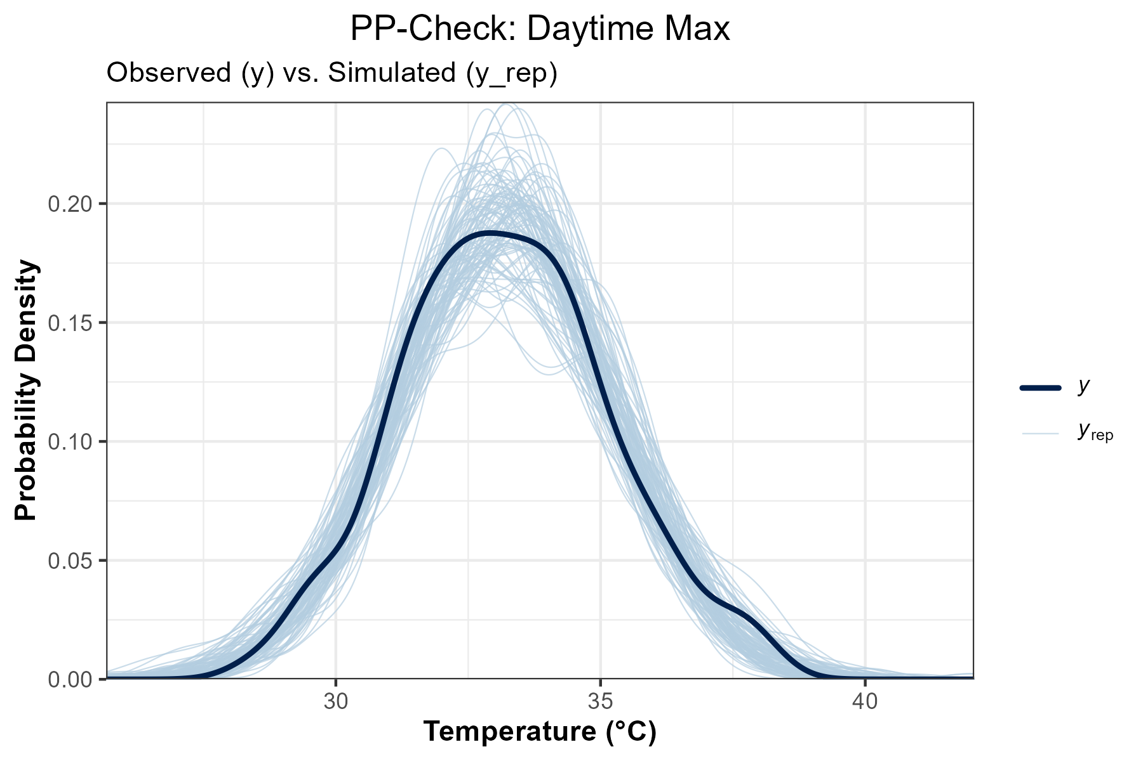
Figure Note: The dark line (y) is observed data; light lines (y_rep) are simulations. This shows how well the model captures the overall shape of the temperature distribution.

Model Calibration: LOO-PIT QQ-Plot
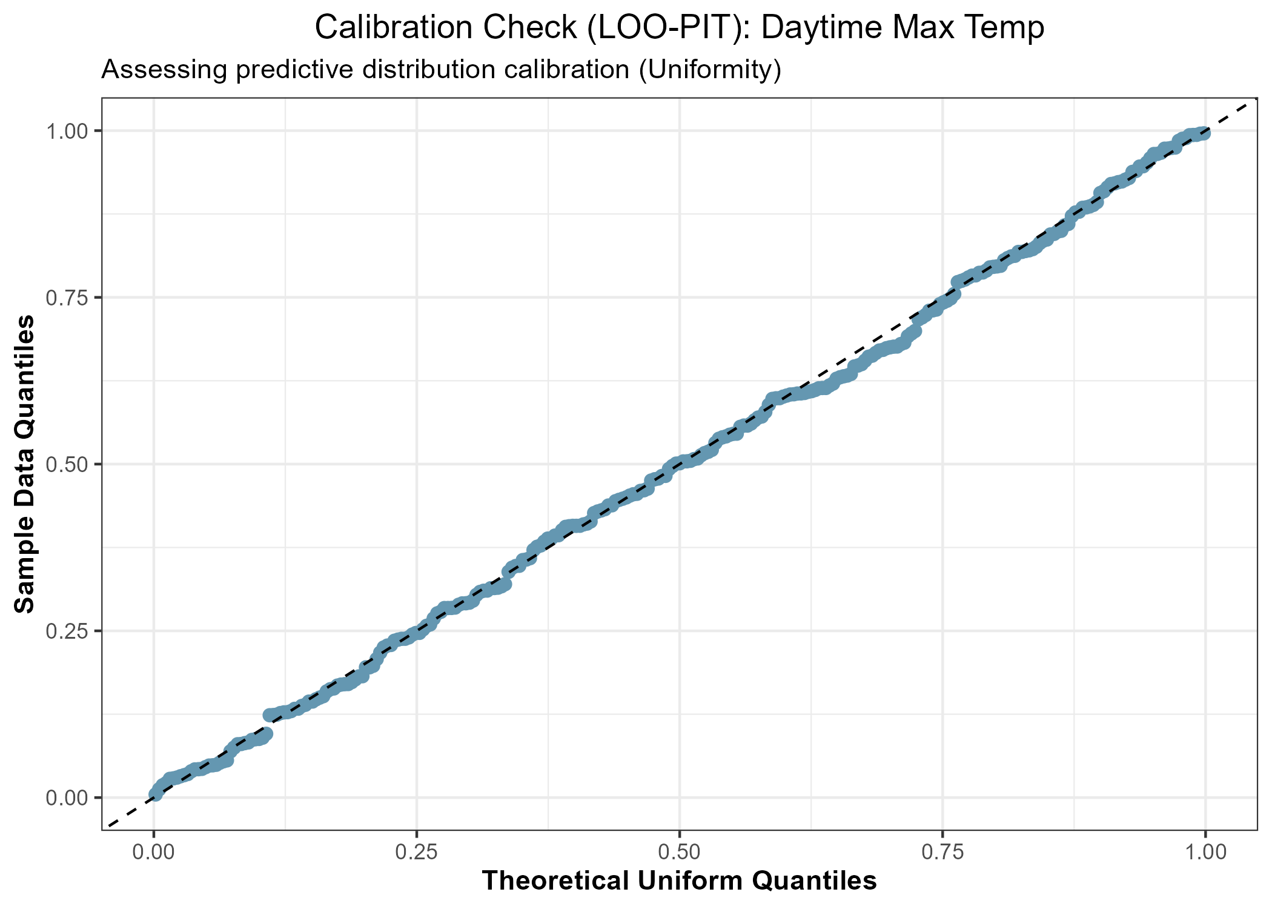
Figure Note: This plot assesses calibration. If the points follow the diagonal line, the model's uncertainty and probability of extremes are correctly estimated.

Sensitivity Analysis (Threshold Comparison)
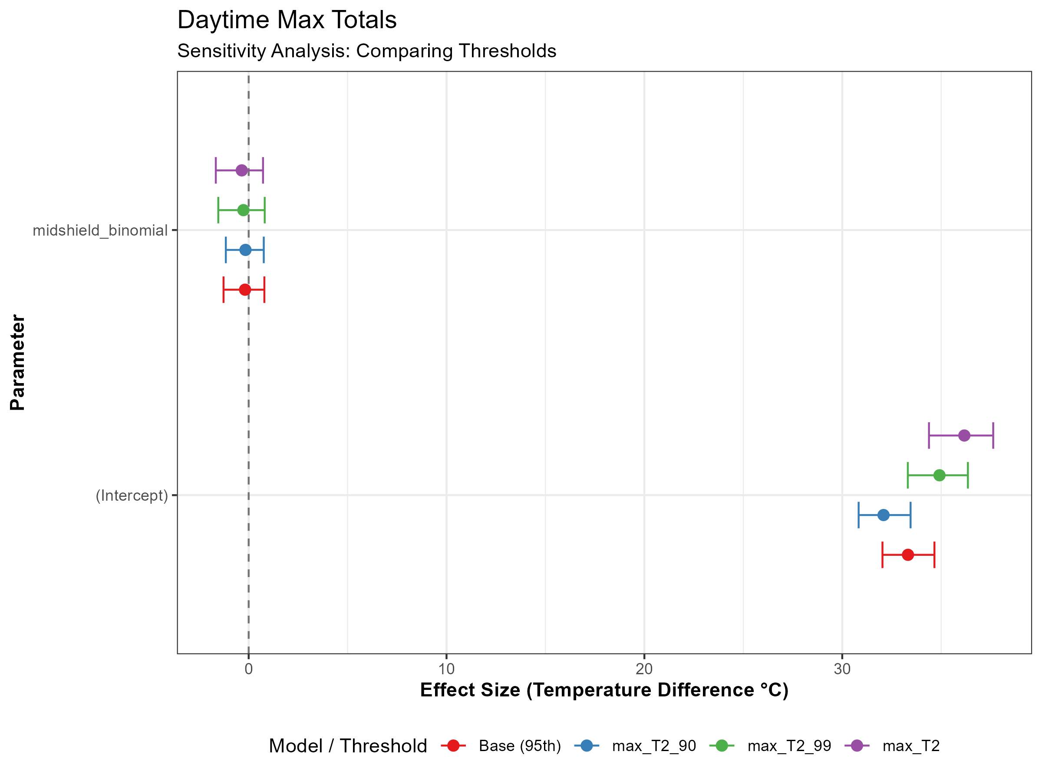
Figure Note: Comparison of effect sizes across 90th, 95th, and 99th percentiles. Consistency across thresholds demonstrates result robustness.

Nighttime Minimum Temperature (Total Period)

Main Bayesian Model Summary (Fixed & Random Effects)
Nighttime Minimum Temperature (Total Period) - Main Model
Parameter | Posterior Mean | Est. Error | 95% Lower CI | 95% Upper CI
Intercept (Grand Mean) | 13.712 | 0.225 | 13.257 | 14.209
midshield_binomial | 0.144 | 0.158 | -0.241 | 0.398
SD (Intercept: dist_wall) | 0.286 | 0.210 | 0.083 | 0.859
SD (Intercept: div) | 0.166 | 0.155 | 0.012 | 0.593
SD (Intercept: treatment) | 0.131 | 0.152 | 0.003 | 0.548
SD (Residual) | 0.520 | 0.022 | 0.479 | 0.565

Posterior Predictive Check: Distribution
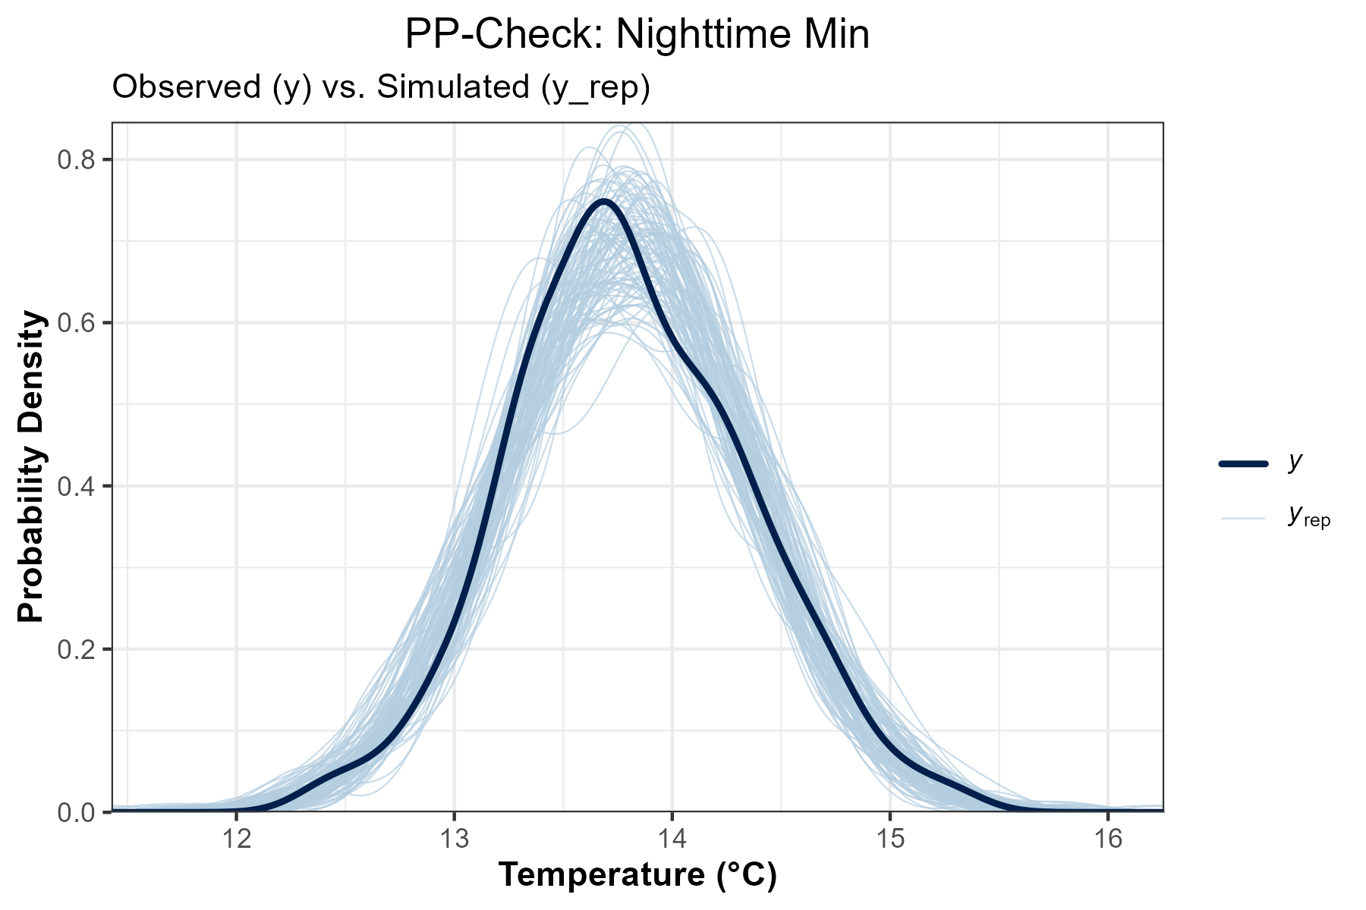
Figure Note: The dark line (y) is observed data; light lines (y_rep) are simulations. This shows how well the model captures the overall shape of the temperature distribution.

Model Calibration: LOO-PIT QQ-Plot
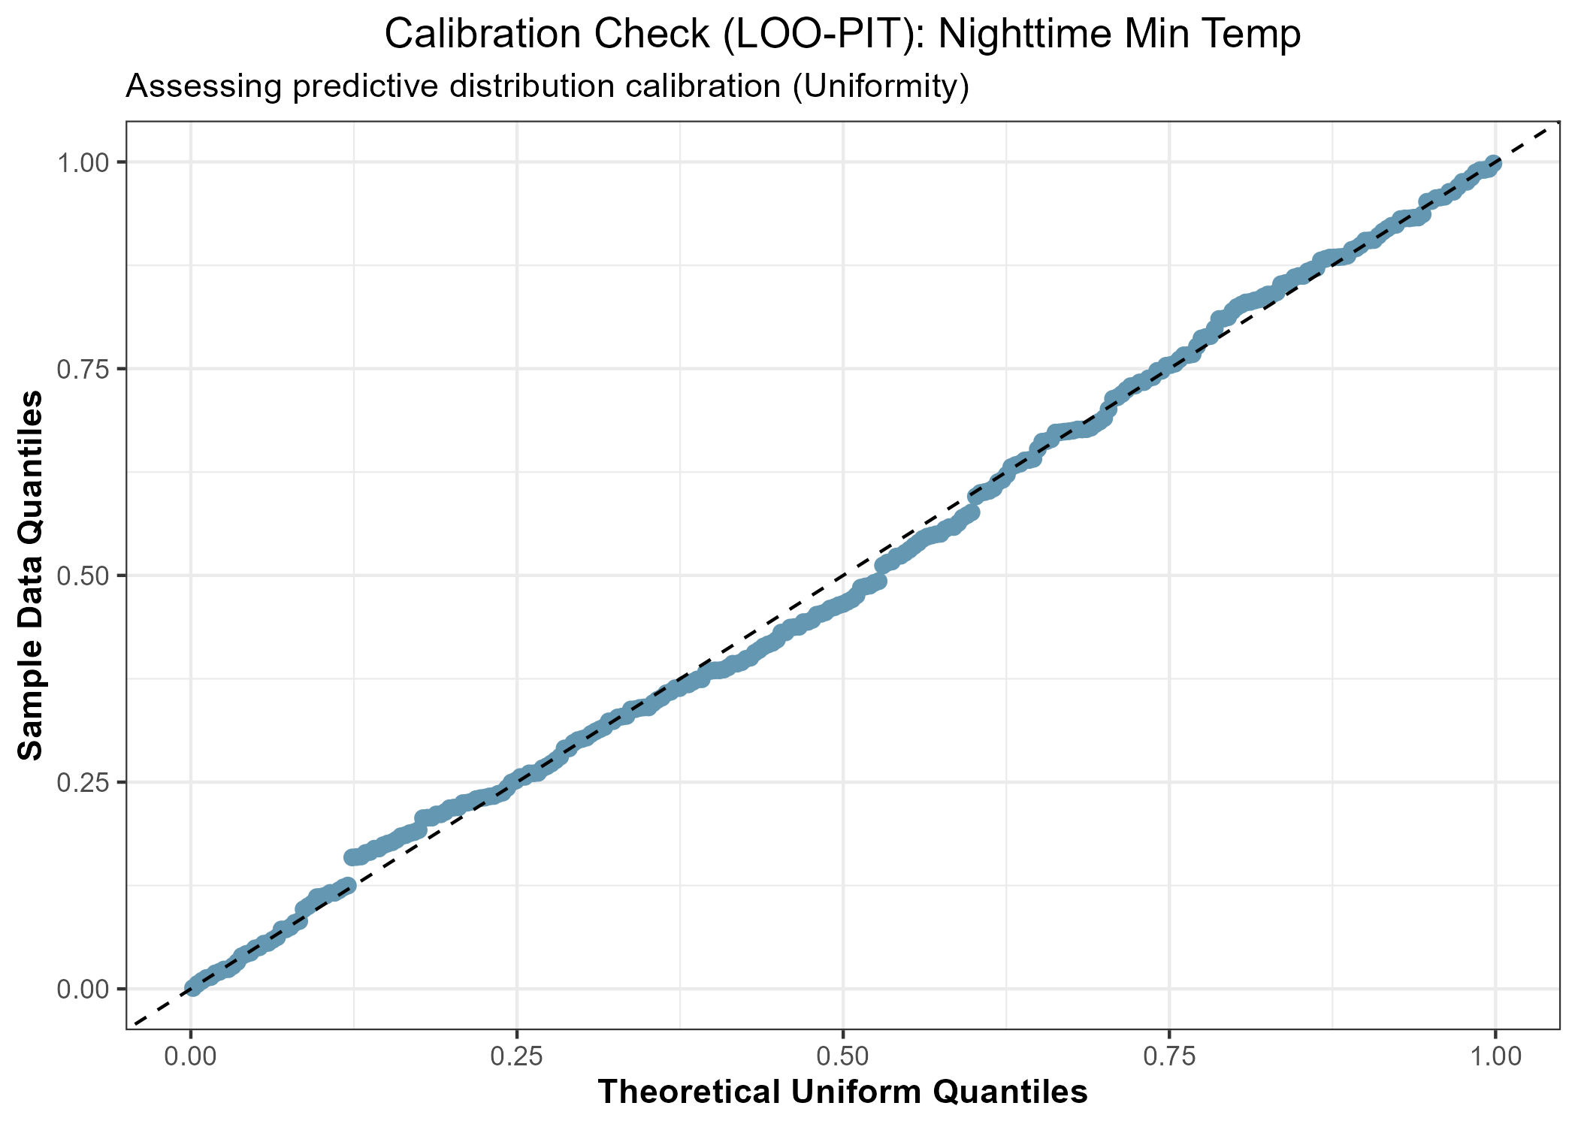
Figure Note: This plot assesses calibration. If the points follow the diagonal line, the model's uncertainty and probability of extremes are correctly estimated.

Sensitivity Analysis (Threshold Comparison)
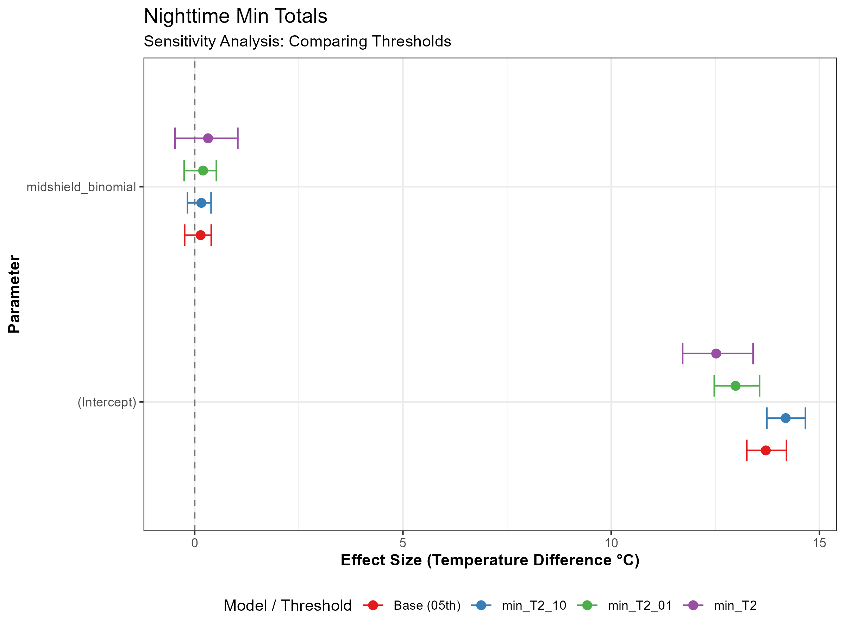
Figure Note: Comparison of effect sizes across 90th, 95th, and 99th percentiles. Consistency across thresholds demonstrates result robustness.

Daytime Maximum Temperature (Daily Interactions)

Main Bayesian Model Summary (Fixed & Random Effects)
Daytime Maximum Temperature (Daily Interactions) - Main Model
Parameter | Posterior Mean | Est. Error | 95% Lower CI | 95% Upper CI
Intercept (Grand Mean) | 29.327 | 0.761 | 27.774 | 30.799
midshield_binomial | -0.177 | 0.251 | -0.682 | 0.316
rad_scaled | 2.428 | 0.486 | 1.460 | 3.387
wind_scaled | -0.335 | 0.370 | -1.121 | 0.340
midshield_binomial:rad_scaled | -0.173 | 0.041 | -0.255 | -0.093
midshield_binomial:wind_scaled | -0.020 | 0.040 | -0.099 | 0.057
SD (Intercept: Date) | 2.507 | 0.349 | 1.942 | 3.301
SD (Intercept: dist_wall) | 0.710 | 0.527 | 0.240 | 2.244
SD (Intercept: div) | 0.306 | 0.279 | 0.092 | 1.018
SD (Intercept: treatment) | 0.729 | 0.518 | 0.248 | 2.217
SD (Residual) | 1.904 | 0.014 | 1.877 | 1.932

Posterior Predictive Check: Distribution
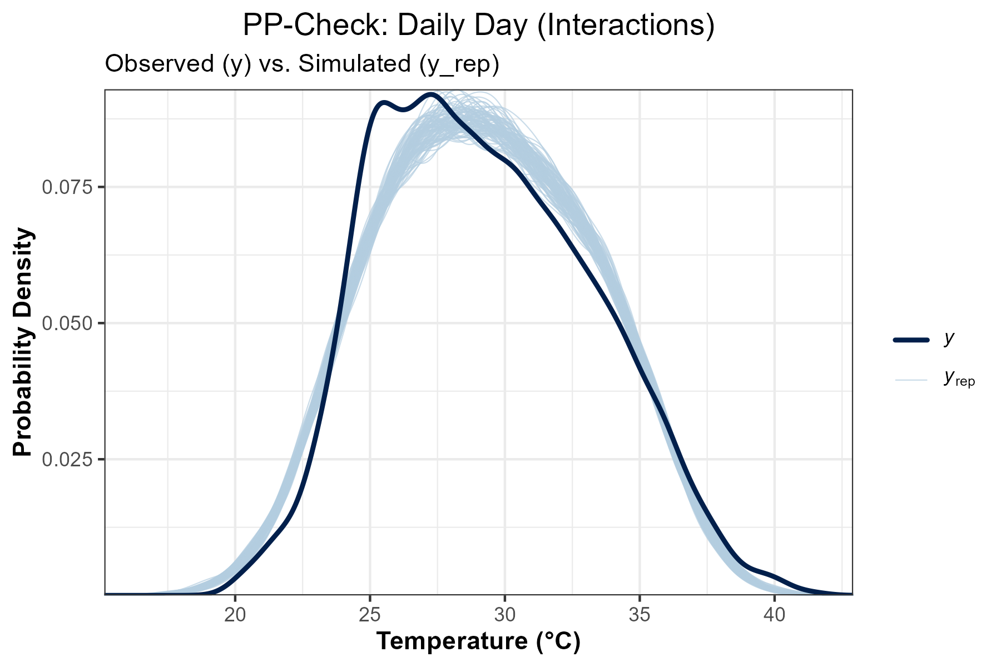
Figure Note: The dark line (y) is observed data; light lines (y_rep) are simulations. This shows how well the model captures the overall shape of the temperature distribution.

Model Calibration: LOO-PIT QQ-Plot
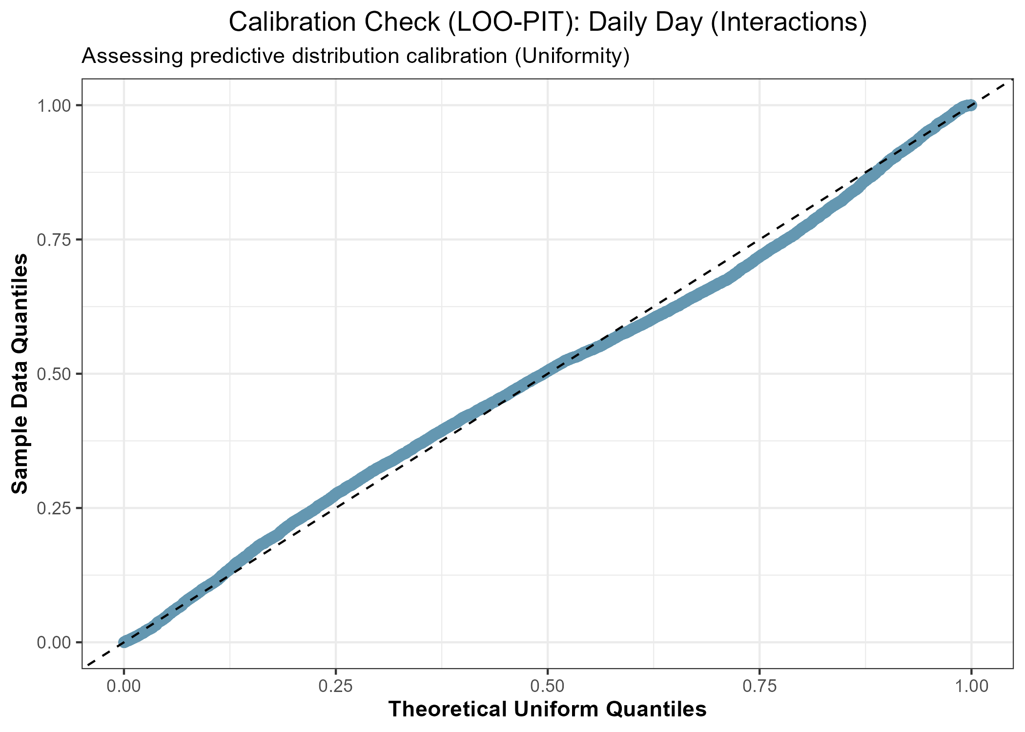
Figure Note: This plot assesses calibration. If the points follow the diagonal line, the model's uncertainty and probability of extremes are correctly estimated.

Sensitivity Analysis (Threshold Comparison)
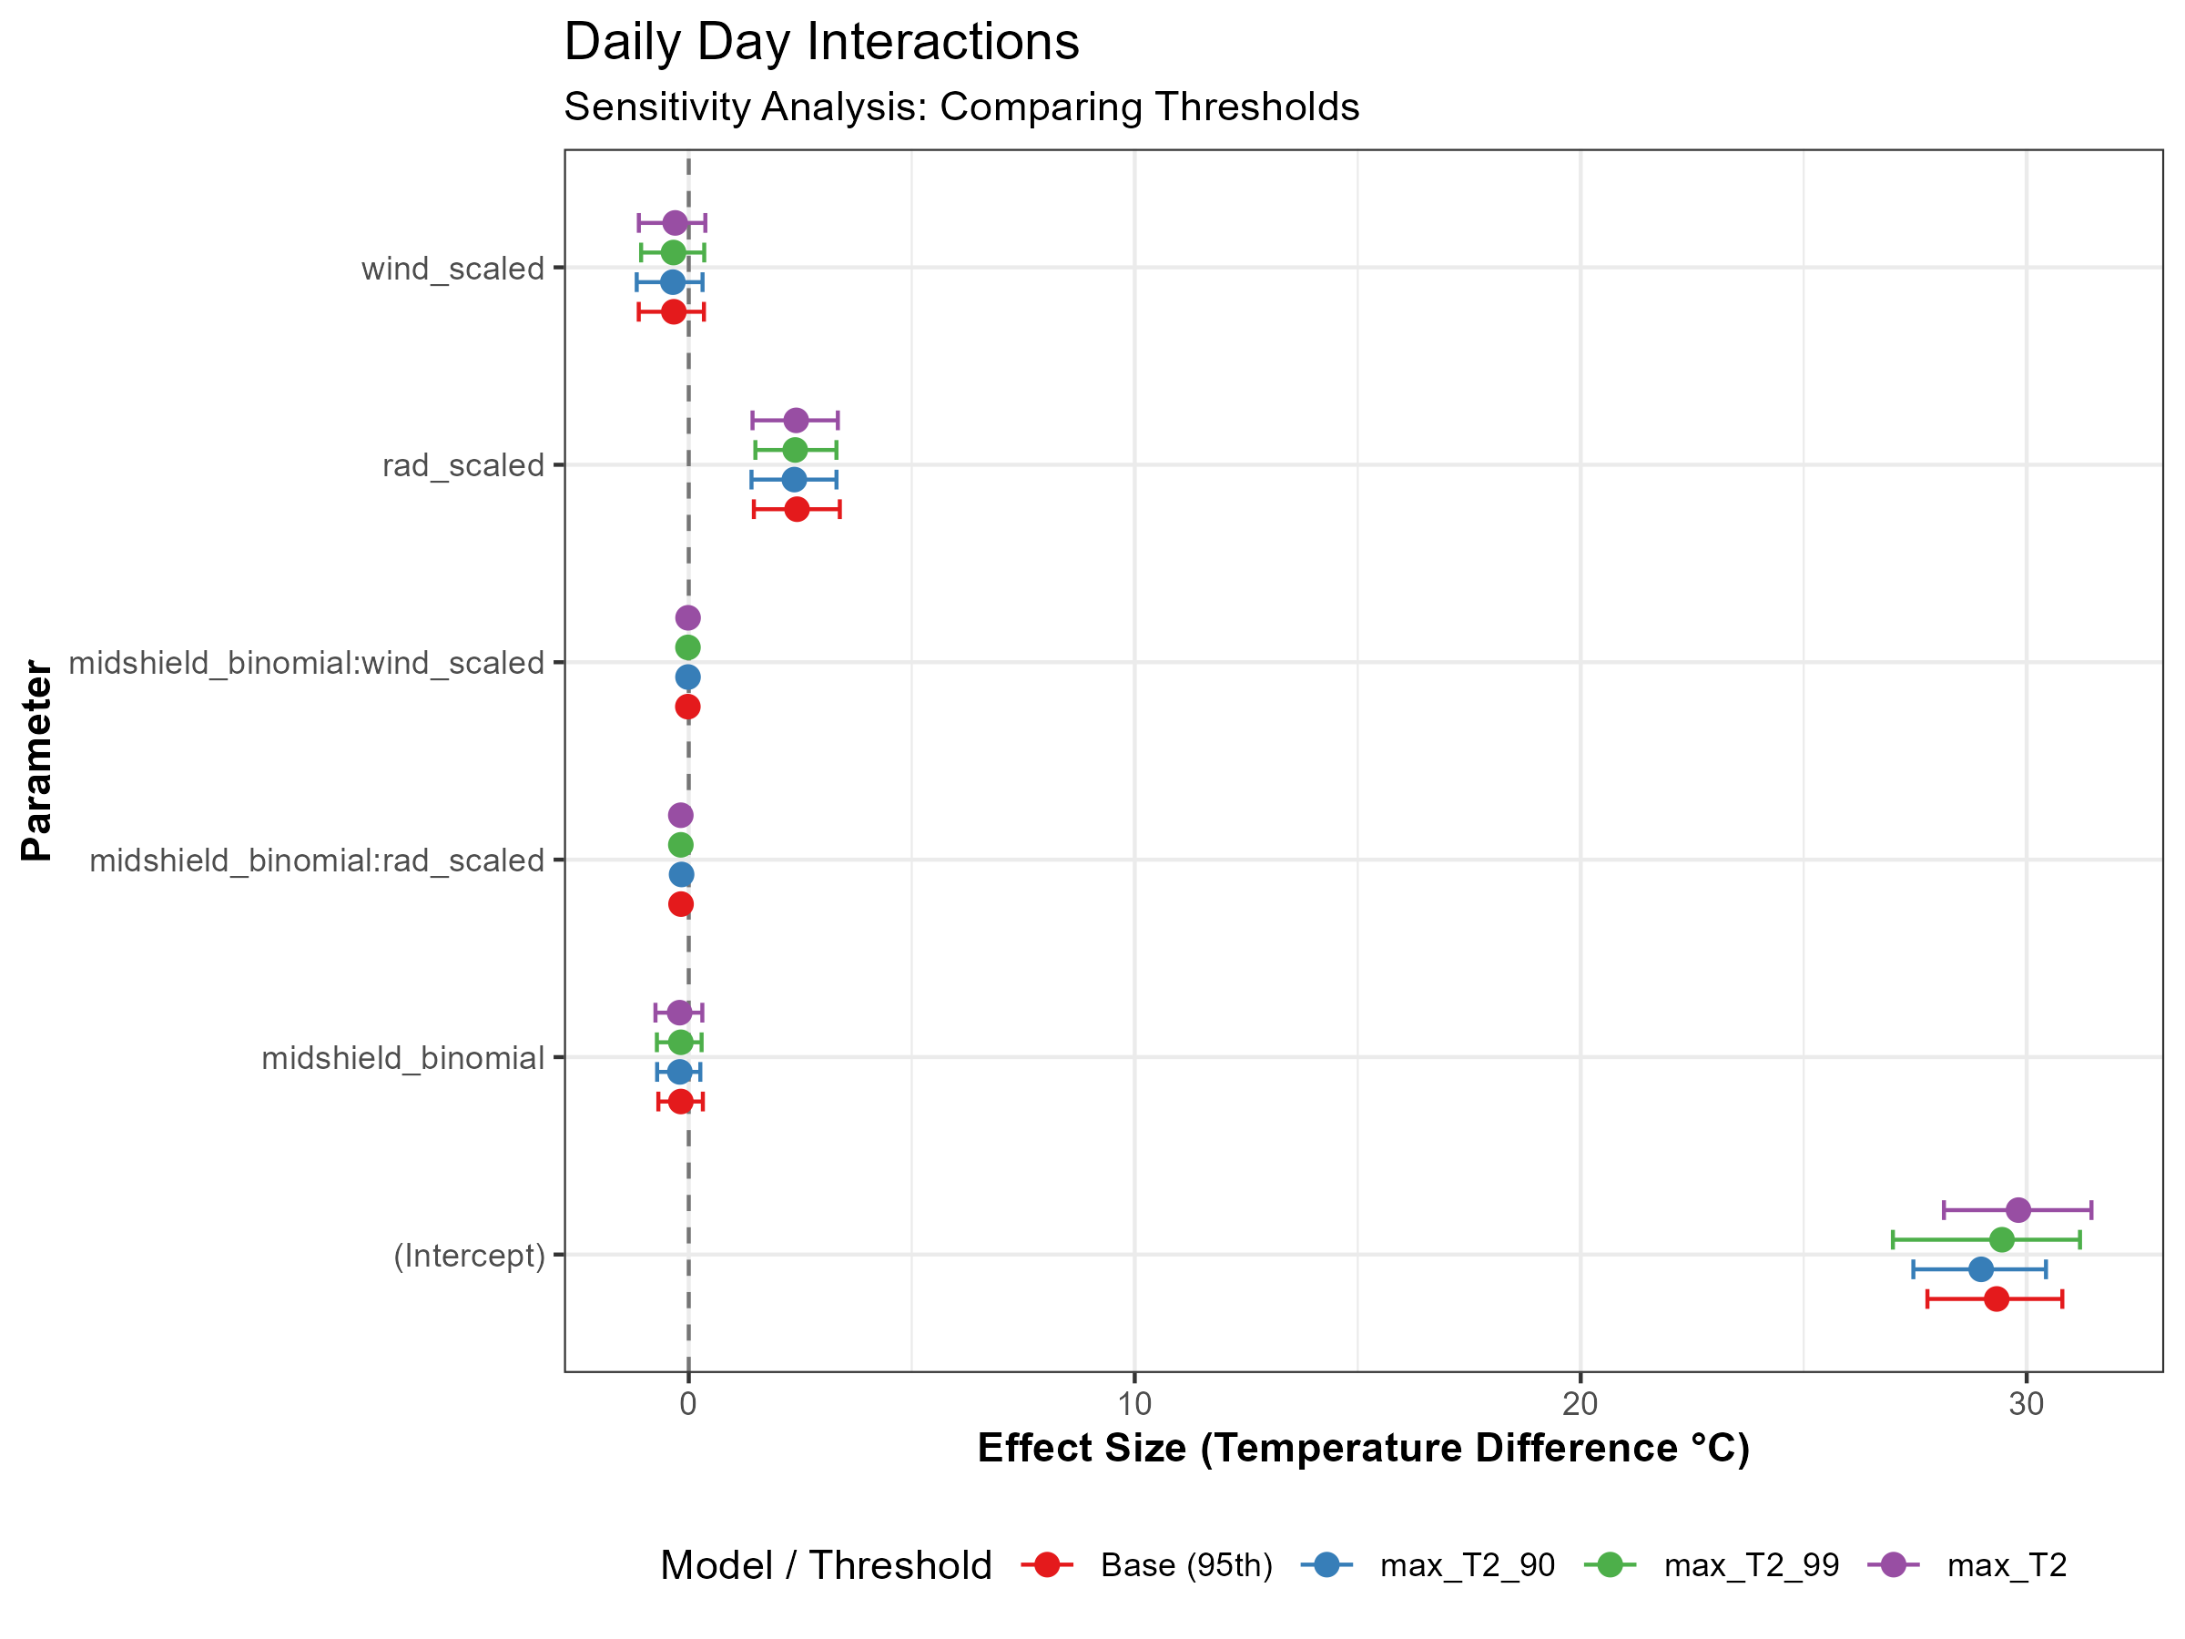
Figure Note: Comparison of effect sizes across 90th, 95th, and 99th percentiles. Consistency across thresholds demonstrates result robustness.

Nighttime Minimum Temperature (Daily Interactions)

Main Bayesian Model Summary (Fixed & Random Effects)
Nighttime Minimum Temperature (Daily Interactions) - Main Model
Parameter | Posterior Mean | Est. Error | 95% Lower CI | 95% Upper CI
Intercept (Grand Mean) | 16.462 | 0.471 | 15.525 | 17.388
midshield_binomial | 0.027 | 0.104 | -0.182 | 0.217
wind_scaled | -0.466 | 0.370 | -1.255 | 0.185
midshield_binomial:wind_scaled | -0.004 | 0.011 | -0.026 | 0.018
SD (Intercept: Date) | 2.262 | 0.300 | 1.762 | 2.927
SD (Intercept: dist_wall) | 0.272 | 0.222 | 0.088 | 0.918
SD (Intercept: div) | 0.219 | 0.188 | 0.070 | 0.709
SD (Intercept: treatment) | 0.242 | 0.225 | 0.045 | 0.855
SD (Residual) | 0.549 | 0.004 | 0.542 | 0.557

Posterior Predictive Check: Distribution
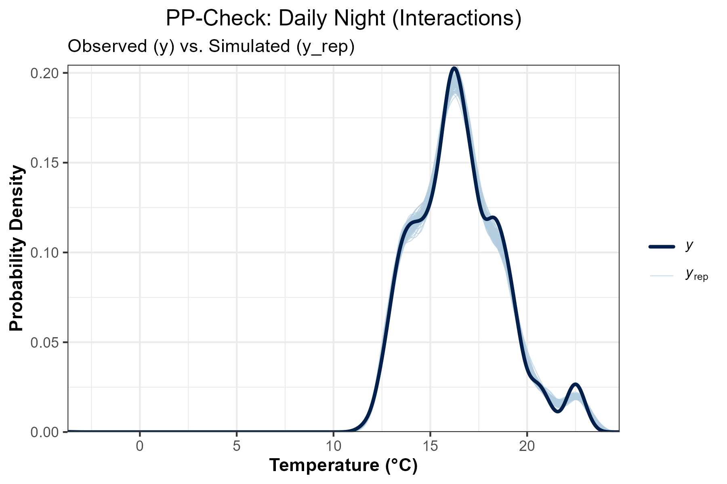
Figure Note: The dark line (y) is observed data; light lines (y_rep) are simulations. This shows how well the model captures the overall shape of the temperature distribution.

Model Calibration: LOO-PIT QQ-Plot
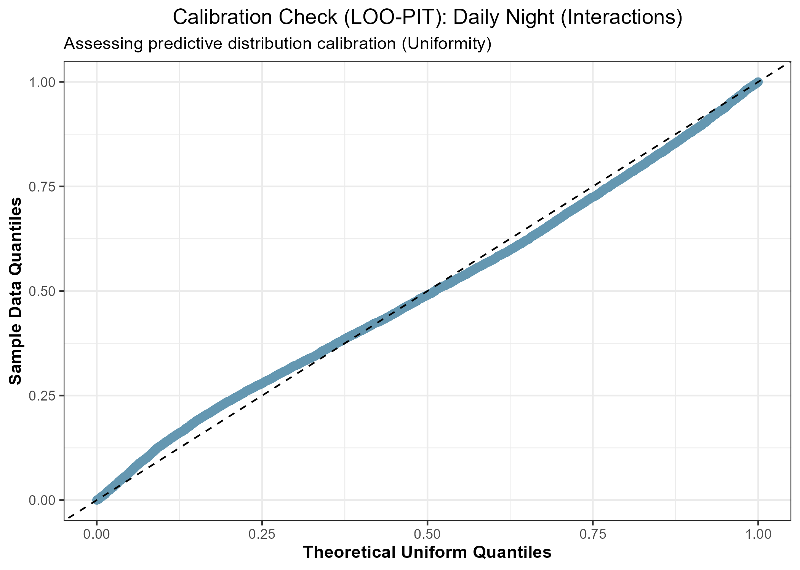
Figure Note: This plot assesses calibration. If the points follow the diagonal line, the model's uncertainty and probability of extremes are correctly estimated.

Sensitivity Analysis (Threshold Comparison)
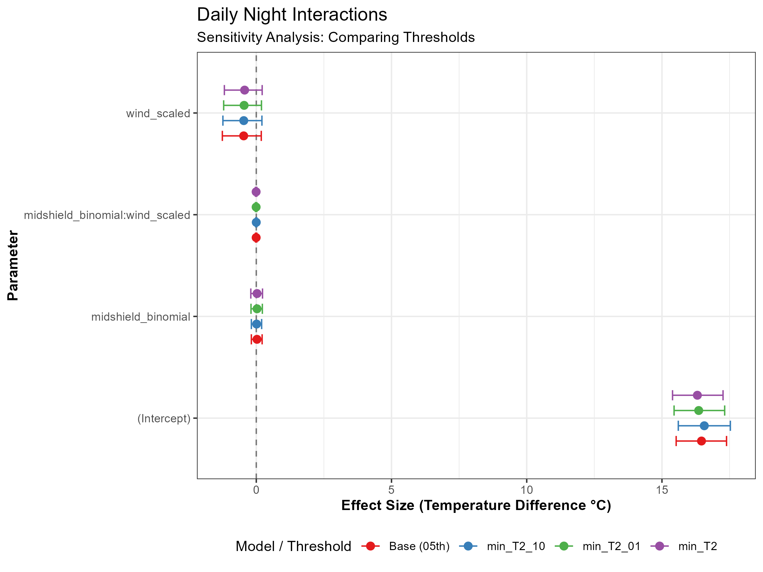
Figure Note: Comparison of effect sizes across 90th, 95th, and 99th percentiles. Consistency across thresholds demonstrates result robustness.

