FAQs

1) How do I build?

Sol: From Terminal: mvn -e clean install

From Eclipse:

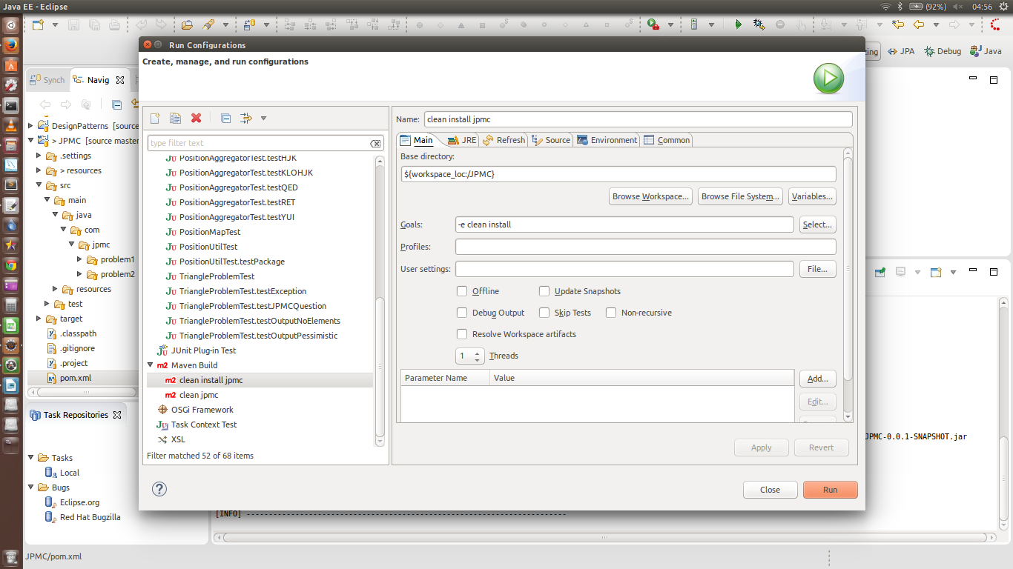

2) How do I run testcases?

Sol: They are packaged as a part of the mvn build.

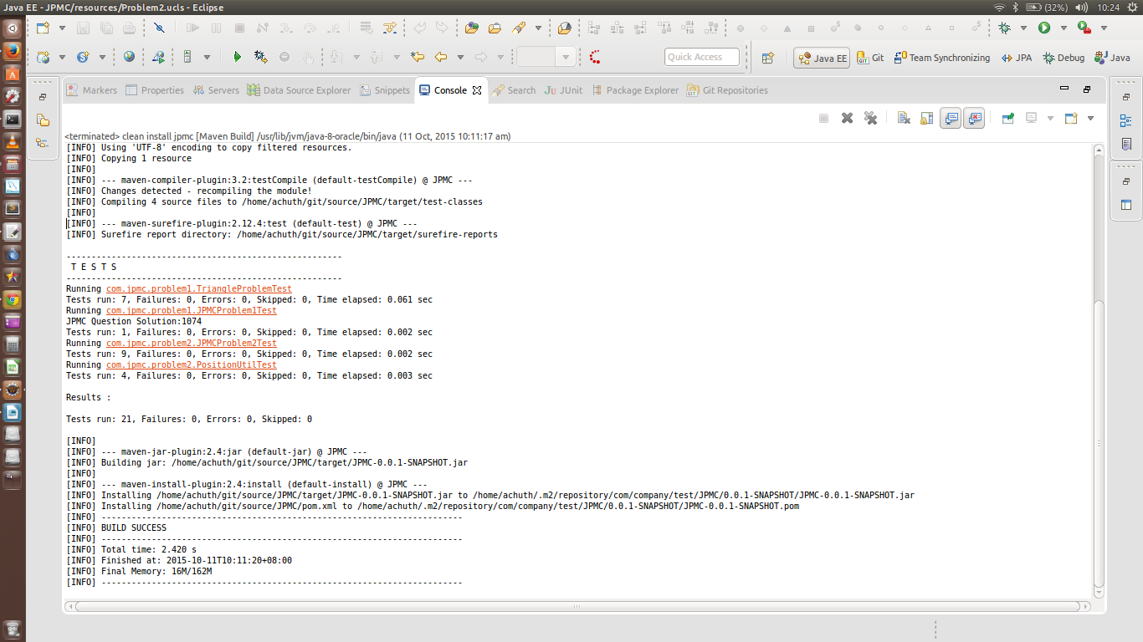

3) Where do I find the original JPMC Problems?

Sol: They are included as a part of the Junit Testcases described in Question 2.

4)How do I understand the code?

Sol: A high resolution Class Diagram in the resource folder called: Problem2.png

