Name: Choi, Minki Student ID:22011955

q.1 code

E=8.854*(10^(-12));

c_cell=cell(2,3);

d=[0.003 0.004 0.005 0.01];

L=[1 2 3];

r=[0.001 0.002 0.003];

c_cell={"d","L","r";d,L,r};

C=(pi*E*c_cell{2,2}(2))/log((c_cell{2,1}(3)-c_cell{2,3}(1))/c_cell{2,3}(1));

q.1 answer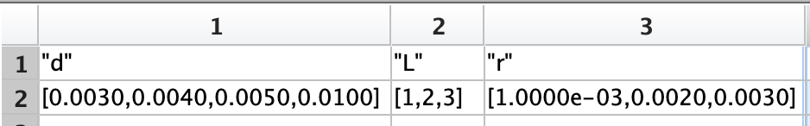

C =

4.0130e-11

q.2 code

%%problem condition is invalid. So I solve it with 10 elements not 9.

vctD=[0:3:27]

vctDop=fliplr(vctD)

q.2 answer

vctD =

0 3 6 9 12 15 18 21 24 27

vctDop =

27 24 21 18 15 12 9 6 3 0

q.3 code

H=[1.25:0.25:2.75;1 2 3 1 2 3 4;45:-5:15];

%%a

G([1 2],:)=[H(1,1:3) H(1,6:7);H(3,3:7)]

%%b

K(:,[1 2 3 4])=H(:,[2 3 5 7]);

K=K'

q.3 answer

G =

1.2500 1.5000 1.7500 2.5000 2.7500

35.0000 30.0000 25.0000 20.0000 15.0000

K =

1.5000 2.0000 40.0000

1.7500 3.0000 35.0000

2.2500 2.0000 25.0000

2.7500 4.0000 15.0000

q.4 code

V0=24;R=3800;C=4000*(10^-6);t0=R*C;

time=0:2:20;

Vc=V0*(1-exp((-time)/t0));

i=V0*exp((-time)/t0)/R;

table=vertcat(time,Vc,i)’

q.4 answer

table =

0 0 0.0063

2.0000 2.9590 0.0055

4.0000 5.5531 0.0049

6.0000 7.8274 0.0043

8.0000 9.8213 0.0037

10.0000 11.5694 0.0033

12.0000 13.1020 0.0029

14.0000 14.4456 0.0025

16.0000 15.6236 0.0022

18.0000 16.6563 0.0019

20.0000 17.5617 0.0017

q.5 code

left=[-4 3 1;5 6 -2;2 -5 4.5];

right=[-18.2;-48.8;92.5];

left\right

q,5 answer

ans =

2.8000

-6.4000

12.2000

q.6 code

mixes = struct('Peanuts', [], 'Almonds', [], 'Walnuts', [], 'Raisins', [], 'M_Ms', []);

mixes(1).Peanuts = 3; mixes(1).Almonds = 1; mixes(1).Walnuts = 1; mixes(1).Raisins = 2; mixes(1).M_Ms = 1;

mixes(2).Peanuts = 1; mixes(2).Almonds = 2; mixes(2).Walnuts = 1; mixes(2).Raisins = 3; mixes(2).M_Ms = 1;

mixes(3).Peanuts = 1; mixes(3).Almonds = 1; mixes(3).Walnuts = 0; mixes(3).Raisins = 3; mixes(3).M_Ms = 3;

mixes(4).Peanuts = 2; mixes(4).Almonds = 0; mixes(4).Walnuts = 3; mixes(4).Raisins = 1; mixes(4).M_Ms = 2;

mixes(5).Peanuts = 1; mixes(5).Almonds = 2; mixes(5).Walnuts = 3; mixes(5).Raisins = 0; mixes(5).M_Ms = 2;

q.6 answer

텍스트, 스크린샷, 번호, 폰트이(가) 표시된 사진

AI가 생성한 콘텐츠는 부정확할 수 있습니다.