Specifications for Boeing 787 simulator Numerical Displays
- A Total of 4 Mini Displays:
  - 3 of them Size: 41mm X 25mm
  - 1 of them size: 41mm x 11mm
- Functionality of each of them
  - Display 1:
3 Digits 7 Segment Display with Decimal Place as shown

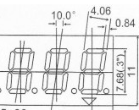
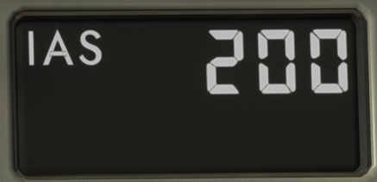

22mm
41mm
Text Display: “IAS” or “MACH”

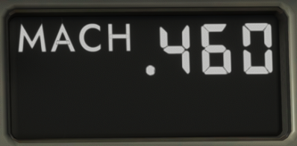

  - Display 2:
3 Digits 7 Segment Display

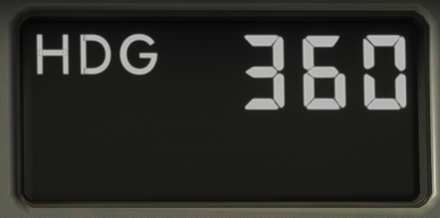

22mm
41mm
Text Display: “HDG” or “TRK”

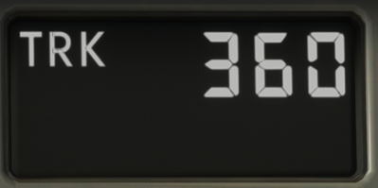

  - Display 3:
11mm
5 Digits 7 Segment Display with “+” or “-“ as shown
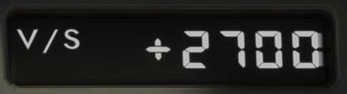
Text Display: “V/S” or “FPA”
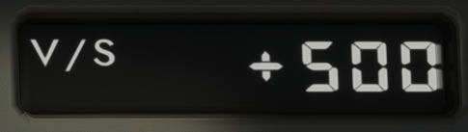

41mm

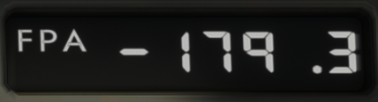

  - Display 4:
5 Digits 7 Segment Display only
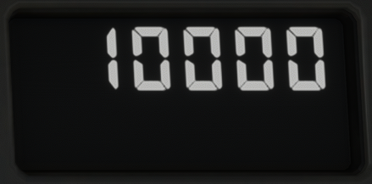

- Other Specifications
  - All Digits must be according to the size below:

  - All Displays must be black background and the display in bright white (High Contrast)
  - All Voltage must be 5v and max 40mWatt
  - Pins must be Segmented for each Digit as per below:
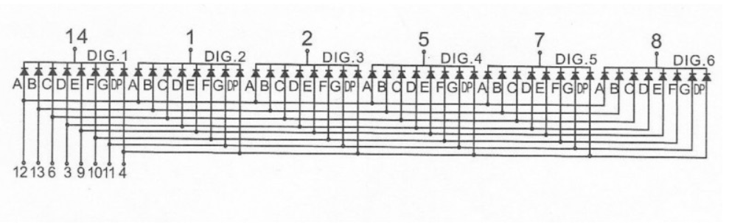
  - Pins for Text must function like lighting up any
  - These will connect to a driver chip MAX7219 which will connect to Arduino 2560 Board.

