South China University of Technology

《Software Engineering》lab1

Homework Title： 医院病房监护系统

Name： 杨子艺 赵旻昆

Student ID： 202030430370 202030430394

Class： 20计创

Teacher： 李剑

**Introduction**

We built up an UML model which contains five diagrams for a hospital ward monitoring system. Our model includes all the necessary functions that the user requirements mentioned adds few extra functions which we consider are reasonable and useful.

**UML Models**

1. **Use Case Diagram**

According to our analysis, the following functions should realized.

1. The disease monitor can send the formatted collected disease signal in real time to the central monitoring system.

2. The central monitoring system compares the standard signal and the patient's signal with the standard disease signal library, and the system automatically alarms when the signal is abnormal.

3. When the disease signal is abnormal, the system automatically updates the medical record and prints the disease report.

4. The nurse on duty can view the disease report and print it.

5. Doctors can view the disease report and request to print the disease report, and they can also view or request to print the medical record.

6. The system automatically updates the medical record regularly.

Further analysis can identify this system roles: duty nurse, doctor, patient, standard disease signal library. The system basic use cases are: central monitoring, disease monitoring, medical record management, and disease report management.

Clarify the ‘extend’ and ‘include’ relationships between use cases. And further decompose the use cases.:

1. Central monitoring includes: medical record management, compare disease signals using the standard signals in the standard disease signal library and disease report management. Especially, when comparing data and detecting abnormal, the central monitoring system will automatically alarm, update the medical records and print the disease report.
2. Disease monitoring includes: collect patient disease signals, formatting the disease signals and send formatted data to the central monitoring system.
3. Medical record management includes: view medical record, update medical record and print medical record.
4. Disease report management includes: view disease report and print disease report.
5. **Package Diagram**

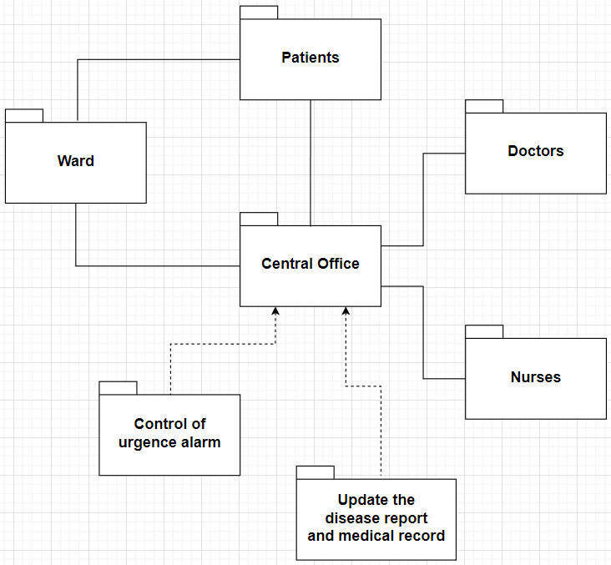

This package diagram specifies the architecture of the system.

1. The relationship between Ward package and Patients package is association. Because, these two sub-systems require communicating with each other. For example, some properties such as calling nurse and urgence alarm are patients’ and also need to be bound to the wards.
2. The Control of urgence alarm package and Update the disease report and medical record package are dependent of Central Office package since they are central office’s key functions.
3. The Ward package, Patients package, Doctors package and Nurse package are all associated with the Central Office package. That’s because not only is the central office supposed to control all the other blocks’ states and behaviors, but also the other blocks mainly have to regard the central office as a bridge which connects the communication themselves.
4. **Sequence Diagram**

A sequence diagram shows process interactions arranged in time sequence in the field of software engineering. It depicts the processes involved and the sequence of messages exchanged between the processes needed to carry out the functionality.

By analysis, there are eight objects in the hospital ward monitoring system: patient, disease monitor, central monitor, normal signal database, disease report, medical record, doctor and nurse.

1. **State Machine Diagram**

A state machine diagram models the behavior of a single object, specifying the sequence of events that an object goes through during its lifetime in response to events.

Considering the hospital ward monitoring system as an object, the following state diagram depicts the series of events and the state the ward monitoring system is in.

The system can stay in five states: collecting, formatting, sending, comparing and one composite state (handling abnormal result after comparing the signal with standard disease signal library).

Furthermore, the system will encounter a series of events: disease monitor will collect the disease signals from patients, formatting the disease signals and send these signals to the central monitor. After sending, central monitor will compare with normal disease signals in standard signals library, if the disease signals are abnormal, the central system alarm, printing disease report and update the disease report automatically.

1. **Class Diagram**

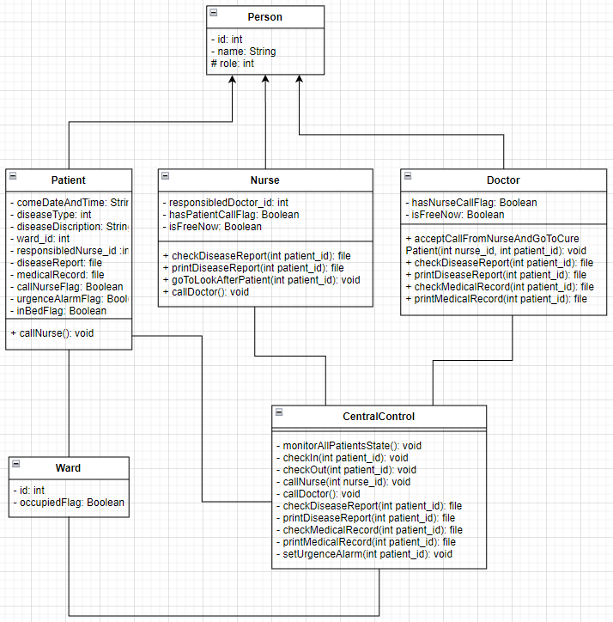

Here is the class diagram.

1. The Person class is the base class of three classes. Its members are id, name and role which denotes the identity of the person.
2. The Patient class, whose role’s value is 0, is inherited from the Person class.

It contains data members that record:

**the data and time of the patient’s being hospitalized;**

**the patient’s disease type and illness’s description;**

**the id of the ward that the patient lies in;**

**the id of the nurse that is in charge of the patient;**

**the patient’s disease report and medical record;**

**several flags that denote whether the patient is calling the nurse, whether his / her urgence alarm on and whether he / she is in bed or not.**

It has a method that **let the patient call the nurse on his / her own**.

1. The Nurse class, whose role value is 1, is inherited from the Person class.

It contains data members that record:

**the id of the doctor that is in charge of the nurse;**

**the flags that denote whether the nurse is being called by patients and whether the nurse is free or not currently.**

It has methods that:

**control the nurse to check a patient’s disease report;**

**control the nurse to print a patient’s disease report;**

**control the nurse to go to look after a patient;**

**control the nurse to call the doctor.**

1. The Doctor class, whose role value is 2, is inherited from the Person class.

It contains data members that record:

**the flags that denote whether the doctor is being called by nurses and whether the doctor is free or not currently.**

It has methods that:

**control the doctor to accept a call from a nurse and go to cure the patient who has called the nurse;**

**control the doctor to check a patient’s disease report;**

**control the doctor to check a patient’s disease report;**

**control the doctor to check a patient’s disease report;**

**control the doctor to check a patient’s disease report.**

1. The Ward class is associated with the patient class and has members id and occupiedFlag.
2. The CentralControl class is associated with all the four classes mentioned above in order to act as the general commander.

It has methods that:

**monitor all patients’ states periodically;**

**handle the patients’ check in;**

**handle the patients’ check out;**

**call a nurse;**

**call a doctor;**

**check a patient’s disease report;**

**print a patient’s disease report;**

**check a patient’s medical record;**

**print a patient’s medical record;**

**set the urgence alarm on;**

1. The methods in the Central Control are private in order to prevent them from being accessed by some people without limits of authority. Except this, other classes’ data members are private and methods are public just like the traditional object-oriented languages’ style.