<http://clarekersley-osteopath.co.uk/wp-content/uploads/ESSENTIAL-STRETCHES-FOR-RUNNERS.pdf>

Calf stretch - Both feet face forwards. - Front knee is directly above the front ankle. - To increase the strength of the stretch, take the back foot further back. - To reduce the strength of the stretch, bring the back foot nearer the front foot. Note: the back heel is on the ground and both feet are facing forward.

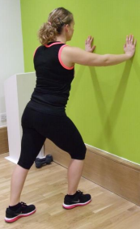

Front of thigh stretch - Stand tall, with your back in your normal alignment i.e. not arching. - Hold your foot/ankle. - If holding your ankle is too much of a stretch and it’s making you arch or twist, then try holding your sock or your trouser leg instead.

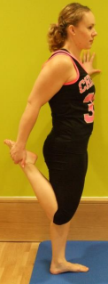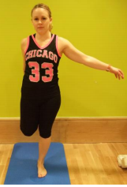

Upper front thigh + groin stretch - Have a cushion, mat or padding under your supporting knee. - Your front knee is directly above your front ankle. - Your trunk is upright. - You should feel a stretch at the top of your thigh/groin on your back leg. - If the stretch is too strong, bring your back knee in closer. - If the stretch is too weak take your supporting knee further back.



Back of thigh stretch - lying down - Relax your neck and shoulders and have a small pillow or pad to support your head. - If your floor leg is buckling at the knee it means you are trying to pull your stretching leg too far in. Instead, keep it straighter and don’t pull as far. If your hamstrings are very tight and you can’t easily reach to pull your straight leg towards you then the main standing back of thigh stretch (above) is a better one for you.

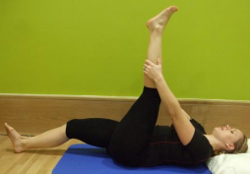

Side stretch - Reach up to the sky with one arm then lean across until you feel a stretch in your side. - Try not to bend forwards or backwards. You just lean sideways. Imagine you are standing in a narrow corridor with a wall in front of you and another behind you so you can’t bend forward or backwards. - You should feel the stretch in your side rather than your back. If you feel it in your back then try reaching your stretched up arm slightly forward when you reach up and across to the side. (Your back is still straight).

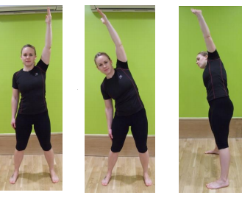

Inner thigh stretch - Note how the foot on the bent knee side is turned outward. It’s pointing in the direction you’re leaning. - Your bent knee is directly above your ankle on that side. - Your hips are facing forward. - To increase the stretch on your inner thigh, keep your legs still and try leaning slightly forward from your hips. NB/ Keep your back straight when you lean. Imagine your top half is sandwiched front and back between rigid boards as you lean down i.e. it’s purely from your hips - your back does not bend.



Buttock stretch - alternative Sit tall, putting one hand on the floor behind you for support. Keep your hips/bottom on the floor and keep your shoulders facing forward, then pull your knee across. NB/ If you let your hip lift up and/or your shoulder turn then this becomes a different sort of exercise and not so much a buttock stretch.

