<https://www.physioroom.com/prevention/stretching4.php>

All stretches will be held for about 20 seconds

[Shoulder & stomach stretch](https://www.physioroom.com/prevention/stretching4_1.php)

The fingers are linked together and the palms of the hands pushed up towards the ceiling. The stretch is felt under the shoulders and in the stomach muscles.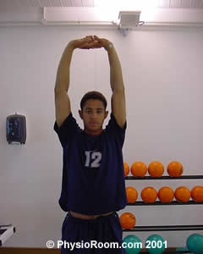

[Shoulder & tricep muscle stretch](https://www.physioroom.com/prevention/stretching4_3.php)

The elbow is bent and grasped with the opposite hand. The hand is then gently pushed down the back. The stretch is felt in the back of the upper arm.

The stretch is then repeated on the other side.

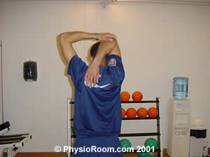

[Back & shoulder stretch](https://www.physioroom.com/prevention/stretching4_5.php)

The feet are placed shoulder width apart and facing forwards. The fingers are linked and the arms pushed out straight with the palms to the front. The arms are then twisted and pushed to one side. The stretch is felt on the outside of the shoulder and in the middle of the back.

The stretch is then repeated to the other side.

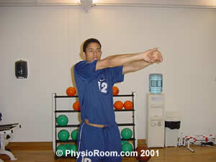

[Shoulder stretch (2)](https://www.physioroom.com/prevention/stretching4_7.php)

The hands are linked behind the back, with the arms out straight. The hands are then gently pushed back. The stretch is felt at the front of the shoulders.

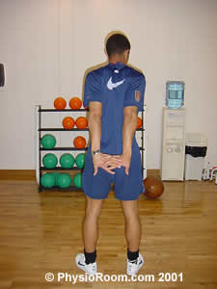

[Abdominal stretch](https://www.physioroom.com/prevention/stretching4_9.php)

Lying on the front with the hands underneath the shoulders, the head and shoulders are gently pushed up with the arms. The pelvis is kept to the ground. The stretch is felt in the front of the stomach.

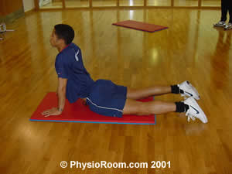

[Back & buttock stretch](https://www.physioroom.com/prevention/stretching4_10.php)

Lying on the back, and keeping one leg to the ground and straight, the opposite leg is bent, brought over and pushed down gently with the hand. The stretch is felt in the middle of the back and in the buttock.

The stretch is then repeated on the other side.

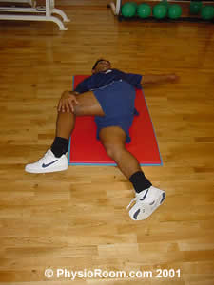

[Gluteal stretch](https://www.physioroom.com/prevention/stretching4_14.php)

Sitting on the floor with one leg out straight, the opposite knee is bent and the foot is placed over the straight leg. The hands are then used to gently push the bent knee up towards the opposite shoulder. The stretch is felt in the buttock.

The stretch is then repeated on the other side.

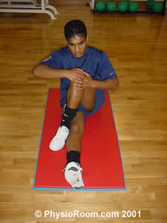

[Hamstring & back stretch](https://www.physioroom.com/prevention/stretching4_17.php)

One foot is placed slightly in front of the other, with the front leg straight and the back leg slightly bent. Bending forwards, the hands slide down the front of the shin. The stretch is felt in the back of the knee.

The toes are pushed down to the floor to feel the stretch more in the middle of the hamstring muscle.

The stretch is then repeated on the other side.

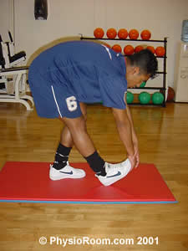

[Hamstring stretch](https://www.physioroom.com/prevention/stretching4_18.php)

The leg is lifted in front of the body and the heel is rested on a flat surface, with the leg out straight. Keeping the back straight, and the other leg bent, the hands slide slowly down the shin. The stretch is felt in the middle of the hamstring muscle.

The stretch is then repeated on the other side.

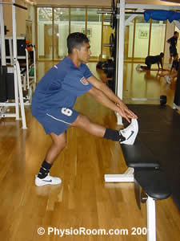

[Thigh muscle stretch](https://www.physioroom.com/prevention/stretching4_20.php)

Lying on the side with the weight of the upper body resting on a bent elbow, the uppermost ankle is pulled towards the buttock. The bent knee is slowly moved backwards. The stretch is felt down the front of the thigh.

The stretch is then repeated on the other side.

