<http://soccerathletics.com/wp-content/uploads/2011/07/DYNAMICWARMUP_ESP_Bonus.pdf>.

**High knee** walking will gradually warm up your quads and hip flexors

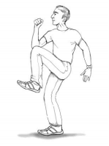

**High knees** with a skip will progressively increase your hip mobility. Push off your opposite leg with each step.

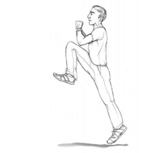

**Walking Butt** kicks involve your hamstrings, and prepare you for fast butt kicks. Kick your heel back toward your butt with each step.

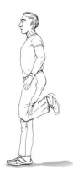

**Fast Butt kicks** activate your hamstrings and prepare them for activity

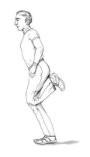

**Lateral lunges** gradually increase your hip and groin mobility. Make sure your knees track over your feet as you step sideways. 15 seconds in each direction.

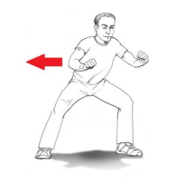

**Grapevine** – Alternate crossing each foot in front and then behind the other. Great for athletic coordination. Repeat in both directions.

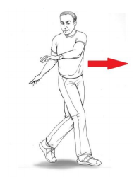

**1 leg deadlift walk** – This drill is great for strengthening your hamstrings, glutes, and core, while improving your balance.

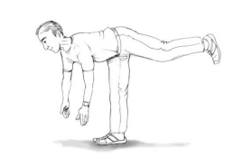

**Straight leg swings** with reach across, actively lengthen your hamstrings & improve rotation at the waist while developing core stability.

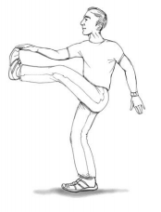

**Lunge walk** – Slowly lower yourself into the lunge position with each step until your knees are bent to about 90 degrees. Push off the front leg as you lunge forward. Keep your core stable.

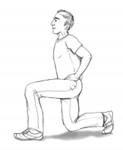

**Arm circles** help improve blood flow and range of motion in the shoulders and upper body. Gradually increase your range of motion and speed of arm movement. 15 seconds in both directions.

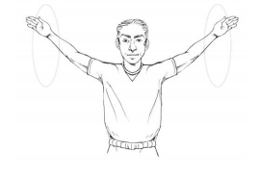

**Heel walking** will strengthen your tibialis anterior (shins) and improve ankle mobility, as well as helping to prevent shin splints. Simply walk on your heels for about 15 seconds without letting the balls of your feet and toes touch the ground.

**Toe walking** strengthens your calves while improving your balance. Simply walk on the balls of your feet for a few seconds while keeping your heels off the ground. Heel & toe walking will prepare your ankles for activity & help protect them from injury.