2012-02-29

|  |
| --- |
| User Manual and Tutorial | N. Schmidt |

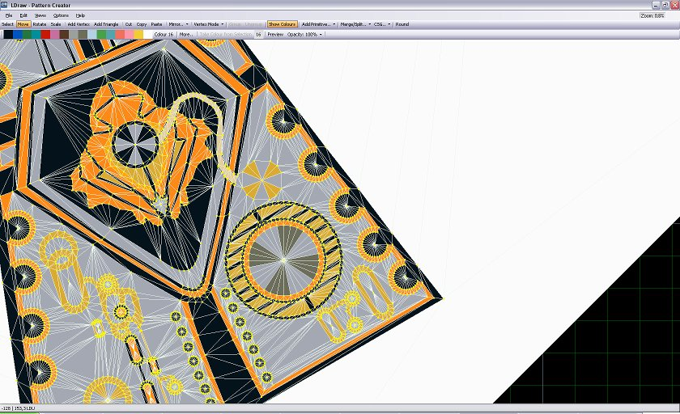

|  |  |
| --- | --- |
| BlackBrick‘s | LD Pattern Creator – Version 1.2.1b |

Table of Contents

**Graphical User Interface1**

Overview2

Toolbar-Functions2

“File”-Menu3

“Edit”-Menu3

“Views”-Menu3

“Options”-Menu3

“Help”-Menu3

**The 2 Ways of Template Creation1**

1. Graphical User Interface

# Overview

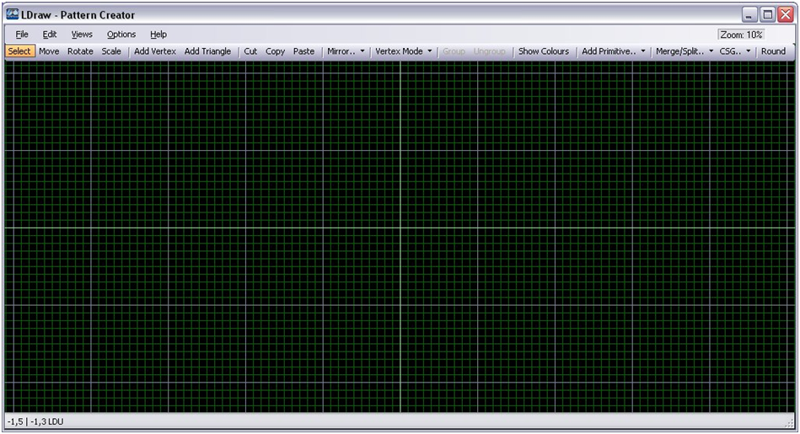

‚File‘-Menu

‚Edit‘-Menu

‚Views‘-Menu

‚Options‘-Menu

‚Help‘-Menu

Minimize

Maximize

Quit

Zoom

Double-click it, to edit the zoom-level.

Toolbar

# Toolbar-Functions

Draw a rectangle around the object

<Primitive Mode> -Selection

<Triangle Mode> -Selection

<Vertex Mode> -Selection

**Select:**

|  |  |
| --- | --- |
| *Access via Context Menu* | *Access via Toolbar* |
| *CSelect.jpg* | *Select.jpg* |
| *Default shortkey:* | *1* |

*Hold/click the left mousebutton to select a object.*

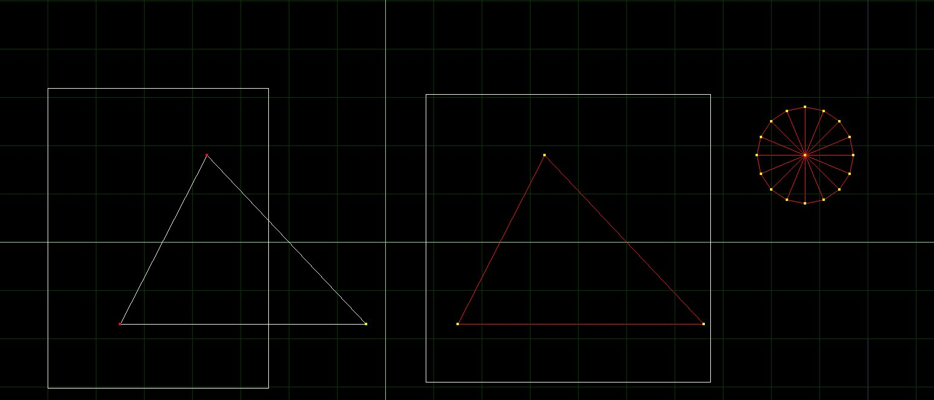

Tip:  
Hold <Ctrl> to add new objects to your current selection.

Click on the object

**Move:**

|  |  |
| --- | --- |
| *Access via Context Menu* | *Access via Toolbar* |
| *CSelect.jpg* | *Select.jpg* |
| *Default shortkey:* | *2* |

*Hold the left mousebutton to move a selection.*