Python Identifiers

1. Class names start with an uppercase letter and all other identifiers with a lowercase letter.
2. Starting an identifier with a single leading underscore (_) indicates by convention that the identifier is meant to be private.
3. Starting an identifier with two leading underscores (__) indicates a strongly private identifier.
4. If the identifier also ends with two trailing underscores, the identifier is a language-defined special name.

Multi-Line Statements

1. Python allows the use of the line continuation character (\) to denote that the line should continue

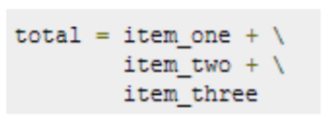

1. The semicolon ( ; ) allows multiple statements on the single line given that neither statement starts a new code block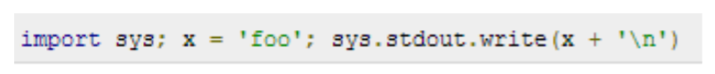

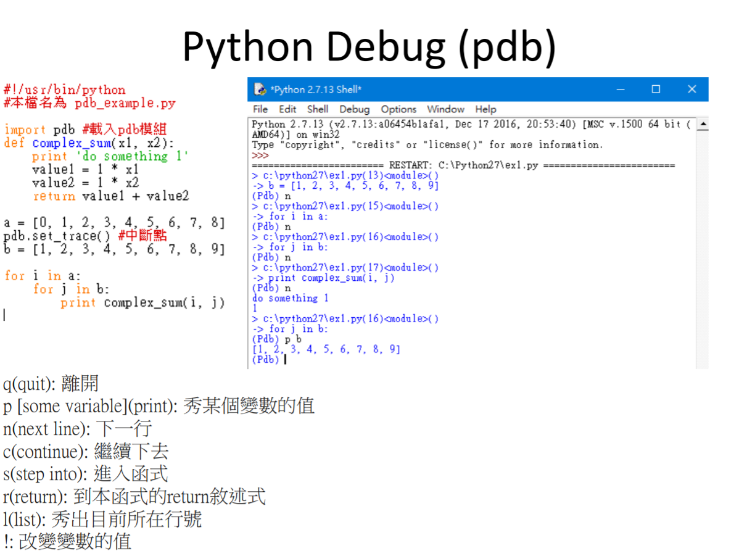

Standard Data Types

1. Numbers (Number data types store numeric values.)

2. String (Strings in Python are identified as a contiguous set of characters in between quotation marks(“ ”).)

3. List (Lists are the most versatile of Python's compound data types.)

4. Tuple (A tuple is another sequence data type that is similar to the list but it is immutable.)

5. Dictionary (Python's dictionaries are kind of hash table type.)

6.Set : frozenset([69, 6.9, ‘str’, True]) immutable –no duplicates & unordered

Python Strings

1. Subsets of strings can be taken using the slice operator ( [ ] and [ : ] ) with indexes starting at 0 in the beginning of the string and working their way from -1 at the end.
2. The plus ( + ) sign is the string concatenation operator.
3. The asterisk ( * ) is the repetition operator.





Python Tuples

1. Tuples are enclosed within parentheses ( ( ) )
2. Lists are enclosed in brackets ( [ ] ) and their elements and size can be changed, while tuples are enclosed in parentheses ( ( ) ) and cannot be updated.
3. Tuples can be thought of as read-only lists

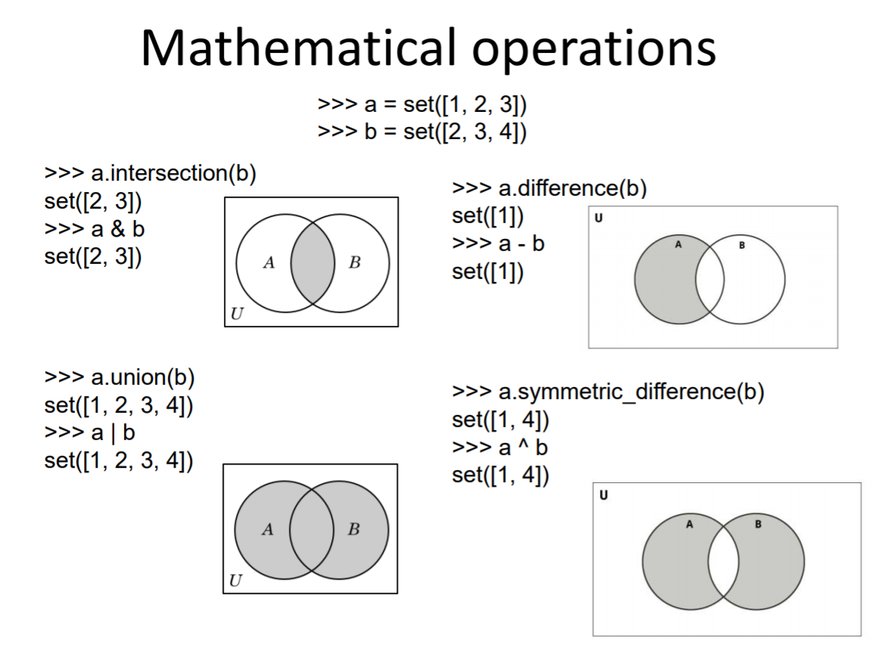

frozenset

1. The frozenset type is immutable and hashable
2. contents cannot be altered after it is created
3. It can be used as a dictionary key or as an element of another set

Python Arithmetic Operators

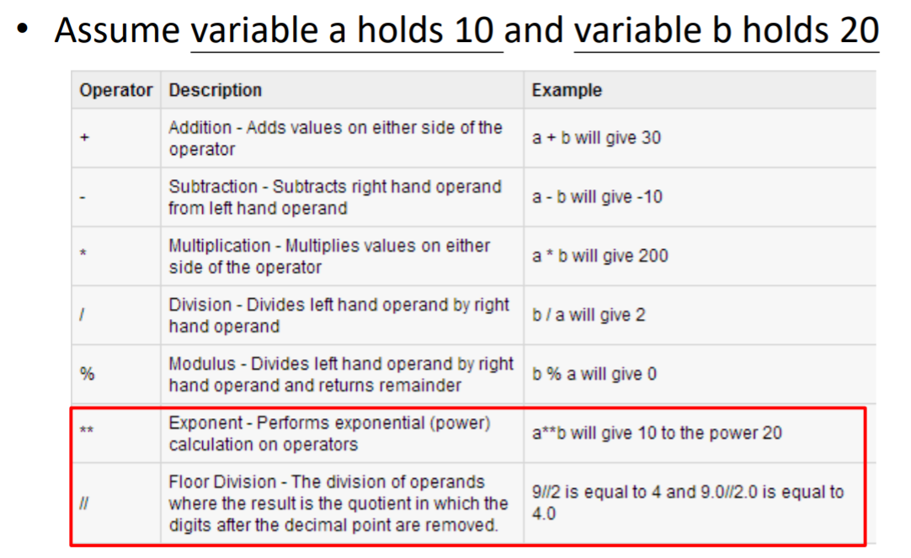

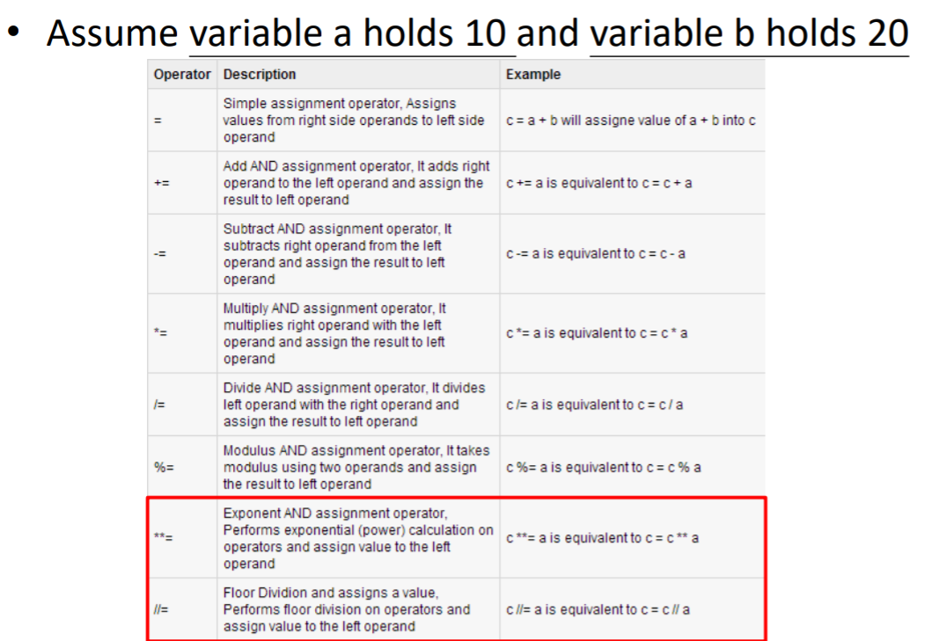

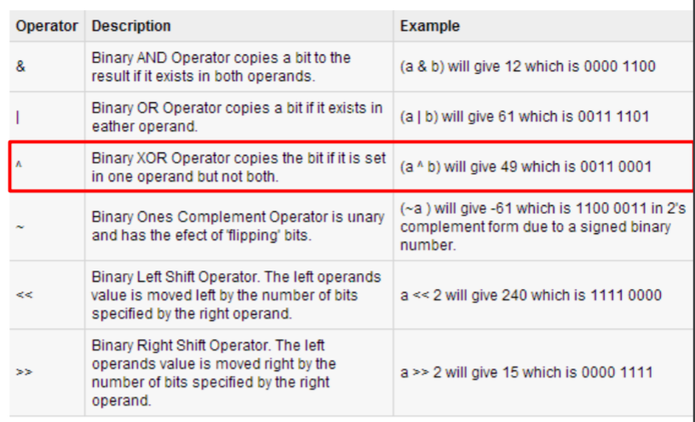

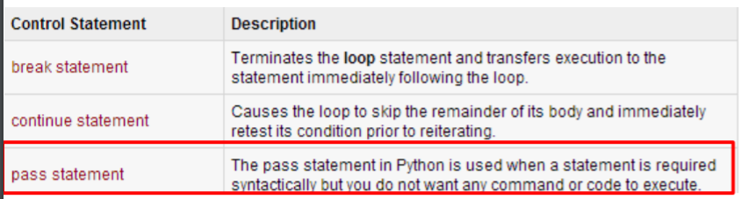

**1. *range*是全部產生完後，return一個 list 回來使用。**  
**2. *xrange*是一次產生一個值，並return一個值回來，所以xrange只適用於loop。不能以list 的方法搜尋**

Chapter 2

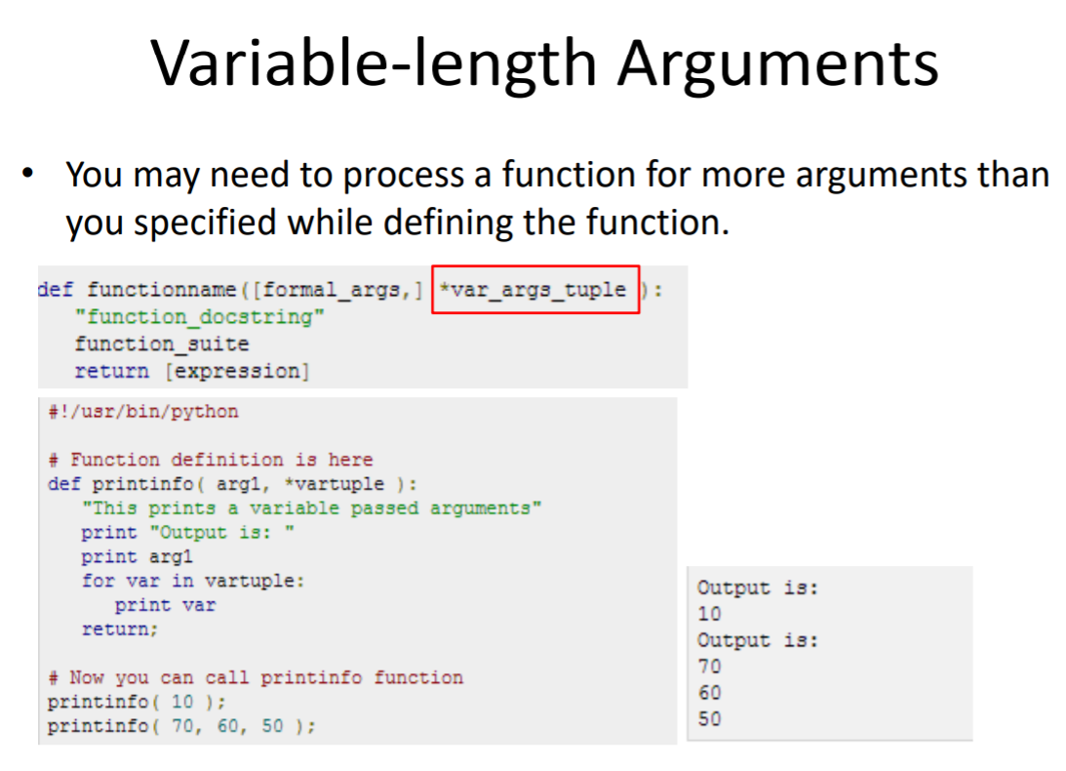

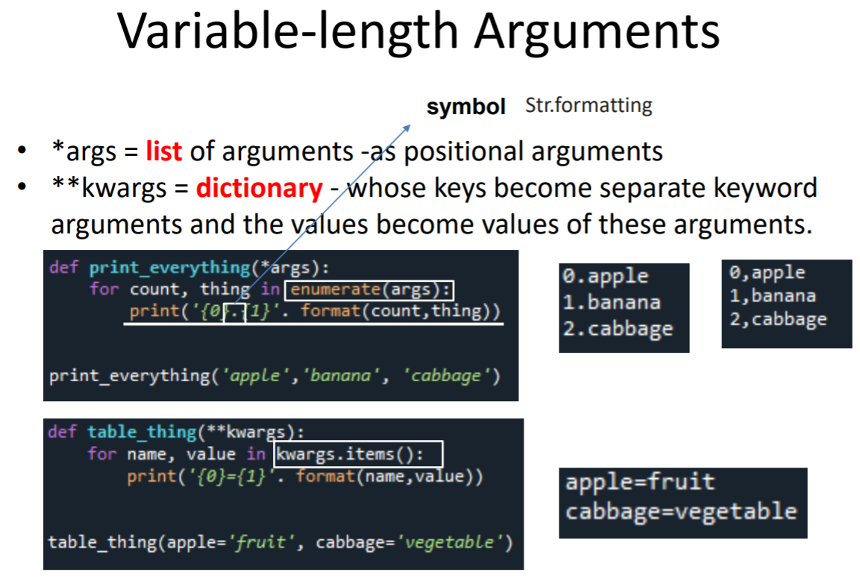

The Anonymous Functions

1. You can use the lambda keyword to create small anonymous functions. 